Supplementary materials for
Design of Biomass-Based Composite Photocatalysts for Wastewater Treatment: A Review Over the Past Decade and Future Prospects

Marina Meloni Gória Pastre^{1*}, Deivisson Lopes Cunha¹, Marcia Marques¹

¹ Department of Sanitary and Environmental Engineering, Rio de Janeiro State University (UERJ), R. São Francisco Xavier, 524, CEP, Rio de Janeiro, RJ 20550-900, Brazil

* Corresponding author: MSc. Marina Pastre
Address: Rio de Janeiro State University (UERJ), R. São Francisco Xavier, 524, CEP, Rio de Janeiro, RJ 20550-900, Brazil
Tel: +5519 99587-7594
Email: pastre.marina@posgraduacao.uerj.br

Table of Contents

Figure S.1: Flowchart of the table data entries. * - Parameters included in the formal statistical analysis. 4
Table S.1: List of the target pollutants discussed in this study. 5
Figure S.2: Principal component analysis (PCA_pol) of biomass composite photocatalysts (BCPs), synthesis parameters, experimental conditions, catalyst characterization, BCP adsorption (ADS) and BCP removal (RE). 7
Table S.2: Values of Kaiser-Meyer-Olkin factor adequacy for PCA_pol. Overall MSA = 0.59 7
Table S.2a: Calculated eigenvalues the first five PCs (%) and variance of each variance in PCA_pol. 7
Table S.2b: Contributions (in %), correlations (r and R2), and p-values for each correlation between quantitative and qualitative variables on PCs 1, 2 and 3, in PCA_pol. 8
Table S.3: Pearson correlation, means, standard deviations, and correlations with confidence intervals of PCA_pol dataset. 9
Figure S.3: Principal component analysis (PCA_dyes) of biomass-based composite photocatalysts (BCPs), synthesis parameters, experimental conditions, catalyst characterization and photocatalytic degradation rate (Kphdeg) for the pollutant class dyes. 10
Table S.4: Values of Kaiser-Meyer-Olkin factor adequacy for PCA_dyes. Overall MSA = 0.55 10
Table S.4a: Calculated eigenvalues the first five PCs (%) and variance of each variance in PCA_dyes. 10
Table S.4b: Contributions (in %), correlations (r and R2), and p-values for each correlation between quantitative and qualitative variables on PCs 1, 2 and 3, in PCA_dyes. 11
Table S.5: Pearson correlation, means, standard deviations, and correlations with confidence intervals of PCA_dyes dataset. 12
Figure S.4: Principal components (PCA_pharma) of biomass-based composite photocatalysts (BCPs), synthesis parameters, experimental conditions, catalyst characterization and photocatalytic degradation rate (Kphdeg) for the pollutant class pharmaceutical compounds. 13
Table S.6: Values of Kaiser-Meyer-Olkin factor adequacy for PCA_pharma. Overall MSA = 0.55 13
Table S.6a: Calculated eigenvalues the first five PCs (%) and variance of each variance in PCA_pharma. 13
Table S.6b: Contributions (in %), correlations (r and R2), and p-values for each correlation between quantitative and qualitative variables on PCs 1, 2 and 3, in PCA_pharma. 14
Table S.7: Pearson correlation, means, standard deviations, and correlations with confidence intervals of PCA_pharma dataset. 15
References 15

Figure S.1: Flowchart of the table data entries. * - Parameters included in the formal statistical analysis.

Table S.1: List of the target pollutants discussed in this study.

Class and target pollutant | Abbreviation | CAS no. | Molecular formula | MW (g/mol) | N | (%)
Dyes |  |  |  |  | 398 | 47.8
Acid Blue 25 | AB25 | 6408-78-2 | C₂₀H₁₃N₂NaO₅S | 416.38 | 18 | 2.2
Acid Fuchsin | AF | 3244-88-0 | C₂₀H₁₇N₃Na₂O₉S₃ | 585.54 | 5 | 0.6
Acid orange 7 | AO7 | 633-96-5 | C₁₆H₁₁N₂NaO₄S | 350.32 | 21 | 2.5
Acid red 97 | RR97 | 10169-02-5 | C₃₂H₂₀N₄Na₂O₈S₂ | 698.63 | 8 | 1.0
Acridine Orange | AO | 494-38-2 | C₁₇H₁₉N₃ | 265.35 |  | 0.0
Brilliant green | BG | 633-03-4 | C₂₇H₃₄N₂O₄S | 482.63 | 5 | 0.6
Congo Red | CD | 573-58-0 | C₃₂H₂₂N₆Na₂O₆S₂ | 696.66 | 4 | 0.5
Crystal violet | CV | 548-62-9 | C₂₅H₃₀N₃Cl | 407.98 | 4 | 0.5
Direct red 23 | DR23 | 3441-14-3 | C₃₅H₂₅N₇Na₂O₁₀S₂ | 813.72 | 6 | 0.7
Direct red 79 | DR79 | 1937-34-4 | C₃₇H₂₈N₆Na₄O₁₇S₄ | 1048.87 | 1 | 0.1
Direct yellow 44 | DY44 | 8005-52-5 | C₂₇H₂₀N₆Na₂O₈S | 634.53 | 1 | 0.1
Ethyl Violet | EV | 2390-59-2 | C₃₁H₄₂N₃Cl | 492.14 | 1 | 0.1
Malachite green | MG | 569-64-2 | C₂₃H₂₅ClN₂ | 364.9 | 20 | 2.4
Methyl orange | MO | 547-58-0 | C₁₄H₁₄N₃NaO₃S | 327.33 | 45 | 5.4
Methylene blue | MB | 61-73-4 | C₁₆H₁₈ClN₃S | 319.85 | 166 | 20.0
Orange G | OrG | 1936-15-8 | C₁₆H₁₀N₂Na₂O₇S₂ | 452.37 | 50 | 6.0
Reactive blue KN-R | KN-R | 2580-78-1 | C₂₂H₁₆N₂Na₂O₁₁S₃ | 626.54 | 6 | 0.7
Rhodamine B | RhB | 81-88-9 | C₂₈H₃₁ClN₂O₃ | 479.01 | 37 | 4.4
Safranine T | ST | 477-73-6 | C₂₀H₁₉ClN₄ | 350.84 | 4 | 0.5
Pharmaceutical Compounds |  |  |  |  | 173 | 20.8
Acetaminophen | ACE | 103-90-2 | C₈H₉NO₂ | 151.16 | 8 | 1.0
Amoxicillin | AMO | 26787-78-0 | C₁₆H₁₉N₃O₅S | 265.40 | 1 | 0.1
Ampicillin | AMP | 69-53-4 | C₁₆H₁₈N₃NaO₄S | 349.41 | 12 | 1.4
Artemether | ART | 71963-77-4 | C₁₆H₂₆O₅ | 298.37 | 12 | 1.4
Carbamazepine | CBZ | 298-46-4 | C₁₅H₁₂N₂O | 236.27 | 17 | 2.0
Ciprofloxacin | CIP | 85721-33-1 | C₁₇H₁₈FN₃O₃ | 331.35 | 15 | 1.8
Dichloroacetic acid | DCA | 79-43-6 | C₂H₂Cl₂O₂ | 128.94 | 2 | 0.2
Diclofenac | DCF | 15307-86-5 | C₁₄H₁₁Cl₂NO₂ | 296.15 | 16 | 1.9
Enrofloxacin | ERO | 93106-60-6 | C₁₉H₂₂FN₃O₃ | 359.39 | 13 | 1.6
Gadoteric acid | Gd-DOTA | 72573-82-1 | C₁₆H₂₅GdN₄O₈ | 558.65 | 3 | 0.4
Gemifloxacin | GMF | 175463-14-6 | C₁₈H₂₀FN₅O₄ | 389.38 | 15 | 1.8
Glyphosate | GLY | 1071-83-6 | C₃H₈NO₅P | 169.07 | 4 | 0.5
Ibuprofen | IBU | 15687-27-1 | C₁₃H₁₈O₂ | 206.28 | 8 | 1.0
Metronidazole | MD | 443-48-1 | C₆H₉N₃O₃ | 171.15 | 13 | 1.6
Norfloxacin | NOF | 70458-96-7 | C₁₆H₁₈FN₃O₃ | 319.33 | 9 | 1.1
Oxolinic Acid | OXA | 14698-29-4 | C₁₃H₁₁NO₅ | 261.23 | 15 | 1.8
Ramipril | RM | 87333-19-5 | C₂₃H₃₂N₂O₅ | 416.51 | 6 | 0.7
Sulfadiazine | SDZ | 68-35-9 | C₁₀H₁₀N₄O₂S | 250.28 | 25 | 3.0
Sulfamethoxazole | SMX | 723-46-6 | C₁₀H₁₁N₃O₃S | 253.28 | 40 | 4.8
Tartrazine | TZ | 1934-21-0 | C₁₆H₉N₄Na₃O₉S₂ | 534.36 | 9 | 1.1
Tetracycline hydrochloride | TH | 64-75-5 | C₂₂H₂₅ClN₂O₈ | 480.90 | 23 | 2.8
Triclosan | TR | 3380-34-5 | C₁₂H₇Cl₃O₂ | 289.54 | 9 | 1.1
Phenolic Compounds |  |  |  |  | 53 | 6.4
Bisphenol A | BPA | 80-05-7 | C₁₅H₁₆O₂ | 228.29 | 3 | 0.4
2,4-dichlorophenol | 2,4-DCP | 120-83-2 | Cl₂C₆H₃OH | 163.00 | 5 | 0.6
Phenol | PH | 108-95-2 | C₆H₅OH | 94.11 | 45 | 5.4
Agrochemicals |  |  |  |  | 11 | 1.3
Clofibric Acid | CLA | 882-09-7 | C₁₀H₁₁ClO₃ | 214.65 | 9 | 1.1
Imidacloprid | IM | 138261-41-3 | C₉H₁₀ClN₅O₂ | 255.66 | 2 | 0.2
Metals |  |  |  |  | 18 | 2.2
Chromium (VI) | CR(VI) | 18540-29-9 | Cr⁺⁶ | 52.00 | 21 | 2.5
Ammonia nitrogen | NH3 | 12125-02-9 | NH₄Cl | 53.49 | 54 | 6.5
Humic acid | HA | 1415-93-6 | C₉H₉NO₆ | 227.17 | 15 | 1.8
Industrial wastewater | WWT | NA | NA | NA | 1 | 0.1
*N: number of observations.

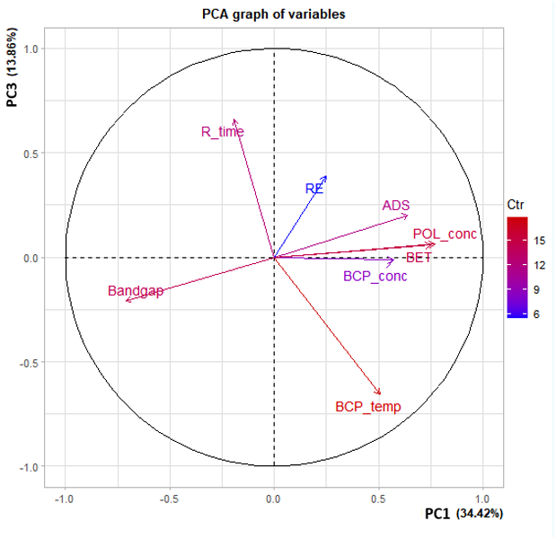Figure S.2: Principal component analysis (PCA_pol) of biomass composite photocatalysts (BCPs), synthesis parameters, experimental conditions, catalyst characterization, BCP adsorption (ADS) and BCP removal (RE).
Variables with a significance level of < 0.01 are shown; each circle represents a sample, colored by BCP synthesis method. The contribution (in percent) of individual variables and samples to principal components 1 and 2 are shown with vector shade and symbol size, respectively. Shaded ellipses display 95% confidence intervals.

Table S.2: Values of Kaiser-Meyer-Olkin factor adequacy for PCA_pol. Overall MSA = 0.59
BCP_temp POL_conc BCP_conc R_time BET Bandgap ADS RE
MSA for each item 0.58 0.71 0.64 0.44 0.67 0.57 0.54 0.36

Table S.2a: Calculated eigenvalues the first five PCs (%) and variance of each variance in PCA_pol.
Eigenvalues | PC1 | PC2 | PC3 | PC4 | PC5
Variance | 2.75 | 1.34 | 1.11 | 0.86 | 0.81
% of var. | 34.42 | 16.75 | 13.86 | 10.80 | 10.16
Cumulative % of var. | 34.42 | 51.17 | 65.03 | 75.83 | 85.98

Table S.2b: Contributions (in %), correlations (r and R2), and p-values for each correlation between quantitative and qualitative variables on PCs 1, 2 and 3, in PCA_pol.
 | PC1 |  |  |  | PC2 |  |  |  |  |  |  | PC3
Quantitative variables
 |  | Cont. (%) | r | p-value |  |  | Cont. (%) |  | r |  | p-value |  |  | Cont. (%) |  |  | r |  |  | p-value
POL_conc |  | 21.59 | 0.77 | 1.42E-32 | RE |  | 48.28 |  | 0.80 |  | 2.60E-37 | R_time |  | 39.45 |  |  | 0.66 |  |  | 2.352E-21
BET |  | 20.52 | 0.75 | 3.51E-30 | ADS |  | 20.64 |  | 0.53 |  | 1.10E-12 | RE |  | 13.51 |  |  | 0.39 |  |  | 4.650E-07
ADS |  | 14.8 | 0.64 | 1.41E-19 | Bandgap |  | 6.52 |  | 0.30 |  | 1.56E-04 | ADS |  | 3.69 |  |  | 0.20 |  |  | 1.061E-02
BCP_conc |  | 11.87 | 0.57 | 3.56E-15 | BET |  | 1.96 |  | -0.16 |  | 4.12E-02 | Bandgap |  | 3.86 |  |  | -0.21 |  |  | 8.886E-03
BCP_temp |  | 9.28 | 0.51 | 1.07E-11 | POL_conc |  | 7.77 |  | -0.32 |  | 3.35E-05 | BCP_temp |  | 38.78 |  |  | -0.66 |  |  | 6.589E-21
RE |  | 2.2 | 0.25 | 1.78E-03 | R_time |  | 13.27 |  | -0.42 |  | 3.10E-08
R_time |  | 1.35 | -0.19 | 1.49E-02
Bandgap |  | 18.39 | -0.71 | 7.46E-26
Qualitative variables
 |  | R2 | p.value |  |  | R2 |  |  |  | p.value |  |  | R2 |  | p.value
Bclass |  | 4.10E-01 | 1.29E-18 |  | BCP_M | 8.960E-02 |  |  |  | 2.196E-03 |  | BCP_S | 1.143E-01 |  | 1.308E-05
BCP_M |  | 2.76E-01 | 6.87E-11 |  |  |  |  |  |  |  |  | Light | 1.295E-01 |  | 8.005E-05
Light |  | 1.91E-01 | 3.25E-07 |  |  |  |  |  |  |  |  | BCP_M | 8.069E-02 |  | 4.462E-03
Sem |  | 1.17E-01 | 9.97E-06 |  |  |  |  |  |  |  |  | POL_class | 8.823E-02 |  | 6.352E-03
POL_class |  | 1.16E-01 | 7.42E-04 |  |  |  |  |  |  |  |  | Bclass | 5.048E-02 |  | 1.759E-02
BCP_S |  | 3.71E-02 | 1.50E-02
PC1, PC2 and PC3: Principal Components 1, 2 and 3, respectively; Cont. (%): Contributions in % of the original variables to the principal components in PCA_par; ; r = linear correlations between the original variables and the principal components in PCA_pol.
In bold: the most relevant contributions by the respective variables to the components.

Table S.3: Pearson correlation, means, standard deviations, and correlations with confidence intervals of PCA_pol dataset.
Variable | M | SD | 1 | 2 | 3 | 4 | 5 | 6 | 7
1. BCP_temp | 407.92 | 231.98
2. POL_conc | 35.90 | 37.01 | .26**
 |  |  | [.10, .40]
3. BCP_conc | 0.77 | 0.46 | .29** | .35**
 |  |  | [.14, .42] | [.20, .48]
4. R_time | 165.19 | 97.78 | -.25** | -.04 | -.01
 |  |  | [-.39, -.10] | [-.19, .12] | [-.16, .15]
5. BET | 167.84 | 127.62 | .32** | .52** | .19* | -.04
 |  |  | [.17, .45] | [.40, .63] | [.03, .33] | [-.19, .12]
6. Bandgap | 2.71 | 0.61 | -.10 | -.57** | -.38** | .07 | -.52**
 |  |  | [-.25, .06] | [-.67, -.45] | [-.50, -.24] | [-.08, .23] | [-.62, -.40]
7. ADS | 32.25 | 24.16 | .27** | .36** | .26** | -.10 | .40** | -.18*
 |  |  | [.12, .41] | [.21, .49] | [.11, .40] | [-.25, .06] | [.26, .52] | [-.32, -.02]
8. RE | 77.90 | 22.28 | -.03 | -.04 | .07 | -.14 | .05 | -.10 | .47**
 |  |  | [-.18, .13] | [-.20, .11] | [-.09, .22] | [-.29, .02] | [-.11, .21] | [-.25, .05] | [.34, .59]
Note. M and SD are used to represent mean and standard deviation, respectively. Values in square brackets indicate the 95% confidence interval for each correlation. The confidence interval is a plausible range of population correlations that could have caused the sample correlation (Cumming 2014). * indicates p < .05. ** indicates p < .01.

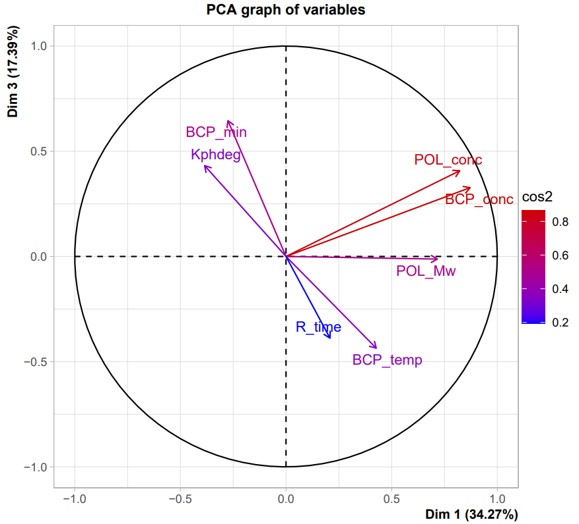

Figure S.3: Principal component analysis (PCA_dyes) of biomass-based composite photocatalysts (BCPs), synthesis parameters, experimental conditions, catalyst characterization and photocatalytic degradation rate (Kphdeg) for the pollutant class dyes.
Variables with a significance level of < 0.01 and the contribution cos2 of individual variables to principal components 1 and 3 are represented by vectors. BCP_conc: catalyst concentration; BCP_temp: catalyst synthesis calcination temperature; BCP_time: catalyst synthesis calcination time; POL_conc: pollutant concentration; POL_Mw: pollutant molecular weight; R_time: reaction time. Results of the PCA analysis are reported in Tables S6, S7, S8 and S9.

Table S.4: Values of Kaiser-Meyer-Olkin factor adequacy for PCA_dyes. Overall MSA = 0.55
BCP_temp BCP_min POL_Mw POL_conc BCP_conc R_time Kphdeg
MSA for each item 0.54 0.53 0.85 0.53 0.54 0.45 0.50

Table S.4a: Calculated eigenvalues the first five PCs (%) and variance of each variance in PCA_dyes.
Eigenvalues | PC1 | PC2 | PC3 | PC4 | PC5
Variance | 2.40 | 1.76 | 1.22 | 0.63 | 0.47
% of var. | 34.27 | 25.08 | 17.39 | 8.97 | 6.74
Cumulative % of var. | 34.27 | 59.35 | 76.74 | 85.70 | 92.44

Table S.4b: Contributions (in %), correlations (r and R2), and p-values for each correlation between quantitative and qualitative variables on PCs 1, 2 and 3, in PCA_dyes.
PC1 |  |  |  |  | PC2 |  |  |  |  |  |  | PC3
Quantitative variables
 | Cont. (%) | r |  | p-value |  |  | Cont. (%) | r | p-value |  |  |  | Cont. (%) |  | r | p-value
BCP_conc | 31.65 | 0.87 |  | 2.80E-24 | R_time |  | 34.89 | 0.78 | 1.10E-16 |  |  | BCP_min | 34.25 |  | 0.65 | 4.00E-10
POL_conc | 28.19 | 0.82 |  | 1.46E-19 | BCP_min |  | 16.62 | 0.54 | 5.71E-07 |  |  | Kphdeg | 15.21 |  | 0.43 | 1.10E-04
POL_Mw | 21.4 | 0.72 |  | 4.89E-13 | BCP_temp |  | 21.6 | -0.62 | 4.12E-09 |  |  | POL_conc | 13.64 |  | 0.40 | 2.86E-04
BCP_temp | 7.6 | 0.43 |  | 1.33E-04 | Kphdeg |  | 26.77 | -0.69 | 1.16E-11 |  |  | BCP_conc | 8.78 |  | 0.33 | 4.20E-03
BCP_min | 3.15 | -0.28 |  | 1.69E-02 |  |  |  |  |  |  |  | R_time | 12.38 |  | -0.39 | 5.80E-04
Kphdeg | 6.19 | -0.38 |  | 6.39E-04 |  |  |  |  |  |  |  | BCP_temp | 15.62 |  | -0.44 | 9.24E-05
Qualitative variables
 | R2 |  | p.value |  |  | R2 |  |  |  | p.value |  |  |  | R2 |  |  | p.value
BCP_M | 1.65E-01 |  | 1.52E-03 |  | Light | 3.31E-01 |  |  |  | 9.97E-06 | BCP_S |  |  | 1.67E-01 |  |  | 2.77E-04
 |  |  |  |  | BCP_M | 1.33E-01 |  |  |  | 1.72E-02 | BCP_M |  |  | 1.57E-01 |  |  | 6.80E-03
 |  |  |  |  | Sem | 5.29E-02 |  |  |  | 4.72E-02 | Light |  |  | 1.49E-01 |  |  | 2.21E-02
PC1, PC2 and PC3: Principal Components 1, 2 and 3, respectively; Cont. (%): Contributions in % of the original variables to the principal components in PCA_dyes; ; r = linear correlations between the original variables and the principal components in PCA_dyes.
In bold: the most relevant contributions by the respective variables to the components.

Table S.5: Pearson correlation, means, standard deviations, and correlations with confidence intervals of PCA_dyes dataset.
Variable | M | SD | 1 | 2 | 3 | 4 | 5 | 6
1. BCP_temp | 497.20 | 243.72
2. BCP_min | 229.20 | 338.54 | -.52**
 |  |  | [-.67, -.33]
3. POL_Mw | 369.06 | 98.81 | .23* | -.12
 |  |  | [.01, .44] | [-.34, .11]
4. POL_conc | 35.88 | 56.57 | .15 | -.06 | .41**
 |  |  | [-.08, .37] | [-.28, .17] | [.20, .58]
5. BCP_conc | 0.82 | 1.00 | .26* | -.06 | .48** | .82**
 |  |  | [.03, .46] | [-.29, .17] | [.28, .64] | [.72, .88]
6. R_time | 154.53 | 89.76 | -.17 | .12 | .12 | -.01 | .10
 |  |  | [-.39, .05] | [-.11, .34] | [-.11, .34] | [-.23, .22] | [-.13, .32]
7. Kphdeg | 0.03 | 0.03 | .07 | .00 | -.24* | -.17 | -.15 | -.61**
 |  |  | [-.16, .29] | [-.22, .23] | [-.44, -.01] | [-.38, .06] | [-.36, .08] | [-.74, -.44]
Note. M and SD are used to represent mean and standard deviation, respectively. Values in square brackets indicate the 95% confidence interval for each correlation. The confidence interval is a plausible range of population correlations that could have caused the sample correlation (Cumming 2014). * indicates p < .05. ** indicates p < .01.

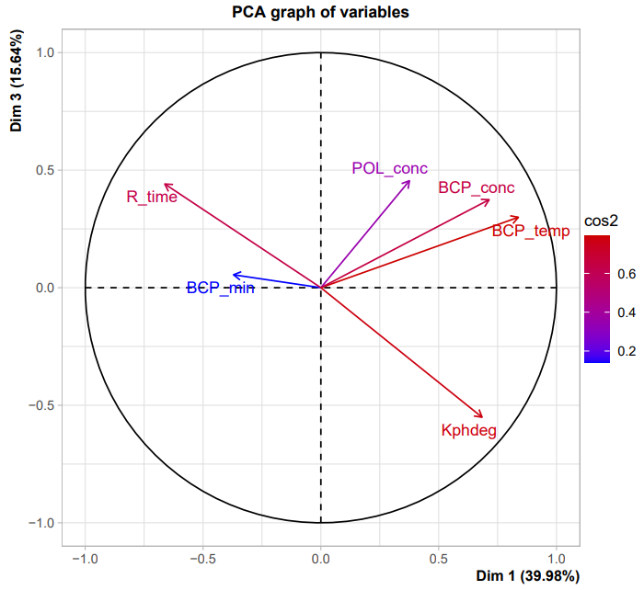
Figure S.4: Principal components (PCA_pharma) of biomass-based composite photocatalysts (BCPs), synthesis parameters, experimental conditions, catalyst characterization and photocatalytic degradation rate (Kphdeg) for the pollutant class pharmaceutical compounds.
Variables with a significance level of < 0.01 and the contribution cos2 of individual variables to principal components 1 and 3 are represented by vectors. BCP_conc: catalyst concentration; BCP_temp: catalyst synthesis calcination temperature; BCP_time: catalyst synthesis calcination time; POL_conc: pollutant concentration; POL_Mw: pollutant molecular weight; R_time: reaction time. Results of the PCA analysis are reported in Tables S10, S11, S12 and S13.

Table S.6: Values of Kaiser-Meyer-Olkin factor adequacy for PCA_pharma. Overall MSA = 0.55
BCP_temp BCP_min POL_conc BCP_conc R_time Kphdeg
MSA for each item 0.56 0.37 0.42 0.58 0.61 0.63

Table S.6a: Calculated eigenvalues the first five PCs (%) and variance of each variance in PCA_pharma.
Eigenvalues | PC1 | PC2 | PC3 | PC4 | PC5
Variance | 2.40 | 1.22 | 0.94 | 0.80 | 0.39
% of var. | 39.98 | 20.38 | 15.64 | 13.28 | 6.48
Cumulative % of var. | 39.98 | 60.35 | 75.99 | 89.27 | 95.75

Table S.6b: Contributions (in %), correlations (r and R2), and p-values for each correlation between quantitative and qualitative variables on PCs 1, 2 and 3, in PCA_pharma.
 | PC1 |  |  |  |  | PC2 |  |  |  |  | PC3
Quantitative |  |  |  |  |  | Quantitative |  |  |  |  | Quantitative
 |  | Cont. (%) | r | p.value |  |  | Cont. (%) | r | p.value |  |  | Cont. (%) | r | p.value
BCP_temp |  | 29.29 | 0.84 | 2.24E-20 | BCP_min |  | 45.76 | 0.75 | 2.88E-14 | POL_conc |  | 22.08 | 0.46 | 5.23E-05
BCP_conc |  | 21.27 | 0.71 | 1.30E-12 | POL_conc |  | 35.66 | 0.66 | 2.09E-10 | R_time |  | 20.74 | 0.44 | 9.40E-05
Kphdeg |  | 19.52 | 0.68 | 2.51E-11 | BCP_temp |  | 5.29 | -0.25 | 2.99E-02 | BCP_conc |  | 14.94 | 0.37 | 1.10E-03
POL_conc |  | 5.89 | 0.38 | 1.05E-03 | R_time |  | 11.33 | -0.37 | 1.19E-03 | BCP_temp |  | 9.56 | 0.30 | 1.00E-02
BCP_min |  | 5.73 | -0.37 | 1.24E-03 |  |  |  |  |  | Kphdeg |  | 32.36 | -0.55 | 4.39E-07
R_time |  | 18.3 | -0.66 | 1.73E-10
Qualitative |  |  |  |  |  | Qualitative
 |  | R2 |  | p.value |  |  |  | R2 | p.value
Light |  | 4.65E-01 |  | 1.00E-08 | BCP_M |  |  | 1.37E-01 | 5.84E-03
BCP_S |  | 2.48E-01 |  | 7.36E-06 | BCP_S |  |  | 5.45E-02 | 4.68E-02
BCP_M |  | 1.90E-01 |  | 6.38E-04
PC1, PC2 and PC3: Principal Components 1, 2 and 3, respectively; Cont. (%): Contributions in % of the original variables to the principal components in PCA_pharma; ; r = linear correlations between the original variables and the principal components in PCA_pharma.
In bold: the most relevant contributions by the respective variables to the components.

Table S.7: Pearson correlation, means, standard deviations, and correlations with confidence intervals of PCA_pharma dataset.
Variable | M | SD | 1 | 2 | 3 | 4 | 5
1.BCP_temp | 426.44 | 176.54
2. BCP_min | 170.14 | 181.11 | -.42**
 |  |  | [-.60, -.22]
3. POL_conc | 21.61 | 18.70 | .26* | .14
 |  |  | [.03, .46] | [-.09, .36]
4. BCP_conc | 17.83 | 41.22 | .63** | -.11 | .16
 |  |  | [.47, .75] | [-.33, .12] | [-.07, .38]
5. R_time | 158.15 | 156.50 | -.33** | .10 | -.31** | -.21
 |  |  | [-.52, -.10] | [-.13, .32] | [-.51, -.09] | [-.42, .03]
6. Kphdeg | 0.03 | 0.03 | .37** | -.10 | .06 | .34** | -.52**
 |  |  | [.15, .55] | [-.33, .13] | [-.17, .29] | [.12, .53] | [-.67, -.32]
Note. M and SD are used to represent mean and standard deviation, respectively. Values in square brackets indicate the 95% confidence interval for each correlation. The confidence interval is a plausible range of population correlations that could have caused the sample correlation (Cumming 2014). * indicates p < .05. ** indicates p < .01.

References

Cumming G (2014) The New Statistics: Why and How. Psychol Sci 25:7–29. https://doi.org/10.1177/0956797613504966

