Measuring the Recycling Potential of Typical High-end Equipment and Its Implications on Anthropogenic Circularity
Supplementary Information
Contents
Supplementary Table 1 Data demands for various approaches S2
Supplementary Table 2 Production capacity of HEE S4
Supplementary Table 3 Obsolescence probability distribution of life-span for six categories of HEE S5
Supplementary Table 4 Typical HEE ownership S6
Supplementary Fig. 1 Linear regression of ownership quantity of HEE S10
Supplementary Table 5 Weight of typical HEE S8
Supplementary Table 6 Total weight of four solid wastes S9
Supplementary Table 7 China's population S12
Supplementary Table 8 China's per capita GDP (US$) S12
Supplementary Table 9 WEEE generation in selected countries S12
Supplementary Table 10 Weight of metal S12
Supplementary Fig. 2 Carbon Footprint of WHEE. S15
Supplementary Table 11 Amounts of generated and potentially saved CO₂ emissions from replacing virgin with recycled materials S15
Supplementary Table 12 Typical material composition of HEE S12
Supplementary Table 13 Market prices of Fe, Al, Nd, and Ti (US$/t) S15
Supplementary Fig. 3 Probability density function of Weibull distribution S16
Supplementary Table 14 Parameters of Weibull lifespan distribution S12
Supplementary Table 15 pdf of Weibull distribution for various HEE S15
Supplementary Fig. 4 Monte Carlo Simulation for LMA, GAA, HST, RL, RPC and RW S16
Supplementary Fig. 5 Uncertainty analysis with 95% confidence intervals S30
Supplementary Note 1: The abbreviations and acronyms of main vocabulary S30
Supplementary References S31

Supplementary Table 1 Data demands for various approaches¹
Approach | Other designation | Sales  (Production,  import and  export) | Lifetime  distribution | Possession | Historical  collected/  generation  amount | Saturation  factor | Substitution  effect | Influential  factors | Econometric  indicators
Market supply method | Classic market supply method  /sales/simple  delay | √ | √
Market supply A method | Distribution delay | √ | √
Stanford method |  | √ | √ |  |  | √
Carnegie Mellon method |  | √ | √
Consumption and use approach | Approximation/  estimate formula/batch  leaching |  | √ | √
Time-step method |  | √ |  | √ | √
MFA method |  | √ |  | √
ICER model |  | √
Use-phase analysis |  |  | √ | √ |  |  | √
Time-series model |  |  |  |  | √
Factor model | Projection |  |  |  | √ |  |  | √
Econometric analysis |  |  |  |  |  |  |  |  | √
Direct waste analysis | Waste facility record  compilation/disposal  related analysis |  |  |  | √
Ownership coefficient method |  |  | √ | √

Supplementary Table 2 Production capacity of HEE
Year | HST | RL | RPC | RW
1990 |  | 655 | 1866 | 18600
1991 |  | 706 | 1674 | 18500
1992 |  | 798 | 1652 | 21600
1993 |  | 922 | 1847 | 29000
1994 |  | 992 | 1837 | 37600
1995 |  | 974 | 2395 | 37300
1996 |  | 1050 | 2616 | 32800
1997 |  | 1069 | 2535 | 31200
1998 |  | 278 | 1576 | 23500
1999 |  | 300 | 1778 | 18600
2000 | 176 | 243 | 3244 | 27300
2001 | 93 | 303 | 3273 | 30700
2002 | 14 | 336 | 2856 | 31300
2003 | 2 | 323 | 1525 | 31200
2004 | 11 | 442 | 1867 | 31700
2005 | 5 | 838 | 2001 | 39200
2006 | 18 | 1000 | 2143 | 39300
2007 | 65 | 1000 | 2425 | 44500
2008 | 264 | 1100 | 2930 | 57300
2009 | 39 | 1800 | 7107 | 42800
2010 | 478 | 2571 | 7450 | 48100
2011 | 1580 | 2530 | 6853 | 66900
2012 | 1983 | 1622 | 7562 | 59200
2013 | 1898 | 1436 | 3631 | 56700
2014 | 3952 | 1658 | 3438 | 34400
2015 | 3798 | 1979 | 2572 | 27300
2016 | 3474 | 1292 | 1303 | 24600
2017 | 2600 | 1500 | 330 | 51800
2018 | 2724 | 1461 | 914 | 50500
2019 | 2117 | 1319 | 1641 | 60300
Source: https://navi.cnki.net/knavi/yearbooks/YZGJN/detail

Supplementary Table 3 Obsolescence probability distribution of life-span for six categories of HEE
Service life (unit: year) | LMA | GGA | HST | RL | RPC | RW
30 | 0.006 | 0.034 | 0.033 | 0.035 | 0.033 | 0.000
29 | 0.011 | 0.039 | 0.045 | 0.041 | 0.045 | 0.001
28 | 0.016 | 0.044 | 0.056 | 0.047 | 0.056 | 0.002
27 | 0.022 | 0.048 | 0.066 | 0.052 | 0.066 | 0.005
26 | 0.030 | 0.052 | 0.074 | 0.056 | 0.074 | 0.012
25 | 0.038 | 0.054 | 0.078 | 0.059 | 0.078 | 0.024
24 | 0.047 | 0.056 | 0.080 | 0.061 | 0.080 | 0.040
23 | 0.056 | 0.057 | 0.078 | 0.061 | 0.078 | 0.060
22 | 0.064 | 0.056 | 0.074 | 0.060 | 0.074 | 0.078
21 | 0.071 | 0.055 | 0.068 | 0.058 | 0.068 | 0.093
20 | 0.076 | 0.052 | 0.060 | 0.054 | 0.060 | 0.102
19 | 0.078 | 0.049 | 0.052 | 0.050 | 0.052 | 0.104
18 | 0.079 | 0.045 | 0.043 | 0.046 | 0.043 | 0.090
17 | 0.069 | 0.041 | 0.035 | 0.041 | 0.035 | 0.088
16 | 0.065 | 0.037 | 0.028 | 0.035 | 0.028 | 0.075
15 | 0.060 | 0.032 | 0.022 | 0.030 | 0.022 | 0.061
14 | 0.054 | 0.028 | 0.017 | 0.025 | 0.017 | 0.048
13 | 0.047 | 0.023 | 0.012 | 0.021 | 0.012 | 0.035
12 | 0.040 | 0.019 | 0.009 | 0.017 | 0.009 | 0.025
11 | 0.033 | 0.015 | 0.006 | 0.013 | 0.006 | 0.017
10 | 0.026 | 0.012 | 0.004 | 0.010 | 0.004 | 0.011
9 | 0.020 | 0.009 | 0.003 | 0.007 | 0.003 | 0.007
8 | 0.015 | 0.007 | 0.002 | 0.005 | 0.002 | 0.004
7 | 0.011 | 0.005 | 0.001 | 0.003 | 0.009 | 0.002
6 | 0.007 | 0.003 | 0.000 | 0.002 | 0.000 | 0.001
5 | 0.004 | 0.002 | 0.000 | 0.001 | 0.000 | 0.000
4 | 0.002 | 0.001 | 0.000 | 0.001 | 0.000 | 0.000
3 | 0.001 | 0.000 | 0.000 | 0.000 | 0.000 | 0.000
2 | 0.000 | 0.000 | 0.000 | 0.000 | 0.000 | 0.000
1 | 0.000 | 0.000 | 0.000 | 0.000 | 0.000 | 0.000
Obsolescence peak rate | 0.618 | 0.61 | 0.633 | 0.643 | 0.574 | 0.691
Age limit of  obsolescence peak (unit: year) | 15-23 | 17-28 | 20-28 | 18-29 | 21-28 | 15-22
Note: The data were calculated by Table S5.

Supplementary Table 4 Typical HEE ownership
Year | RL | RPC | RW | HST | LMA | GAA
1987 | 12729 | 23474 | 328146
1988 | 13163 | 24917 | 340299
1989 | 13366 | 26304 | 353041
1990 | 13592 | 27261 | 364966 |  |  | 217
1991 | 13906 | 27612 | 370054 |  | 139 | 196
1992 | 14083 | 28464 | 373233 |  | 211 | 287
1993 | 14397 | 29395 | 390097 |  | 280 | 273
1994 | 14694 | 31018 | 415919 |  | 316 | 392
1995 | 15146 | 32404 | 432731 |  | 330 | 306
1996 | 15403 | 34516 | 448280 |  | 356 | 302
1997 | 15335 | 35171 | 442501 |  | 397 | 285
1998 | 15176 | 34246 | 439326 |  | 443 | 278
1999 | 14480 | 34535 | 436236 |  | 445 | 285
2000 | 14472 | 35989 | 439943 |  | 462 | 301
2001 | 14955 | 37214 | 449921 |  | 486 | 296
2002 | 15159 | 37942 | 446707 |  | 525 | 335
2003 | 15456 | 38972 | 503868 |  | 580 | 343
2004 | 16066 | 39766 | 520101 |  | 675 | 365
2005 | 16547 | 40328 | 541824 |  | 785 | 383
2006 | 16904 | 40945 | 558483 |  | 921 | 457
2007 | 17311 | 42471 | 571078 |  | 1050 | 457
2008 | 17336 | 43215 | 584961 | 1810 | 1155 | 484
2009 | 17825 | 47436 | 594388 | 2850 | 1297 | 555
2010 | 18349 | 50391 | 622284 | 4080 | 1453 | 606
2011 | 19590 | 52838 | 644677 | 6816 | 1601 | 1124
2012 | 19625 | 55764 | 664333 | 8656 | 1769 | 1320
2013 | 19686 | 56841 | 715492 | 10464 | 1985 | 1519
2014 | 21096 | 60945 | 716578 | 13969 | 2218 | 1798
2015 | 21366 | 67706 | 768516 | 17648 | 2499 | 1904
2016 | 21453 | 70872 | 764783 | 20686 | 2789 | 2096
2017 | 21420 | 72262 | 808736 | 23480 | 3120 | 2297
2018 | 21482 | 73335 | 839213 | 26048 | 3452 | 2495
2019 | 22000 | 74848 | 877134 | 29319 | 3626 | 2707
2020 | 22000 | 76000 | 912000 | 31340 | 3850 | 2961
2021 | 23114 | 78075 | 928762 | 34477 | 4104 | 3174
2022 | 23527 | 80299 | 957287 | 37307 | 4359 | 3388
2023 | 23939 | 82524 | 985812 | 40136 | 4613 | 3601
2024 | 24352 | 84748 | 1014337 | 42965 | 4867 | 3815
2025 | 24764 | 86973 | 1042862 | 45795 | 5122 | 4028
2026 | 25177 | 89197 | 1071387 | 48624 | 5376 | 4242
2027 | 25590 | 91422 | 1099912 | 51454 | 5630 | 4455
2028 | 26002 | 93646 | 1128437 | 54283 | 5884 | 4669
2029 | 26415 | 95871 | 1156962 | 57113 | 6139 | 4882
2030 | 26827 | 98095 | 1185487 | 59942 | 6393 | 5096
2031 | 27240 | 100320 | 1214012 | 62771 | 6647 | 5309
2032 | 27652 | 102544 | 1242537 | 65601 | 6902 | 5523
2033 | 28065 | 104769 | 1271061 | 68430 | 7156 | 5736
2034 | 28477 | 106993 | 1299586 | 71260 | 7410 | 5950
2035 | 28890 | 109218 | 1328111 | 74089 | 7665 | 6163
2036 | 29303 | 111442 | 1356636 | 76919 | 7919 | 6377
2037 | 29715 | 113667 | 1385161 | 79748 | 8173 | 6590
2038 | 30128 | 115891 | 1413686 | 82577 | 8428 | 6804
2039 | 30540 | 118116 | 1442211 | 85407 | 8682 | 7017
2040 | 30953 | 120340 | 1470736 | 88236 | 8936 | 7231
2041 | 31365 | 122565 | 1499261 | 91066 | 9191 | 7444
2042 | 31778 | 124790 | 1527786 | 93895 | 9445 | 7658
2043 | 32191 | 127014 | 1556311 | 96725 | 9699 | 7871
2044 | 32603 | 129239 | 1584836 | 99554 | 9953 | 8085
2045 | 33016 | 131463 | 1613360 | 102383 | 10208 | 8298
2046 | 33428 | 133688 | 1641885 | 105213 | 10462 | 8512
2047 | 33841 | 135912 | 1670410 | 108042 | 10716 | 8725
2048 | 34253 | 138137 | 1698935 | 110872 | 10971 | 8939
2049 | 34666 | 140361 | 1727460 | 113701 | 11225 | 9152
2050 | 35078 | 142586 | 1755985 | 116530 | 11479 | 9366
Source: https://data.stats.gov.cn/easyquery.htm?cn=C01&zb=A060401&sj=2020; https://navi.cnki.net/knavi/yearbooks/YZGTD/detail

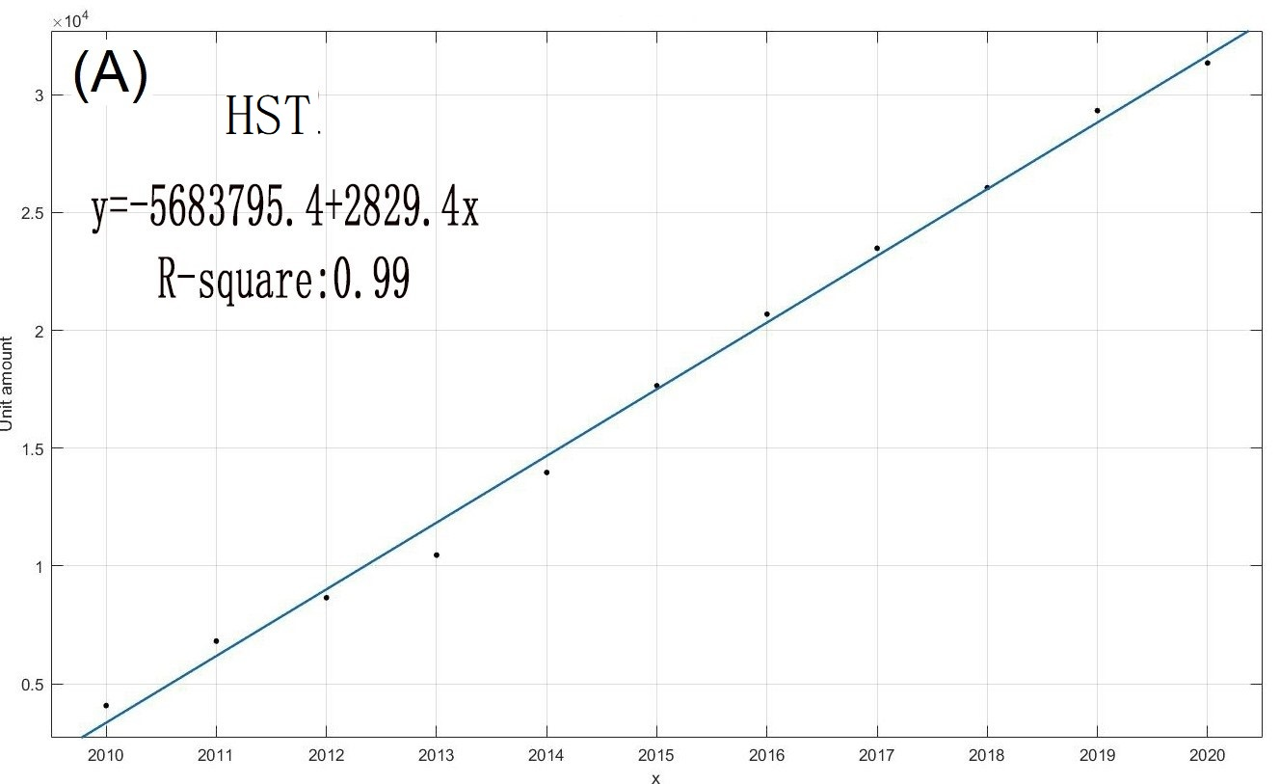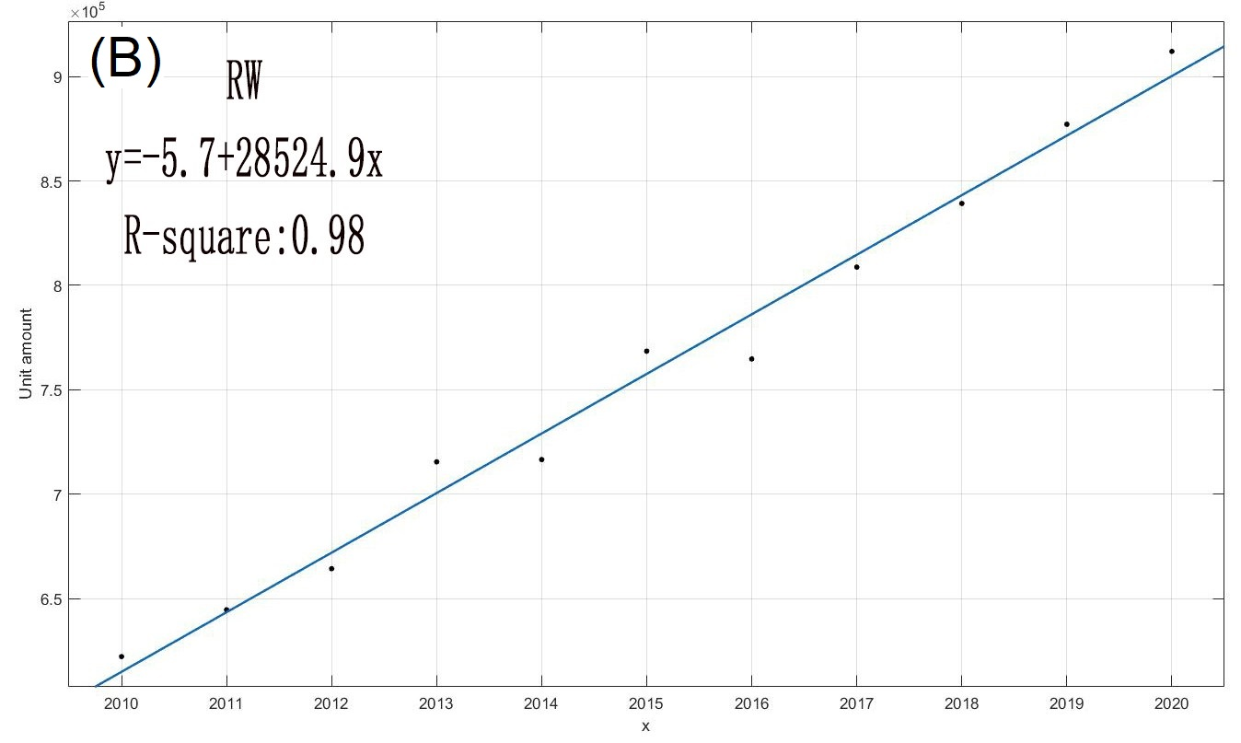
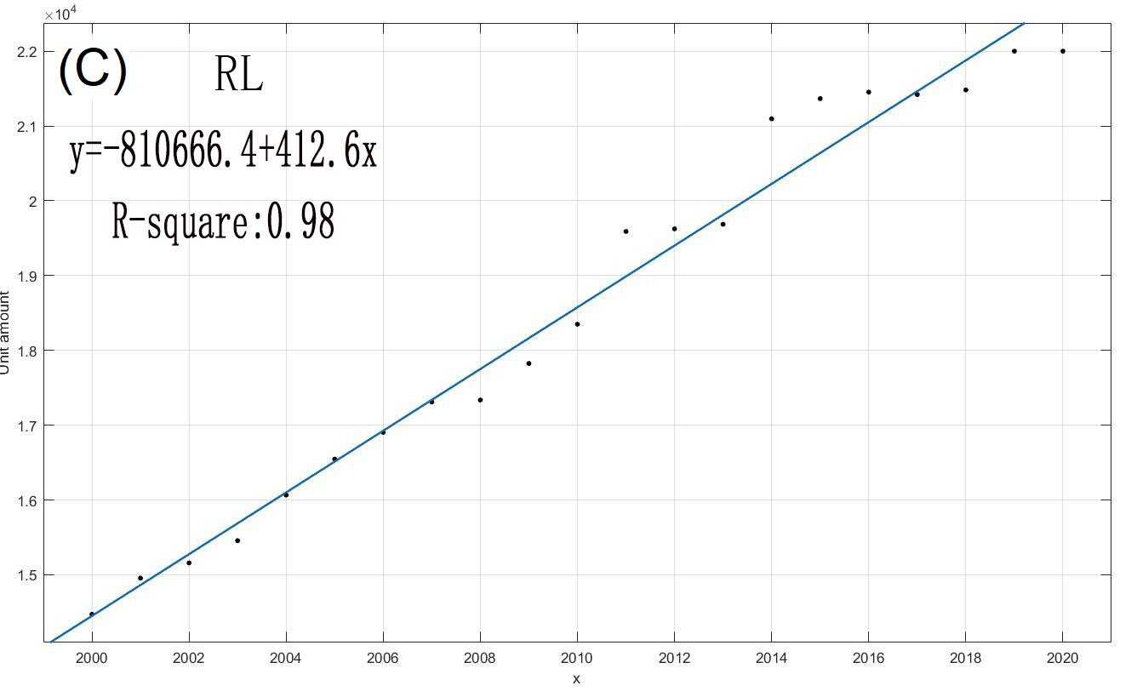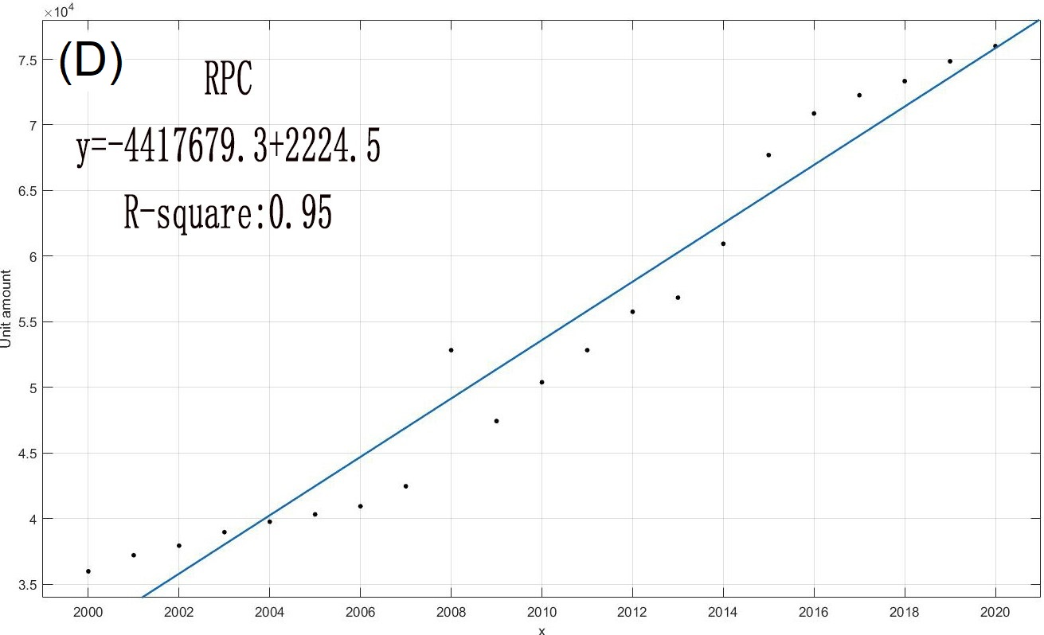
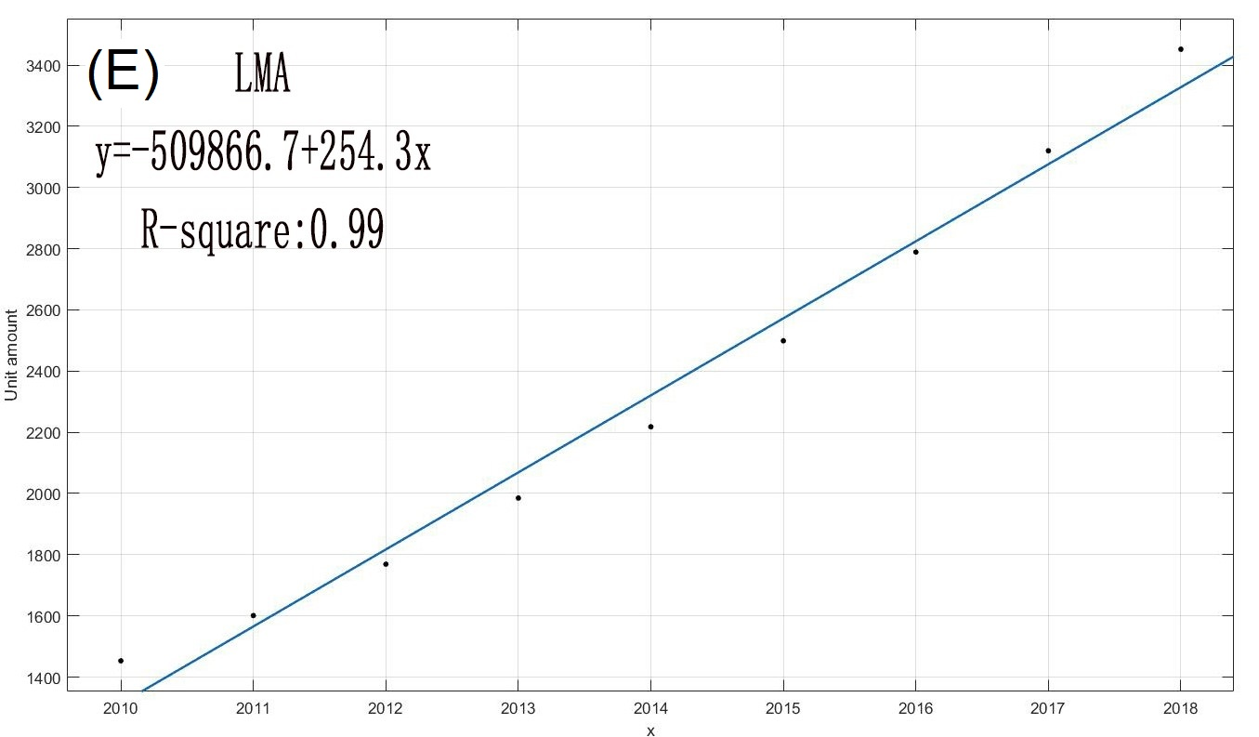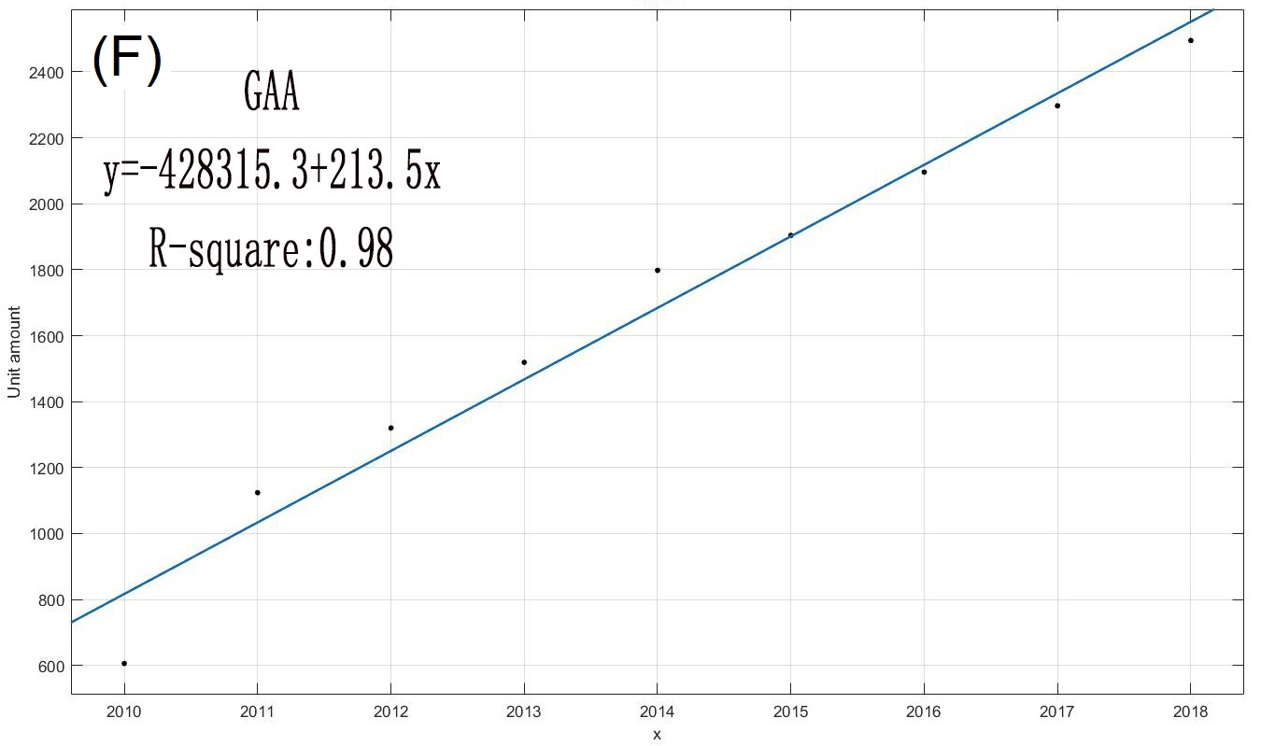
Supplementary Fig. 1 Linear regression of ownership quantity of HEE.

Supplementary Table 5 Weight of typical HEE (t)^{2, 3}
Date | LMA | GAA | HST | RL | RPC | RW
Mean | 130 | 42 | 450 | 130 | 750 | 800
Range | 90−177 | 38−48 | 420−510 | 126−132 | 700−800 | 750−850
Note: the data fits for beta distribution.
Supplementary Table 6 Total weight of four solid wastes⁴
Year | WHEE/Mt | WEEE/Mt | ELV/Mt | WWC/Mt
2020 | 28 | 15 | 42 | 1
2021 | 28 | 17 | 45 | 2
2022 | 28 | 18 | 49 | 2
2023 | 29 | 19 | 50 | 3
2024 | 29 | 20 | 53 | 3
2025 | 32 | 21 | 54 | 4
2026 | 33 | 23 | 56 | 5
2027 | 35 | 24 | 57 | 6
2028 | 36 | 25 | 58 | 6
2029 | 36 | 26 | 60 | 6
2030 | 37 | 27 | 61 | 6
2031 | 38 | 28 | 63 | 7
2032 | 40 | 30 | 65 | 8
2033 | 41 | 31 | 67 | 9
2034 | 42 | 32 | 68 | 10
2035 | 45 | 33 | 70 | 11
2036 | 46 | 34 | 72 | 12
2037 | 49 | 36 | 74 | 13
2038 | 49 | 37 | 76 | 14
2039 | 52 | 38 | 78 | 15
2040 | 54 | 39 | 80 | 17
2041 | 56 | 41 | 82 | 18
2042 | 59 | 42 | 84 | 19
2043 | 60 | 43 | 86 | 21
2044 | 62 | 44 | 87 | 22
2045 | 64 | 45 | 89 | 23
2046 | 66 | 47 | 91 | 25
2047 | 68 | 48 | 92 | 27
2048 | 70 | 49 | 94 | 28
2049 | 72 | 50 | 96 | 30
2050 | 74 | 52 | 97 | 31

Supplementary Table 7 China's population
Year | Population | Year | Population
2000 | 1,262,645,000 | 2011 | 1,344,130,000
2001 | 1,271,850,000 | 2012 | 1,350,695,000
2002 | 1,280,400,000 | 2013 | 1,357,380,000
2003 | 1,288,400,000 | 2014 | 1,364,270,000
2004 | 1,296,075,000 | 2015 | 1,371,220,000
2005 | 1,303,720,000 | 2016 | 1,378,665,000
2006 | 1311020,000 | 2017 | 1,386,395,000
2007 | 1,317,885000 | 2018 | 1,392,730,000
2008 | 1,324,655,000 | 2019 | 1,397,715,000
2009 | 1,331,260,000 | 2020 | 1,402,112,000
2010 | 1,337,705,000
Source: https://data.worldbank.org.cn/indicator/SP.POP.TOTL?locations=CN
Supplementary Table 8 China's per capita GDP (US$)
Year | Per capita GDP | Year | Per capita GDP
2000 | 959 | 2011 | 5618
2001 | 1053 | 2012 | 6317
2002 | 1149 | 2013 | 7051
2003 | 1289 | 2014 | 7679
2004 | 1509 | 2015 | 8067
2005 | 1753 | 2016 | 8148
2006 | 2099 | 2017 | 8879
2007 | 2694 | 2018 | 9977
2008 | 3468 | 2019 | 10217
2009 | 3832 | 2020 | 10500
2010 | 4550
Source: https://data.worldbank.org.cn/indicator/NY.GDP.PCAP.CD?locations=CN

Supplementary Table 9 WEEE generation in selected countries^{4, 5, 6, 7}
Year | WEEE in  China/Mt | WEEE in  Indonesia/kt | WEEE in  Australia/kt | WEEE in  Denmark/kt
2010 | 4 | 1211 | 223 | 75
2011 | 5 | 1265 | 237 | 76
2012 | 6 | 1381 | 248 | 78
2013 | 7 | 1462 | 261 | 79
2014 | 8 | 1473 | 273 | 80
2015 | 9 | 1533 | 285 | 81
2016 | 10 | 1653 | 296 | 82
2017 | 12 | 1698 | 307 | 82
2018 | 13 | 1798 | 319 | 83
2019 | 14 | 1862 | 331 | 83
2020 | 15 | 1926 | 342 | 83
2021 | 17 | 1989 | 354 | 84
2022 | 18 | 2053 | 365 | 84
2023 | 19 | 2117 | 377 | 84
2024 | 20 | 2180 | 389 | 84
2025 | 21 | 2244 | 400 | 84

Supplementary Table 10 Weight of metal
Year | Fe（Mt） |  |  | Al (kt) |  |  | Ti (t) |  |  | Nd (t)
Year | Min | Average | Max | Min | Average | Max | Min | Average | Max | Min | Average | Max
2000 | 0.47 | 0.47 | 0.48 | 2.53 | 5.05 | 7.58
2001 | 0.78 | 0.79 | 0.80 | 4.18 | 8.36 | 12.54
2002 | 1.25 | 1.26 | 1.28 | 6.69 | 13.37 | 20.06
2003 | 1.92 | 1.94 | 1.96 | 10.24 | 20.47 | 30.71
2004 | 2.84 | 2.87 | 2.90 | 15.08 | 30.17 | 45.25
2005 | 4.04 | 4.09 | 4.13 | 21.43 | 42.86 | 64.30
2006 | 5.57 | 5.64 | 5.69 | 29.55 | 59.10 | 88.66
2007 | 7.44 | 7.52 | 7.60 | 39.48 | 78.97 | 118.45
2008 | 9.59 | 9.70 | 9.80 | 50.91 | 101.83 | 152.74
2009 | 11.96 | 12.09 | 12.22 | 63.50 | 127.01 | 190.51
2010 | 14.56 | 14.72 | 14.88 | 77.35 | 154.70 | 232.04 |  |  |  | 0.05 | 0.07 | 0.10
2011 | 16.86 | 17.05 | 17.23 | 89.75 | 179.51 | 269.26 |  |  |  | 0.05 | 0.07 | 0.10
2012 | 19.05 | 19.26 | 19.46 | 101.63 | 203.26 | 304.88 |  |  |  | 0.09 | 0.14 | 0.20
2013 | 20.91 | 21.14 | 21.37 | 111.90 | 223.80 | 335.69 |  |  |  | 0.14 | 0.22 | 0.30
2014 | 22.36 | 22.61 | 22.85 | 120.72 | 240.95 | 361.18 | 24.09 | 48.19 | 72.28 | 0.23 | 0.36 | 0.50
2015 | 23.39 | 23.65 | 23.90 | 127.08 | 253.43 | 379.77 | 36.57 | 73.15 | 109.72 | 0.27 | 0.43 | 0.59
2016 | 25.58 | 25.87 | 26.15 | 140.58 | 280.19 | 419.80 | 48.53 | 97.07 | 145.60 | 0.41 | 0.65 | 0.89
2017 | 26.63 | 26.94 | 27.23 | 146.60 | 292.11 | 437.62 | 54.77 | 109.55 | 164.32 | 0.54 | 0.86 | 1.19
2018 | 27.59 | 27.91 | 28.21 | 152.22 | 303.02 | 453.83 | 70.87 | 137.19 | 203.50 | 0.77 | 1.22 | 1.68
2019 | 27.27 | 27.59 | 27.88 | 150.78 | 300.07 | 449.37 | 74.05 | 143.99 | 213.93 | 0.68 | 1.08 | 1.49
2020 | 27.14 | 27.45 | 27.75 | 150.72 | 299.71 | 448.69 | 86.89 | 167.76 | 248.63 | 1.49 | 2.38 | 3.27
2021 | 27.01 | 27.33 | 27.62 | 150.55 | 299.22 | 447.89 | 93.99 | 182.24 | 270.49 | 1.73 | 2.77 | 3.81
2022 | 27.32 | 27.63 | 27.94 | 152.79 | 303.55 | 454.31 | 101.83 | 195.43 | 289.02 | 1.98 | 3.17 | 4.36
2023 | 27.97 | 28.30 | 28.61 | 156.56 | 311.12 | 465.69 | 99.36 | 192.29 | 285.22 | 2.23 | 3.56 | 4.90
2024 | 27.90 | 28.23 | 28.54 | 156.93 | 311.79 | 466.65 | 103.27 | 200.19 | 297.11 | 2.48 | 3.96 | 5.45
2025 | 31.26 | 31.63 | 31.97 | 174.64 | 347.10 | 519.56 | 108.96 | 211.93 | 314.90 | 2.72 | 4.36 | 5.99
2026 | 32.16 | 32.54 | 32.89 | 179.26 | 356.16 | 533.07 | 118.05 | 230.26 | 342.47 | 2.97 | 4.75 | 6.53
2027 | 33.44 | 33.83 | 34.20 | 186.42 | 370.15 | 553.88 | 134.96 | 263.93 | 392.90 | 3.22 | 5.15 | 7.08
2028 | 34.48 | 34.88 | 35.26 | 192.79 | 382.48 | 572.17 | 155.03 | 303.74 | 452.45 | 3.47 | 5.54 | 7.62
2029 | 35.28 | 35.69 | 36.08 | 197.92 | 392.28 | 586.64 | 178.29 | 350.36 | 522.43 | 3.71 | 5.94 | 8.17
2030 | 36.13 | 36.55 | 36.95 | 203.21 | 402.36 | 601.51 | 203.11 | 399.18 | 595.25 | 3.96 | 6.34 | 8.71
2031 | 36.74 | 37.17 | 37.57 | 207.16 | 409.89 | 612.61 | 221.81 | 436.42 | 651.02 | 4.21 | 6.73 | 9.26
2032 | 38.41 | 38.85 | 39.28 | 216.72 | 428.48 | 640.25 | 247.81 | 487.95 | 728.10 | 4.46 | 7.13 | 9.80
2033 | 39.75 | 40.21 | 40.64 | 224.57 | 443.62 | 662.67 | 275.98 | 543.92 | 811.86 | 4.70 | 7.52 | 10.35
2034 | 40.93 | 41.40 | 41.85 | 231.67 | 457.21 | 682.75 | 306.30 | 603.00 | 899.70 | 4.95 | 7.92 | 10.89
2035 | 43.99 | 44.49 | 44.98 | 248.71 | 490.71 | 732.72 | 335.42 | 661.24 | 987.06 | 5.20 | 8.32 | 11.43
2036 | 44.09 | 44.60 | 45.09 | 250.56 | 493.63 | 736.70 | 374.56 | 738.95 | 1103.35 | 5.43 | 8.69 | 11.95
2037 | 47.36 | 47.91 | 48.43 | 270.04 | 531.70 | 793.36 | 419.42 | 827.18 | 1234.95 | 8.55 | 13.68 | 18.81
2038 | 47.33 | 47.89 | 48.41 | 272.39 | 535.34 | 798.30 | 471.34 | 929.95 | 1388.56 | 12.24 | 19.58 | 26.93
2039 | 50.09 | 50.68 | 51.24 | 289.93 | 568.77 | 847.62 | 554.24 | 1084.87 | 1615.51 | 20.45 | 32.72 | 44.99
2040 | 52.06 | 52.69 | 53.27 | 303.18 | 593.87 | 884.57 | 623.96 | 1220.20 | 1816.44 | 25.97 | 41.55 | 57.13
2041 | 54.37 | 55.02 | 55.63 | 317.58 | 621.27 | 924.97 | 694.04 | 1356.19 | 2018.33 | 31.39 | 50.23 | 69.06
2042 | 56.70 | 57.39 | 58.03 | 332.64 | 650.44 | 968.25 | 741.78 | 1445.80 | 2149.83 | 41.91 | 67.05 | 92.20
2043 | 58.13 | 58.84 | 59.51 | 343.84 | 671.94 | 1000.04 | 787.27 | 1534.56 | 2281.85 | 52.94 | 84.71 | 116.48
2044 | 60.03 | 60.77 | 61.46 | 356.60 | 696.32 | 1036.05 | 843.45 | 1642.89 | 2442.32 | 62.06 | 99.29 | 136.53
2045 | 61.83 | 62.60 | 63.31 | 368.28 | 718.57 | 1068.85 | 900.19 | 1752.15 | 2604.11 | 70.44 | 112.70 | 154.97
2046 | 63.61 | 64.40 | 65.14 | 379.72 | 740.30 | 1100.88 | 956.75 | 1861.11 | 2765.46 | 78.14 | 125.03 | 171.92
2047 | 65.43 | 66.25 | 67.01 | 391.63 | 762.98 | 1134.33 | 1014.19 | 1971.53 | 2928.87 | 87.96 | 140.73 | 193.51
2048 | 67.20 | 68.05 | 68.83 | 403.05 | 784.61 | 1166.17 | 1074.26 | 2086.35 | 3098.43 | 94.02 | 150.43 | 206.84
2049 | 69.04 | 69.92 | 70.73 | 415.24 | 807.84 | 1200.45 | 1131.79 | 2196.93 | 3262.06 | 103.43 | 165.49 | 227.55
2050 | 70.90 | 71.80 | 72.63 | 427.46 | 831.13 | 1234.81 | 1189.33 | 2307.51 | 3425.69 | 111.92 | 179.07 | 246.22

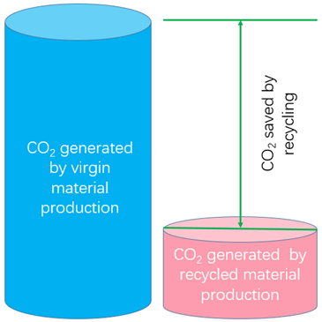
Supplementary Fig. 2 Carbon Footprint of WHEE.
Table S11 Amounts of generated and potentially saved CO₂ emissions from replacing virgin with recycled materials^{8, 9, 10}.
Recyclable material | CO₂ generated by virgin material  production  (t CO2/t material) | Error | CO₂ generated by recycled material  production  (t CO2/t material) | Error | CO₂ saved by recycling  (kg CO2/kg material) | Error
Fe | 1.76 | ±1.3 | 0.7 | ±0.32 | 1.06 | ±0.98
Al | 5.83 | ±1.94 | 0.6 | ±0.31 | 5.23 | ±1.63
Ti | 1.25 | ±0.5 | 0.44 | ±0.16 | 0.81 | ±0.34
Nd | 5.4 | ±1.8 | 2 | ±0.6 | 3.4 | ±1.2

Supplementary Table 12 Typical material composition of HEE
(A) LMA (%)
Material | Min | Average | Max
Al | 55 | 70 | 85
Fe | 9 | 12 | 15
Nd | - | - | -
Ti | 2 | 4 | 6
(B) GAA (%)
Material | Min | Average | Max
Al | 70 | 80 | 90
Fe | 9 | 13 | 16
Nd | - | - | -
Ti | 3 | 5 | 7
(C) HST (%)
Material | Min | Average | Max
Al | 1 | 2 | 3
Fe | 82 | 90 | 95
Nd | 0.01 | 0.016 | 0.022
Ti | 0 | 0 | 0
(D) RL (%)
Material | Min | Average | Max
Al | 0.5 | 1 | 1.5
Fe | 95 | 96 | 98
Nd | 0 | 0 | 0
Ti | 0 | 0 | 0
(E) RPC (%)
Material | Min | Average | Max
Al | 1 | 2 | 3
Fe | 92 | 95 | 97
Nd | 0 | 0 | 0
Ti | 0 | 0 | 0
(F) RW (%)
Material | Min | Average | Max
Al | 0.5 | 1 | 1.5
Fe | 97 | 98 | 99
Nd | 0 | 0 | 0
Ti | 0 | 0 | 0
Note: Data source^{3, 9, 11}.

Supplementary Table 13 Market prices of Fe, Al, Nd, and Ti (US$/t)^{12, 13, 14}
Resource | 2017 | 2018 | 2019 | 2020 | 2021 | Average | Error
Fe | 442 | 416 | 432 | 432 | 436 | 432 | ±13
Al | 2241 | 1962 | 1789 | 2028 | 2676 | 2139 | ±444
Nd | 65831 | 64734 | 58307 | 96238 | 157523 | 88527 | ±49608
Ti | 740 | 990 | 1256 | 1664 | 2189 | 1368 | ±725

Supplementary Fig. 3 Probability density function of Weibull distribution: (A) cumulative distribution function; (B) probability density function
Note: The HEE cumulative and annual failure rates are shown in Figures S1 (A),(B), respectively. The two zones of in-use and waste are located above and below the function curve, respectively. Therefore, Figure S1 (A) can be employed to define the cumulative obsolete amount and stocked resources of various WHEE, and Figure S1 (B) can be utilized to determine the yearly obsolete amount and stocked resources of various WHEE¹⁵.
Supplementary Table 14 Parameters of Weibull lifespan distribution
Parameter | RL | RPC | RW | HST | LMA | GAA
η (scale) | 25 | 25 | 20 | 25,[20-30] | 20,[15-25] | 25,[20-30]
β (shape) | 4,[3-5] | 5.33,[5-6] | 5.58[5-6] | 5.33,[5-6] | 3.7,[3-4] | 3.7,[3-4]

Supplementary Table 15 pdf of Weibull distribution for various HEE
HEE | η (scale) | β (shape) | $$P_{x}=\frac{β}{η}{(\frac{x}{η})}^{β-1}ⅇ^{-{\left(x/η\right)}^{β}}$$
RL | 25 | 4 | $$\frac{4}{25}{(\frac{x}{25})}^{3}ⅇ^{-{\left(x/{25}\right)}^{4}}$$
RPC | 25 | 5.33 | $$\frac{5.33}{25}{(\frac{x}{25})}^{4.33}ⅇ^{-{\left(x/{25}\right)}^{5.33}}$$
RW | 20 | 5.58 | $$\frac{5.58}{20}{(\frac{x}{20})}^{4.58}ⅇ^{-{\left(x/{20}\right)}^{5.58}}$$
HST | 25 | 5.33 | $$\frac{5.33}{25}{(\frac{x}{25})}^{4.33}ⅇ^{-{\left(x/{25}\right)}^{5.33}}$$
LMA | 20 | 3.7 | $$\frac{3.7}{20}{(\frac{x}{20})}^{2.7}ⅇ^{-{\left(x/{20}\right)}^{3.7}}$$
GAA | 25 | 3.7 | $$\frac{3.7}{25}{(\frac{x}{25})}^{2.7}ⅇ^{-{\left(x/{25}\right)}^{3.7}}$$
Note: Table S15 was obtained from Table S1

(A) LMA
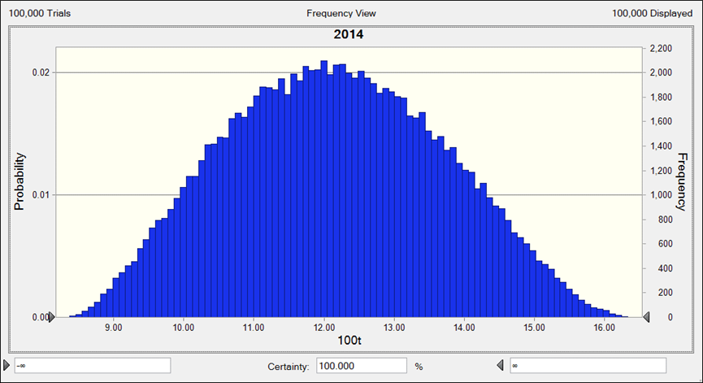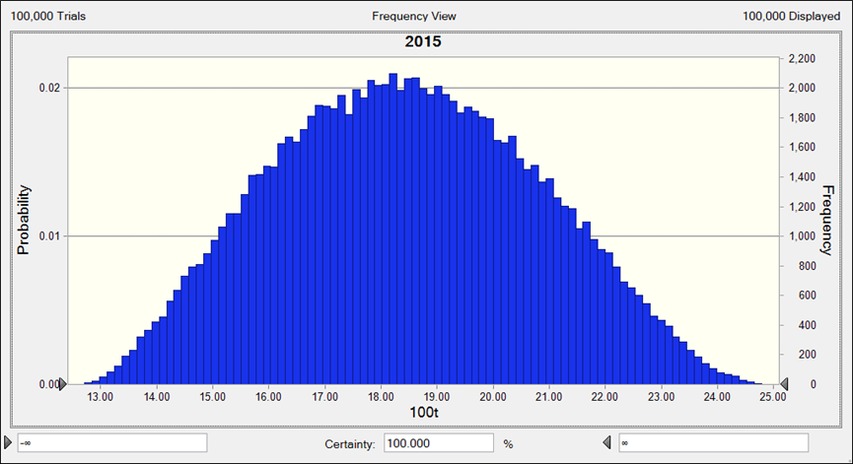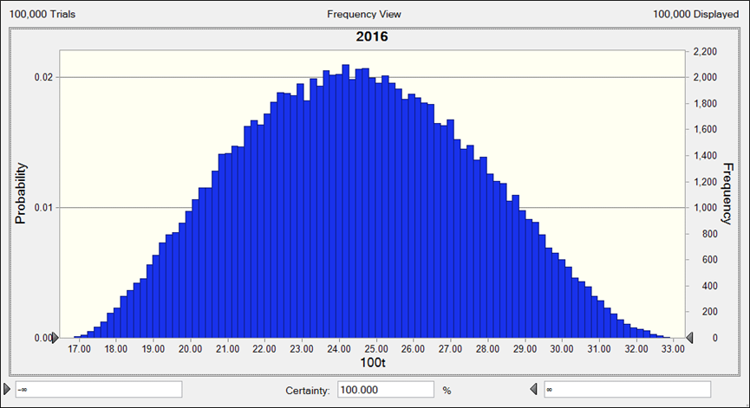
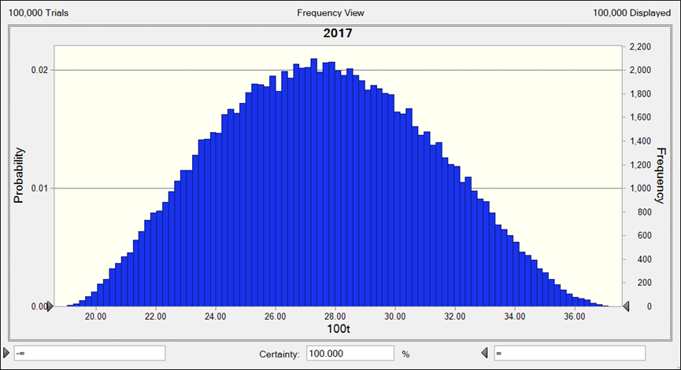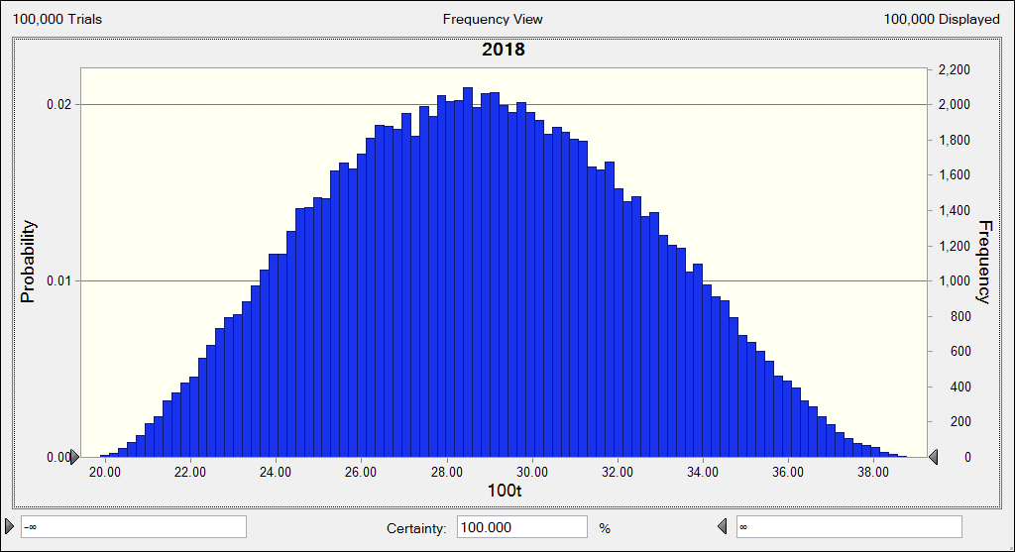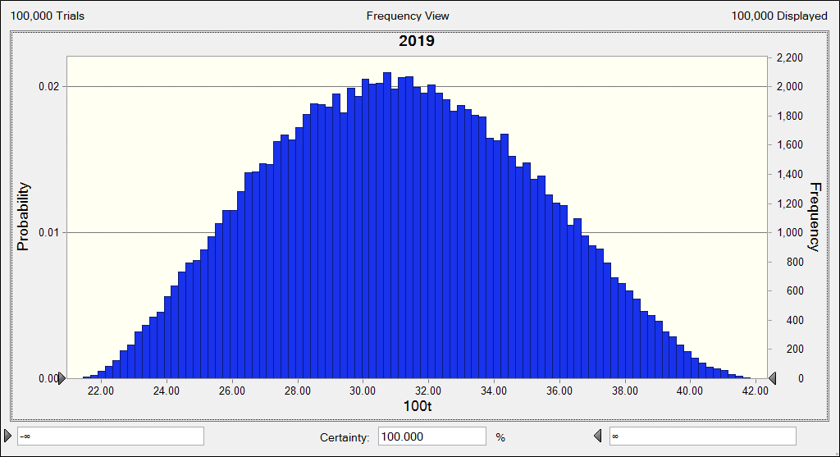
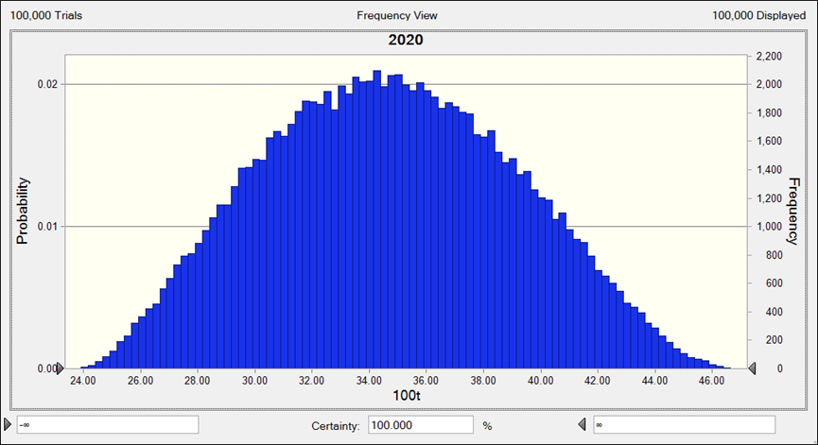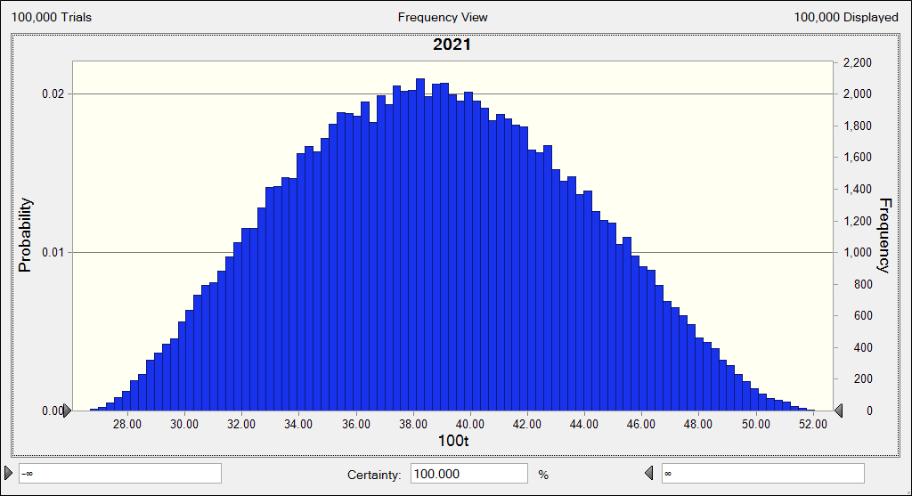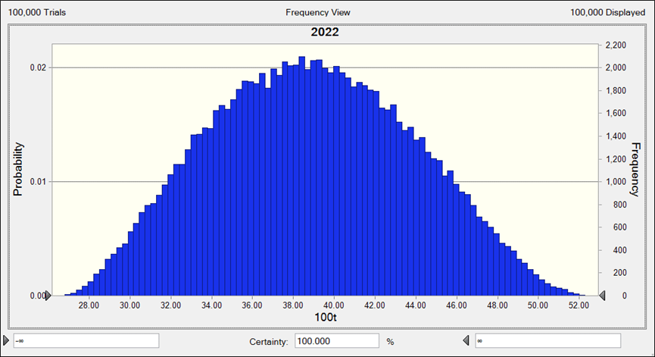
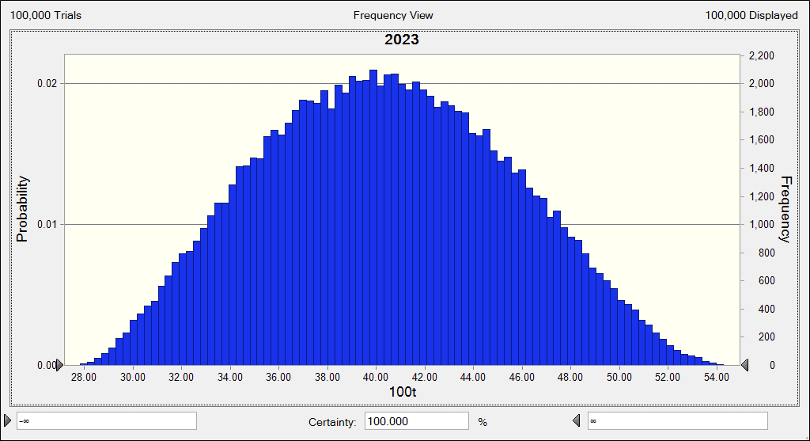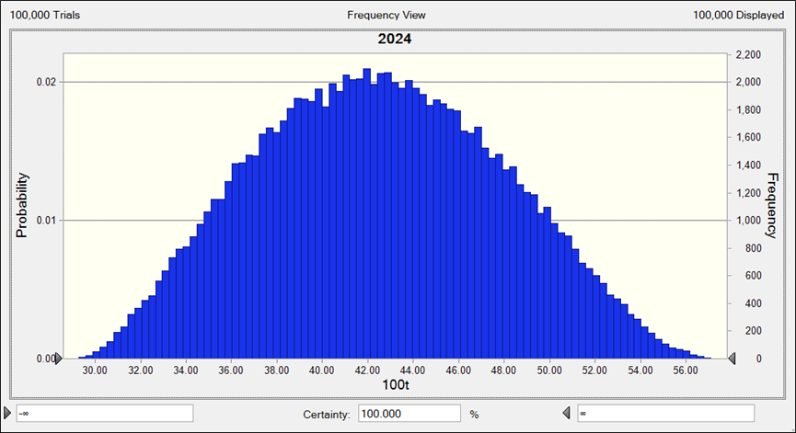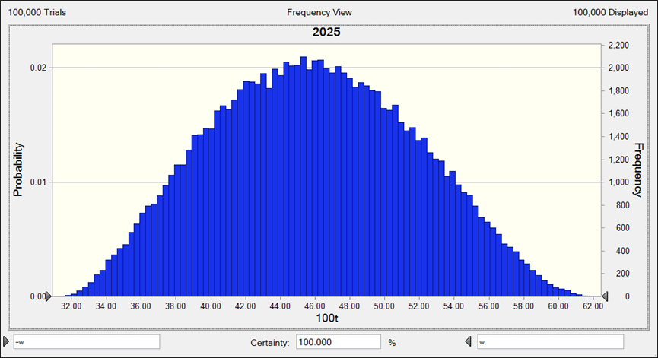
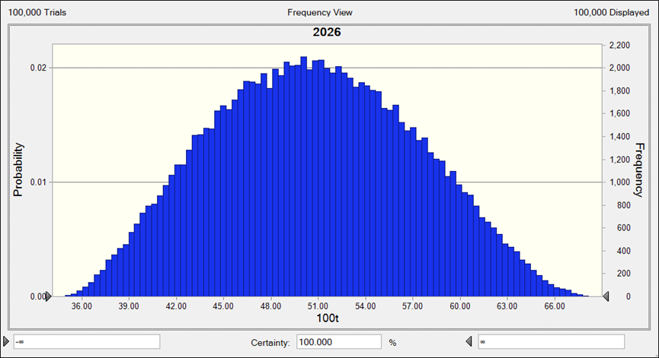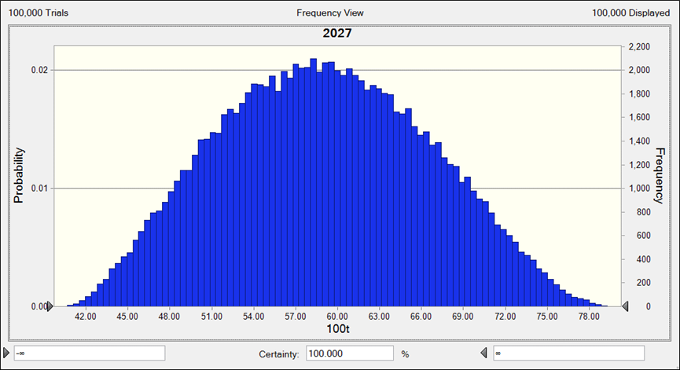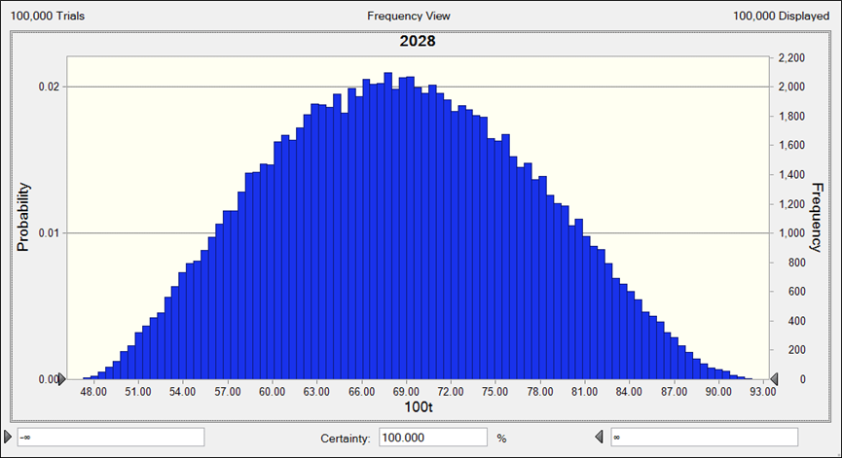
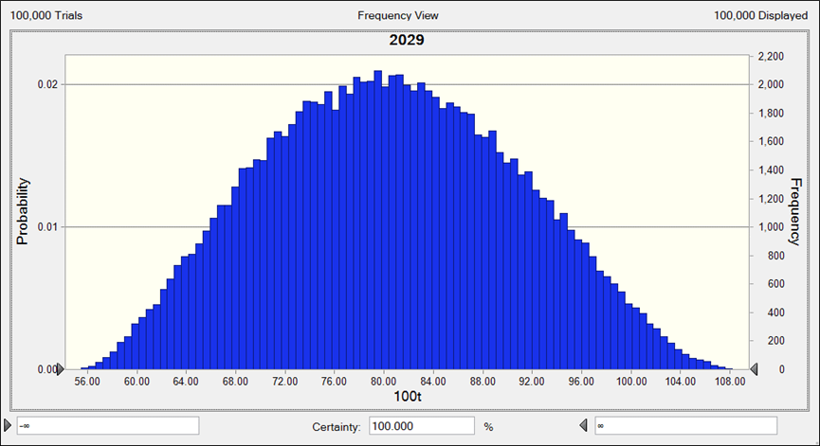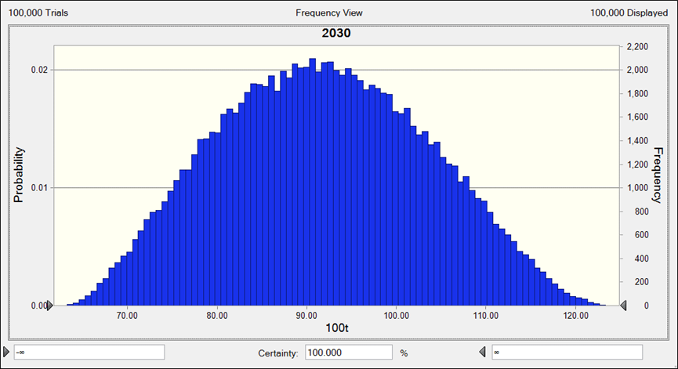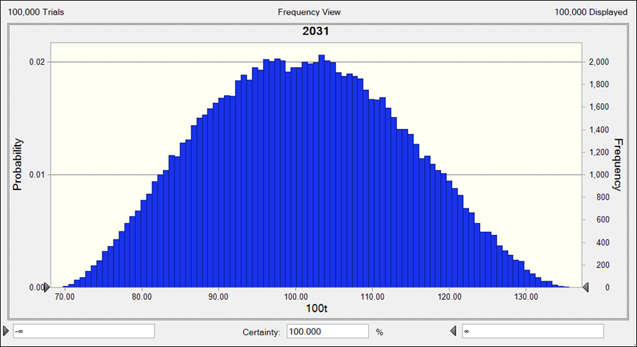
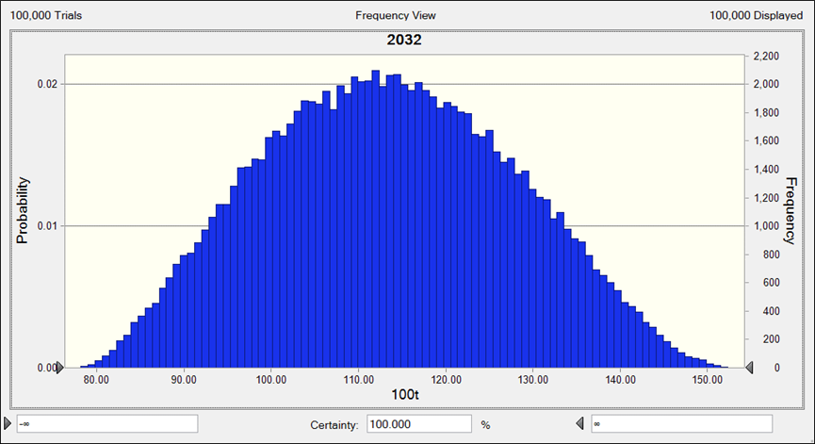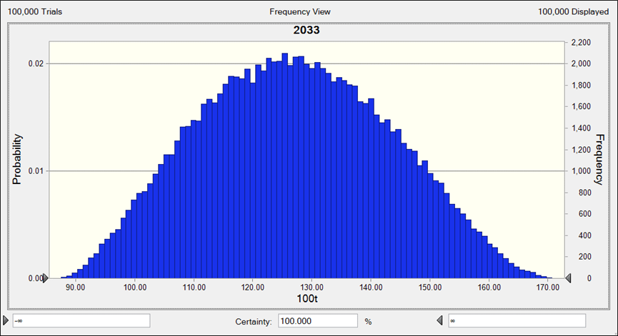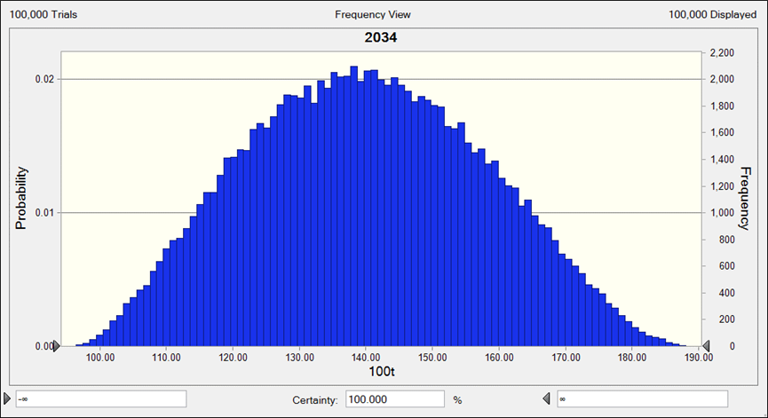
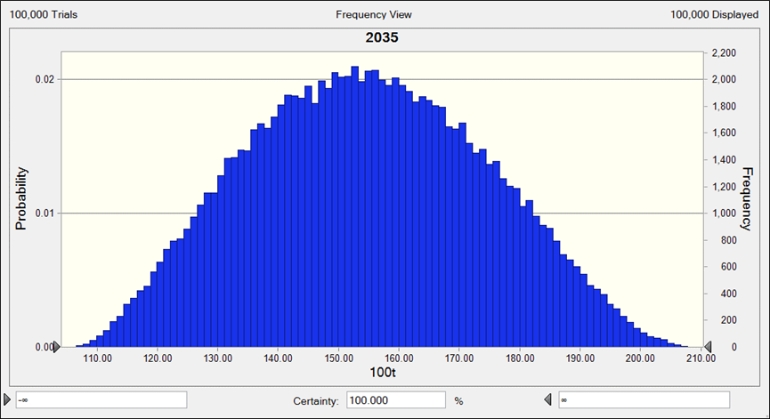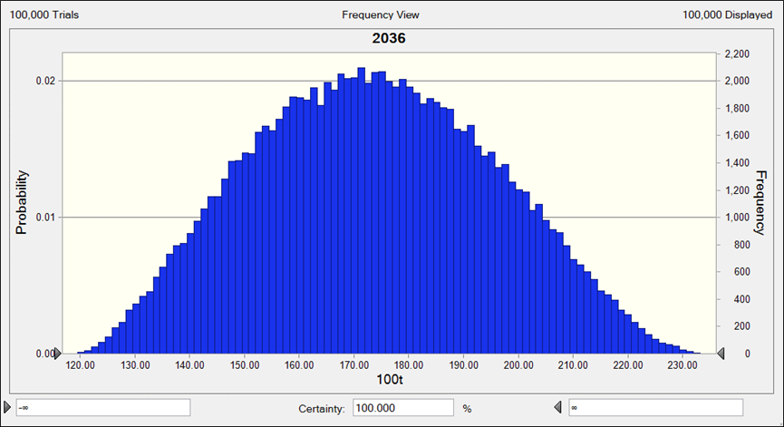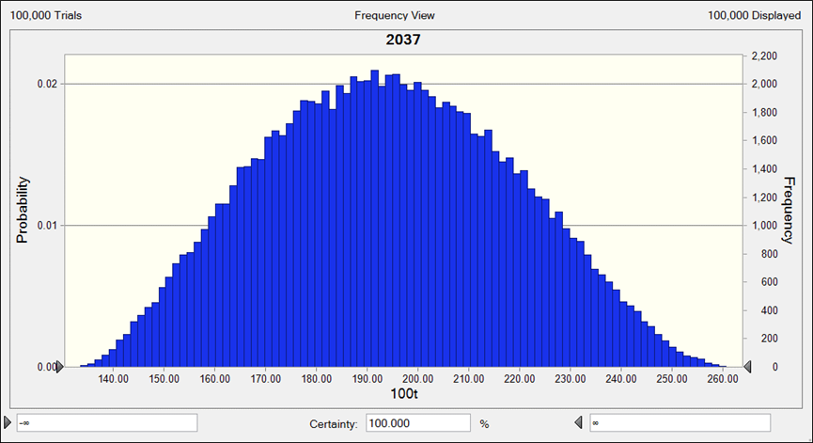
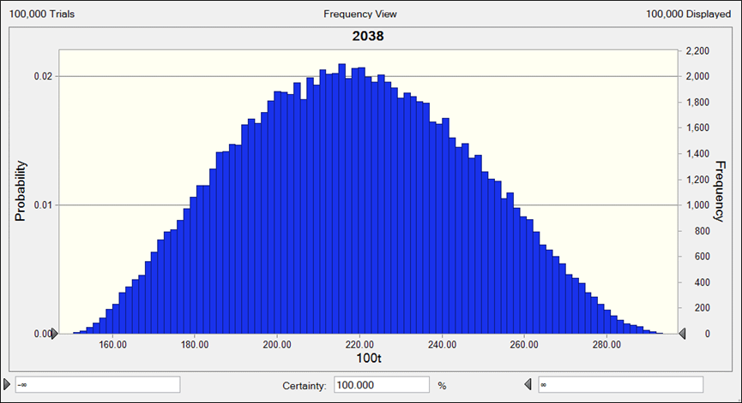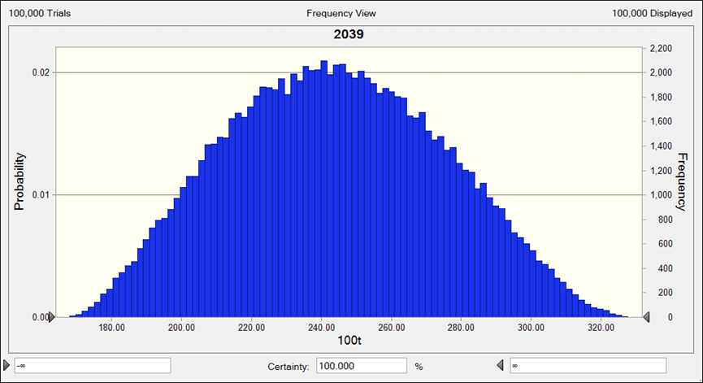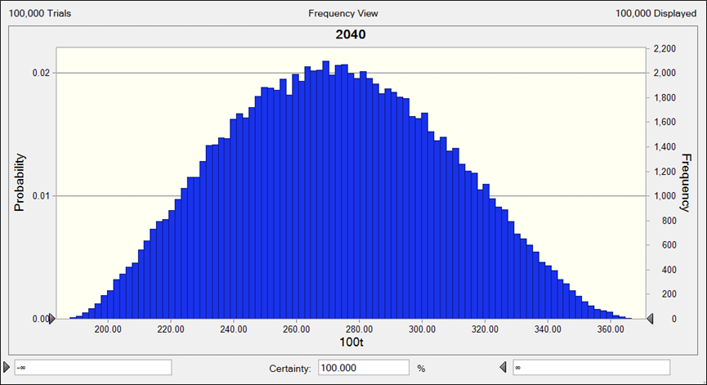
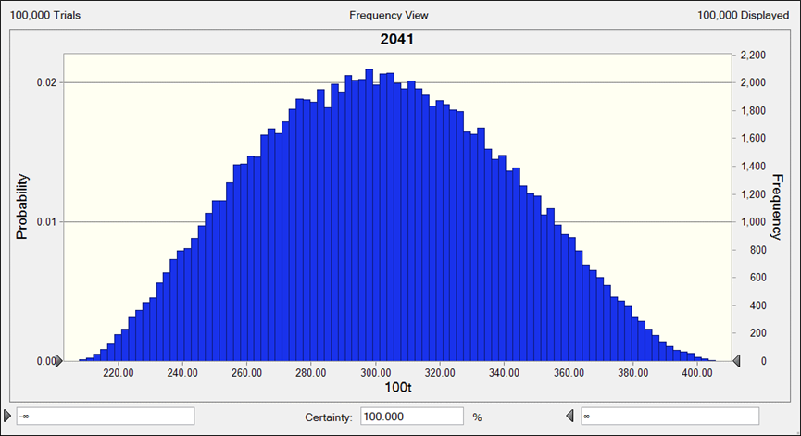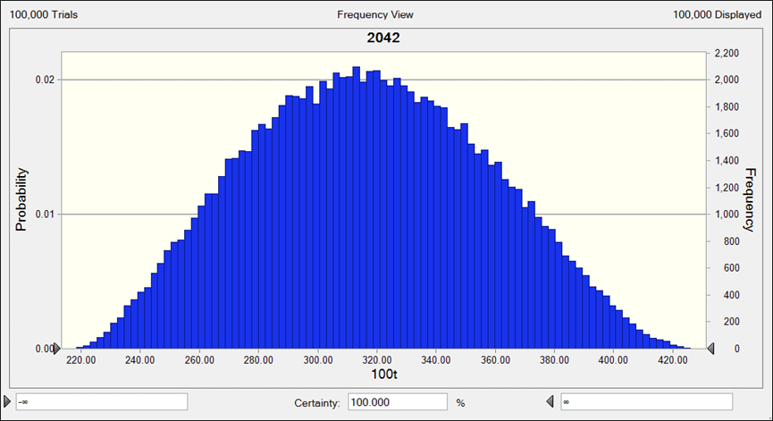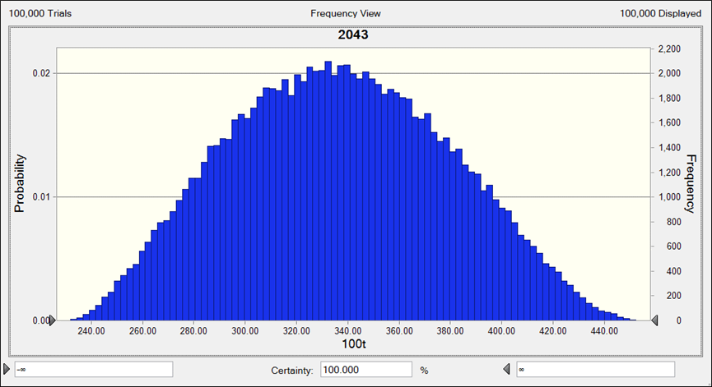
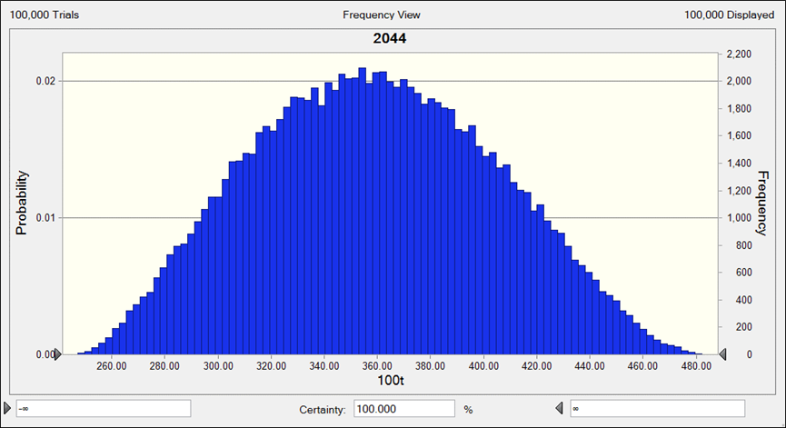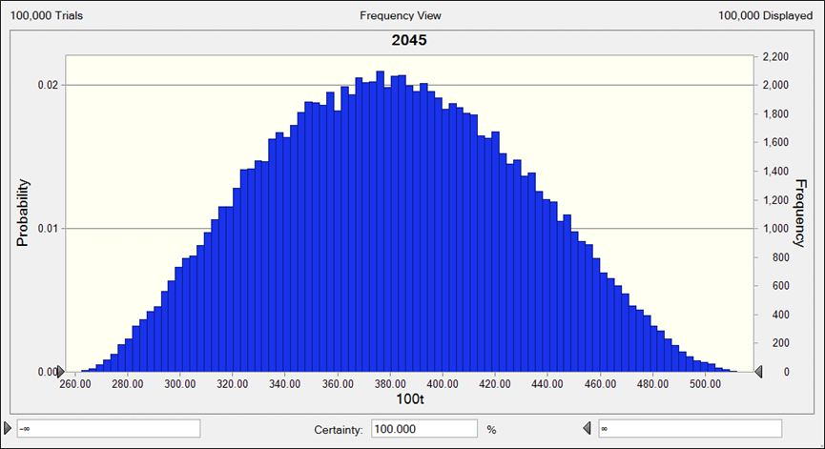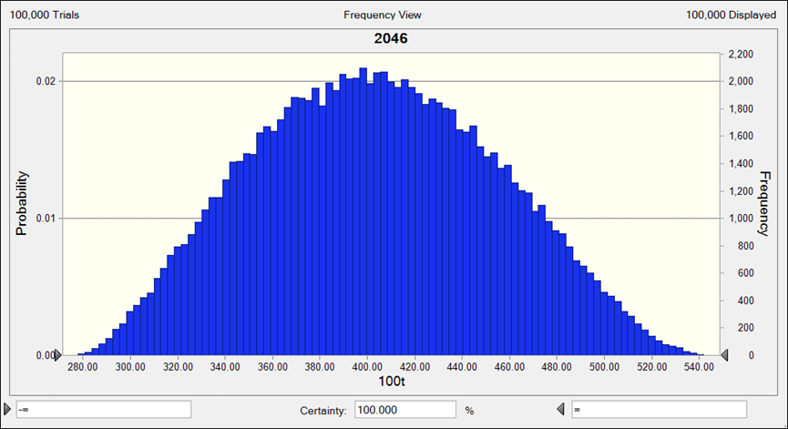
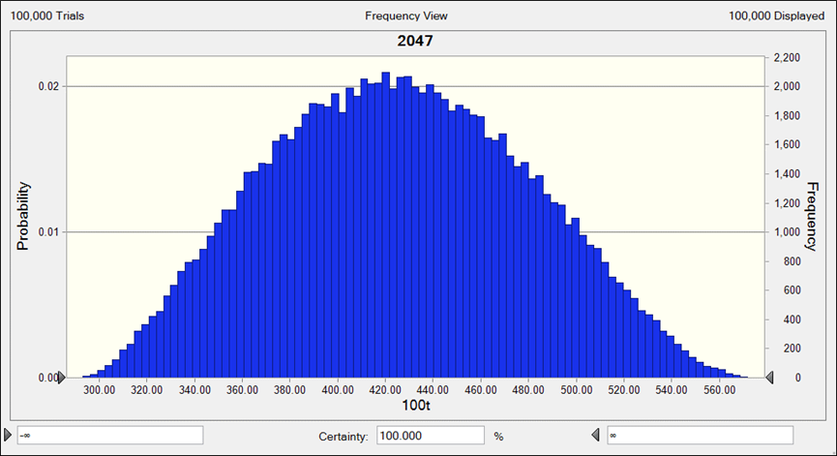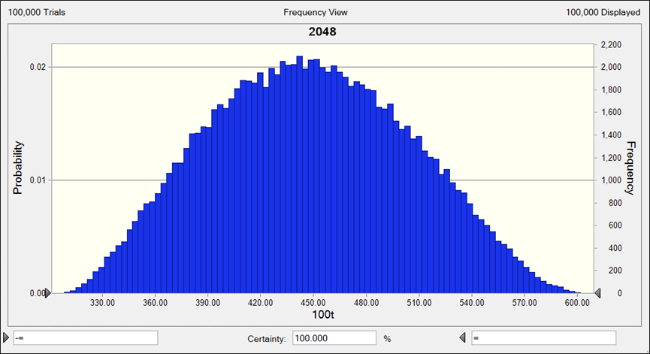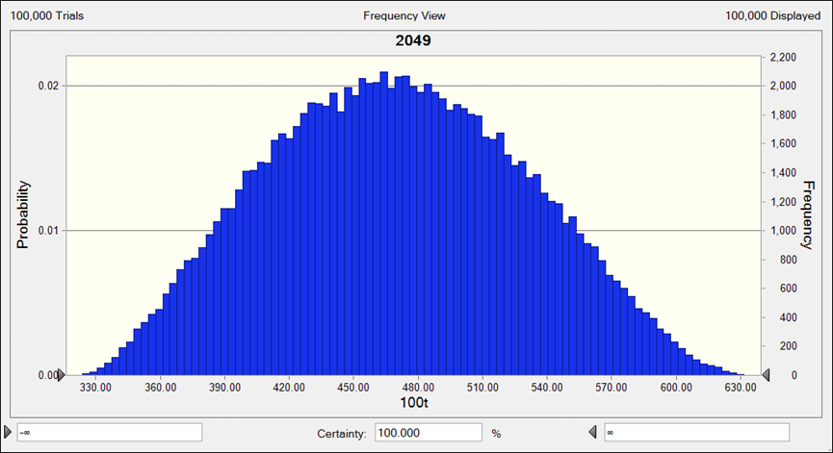
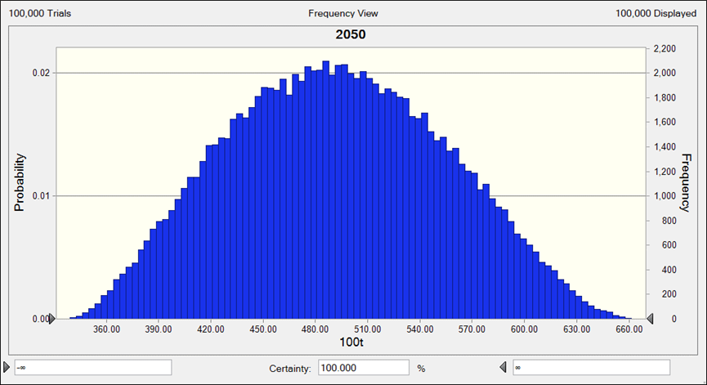

(B) GAA
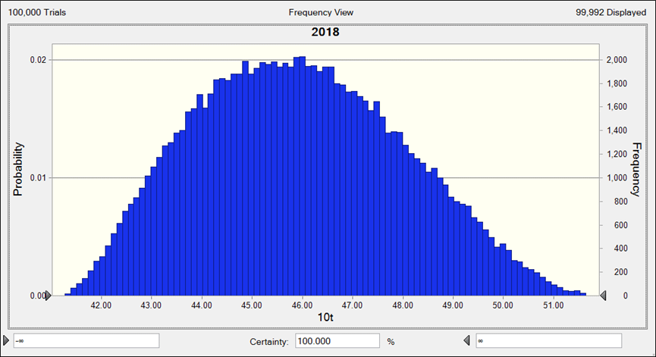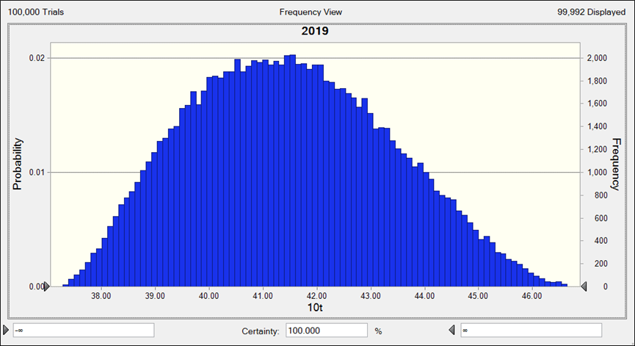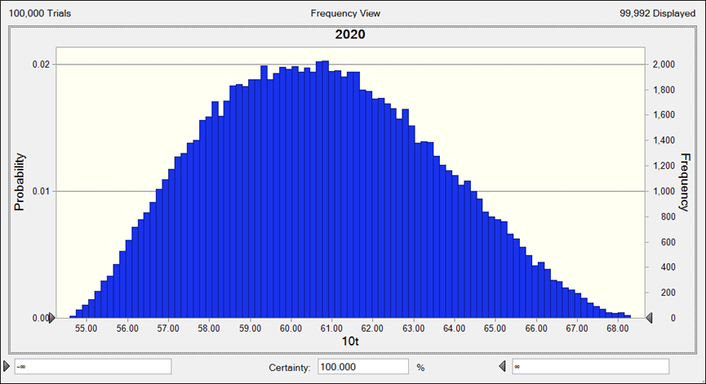
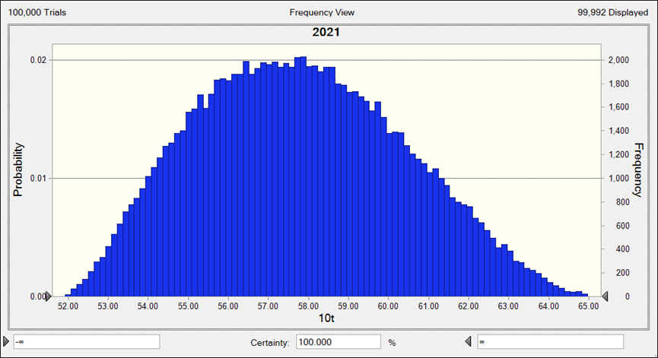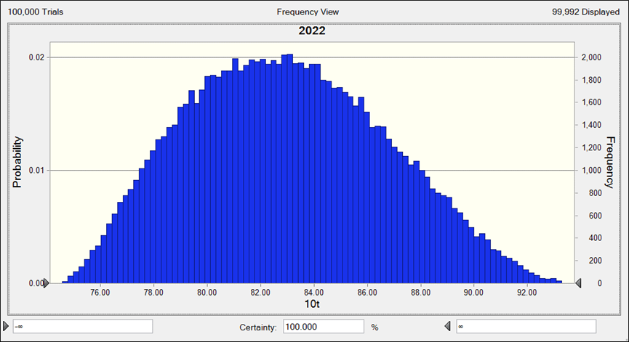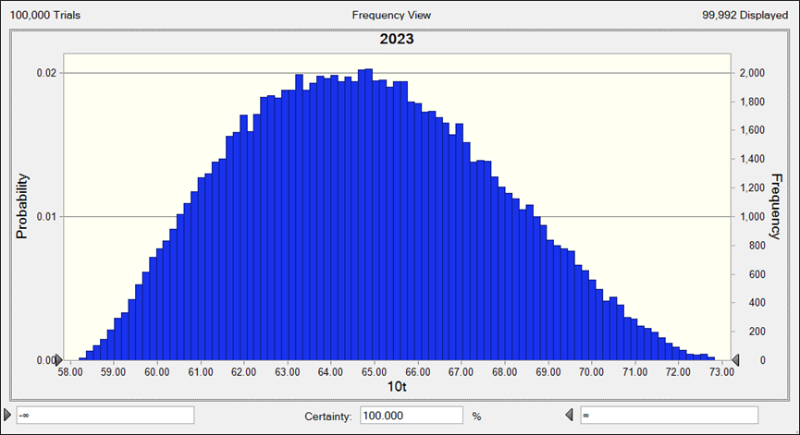
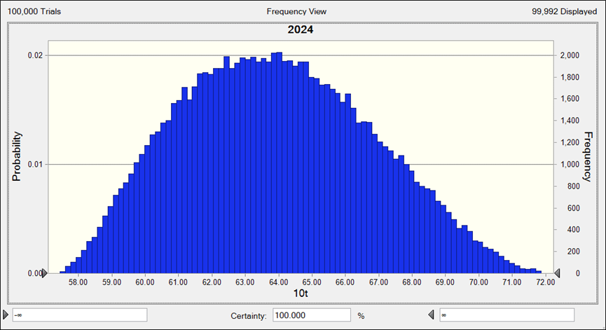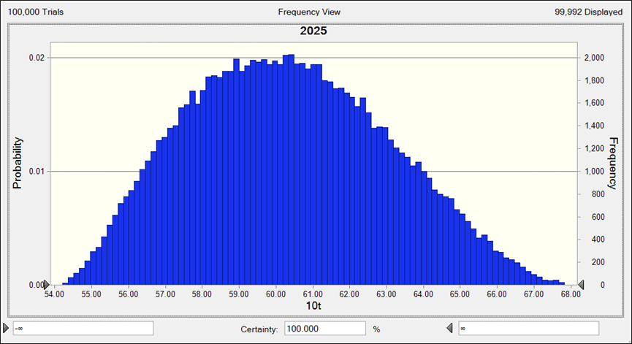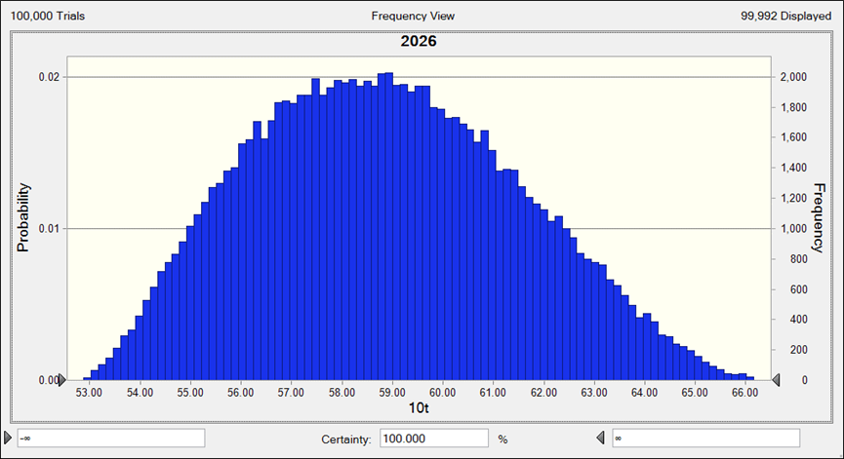
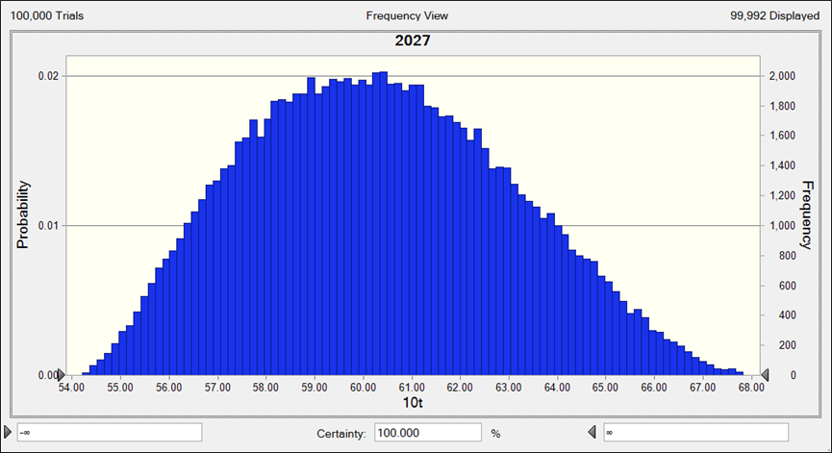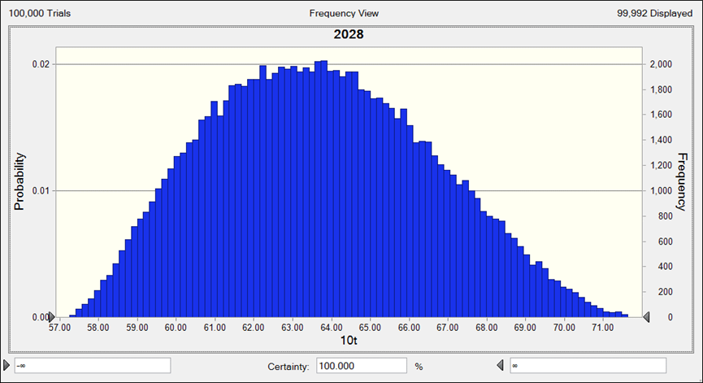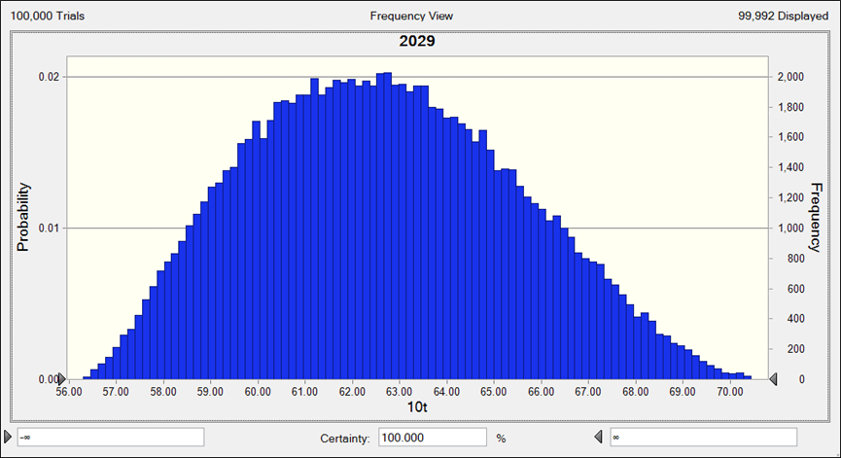
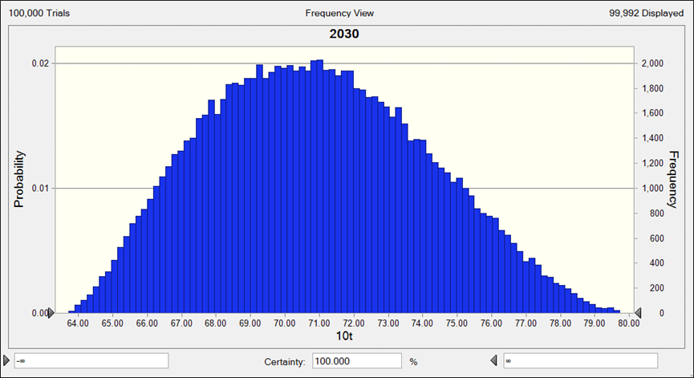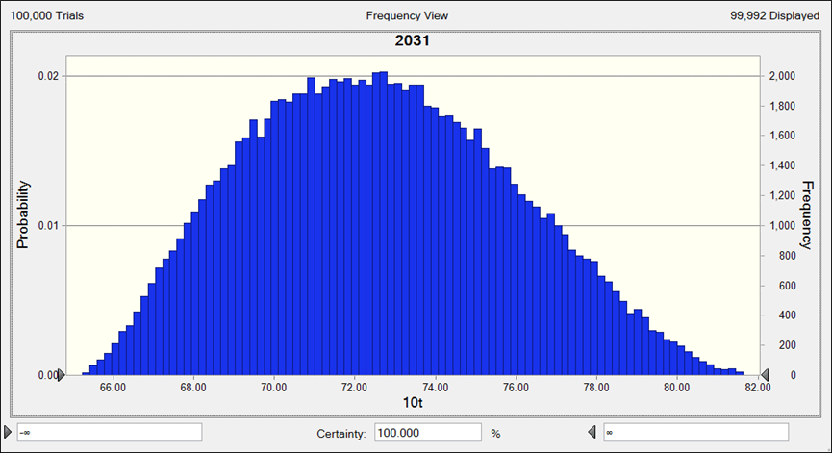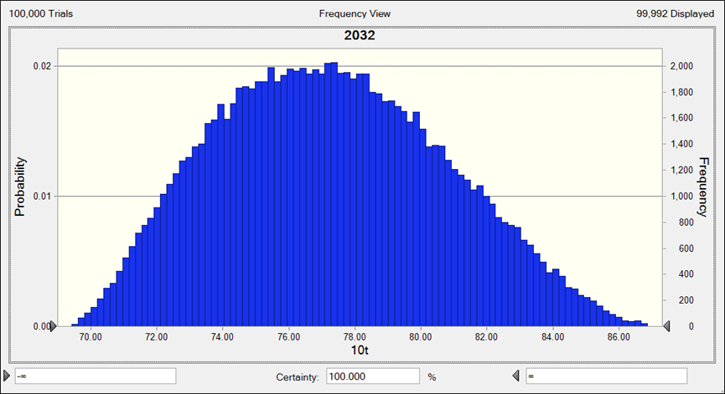
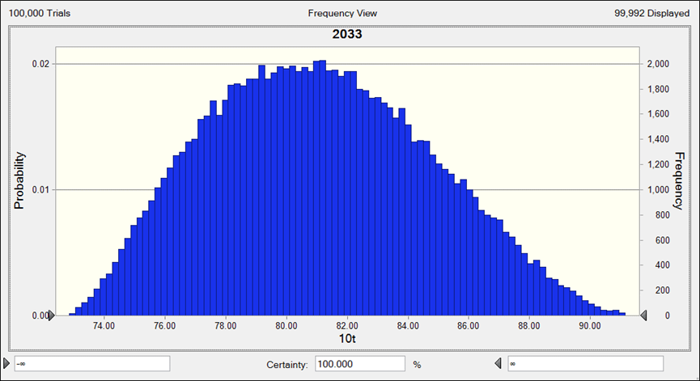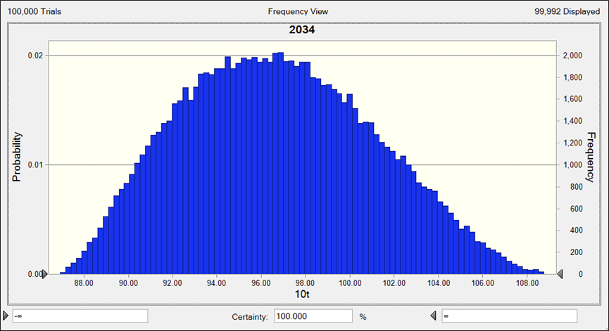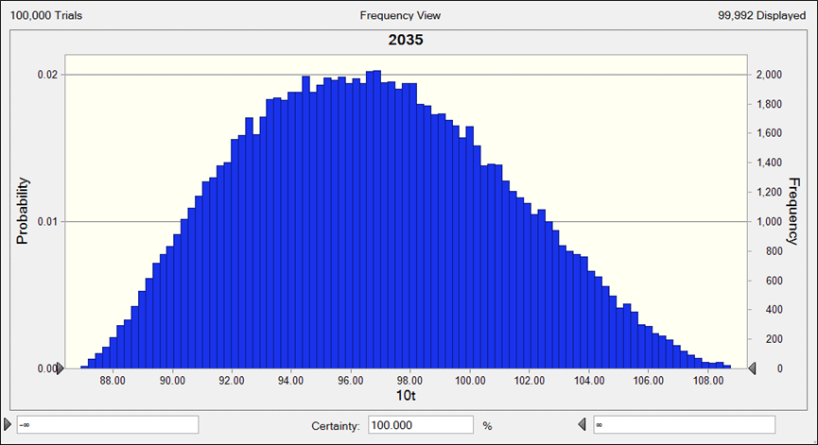
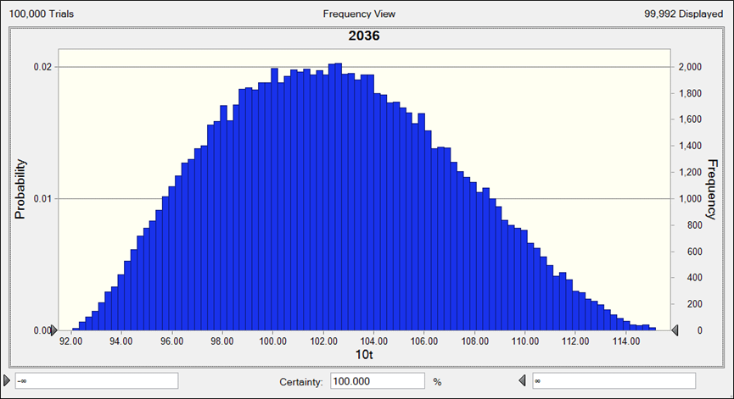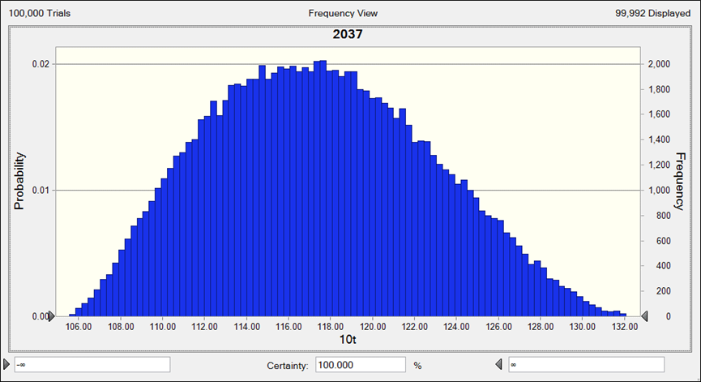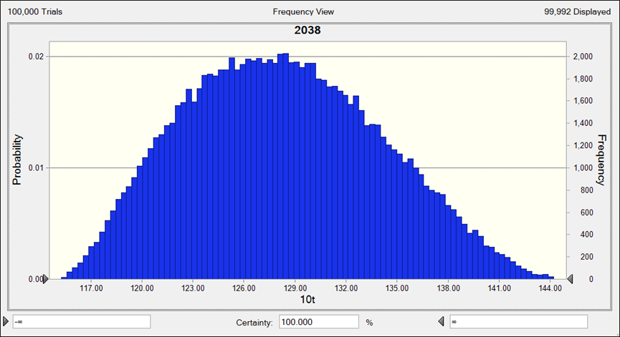
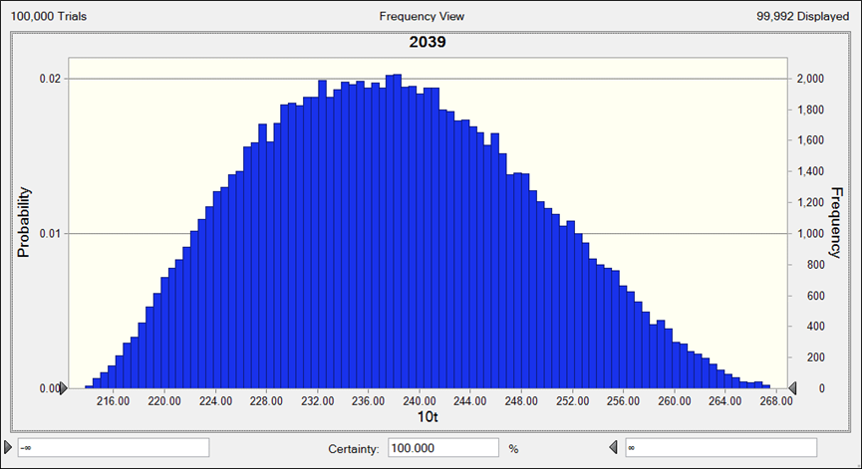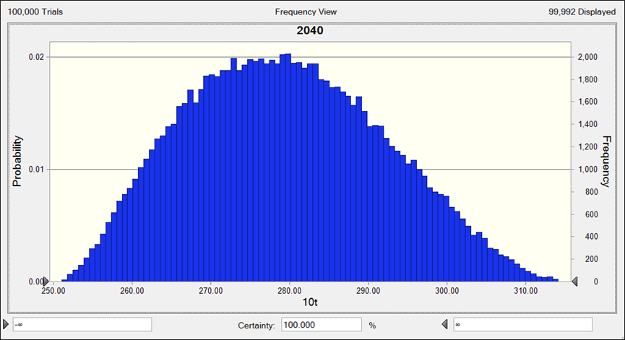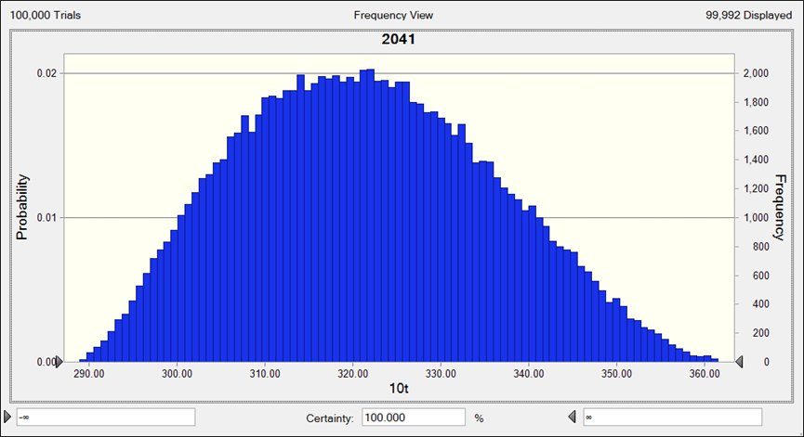
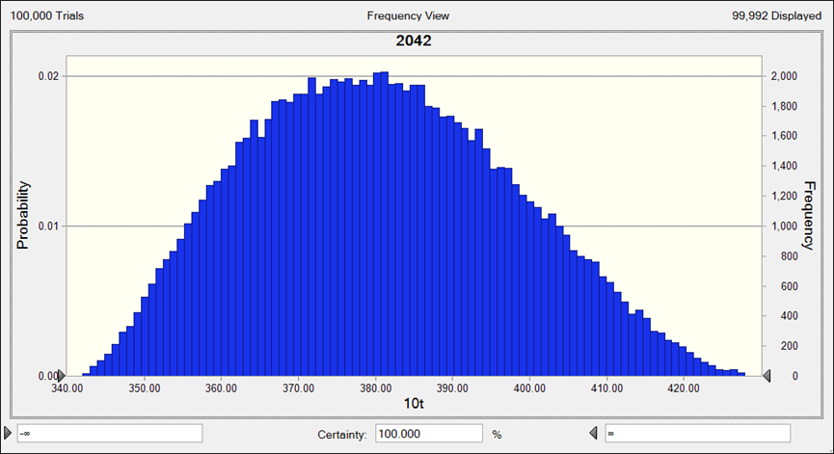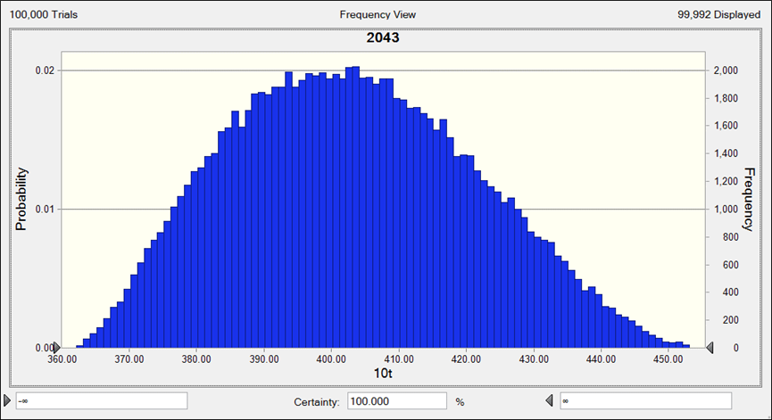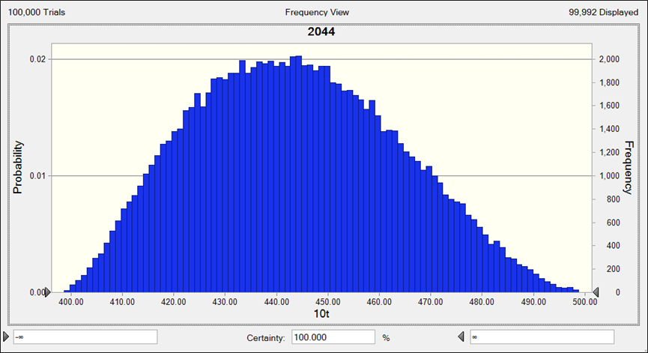
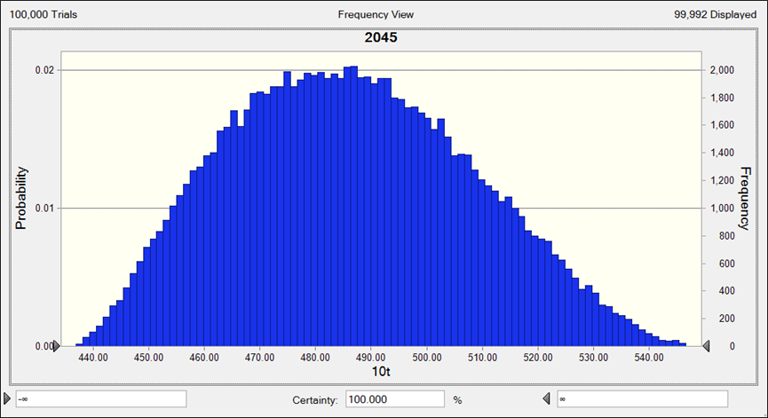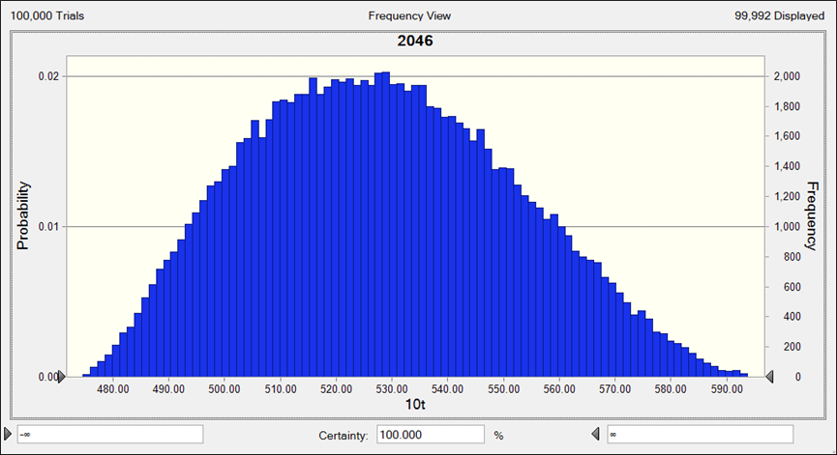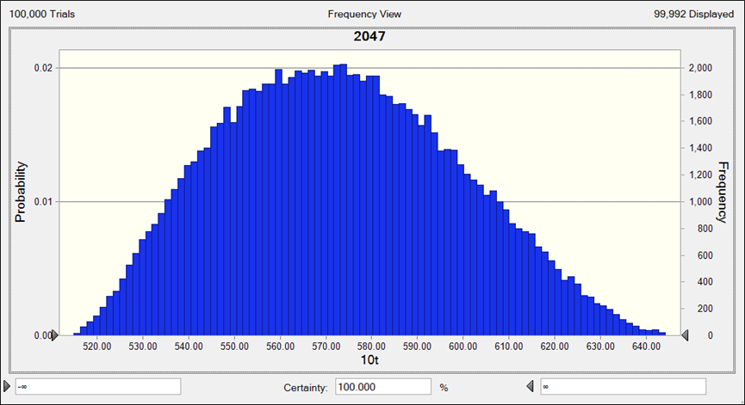
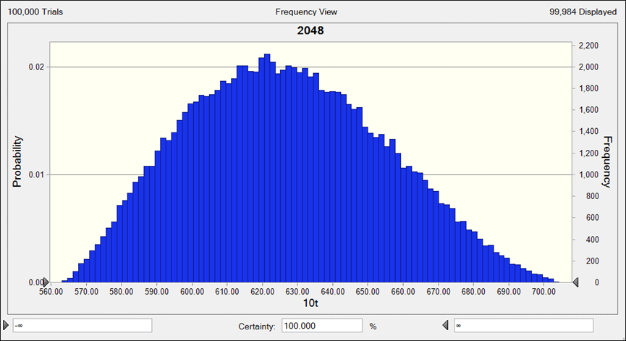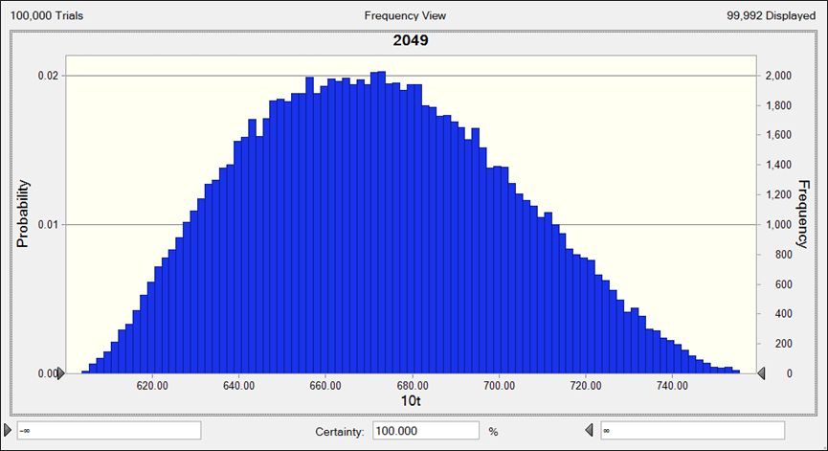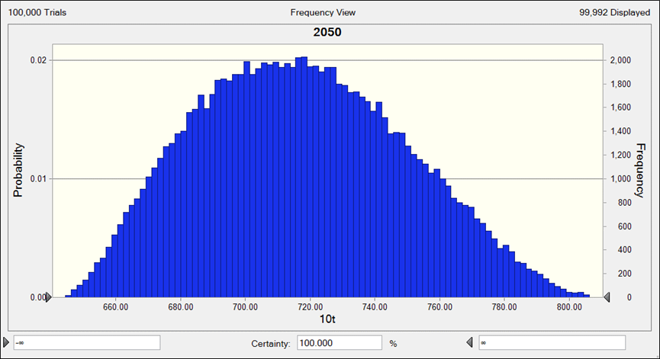
(C) HST
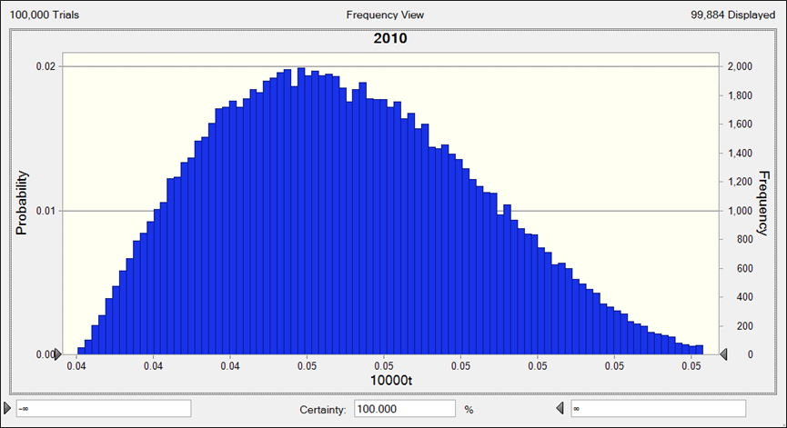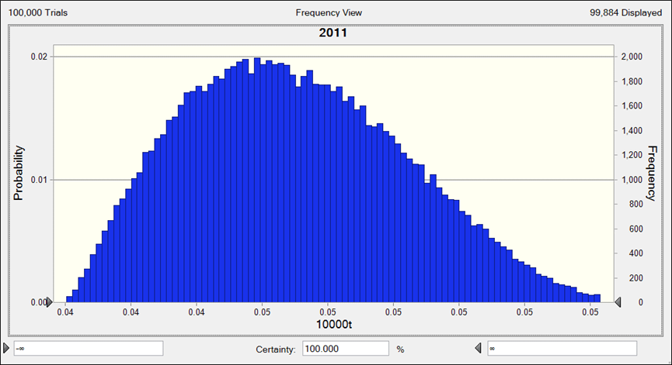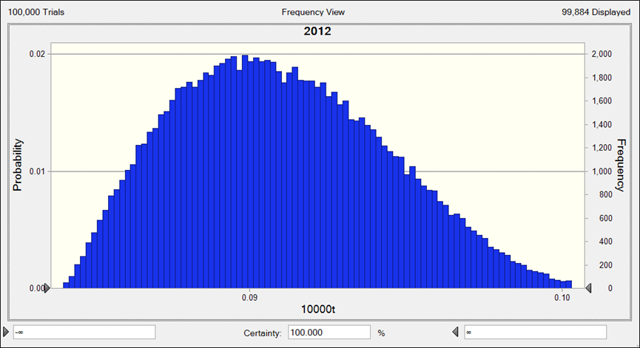
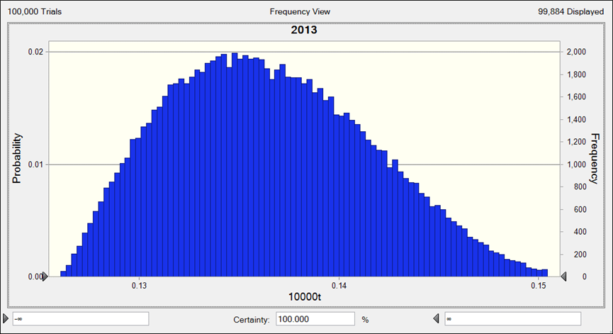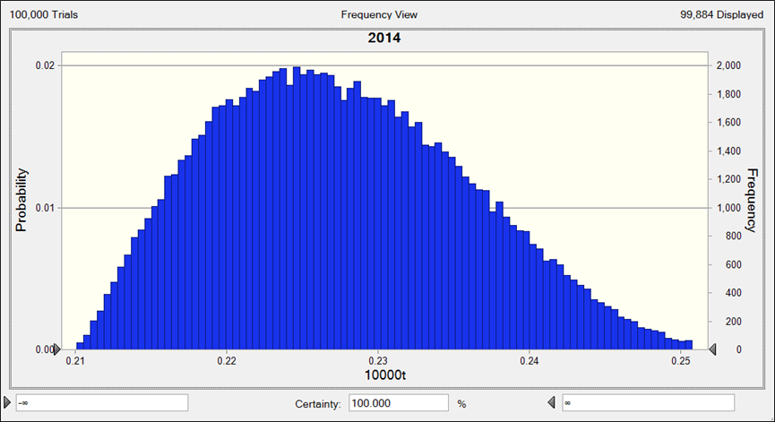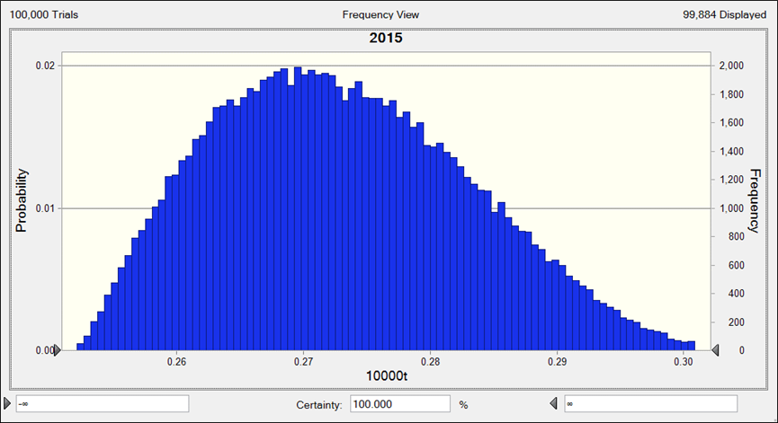
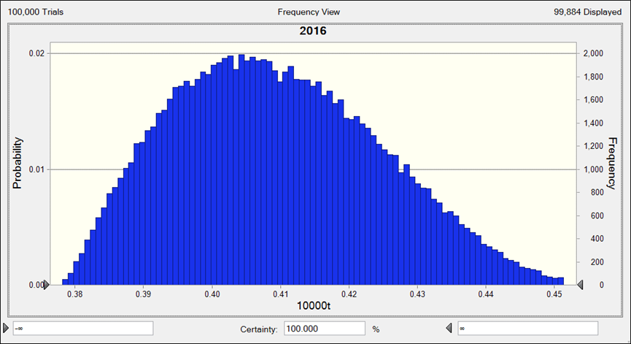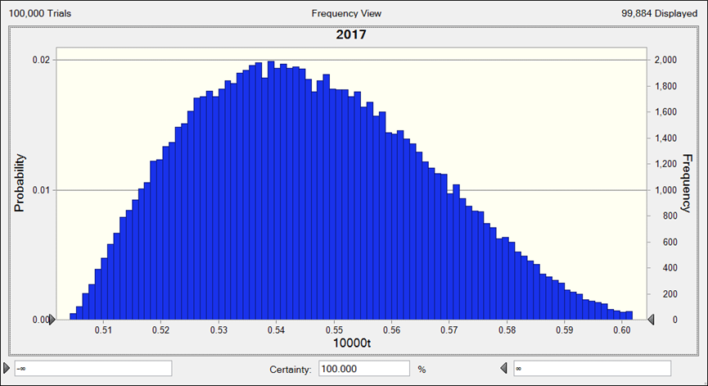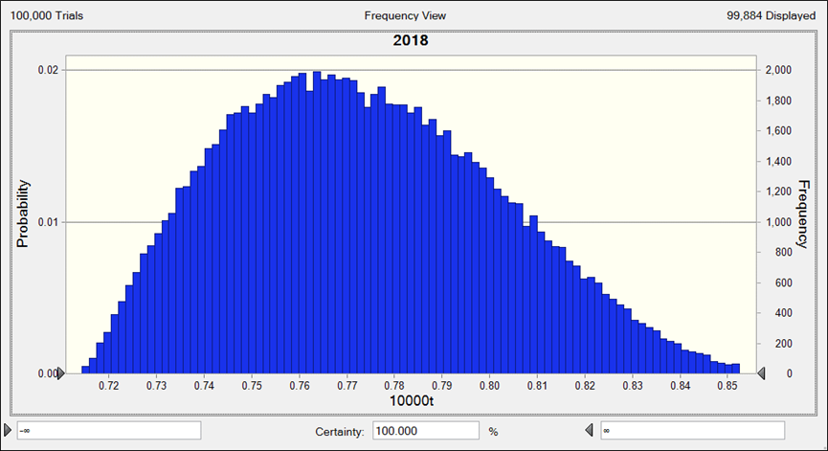
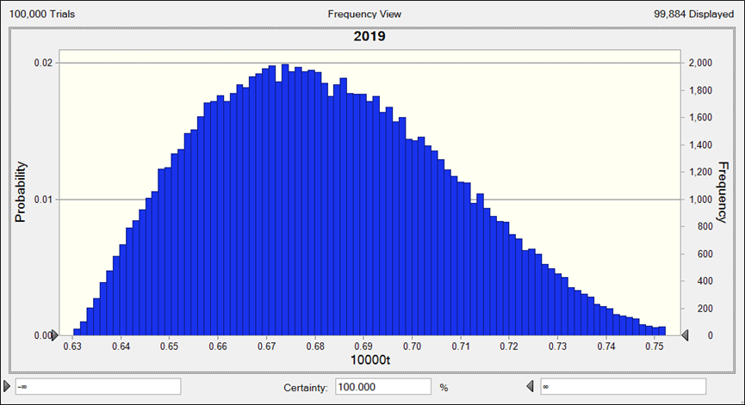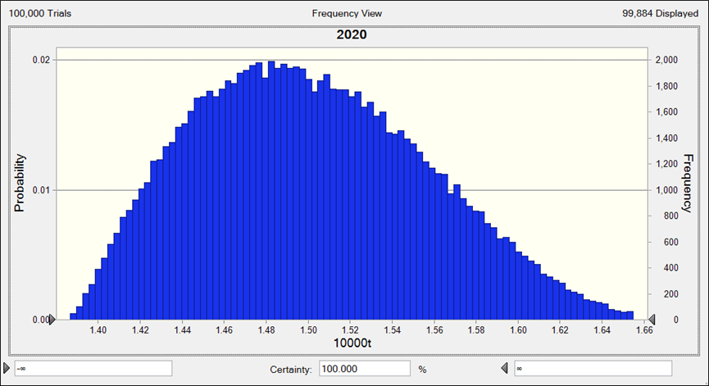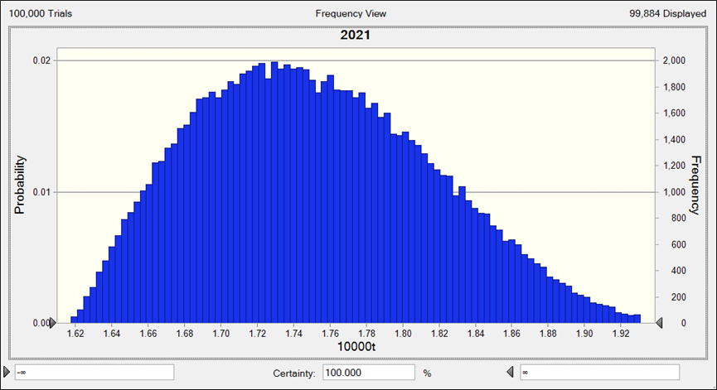
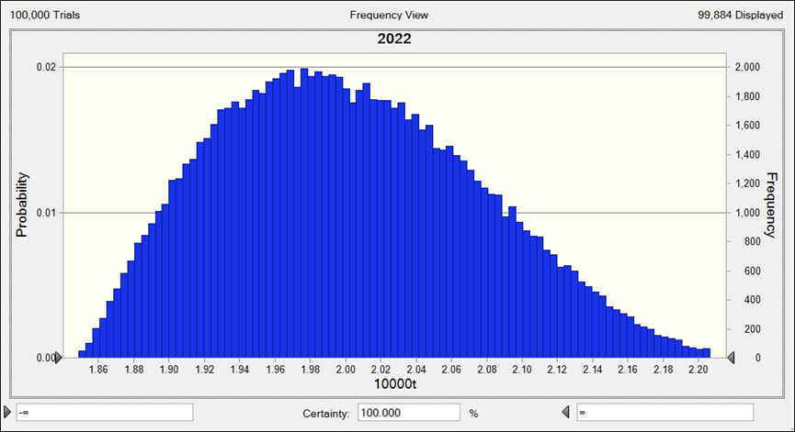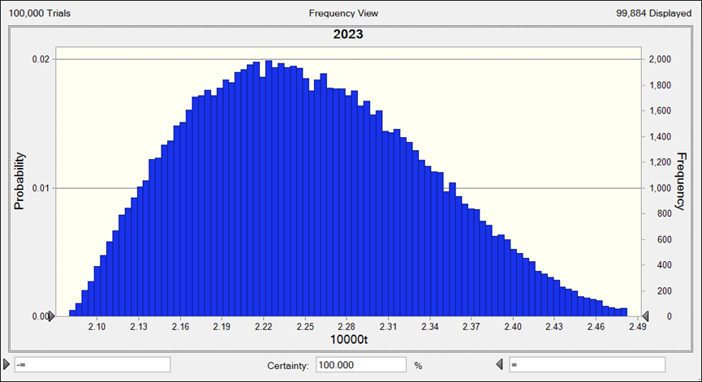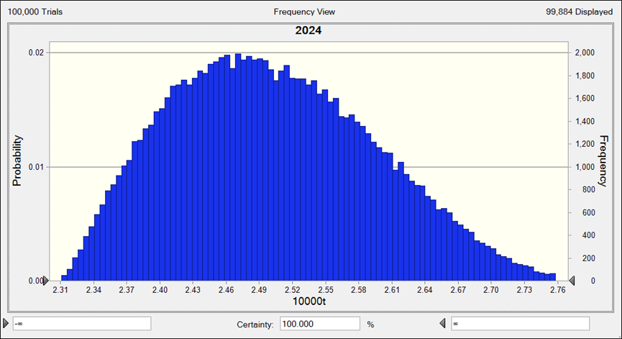
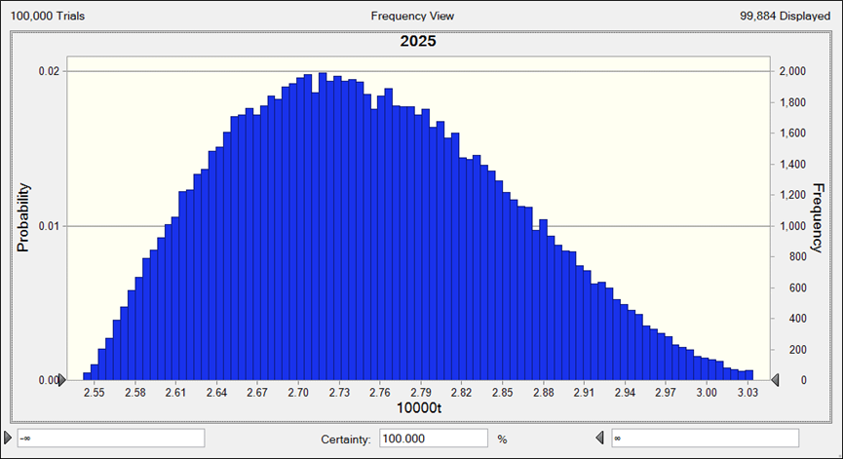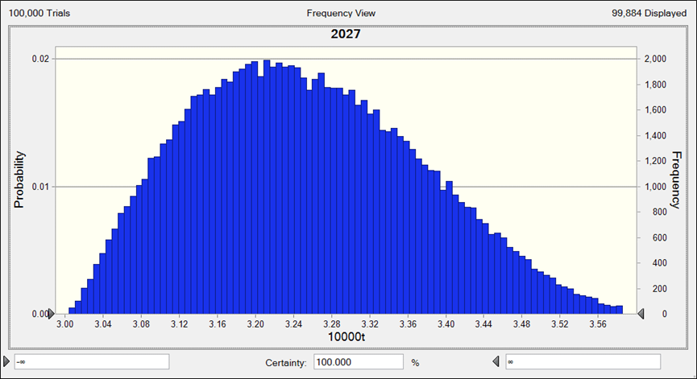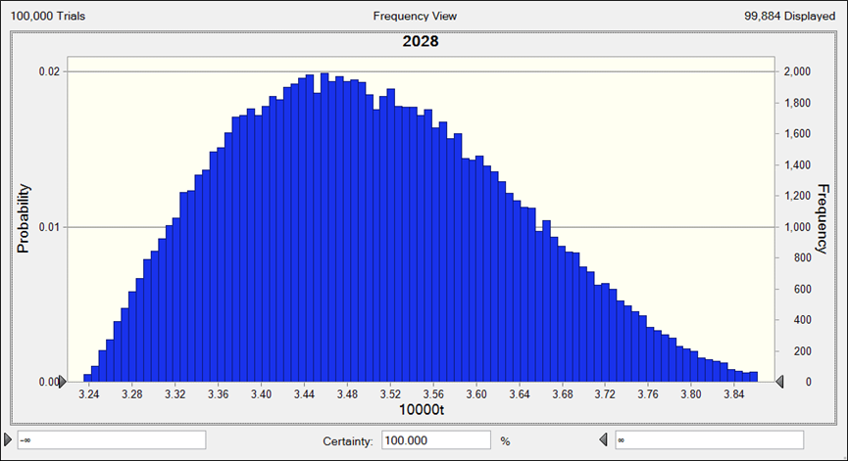
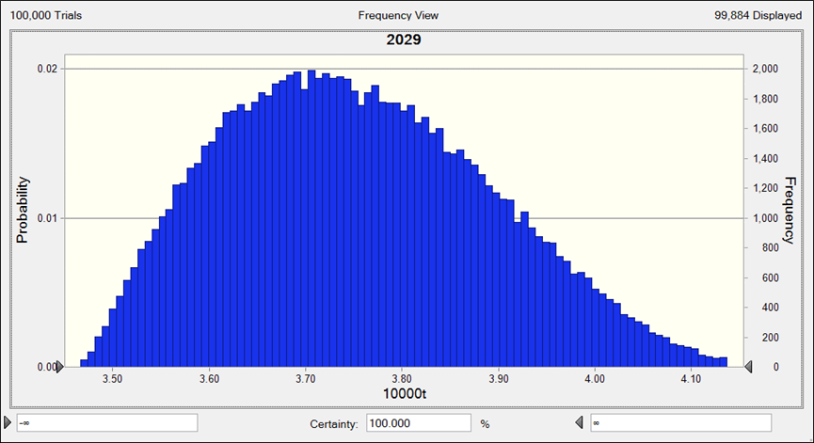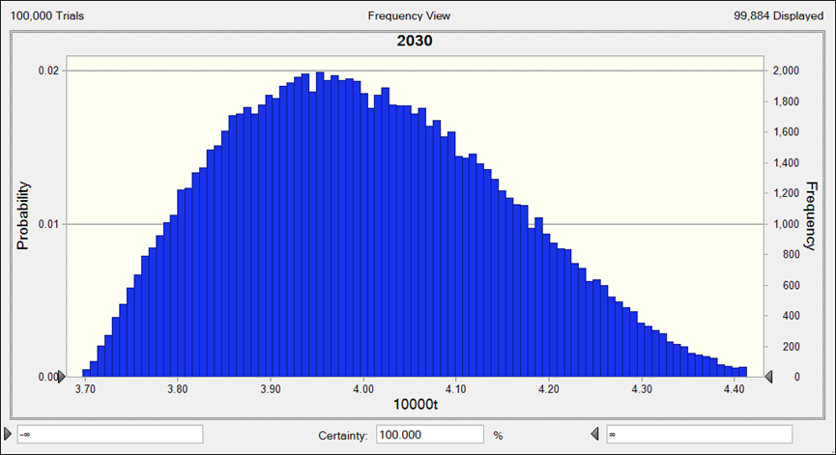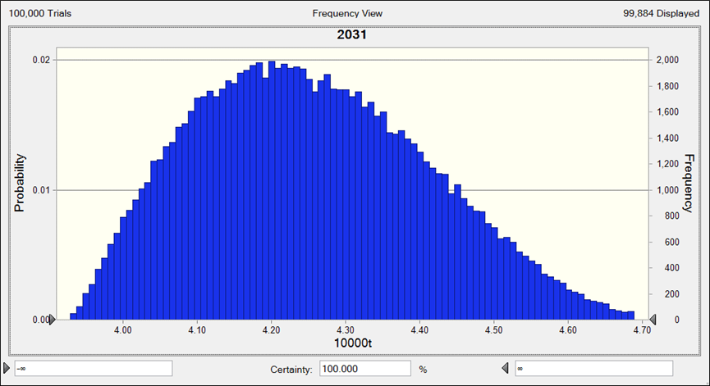
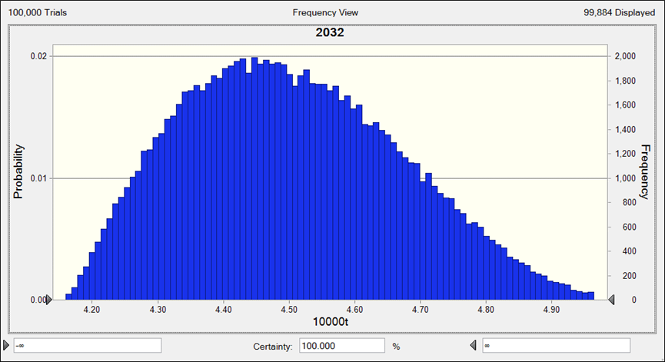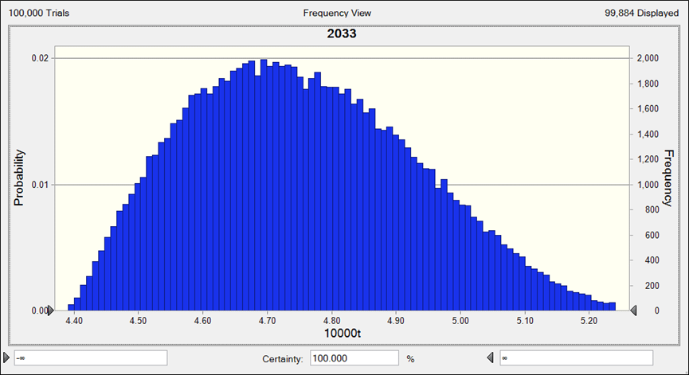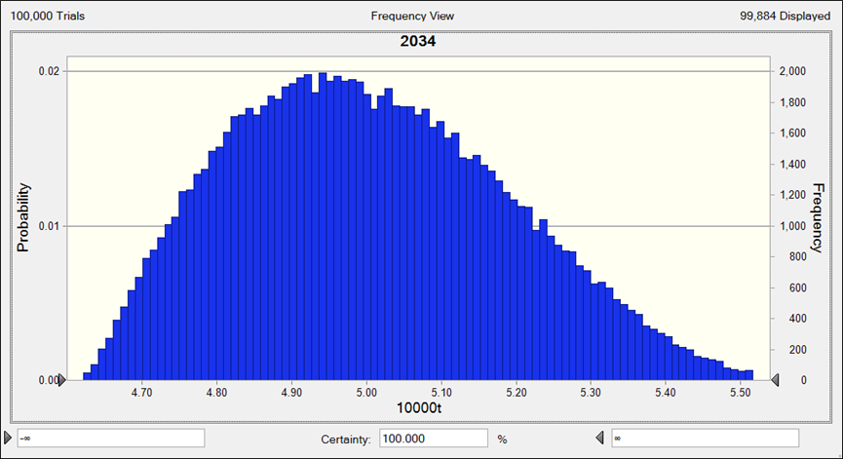
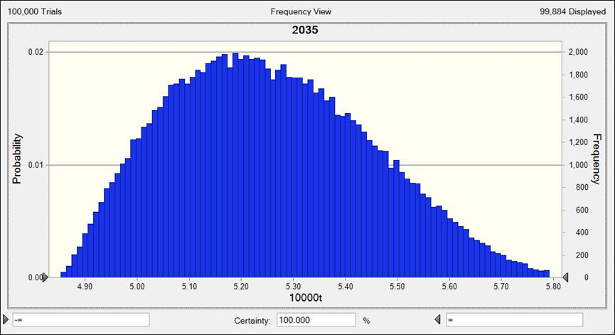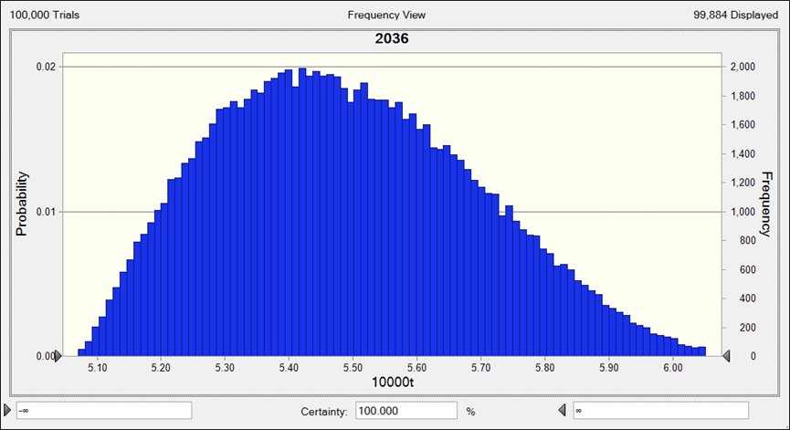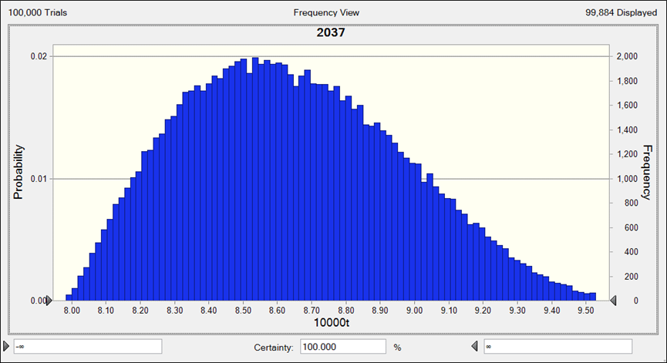
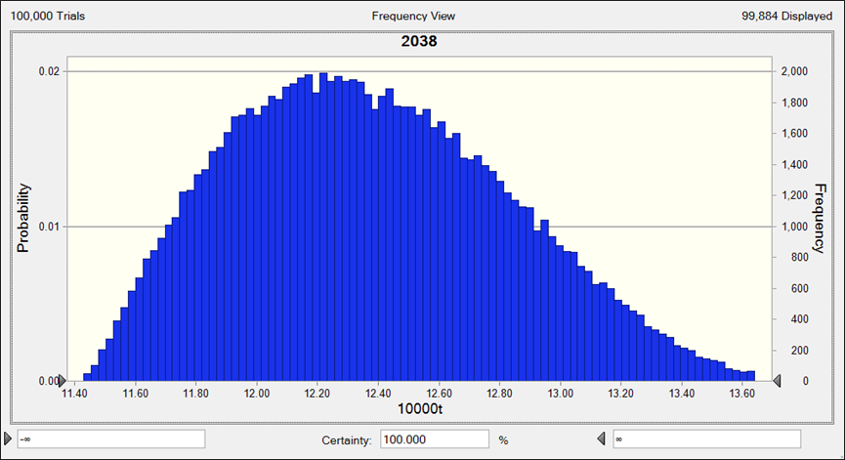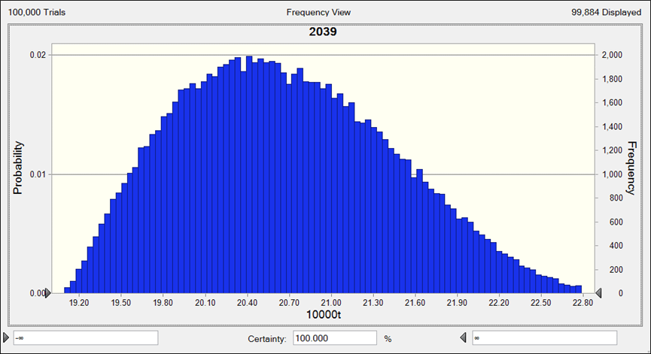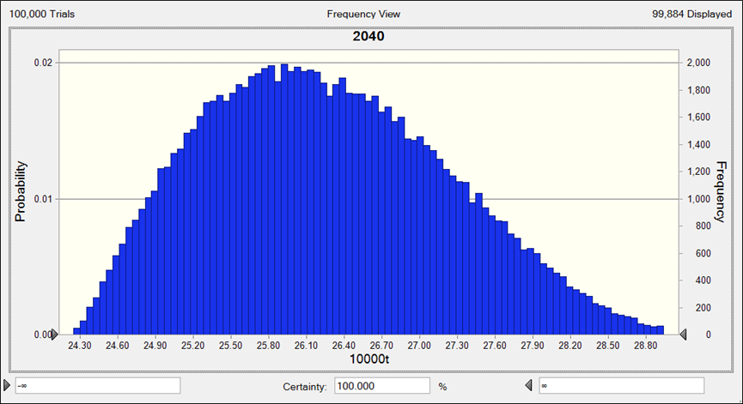
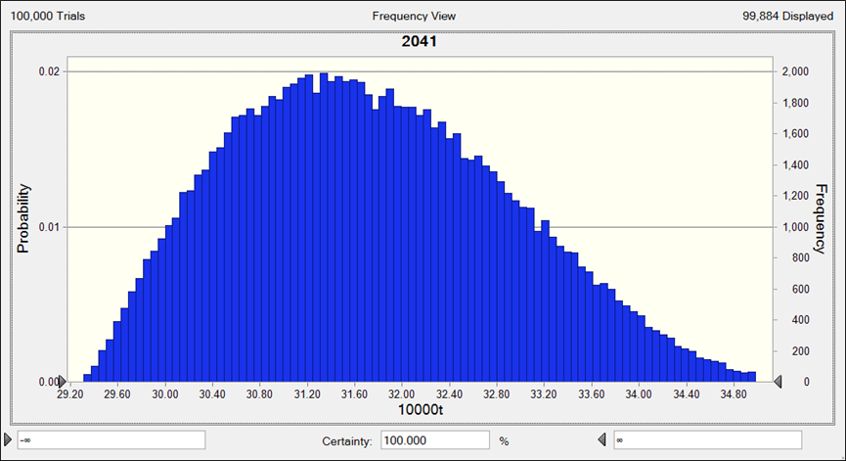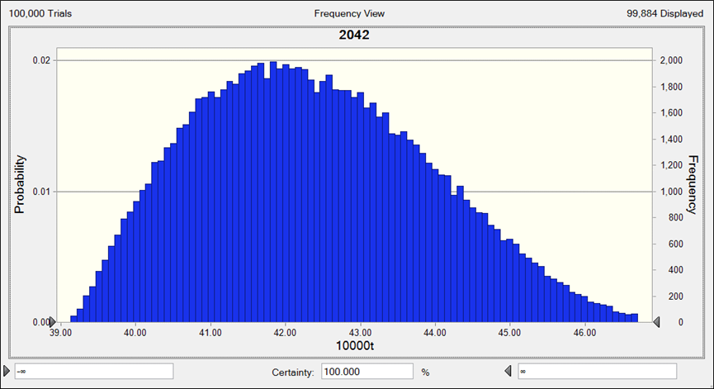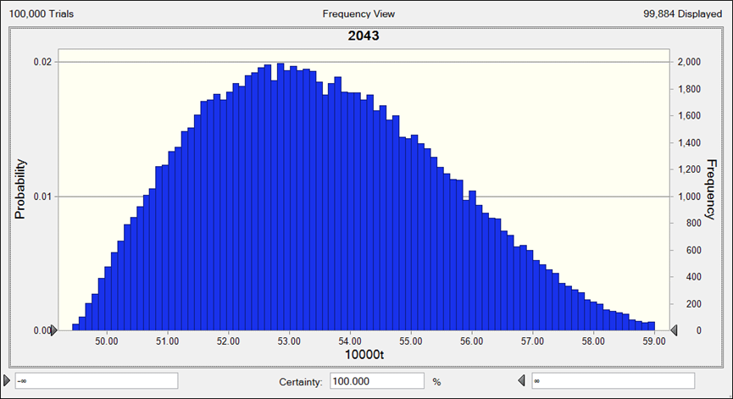
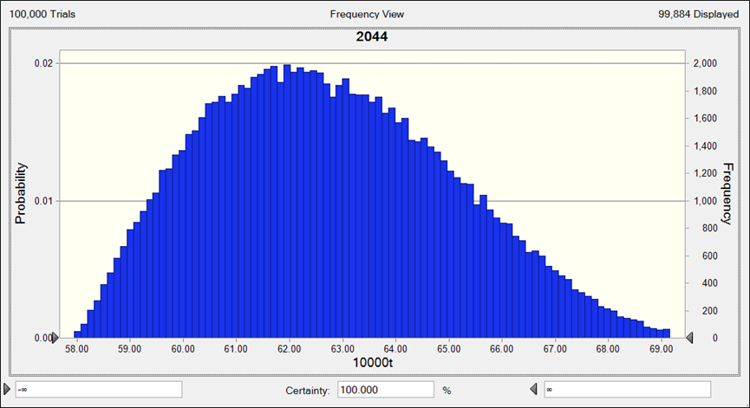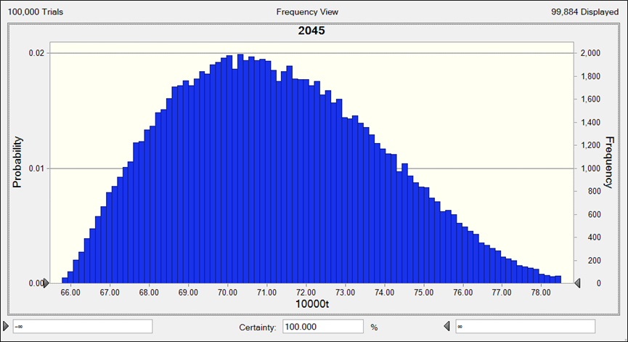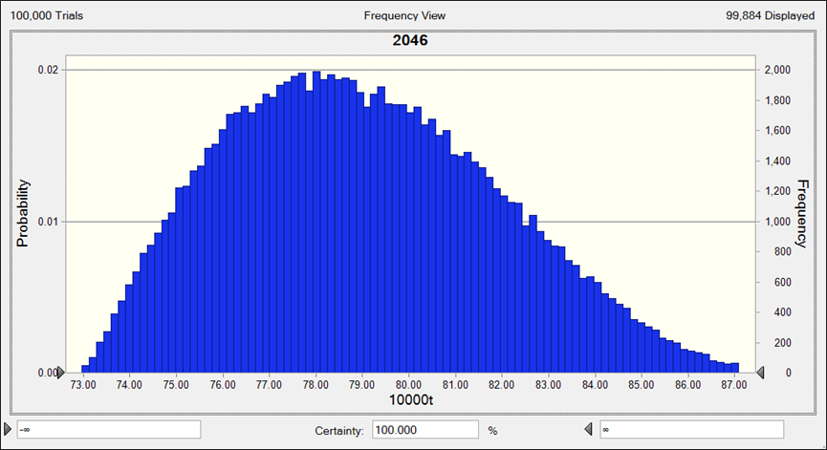
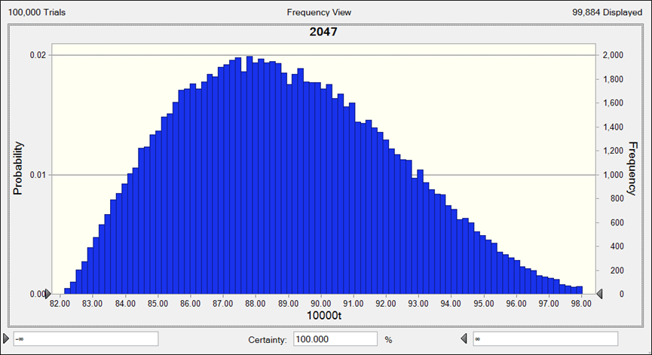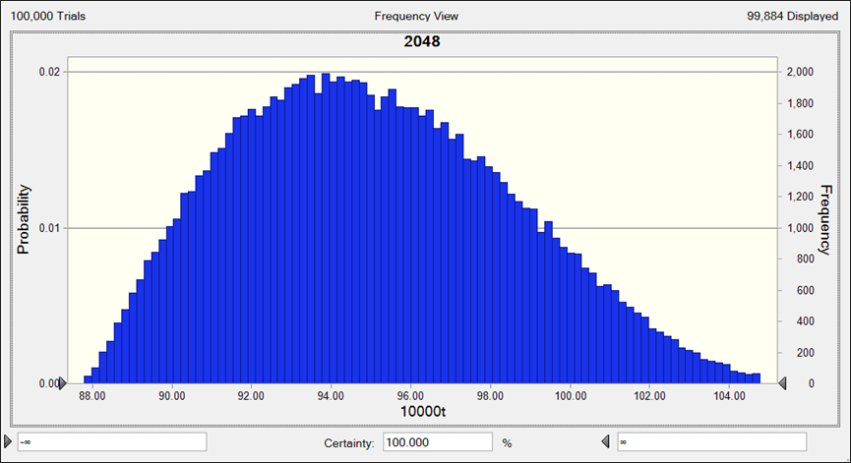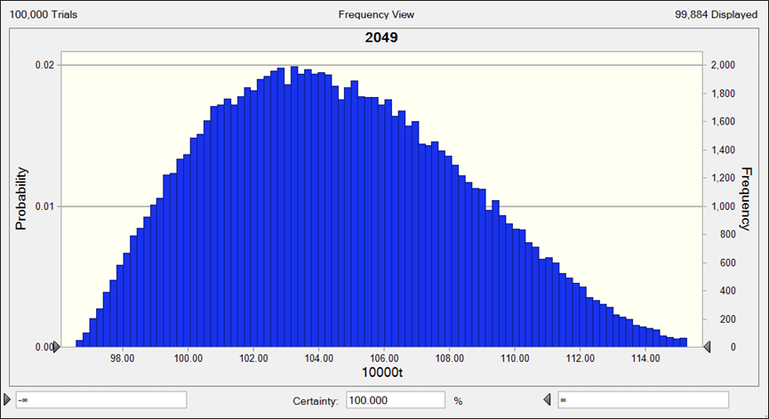
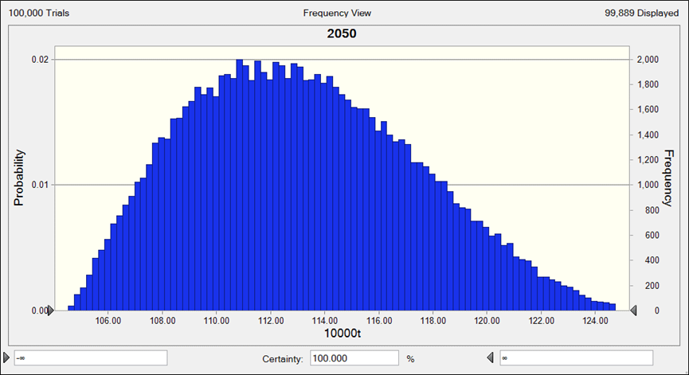
(D) RL
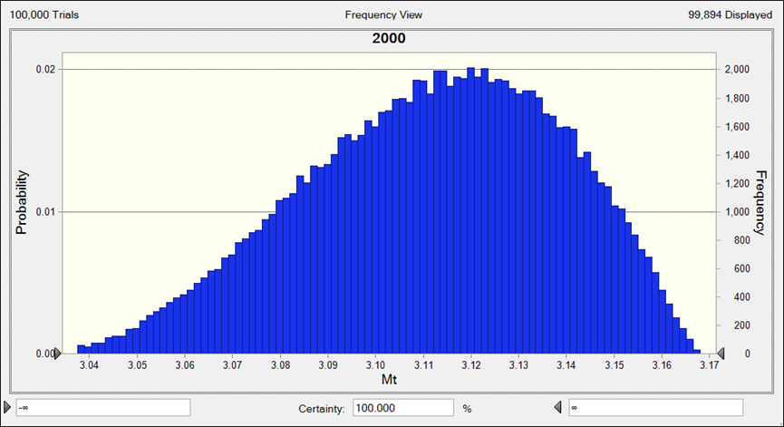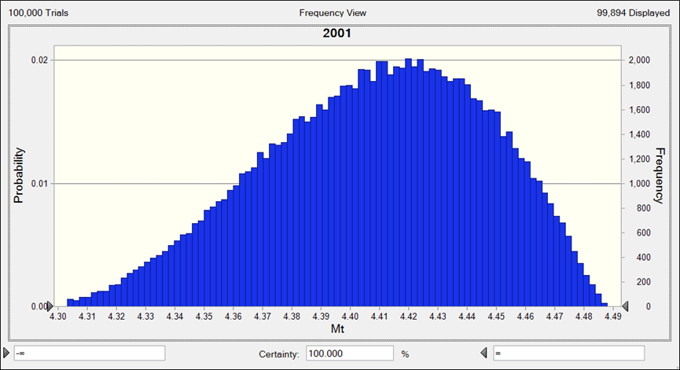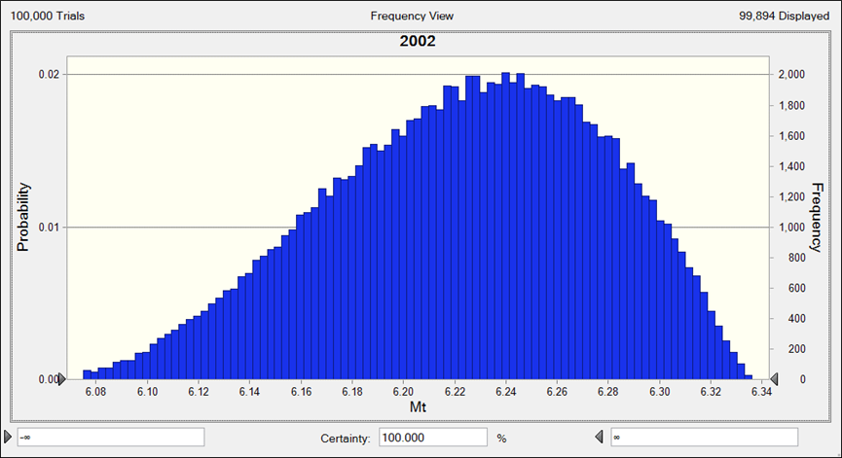
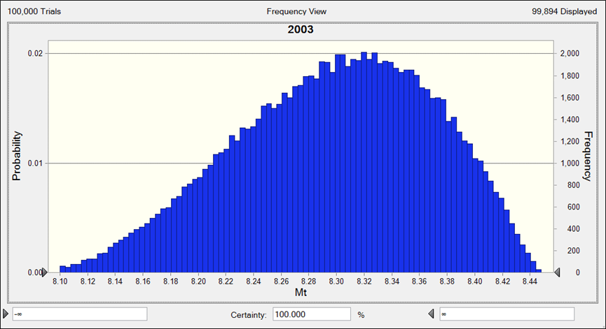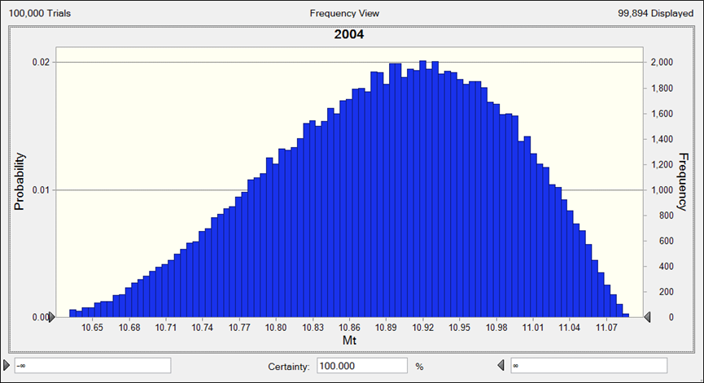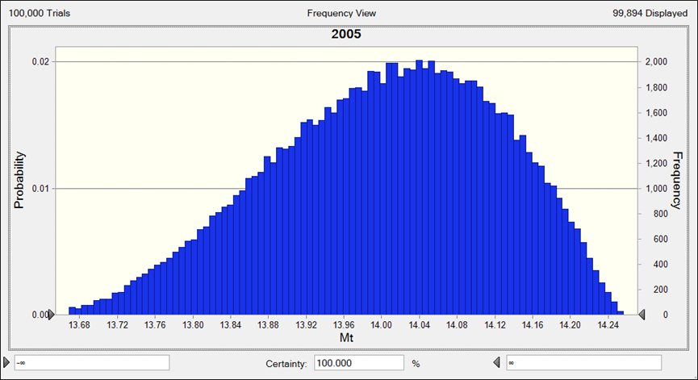
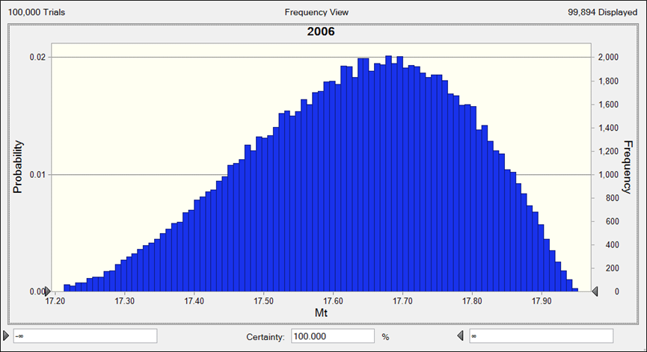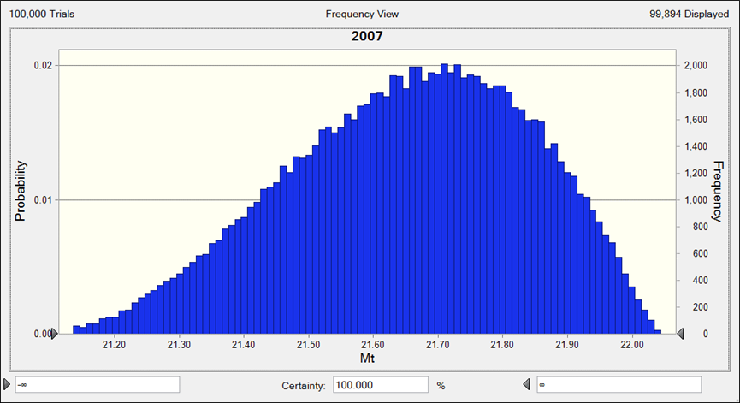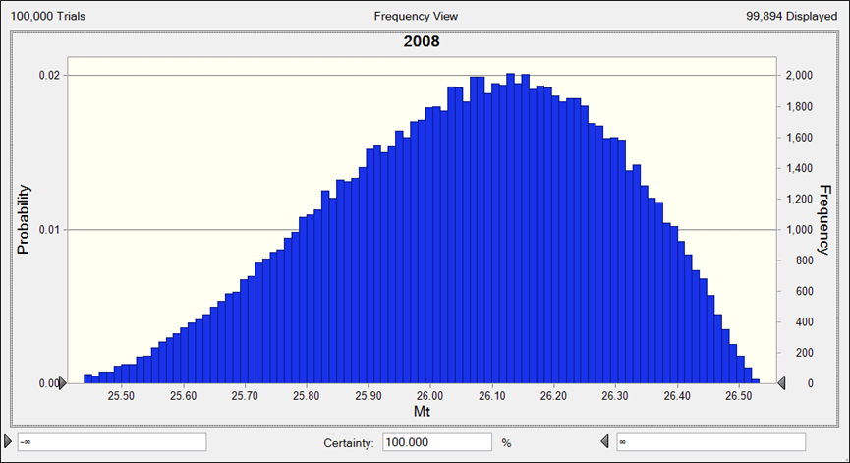
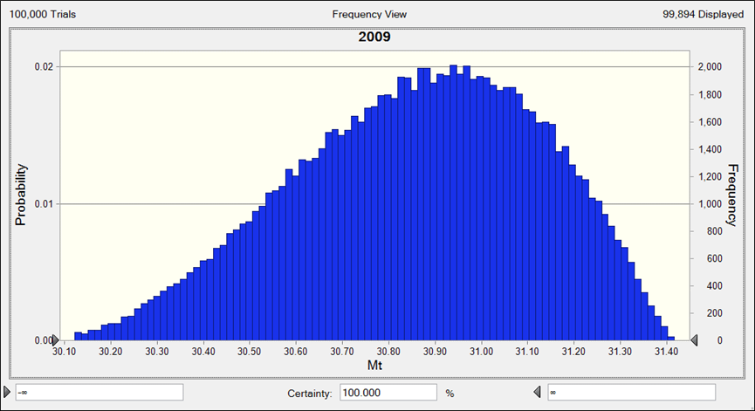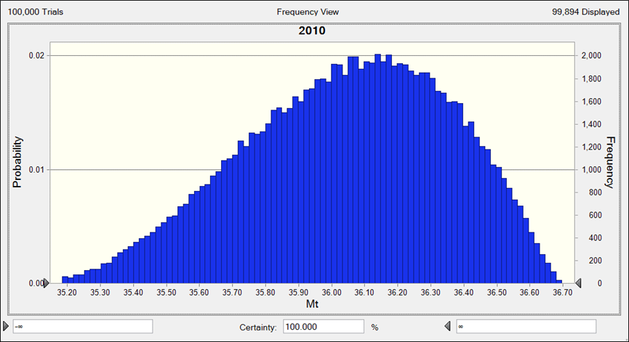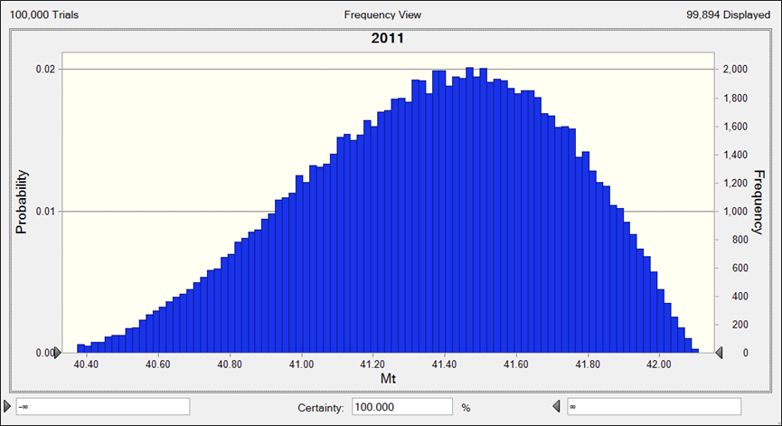
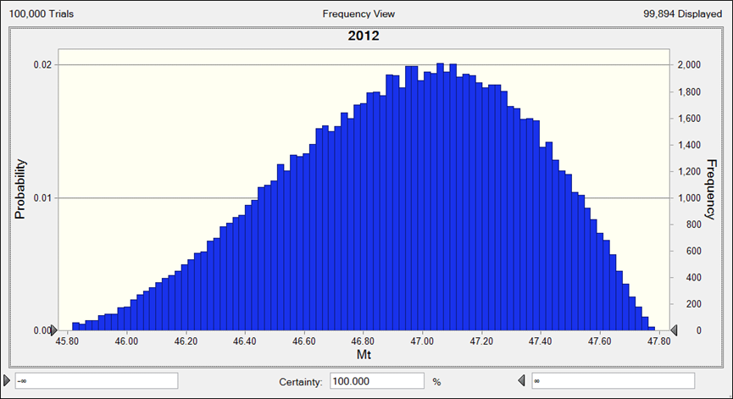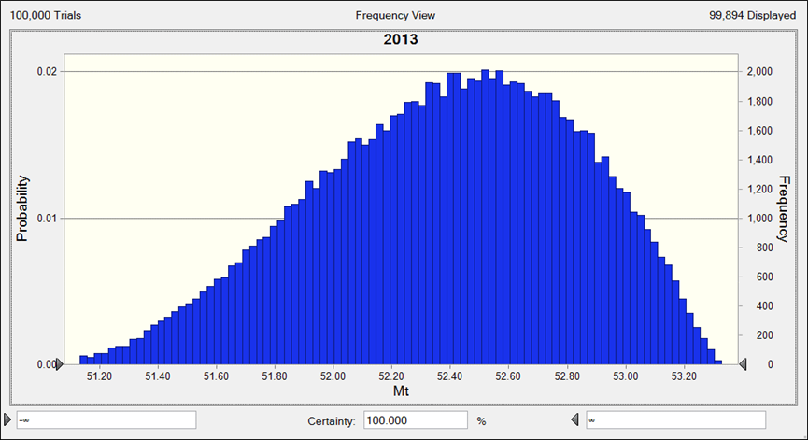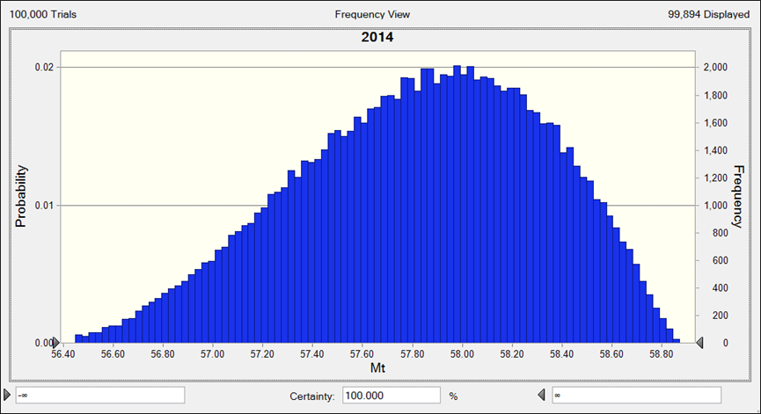
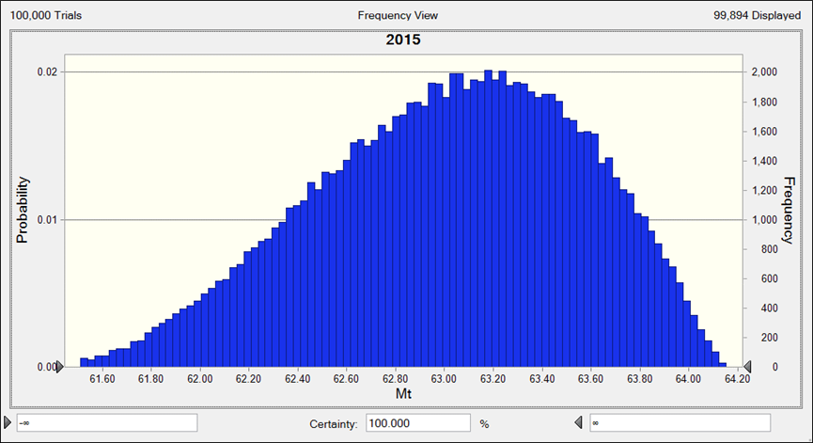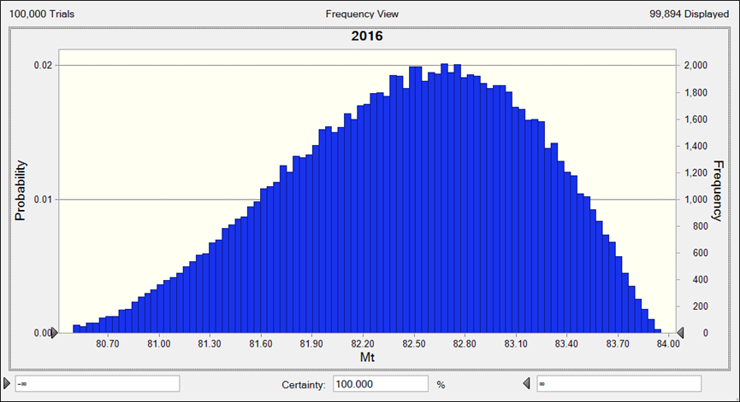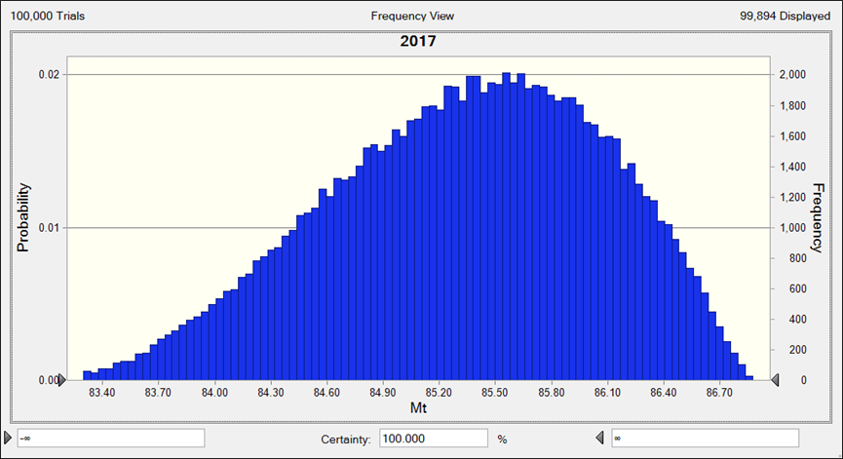
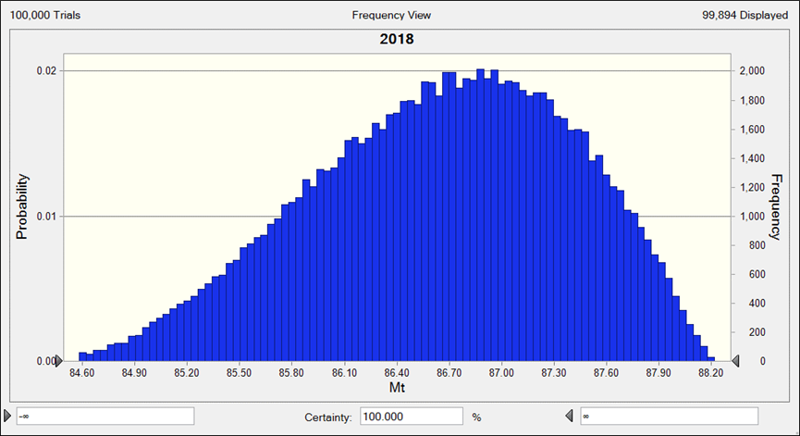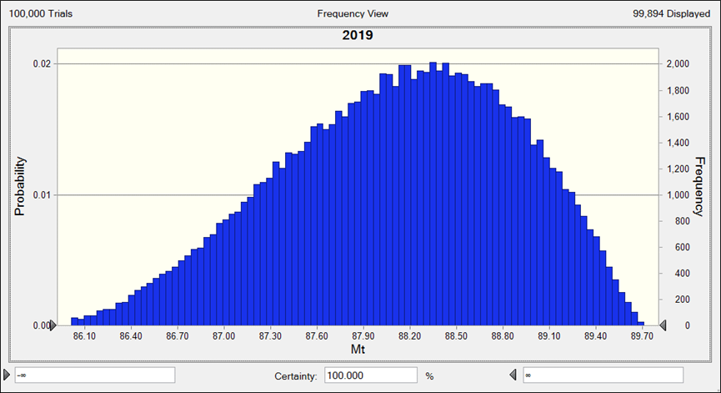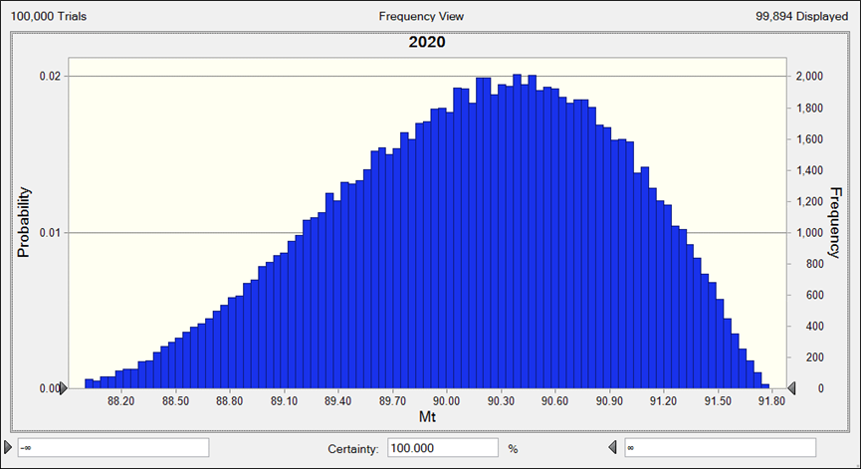
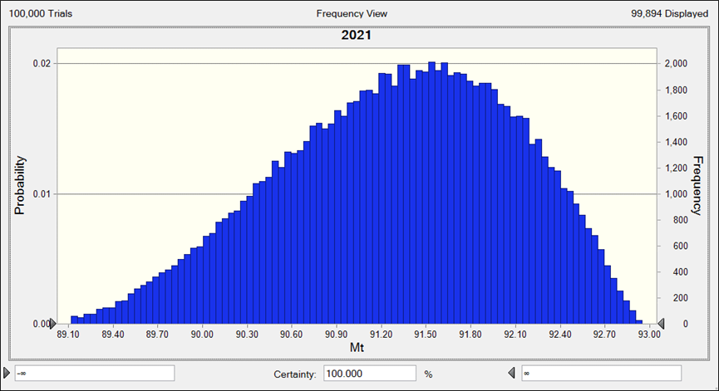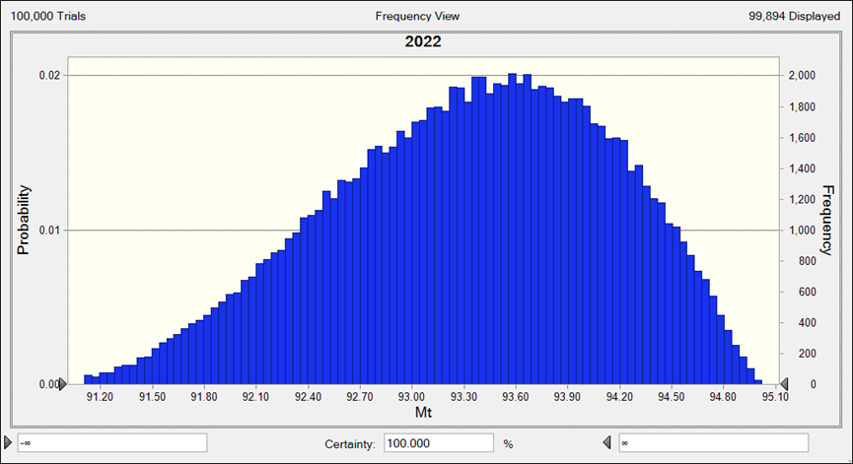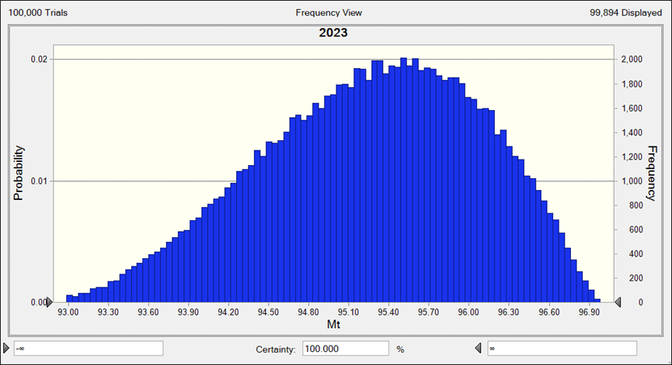
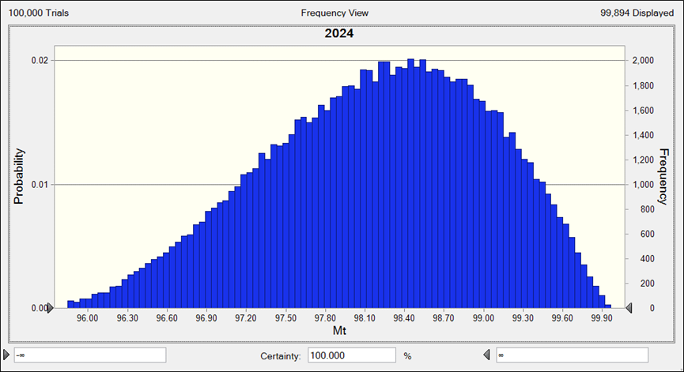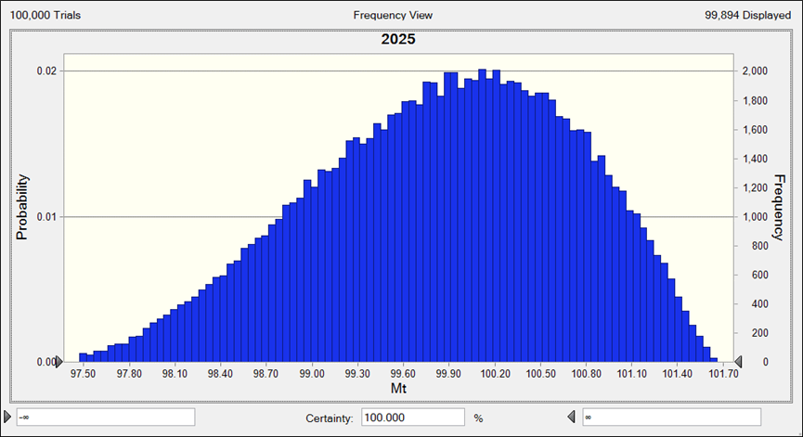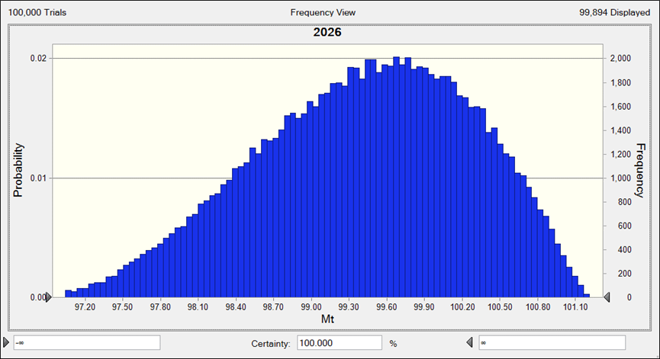
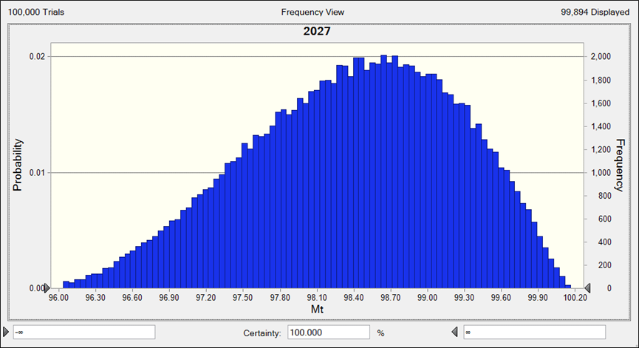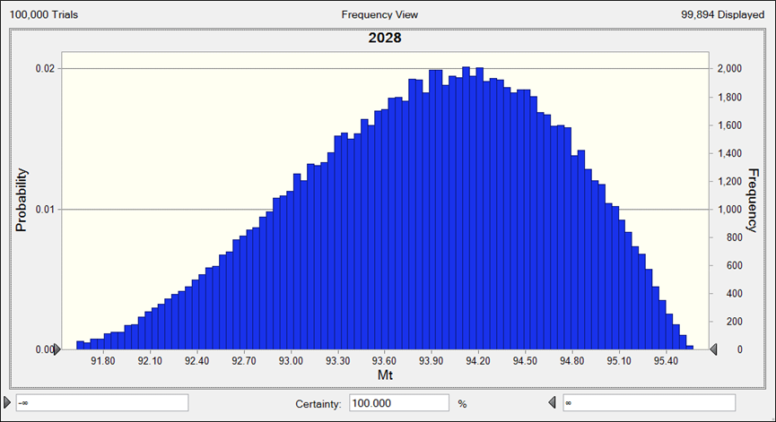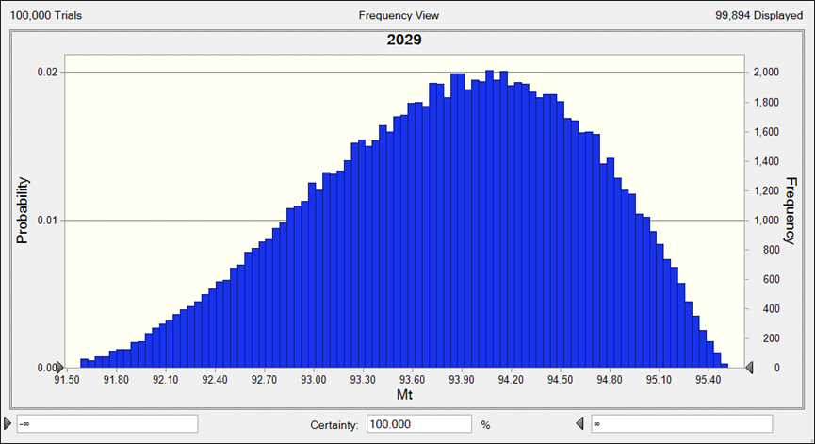
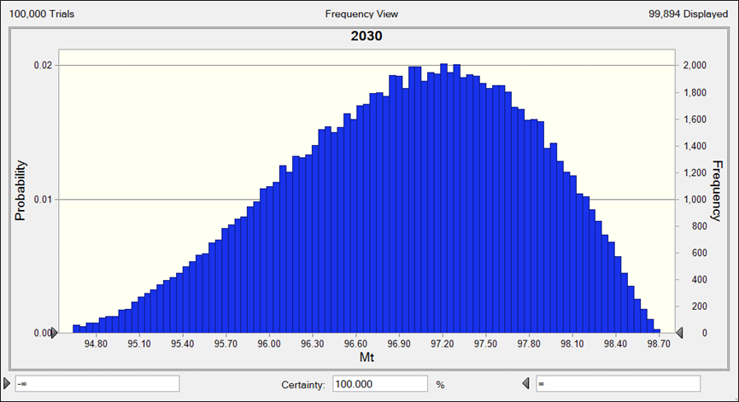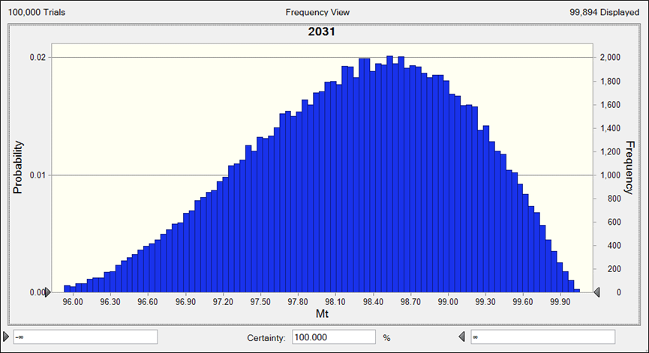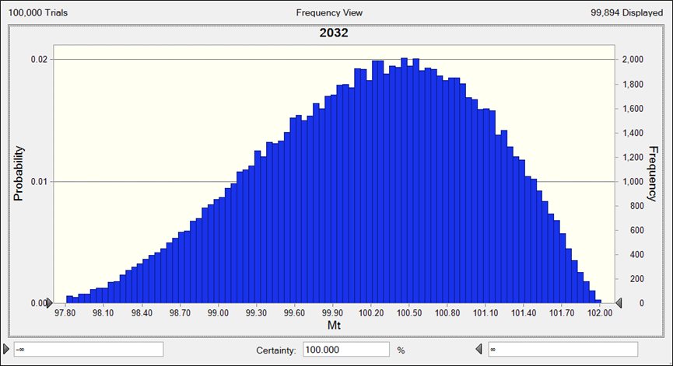
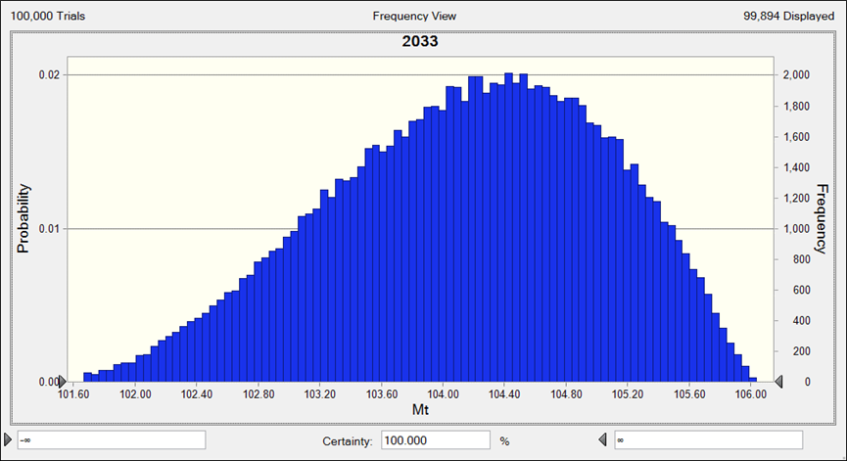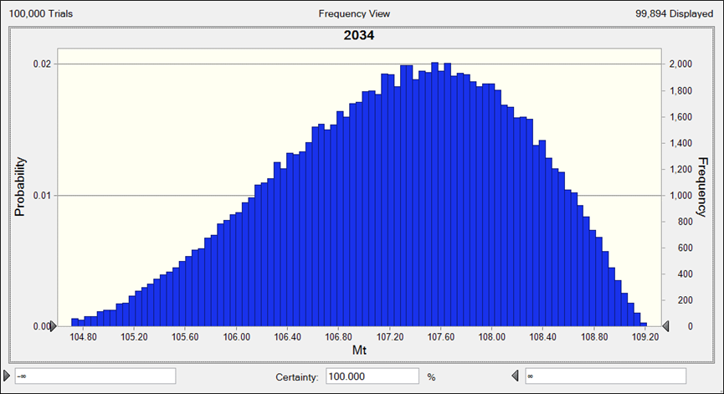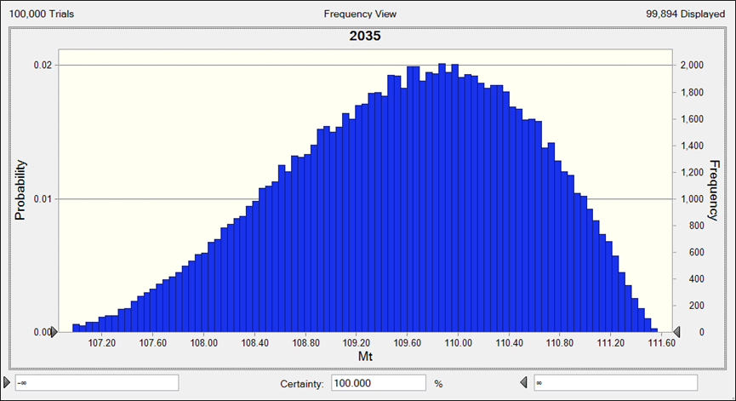
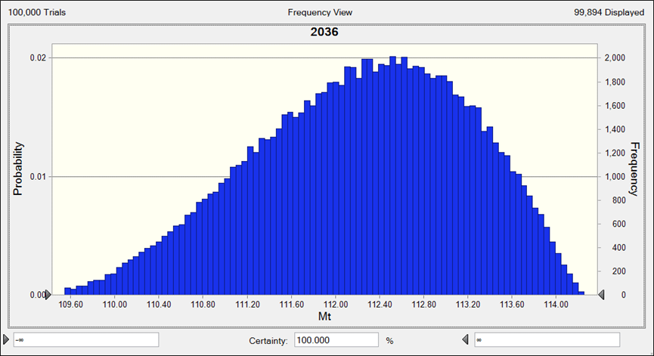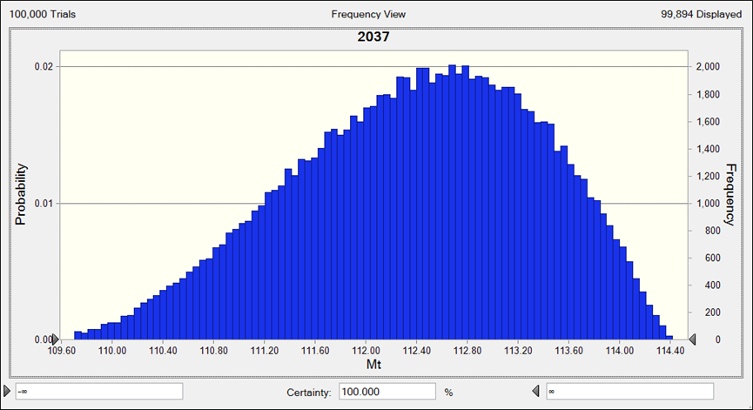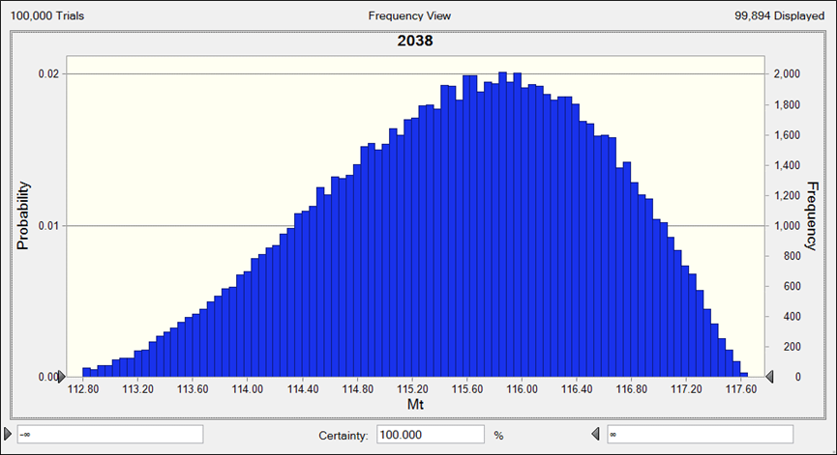
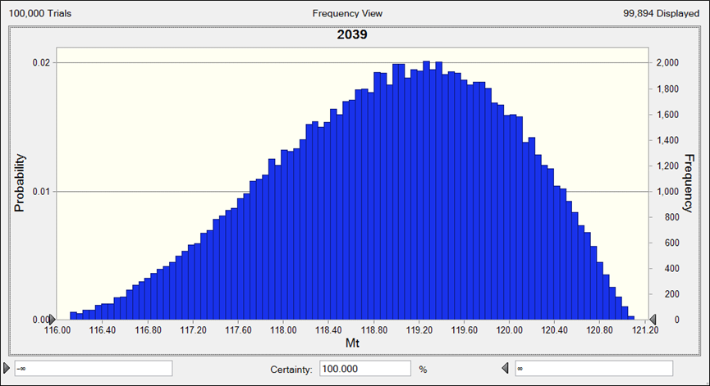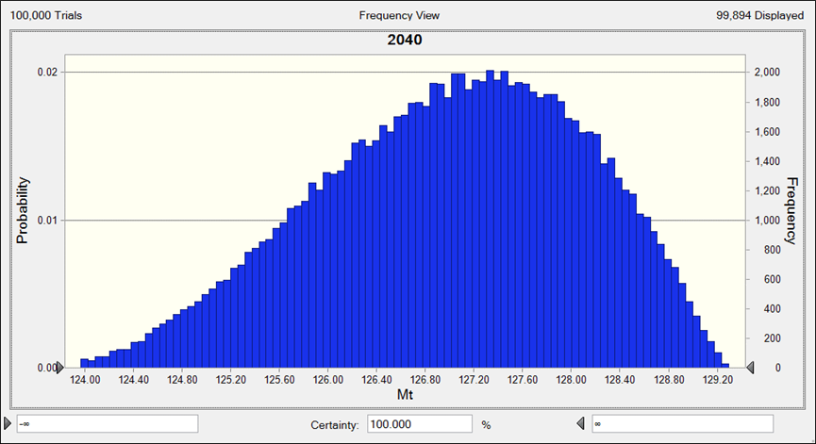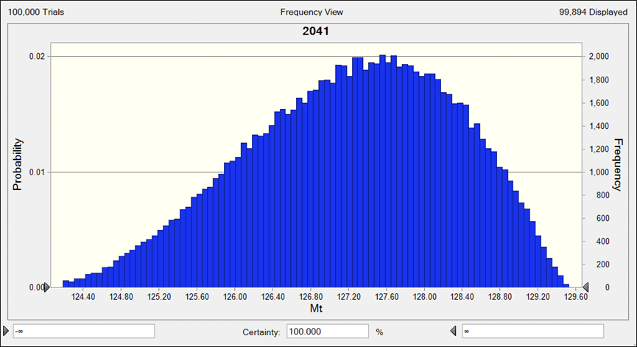
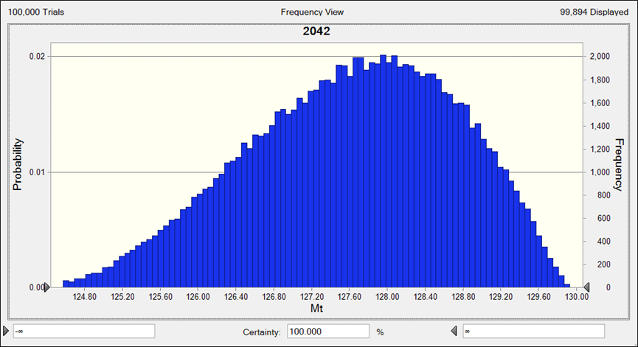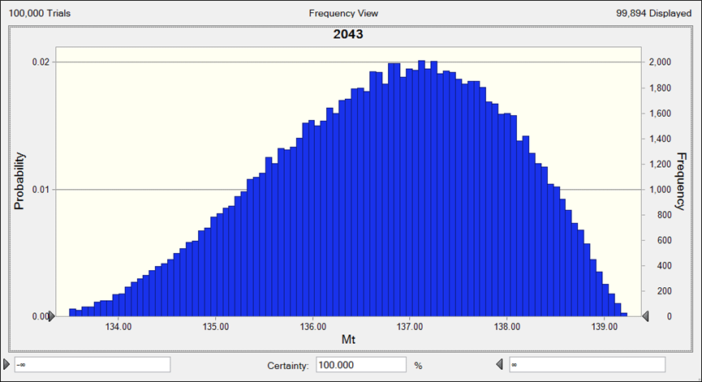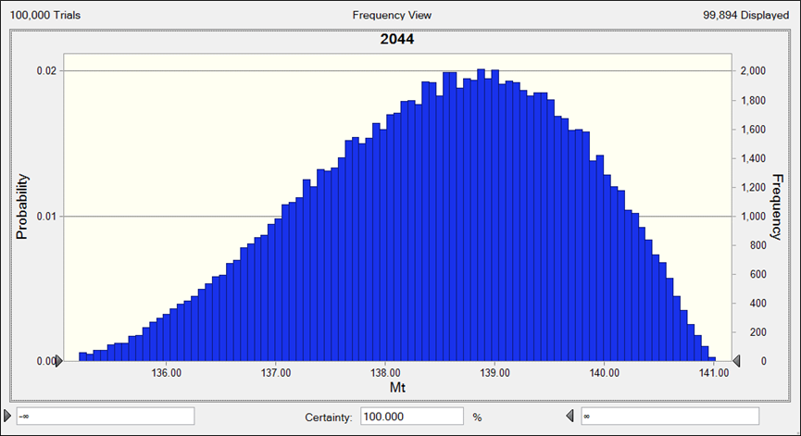
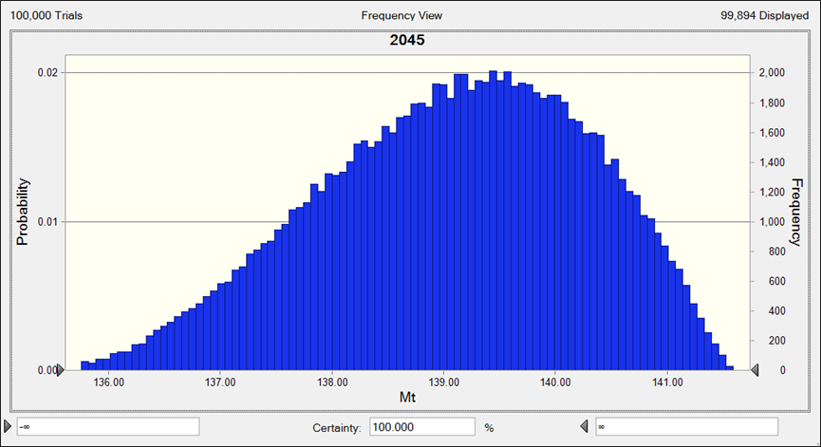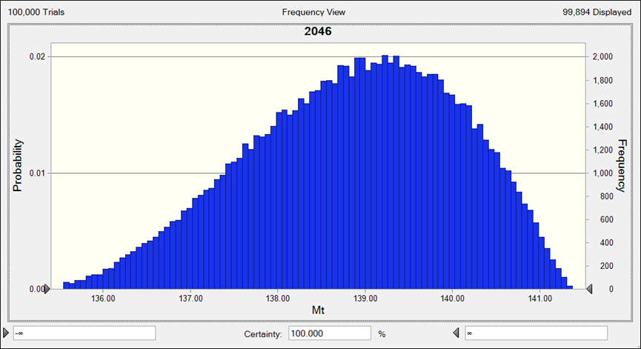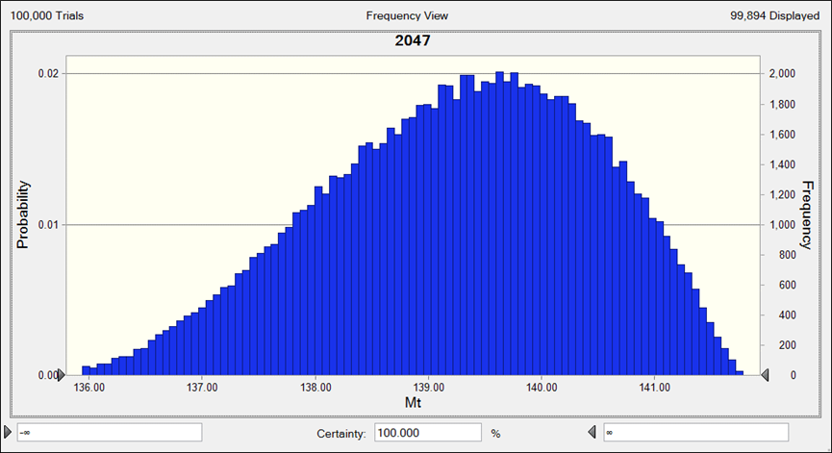
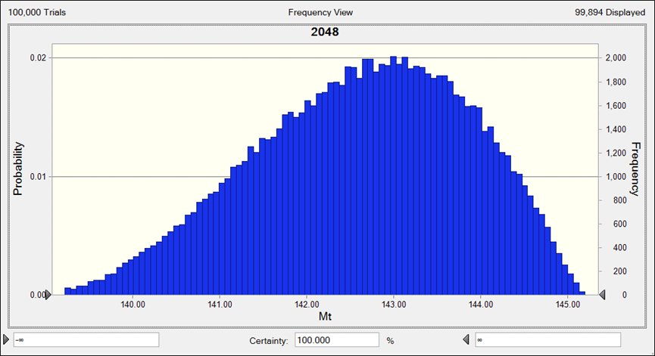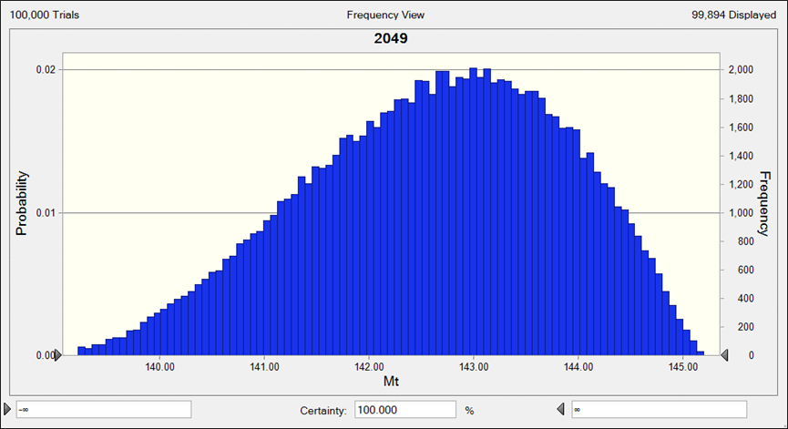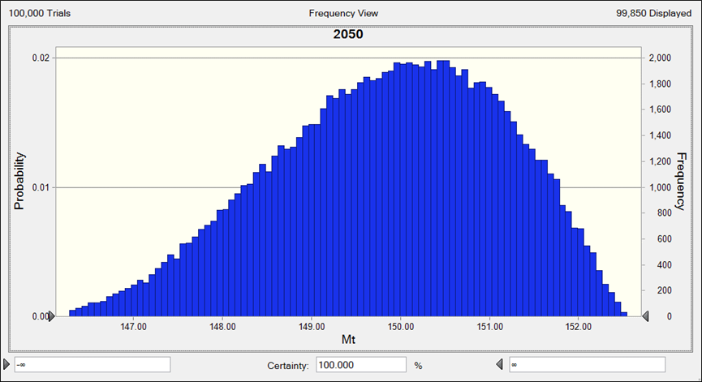
(E) RPC
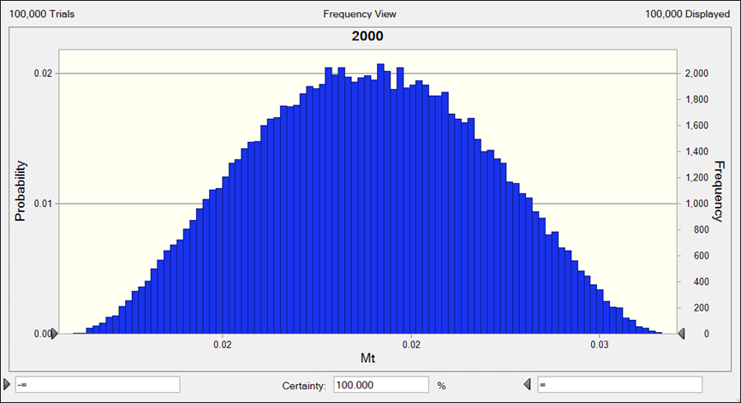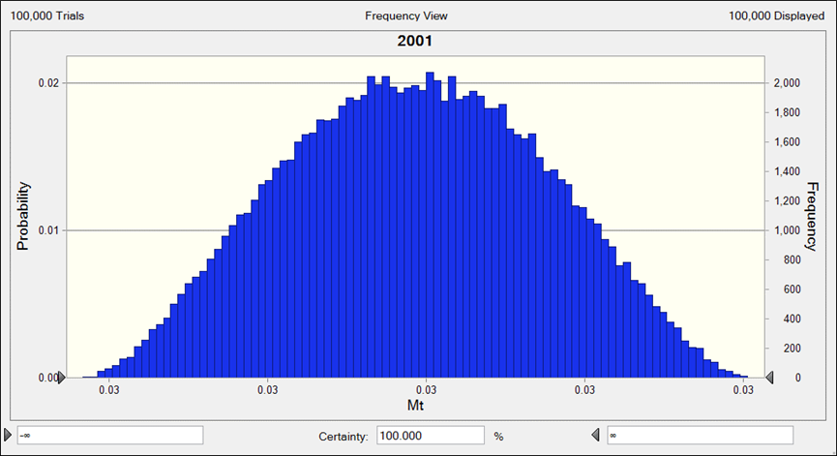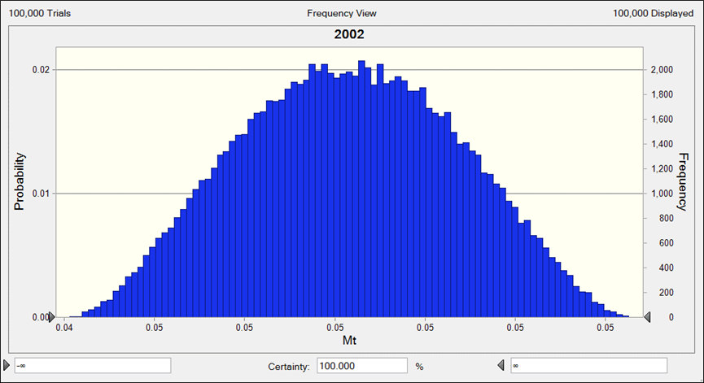
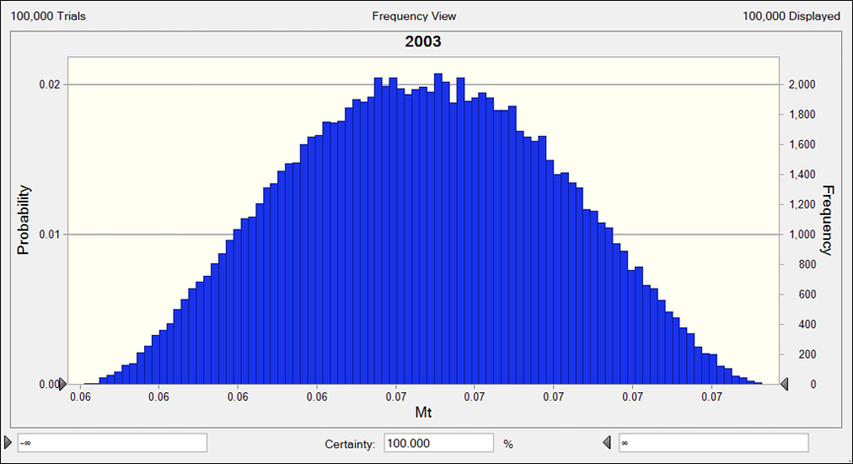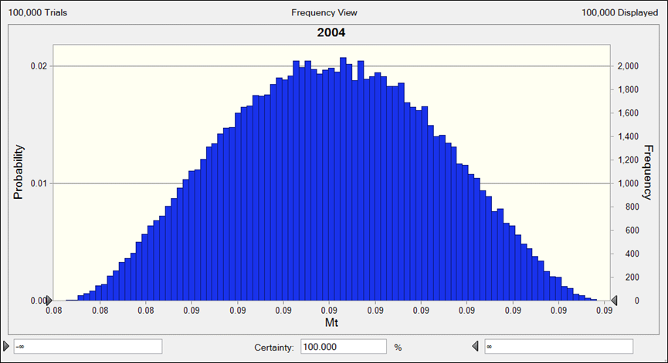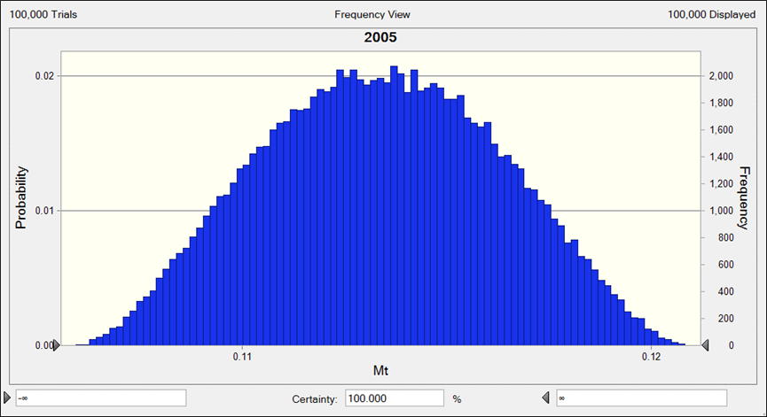
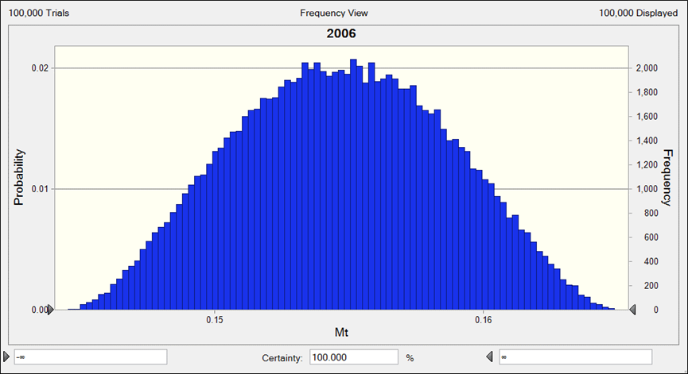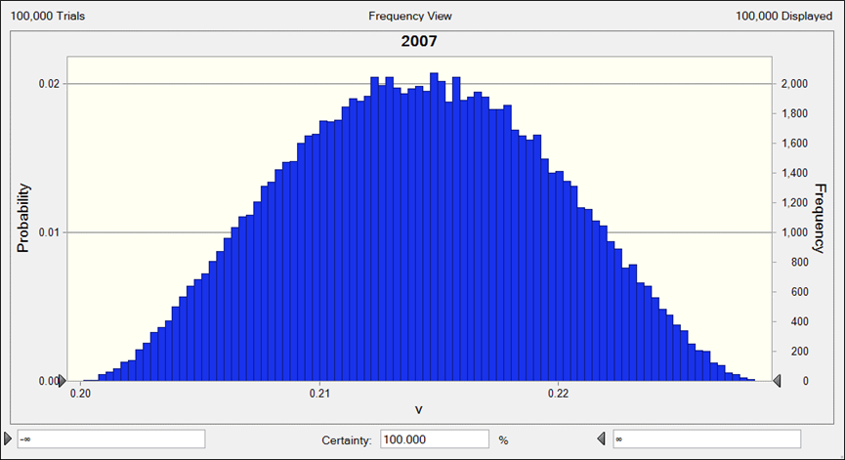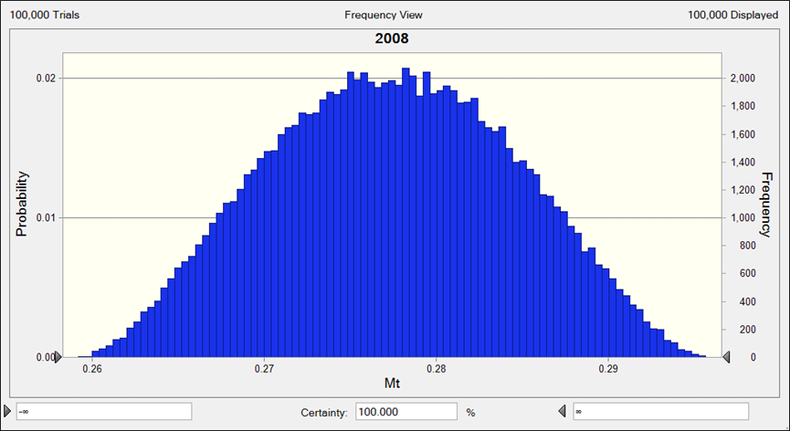
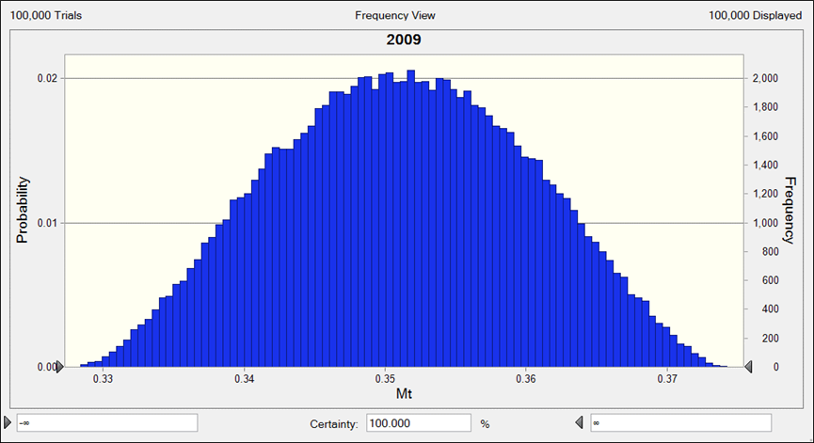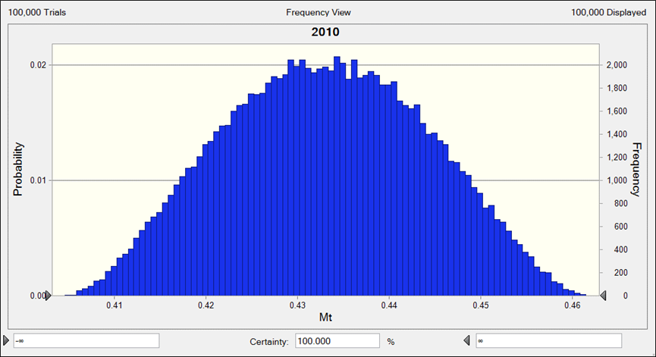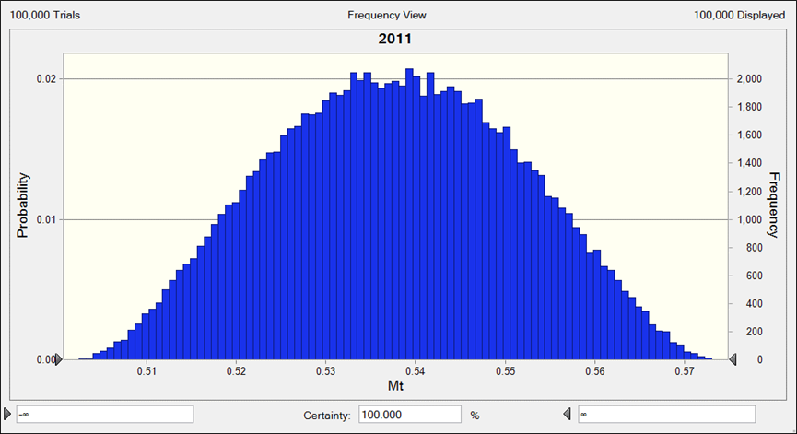

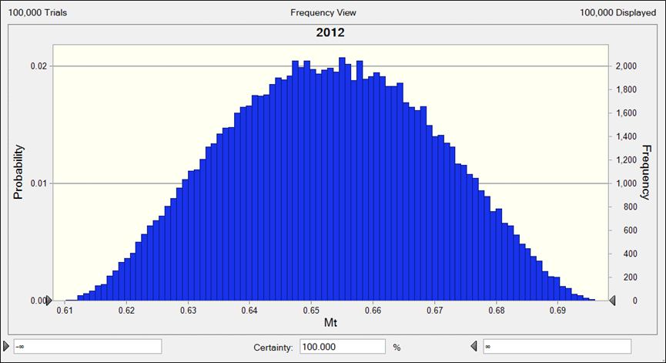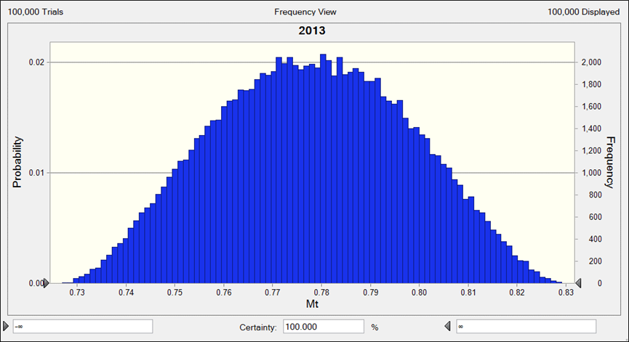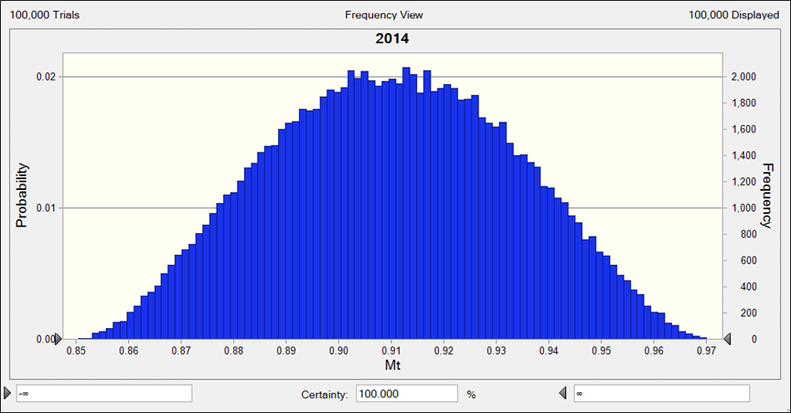
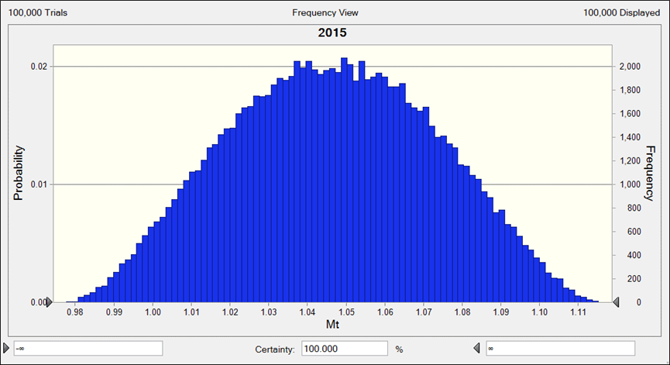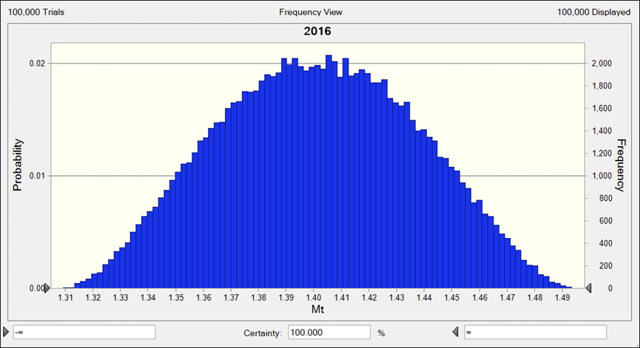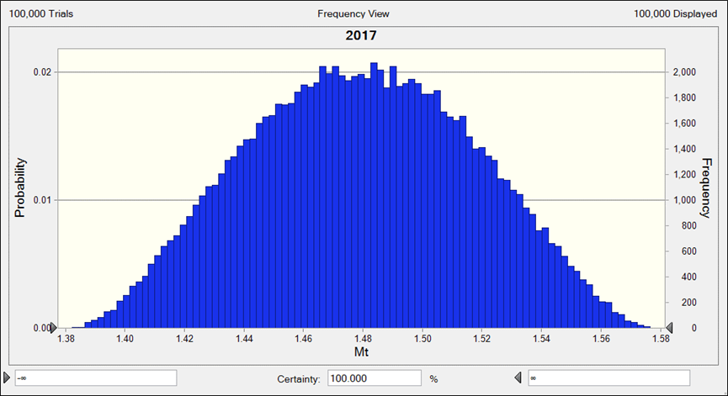
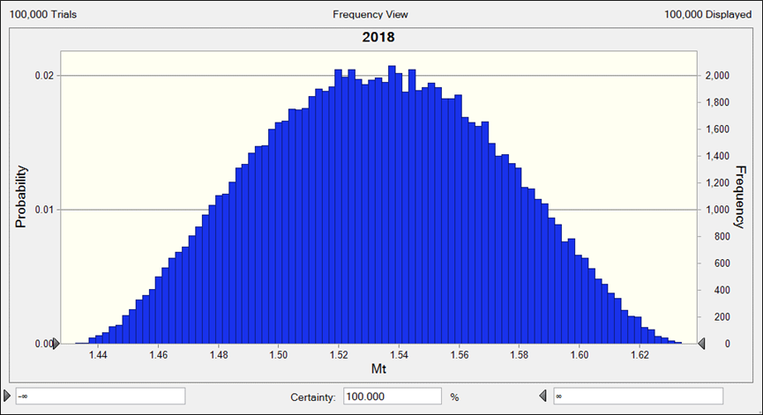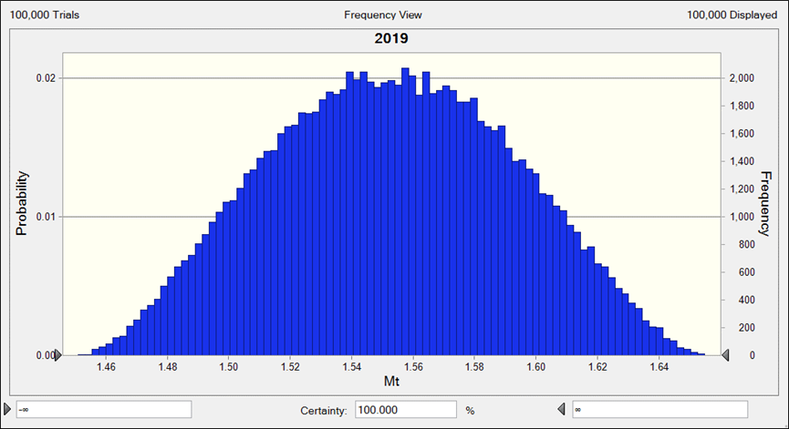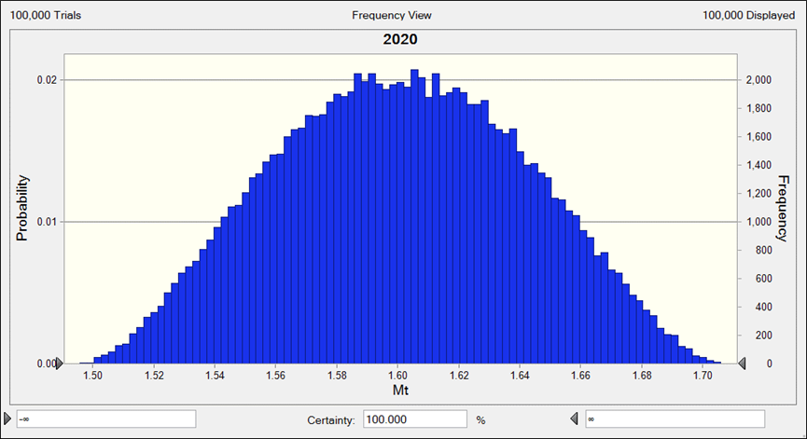
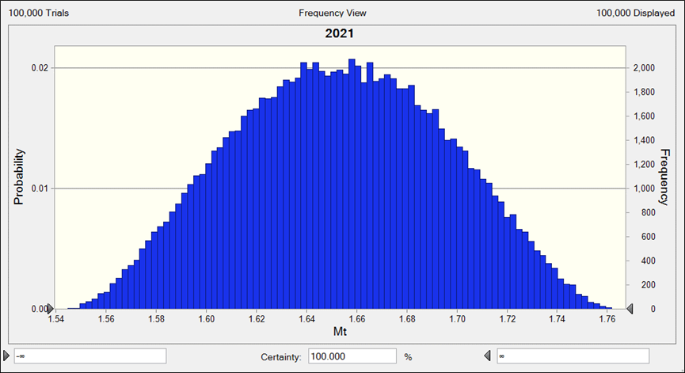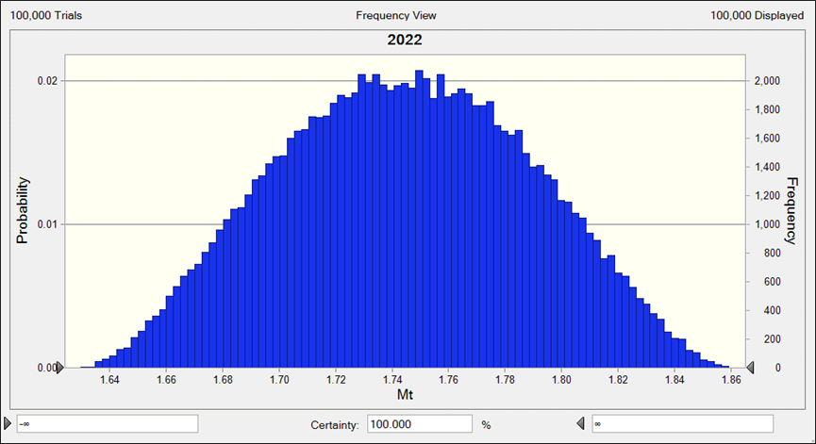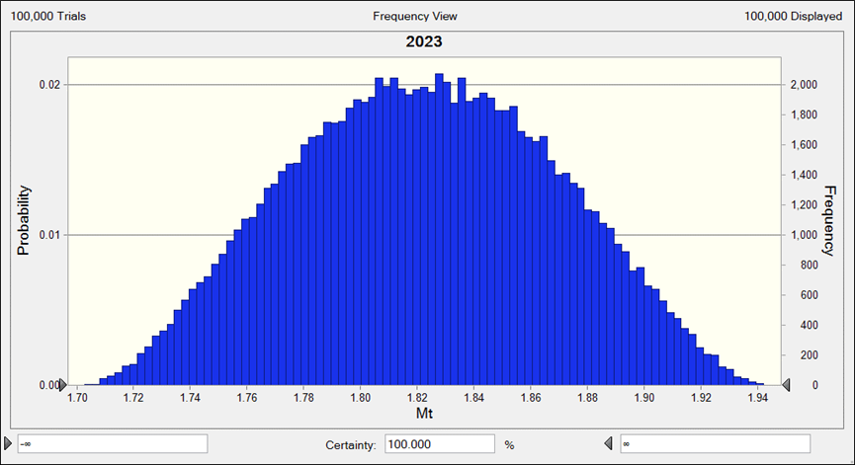
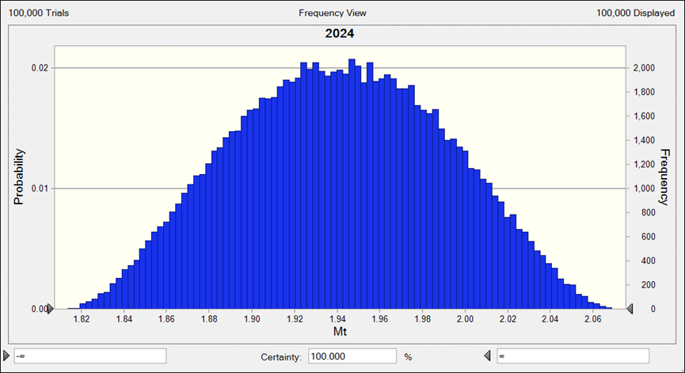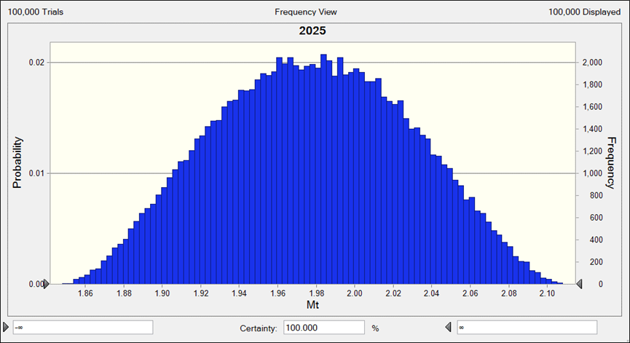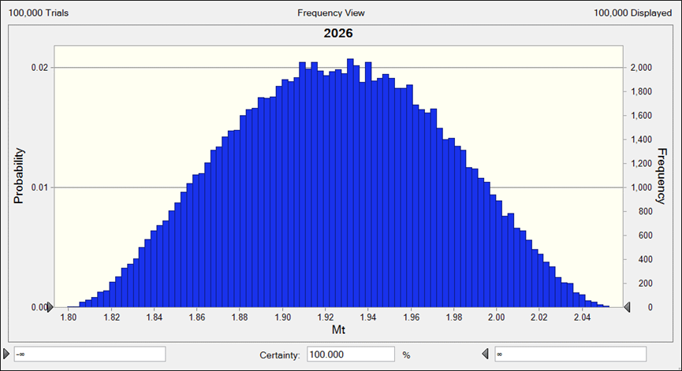
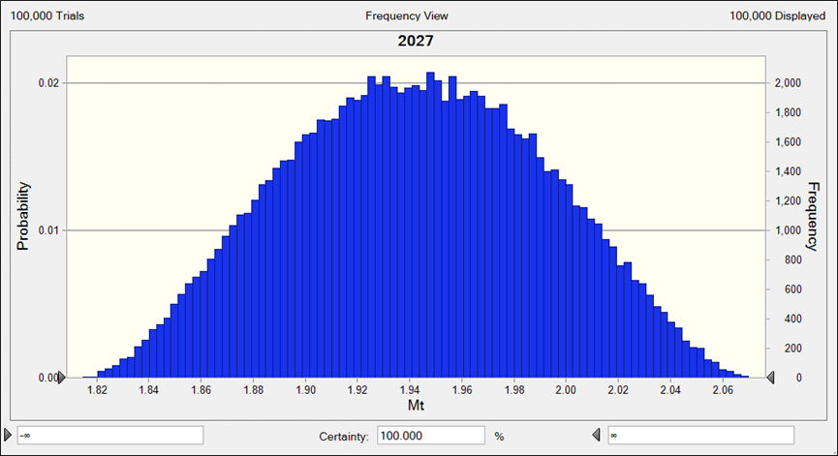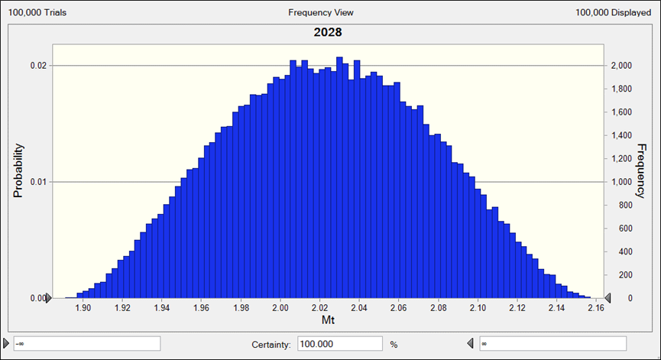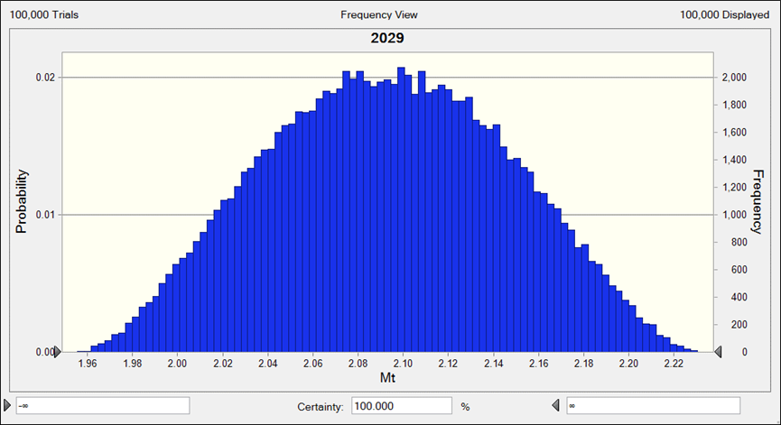
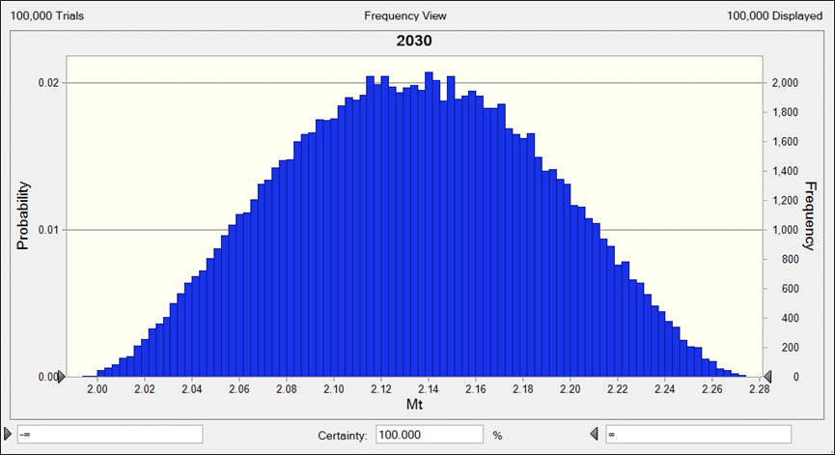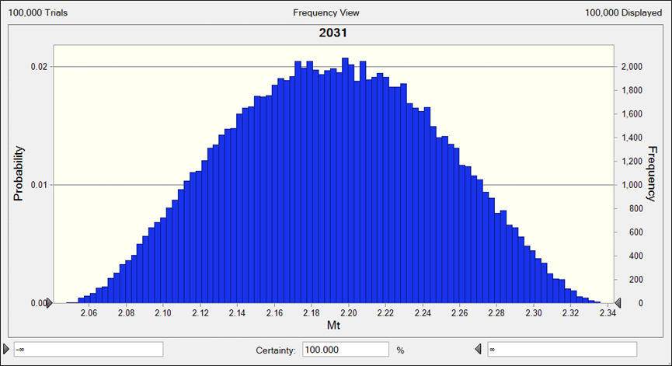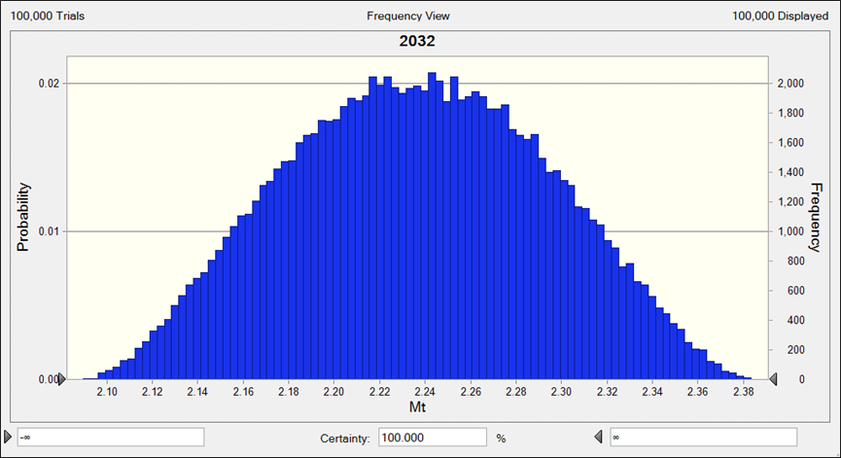
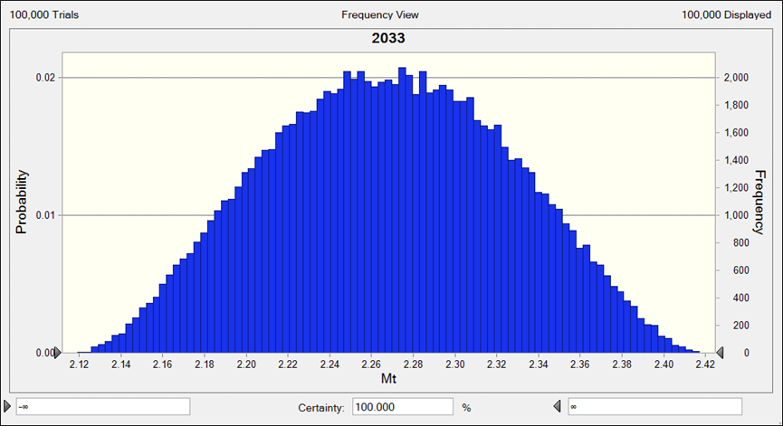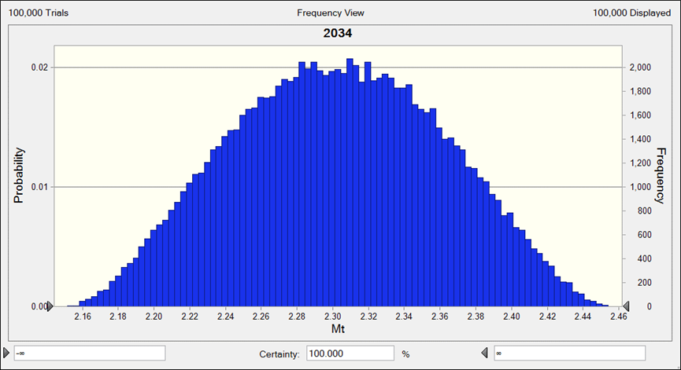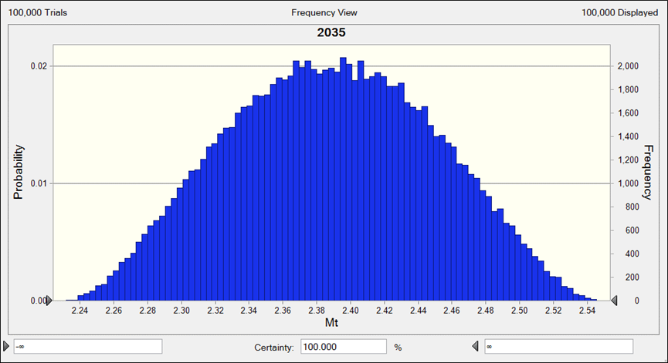
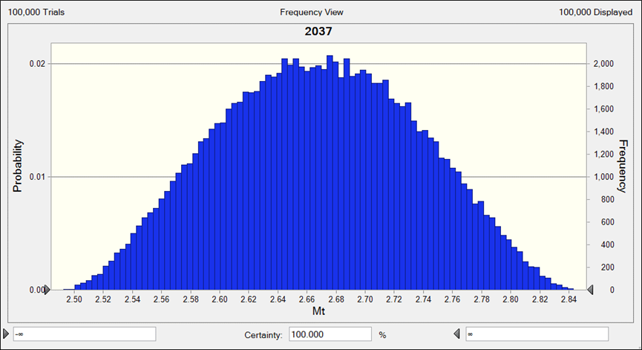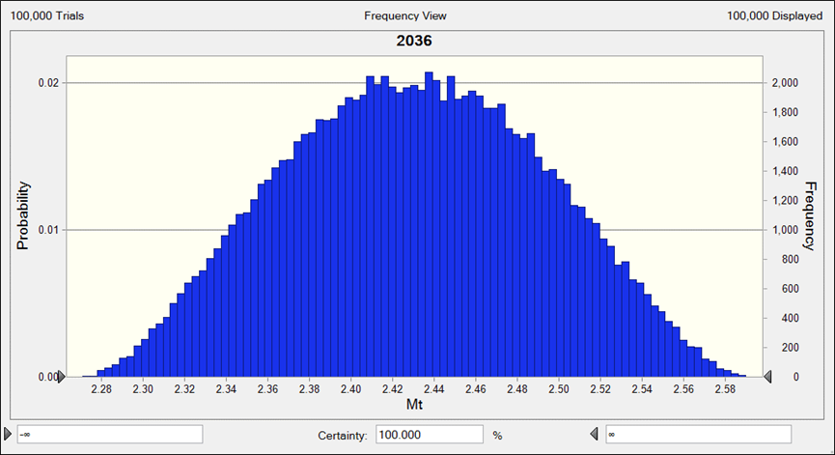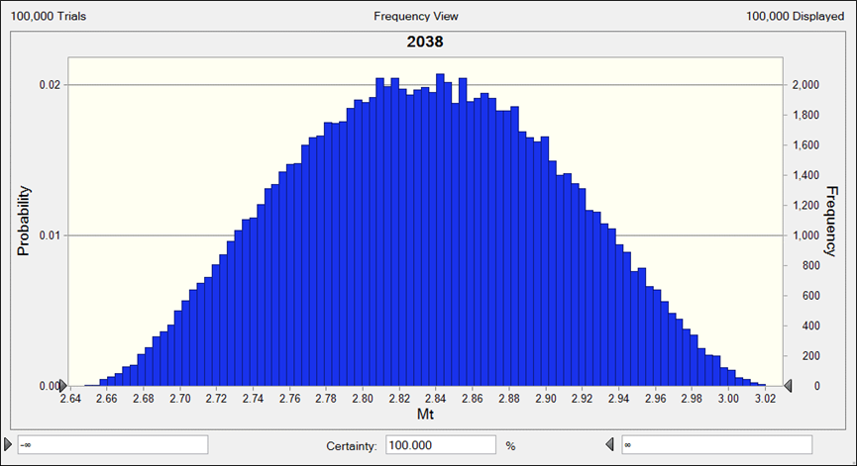
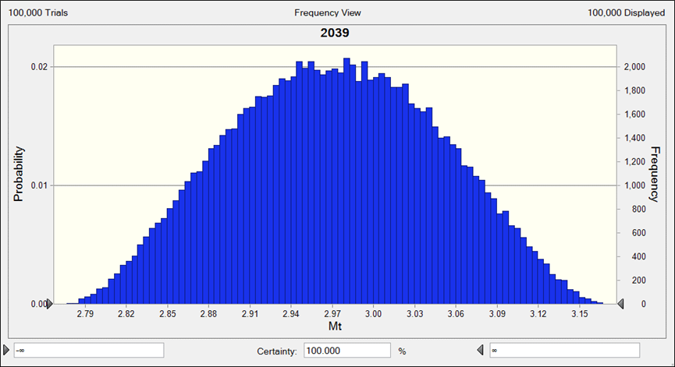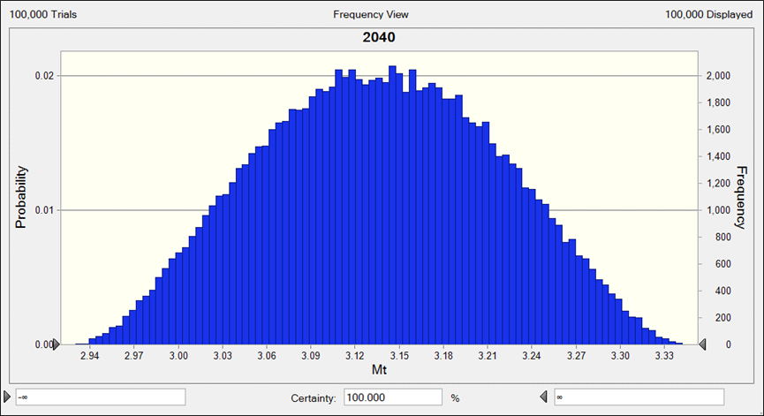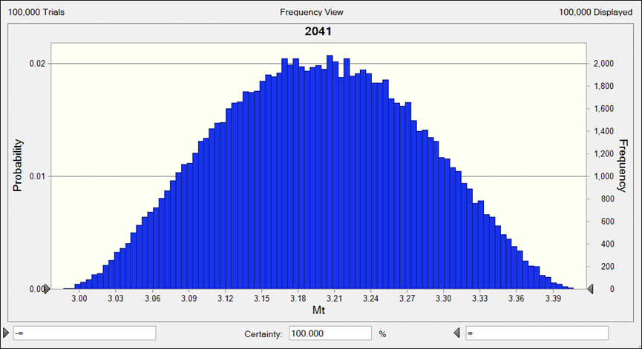
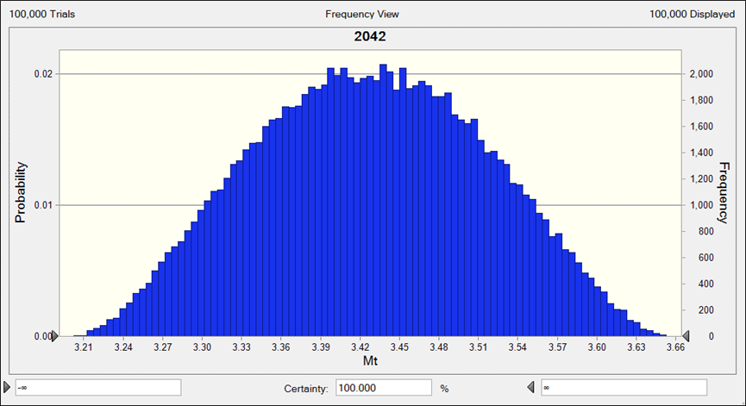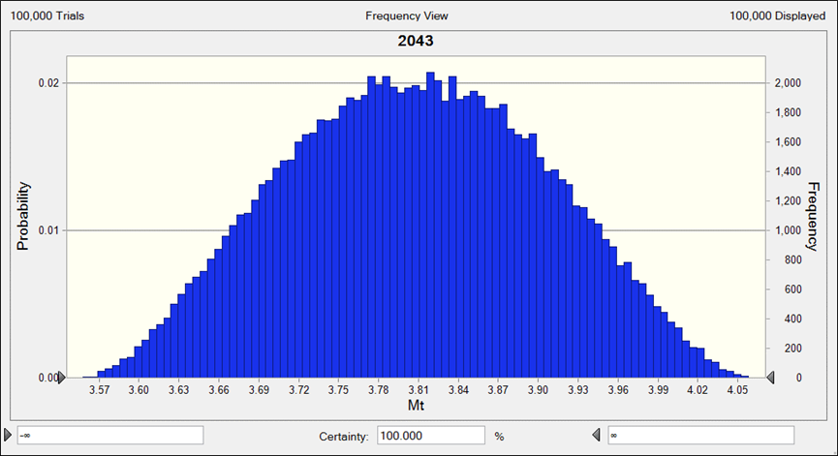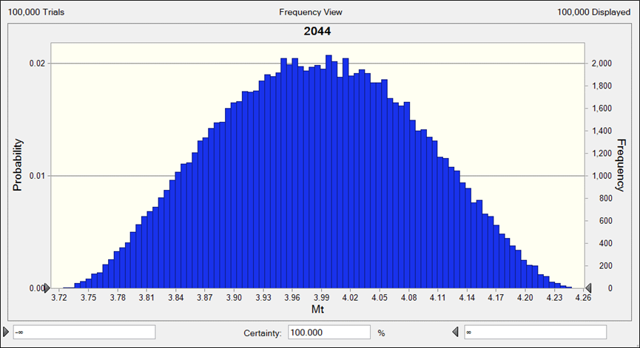
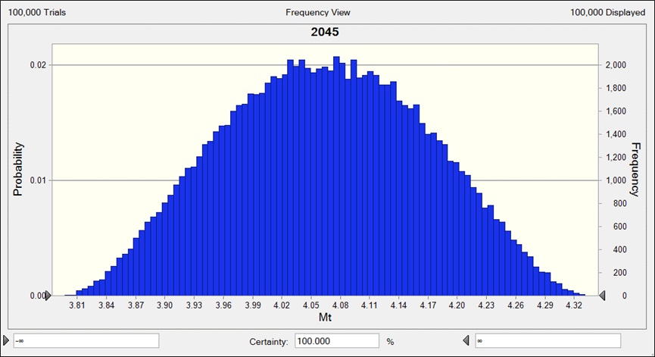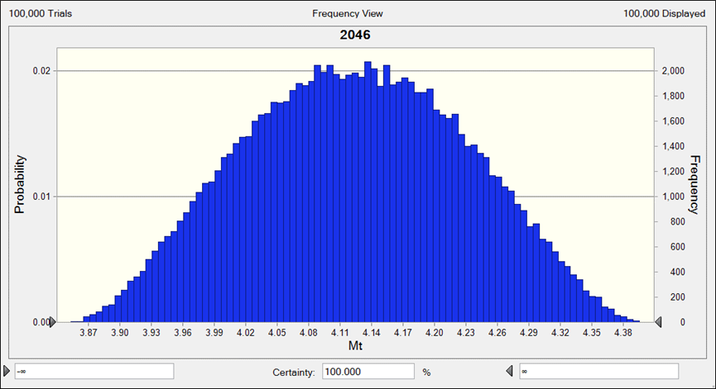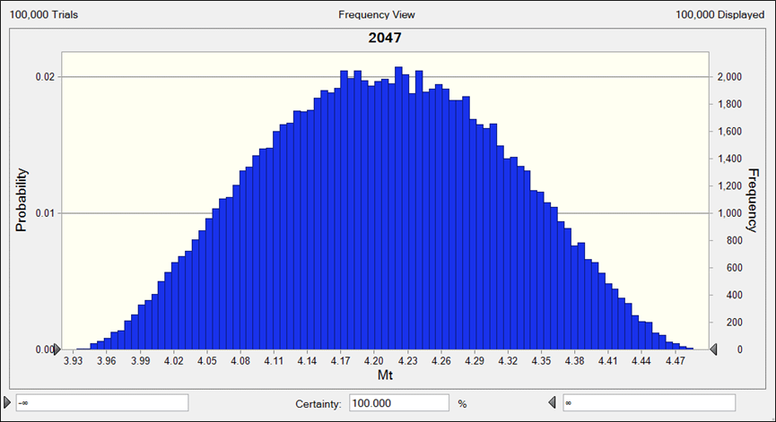
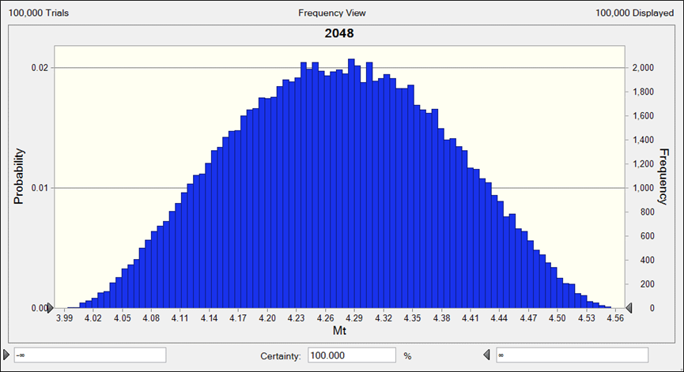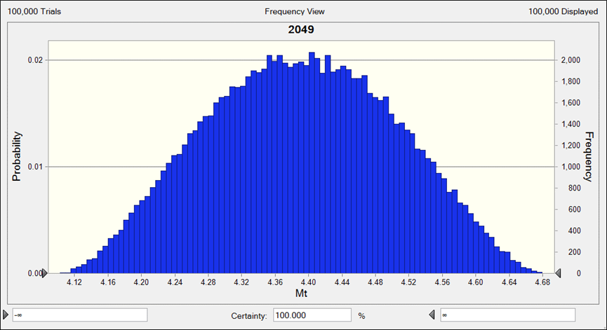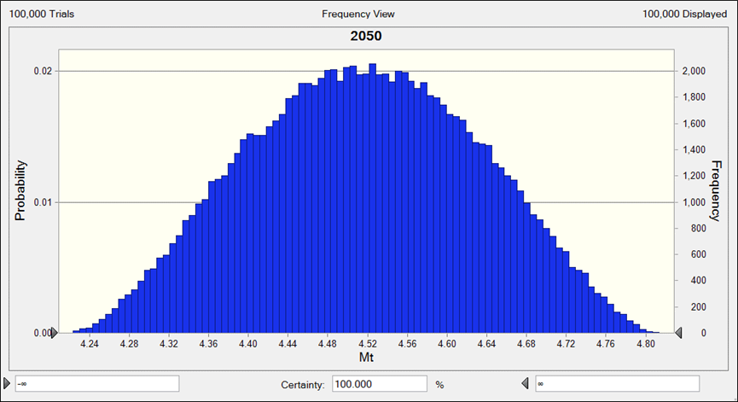

(F)RW
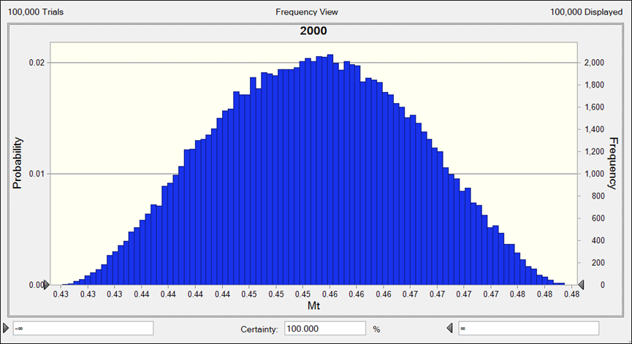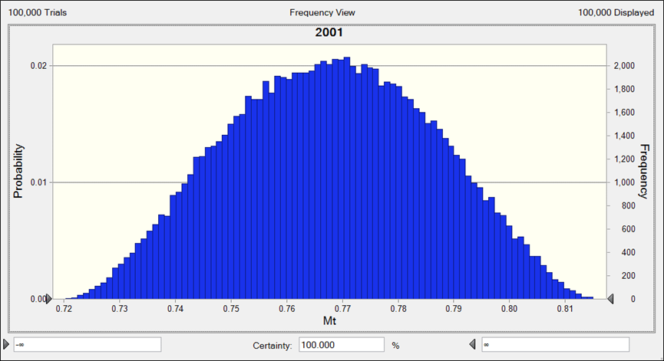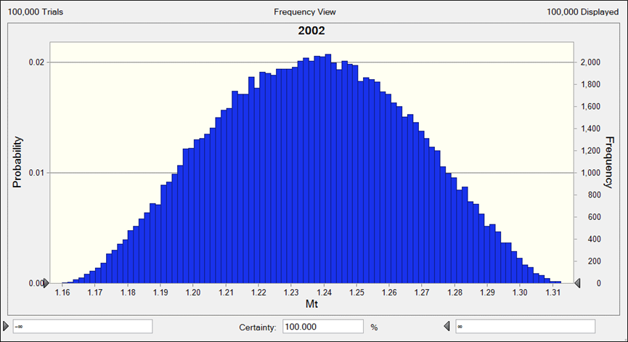
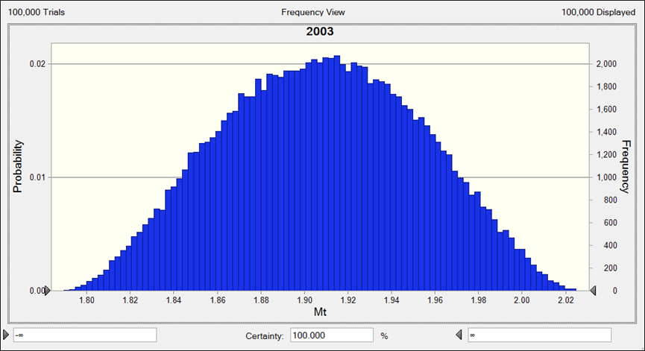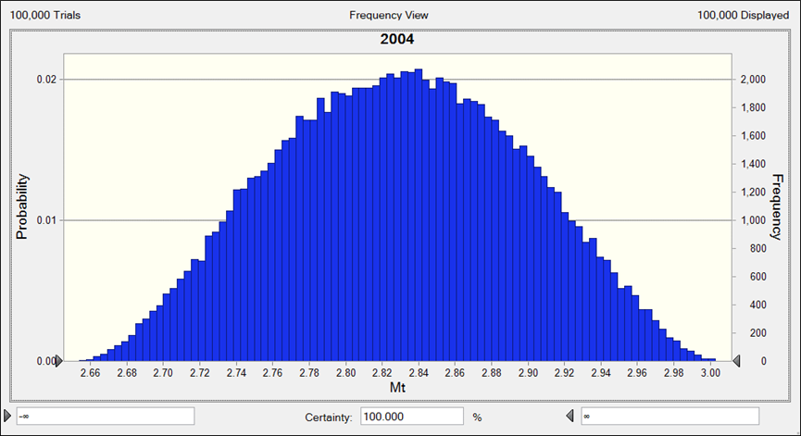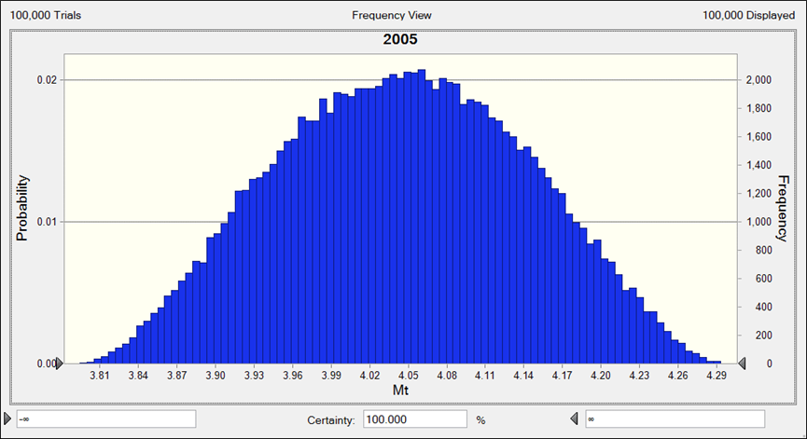
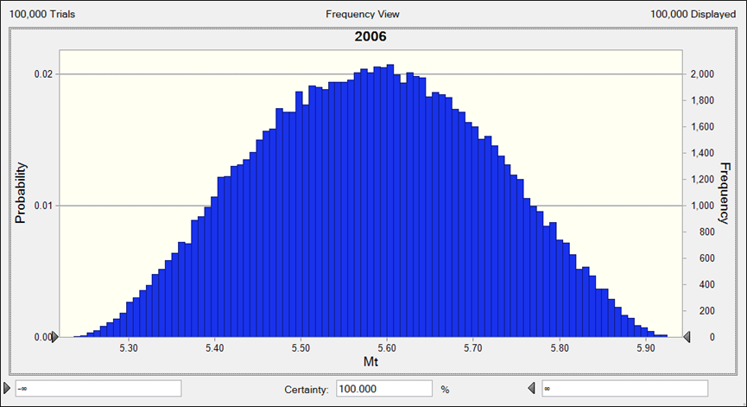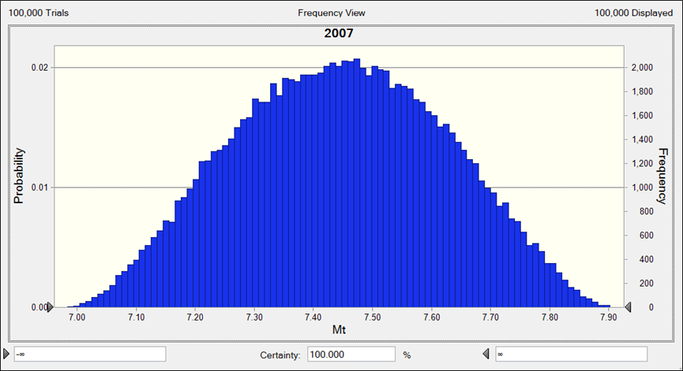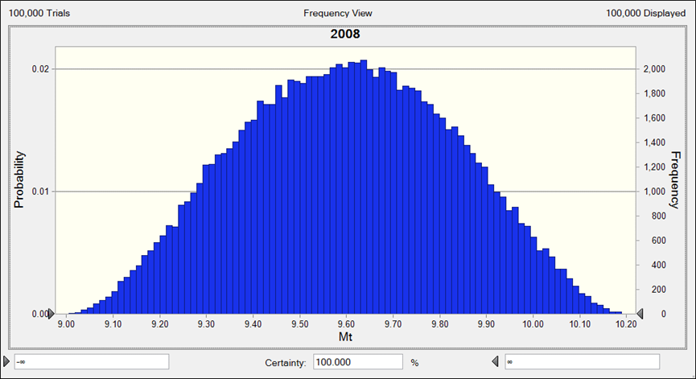
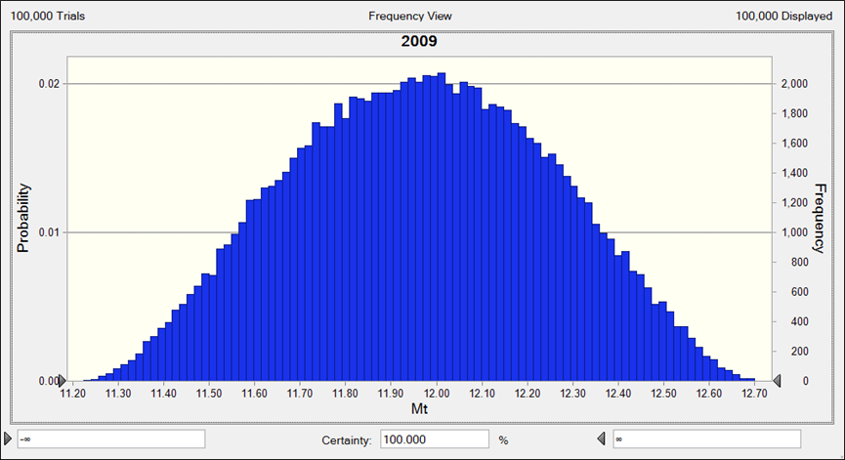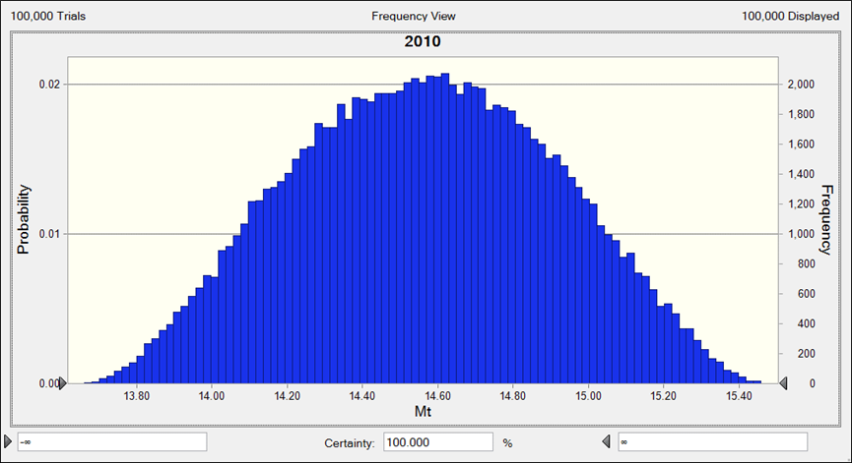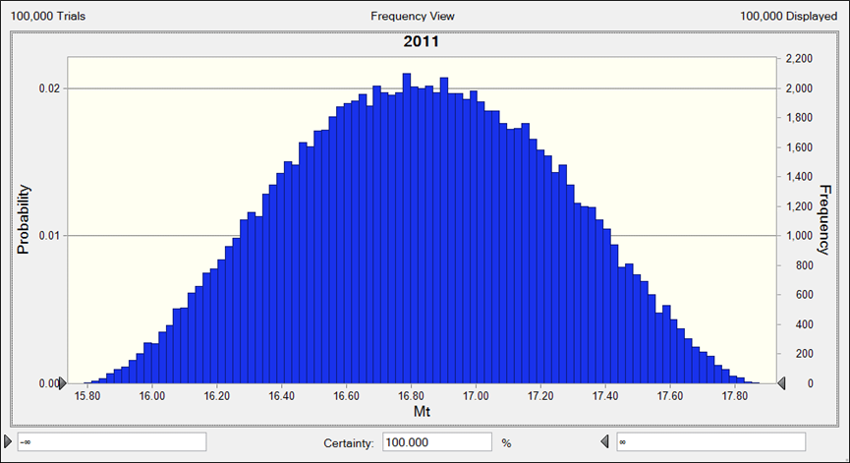
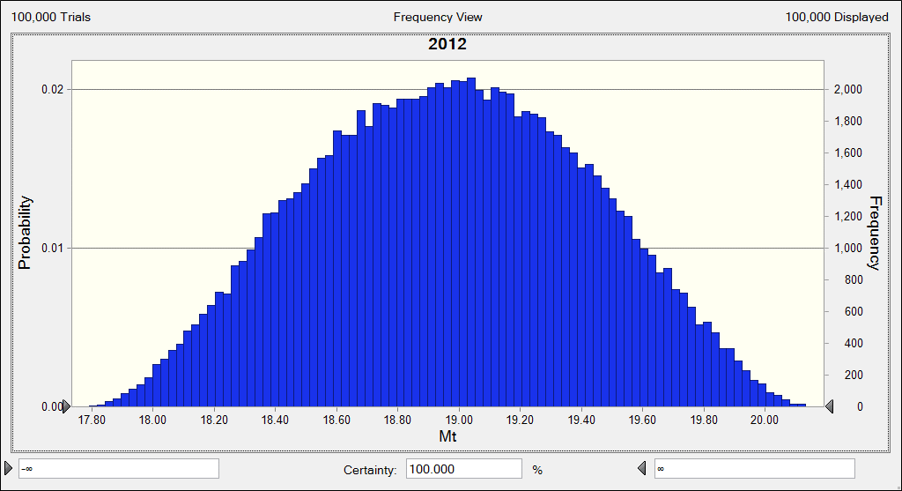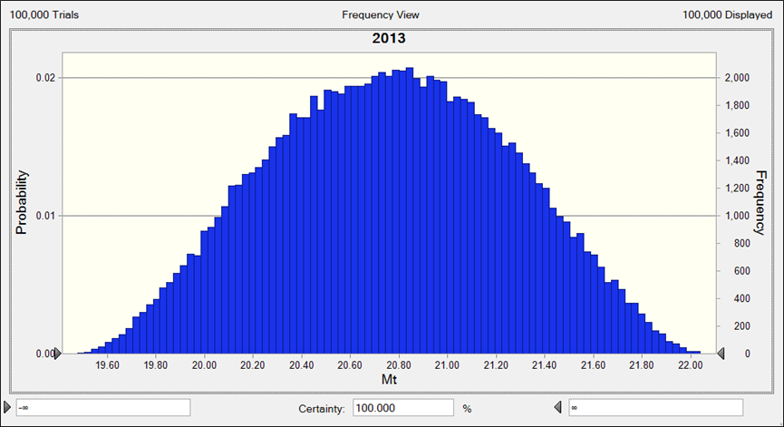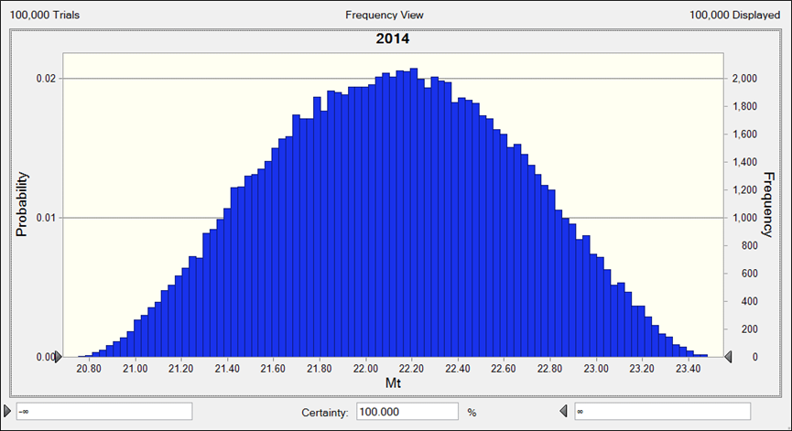
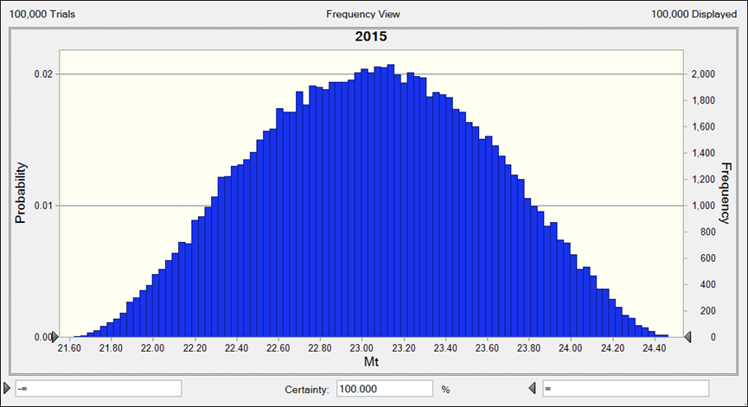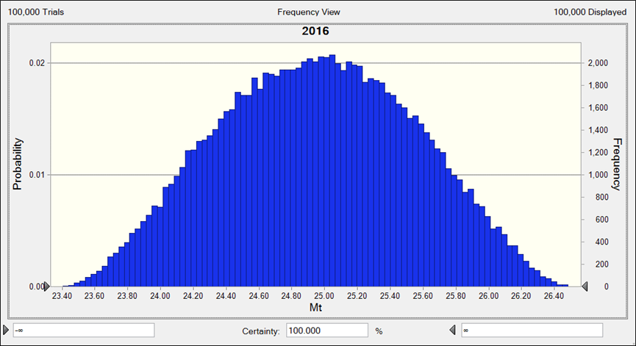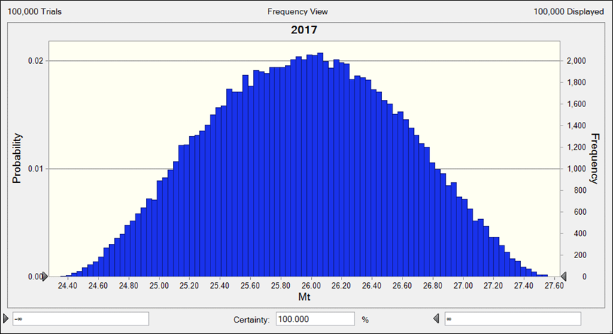
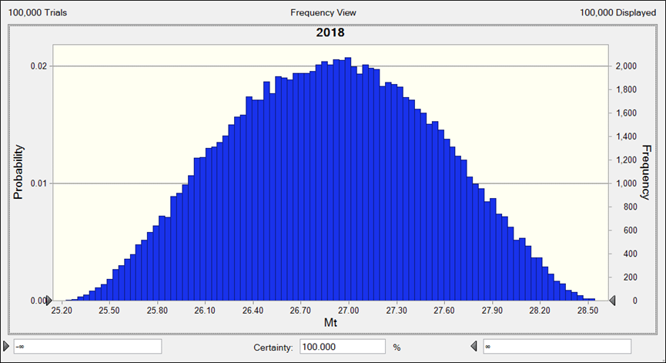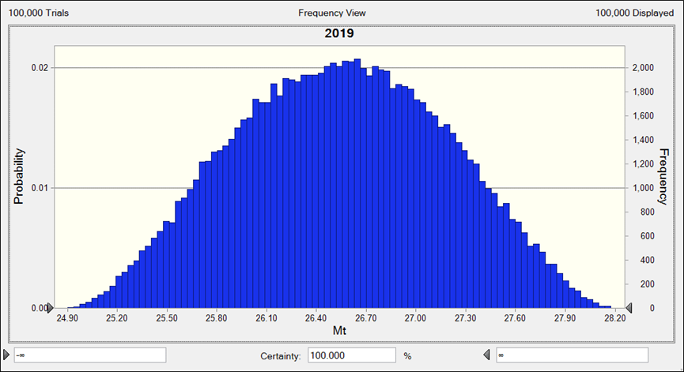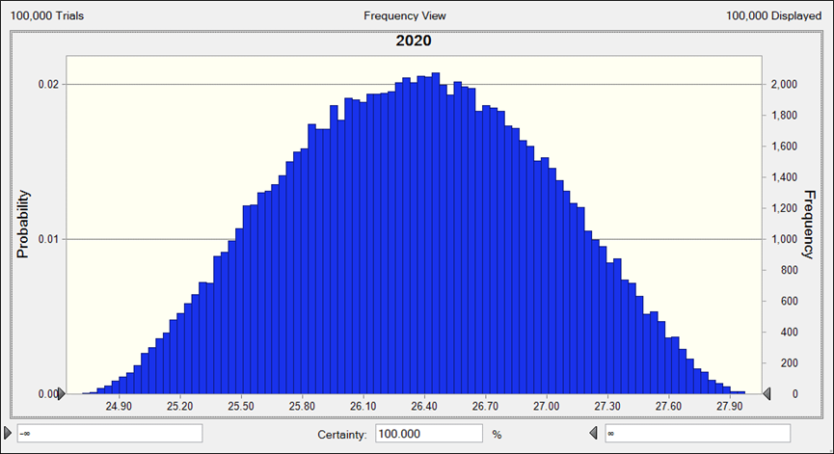
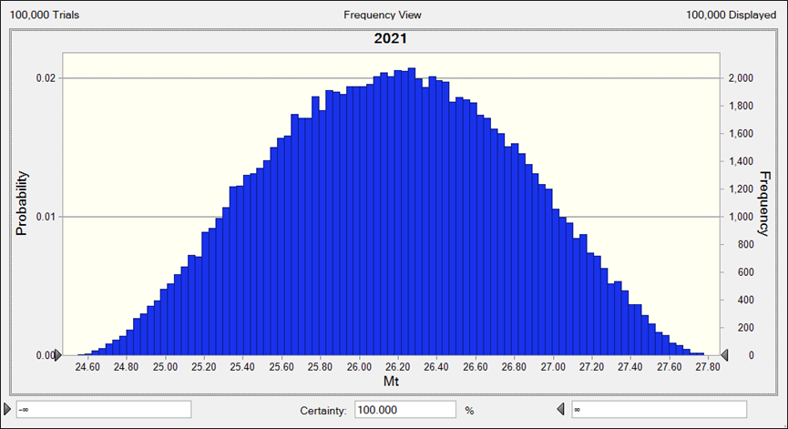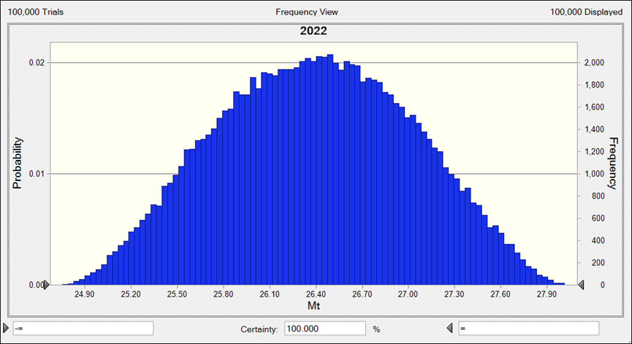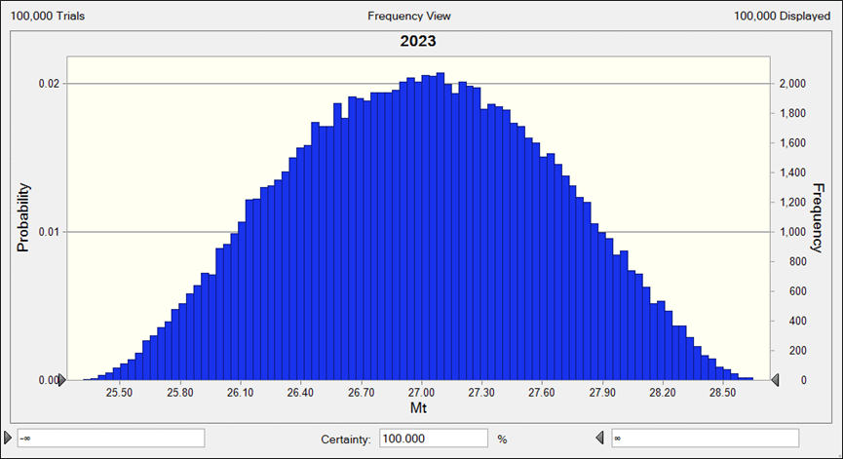
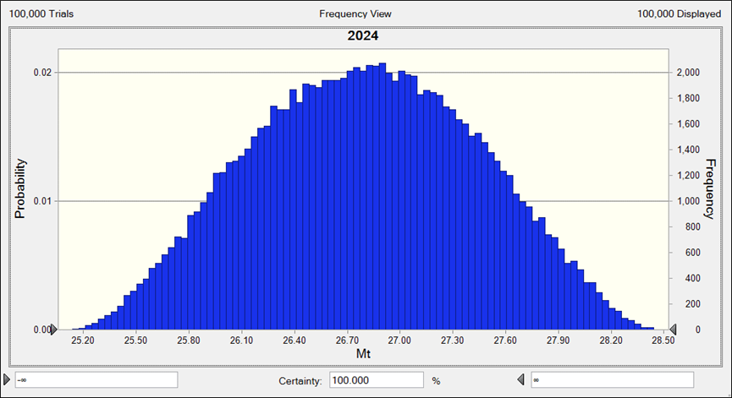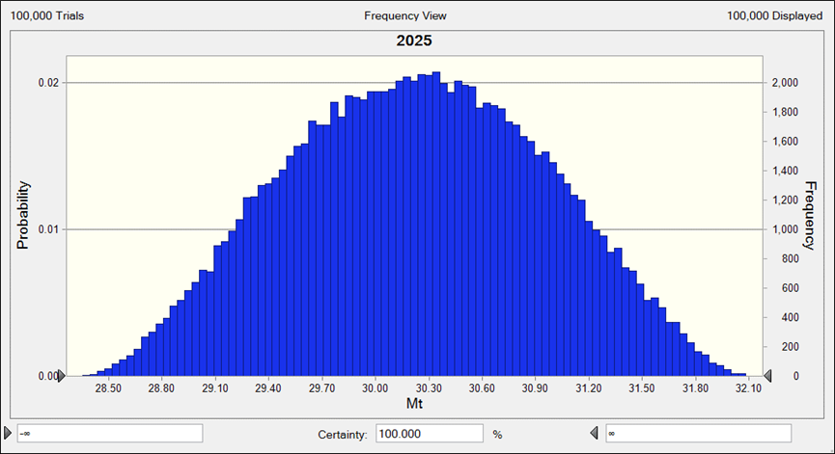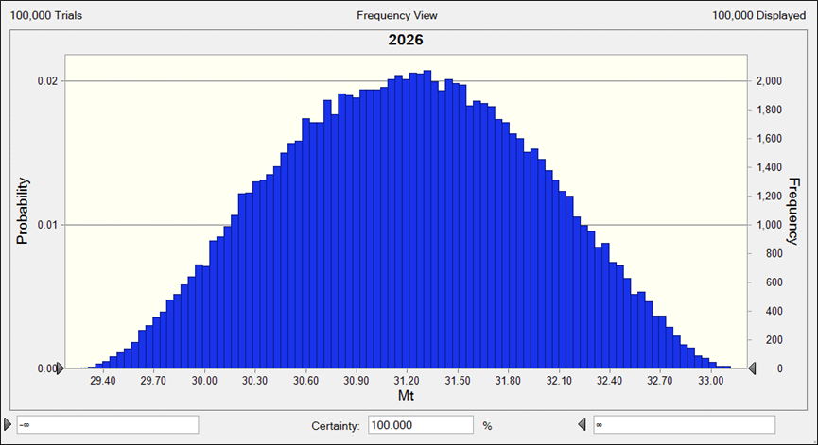
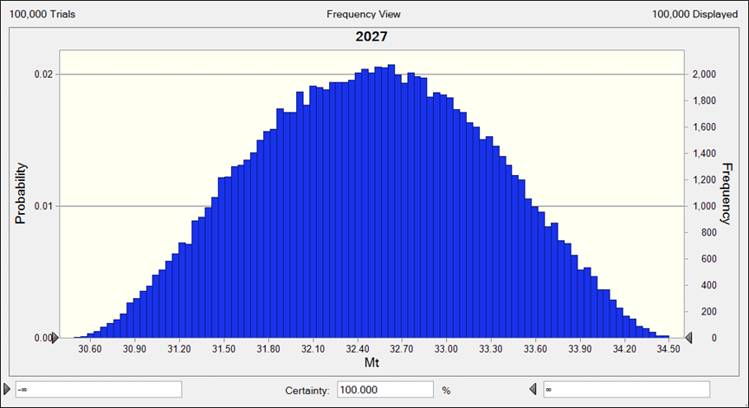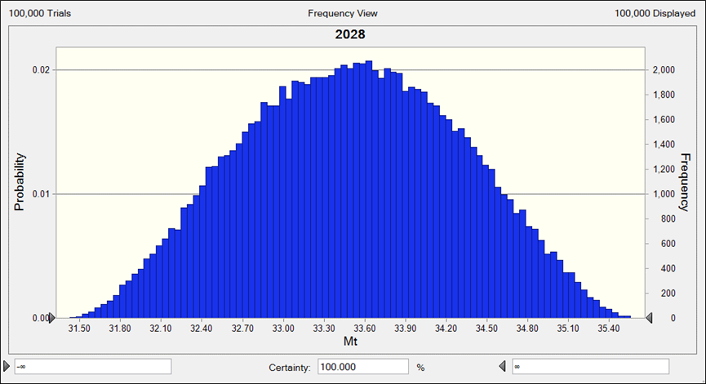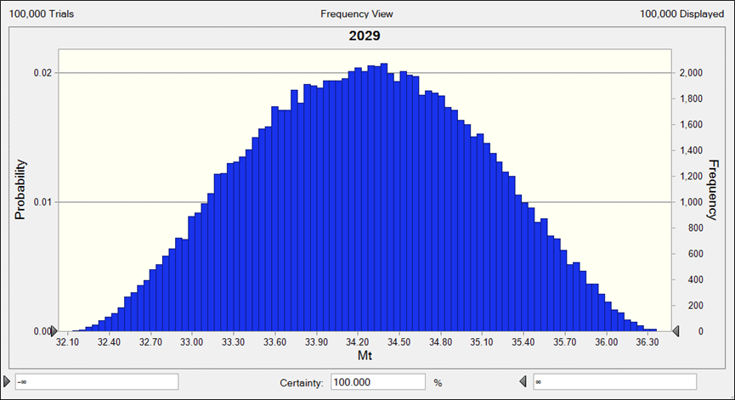
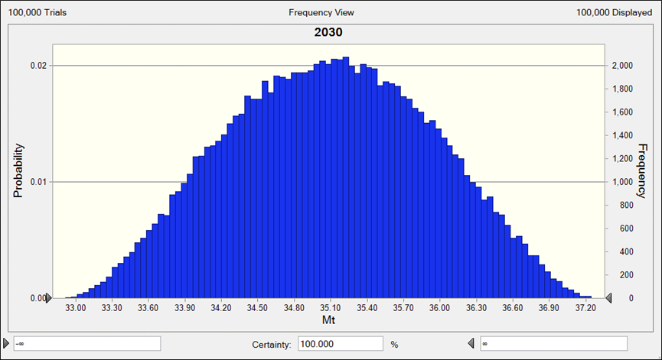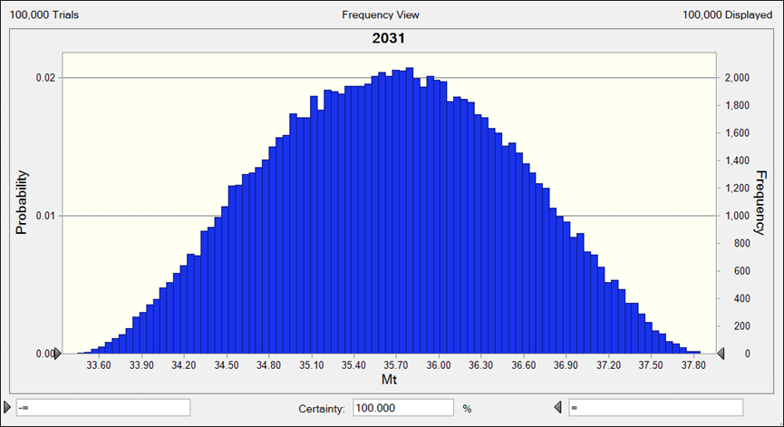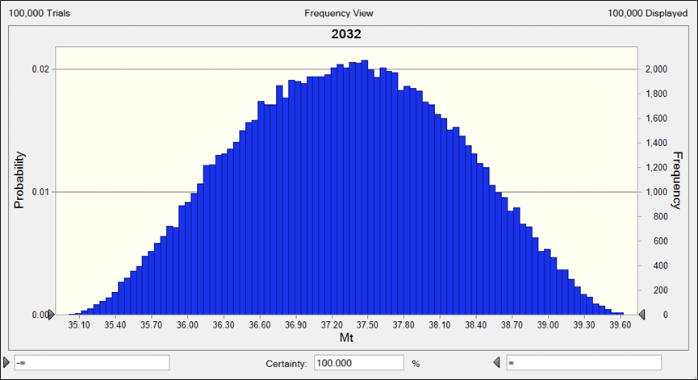
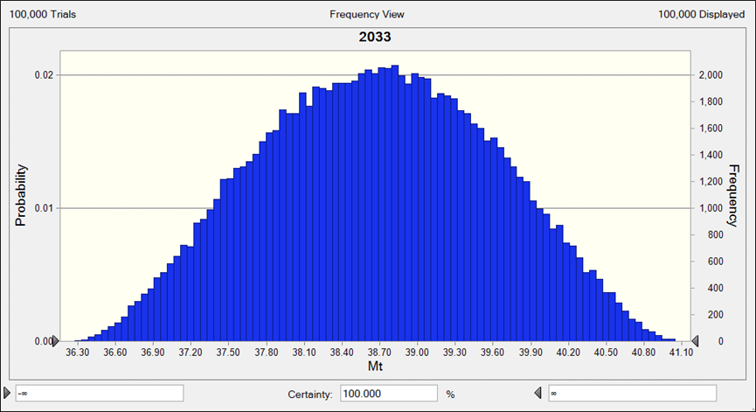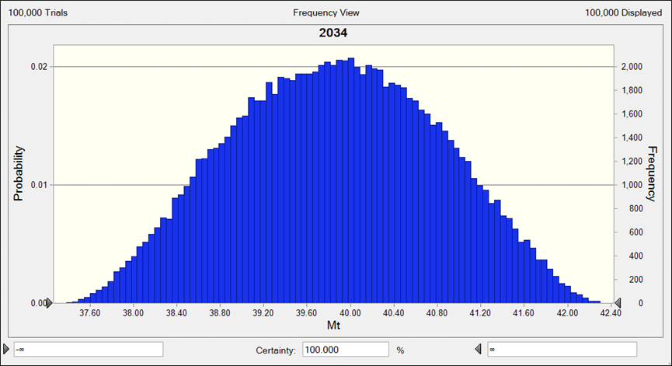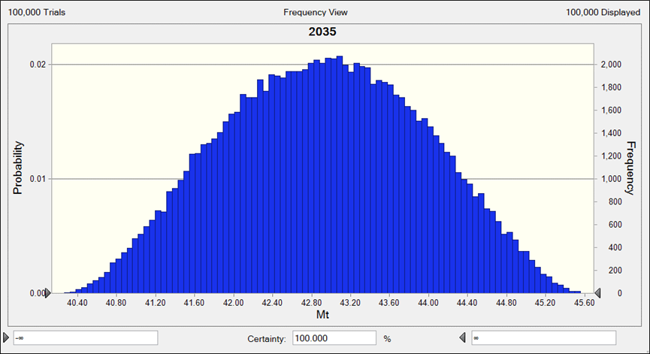
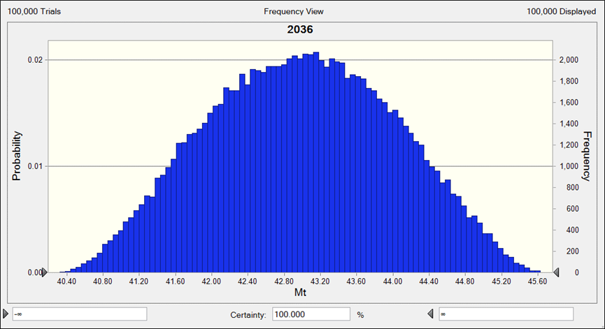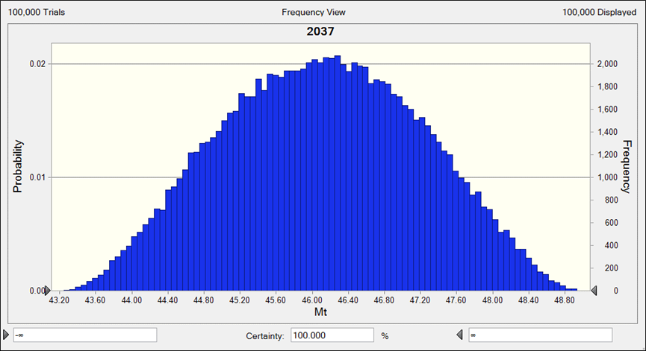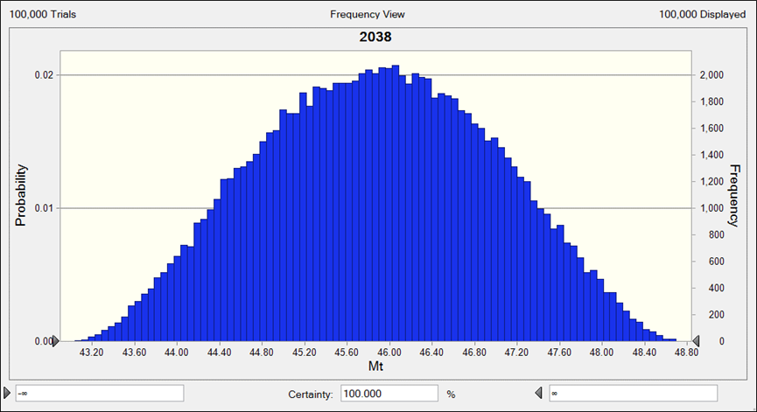
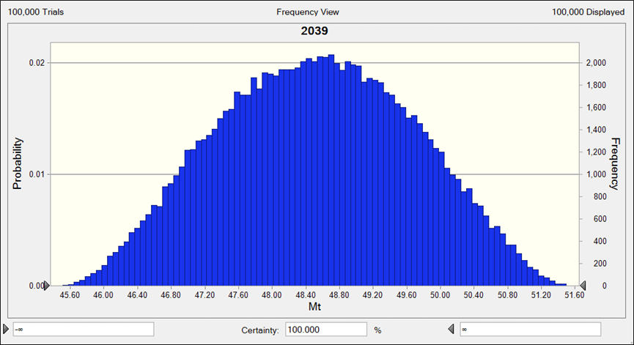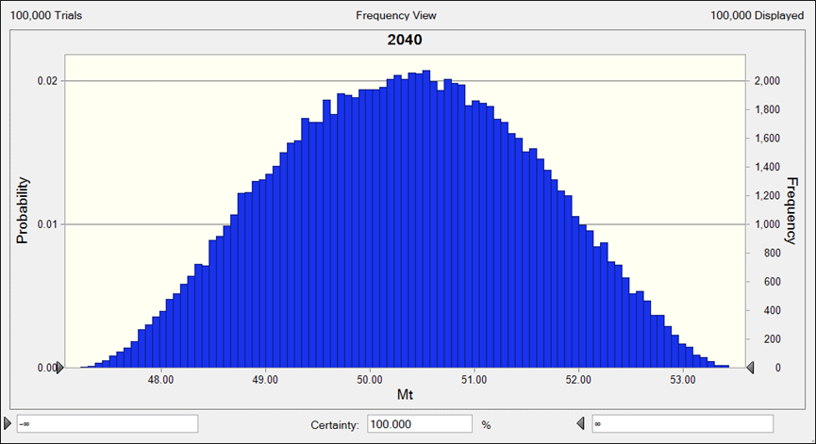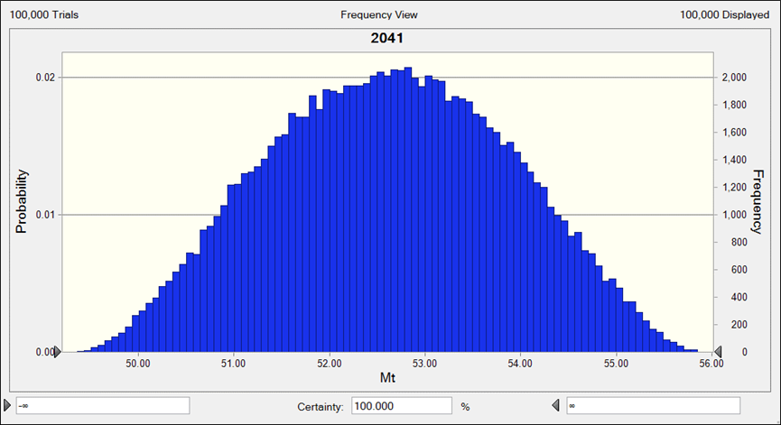
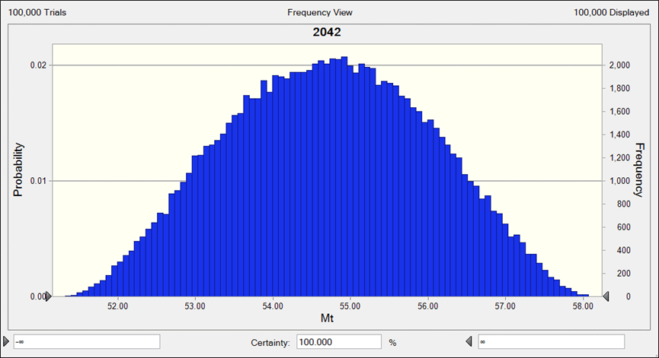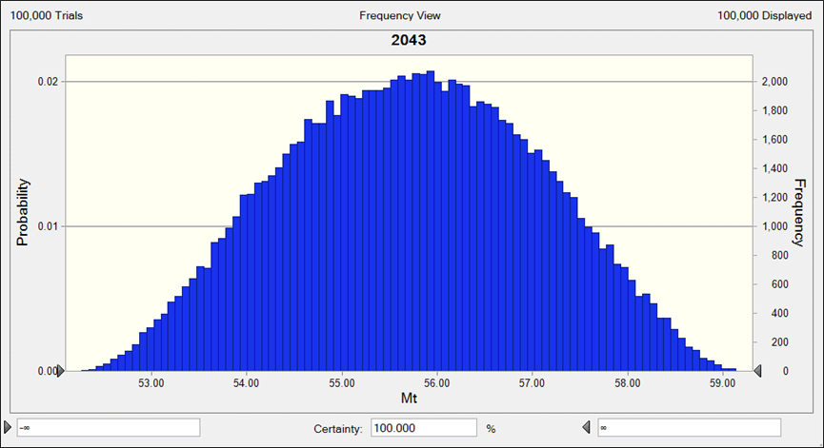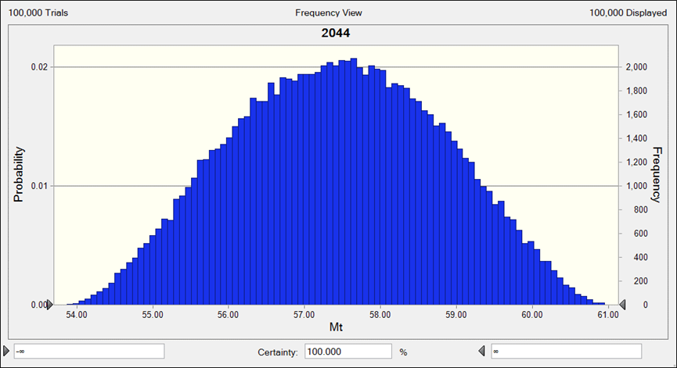
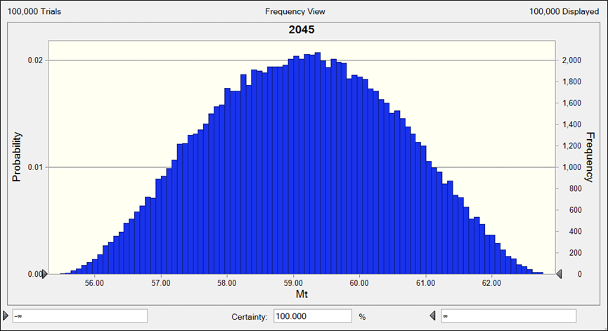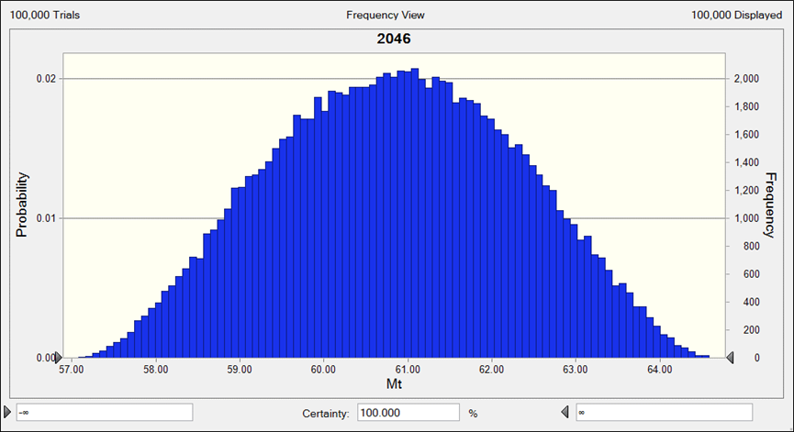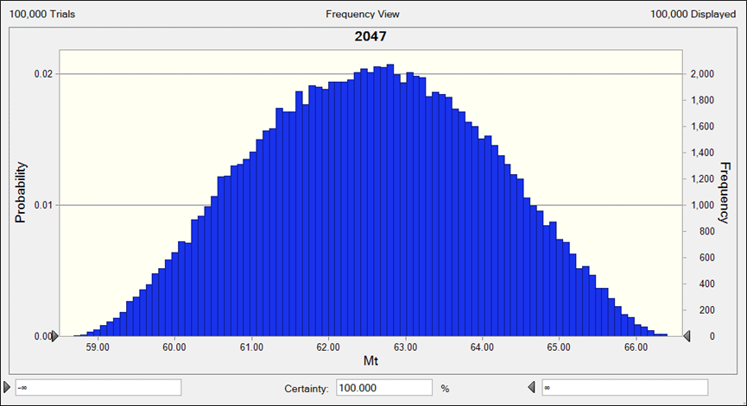
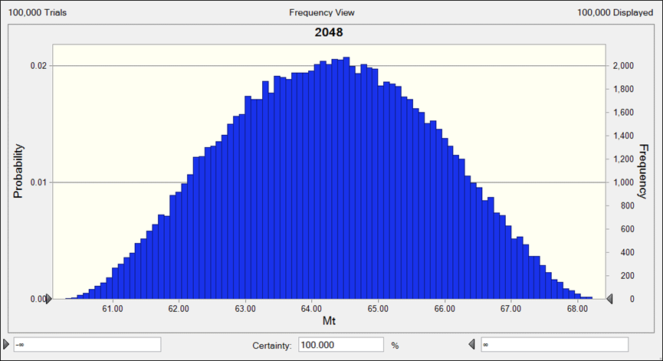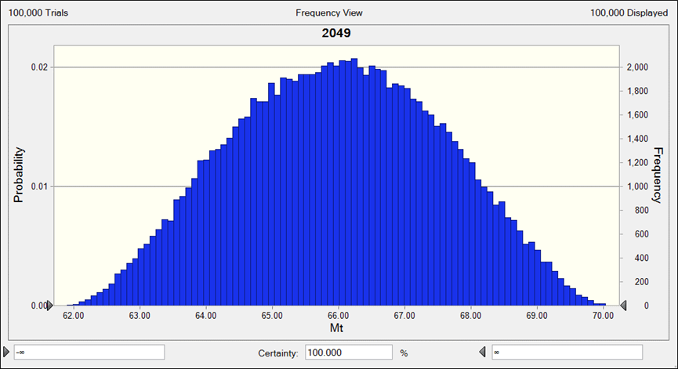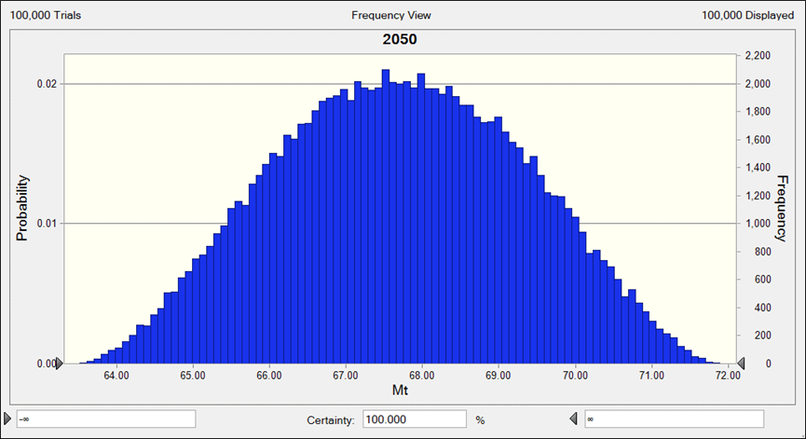
Supplementary Fig. 4 Monte Carlo Simulation for LMA, GAA, HST, RL, RPC and RW

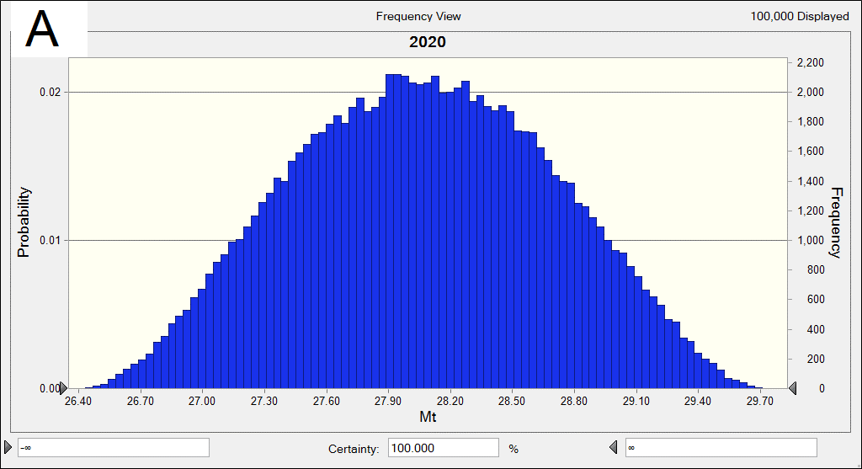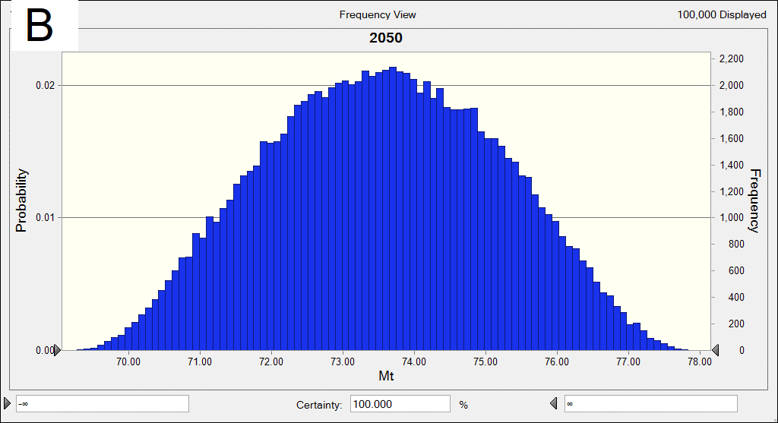
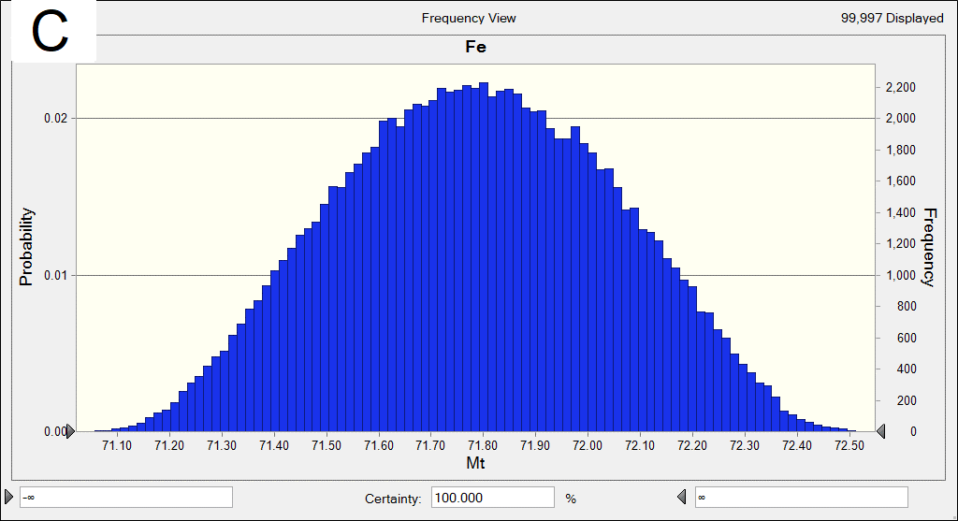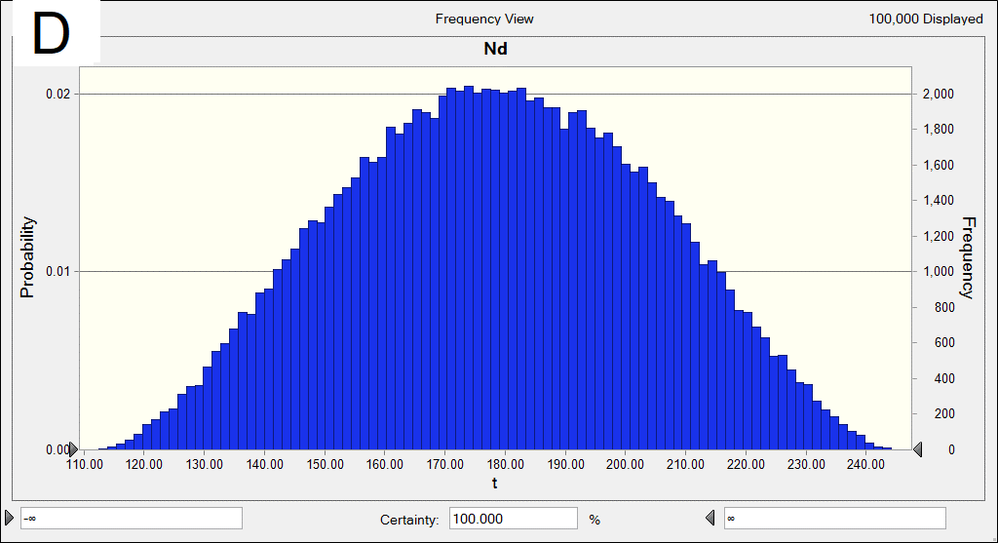
Supplementary Fig. 5 Uncertainty analysis with 95% confidence intervals
(A) weight of WHEE in 2020 affected by each HEE weight;(B) weight of WHEE in 2050 affected by each HEE weight; (C) production weight of Fe in 2050 affected by each HEE weight and material compositions; (D) production weight of Nd in 2050 affected by each HEE weight and material compositions.
Supplementary Note: The abbreviations and acronyms of main vocabulary
ELV end-of-life vehicle
GAA general aviation aircraft
HEE high-end equipment
HST high speed train
LMA Large and medium aircraft
MFA Material flow analysis
RL Railway locomotive
RPC railway passenger car
RW railway wagon
WEEE waste electrical and electronic equipment
WHEE waste high-end equipment
WWC waste wiring & cable

Supplementary References
1. Li B, Yang J, Lu B, Song X. Estimation of retired mobile phones generation in China: A comparative study on methodology. Waste Manage 35, 247-254 (2015).
2. Weight of high-end equipment .https://www.docin.com/p-2345769054.html (accessed May 4, 2021),.
3. Woidasky J, Klinke C, Jeanvré S. Materials Stock of the Civilian Aircraft Fleet. Recycling 2, 21 (2017).
4. Zeng X, Ali SH, Li J. Estimation of waste outflows for multiple product types in China from 2010-2050. Sci Data 8, 15 (2021).
5. Mairizal AQ, Sembada AY, Tse KM, Rhamdhani MA. Electronic waste generation, economic values, distribution map, and possible recycling system in Indonesia. J Cleaner Prod 293, 126096 (2021).
6. Islam MT, Huda N. Assessing the recycling potential of “unregulated” e-waste in Australia. Resour Conserv Recy 152, 104526 (2020).
7. Parajuly K, Habib K, Liu G. Waste electrical and electronic equipment (WEEE) in Denmark: Flows, quantities and management. Resour Conserv Recy 123, 85-92 (2017).
8. Sprecher B, et al. Life cycle inventory of the production of rare earths and the subsequent production of NdFeB rare earth permanent magnets. Environ Sci Technol 48, 3951-3958 (2014).
9. Asmatulu E, Twomey J, Overcash M. Evaluation of recycling efforts of aircraft companies in Wichita. Resour Conserv Recy 80, 36-45 (2013).
10. Sue G, John, D., Jeannie, G. Report on the Environmental Benefits of Recycling.) (2016).
11. Zhang A. Rare earth has broad application space in rail transit. Rare Earth Inform, 34-37 (in Chinese) (2019).
12. Panchal R, Singh A, Diwan H. Economic potential of recycling e-waste in India and its impact on import of materials. Resour Policy 74, 102264 (2021).
13. Price of aluminum. https://www.mining.com/markets/commodity/aluminum/ (accessed November 19, 2021),.
14. Price of neodymium. https://www.ac-rei.org.cn/module/d611b22f-9ba5-4e84-915d-2d6763f46e26 (accessed November 19, 2021),.).
15. Zeng X, Gong R, Chen WQ, Li J. Uncovering the Recycling Potential of "New" WEEE in China. Environ Sci Technol 50, 1347-1358 (2016).

