Systematic Pan-Cancer Analysis Identifies REST as an Oncogenic and Immunological Biomarker in Brain Low Grade Glioma

Authors: Guan Wang ª, Meng Li ª, Meng Dong ª, Rui Xu ª, and Chen Zhang ^{a*}
Institutional affiliations:
ª Department of Pediatrics, Qilu Hospital of Shandong University, No.107 West Wenhua Road, Jinan, 250012, Shandong Province, China

*Correspondence Author:
Chen Zhang, Department of Pediatrics, Qilu Hospital of Shandong University, No.107 West Wenhua Road, Jinan, 250012, Shandong Province, China
Email: zczc_8888@163. com

Supplementary material
Figure 1 The prognostic value of predicted miRNAs in LGG assessed by Kaplan-Meier plotter.
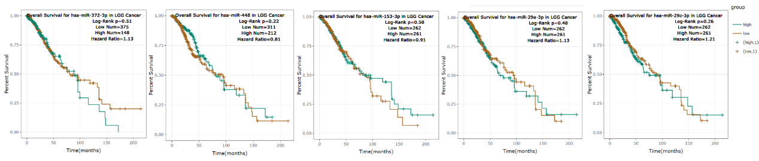
Table 1 Tumor abbreviations.
