‘Tropicalization’ of megafauna community in a South Atlantic warming hot spot: evidences from demersal fisheries off Brazil

Supplementary Material

Jose Angel A. Perez^{1,2}, Rodrigo Sant’Ana¹
¹ Escola do Mar. Ciência e Tecnologia –EMCT, Universidade do Vale do Itajaí – UNIVALI, Rua Uruguai, 458, Itajaí, CEP 88302-901, Santa Catarina, Brazil.
² Corresponding author: angel.perez@univali.br

Table 1. Summary of fishing trips of demersal fleets operating in the Brazilian Meridional Margin between 2000 and 2019, as recorded in the fishing harbours of the State of Santa Catarina, southern Brazil. Fishing trips are pooled by years, fishing methods and métiers.
 | Method | Double-rig Trawl |  |  |  | Pair Trawl |  |  | Stern Trawl |  |  |  | Gillnet |  |  | Total
Year | métier | DR_1 | DR_2 | DR_3 |  | PT_1 | PT_2 |  | ST_1 | ST_2 | ST_3 |  | GN_1 | GN_2
2000 |  | 412 | 4 | 129 |  | 103 | 29 |  | 10 | 70 | 1 |  | 20 | 7 |  | 785
2001 |  | 1025 | 101 | 89 |  | 141 | 61 |  | 10 | 70 | 1 |  | 261 | 83 |  | 1842
2002 |  | 1035 | 104 | 112 |  | 89 | 52 |  | 10 | 129 | 4 |  | 258 | 46 |  | 1839
2003 |  | 435 | 8 | 71 |  | 58 | 42 |  | 5 | 73 | 3 |  | 223 | 49 |  | 967
2004 |  | 268 | 19 | 76 |  | 31 | 37 |  | 7 | 23 | 5 |  | 173 | 94 |  | 733
2005 |  | 391 | 29 | 54 |  | 79 | 44 |  | 22 | 35 | 4 |  | 244 | 211 |  | 1113
2006 |  | 669 | 89 | 94 |  | 89 | 36 |  | 37 | 43 | 2 |  | 484 | 184 |  | 1727
2007 |  | 867 | 174 | 155 |  | 77 | 71 |  | 35 | 58 | 1 |  | 444 | 89 |  | 1971
2008 |  | 767 | 106 | 252 |  | 113 | 41 |  | 40 | 42 | 6 |  | 409 | 217 |  | 1993
2009 |  | 848 | 107 | 245 |  | 93 | 15 |  | 79 | 46 | 15 |  | 436 | 152 |  | 2036
2010 |  | 722 | 152 | 131 |  | 82 | 26 |  | 68 | 97 | 23 |  | 526 | 84 |  | 1911
2011 |  | 750 | 155 | 124 |  | 34 | 28 |  | 50 | 75 | 46 |  | 577 | 41 |  | 1880
2012 |  | 980 | 87 | 197 |  | 8 | 20 |  | 47 | 44 | 30 |  | 585 | 25 |  | 2023
2013 |  | 863 | 37 | 147 |  | 17 | 24 |  | 25 | 15 | 22 |  | 469 | 26 |  | 1645
2014 |  | 255 | 10 | 55 |  | 11 | 16 |  | 6 | 8 | 3 |  | 183 | 14 |  | 561
2015 |  | 230 | 23 | 116 |  | 27 | 1 |  | 14 | 10 | 4 |  | 256 | 51 |  | 732
2016 |  | 364 | 36 | 177 |  | 43 | 48 |  | 22 | 12 | 6 |  | 328 | 87 |  | 1123
2017 |  | 603 | 55 | 164 |  | 87 | 29 |  | 46 | 8 | 13 |  | 542 | 88 |  | 1635
2018 |  | 649 | 87 | 42 |  | 91 | 30 |  | 43 | 6 | 4 |  | 538 | 47 |  | 1537
2019 |  | 377 | 27 | 16 |  | 74 | 15 |  | 17 | 4 | 1 |  | 416 | 21 |  | 968
Total |  | 12510 | 1410 | 2446 |  | 1347 | 665 |  | 593 | 868 | 194 |  | 7372 | 1616 |  | 29021
% |  | 43.1 | 4.9 | 8.4 |  | 4.6 | 2.3 |  | 2.0 | 3.0 | 0.7 |  | 25.4 | 5.6

Table 2. Mean biomass gains and losses of species in the catches of demersal fisheries in the Brazilian Meridional Margin between three periods of greater catch composition similarity: GI (2000-02), GII (2003-07), GIII (2008-16), GIV (2017-19). Values are expressed in percentages. Only species with contributions greater than 1% are included in the table. Species in red and blue have affinity for warm- and cold-water, respectively.
Period Transition | GI - GII | GII - GIII | GIII - GIV | GI - GIV
Gains
Balistes capriscus |  | 3.75 |  | 3.34
Cynoscion guatucupa | 10.30
Cynoscion jamaicensis | 1.42
Micropogonias furnieri | 39.02 | 6.58 |  | 25.58
Paralichthys patagonicus | 1.83 | 2.94
Penaeus brasiliensis |  | 1.90 |  | 2.01
Artemesia longinaris | 4.25 | 4.99
Cynoscion acoupa | 4.05
Genypterus brasiliensis |  | 1.24
Merluccius hubbsi |  | 4.71
Penaeus paulensis |  | 1.57 |  | 1.69
Percophis brasiliensis |  | 1.29
U. canosai | 14.86
Urophycis mystacea | 13.11 | 23.25 |  | 7.67
Mean Biomass Gains (t) | 17,342.5 | 5,085.9 | 349.0 | 5,458.1
Losses
Cynoscion guatucupa |  | 8.13 | 8.77 | 5.12
Cynoscion jamaicensis |  | 3.42
Doryteuthis pleii |  | 1.46 |  | 2.06
Micropogonias furnieri |  |  | 20.66
Octopus americanus |  |  |  | 1.37
Paralichthys patagonicus |  |  | 3.19
Paralonchurus brasiliensis |  | 2.04 |  | 2.57
Xiphopenaeus kroyeri |  |  | 2.05 | 1.37
Artemesia longinaris |  |  | 9.65 | 6.19
Cynoscion acoupa |  | 4.71 | 1.91
Illex argentinus |  |  | 1.06 | 1.86
Lophius gastrophysus |  |  | 2.44 | 5.08
Macrodon atricauda | 1.71 |  |  | 3.15
Merluccius hubbsi |  |  | 6.94 | 6.82
Percophis brasiliensis |  |  | 1.02
Pleoticus muelleri |  |  | 1.95 | 1.80
Umbrina canosai |  | 17.35 | 15.35 | 15.44
Urophycis mystacea |  |  | 16.30
Mean Biomass Losses (t) | 795.3 | 3,615.0 | 20,511.3 | 7.602,5
Total mean biomass variation (t) | 16,547.1 | 1,470.9 | -20,162.3 | -2,144.4

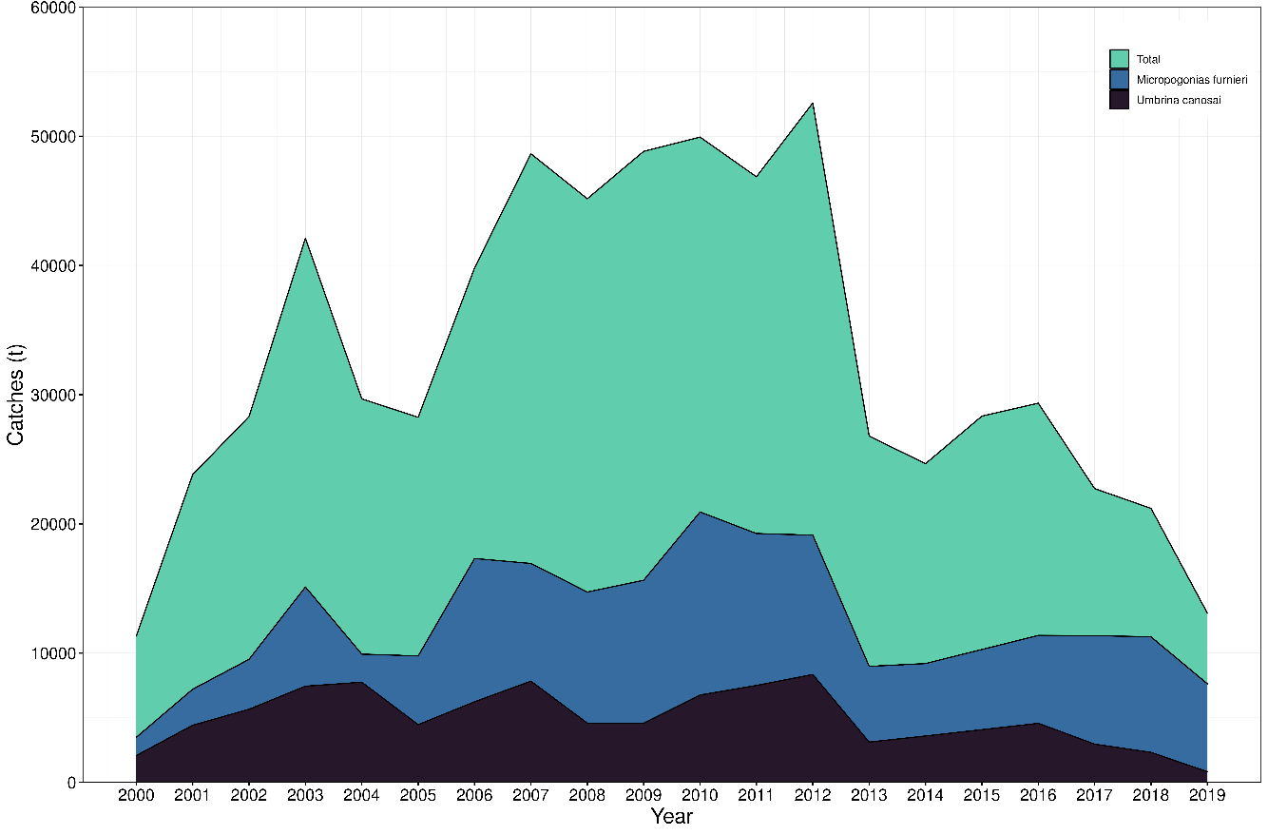
Figure 1. Annual catches of the demersal fisheries monitored in the harbours of Santa Catarina State, Southern Brazil, between 2000 and 2019.

Figure 2. Catches of demersal species with warm-water affinity in the Brazilian Meridional Margin. a) whitemouth croaker (Micropogonias furnieri), b) stripped weakfish (Cynoscion guatucupa), c) gray triggerfish (Balistes capriscus), d) spotted pink shrimp (Penaeus brasiliensis). Catches were monitored in Santa Catarina States, southern Brazil, between 2000 and 2019.

Figure 3. Catches of demersal species with cold-water affinity in the Brazilian Meridional Margin. a) Argentine croaker (Umbrina canosai), b) codling (Urophycis mystacea), c) monkfish (Lophius gastrophysus), d) argentine stiletto shrimp (Artemesia longirostris). Catches were monitored in Santa Catarina States, southern Brazil, between 2000 and 2019.

Figure 4. Analysis of the catch composition of the demersal fisheries in the Brazilian Meridional Margin (BMM) monitored between 2000 and 2019 in the harbours of Santa Catarina State. southern Brazil. Annual contribution to total beta-diversity (YCBD) computed between 2000 and 2019. The dotted line indicates total beta-diversity value. Significant annual contributions are indicated by the p-values

