Supplementary Material

Table S1. List of climate models considered in the present study.
 | MODELS | Country | Resolution | LON x LAT
1 | AWI-CM-1-1-MR | Germany | 0.9 x 0.9° | (384 x 192)
2 | BCC-CSM2-MR | China | 1.1 x 1.1° | (320 x 160)
3 | CMCC-ESM2 | Italy | 0.9 x 1.3° | (288 x 192)
4 | CNRM-CM6-1-HR | France | 0.5 x 0.5° | (720 x 360)
5 | EC-Earth3 | Europe | 0.7 x 0.7° | (512 x 256)
6 | EC-Earth3-Veg | Europe | 0.7 x 0.7° | (512 x 256)
7 | GFDL-ESM4 | USA | 1.3 x 1.0° | (288 x 180)
8 | HadGEM3-GC31-MM | UK | 0.8 x 0.5° | (432 x 324)
9 | MPI-ESM-1-2-HR | Germany | 0.9 x 0.9° | (384 x 192)
10 | MRI-ESM2-0 | Japan | 1.1 x 1.1° | (320 x 160)
11 | NorESM2-MM | Norway | 0.9 x 1.3° | (288 x 192)

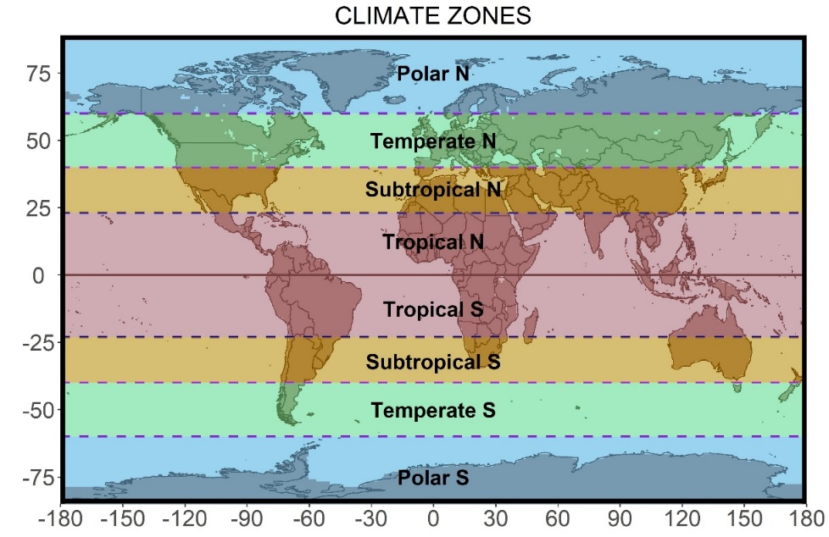
Figure S1. Geographical division in climatic zones based on latitudes for the northern (N) and southern (S) hemispheres.

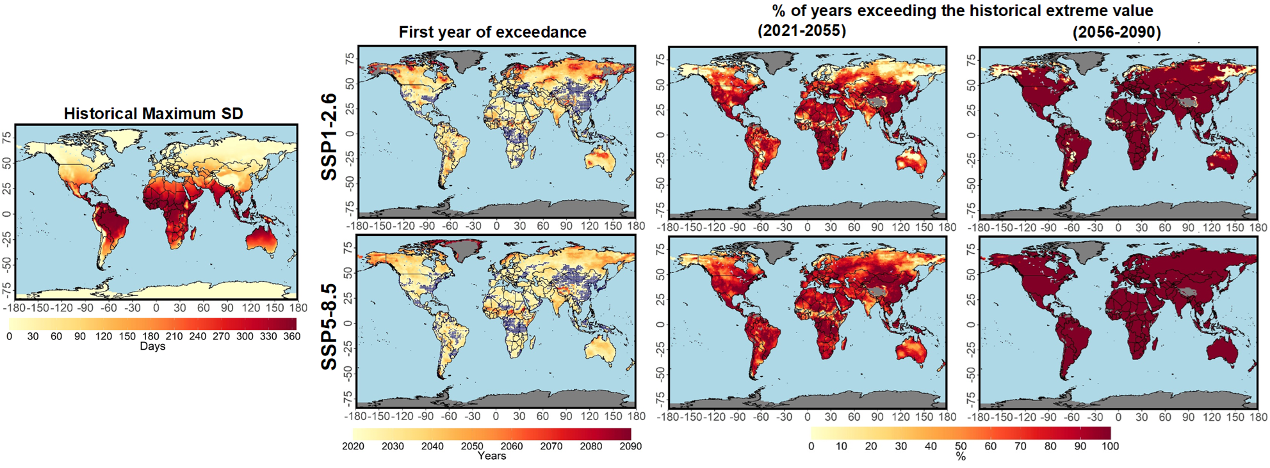
Figure S2. Historical maximum annual number of summer days (SD) as simulated by an ensemble of CMIP6 global models (left). First year of exceeding the absolute extreme SD value for the 21-year running mean (second column). Areas where the first year of exceedance is equal to 2021 (or earlier) are highlighted in blue. Percentage of years where mean conditions are projected to exceed the absolute historical extreme SD value for 2021-2055 and 2056-2090 (third and fourth columns).

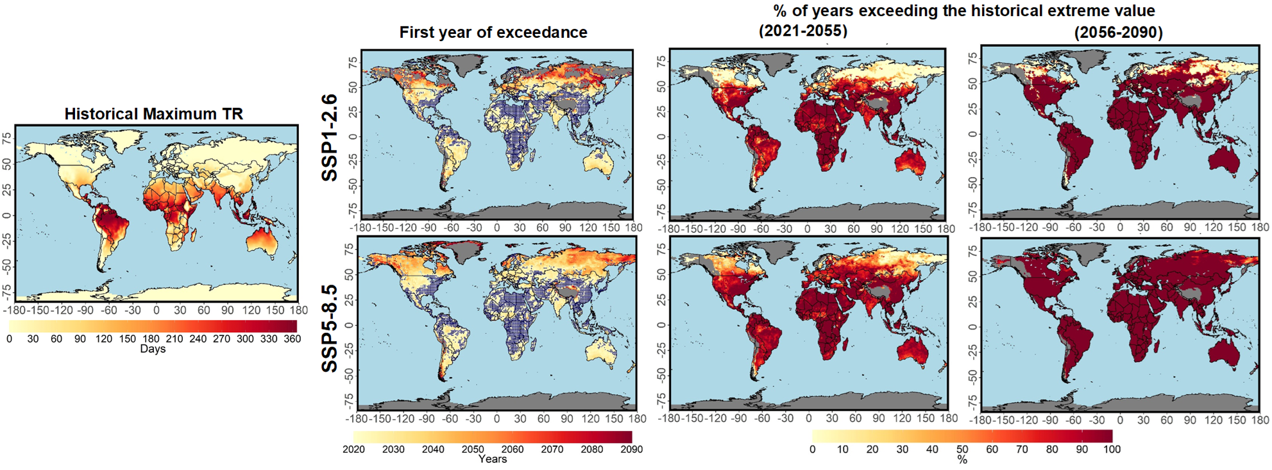
Figure S3. Historical maximum annual number of tropical nights (TR) as simulated by an ensemble of CMIP6 global models (left). First year of exceeding the absolute extreme TR value for the 21-year running mean (second column). Areas where the first year of exceedance is equal to 2021 (or earlier) are highlighted in blue. Percentage of years where mean conditions are projected to exceed the absolute historical extreme TR value for 2021-2055 and 2056-2090 (third and fourth columns).

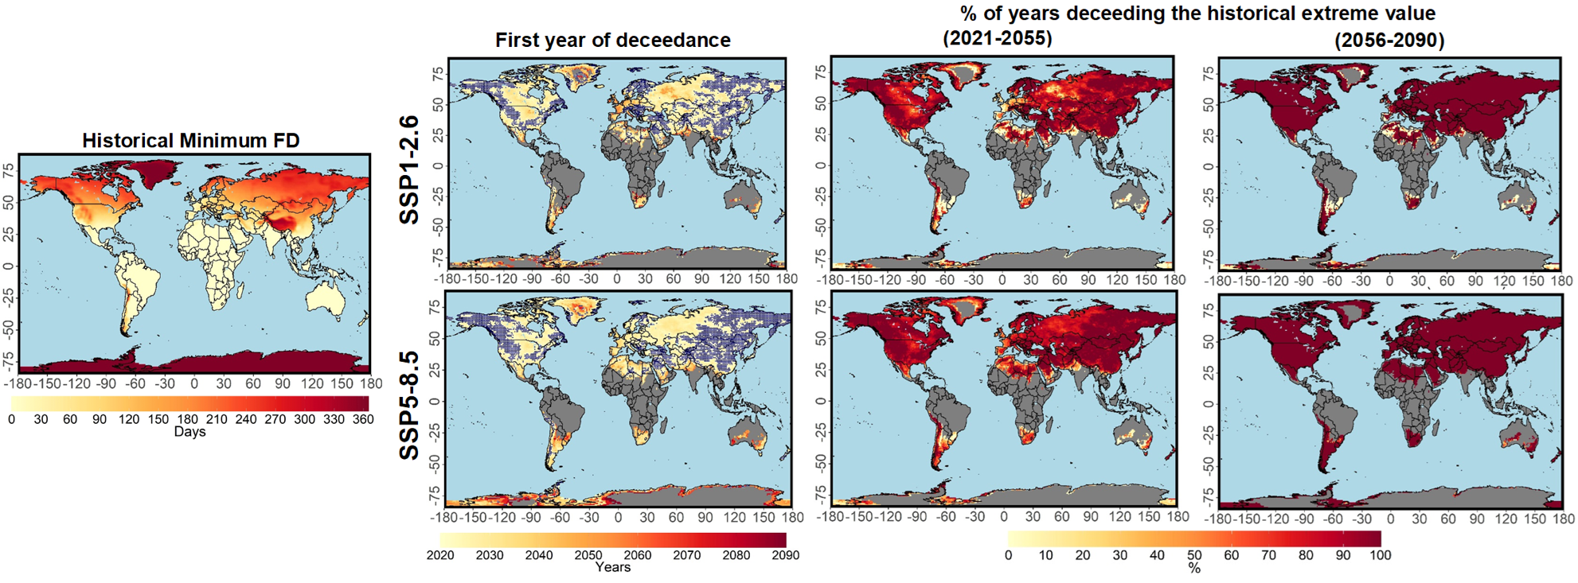
Figure S4. Historical maximum annual number of frost days (FD) as simulated by an ensemble of CMIP6 global models (left). First year of deceeding the absolute extreme FD value for the 21-year running mean (second column). Areas where the first year of deceedance is equal to 2021 (or earlier) are highlighted in blue. Percentage of years where mean conditions are projected to exceed the absolute historical extreme FD value for 2021-2055 and 2056-2090 (third and fourth columns).

