Supplementary Information

Pyroelectric Catalysis-based “Nano-lymphatic” Reduces Tumor Interstitial Pressure for Enhanced Penetration and Hydrodynamic Therapy

Yuchu He¹, Zhuo Li¹, Cong Cong¹, Fei Ye¹, Jingyue Yang¹, Xuwu Zhang¹, Yi Yuan², Zhenhe Ma³, Kaiqing Zhang², Yang Lin³, Lizhao Zheng³, Dawei Gao^{1*}

- State Key Laboratory of Metastable Materials Science and Technology, Applying Chemistry Key Lab of Hebei Province, Yanshan University, Qinhuangdao 066004, P. R. China
- School of Electrical Engineering, Yanshan University, Qinhuangdao 066004, P. R. China
- School of Control Engineering, Northeastern University at Qinhuangdao, Qinhuangdao 066004, P. R. China

*Corresponding author: Prof. Dawei Gao, Tel: (+86)13930338376.
E-mail: dwgao@ysu.edu.cn

Supplementary Figure 1. Zeta potentials of MXene, CdS NPs, M/CdS and M/CdS-HA.

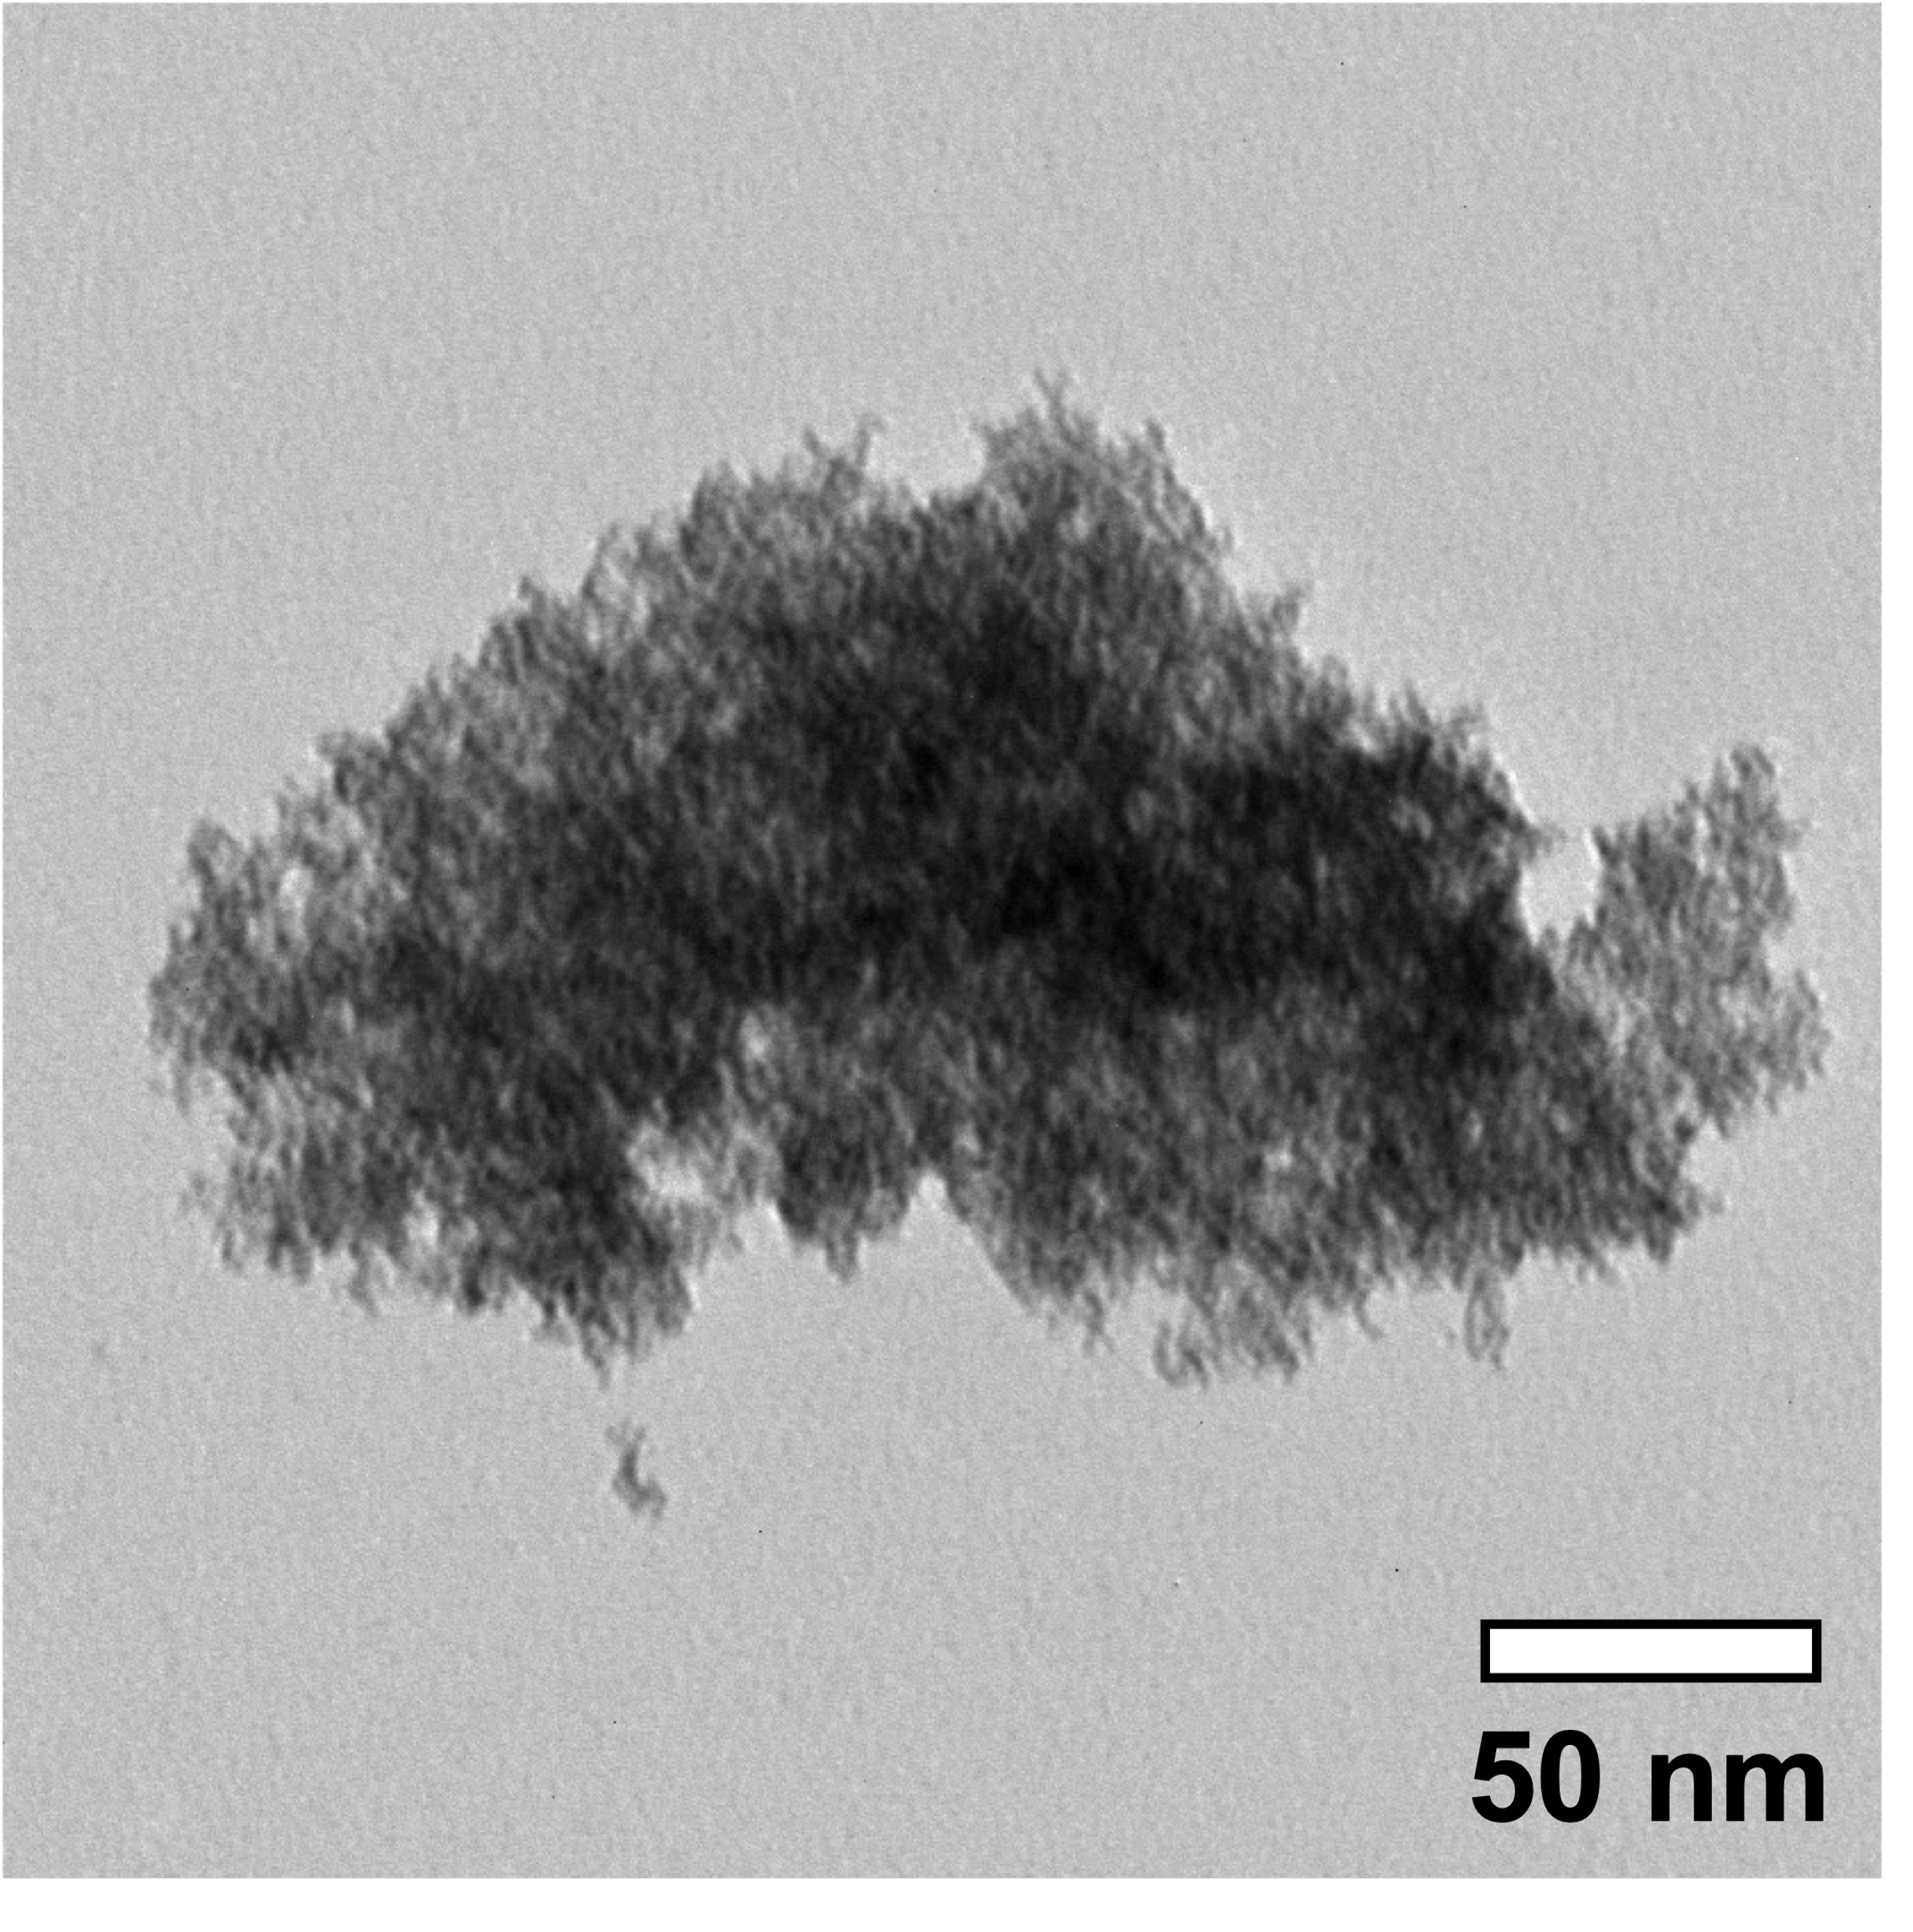
Supplementary Figure 2. TEM image of M/CdS after 5 min of 1064-nm laser irradiation.

Supplementary Figure 3. Tumor photograph of mice treated with Saline, M/CdS-HA, MXene-HA +L, CdS-HA +L and M/CdS-HA +L.

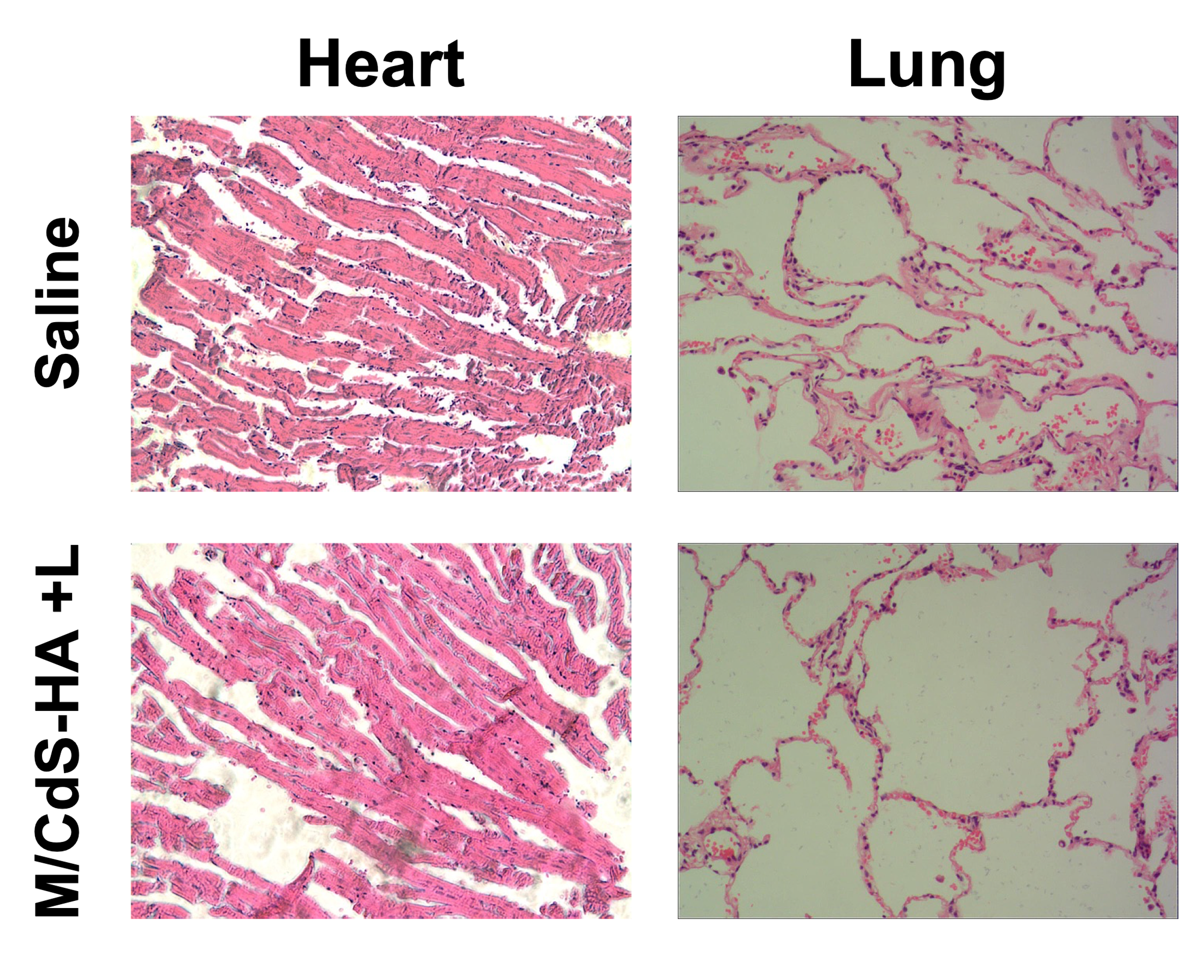
Supplementary Figure 4. Histological H&E staining for heart and lung from the mice treated with Saline and M/CdS-HA +L.

