Sugar-based activated carbon regulated BiOBr nanosheets composite for considerably improved photocatalytic capability
Huilan Ye¹, Yiting Wu¹, Weiming Zhou¹, Ming Lin¹*, Liwei Wang³*, Zhanhui Yuan¹*
¹College of Materials Engineering, Fujian Agriculture and Forestry University, Fuzhou, 350002, China
²College of Mechanical and electrical Engineering, Fujian Agriculture and Forestry University, Fuzhou, 350002, China
³Ocean College, Minjiang University, Fuzhou 350108, China
*Corresponding author: zhanhuiyuan@fafu.edu.cn (+86)13950268166

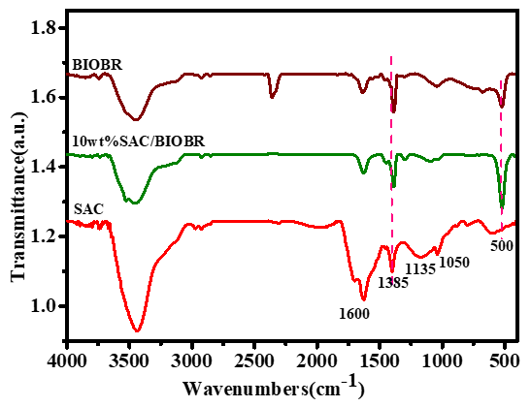
Fig. 1s The FTIR image of SAC, BiOBr and 10wt%SAC/BiOBr composite.

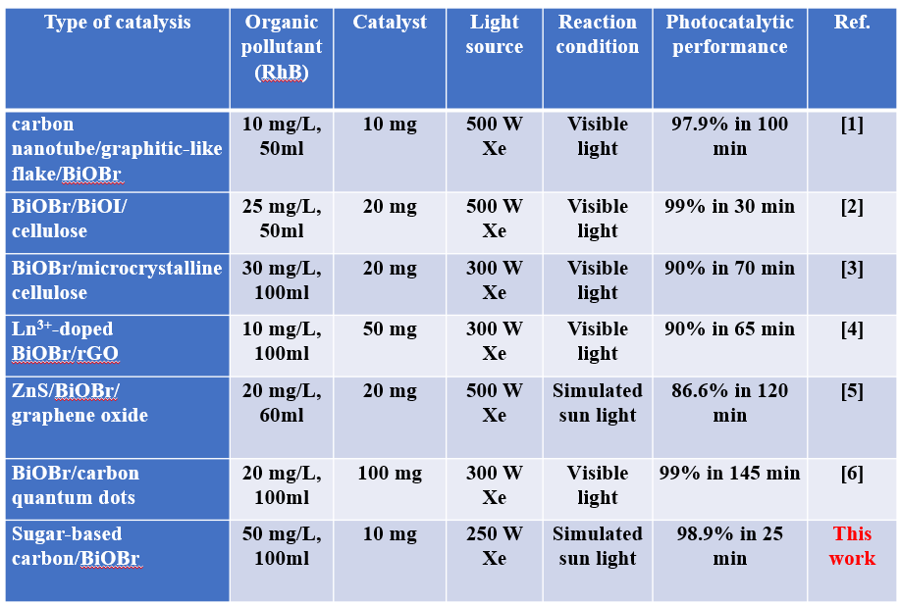
Table. S1 The recent similar composites for photocatalytic dye degradation.
Reference
1. W. Tie, Z. Du, H. Yue, S. Sarathi Bhattacharyya, Z. Zheng, W. He, and S. Hee Lee, Journal of Colloid and Interface Science 579, 862 (2020).
2. M. Du, Y. Du, Y. Feng, Z. Li, J. Wang, N. Jiang, and Y. Liu, Cellulose 26, 5543 (2019).
3. W. Zhou, S. Sun, Y. Jiang, M. Zhang, I. Lawan, G. F. Fernando, L. Wang, and Z. Yuan, Cellulose 26, 9529 (2019).
4. X. Ren, Y. Sun, H. Xing, K. Wu, W. Wang, J. Yin, S. Yao, X. Zhao, and H. Yang, Journal of Nanoparticle Research 21, (2019).
5. W. Zhang, J. Fu, Y. Wang, X. Zhang, and J. Li, Journal of Physics and Chemistry of Solids 127, 19 (2019).
6. C. Zhao, W. Li, Y. Liang, Y. Tian, and Q. Zhang, Applied Catalysis A: General 527, 127 (2016).

