Supplementary Information
Self-reduction assisted MXene/Silver composite Tencel cellulose-based fabric with electrothermal conversion and NIR photothermal actuation
Han Li¹, Yinuo Pan¹, Zhaoqun Du¹*
Engineering Research Center of Technical Textiles, Ministry of Education, Donghua University, Shanghai, China 201620
E-mail: duzq@dhu.edu.cn
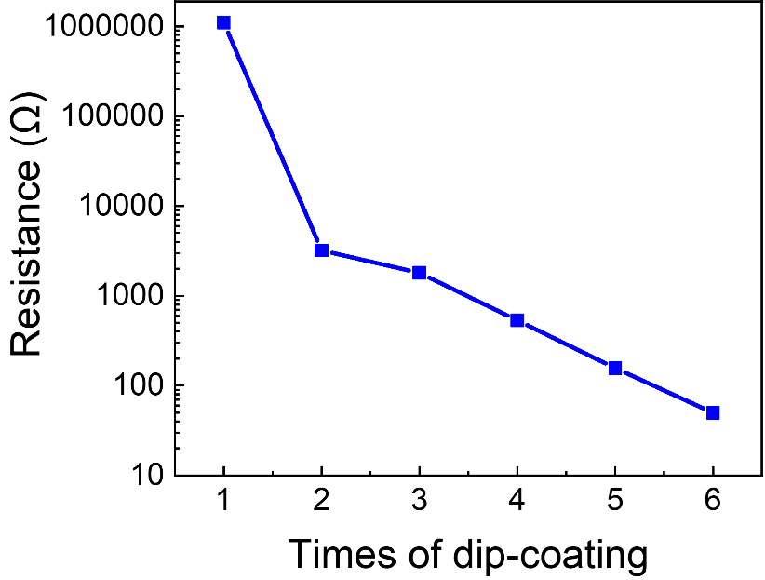
Figure S1. Resistance values under different dip-coating times.

Table S1. The O 1s XPS peak fitting results of MXene, in which Peak BE represents Peak Binding Energy, and FWHM represents full-widths at half maximum.
Name | Peak BE | FWHM eV | Area (P) CPS.eV | Atomic %
TiO₂ | 530.02 | 1.14 | 10242.16 | 15.35
C-Ti-O_{x}(I) | 531.06 | 1.35 | 20257.45 | 30.38
C-Ti-(OH)_{x} | 532.01 | 1.37 | 16298.48 | 24.46
Al₂O₃ | 532.89 | 1.03 | 6676.81 | 10.03
H₂O_{ads} | 533.77 | 1.19 | 8716.84 | 13.1
Al (OF)_{x} | 534.71 | 1.2 | 4453.86 | 6.7

Table S2. The F 1s XPS peak fitting results of MXene.
Name | Peak BE | FWHM eV | Area (P) CPS.eV | Atomic %
C-Ti-F_{x}(III) | 685.13 | 1.31 | 106445.19 | 32.96
Al F_{x} | 685.86 | 1.28 | 182277.39 | 56.48
Al (OF)_{x} | 686.81 | 1.22 | 34050.05 | 10.56

Note S1. Reasonable and simplified equations for selective etching of Ti₃AlC₂ in HCl solution: (Naguib M et al., 2011)
LiF + HCl = HF + HCl (1)
Ti₃AlC₂ + 3HF = AlF₃ + 3/2H₂ + Ti₃C₂ (2)
Ti₃C₂ + 2H₂O = Ti₃C₂(OH)₂ + H₂ (3)
Ti₃C₂ + 2HF = Ti₃C₂F₂ + H₂ (4)

Naguib, M., Kurtoglu, M., Presser, V., Lu, J., Niu, J., Heon, M., Hultman, L., Gogotsi, Y., Barsoum, M.W. (2011) Two‐dimensional nanocrystals produced by exfoliation of Ti₃AlC₂. Adv. Mater. 23: 4248-4253.

