Supporting information
Supplemental Table 1. Primers in This Study.
Gene name | Primer name |  | Sequences (5' to 3')
qRT-PCR assays
Lgals1 | Lgals1-F |  | TCAAACCTGGAGAGTGCCTT
Lgals1 | Lgals1-R |  | CACACCTCTGCAACACTTCC
LMP1 | LMP1-F |  | CTGCTGGAAATGATGGAGGC
LMP1 | LMP1-R |  | AGAAGAACCCAAAAGCAGCG
PD-L1 | PD-L1-F |  | GTGCCGACTACAAGCGAATT
PD-L1 | PD-L1-R |  | CTTGGAATTGGTGGTGGTGG
IRF-1 | IRF-1-F |  | ATGCTTCCACCTCTCACCAA
IRF-1 | IRF-1-R |  | TGTAGCTGCTGTGGTCATCA
β-actin | β-actin-F |  | GAAGAGCTACGAGCTGCCTGA
β-actin | β-actin-R |  | CAGACAGCACTGTGTTGGCG

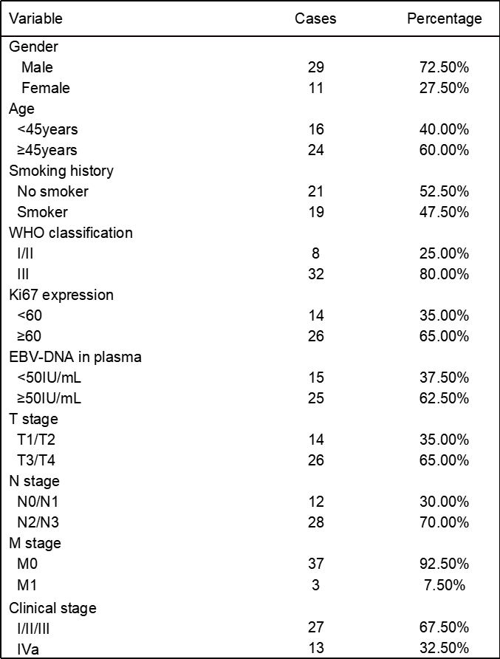
Supplemental Table 2. General information and clinical characteristics of patients.
Abbreviations: EBV, Epstein-Barrvirus; M metastasis; N, node; T, tumor.

