Integrating cell interaction with transcript factors to obtain a robust gene panel for prognostic prediction and therapies in cholangiocarcinoma
Tingjie Wang, Chuanrui Xu, Dan Xu, Xiaofei Yang , Yaxin Liu, Xiujuan Li, Zihang Li, Ningxin Dang, Zhijing Zhang, Kai Ye

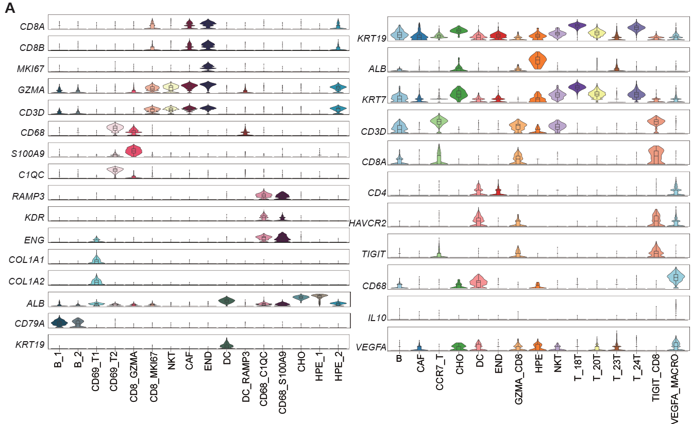

Figure S1: Gene profile in normal and cancer in CCA single cell RNAseq dataset (GSE138709).
(A) Violin plots showing marker genes for four distinct endothelial and five fibroblast subtypes, colored according to cell types.

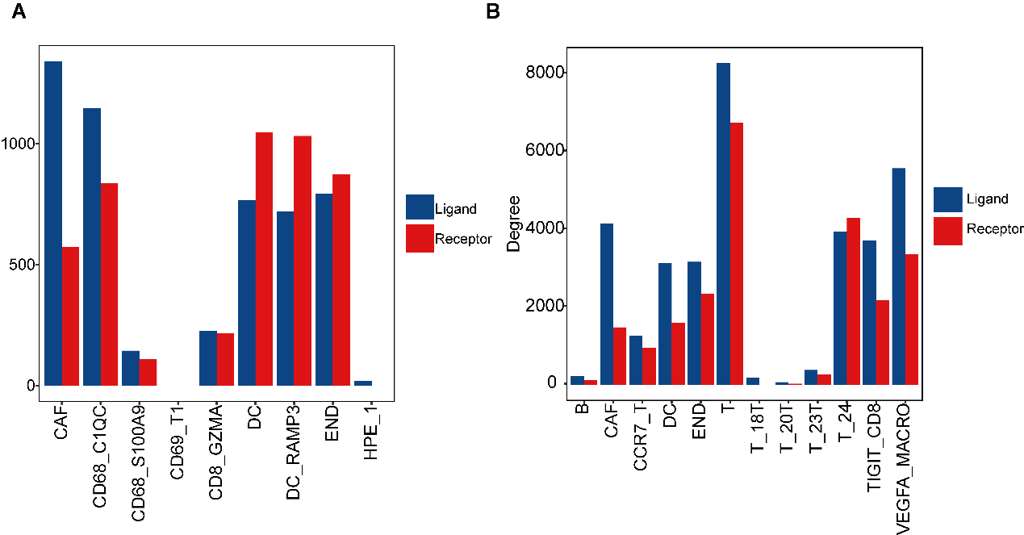

Figure S2: Cell interaction genes in normal and cancer in CCA single cell RNAseq dataset (GSE138709).
Ligand (blue) and receptor (red) gene numbers in normal (A) and cancer (B) in CCA single cell RNAseq dataset (GSE138709).
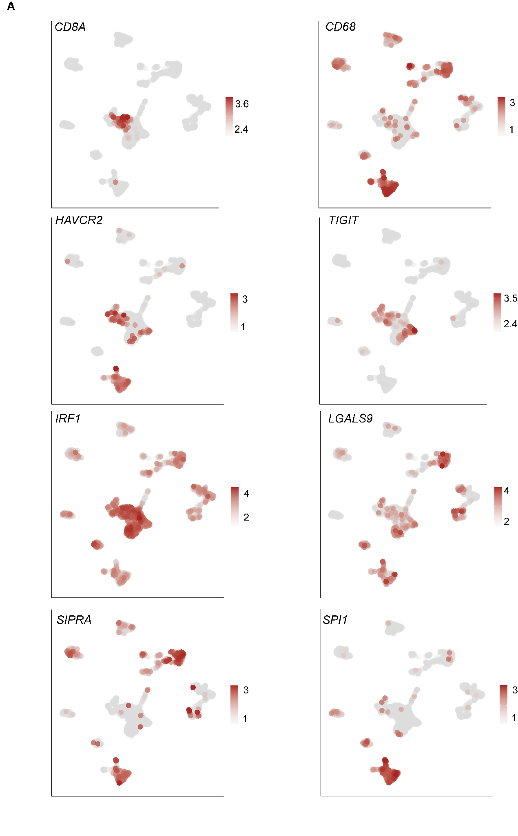

Figure S3: Validation the critical genes in CCA single cell RNAseq dataset (GSE151530).
UMAP plot showing the expression level of marker genes in the other single cell dataset GSE151530. Color from grey to red represent the expression level from low to high.

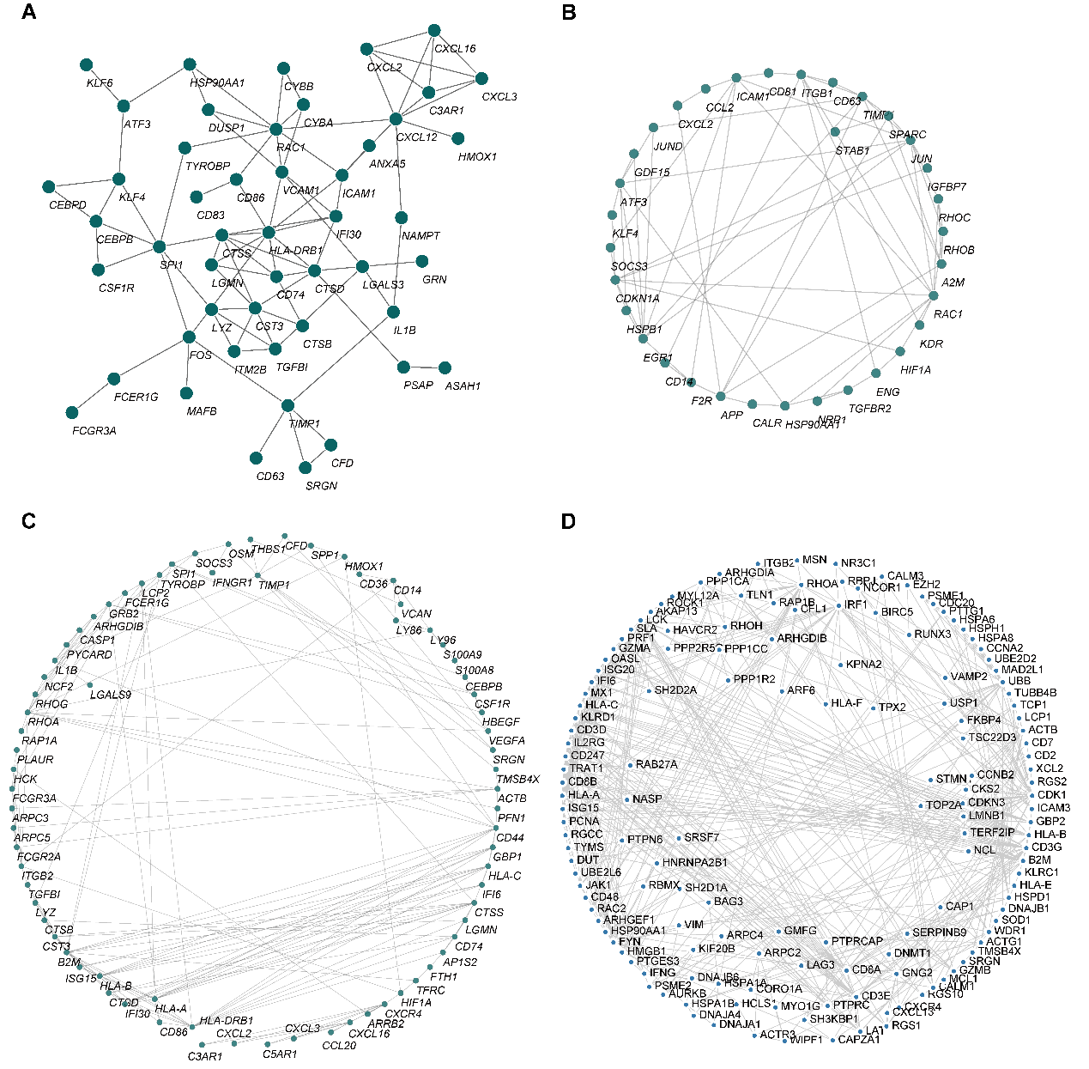

Figure S4: Trimmed-PPI network from the mutually connected cell types that ligand or receptor genes participate in normal and tumor tissues via eLBP.
(A) PPI network that ligand gene CXCL12 participated in the cell type CD68_C1QC from normal tissue. (B) PPI network that ligand gene CLEC1B participated in the cell type DC_RAMP3 from normal tissue. (C) PPI network that ligand gene LGALS9 participated in the cell type VEGFA_MACRO. (D) PPI network that receptor gene HAVCR2 participated in the cell type TIGIT_CD8.

Figure S5: Heatmap showing the consensus cluster result using different cluster number.
Heatmap showing the consensus cluster result using different cluster number from 2 to 5 (A-D).
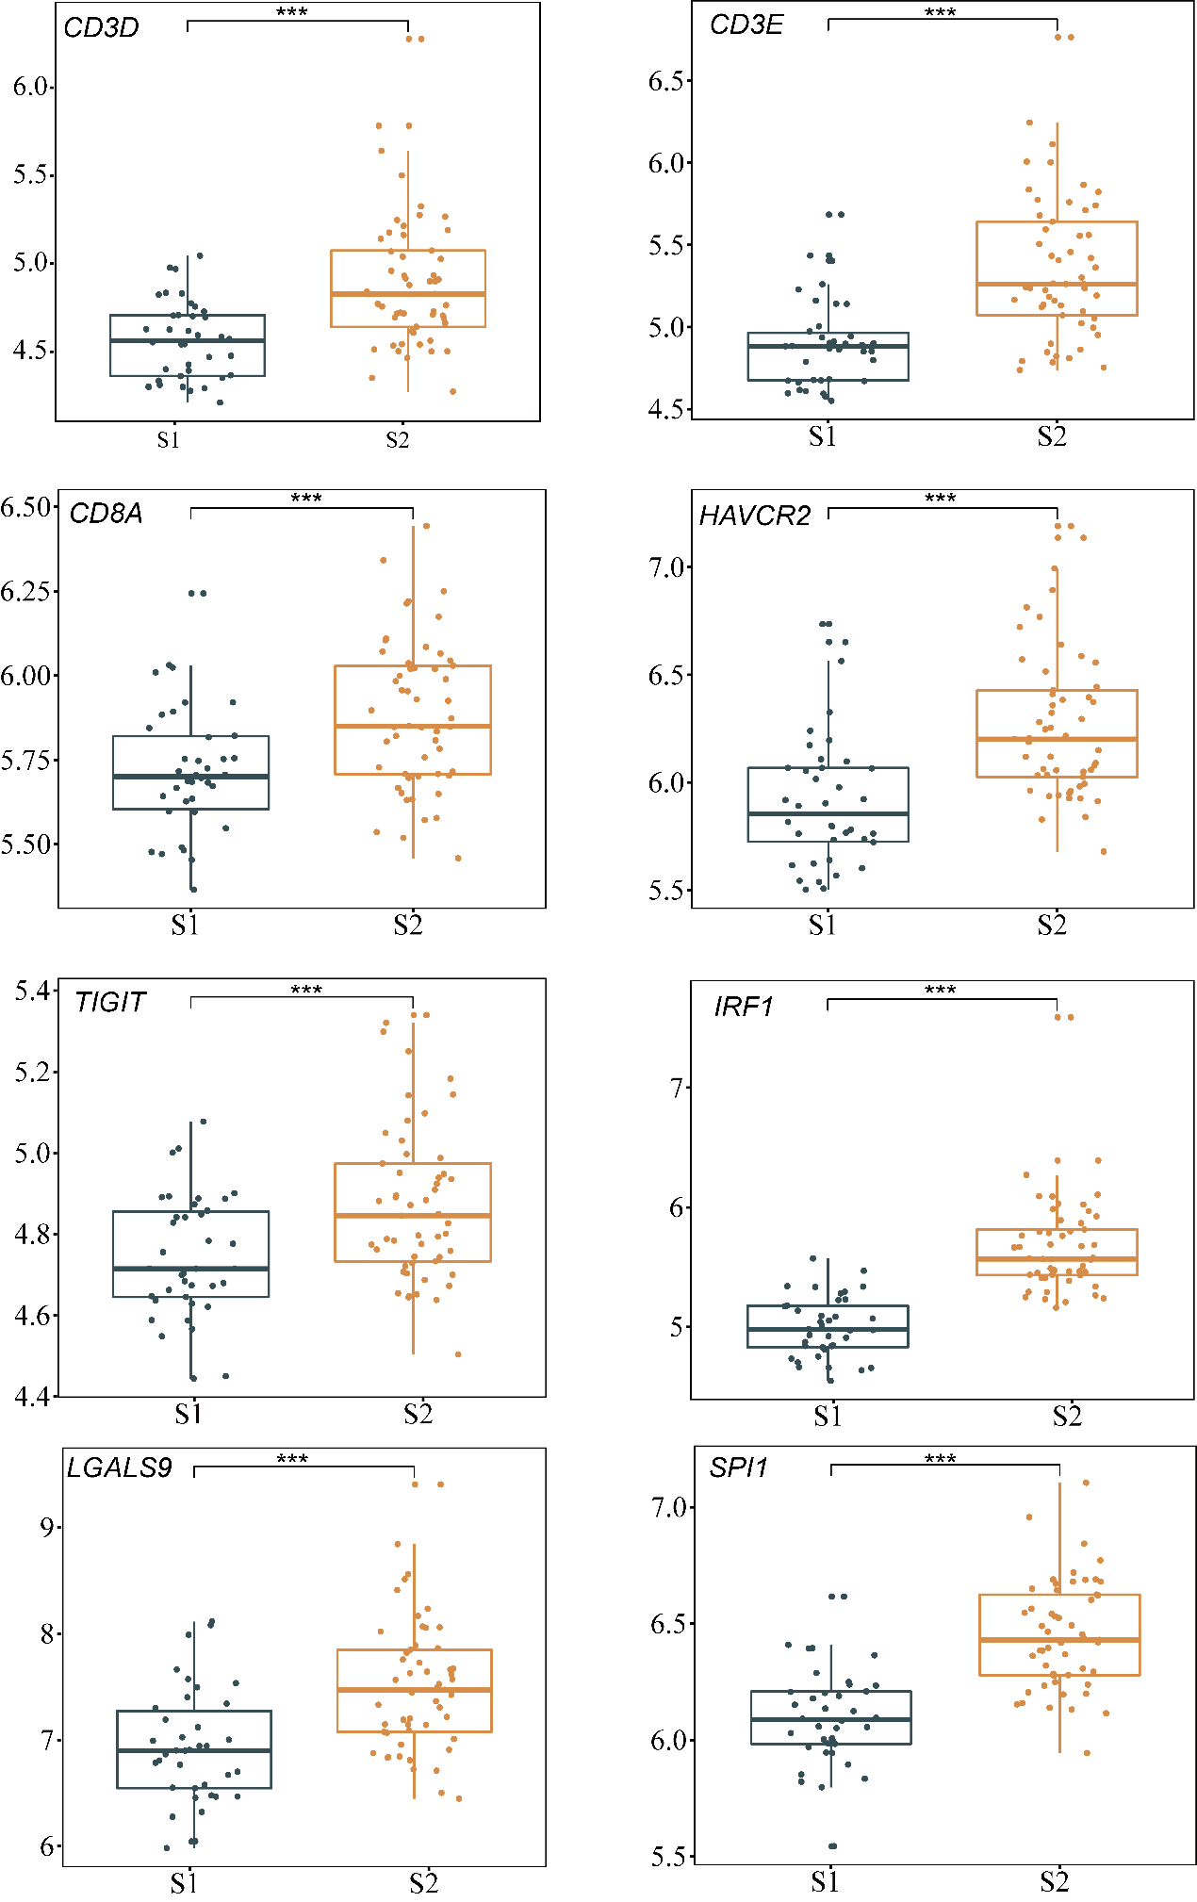

Figure S6: Validation the gene expression level of critical genes in CCA cohort GSE76297.
Box plot showing the patients in S2 from GSE76297 had higher expression levels of LGALS9, IRF1, SPI1 and immune genes, and similar TIL profiles with the GSE89749 data (***P < 0.001, Wilcoxon rank sum test).

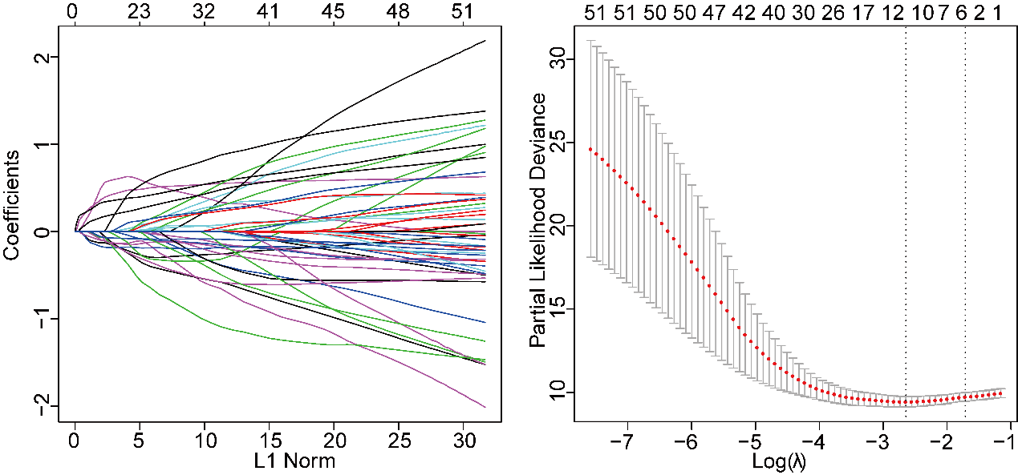

Figure S7: LASSO regression plot showing the signatures selection process.
(A) Lambda value of the 52 genes in least absolute shrinkage and selection operator (LASSO) model. (B) The most appropriate log (Lambda) value in the LASSO model.

Table S1. Deposited data.
Dataset | Type | Site | patient number | prognosis
GSE138709 | single cell | https://www.ncbi.nlm.nih.gov/geo/query/acc.cgi?acc=GSE138709 | Adjacent:3, Tumor:5 | No
GSE151530 | single cell | https://www.ncbi.nlm.nih.gov/geo/query/acc.cgi?acc=GSE151530 | Tumor:12 | No
GSE89749 | Bulk | https://www.ncbi.nlm.nih.gov/geo/query/acc.cgi?acc=GSE89749 | Tumor:138;Adjacent:4 | Yes
GSE107943 | Bulk | https://www.ncbi.nlm.nih.gov/geo/query/acc.cgi?acc=GSE107943 | Tumor:30;Adjacent:27 | Yes
GSE76297 | Bulk | https://www.ncbi.nlm.nih.gov/geo/query/acc.cgi?acc=GSE76297 | Tumor:91;Adjacent:92 | No
E-MTAB-6389 | Bulk | https://www.ebi.ac.uk/arrayexpress/experiments/E-MTAB-6389/ | Tumor:78;Adjacent:31 | Yes

Table S2. Cell type distribution between normal and tumor tissues.
Patients | Cell Type | Enrich Scores | Patients | Cell Type | Enrich Scores
18T | B | 0.03 | 23T | HPE | 0.49
20T | B | 0.12 | 24T | HPE | 2.54
23T | B | 0.26 | 18T | NKT | 0
24T | B | 2.66 | 20T | NKT | 6.07
18T | CAF | 0.13 | 23T | NKT | 0
20T | CAF | 0.17 | 24T | NKT | 0.11
23T | CAF | 0.49 | 18T | T_18T | 3.44
24T | CAF | 2.41 | 20T | T_18T | 0
18T | CCR7_T | 0.02 | 23T | T_18T | 0
20T | CCR7_T | 1.15 | 24T | T_18T | 0
23T | CCR7_T | 0.31 | 18T | T_20T | 0
24T | CCR7_T | 2.16 | 20T | T_20T | 6.27
18T | CHO | 0 | 23T | T_20T | 0
20T | CHO | 0 | 24T | T_20T | 0.01
23T | CHO | 0.41 | 18T | T_23T | 0
24T | CHO | 2.65 | 20T | T_23T | 0
18T | DC | 0.39 | 23T | T_23T | 4.88
20T | DC | 1.03 | 24T | T_23T | 0
23T | DC | 0.3 | 18T | T_24T | 0.01
24T | DC | 1.92 | 20T | T_24T | 0
18T | END | 0.08 | 23T | T_24T | 0
20T | END | 0.33 | 24T | T_24T | 2.88
23T | END | 0.32 | 18T | TIGIT_CD8 | 0.04
24T | END | 2.49 | 20T | TIGIT_CD8 | 0.13
18T | GZMA_CD8 | 0 | 23T | TIGIT_CD8 | 3.74
20T | GZMA_CD8 | 0 | 24T | TIGIT_CD8 | 0.58
23T | GZMA_CD8 | 4.88 | 18T | VEGFA_MACRO | 0.21
24T | GZMA_CD8 | 0 | 20T | VEGFA_MACRO | 0.28
18T | HPE | 0 | 23T | VEGFA_MACRO | 1.18
20T | HPE | 0.13 | 24T | VEGFA_MACRO | 1.89

Table S3. Scores of ligand or receptor genes participated in the cell communication calculated by eLBP algorithm.
CellType | Gene | L/R value | Type | Sample Type
B | CD27 | 0.937418 | receptor | Tumor
B | CXCR4 | 0.872329 | receptor | Tumor
B | HLA-A | 0.568182 | ligand | Tumor
B | HLA-B | 0.60824 | ligand | Tumor
B | HLA-C | 0.954512 | ligand | Tumor
B | ICAM2 | 0.975225 | receptor | Tumor
B | IFNAR2 | 0.304385 | receptor | Tumor
B | IL2RG | 0.808196 | receptor | Tumor
CAF | ANGPT2 | 0.007568 | ligand | Tumor
CAF | ANGPTL4 | 0.017046 | ligand | Tumor
CAF | APP | 0.965958 | ligand | Tumor
CAF | C3 | 0.131565 | ligand | Tumor
CAF | CCL2 | 0.245411 | ligand | Tumor
CAF | COL1A1 | 0.999285 | ligand | Tumor
CAF | COL1A2 | 0.026041 | ligand | Tumor
CAF | COL4A1 | 0.460353 | ligand | Tumor
CAF | COL4A2 | 0.402108 | ligand | Tumor
CAF | COL6A1 | 0.434307 | ligand | Tumor
CAF | COL6A2 | 0.630021 | ligand | Tumor
CAF | COL6A3 | 0.072348 | ligand | Tumor
CAF | FN1 | 0.99785 | ligand | Tumor
CAF | IL6 | 0.998801 | ligand | Tumor
CAF | ITGA1 | 0.001653 | receptor | Tumor
CAF | LRP1 | 0.123011 | receptor | Tumor
CAF | MCAM | 0.313007 | receptor | Tumor
CAF | NOTCH3 | 0.999999 | receptor | Tumor
CAF | PDGFRB | 0.04058 | receptor | Tumor
CAF | PGF | 0.021136 | ligand | Tumor
CAF | POSTN | 0.038931 | ligand | Tumor
CAF | SDC2 | 0.028548 | receptor | Tumor
CAF | THBS1 | 0.972057 | ligand | Tumor
CAF | THBS2 | 0.066542 | ligand | Tumor
CAF | THY1 | 0.000223 | ligand | Tumor
CCR7_T | CCR6 | 0.007494 | receptor | Tumor
CCR7_T | CCR7 | 0.426381 | receptor | Tumor
CCR7_T | CD44 | 0.773747 | receptor | Tumor
CCR7_T | CXCR6 | 0.796945 | receptor | Tumor
CCR7_T | GZMA | 0.999861 | ligand | Tumor
CCR7_T | IL2RG | 0.987716 | receptor | Tumor
CCR7_T | IL7R | 0.502258 | receptor | Tumor
CCR7_T | ITGB2 | 0.828232 | receptor | Tumor
CCR7_T | TGFB1 | 0.999864 | ligand | Tumor
CCR7_T | TNFRSF1B | 0.659264 | receptor | Tumor
CCR7_T | TNFRSF4 | 0.355402 | receptor | Tumor
END | APP | 0.662696 | ligand | Tumor
END | BMPR2 | 0.975543 | receptor | Tumor
END | CALCRL | 0.006265 | receptor | Tumor
END | CCL2 | 0.391902 | ligand | Tumor
END | CD34 | 0.837534 | receptor | Tumor
END | CD36 | 0.588576 | receptor | Tumor
END | CD55 | 0.184108 | receptor | Tumor
END | CD99 | 0.851937 | receptor | Tumor
END | CDH5 | 0.034587 | receptor | Tumor
END | COL4A1 | 0.737987 | ligand | Tumor
END | COL4A2 | 0.72551 | ligand | Tumor
END | CXCL12 | 0.065361 | ligand | Tumor
END | CXCL2 | 0.699485 | ligand | Tumor
END | CXCL3 | 0.294942 | ligand | Tumor
END | EDN1 | 0.358146 | ligand | Tumor
END | ENTPD1 | 0.950192 | ligand | Tumor
END | ESAM | 0.999994 | receptor | Tumor
END | F2R | 0.996875 | receptor | Tumor
END | HLA-A | 0.555645 | ligand | Tumor
END | HSPG2 | 0.675106 | ligand | Tumor
END | ICAM1 | 0.142266 | receptor | Tumor
END | ICAM2 | 0.347015 | receptor | Tumor
END | IL6ST | 0.995693 | receptor | Tumor
END | INSR | 0.010012 | receptor | Tumor
END | ITGA5 | 0.999754 | receptor | Tumor
END | MCAM | 0.996823 | receptor | Tumor
END | NOTCH4 | 0.181808 | receptor | Tumor
END | SELE | 0.061516 | receptor | Tumor
END | TGFBR2 | 0.004186 | receptor | Tumor
END | VCAM1 | 0.993264 | receptor | Tumor
END | VWF | 0.687645 | ligand | Tumor
T_18T | ANXA1 | 0.665035 | ligand | Tumor
T_18T | AREG | 0.922063 | ligand | Tumor
T_18T | EREG | 0.731488 | ligand | Tumor
T_18T | HBEGF | 0.529966 | ligand | Tumor
T_18T | LAMB3 | 0.86621 | ligand | Tumor
T_18T | LAMC2 | 0.566191 | ligand | Tumor
T_18T | MIF | 0.296488 | ligand | Tumor
T_18T | NMB | 0.556031 | ligand | Tumor
T_18T | NMU | 0.005094 | ligand | Tumor
T_18T | SPP1 | 0.555359 | ligand | Tumor
T_20T | AGT | 0.645208 | ligand | Tumor
T_20T | CXCL1 | 0.309881 | ligand | Tumor
T_20T | CXCL6 | 0.994013 | ligand | Tumor
T_20T | GDF15 | 0.968601 | ligand | Tumor
T_20T | IGF2 | 0.869312 | ligand | Tumor
T_20T | IL18 | 0.960998 | ligand | Tumor
T_20T | ITGB1 | 0.364268 | receptor | Tumor
T_20T | OCLN | 0.987488 | receptor | Tumor
T_20T | TNFRSF11B | 0.066387 | receptor | Tumor
T_23T | AGT | 0.465985 | ligand | Tumor
T_23T | C3 | 0.5063 | ligand | Tumor
T_23T | CDH2 | 0.630228 | receptor | Tumor
T_23T | CXCL6 | 0.999041 | ligand | Tumor
T_23T | HGF | 0.824477 | ligand | Tumor
T_23T | HLA-B | 0.969892 | ligand | Tumor
T_23T | ICAM1 | 0.993305 | receptor | Tumor
T_23T | MDK | 0.994719 | ligand | Tumor
T_23T | NPW | 0.979833 | ligand | Tumor
T_23T | NPY1R | 0.746866 | receptor | Tumor
T_23T | PTPRF | 0.573591 | receptor | Tumor
T_23T | VCAM1 | 0.475359 | receptor | Tumor
T_24T | AGRN | 0.960607 | ligand | Tumor
T_24T | APP | 0.999296 | ligand | Tumor
T_24T | CD44 | 0.571191 | receptor | Tumor
T_24T | CDH11 | 0.220607 | receptor | Tumor
T_24T | COL1A1 | 0.842983 | ligand | Tumor
T_24T | COL4A1 | 0.756696 | ligand | Tumor
T_24T | COL4A2 | 0.729679 | ligand | Tumor
T_24T | COL6A1 | 0.70866 | ligand | Tumor
T_24T | COL6A2 | 0.999897 | ligand | Tumor
T_24T | EGFR | 0.01152 | receptor | Tumor
T_24T | EPHA2 | 0.332452 | receptor | Tumor
T_24T | FN1 | 0.999997 | ligand | Tumor
T_24T | IGF2 | 0.197637 | ligand | Tumor
T_24T | ITGA2 | 0.022309 | receptor | Tumor
T_24T | ITGA3 | 0.999952 | receptor | Tumor
T_24T | ITGA6 | 0.40602 | receptor | Tumor
T_24T | ITGB4 | 0.356955 | receptor | Tumor
T_24T | ITGB8 | 1 | receptor | Tumor
T_24T | LAMA5 | 0.051779 | ligand | Tumor
T_24T | LAMC2 | 0.46311 | ligand | Tumor
T_24T | PDGFA | 0.999743 | ligand | Tumor
T_24T | SAA1 | 0.984696 | ligand | Tumor
T_24T | SDC4 | 0.321337 | receptor | Tumor
T_24T | TNC | 0.001574 | ligand | Tumor
T_24T | TNFRSF1A | 0.978243 | receptor | Tumor
TIGIT_CD8 | CAP1 | 0.993139 | receptor | Tumor
TIGIT_CD8 | CD48 | 0.744565 | ligand | Tumor
TIGIT_CD8 | CD8A | 0.626231 | receptor | Tumor
TIGIT_CD8 | CD8B | 0.999031 | receptor | Tumor
TIGIT_CD8 | CXCL13 | 0.307984 | ligand | Tumor
TIGIT_CD8 | CXCR4 | 0.902555 | receptor | Tumor
TIGIT_CD8 | GZMA | 0.99982 | ligand | Tumor
TIGIT_CD8 | HAVCR2 | 0.588542 | receptor | Tumor
TIGIT_CD8 | HLA-A | 0.749743 | ligand | Tumor
TIGIT_CD8 | HLA-B | 0.821942 | ligand | Tumor
TIGIT_CD8 | HLA-C | 0.763485 | ligand | Tumor
TIGIT_CD8 | HLA-E | 0.999732 | ligand | Tumor
TIGIT_CD8 | HLA-F | 0.569004 | ligand | Tumor
TIGIT_CD8 | IFNG | 0.772216 | ligand | Tumor
TIGIT_CD8 | IL2RG | 0.995671 | receptor | Tumor
TIGIT_CD8 | ITGB2 | 0.837769 | receptor | Tumor
TIGIT_CD8 | KLRC1 | 0.153706 | receptor | Tumor
TIGIT_CD8 | LCK | 0.777787 | ligand | Tumor
TIGIT_CD8 | NCL | 0.256241 | receptor | Tumor
TIGIT_CD8 | PTPRC | 0.912257 | receptor | Tumor
TIGIT_CD8 | TNFRSF1B | 0.698538 | receptor | Tumor
TIGIT_CD8 | XCL2 | 0.575878 | ligand | Tumor
VEGFA_MACRO | C3AR1 | 0.156018 | receptor | Tumor
VEGFA_MACRO | C5AR1 | 0.008711 | receptor | Tumor
VEGFA_MACRO | CCL20 | 0.025665 | ligand | Tumor
VEGFA_MACRO | CD36 | 0.38847 | receptor | Tumor
VEGFA_MACRO | CD44 | 0.616332 | receptor | Tumor
VEGFA_MACRO | CD74 | 0.8774 | receptor | Tumor
VEGFA_MACRO | CD86 | 0.855713 | ligand | Tumor
VEGFA_MACRO | CSF1R | 0.997422 | receptor | Tumor
VEGFA_MACRO | CXCL16 | 0.6148 | ligand | Tumor
VEGFA_MACRO | CXCL2 | 0.375592 | ligand | Tumor
VEGFA_MACRO | CXCL3 | 0.008753 | ligand | Tumor
VEGFA_MACRO | CXCR4 | 0.856024 | receptor | Tumor
VEGFA_MACRO | EREG | 0.949843 | ligand | Tumor
VEGFA_MACRO | FPR1 | 1 | receptor | Tumor
VEGFA_MACRO | HBEGF | 0.638527 | ligand | Tumor
VEGFA_MACRO | HCST | 0.99956 | receptor | Tumor
VEGFA_MACRO | HLA-A | 0.705015 | ligand | Tumor
VEGFA_MACRO | HLA-B | 0.782826 | ligand | Tumor
VEGFA_MACRO | HLA-C | 0.737404 | ligand | Tumor
VEGFA_MACRO | HLA-DQA1 | 0.907946 | ligand | Tumor
VEGFA_MACRO | HLA-DQB1 | 0.90441 | ligand | Tumor
VEGFA_MACRO | HLA-DRB1 | 1 | ligand | Tumor
VEGFA_MACRO | HLA-E | 0.979905 | ligand | Tumor
VEGFA_MACRO | IFNGR1 | 0.84088 | receptor | Tumor
VEGFA_MACRO | IL1B | 0.292496 | ligand | Tumor
VEGFA_MACRO | ITGB2 | 0.999838 | receptor | Tumor
VEGFA_MACRO | LGALS9 | 0.947457 | ligand | Tumor
VEGFA_MACRO | NAMPT | 0.381893 | ligand | Tumor
VEGFA_MACRO | OSM | 1 | ligand | Tumor
VEGFA_MACRO | PSAP | 0.328239 | ligand | Tumor
VEGFA_MACRO | PTPRC | 0.854003 | receptor | Tumor
VEGFA_MACRO | SPP1 | 0.408392 | ligand | Tumor
VEGFA_MACRO | THBS1 | 0.344107 | ligand | Tumor
VEGFA_MACRO | TREM2 | 0.214936 | receptor | Tumor
VEGFA_MACRO | VEGFA | 0.276596 | ligand | Tumor
CD68_C1QC | AXL | 0.130178 | receptor | Normal
CD68_C1QC | C3AR1 | 0.993243 | receptor | Normal
CD68_C1QC | CD74 | 0.630487 | receptor | Normal
CD68_C1QC | CD86 | 0.999995 | ligand | Normal
CD68_C1QC | CSF1R | 0.236971 | receptor | Normal
CD68_C1QC | CXCL12 | 0.946853 | ligand | Normal
CD68_C1QC | CXCL16 | 0.626379 | ligand | Normal
CD68_C1QC | CXCL2 | 0.317973 | ligand | Normal
CD68_C1QC | CXCL3 | 0.946737 | ligand | Normal
CD68_C1QC | GRN | 0.999213 | ligand | Normal
CD68_C1QC | ICAM1 | 0.391952 | receptor | Normal
CD68_C1QC | IL1B | 0.400206 | ligand | Normal
CD68_C1QC | NAMPT | 0.999996 | ligand | Normal
CD68_C1QC | PSAP | 0.593675 | ligand | Normal
CD68_S100A9 | C5AR1 | 0.316894 | receptor | Normal
CD68_S100A9 | CD44 | 0.94025 | receptor | Normal
CD68_S100A9 | CXCL2 | 0.983321 | ligand | Normal
CD68_S100A9 | CXCL3 | 0.947406 | ligand | Normal
CD68_S100A9 | FPR1 | 0.27028 | receptor | Normal
CD68_S100A9 | IL1B | 0.419178 | ligand | Normal
CD68_S100A9 | NAMPT | 0.984034 | ligand | Normal
CD68_S100A9 | PSAP | 0.54183 | ligand | Normal
CD8_GZMA | CD8A | 0.01606 | receptor | Normal
CD8_GZMA | CD8B | 0.008944 | receptor | Normal
CD8_GZMA | CXCR4 | 0.187092 | receptor | Normal
CD8_GZMA | IFNG | 0.909477 | ligand | Normal
CD8_GZMA | IL2RG | 0.830966 | receptor | Normal
CD8_GZMA | KLRB1 | 0.924526 | receptor | Normal
CD8_GZMA | LCK | 0.05959 | ligand | Normal
CD8_GZMA | PTPRC | 0.888724 | receptor | Normal
DC | CD74 | 0.467202 | receptor | Normal
DC | CXCL16 | 0.66331 | ligand | Normal
DC | HLA-DQA1 | 0.665528 | ligand | Normal
DC | HLA-DQB1 | 0.58048 | ligand | Normal
DC | HLA-DRB1 | 0.997982 | ligand | Normal
DC_RAMP3 | ADM | 0.057813 | ligand | Normal
DC_RAMP3 | APP | 0.999855 | ligand | Normal
DC_RAMP3 | CCL2 | 0.008797 | ligand | Normal
DC_RAMP3 | CD36 | 0.227805 | receptor | Normal
DC_RAMP3 | CLEC1B | 0.666528 | ligand | Normal
DC_RAMP3 | CXCL2 | 0.622369 | ligand | Normal
DC_RAMP3 | F2R | 0.994335 | receptor | Normal
DC_RAMP3 | GDF15 | 0.051588 | ligand | Normal
DC_RAMP3 | ICAM1 | 0.987297 | receptor | Normal
DC_RAMP3 | IL6ST | 0.88371 | receptor | Normal
DC_RAMP3 | INSR | 0.309696 | receptor | Normal
DC_RAMP3 | ITGB1 | 0.975566 | receptor | Normal
DC_RAMP3 | KDR | 0.143692 | receptor | Normal
DC_RAMP3 | LIFR | 0.989718 | receptor | Normal
DC_RAMP3 | NRP1 | 0.064892 | receptor | Normal
DC_RAMP3 | TGFBR2 | 0.985851 | receptor | Normal
END | APP | 0.641643 | ligand | Normal
END | CCL2 | 0.957142 | ligand | Normal
END | CD36 | 0.57942 | receptor | Normal
END | CXCL2 | 0.984355 | ligand | Normal
END | HSPG2 | 0.867246 | ligand | Normal
END | IL6ST | 0.999626 | receptor | Normal
END | INSR | 0.005206 | receptor | Normal
END | ITGB1 | 0.983286 | receptor | Normal
END | TGFBR2 | 0.996013 | receptor | Normal
END | VWF | 0.047824 | ligand | Normal
HPE_1 | MIF | 1 | ligand | Normal
HPE_1 | SAA1 | 0.98614 | ligand | Normal

Table S4. Cell type interaction scores calculated by eLBP algorithm.
Ligand | Receptor | Interaction Score | Type
CAF | CCR7_T | 0.761605 | Tumor
CAF | T_24T | 0.560202 | Tumor
CAF | VEGFA_MACRO | 0.680335 | Tumor
END | CCR7_T | 0.557263 | Tumor
END | END | 0.862893 | Tumor
T_18T | VEGFA_MACRO | 0.588971 | Tumor
T_24T | CCR7_T | 0.64026 | Tumor
T_24T | T_24T | 0.563989 | Tumor
T_24T | VEGFA_MACRO | 0.645288 | Tumor
TIGIT_CD8 | TIGIT_CD8 | 0.563293 | Tumor
VEGFA_MACRO | TIGIT_CD8 | 0.571811 | Tumor
CD68_C1QC | CD8_GZMA | 0.173599 | Normal
CD68_C1QC | DC_RAMP3 | 0.299383 | Normal
CD68_S100A9 | DC_RAMP3 | 0.293443 | Normal
DC_RAMP3 | CD68_C1QC | 0.625614 | Normal
DC_RAMP3 | CD8_GZMA | 0.605967 | Normal
DC_RAMP3 | DC | 0.463848 | Normal
END | CD68_C1QC | 0.399777 | Normal
END | DC | 0.296459 | Normal

Table S5. Interaction scores of gene pairs among the cell types calculated by eLBP algorithm.
Ligand Cluster | Receptor Cluster | Interaction pairs | Interaction Scores | Type
CAF | CCR7_T | FN1_CD44 | 0.75929 | Tumor
CAF | CCR7_T | COL1A1_CD44 | 0.763919 | Tumor
CAF | T_24T | FN1_CD44 | 0.558588 | Tumor
CAF | T_24T | COL1A1_CD44 | 0.561816 | Tumor
CAF | VEGFA_MACRO | FN1_CD44 | 0.598488 | Tumor
CAF | VEGFA_MACRO | COL1A1_CD44 | 0.6027 | Tumor
CAF | VEGFA_MACRO | APP_CD74 | 0.839818 | Tumor
END | CCR7_T | COL4A1_CD44 | 0.562916 | Tumor
END | CCR7_T | COL4A2_CD44 | 0.551611 | Tumor
T_18T | VEGFA_MACRO | ANXA1_FPR1 | 0.65267 | Tumor
T_18T | VEGFA_MACRO | LAMB3_CD44 | 0.525272 | Tumor
T_24T | CCR7_T | FN1_CD44 | 0.763801 | Tumor
T_24T | CCR7_T | COL1A1_CD44 | 0.643339 | Tumor
T_24T | CCR7_T | COL4A1_CD44 | 0.57464 | Tumor
T_24T | CCR7_T | COL4A2_CD44 | 0.55626 | Tumor
T_24T | CCR7_T | COL6A1_CD44 | 0.53842 | Tumor
T_24T | CCR7_T | COL6A2_CD44 | 0.765101 | Tumor
T_24T | VEGFA_MACRO | FN1_CD44 | 0.602598 | Tumor
T_24T | VEGFA_MACRO | COL1A1_CD44 | 0.508525 | Tumor
T_24T | VEGFA_MACRO | COL6A2_CD44 | 0.603783 | Tumor
T_24T | VEGFA_MACRO | APP_CD74 | 0.866246 | Tumor
VEGFA_MACRO | TIGIT_CD8 | LGALS9_HAVCR2 | 0.538534 | Tumor
VEGFA_MACRO | TIGIT_CD8 | HLA-E_CD8A | 0.605088 | Tumor
CD68_C1QC | CD8_GZMA | CXCL12_CXCR4 | 0.173599 | Normal
CD68_C1QC | DC_RAMP3 | NAMPT_INSR | 0.299383 | Normal
CD68_S100A9 | DC_RAMP3 | NAMPT_INSR | 0.293443 | Normal
DC_RAMP3 | CD68_C1QC | APP_CD74 | 0.625614 | Normal
DC_RAMP3 | CD8_GZMA | CLEC1B_KLRB1 | 0.605967 | Normal
DC_RAMP3 | DC | APP_CD74 | 0.463848 | Normal
END | CD68_C1QC | APP_CD74 | 0.399777 | Normal
END | DC | APP_CD74 | 0.296459 | Normal

Table S6. Critical TFs participated in the cell communication among the cell types.
TF | TF_combind_score | mean_TF | Database | Cell Type | Tissue Type
KLF2 | 0.93 | 0.903021 | ChEA3 | CD68_C1QC | Normal
STAT1 | 0.79 | 0.984897 | ENCODE | CD68_C1QC | Normal
EGR1 | 0.75 | 0.978537 | ENCODE | CD68_C1QC | Normal
JUN | 0.81 | 3.227345 | ENCODE | CD68_C1QC | Normal
JUND | 0.81 | 1.443561 | ENCODE | CD68_C1QC | Normal
FOS | 0.8 | 10.14944 | ENCODE | CD68_C1QC | Normal
ATF3 | 0.84 | 1.855805 | ChEA3 | DC_RAMP3 | Normal
KLF4 | 0.82 | 1.262172 | ChEA3 | DC_RAMP3 | Normal
EGR1 | 0.85 | 1.531835 | ChEA3 | DC_RAMP3 | Normal
SOX17 | 0.91 | 1.048689 | ChEA3 | DC_RAMP3 | Normal
STAT3 | 0.83 | 0.827715 | ChEA3 | DC_RAMP3 | Normal
FOS | 0.83 | 7.588015 | ENCODE | DC_RAMP3 | Normal
JUN | 0.82 | 11.99064 | ENCODE | DC_RAMP3 | Normal
MEF2C | 0.87 | 1.537453 | ENCODE | DC_RAMP3 | Normal
H2AFZ | 0.82 | 1.046816 | ENCODE | DC_RAMP3 | Normal
SPI1 | 0.85 | 3.004563 | ChEA3 | VEGFA_MACRO | Tumor
NUCKS1 | 0.81 | 1.720991 | ChEA3 | VEGFA_MACRO | Tumor
CEBPB | 0.84 | 5.097784 | ChEA3 | VEGFA_MACRO | Tumor
NFE2L2 | 0.89 | 2.559974 | ChEA3 | VEGFA_MACRO | Tumor
SPI1 | 0.87 | 3.004563 | ENCODE | VEGFA_MACRO | Tumor
STAT3 | 0.83 | 1.08279 | ENCODE | VEGFA_MACRO | Tumor
STAT1 | 0.84 | 1.593872 | ENCODE | VEGFA_MACRO | Tumor
FOS | 0.84 | 13.12256 | ENCODE | VEGFA_MACRO | Tumor
CEBPB | 0.86 | 5.097784 | ENCODE | VEGFA_MACRO | Tumor
CHD1 | 0.83 | 1.22751 | ENCODE | VEGFA_MACRO | Tumor
H2AFZ | 0.86 | 2.777705 | ENCODE | VEGFA_MACRO | Tumor
JUND | 0.86 | 2.984355 | ENCODE | VEGFA_MACRO | Tumor
MEF2C | 0.84 | 1.085398 | ENCODE | VEGFA_MACRO | Tumor
CHD2 | 0.84 | 0.945893 | ENCODE | VEGFA_MACRO | Tumor
EGR1 | 0.84 | 1.511734 | ENCODE | VEGFA_MACRO | Tumor
JUN | 0.84 | 6.292699 | ENCODE | VEGFA_MACRO | Tumor
ELF1 | 0.85 | 1.490874 | ENCODE | VEGFA_MACRO | Tumor
IRF1 | 0.83 | 1.276402 | ENCODE | VEGFA_MACRO | Tumor
IRF1 | 0.82 | 1.276402 | TRANSFAC | VEGFA_MACRO | Tumor
ETS2 | 0.81 | 1.236636 | TRANSFAC | VEGFA_MACRO | Tumor
ELF1 | 0.79 | 1.490874 | TRANSFAC | VEGFA_MACRO | Tumor
REL | 0.86 | 4.304433 | TRANSFAC | VEGFA_MACRO | Tumor

Table S7. 54-gene classifiers
Gene | Gene | Gene
IRF1 | PTPRC | NCF2
STX11 | PLAUR | C1QA
TYROBP | ACP5 | ARHGDIB
CYBB | RAP1A | CSF1R
EREG | SOCS3 | CXCR4
GABARAP | EIF4A3 | CD74
ISG15 | IFNGR1 | FCER1G
OSM | CORO1A | ITGB2
VAMP8 | SRGN | CD14
LGALS9 | FPR1 | HCK
CYBA | AP1S2 | LYZ
C1QC | RGS10 | CD86
RHOA | SLC2A3 | RGS1
SPI1 | LCP1 | VCAN
LY96 | CEBPB | HCLS1
CST3 | HCST | CD83
FCGR2A | MAP3K8 | CD68
ASAH1 | NR4A2 | TREM1

