Baseline radial bone mineral density and serum C-terminal telopeptide of type-I collagen independently predict the progression of carotid plaque in rheumatoid arthritis: a three-year prospective cohort study

Seungwoo Han¹, Na-Ri Kim¹, Jong-Wan Kang², Jung-Su Eun¹, and Young-Mo Kang¹

¹Division of Rheumatology, Department of Internal Medicine, Kyungpook National University, School of Medicine, Daegu, Republic of Korea.
²Division of Rheumatology, Department of Internal medicine, Daegu Fatima Hospital, Daegu, Republic of Korea

Running title: Bone parameters and carotid plaque in RA

Supplementary data
Supplementary figure 1. Forest plot showing the odds ratio for risk of the progression of carotid plaque.
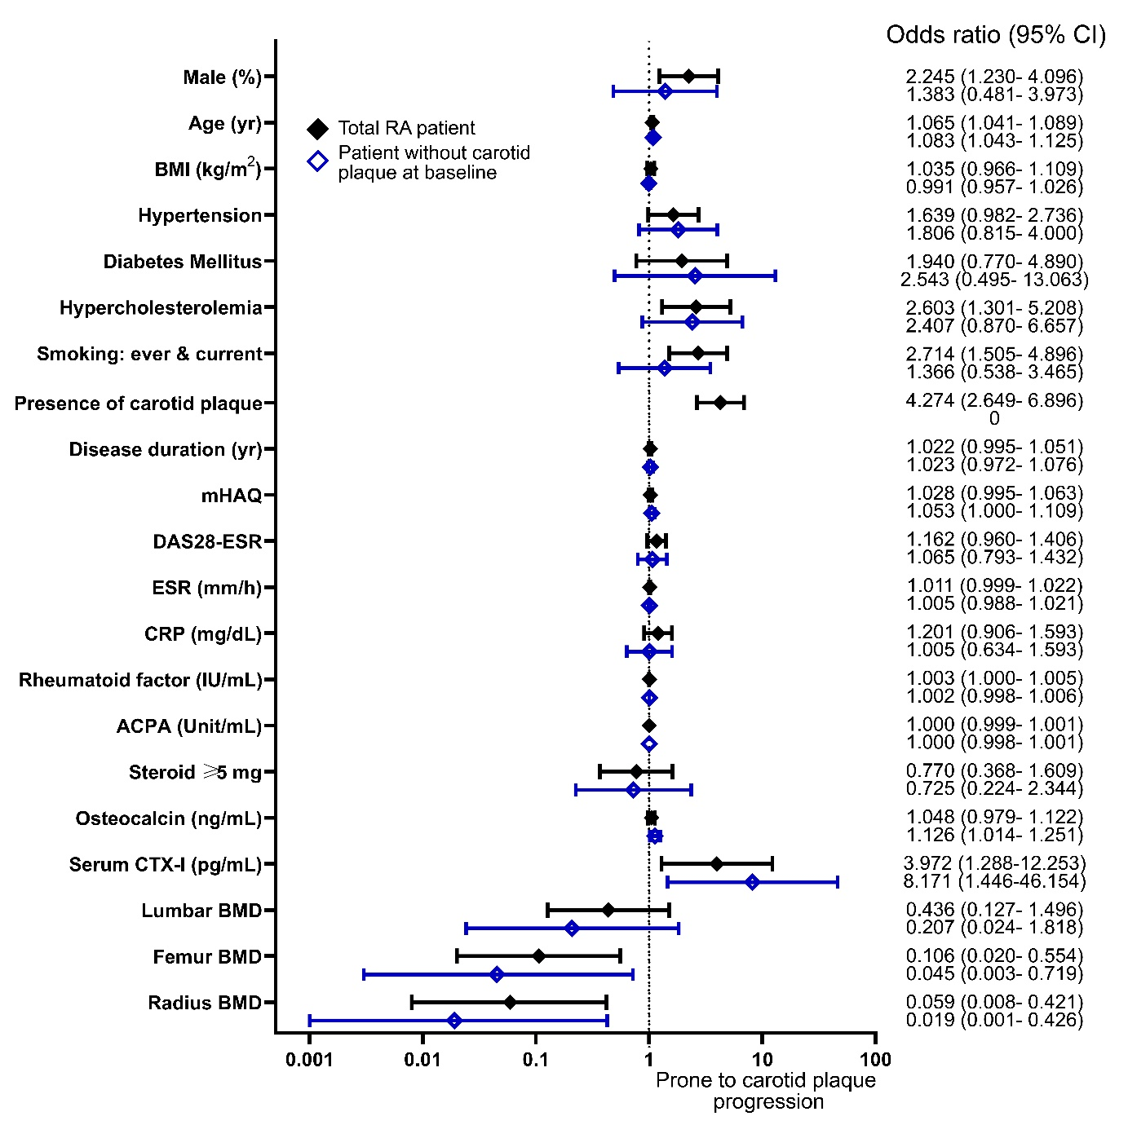
Supplementary figure 2. RA disease activity at baseline and changes in mean carotid IMT
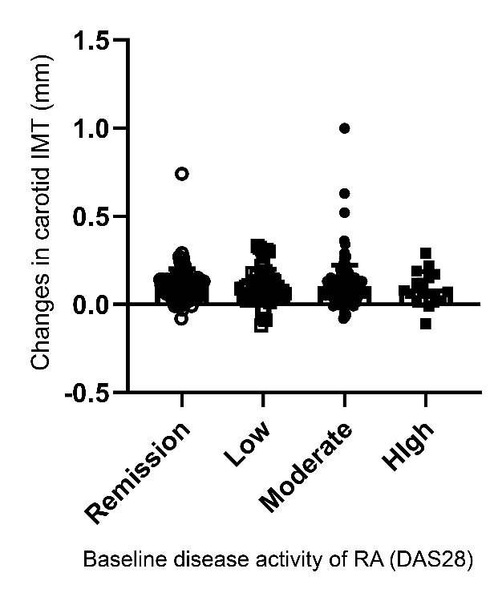

Supplementary Table 1. Disease activity and the progression of carotid plaque in RA patients
DAS28-ESR | Remission (<2.6) | Low  (2.6–3.2) | Moderate  (3.21–5.1) | High (> 5.1) | Total
Aggravation of carotid plaque | 37/90 (41.1) | 29/63 (46.0) | 61/138 (44.2) | 10/17 (58.8) | 137/308
Newly developed carotid plaque | 16/58 (27.6) | 11/31 (35.5) | 19/73 (26.0) | 3/7 (42.9) | 48/169

