Supplemental Information

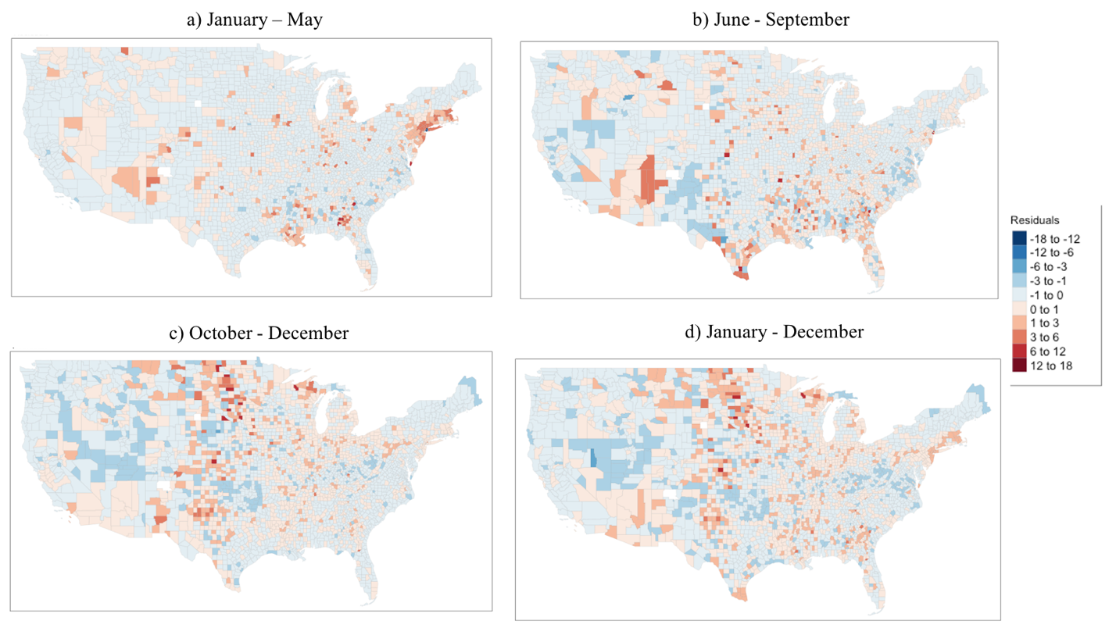
Figure S1: Spatial distribution of residuals for OLS models

