Table S1. Detailed information for the primers used in this study.
Fragments | Primer name | Sequence(5’-3’) | Position | Sizes (bp)
for CTV detection | CTV CP-F | CTGCTTTAAGGGTCGTTAATTG | 16076-16097 | 770
for CTV detection | CTV CP-R | TGAAACTCCACCATCCCGAT | 16845-16826 | 770
1 | JY-1F | TCCTCTCGACGCTCCACATTCAGG | 343-366 | 2132
1 | JY-1R | ACTCGTTTATAGGCGCGCTCT | 2475-2455 | 2132
2 | JY-2F | GTCGTCTCCCCATTTCCCGTTGC | 2184-2206 | 2468
2 | JY-2R | TATCCTCACACGGAACGATTTCGGAAG | 4652-4626 | 2468
3 | JY-3F | TCTGTCCGACCCCTTACTTACGAT | 4444-4467 | 1759
3 | JY-3R | GACACCCGACGACAAAATTGGACA | 6203-6180 | 1759
4 | JY-4F | TAAGGAAGCGTGTATCACCTTCGT | 5620-5643 | 1890
4 | JY-4R | CCCATCGCAAACTAACGTCGACT | 7510-7488 | 1890
5 | JY-5F | CCTTTCGAGTTATTCCGGTTTGCGTGT | 7124-7150 | 2572
5 | JY-5R | AGTTGGTAATTTGCTCCTCCACCGA | 9696-9672 | 2572
6 | JY-6F | TGCTGCTGTTATCGAACGTTGCTT | 9518-9541 | 2459
6 | JY-6R | TAACTGGCTTAGTCGTACACCGAT | 11977-11954 | 2459
7 | JY-7F | TCGCTATCGTTGTCCCAAACACT | 11614-11636 | 2126
7 | JY-7R | TCGAAACAACGATCCCCAGACGTGA | 13740-13764 | 2126
8 | JY-8F | CCACCAGAAAATTGTTGAGGCTTAGCG | 13534-13560 | 2610
8 | JY-8R | TGTCTCGTCGTCCATGATTCAAACCT | 16144-16119 | 2610
9 | JY-9F | TACCGATAGAGAGACTCCTAATGCTT | 15739-15764 | 1432
9 | JY-9R | AGAATCATCAACATTAGTACCCACGA | 17171-17146 | 1432
10 | JY-10F | TGCGTTACACGTTCCTAGCGAAGACA | 16877-16902 | 1468
10 | JY-10R | AACAACAAGTTCTTCGAATTGGTCAG | 18345-18320 | 1468
5’ | 5’RACE JY-1 | CAGGTCGGCGGTTAGTTCGGGTTG | 659-636 | 659
5’ | 5’RACE JY-2 | CAGATTCCCGCTTTGCCTGACGAA | 509-486 | 509
3’ | 3’RACE JY-1 | GTCAACCGTTTGCAGTCAGTTCGAT | 18230-18254 | 658
3’ | 3’RACE JY-2 | TCGATGCTTTGATACGGAAAACCAGT | 18500-18525 | 467

Table S2. Averaged nucleotide and amino acid sequence identities for JY genotype with other extant CTV genotypes.
Genotypeª | VT |  | T30 |  | T3 |  | T68 |  | HA16-5 |  | S1 |  | L1 |  | A18 |  | M1 |  | T36 |  | RB
ORF^{c} | nt^{b} | aa^{b} | nt^{b} | aa^{b} | nt^{b} | aa^{b} | nt^{b} | aa^{b} | nt^{b} | aa^{b} | nt^{b} | aa^{b} | nt^{b} | aa^{b} | nt^{b} | aa^{b} | nt^{b} | aa^{b} | nt^{b} | aa^{b} | nt^{b} | aa^{b}
p33 | 82.9 | 83.8 | 83.0 | 83.5 | 83.2 | 83.2 | 82.9 | 82.8 | 82.6 | 83.2 | 81.2 | 80.5 | 85.4 | 83.8 | 83.8 | 83.8 | 85.9 | 82.5 | 80.8 | 80.9 | 83.1 | 81.8
p6 | 93.6 | 98.0 | 94.9 | 98.0 | 92.9 | 98.0 | 94.9 | 98.0 | 91.7 | 96.1 | 87.2 | 98.0 | 92.3 | 96.1 | 95.5 | 98.0 | 90.4 | 94.1 | 86.5 | 94.1 | 95.5 | 96.1
p65 | 89.9 | 96.6 | 87.6 | 93.4 | 89.4 | 96.1 | 89.7 | 95.6 | 88.2 | 93.4 | 88.0 | 94.3 | 89.9 | 94.1 | 90.8 | 95.6 | 90.8 | 95.1 | 88.3 | 93.8 | 89.1 | 95.1
p61 | 87.0 | 91.0 | 87.3 | 90.8 | 87.0 | 91.5 | 86.7 | 89.5 | 87.3 | 89.1 | 87.7 | 91.2 | 86.8 | 92.5 | 88.9 | 92.9 | 88.2 | 92.5 | 87.6 | 91.0 | 88.8 | 90.0
p27 | 87.7 | 94.2 | 87.8 | 93.3 | 87.5 | 93.8 | 87.7 | 94.6 | 87.3 | 93.8 | 89.1 | 94.6 | 89.4 | 92.1 | 88.9 | 94.6 | 90.2 | 92.1 | 86.7 | 92.1 | 87.8 | 94.2
p18 | 87.9 | 93.4 | 88.5 | 93.4 | 88.9 | 92.2 | 88.1 | 94.0 | 88.7 | 92.2 | 90.1 | 94.0 | 91.1 | 92.2 | 90.3 | 95.8 | 89.7 | 92.2 | 88.7 | 92.2 | 89.3 | 93.4
p13 | 88.6 | 88.2 | 88.9 | 89.1 | 89.7 | 89.1 | 88.9 | 89.9 | 89.4 | 85.7 | 90.3 | 89.1 | 90.6 | 89.1 | 90.8 | 89.1 | 87.8 | 89.9 | 89.2 | 88.2 | 90.3 | 88.2
p20 | 90.2 | 94.0 | 88.9 | 90.7 | 88.7 | 92.9 | 90.5 | 94.5 | 88.2 | 94 | 90.0 | 92.9 | 90.3 | 93.4 | 89.1 | 92.9 | 90.7 | 95.1 | 88.9 | 93.4 | 89.4 | 92.3
p23 | 90.6 | 91.9 | 91.3 | 90.0 | 92.1 | 90.4 | 90.6 | 90.9 | 89.7 | 86.6 | 91.1 | 90.0 | 87.8 | 86.1 | 92.7 | 91.9 | 87.5 | 84.2 | 89.8 | 86.6 | 88.9 | 87.1
ª VT: T318A (DQ151548); T30:T385 (Y18420); T68: T68-1(JQ965169); S1:CA-S1-L (KU589212); T36: T36 (U16304); RB: NZRB-TH30 (FJ525434); A18: A18 (JQ798289); T3:T3 (KC525952); HA16-5: Taiwan-Pum/M/T5 (JX266713); M1:CN-M1-ZT1 (MH323442); L1: CN-L1-ZT1 (MH323441).
^{b} nt = nucleotide; aa = amino acid.
^{c} ORF, Open Reading Frame

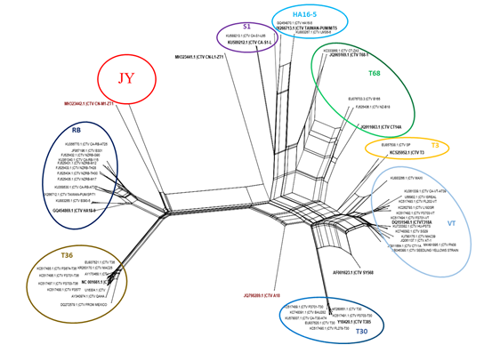
Fig. S1 Neighbor-network reconstruction of relationships among the complete genome nucleotide of representative isolates of the CTV. The consensus tree was obtained using SplitsTree4 software. An isolate for which the complete genomes were sequenced in the present study are indicated by ‘‘red’’.

Table S3 Location and origin of recombination events present in JY genotype of Citrus tristeza virus. Recombination events were identified based on analysis of 80 full-length CTV sequences available in the NCBI database and one in this study. NS no statistical difference recorded for this recombination event using RDP5 software (P < 0.01)
CTV isolate | Begin | End | Major parent | Minor parent | RDP | GENECONV | BootScan | MaxChi | Chimaere | SiScan | 3Seq
JY-2 | 17118 | 19303 | CN-M1-ZT1 | CTV_T385 | NS | NS | NS | 8.813×10⁻¹⁴ | 6.939×10⁻¹⁰ | 5.97×10⁻⁶ | 9.734×10⁻³
JY-2 | 18603 | 18855 | Unknown | CTV_T3 | 2.16×10⁻⁵ | 3.172×10⁻⁶ | 8.707×10⁻³ | 1.697×10⁻⁶ | 2.226×10⁻³ | 2.972×10⁻³ | NS
JY-2 | 15297 | 15633 | CN-M1-ZT1 | CTV_T3 | 5.952×10⁻⁶ | 6.451×10⁻⁷ | NS | NS | 4.822×10⁻⁷ | 3.029×10⁻⁵ | NS
A18 | 9357 | 10674 | CTV_T3 | JY-2 | 3.187×10⁻⁷⁵ | 2.396×10⁻⁴³ | 2.412×10⁻⁶⁰ | 5.161×10⁻²³ | 2.008×10⁻²⁶ | 1.173×10⁻²⁴ | NS

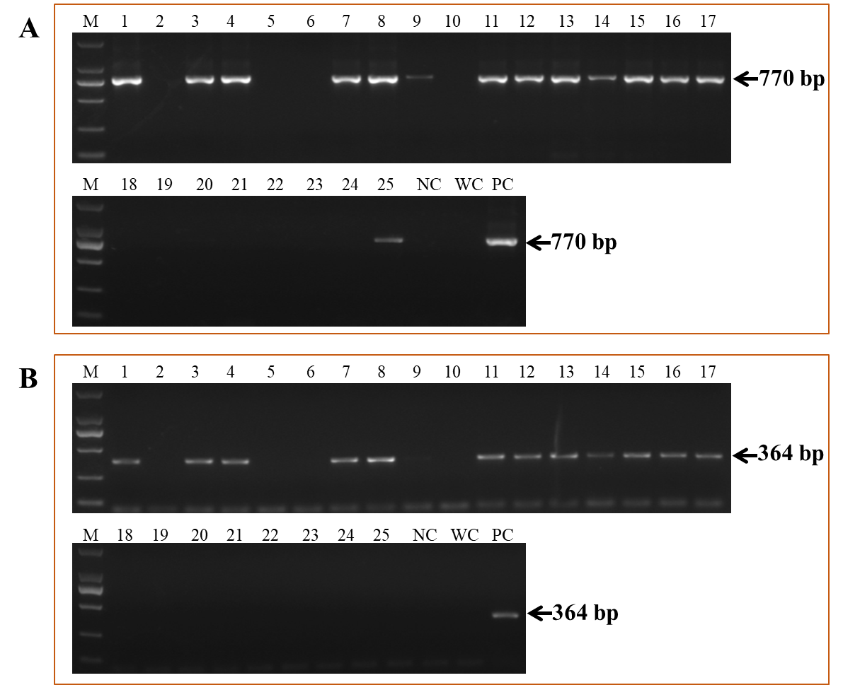
Fig. S2 A total of 25 wild citrus leaf samples (1~25) from Jiangyong (Hunan Province) were detected by RT-PCR using CTV-specific primer sets CTV CP-F/R (A) and CTV-JY-specific primer sets JY-7F/ 6R (B), respectively.M: DL2000 Maker; NC: negatively control. WC: RNase-free water control. PC: positively control.

