Appendix A
Databases searched | Search Results 20 December 2018
PubMed (789 items) | ("Social Stigma"[Mesh] OR stigma*[tiab] OR mental health belief*[tiab] OR patient belief*[tiab] OR patients belief*[tiab]) AND ("Transients and Migrants"[Mesh] OR "Emigrants and Immigrants"[Mesh] OR "Ethnic Groups"[Mesh] OR "Minority Groups"[Mesh] OR "Minority Health"[Mesh] OR "Refugees"[Mesh] OR "Refugee Camps"[Mesh] OR immigrant*[tiab] OR migrant*[tiab] OR ethnic*[tiab] OR minorit*[tiab] OR non-western[tiab] OR nonwestern[tiab] OR refug*[tiab] OR asylum[tiab]) AND ("Mental Disorders"[Mesh:noexp] OR "Stress, Psychological"[Mesh] OR "Mood Disorders"[Mesh:NoExp] OR "Anxiety Disorders"[Mesh] OR "Diagnostic and Statistical Manual of Mental Disorders"[Mesh] OR "Anxiety"[Mesh:NoExp] OR "Depression"[Mesh] OR "Depressive Disorder, Major"[Mesh] OR "Dysthymic Disorder"[Mesh] OR psychological distress[tiab] OR psychological stress[tiab] OR anxiety[tiab] OR anxieties[tiab] OR anxious[tiab] OR depress*[tiab] OR dysthymi*[tiab] OR phobi*[tiab] OR panic[tiab] OR common mental disorder*[tiab] OR "Stress Disorders, Traumatic"[Mesh:NoExp] OR "Stress Disorders, Post-Traumatic"[Mesh] OR "Stress Disorders, Traumatic, Acute"[Mesh] OR Acute Stress Disorder*[tiab] OR Post-Traumatic Stress Disorder*[tiab] OR PTSD[tiab] OR mood disorder*[tiab])
Embase (1015 items) | ('social stigma'/exp OR stigma*:ab,ti,kw OR 'mental health belief*':ab,ti,kw OR 'patient belief*':ab,ti,kw OR 'patients belief*':ab,ti,kw) AND ('migration'/exp OR 'migrant'/exp OR 'ethnic group'/exp OR 'minority group'/exp OR 'minority health'/exp OR 'refugee camp'/exp OR immigrant*:ab,ti,kw OR migrant*:ab,ti,kw OR ethnic*:ab,ti,kw OR minorit*:ab,ti,kw OR 'non-western':ab,ti,kw OR nonwestern:ab,ti,kw OR refug*:ab,ti,kw OR asylum:ab,ti,kw) AND ('mental disease'/de OR 'mental stress'/exp OR 'mood disorder'/de OR 'anxiety disorder'/exp OR 'diagnostic and statistical manual of mental disorders'/exp OR 'anxiety'/de OR 'depression'/de OR 'dysthymia'/exp OR 'major depression'/exp OR 'major affective disorder'/exp OR 'psychological distress':ab,ti,kw OR 'psychological stress':ab,ti,kw OR anxiety:ab,ti,kw OR anxieties:ab,ti,kw OR anxious:ab,ti,kw OR depress*:ab,ti,kw OR dysthymi*:ab,ti,kw OR phobi*:ab,ti,kw OR panic:ab,ti,kw OR 'common mental disorder*':ab,ti,kw OR 'acute stress disorder*':ab,ti,kw OR 'post-traumatic stress disorder*':ab,ti,kw OR ptsd:ab,ti,kw OR 'mood disorder*':ab,ti,kw)
PsycINFO (846 items) | ( DE "Stigma" OR TI (stigma* OR "mental health belief*" OR "patient belief*" OR "patients belief*") OR AB (stigma* OR "mental health belief*" OR "patient belief*" OR "patients belief*") ) AND ( DE "Human Migration" OR DE "Refugees" OR DE "Asylum Seeking" OR DE "Immigration" OR DE "Racial and Ethnic Groups" OR DE "Minority Groups" OR TI (immigrant* OR migrant* OR ethnic* OR minorit* OR "non-western" OR nonwestern OR refug* OR asylum) OR AB (immigrant* OR migrant* OR ethnic* OR minorit* OR "non-western" OR nonwestern OR refug* OR asylum) ) AND ( DE "Mental Disorders" OR DE "Psychological Stress" OR DE "Diagnostic and Statistical Manual" OR DE "Anxiety Disorders" OR DE "Acute Stress Disorder" OR DE "Panic Disorder" OR DE "Phobias" OR DE "Post-Traumatic Stress" OR DE "Posttraumatic Stress Disorder" OR DE "Anxiety" OR DE "Affective Disorders" OR DE "Major Depression" OR DE "Dysthymic Disorder" OR DE "Depression (Emotion)" OR TI ("psychological distress" OR "psychological stress" OR anxiety OR anxieties OR anxious:ab,ti,kw OR depress* OR dysthymi* OR phobi* OR panic OR "common mental disorder*" OR "Acute Stress Disorder*" OR "Post-Traumatic Stress Disorder*" OR PTSD OR "mood disorder*") OR AB ("psychological distress" OR "psychological stress" OR anxiety OR anxieties OR anxious:ab,ti,kw OR depress* OR dysthymi* OR phobi* OR panic OR "common mental disorder*" OR "Acute Stress Disorder*" OR "Post-Traumatic Stress Disorder*" OR PTSD OR "mood disorder*") )

Appendix B

Vignette and Manipulation

J.S. was a typical man who enjoyed going out to dinner after work with his coworkers, and playing sports on the weekend with his friends. Recently, he started feeling very down and unhappy. After he found it very hard to get out of bed, get dressed, go to work, or do anything for several weeks, he decided to go see a psychiatrist. The psychiatrist asked him about his symptoms, which included not getting any pleasure out of things he normally would and having trouble sleeping and eating. At times, he would also feel completely worthless and even had thoughts about killing himself.

Genetic condition:
Because of J.S.’s symptoms, the psychiatrist diagnosed him with depression and recommended that he enroll in treatment. Many experts and doctors also tested to see what had caused J.S.'s problem. After many assessments, the doctors found no imbalance of brain chemicals, and no significant childhood or recent events that could have contributed to the onset of depression. But experts in genetics did find a genetic predisposition and family history of depression, and the majority of doctors concluded that J.S.'s problem was largely due to J.S.'s genes (i.e., genetic factors).

Neurobiological condition:
Because of J.S.’s symptoms, the psychiatrist diagnosed him with depression and recommended that he enroll in treatment. Many experts and doctors also tested to see what had caused J.S.'s problem. After many assessments, the doctors found no genetic predisposition or family history of mental illness, and no significant childhood or recent events that could have contributed to the onset of depression. But experts in neurobiology did find an imbalance of brain chemicals and the majority of doctors concluded that J.S.'s problem was largely due to the imbalance of brain chemicals (i.e., neurobiological factors).

Social condition:
Because of J.S.’s symptoms, the psychiatrist diagnosed him with depression and recommended that he enroll in treatment. Many experts and doctors also tested to see what had caused J.S.'s problem. After many assessments, the doctors found no genetic predisposition or family history of mental illness, and no imbalance of brain chemicals. But experts did find that J.S. had gone through many significant events, such as losing his best friend at a young age and a recent divorce that could have contributed to the onset of depression. The majority of doctors concluded that J.S.'s problem was largely due to his childhood and recent events (i.e., social factors).

Control condition:
Because of J.S.’s symptoms, the psychiatrist diagnosed him with depression and recommended that he enroll in treatment. Many experts and doctors also tested to see what had caused J.S.'s problem. After many assessments, the majority of doctors were not able to come to a decision about what had caused J.S.'s problem.

Correspondence should be addressed to Zhen H. Cheng, Department of Psychology, University of Oregon, Eugene, OR 97403. E-mail: zcheng@uoregon.edu

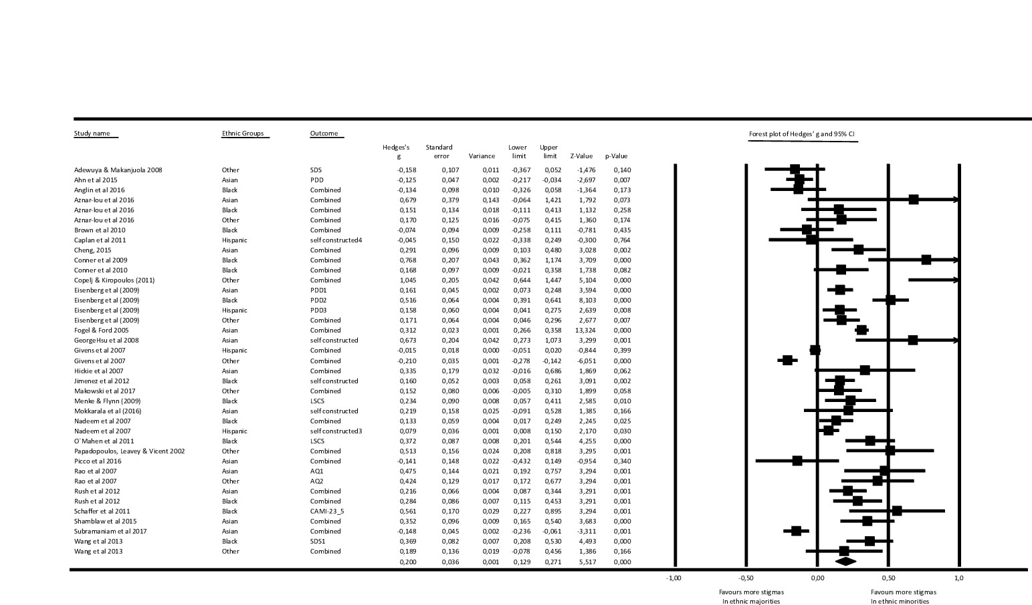
Appendix C

Appendix D
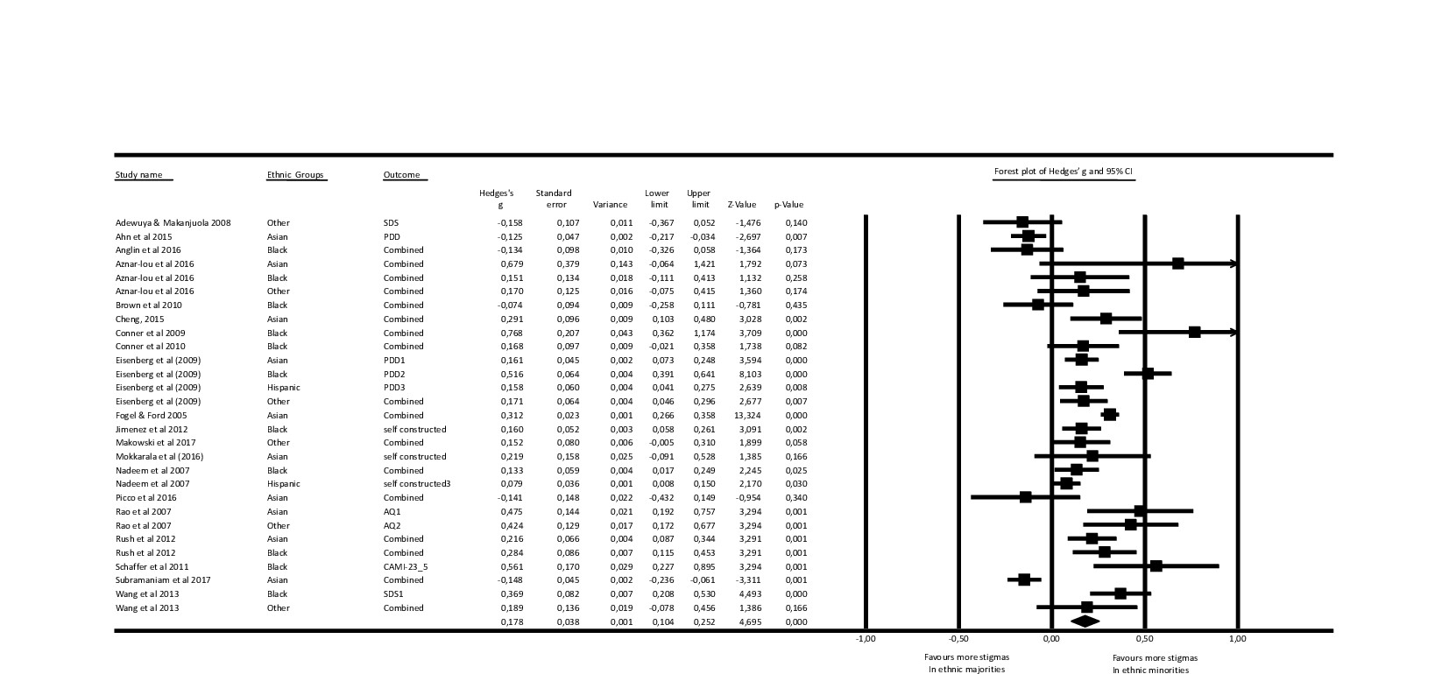

Appendix E
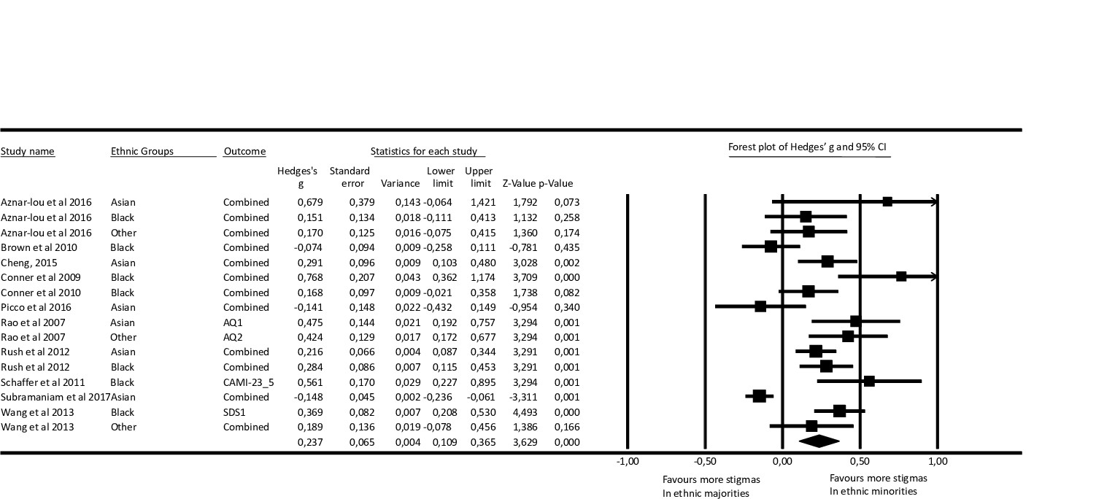

Appendix F
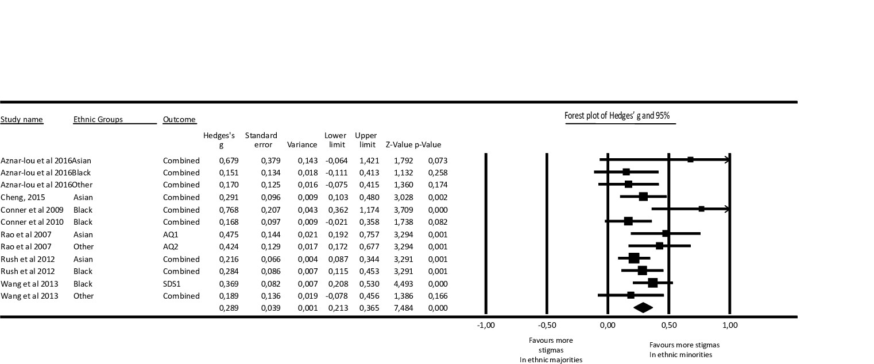

Appendix G
