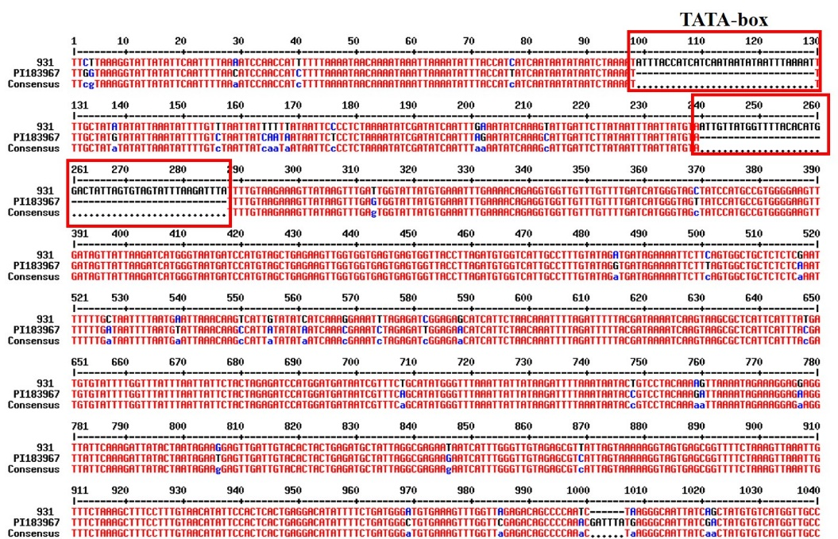
Supplementary information
Fig. S1 Variations in the 5’ regulatory regions of candidate gene Csa6G046210 between the two parentals ‘931’ and ‘PI183967’. The TATA box motifs are marked in red squares.

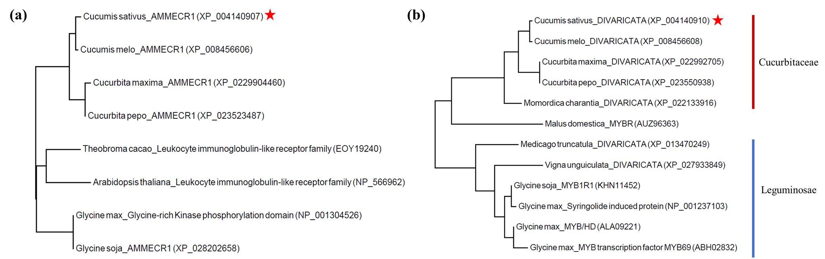
Fig. S2 Results of a phylogenetic analysis of (a) Csa6G046210 and (b) Csa6G046240. The phylogenetic trees were derived from an analysis of the predicted amino acid sequences of the two candidate genes and their orthologues in the Cucurbitaceae and the Leguminosae. Csa6G046210 is annotated as an AMMECR1, and Csa6G046240 as a DIVARICATA protein. Protein sequences were retrieved from the National Center for Biotechnology Information (NCBI). The red pentagrams indicate the cucumber candidate genes identified in this study.

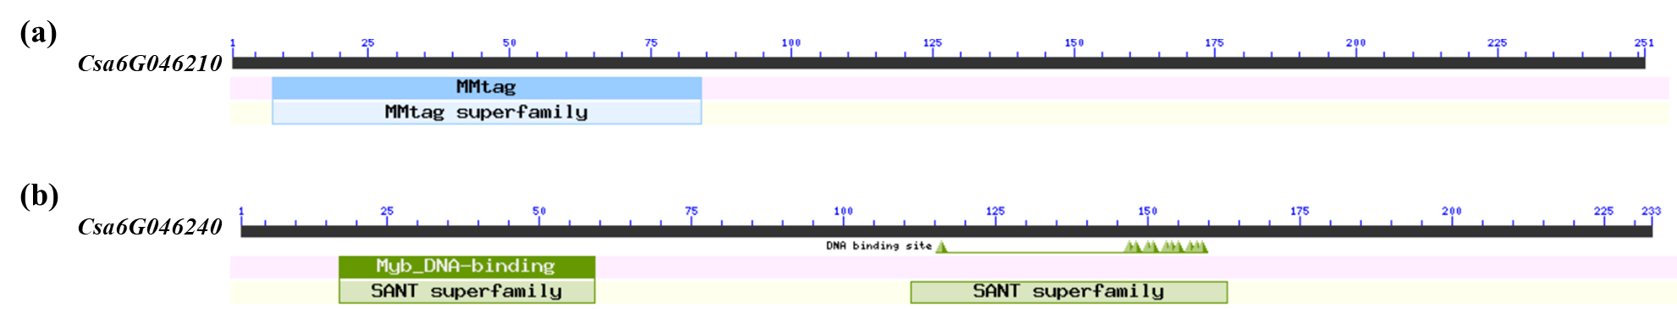
Fig. S3 The conserved structural domain of the predicted amino acid sequence of candidate genes, (a) Csa6G046210 and (b) Csa6G046240.

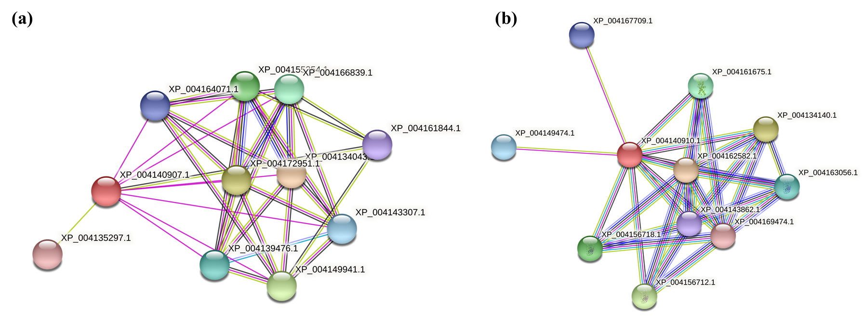
Fig. S4 Predicted protein-protein interactions using the predicted amino acid sequence of (a) Csa6G046210 and (b) Csa6G046240 as the query sequence against the STRING database. Predicted polypeptide sequence XP_004140907.1 is encoded by Csa6G046210 and predicted polypeptide sequence XP_004140910.1_is encoded by Csa6G046240.

Table S1 Information of markers within gsb-s6.2 used in this study
Marker | Physical position (bp)
SSR04083 | 3,212,336
MarkerG19684 | 3,424,481
MarkerG19776 | 3,596,635
MarkerP23383 | 3,941,992
MarkerG19886 | 3,984,480
SSR15245 | 4,045,026
CSWCT10 | 4,342,789
MarkerG19974 | 4,438,998
MarkerP23536 | 4,546,050
MarkerG20046 | 4,631,454
SSR16020 | 5,421,428

Table S2 Primers developed for fine mapping of gsb-s6.2
Primer Name | Physical position  (bp) | Forward primer (5’→3’) | Reverse primer (5’→3’) | Type
SSR04083 | 3,212,336 | TCTTTGGATTGCTAGGTTGACA | GTAAAGTTGGGTGTGGTGGG | SSR
gsb6.2-22 | 3,593,286 | ATCTCCCAAGTCTCAAGGCT | TTGCTAAGCCTAGTCCTCGT | InDel
gsb6.2-reIndel3 | 3,671,399 | AGTCCTATAAAACCGTCCTTCA | AAAGGCCAACTCATTCAACT | InDel
gsb6.2-Indel7 | 3,672,746 | TTCAAAGGATGCCATGTCAC | TGGGGAATCTCACAACTCGA | InDel
gsb6.2-Indel1 | 3,699,335 | TTAACGGTTCTTGTCCAGGG | TGGTTTCTTGTTCCATCTTCCA | InDel
gsb6.2-reSNP2 | 3,705,010 | ACACACGGCAGTCATGTTTA | GGATGATGCTAGCACTTTTCC | SNP
gsb6.2-Indel2 | 3,711,438 | CGCCGTCGTTCTAATCATCA | CGGATCTCCTGGTTCTGTGA | InDel
gsb6.2-Indel3 | 3,765,635 | TCGATTCGTGCTTTGCTACA | CAAAATTCCGTGTTCTTCT | InDel
gsb6.2-4 | 3,782,125 | CTGTGTCGCTGTCTCTTCCT | TTGAACAACTCCAAGCGGTG | InDel
gsb6.2-6 | 4,017,385 | AGGGACCATTTGACCAATTGA | TGTGATGTTTAGCCGATTGT | InDel
gsb6.2-12 | 4,971,080 | CGCTTAACCCGCTTGTTCTT | TCACCAAGCAAACCTCAACC | InDel
SSR02940 | 5,125,572 | GAGAGAGGGCATAGTTTTTGC | TCCTTCTCCTGTTGTGTGTGA | SSR

Table S3 Primers of candidate genes for qRT-PCR analysis
Primer name | Forward primer (5’→3’) | Reverse primer (5’→3’)
qCsa3G020050 | GCTCAAGTCTATCATCCTGACA | ATTTCGTATGCTTCGCAGATTC
qCsa3G020060 | ACTACTTTTACTATGCTCCCGG | CCGGTATTTTCTTCAATCCGTC
qCsa3G020070 | ATCAATGCTGGGTCAGGATTTA | TGAATTTTAGCTAACGTGCGAG
qCsa3G020080 | GACCATGATGATCGTTCTGTTG | ACATTACCTCCGAAACCAGAAT
qCsa3G020090 | TAGGAGCAGGATCAAGGAGG | TACAGATTCGCAGGCAAGTC
qCsa3G020590 | ATGAGTTGCAATGGTTGTCG | TCGCAGTTGTTCATTTGGGA
qCsa6G045200 | GATGAGTCAGAAAGGCCTGATA | ATTCCCTGAGAATGATGTGTGT
qCsa6G046200 | GTGCATAGGAACTCTAGAAGCT | CTAGCATTATAATCGGGGTCGT
qCsa6G046210 | GATTCTAGTTCTCTCCAGCCTG | CCTCTTCTTTTGCATTCCTAGC
qCsa6G046220 | AGGCCATTCTGTTTCTTGGT | TGGTTCCGTCGGTTCATTTT
qCsa6G046230 | CGAGTGCTTAGTGAGGAGGA | ACTGGGTCCCTTCATGTTTC
qCsa6G046240 | GTCGAGTTGAGTTACCGAGTTA | GGATCCAAAAGAGATCTGTCCA

Table S4 Protein-protein interaction information of Csa6G046210
Node | Identifier | Annotation
XP_004134043.1 | 3659.XP_004134043.1 | U-box domain-containing protein 72-like
XP_004135297.1 | 3659.XP_004135297.1 | Signal recognition particle 72 kDa protein-like
XP_004139476.1 | 3659.XP_004139476.1 | Protein BUD31 homolog 1-like isoform
XP_004140907.1 | 3659.XP_004140907.1 | Multiple myeloma tumor-associated protein
XP_004143307.1 | 3659.XP_004143307.1 | Bud site selection protein
XP_004149941.1 | 3659.XP_004149941.1 | WD repeat-containing protein
XP_004155354.1 | 3659.XP_004155354.1 | Pre-mRNA-processing factor 17-like
XP_004161844.1 | 3659.XP_004161844.1 | AP-3 complex subunit delta-like
XP_004164071.1 | 3659.XP_004164071.1 | Protein BUD31 homolog 2-like
XP_004166839.1 | 3659.XP_004166839.1 | Wd repeat-containing protein
XP_004172951.1 | 3659.XP_004172951.1 | U-box domain-containing protein 72-like

Table S5 Protein-protein interaction information of Csa6G046240
Node | Identifier | Annotation
XP_004134140.1 | 3659.XP_004134140.1 | Heat shock 70 kda protein 8-like
XP_004140910.1 | 3659.XP_004140910.1 | Transcription factor DIVARICATA-like
XP_004143862.1 | 3659.XP_004143862.1 | Endoplasmic reticulum chaperone BIP
XP_004149474.1 | 3659.XP_004149474.1 | Uncharacterized protein LOC101213463
XP_004156712.1 | 3659.XP_004156712.1 | Heat shock cognate 70 kDa protein-like isoform 1
XP_004156718.1 | 3659.XP_004156718.1 | Heat shock cognate 70 kDa protein-like isoform 1
XP_004161675.1 | 3659.XP_004161675.1 | Heat shock protein 70
XP_004162582.1 | 3659.XP_004162582.1 | Heat shock 70 kDa protein 17-like
XP_004163056.1 | 3659.XP_004163056.1 | Heat shock 70 kDa protein-like
XP_004167709.1 | 3659.XP_004167709.1 | Uncharacterized protein LOC101225796
XP_004169474.1 | 3659.XP_004169474.1 | Heat shock protein 70 family

