Supporting Information

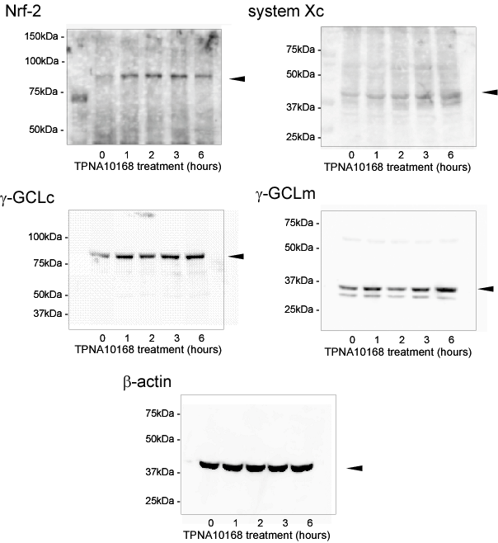

Supplementary Figure 1. Whole uncropped immunoblot images of Nrf2, system Xc, γ-GCLc, γ-GCLm and β-actin:
Cultured mouse astrocytes were treated with 30μM TPNA10168 for the time indicated and cell lysate was prepared as described in Materials and Methods. Typical uncropped immunoblot images are preented
. SDS-PAGE for Nrf-2 and γ-GCLc was run on a 7.5% acrylamide gel, and that for system Xc, γ-GCLm and β-actin was on a 10% acrylamide gel. As a molecular weight marker, BioRad Precision Plus Dual standard marker (cat#161-0374) was used. Arrow heads indicate the protein bands that were subjected to densitometric analysis.

