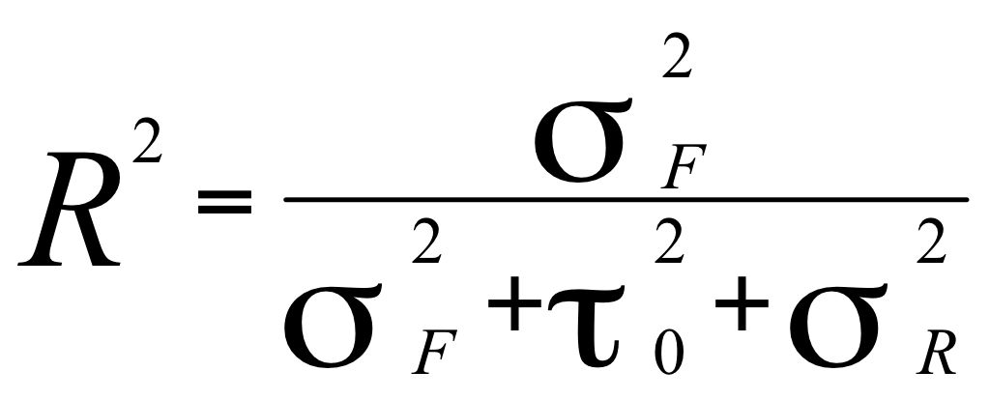
Where: 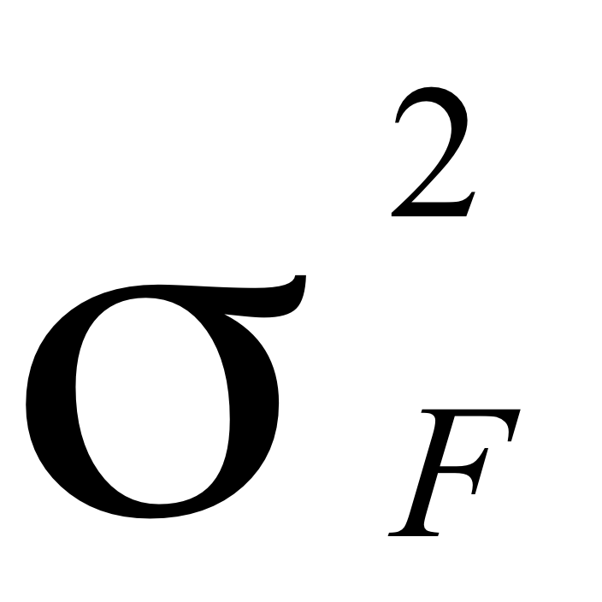 is the explained part of the total variance
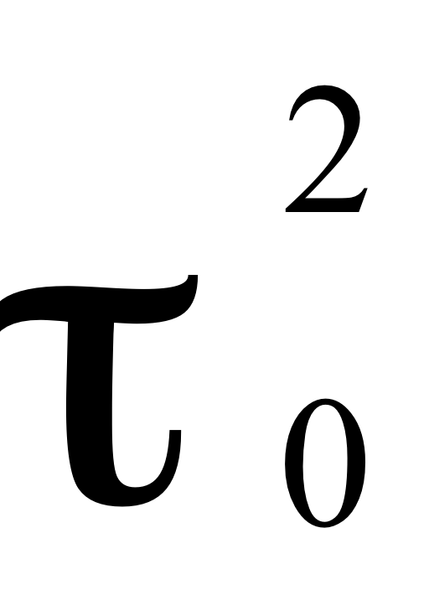 is the unexplained variance at the neighbourhood level
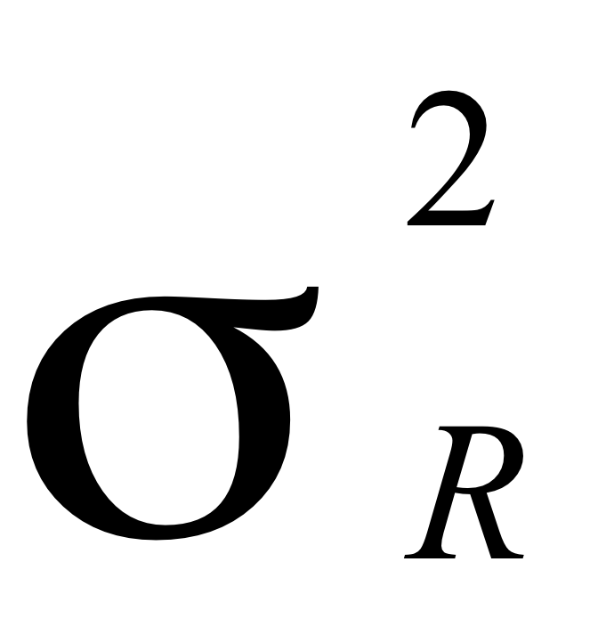 is the unexplained variance at the individual level (assumed to be π²/3 = 3.29).

