Ordered Mesoporous Silica (SBA-15) Anchored Tungsten and Molybdenum Aminophenolate Complexes: as Efficient and Reusable Catalysts for Selective Oxidation of Sulfides with H₂O₂

Iraj Saberikia¹, Elham Safaei^{*2}, Babak Karimi¹
¹Institute for Advanced Studies in Basic Sciences (IASBS), 45137-66731, Zanjan, Iran
²Department of Chemistry, College of Sciences, Shiraz University, Shiraz, 71454, Iran

Correspondence
Elham Safaei, Department of Chemistry, College of Sciences, Shiraz University, Shiraz, 71454, Iran
Email: e.safaei@shirazu.ac.ir

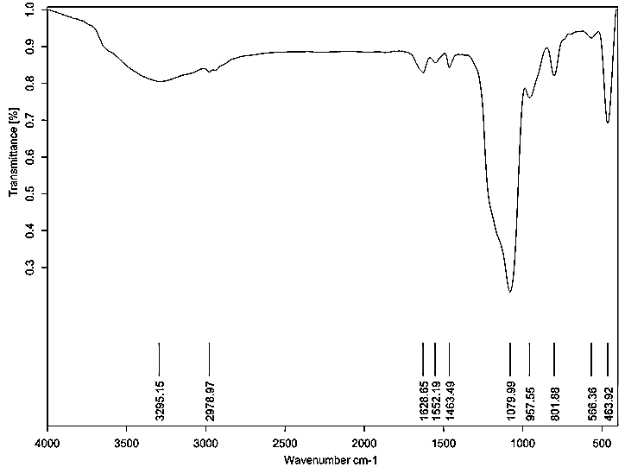
Fig. S1: FT-IR spectra of SBA-15@AP-L^{Pro}-Mo

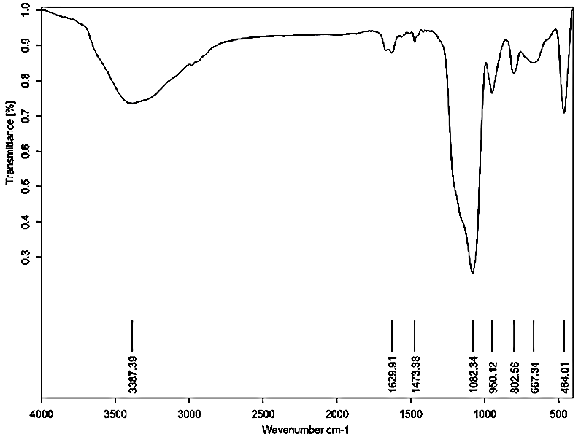
Fig. S2: FT-IR spectra of SBA-15@AP-L^{Pro}-W

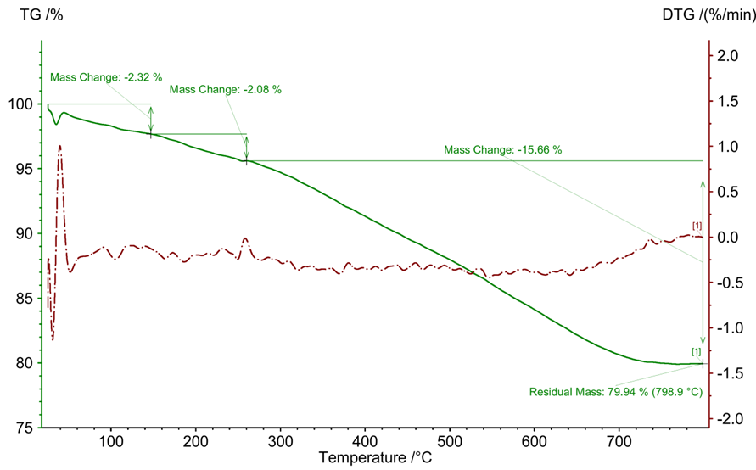
Fig. S3: Thermo-gravimetric analysis (TGA) of SBA-15@AP-L^{Pro}-Mo

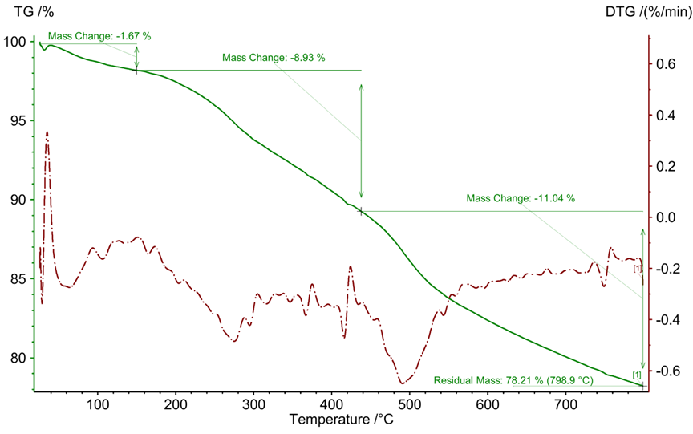
Fig. S4: Thermo-gravimetric analysis (TGA) of SBA-15@AP-L^{Pro}-W

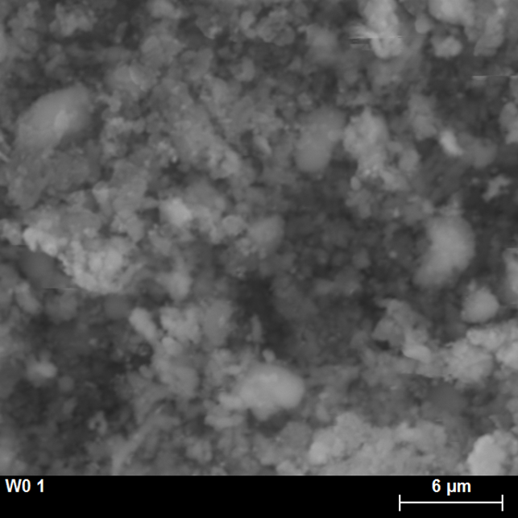
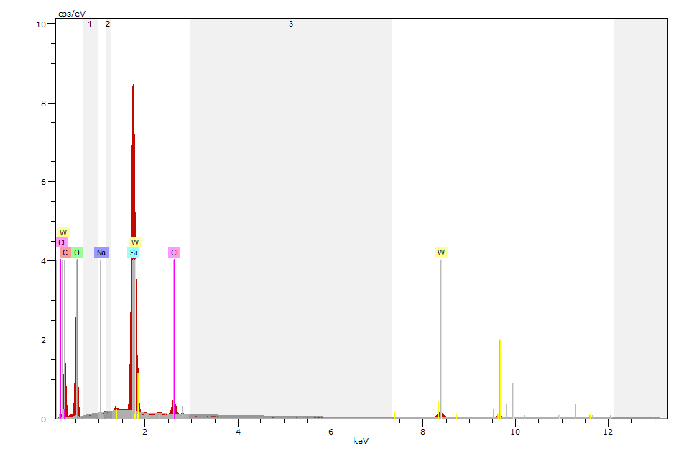
Fig. S5: SEM-EDX spectra of SBA-15@AP-L^{Pro}-Mo

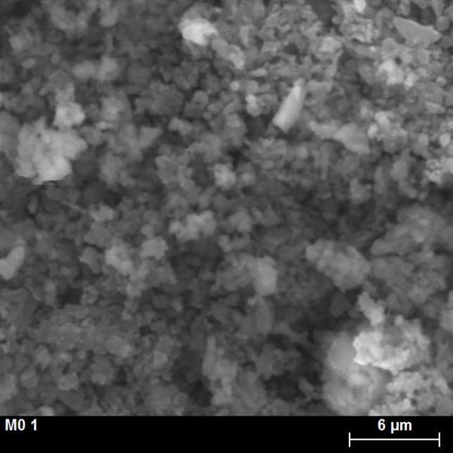
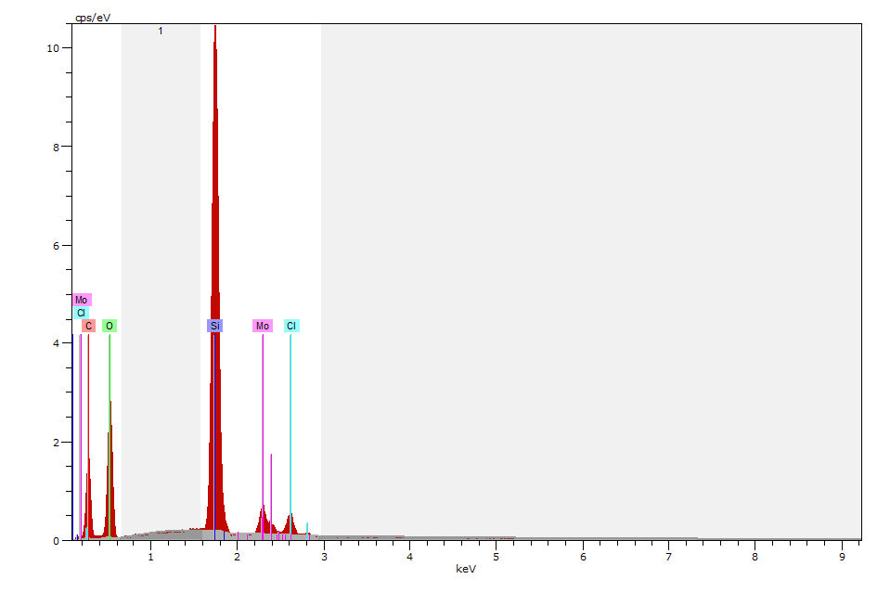
Fig. S6: SEM-EDX spectra of SBA-15@AP-L^{Pro}-Mo

Table S1: Textural properties of SBA-15, SBA-15@AP, SBA-15@AP-LPro-Mo and SBA-15@AP-LPro-W
Material | S_{BET} ª  (m²g⁻¹) | V_{p} ^{b}  (cm³g⁻¹) | D_{BJH} ^{c}  (nm) | Loading of M (M= Mo & W) (mmol.g⁻¹)^{e}
SBA-15@AP | 660 | 0.9 | 7.06 | -
SBA-15@AP-L^{Pro}-Mo | 406 | 0.72 | 7.04 | 0.32
SBA-15@AP-L^{Pro}-W | 372 | 0.57 | 9.20 | 0.41
Re-SBA-15@AP-L^{Pro}-Mo | 315 | 0.56 | 7.91 | 0.29
Re-SBA-15@AP-L^{Pro}-W | 197 | 0.40 | 6.18 | 0.38

[a] S_{BET} = specific surface area derived from linear part of adsorbed nitrogen in the range from 0.05 to 0.3.
[b] V_{p} = pore volume derived from adsorbed nitrogen from relative pressure ≈ 0.99.
[c] D_{BJH} = pore size distributions calculated from the adsorption branch using BJH method.
[d] Calculated using elemental analysis (CHN).
[e] Estimated by ICP techniques.
[f] Estimated after 5 run.

