Supplementary Information

Analysis of single molecules on a gold surface
To understand the chemical structure of single molecules frequently observed on a Au(111) surface, which do not participate in the formation of the chains, we have carried out a comparative study of experimental and simulated high-resolution AFM images of possible candidates on a Au(111) surface. As shown by Siri et al.¹⁵ hydrogenation of benzoquinonediimine ligands (see Supp. Fig. 1a) results in delocalization of one of the formerly localized 6π-electron conjugated systems. Therefore, we considered three possible models: i) a hydrogenated DABQDI (Supp. Fig. 1b); ii) an intact DABQDI (Supp. Fig. 1c) and iii) a dehydrogenated DABQDI molecule (Supp. Fig. 1d) The simulated AFM images were calculated with the PP-AFM toolkit using fully optimized structures deposited on a Au(111) surface obtained from total energy DFT simulations.
Supp. Fig. 1b shows the optimized structure of a hydrogenated precursor and the simulated AFM images at two different tip-sample heights. The simulated AFM images agree very well with the experimental images of single molecular species observed on the sample surface (Fig. 2a). The asymmetry in the nc-AFM signal contrast arises due to the adsorption height difference (side view on right panel of Supp. Fig. 1b). We consider two possible sources of the additional hydrogen – either a hydrogen transferred from other molecules or residual hydrogen gas in the UHV system. In the STM overview images, we have observed step edges decorated with clusters of undistinguishable molecular residues. These could potentially be dehydrogenated molecular units; however, we were not able to fully experimentally confirm either of these scenarios.
On the other hand, the calculated AFM images of a single DABQDI molecule fit well to the experimental AFM images acquired after deposition of DABQDI precursors onto the Au(111) substrate held at 5 K. (see Supp. Fig. 1c). In the case of the dehydrogenated DABQDI molecule Supp. Fig. 1d), we could not find any experimental counterparts.

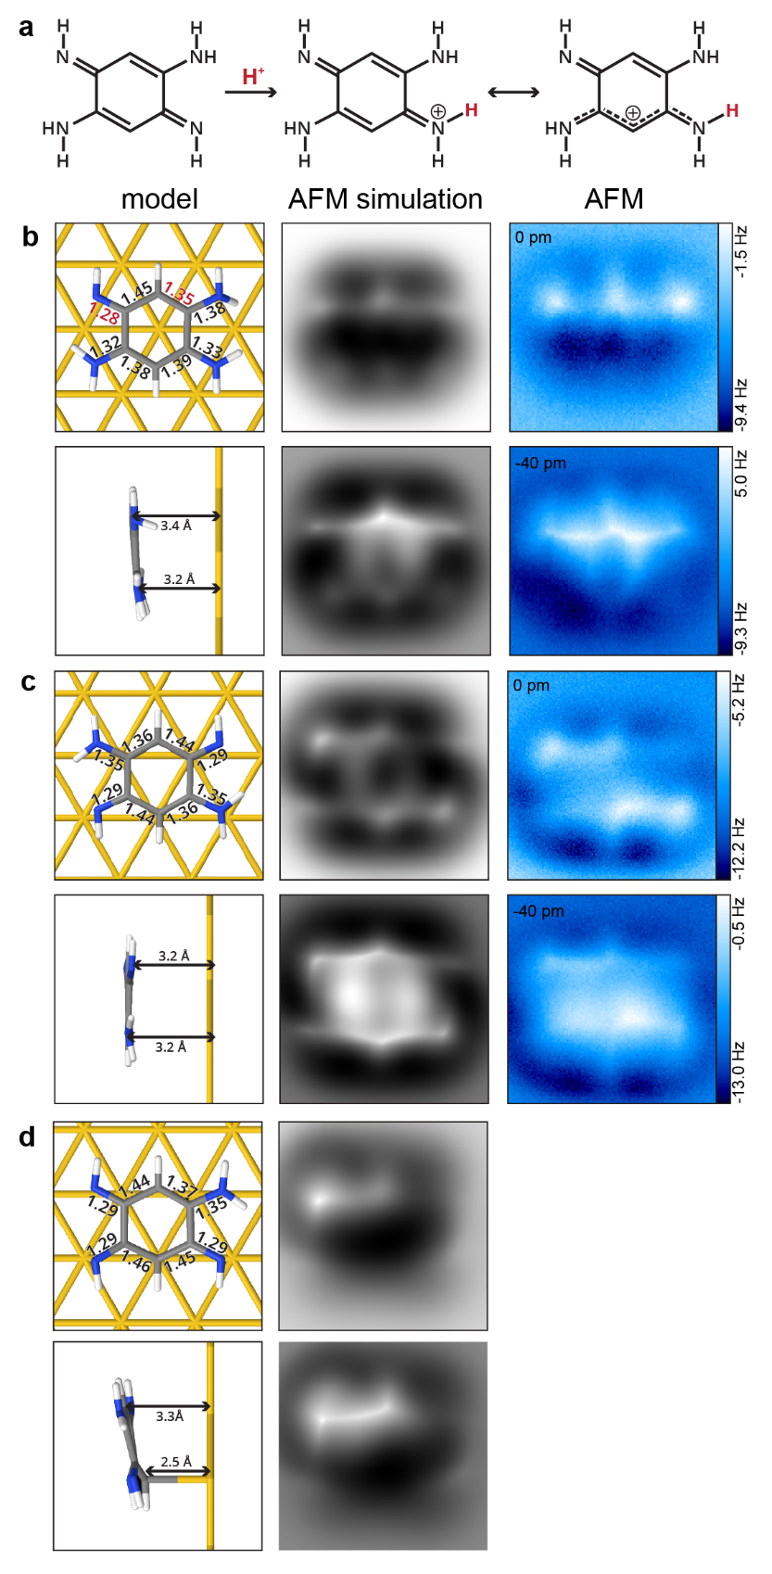
Supplementary figure 1: a) Protonation reaction of 2,5-diamino-1,4-benzoquinonediimine. b) DFT calculated structure, simulated AFM images and assigned experimental AFM images acquired at two distinct tip heights of C₆N₄H₉ (deposition on a sample kept at RT). Comparison of interatomic distances in the model confirms the delocalization of the protonated conjugated system. The contrast asymmetry in the AFM images stems from the adsorption height difference. c) DFT calculated structure, simulated AFM images and assigned experimental AFM images acquired at two distinct tip heights of C₆N₄H₈ (deposition on a cold sample - 4 K). In this case the AFM image exhibits symmetric contrast. d) DFT calculated structure and simulated AFM image of C₆N₄H₇. The species was never experimentally observed.

Supporting arguments to exclude metal-organic Au-DABQDI as the symmetric chains
Here we provide a series of arguments to rule out the presence of gold atoms in the linear chains.
- Observation of defective chains with incorporated gold atoms
Extended Data Fig. 3 shows an AFM image of a short defective chain, which we very rarely observe upon preparation of the sample at RT. The submolecular AFM contrast of such chains is quite distinct from those observed for the symmetric and canted chains. In the intermolecular region connecting two molecular units, a characteristic “x-like” feature is observed (marked by red arrows in the high pass filtered image shown in Ext. Data Fig. 3b). This feature fits well to our simulated AFM images of a molecular trimer with four-fold coordinated gold atoms between the molecular units on a Au(111) surface (see Ext. Data Fig. 3c). The total energy DFT calculations reveal only a minor out-of-molecular plane relaxation of four-fold coordinated gold atoms towards the surface, as shown in Ext. Data Fig. 3d. As was recently shown⁴², a similar characteristic contrast can be observed in AFM images of gold porphyrins formed by on surface self-metalation of 2H-4FPP on a Au(111) surface.
Note that the simulated AFM image (Ext. Data Fig. 3c) shows slightly asymmetric contrast at both ends of the trimer. We tentatively attribute this experimentally observed symmetric contrast to the proton tunneling between the two nitrogen atoms at the end, which cannot be captured by classical DFT calculations.
- Incommensurability of the linear chain with the Au(111) substrate
It could be argued that the DFT calculations fail to predict the correct optimal structure of the Au-DABQDI chains on the Au(111) surface. A strong out-of-plane displacement of gold atoms, resulting in their invisibility in AFM images, would indicate a strong interaction of gold atoms with the underlying substrate. Such a strong adatom-substrate interaction would require commensurability of the chain with the substrate. Supp. Fig. 2 shows a registration of the symmetric DABQDI chain with the Au(111) substrate using high-resolution AFM imaging, which clearly demonstrates the incommensurable alignment of the symmetric chain with the Au(111) substrate. Note that a strong interaction of the gold atoms with the substrate would also inhibit the possibility to readily manipulate the chains laterally on the surface with the probe.
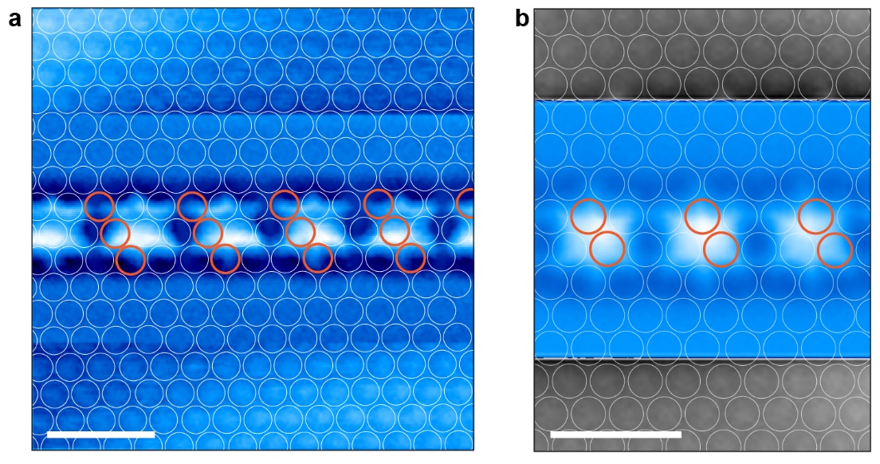
Supplementary figure 2: a), b) Two experimentally acquired high resolution AFM images displaying the registration of the straight chain with the substrate demonstrating incommensurability with the underlying Au(111). Orange circles mark every third Au row to guide the eye. (scale bars 10nm)
- Formation of transition metal metal-organic chains at elevated temperatures
Thermodynamic considerations provide indirect evidence against the inclusion of Au adatoms in the chains of interest. We are able to grow 1D metal-organic chains (see Santhini et al.²⁶) up to hundreds of nanometers in length on Au(111) substrate by co-deposition of DABQDI and selected transition metals (TM = Fe, Co, Ni, Cr). In such chains, TM atoms adopt a four-fold coordination with the ligand similar to that shown for gold on Extended Data Fig. 3d. In the same work we also show that native DABQDI molecules deposited on Au(111) at room temperature exhibit two components in the XPS spectra of N1s region that correspond to both -NH₂ and –NH groups (see Figure S3 in Santhini et al.²⁶). This decisively demonstrates that there is no metalation of DABQDI molecules by Au atoms at room temperature. A crucial parameter for the formation of the well-ordered and hundreds of nanometers long metal-organic chains on Au(111) surface is the co-deposition at elevated sample temperatures ~ 300⁰C. For comparison we attach a STM overview and AFM image of the Fe-quinone chains (see Supp. Fig. 3a,b²⁶). However, if we only deposit the DABQDI itself on Au(111) surface in such elevated temperatures, we don’t observe formation of any long-ordered metal-organic chains (the substrate remains clean). This indicates that the formation of long metal-organic Au-DABQDI is not energetically favorable even in such elevated temperatures. Consequently, the formation of well-ordered metal-organic Au-DABQDI chains at RT seems to be very unlikely. This also explains why we find very rarely the defective chains shown in Extended Data Fig. 3a.
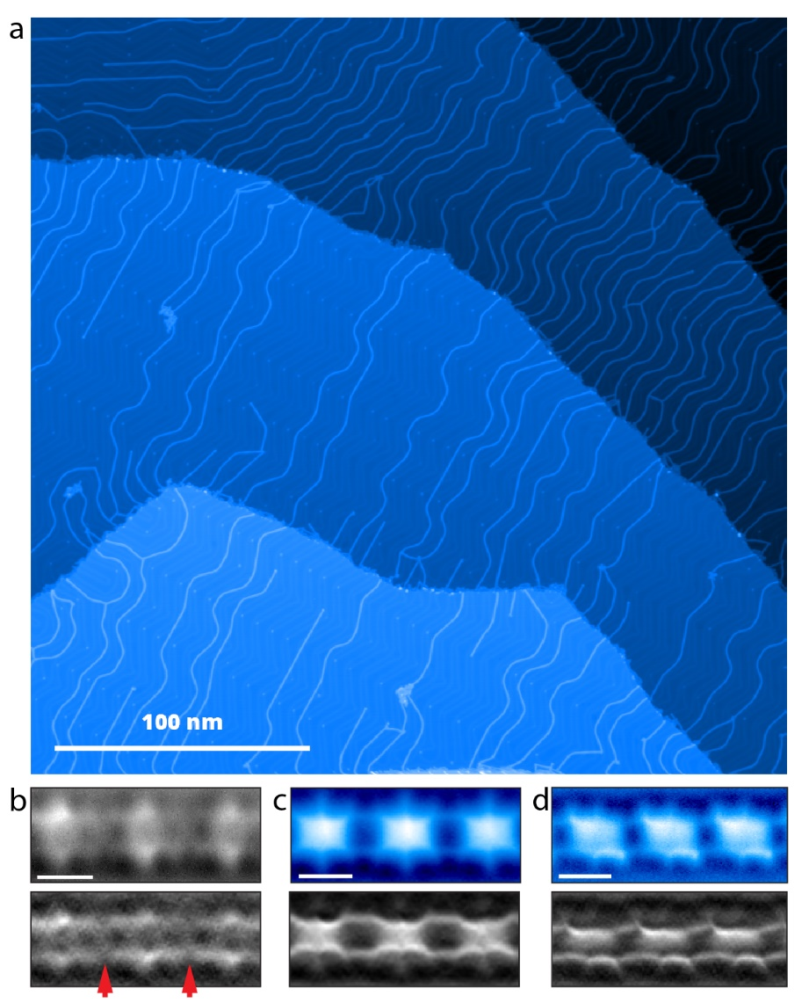
Supplementary figure 3: a) Representative overview STM image of Fe-Quinone chains grown by a co-deposition of Fe and DABQDI molecules onto Au(111) substrate held at 400 ⁰C. b) Experimentally acquired high resolution AFM image and its high pass filtered version of the chain with incorporated Fe adatoms that exhibits similar “x-like” feature as shown in Extended Data Fig 2. c), d) Experimental AFM images of straight and canted chain respective for a direct comparison. (b-d) scale bars 500 pm)

Supporting arguments to exclude other possible scenarios

With respect to other possible scenarios explaining the experimental observations, the UHV and low temperature environment make the possibility of any contaminant species very unlikely except for atomic hydrogen and gold atoms. Such well-defined conditions reduce the pool of possibilities significantly.
Besides the incorporation of gold adatoms, we explored the possibility of chains terminated with molecules with hydrogens either added or subtracted at the end. The presence of an extra hydrogen forming two amine NH₂ groups at the ends introduces strong steric repulsion between them, resulting in a non-planar structure that we do not observe with our ncAFM measurements. Both the non-planar and asymmetric arrangement is confirmed by our total energy DFT simulations, see Supp. Fig. 4a. We do not see any reason or mechanism explaining how the presence of the double amine groups at the ends of the chain would impose the fully symmetric arrangement of internal molecular units along the entire chain. Similarly, we can rule out a scenario including dehydrogenated ends of molecular chains, the total energy DFT simulations and related simulated AFM images shown in Supp. Fig.4b. Furthermore, neither scenario could convincingly explain the enhanced mechanical stability of straight chains. 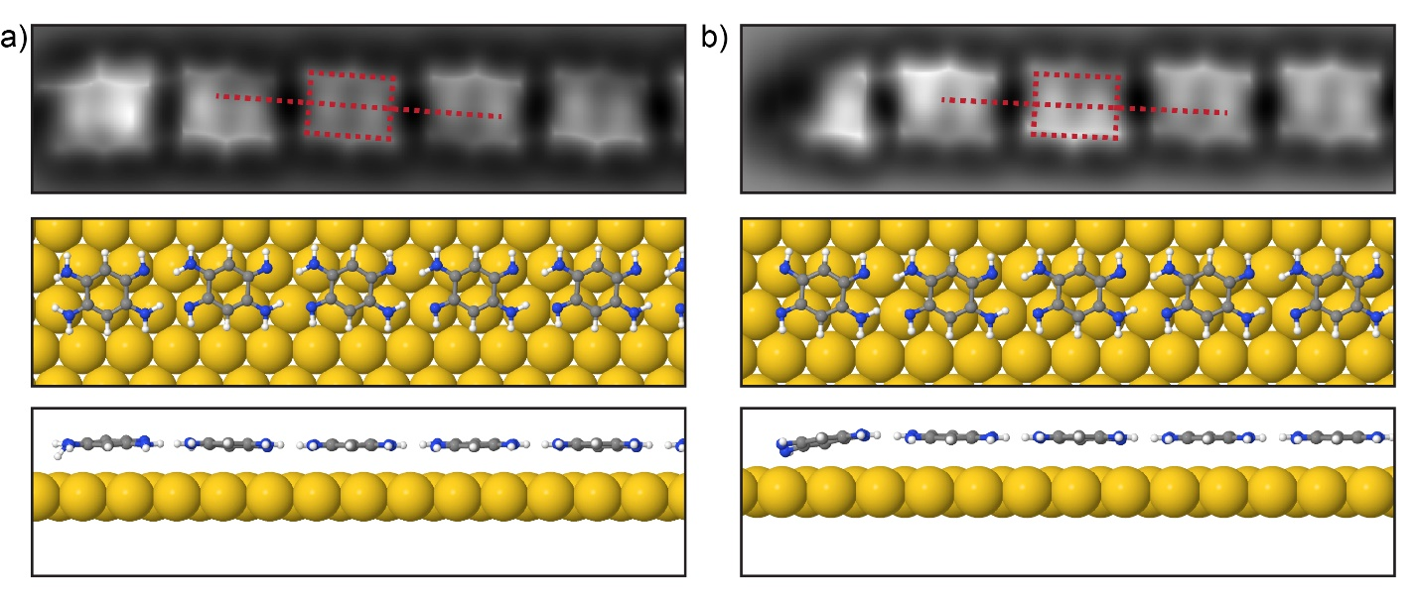
Supplementary figure 4: Middle, Bottom: Top and side view of relaxed structure of a chain with the last molecule a) hydrogenated and b) dehydrogenated. Top: respective simulated AFM images. Molecules in the middle of the chain remain canted.

Notes on the sample preparation

The procedure that reproducibly results in the formation of straight chains requires three steps:
- deposition of the DABQDI molecular precursor in the microscope chamber into the microscope head on a cold substrate (5 K) - single precursor molecules observed on the substrate (Supplementary Fig. 1c),
- transfer of the sample out of the microscope head to the microscope chamber, where the sample is kept on the wobblestick until it warms up almost to the room temperature,
- transfer of the sample back to the microscope head (5 K) - straight chains are observed on the substrate.
In the case of a direct deposition of the molecular precursors in the preparation chamber onto the sample kept at RT, we have observed both the formation of straight and canted chains. Once preparation parameters for either type of growth (canted/straight) were established, we could reproducibly prepare several samples with the same type of chain growth. For the straight chain growth these parameters typically included lower sublimation temperature for precursor molecule. However, once we changed the experimental setup (a replacement of evaporator, new batch of molecules or change of the microscope system), the previously optimal parameters sometimes did not provide the desired chain growth anymore.
Despite our best effort we have not been able to reliably identify the crucial parameter unconditionally resulting in either chain growth. Therefore, to ensure the formation of the straight chains more reliably, we have tested the aforementioned procedure involving deposition on the substrate held at low temperature in the microscope head.
These observations suggest that the concerted proton tunneling is initiated by the conditions at which the molecules are deposited onto the surface at room temperature. One possible scenario is that the deposition on a sample at room temperature initiates the hydrogenation process of the precursor forming DABQDI species with an extra hydrogen, which we frequently find on the surface. The presence of critical amounts of defective molecules prevents formation of the straight chains.

STS of the end states with different metallic tips
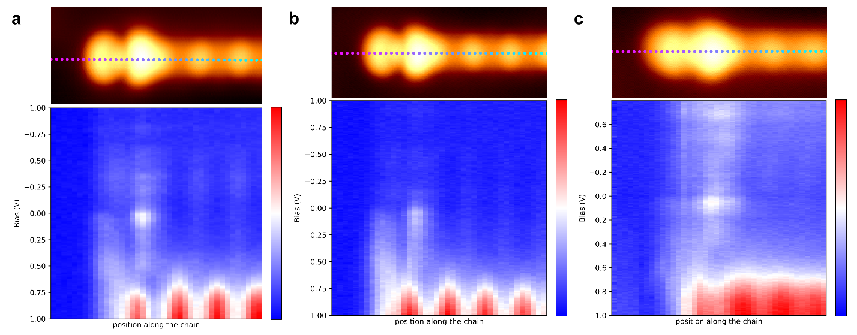
Supplementary figure 5: a), b), c) Maps of STS spectra (bottom; dI/dV colorscale in a.u.) taken with different metallic tips along the chain axis at positions indicated in STM image (top) showing the spatial localization of the end state around the terminating molecular unit.

STS comparison of canted and straight chains
Depending on the preparation conditions, in rare instances we have observed a formation of straight chains on a sample with predominantly canted chains. The dIdV spectra acquired over molecules in both types of chains with an identical tip are shown in Supplementary figure 6. From the position of LUMO orbital, it is apparent that the bandgap of canted chains is distinguishably larger than in the case of straight chains. Please note that we also observe instabilities in both kinds of chains when we try to reach critical biases of frontier orbitals, which induces chemical transformation of molecular units in the chain. For this reason we were unable to reach the HOMO orbital in both types of chains or reach states at higher positive bias.

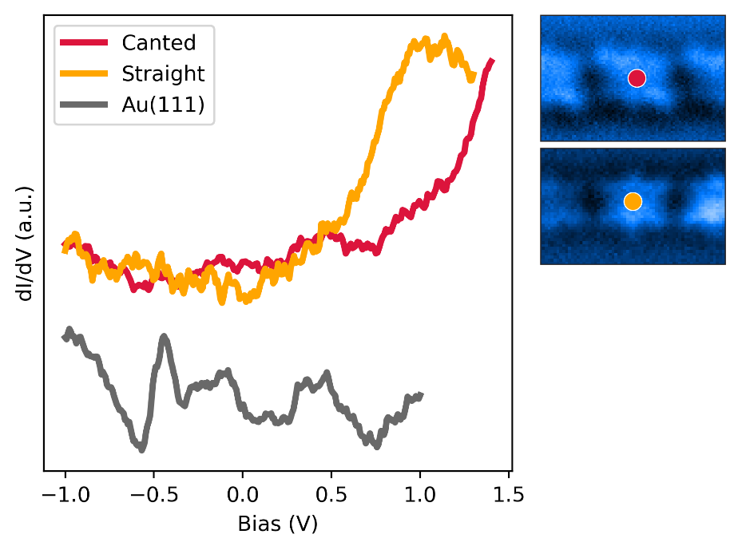
Supplementary figure 6: Comparison of STS measurement acquired over DABQDI molecules in canted and straight chains recorded with the same tip. dIdV spectrum acquired over bare Au(111) surface is shown for reference.

The experiment with deuterated DABQDI precursors.

There are two main obstacles to isolating the deuterated molecule in the solid state: 1/ the lack of solubility of unsubstituted DABQDI in chlorinated solvents (water free); and 2/ a back proton exchange of deuterated DABQDI molecules in the presence of hydrogen sources.

The H/D exchange is an equilibrium reaction in which the amount of deuterium should be high compared to the exchangeable protons of DABQDI. During the isolation process from a solvent (a mixture DMSO-d6 and CD3OD), the equilibrium is shifted towards the hydrogenated compound because of i) the presence of traces of water in these solvents, and ii) a decrease of the concentration of the deuterium source. This results in subsequent back proton exchange of deuterated DABQDI.

In this context, the need to use chlorinated solvents such as chloroform (CHCl3) is essential because of the extremely low concentration of water in these solvents (chlorinated solvents are immiscible with water in contrast to DMSO and methanol), preventing undesired side reactions (D/H exchange). Unfortunately, the lack of solubility of the unsubstituted DABQDI in such a solvent (as reported by Limbach and Rumpel¹⁷) impedes the deuteration reaction through this way.

Even if it was possible to prepare and isolate pure deuterated DABQDI, it is indispensable to use inert conditions in order to exclude air, moisture and other impurities that might catalyze back proton exchange (i.e. the exchange of deuterium with protons when there is a lack of a sufficiently large reservoir of deuterium). This presents a serious obstacle in the practicalities of introducing these molecules into the UHV microscope. During this procedure, we would unavoidably expose the deuterated molecules to the air and thus allow additional D/H exchange to occur. Thus, we do not see any option to ensure the controlled deposition of deuterated DABQDI precursor into the UHV chamber.

Comparison of FHI-AIMS and Fireball DFT methods
Path Integral Molecular Dynamics (PIMD) has been performed with the local orbital Fireball DFT package. To validate the accuracy of Fireball BLYP-D3 we compared it with the potential energy landscape of a single proton transfer in a periodic system calculated with the FHI-AIMS package using B3LYP-TS. Supplementary Figure 7 compares the calculated energy barriers, which are similar. This justifies our use of the Fireball package to increase the conformational sample in our PIMD simulations.

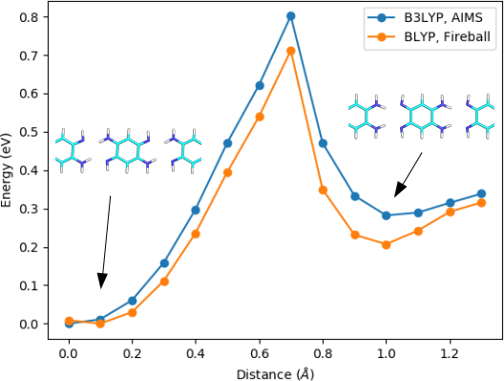
Supplementary figure 7: Comparison of potential energy profiles of the single proton transfer in a periodic system obtained with FHI-AIMS B3LYP-TS (blue), and Fireball BLYP-D3 (orange) calculations.

Convergence based on the number of replicas in PIMD calculations at different temperatures
The dependence of the number of replicas with temperature has been studied for 5, 10 and 20 K, with 32, 64, 128, 256, 512, 768 and 1024 replicas for the PIMD. To ensure that the system is stable we performed 10000 steps of PIMD with a time step of 0.25 fs for each pair of values. In order to see the convergence with the number of replicas for this system we represent the average over the last 2000 steps for each case, shown in Supplementary figure 8. Based on these simulations we conclude that we can do simulations at 20 K and 10 K with 1024 replicas. The simulations at 5 K seem to need more than 1024 replicas for full convergence and the computational cost to perform free energy calculations becomes prohibitive.
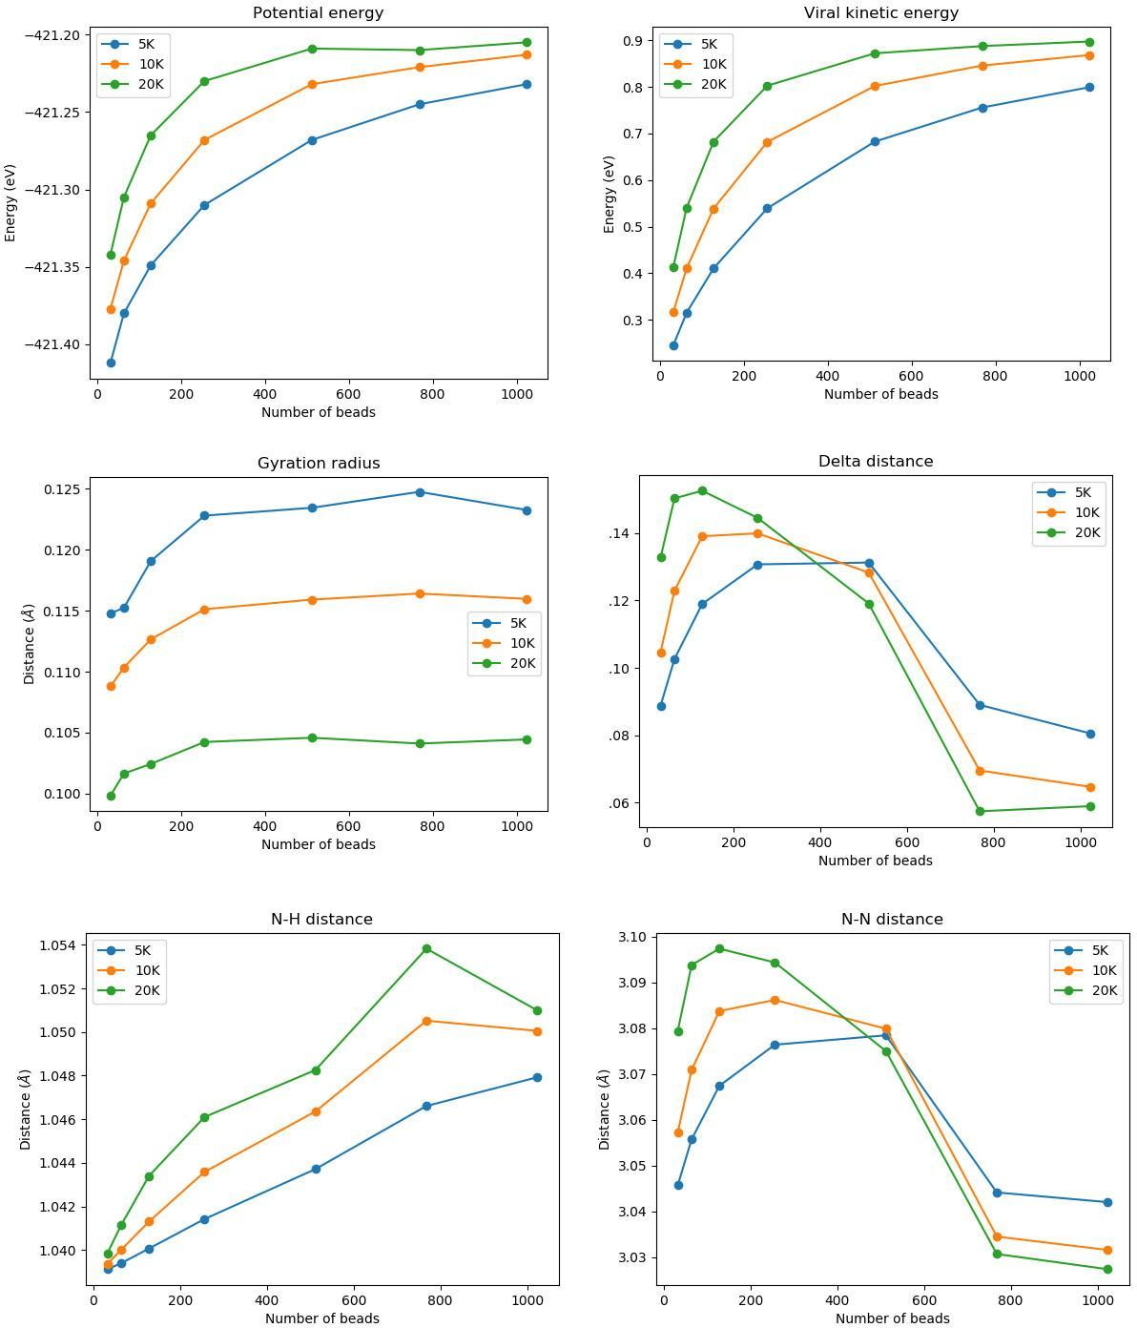
Supplementary figure 8: Evolution of the mean value for the last 2000 steps of the PIMD for potential energy, viral kinetic energy, gyration radius delta distance, N-H distance and N-N distance at different temperatures (blue 5 K, green 10 K and red 20 K) when we change the number of replicas.

Free energy calculations
Free energy profile calculations were carried out for a system consisting of three quinone molecules on the gold surface using the QM/MM scheme described below. We employed the WHAM method using 51 windows along the reaction coordinate. We have performed 3000 steps in each window with a time step of 0.25 fs.

To understand the behavior of the system, we considered distinct reaction coordinates transferring the hydrogen atoms from one nitrogen to the opposite nitrogen along the H-bond. Namely, we have tested as reaction coordinates the position of just one hydrogen atom, the collective reaction coordinate (average of the positions of all hydrogens), and also a different umbrella-like restraint for each hydrogen atom (see Supplementary Figure 9).

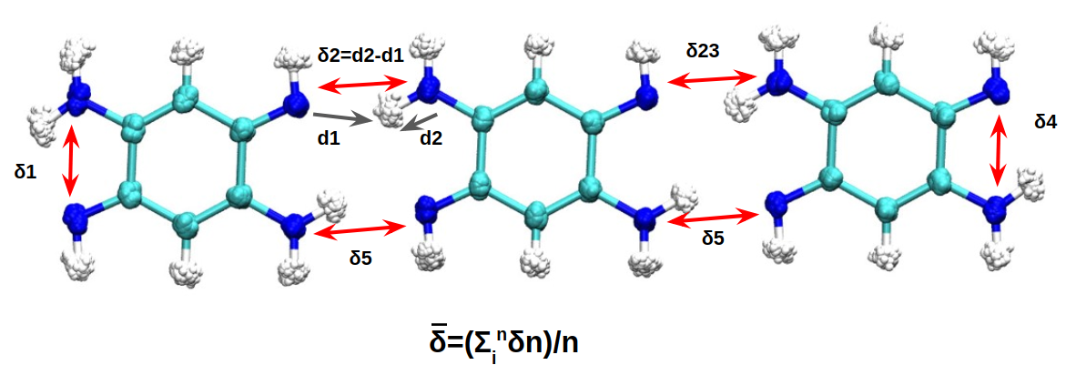
Supplementary figure 9: Scheme of the reaction coordinates used for the classical and PIMD QM/MM simulations.

The behavior of the system for the average of the δ and for six restraints is the same for PIMD simulations, consistent with the idea that coordinated proton tunneling takes place in the system. For the free energy profile at 20 K, a restraint has been added to the centroid of the ring polymer with 512 replicas. In the case of the 10 K free energy profile, a restraint has been added to two contracted replicas. This is due to the large delocalization of the ring polymer around δ=0 Å, which creates hysteresis along the reaction when we apply the restraint only over the centroid.
For the classical QM/MM simulations, we have to carry out the simulation restraining every hydrogen simultaneously to obtain the same geometries that we observe in PIMD simulations. If we apply the restraint in the average δ in the classical MD simulations, we don't have a coordinated movement, but rather multiple barriers in a stepwise process. In Figure 3a of the main text the barrier for the classical MD at 10 K has been performed with a restraint on all the δ to be able to compare the energy.
We performed PIMD simulations replacing hydrogen with deuterium and found distinctive behavior of the deuterated chains. Supplementary Figure 10 shows a comparison of the calculated activation barriers of concerted proton transfer for hydrogen and deuterium based DABQDI chains revealing that the activation energy is substantially increased - more than double and, in fact, comparable to the classical one, and that deuterium delocalization in the transient state is much smaller than in the case of hydrogen.

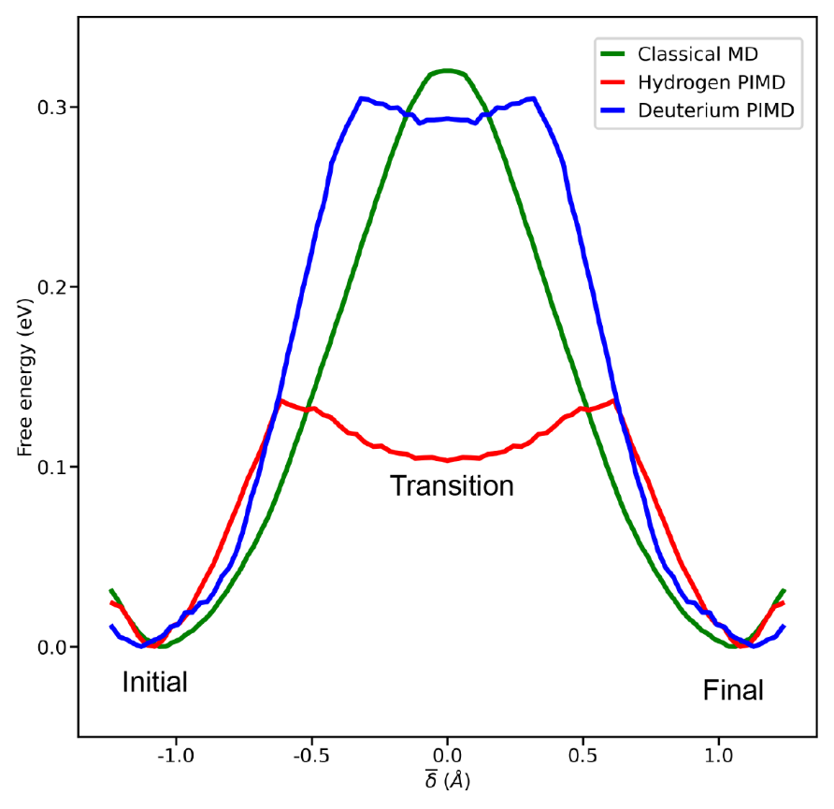
Supplementary figure 10: Free energy profile at 10 K of the concerted proton transfer in DABQDI chains using classical MD(green) or path Integral MD for hydrogen(red) or deuterium(blue) for the transferring atoms. The delta reaction coordinate is defined in the main text. Note that the steeper increase of the free energy in the quantum case is due to the delocalization of the hydrogen/deuterium atom in the potential well.
In Supplementary figure 11, appreciable differences between the MD and PIMD approaches can be observed. In the classical MD simulation, the protons are located just in the middle of the hydrogen bond, while in the PIMD simulations we observe a delocalization of the hydrogens along the hydrogen bond. This difference in behaviour is responsible for the flatness of the barrier and characteristic of the deep tunneling regime. Moreover, we observe a further difference between the PIMD simulations at 10 K and 20 K.

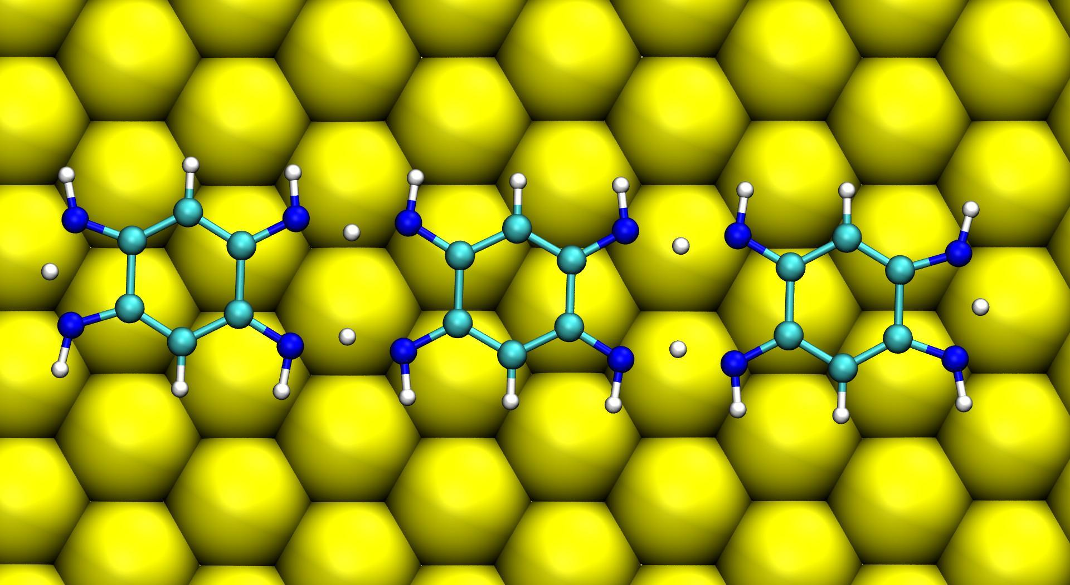
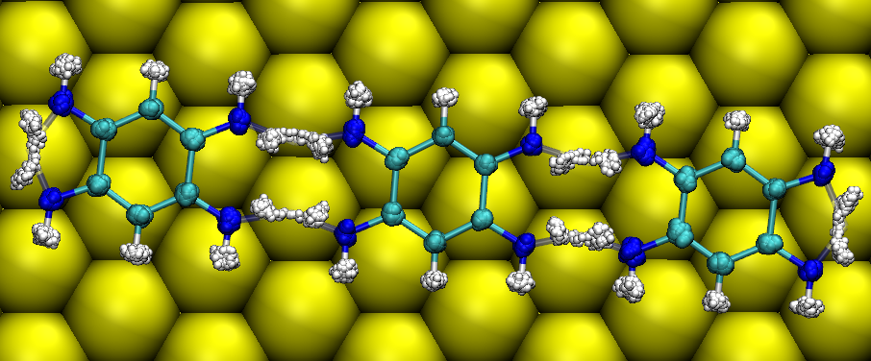
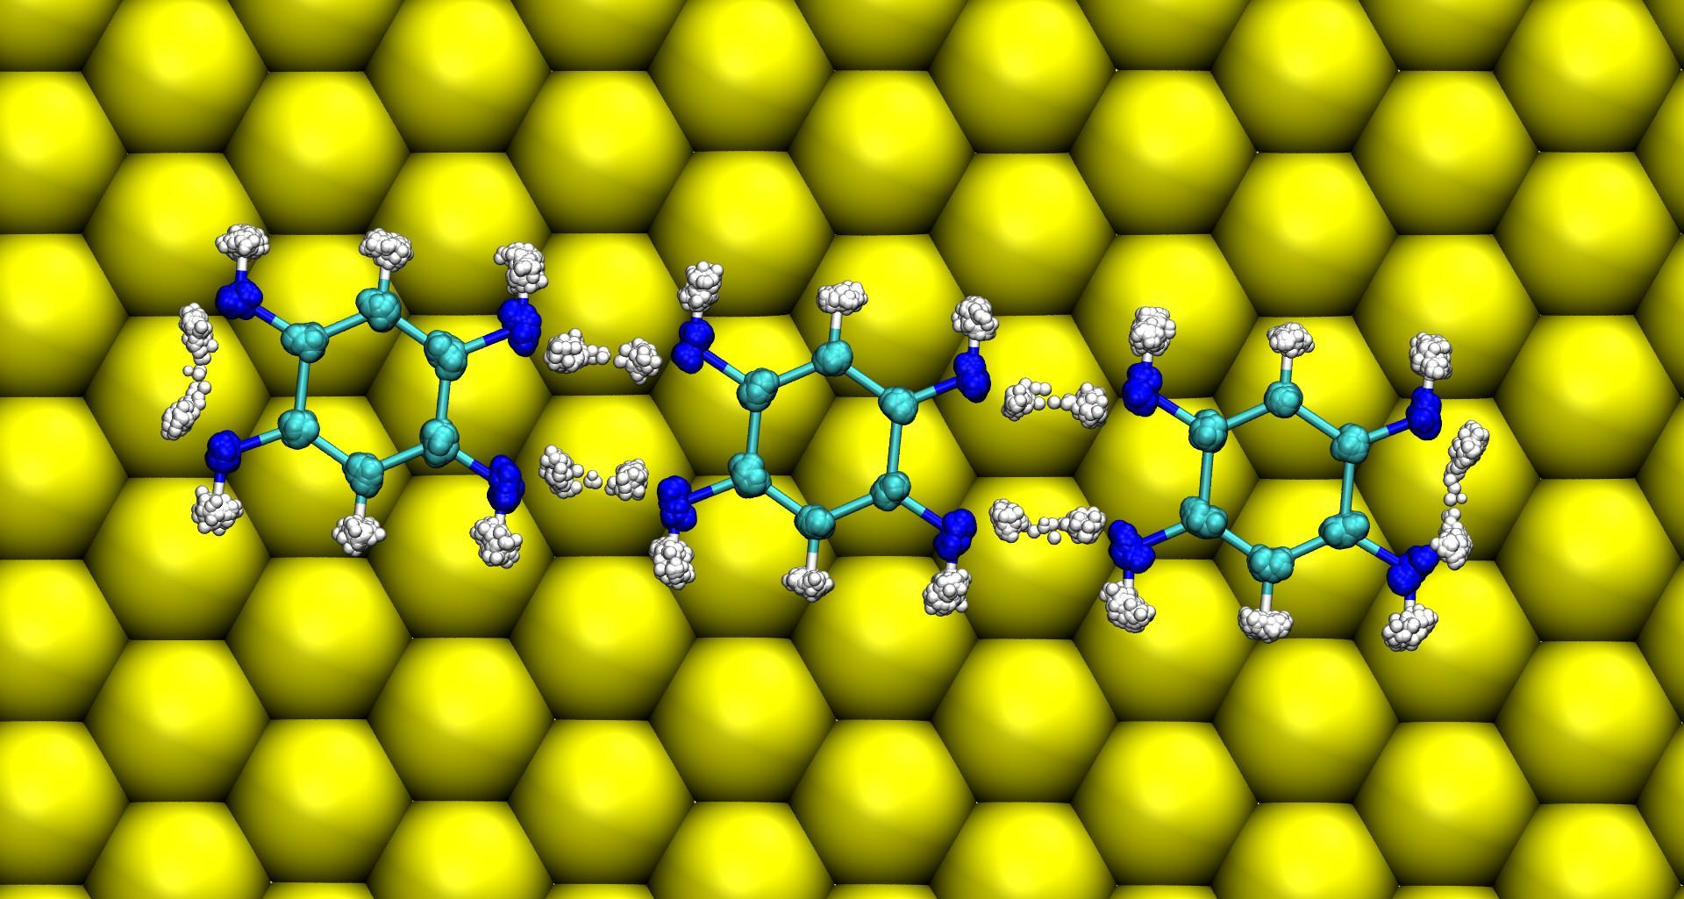

Supplementary figure 11: Representation of the proton distribution at δ=0 Å with classical MD at 10 K (top), PIMD at 20 K (middle) and PIMD at 10 K (bottom).

Analysis of the concerted motion of protons
To study the correlation of the different protons we perform a 5000 step of free dynamics calculation at 10 K starting in the window corresponding to δ=0 Å in the free energy profile. During the last 2000 steps of this PIMD we measured the δ coordinate of all the hydrogen bonds for the centroid trajectory and for all the 1024 replicas of our system. During this simulation the average δ stays around 0 Å but we can see that the distribution of the delta value for the replicas' trajectories has two clear peaks for each protonation state, as shown in Supplementary figure 12.

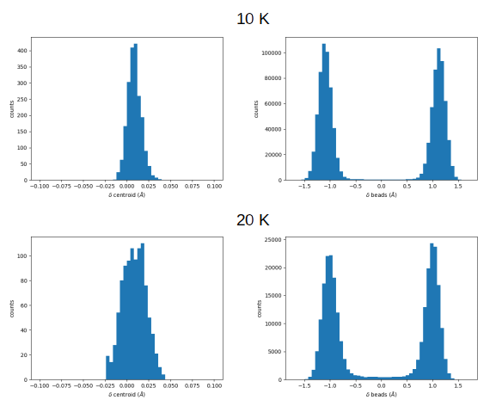
Supplementary figure 12: Histogram of the distribution of the δ₂ value for the centroid (left images), the δ₂ for all the replicas (right images) at 10 K (top images) and 20 K (bottom images).

When the centroid coordinate in the PIMD simulation has a value of δ=0 Å the state of the system is actually a combination of the two possible protonation states. In this way the system is able to maintain the π-conjugation in each of the protonated states.
Supplemental figure 13 displays histogram of distribution of δ-coordinates of all hydrogen atoms involved in the proton transfer mechanism obtained from the PIMD simulations at 10 K. The distribution shows strong correlation between positions of all hydrogen atoms, which is dictated by conservation of the π-conjugation. This demonstrates that the proton transfer is concerted.

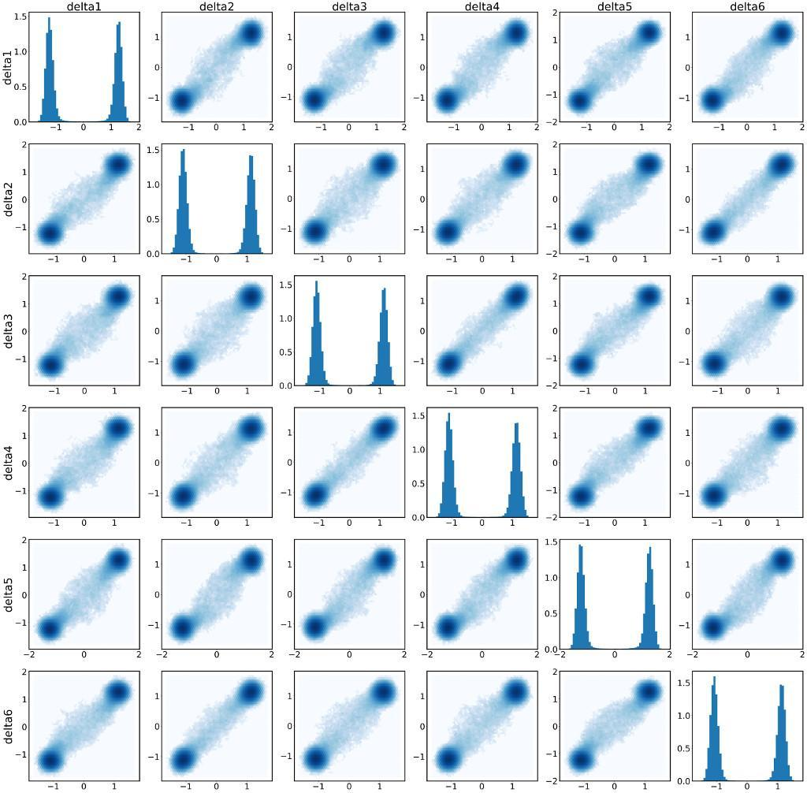

Supplementary figure 13: Plot with the correlation between the δ-coordinates and the histogram with the distribution of each δ in the diagonal. δ₁ and δ₄ correspond to hydrogens in the edges and δ₂, δ₃, δ₅, δ₆ are hydrogens in the middle of the chain.

Another way to see the correlation is to calculate the Pearson correlation coefficients that measure how far the reaction coordinates δ_{i} are from a linear correlation where 1.0 corresponds to perfect linear correlation and 0.0 means complete lack of correlation. In this matrix, representation we can see these values between each set of δ-coordinates in the PIMD simulations of the molecular trimer. The positions in the matrix correspond to the sub-index of the reaction coordinates δ shown in Supplementary figure 9.

δ₁ δ₂ δ₃ δ₄ δ₅ δ₆
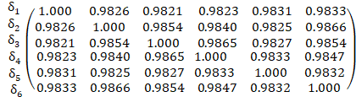
Supplementary table 1: Pearson correlation coefficients between distinct reaction coordinates δ_{i} obtained from the PIMD simulation.

Tight-Binding model on the molecular chain
To construct the Tight-Binding model used in our analysis, we first considered an isolated molecule in the XY-plane and constructed its Hamiltonian with Fireball in the orthonormal Löwdin basis, using the BLYP functional for the calculation. We then selected the 10x10 matrix corresponding to the π-conjugated system (the Hamiltonian elements between the pairs of Löwdin π-orbitals associated to p_{z} orbitals of carbon and nitrogen atoms). All the matrix elements between atoms not bonded covalently are 20 to 30 times smaller than those representing bonded atoms, so they are set to zero in our model. With p_{z} orbitals labelled by the number of the atom (see Supp. Fig. 14), the resulting Hamiltonian H_{tb,0} is (in the units of eV):
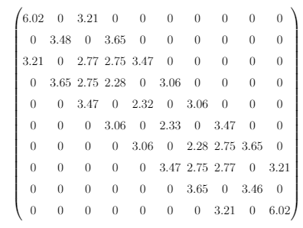
Supplementary table 2: Tight-binding Hamiltonian of the molecular unit obtained from Fireball DFT calculations. Labeling of sites with the molecular unit is represented in Supplementary figure 14.
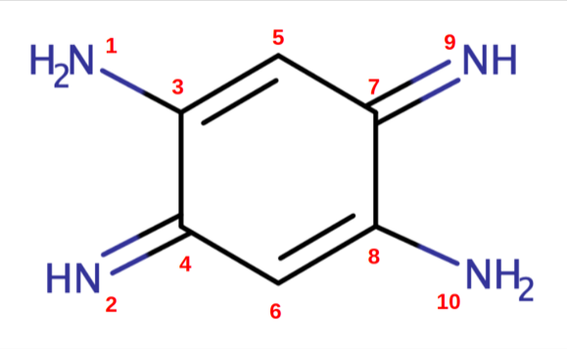
Supplementary figure 14 Labeling used for the tight-binding Hamiltonian.

To study a chain consisting of multiple units, we constructed a block matrix built up from replicas of H_{tb,0} and added the hoppings associated to the hydrogen bonds connecting the neighboring units, τ_{hbond} (i.e. sites 9 and 1 of two adjacent blocks are coupled and similarly, sites 2 and 10). We assume that proton tunneling enhances this coupling compared to the 'frozen-proton hydrogen bond' case and also allows for a direct link between the terminal nitrogen pairs of the chain: a hopping τ_{edge} between the pairs of nitrogen atoms 1&2 in the first and 9&10 in the last molecule is added. We then proceed to explore our model over a wide range of values of τ_{edge} and τ_{hbond}. The reason for this is that, at very low temperatures, the hydrogen transfer rate is heavily affected by nuclear quantum corrections, and thus cannot be correctly estimated by means of a DFT calculation relying on the Born-Oppenheimer approximation. We find that for situations in which τ_{edge} > τ_{hbond}, edge states appear in the gap as HOMO, HOMO-1, LUMO and LUMO+1 molecular levels, for values of τ_{edge} and τ_{hbond} which are small compared to the rest of the non-zero matrix elements (~0.5-1.5 eV), but still larger than the usual hopping for atoms bonded by hydrogen bonds (0.1 eV). This corroborates the importance of quantum nuclear effects at low temperature. The tunneling regime of the hydrogens leads to an effective interaction between the nitrogen atoms which is comparable in strength to a covalent bond.
Supplementary figure 15 summarizes the weights over the edges (defined as the two first and the last two molecules in the chain) of the HOMO and LUMO orbitals. The horizontal axis is the value of the hopping τ_{hbond}, the vertical one is τ_{edge}, and the color represents the projection of the wave function of the eigenstates on the sites that we identify as the edge regions. We also remark that our tight-binding model with τ_{edge}=0 implies the existence of edge states related to the topologically-nontrivial states in the Su-Schrieffer-Heeger model,⁴³ but these never occur close to the Fermi level.

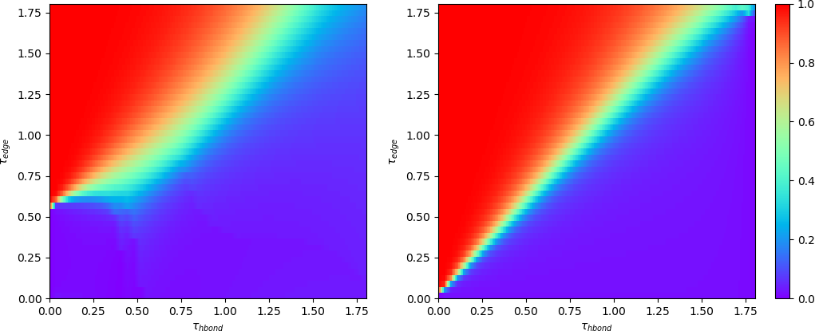

Supplementary figure 15: Projection of the HOMO (a) and LUMO (b) to the edge region in our tight-binding model. Red color corresponds to the parameter region (τ_{edge}, τ_{hbond}) where the edge states occur.

44. Cirera, B. et al. On-Surface Synthesis of Gold Porphyrin Derivatives via a Cascade of Chemical Interactions: Planarization, Self-Metalation, and Intermolecular Coupling. Chem. Mater. 31, 3248–3256 (2019).

45. Su, W. P., Schrieffer, J. R. & Heeger, A. J. Soliton excitations in polyacetylene. Phys. Rev. B 22, 2099–2111 (1980).

