Supplemental Digital Content
Development and external validation of multivariable risk models to predict incident and resolved neuropathic pain in the Scottish population: a DOLORisk Dundee study.
Harry L Hébert¹, Abirami Veluchamy^{1,2}, Georgios Baskozos³, Francesca Fardo⁴,
Dimitri Van Ryckeghem^{5,6}, Ewan R Pearson², Lesley A. Colvin¹, Geert Crombez⁵, David L H Bennett³, Weihua Meng¹, Colin N A Palmer², Blair H Smith¹*

¹Chronic Pain Research Group, Division of Population Health and Genomics, Mackenzie Building, Ninewells Hospital & Medical School, University of Dundee, Dundee, UK
²Pat Macpherson Centre for Pharmacogenetics and Pharmacogenomics, Division of Population Health and Genomics, Ninewells Hospital & Medical School, University of Dundee, Dundee, UK
³Neural Injury Group, Nuffield Department of Clinical Neuroscience, John Radcliffe Hospital, University of Oxford, Oxford, UK
⁴Danish Pain Research Center, Department of Clinical Medicine, Aarhus University, Denmark
⁵Department of Experimental-Clinical and Health Psychology, Faculty of Psychology and Educational Sciences, Ghent University, Ghent, Belgium
⁶Section Experimental Health Psychology, Clinical Psychological Science, Departments, Faculty of Psychology and Neuroscience, Maastricht University, Netherlands
Contents
Supplementary Table S1. TRIPOD Checklist: Prediction Model Development and Validation
Supplementary Table S2 – Univariate analysis of incident neuropathic pain in GS:SFHS (pooled analysis after multiple imputation m = 59)
Supplementary Table S3 - Univariate analysis of resolved neuropathic pain in GS:SFHS (pooled analysis after multiple imputation m = 59)
Supplementary Table S4. Internal validation performance metrics in each imputed dataset for the risk model for incident neuropathic pain
Supplementary Table S5. External validation performance metrics in each imputed dataset for the risk model for incident neuropathic pain
Supplementary Table S6. Internal validation performance metrics in each imputed dataset for the risk model for resolved neuropathic pain
Supplementary Table S7. External validation performance metrics in each imputed dataset for the risk model for resolved neuropathic pain
Supplementary Figure S1. ROC curve for internal validation of the risk model for incident neuropathic pain (imputed dataset 32)
Supplementary Figure S2. Precision-recall curve for internal validation of the risk model for incident neuropathic pain (imputed dataset 32)
Supplementary Figure S3. Calibration curve for internal validation of the risk model for incident neuropathic pain (imputed dataset 32)
Supplementary Figure S4. ROC curve for internal validation of the risk model for resolved neuropathic pain (imputed dataset 29)
Supplementary Figure S5. Precision-recall curve for internal validation of the risk model for resolved neuropathic pain (imputed dataset 29)
Supplementary Figure S6. Calibration curve for internal validation of the risk model for resolved neuropathic pain (imputed dataset 29)

Supplementary Table S1. TRIPOD Checklist: Prediction Model Development and Validation
Section/Topic | Item |  | Checklist Item | Page
Title and abstract
Title | 1 | D;V | Identify the study as developing and/or validating a multivariable prediction model, the target population, and the outcome to be predicted. | Title Page
Abstract | 2 | D;V | Provide a summary of objectives, study design, setting, participants, sample size, predictors, outcome, statistical analysis, results, and conclusions. | Abstract
Introduction
Background and objectives | 3a | D;V | Explain the medical context (including whether diagnostic or prognostic) and rationale for developing or validating the multivariable prediction model, including references to existing models. | Introduction  Paragraphs 1-4
Background and objectives | 3b | D;V | Specify the objectives, including whether the study describes the development or validation of the model or both. | Introduction  Paragraph 5
Methods
Source of data | 4a | D;V | Describe the study design or source of data (e.g., randomized trial, cohort, or registry data), separately for the development and validation data sets, if applicable. | Methods  Study Design Paragraphs 1-3
Source of data | 4b | D;V | Specify the key study dates, including start of accrual; end of accrual; and, if applicable, end of follow-up. | Methods  Recruitment Paragraphs 1-2
Participants | 5a | D;V | Specify key elements of the study setting (e.g., primary care, secondary care, general population) including number and location of centres. | Methods  Study Design Paragraphs 1-3
Participants | 5b | D;V | Describe eligibility criteria for participants. | Methods  Recruitment Paragraphs 1-2
Participants | 5c | D;V | Give details of treatments received, if relevant. | n/a
Outcome | 6a | D;V | Clearly define the outcome that is predicted by the prediction model, including how and when assessed. | Methods  Outcome
Outcome | 6b | D;V | Report any actions to blind assessment of the outcome to be predicted. | n/a
Predictors | 7a | D;V | Clearly define all predictors used in developing or validating the multivariable prediction model, including how and when they were measured. | Methods  Predictors  Table 1
Predictors | 7b | D;V | Report any actions to blind assessment of predictors for the outcome and other predictors. | n/a
Sample size | 8 | D;V | Explain how the study size was arrived at. | Methods  Sample Size  Paragraphs 1-2
Missing data | 9 | D;V | Describe how missing data were handled (e.g., complete-case analysis, single imputation, multiple imputation) with details of any imputation method. | Methods  Missing Data  Paragraphs 1-2
Statistical analysis methods | 10a | D | Describe how predictors were handled in the analyses. | Methods  Statistical Analysis  Paragraph 2
Statistical analysis methods | 10b | D | Specify type of model, all model-building procedures (including any predictor selection), and method for internal validation. | Methods  Statistical Analysis  Paragraph 2 and 5
Statistical analysis methods | 10c | V | For validation, describe how the predictions were calculated. | Methods  Statistical Analysis  Paragraph 5
Statistical analysis methods | 10d | D;V | Specify all measures used to assess model performance and, if relevant, to compare multiple models. | Methods  Statistical Analysis  Paragraphs 3-8
Statistical analysis methods | 10e | V | Describe any model updating (e.g., recalibration) arising from the validation, if done. | Methods  Statistical Analysis  Paragraph 7
Risk groups | 11 | D;V | Provide details on how risk groups were created, if done. | n/a
Development vs. validation | 12 | V | For validation, identify any differences from the development data in setting, eligibility criteria, outcome, and predictors. | Methods  Study Design  Paragraph 3
Results
Participants | 13a | D;V | Describe the flow of participants through the study, including the number of participants with and without the outcome and, if applicable, a summary of the follow-up time. A diagram may be helpful. | Results  Participant Flow  Paragraph 1
Participants | 13b | D;V | Describe the characteristics of the participants (basic demographics, clinical features, available predictors), including the number of participants with missing data for predictors and outcome. | Results  Baseline Characteristics  Tables 2-3
Participants | 13c | V | For validation, show a comparison with the development data of the distribution of important variables (demographics, predictors and outcome). | Results  Baseline Characteristics  Tables 2-3
Model development | 14a | D | Specify the number of participants and outcome events in each analysis. | Results  Model Development  Paragraphs 1 and 4
Model development | 14b | D | If done, report the unadjusted association between each candidate predictor and outcome. | Results  Model Development  Paragraphs 2 and 5  Supplementary Tables S1-S2
Model specification | 15a | D | Present the full prediction model to allow predictions for individuals (i.e., all regression coefficients, and model intercept or baseline survival at a given time point). | Results  Model Development  Paragraphs 3 and 6  Tables 4-5
Model specification | 15b | D | Explain how to the use the prediction model. | Results  Model Algorithms
Model performance | 16 | D;V | Report performance measures (with CIs) for the prediction model. | Results  Model Development  Table 6
Model-updating | 17 | V | If done, report the results from any model updating (i.e., model specification, model performance). | Results  Model Algorithms
Discussion
Limitations | 18 | D;V | Discuss any limitations of the study (such as nonrepresentative sample, few events per predictor, missing data). | Discussion  Strengths and Limitations  Paragraph 4
Interpretation | 19a | V | For validation, discuss the results with reference to performance in the development data, and any other validation data. | Discussion  Interpretation  Paragraphs 2-3
Interpretation | 19b | D;V | Give an overall interpretation of the results, considering objectives, limitations, results from similar studies, and other relevant evidence. | Discussion  Interpretation  Paragraphs 4-8
Implications | 20 | D;V | Discuss the potential clinical use of the model and implications for future research. | Discussion  Further Work  Paragraphs 1-3
Other information
Supplementary information | 21 | D;V | Provide information about the availability of supplementary resources, such as study protocol, Web calculator, and data sets. | Methods  Study Design  Paragraph 1
Funding | 22 | D;V | Give the source of funding and the role of the funders for the present study. | Acknowledgements  Paragraphs 1-3
*Items relevant only to the development of a prediction model are denoted by D, items relating solely to a validation of a prediction model are denoted by V, and items relating to both are denoted D;V. We recommend using the TRIPOD Checklist in conjunction with the TRIPOD Explanation and Elaboration document.

Supplementary Table S2 – Univariate analysis of incident neuropathic pain in GS:SFHS (pooled analysis after multiple imputation m = 59)
Characteristic | Odds Ratio (95% Confidence Interval) | Standard Error | P-value
Age (≥65 years) | 1.07 (0.79-1.46) | 0.158 | 0.654
Gender (Male) | 1.11 (0.83-1.50) | 0.152 | 0.476
Social Deprivation (SIMD)  1 (Most deprived)  2  3  4  5 (Least deprived) | -  0.93 (0.45-1.91)  0.73 (0.37-1.46)  0.86 (0.46-1.61)  0.55 (0.29-1.03) | -  0.370  0.353  0.320  0.322 | -  0.835  0.378  0.638  0.062
Depression (PROMIS SF4a T-score ≥ 50) | 1.68 (1.23-2.29) | 0.159 | 0.001
Anxiety (PROMIS SF4a T-score ≥ 50) | 1.38 (1.02-1.87) | 0.155 | 0.038
Sleep Disturbance (PROMIS SF4a T-score ≥ 50) | 1.96 (1.44-2.66) | 0.157 | <0.001
Extraversion (TIPI ≥ 5.0) | 0.95 (0.70-1.30) | 0.158 | 0.763
Agreeableness (TIPI ≥ 5.0) | 0.90 (0.65-1.23) | 0.161 | 0.502
Conscientiousness (TIPI ≥ 5.0) | 0.88 (0.60-1.30) | 0.199 | 0.528
Emotional Stability (TIPI ≥ 5.0) | 0.71 (0.53-0.97) | 0.154 | 0.029
Open to New Experiences (TIPI ≥ 5.0) | 1.24 (0.91-1.67) | 0.154 | 0.168
Traumatic events before 18 years of age | 1.81 (1.34-2.45) | 0.154 | <0.001
Hospital stay before 18 years of age | 1.08 (0.56-2.09) | 0.336 | 0.818
Ever smoked | 1.64 (1.22-2.20) | 0.151 | 0.001
Currently drink alcohol | 0.85 (0.52-1.39) | 0.251 | 0.525
Physical Activity (High) | 0.86 (0.59-1.25) | 0.188 | 0.426
Health-related quality of life (EQ-5D-5L Index ≥ 0.800) | 0.29 (0.22-0.40) | 0.154 | <0.001
BMI (≥30kg/m²) | 1.54 (1.06-2.24) | 0.192 | 0.025
Blood pressure (≥140/90 mmHg) | 1.17 (0.85-1.61) | 0.163 | 0.341
Total cholesterol (≥5 mmol/L) | 0.96 (0.70-1.33) | 0.163 | 0.813
BMI, Body mass index; BPM, beats per minute; EQ-5D-5L, EuroQoL-five dimensions-five levels; GS:SFHS, Generation Scotland: Scottish Family Health Study; PROMIS, Patient-Reported Outcomes Measurement Information System; SF4a, short form four answers; SIMD, Scottish Index of Multiple Deprivation; TIPI, Ten Item Personality Inventory

Supplementary Table S3 - Univariate analysis of resolved neuropathic pain in GS:SFHS (pooled analysis after multiple imputation m = 59)
Characteristic | Odds Ratio (95% Confidence Interval) | Standard Error | P-value
Age (≥65 years) | 0.90 (0.58-1.38) | 0.219 | 0.622
Gender (Male) | 1.19 (0.79-1.77) | 0.204 | 0.401
Social Deprivation (SIMD)  1 (Most deprived)  2  3  4  5 (Least deprived) | -  1.79 (0.83-3.86)  2.97 (1.34-6.58)  2.17 (1.04-4.50)  3.24 (1.59-6.57) | -  0.391  0.404  0.371  0.360 | -  0.137  0.007  0.038  0.001
Depression (PROMIS T-score ≥ 50) | 0.50 (0.34-0.75) | 0.202 | <0.001
Anxiety (PROMIS T-score ≥ 50) | 0.47 (0.31-0.70) | 0.205 | <0.001
Sleep Disturbance (PROMIS T-score ≥ 50) | 0.40 (0.25-0.63) | 0.230 | <0.001
Extraversion (TIPI ≥ 5.0) | 1.23 (0.82-1.85) | 0.208 | 0.321
Agreeableness (TIPI ≥ 5.0) | 1.06 (0.71-1.60) | 0.207 | 0.764
Conscientiousness (TIPI ≥ 5.0) | 3.28 (1.99-5.42) | 0.255 | <0.001
Emotional Stability (TIPI ≥ 5.0) | 2.30 (1.55-3.42) | 0.202 | <0.001
Open to New Experiences (TIPI ≥ 5.0) | 1.37 (0.93-2.03) | 0.198 | 0.109
Pain-related worrying (PCS ≥ 30) | 0.41 (0.19-0.89) | 0.395 | 0.024
Traumatic events before 18 years of age | 0.63 (0.42-0.93) | 0.202 | 0.021
Hospital stay before 18 years of age | 1.25 (0.61-2.53) | 0.360 | 0.542
Ever smoked | 0.64 (0.43-0.94) | 0.197 | 0.022
Currently drink alcohol | 1.87 (1.05-3.34) | 0.294 | 0.033
Physical Activity (High) | 0.67 (0.39-1.15) | 0.270 | 0.144
Health-related quality of life (EQ-5D-5L Index ≥ 0.800) | 4.69 (2.74-8.04) | 0.274 | <0.001
BMI (≥30 kg/m²) | 0.79 (0.52-1.21) | 0.213 | 0.280
Blood pressure (≥140/90mmHg) | 1.09 (0.72-1.65) | 0.210 | 0.666
Creatinine (≥100µmol/L) | 1.71 (0.72-4.05) | 0.439 | 0.223
Total cholesterol (≥5mmol/L) | 0.79 (0.53-1.19) | 0.205 | 0.261
High Density Lipoprotein (≥1mmol/L) | 1.11 (0.52-2.37) | 0.387 | 0.791
BMI, Body mass index; BPM, beats per minute; EQ-5D-5L, EuroQoL-five dimensions-five levels; GS:SFHS, Generation Scotland: Scottish Family Health Study; PROMIS, Patient-Reported Outcomes Measurement Information System; SF4a, short form four answers; SIMD, Scottish Index of Multiple Deprivation; TIPI, Ten Item Personality Inventory

Supplementary Table S4. Internal validation performance metrics in each imputed dataset for the risk model for incident neuropathic pain
Dataset | Performance | Discrimination |  | Calibration
Dataset | Nagelkerke R² | AUROC | AUPRC | Slope | Intercept
1 | 0.091 | 0.719 | 0.128 | 1.026 | 0.026
2 | 0.092 | 0.720 | 0.133 | 1.037 | 0.042
3 | 0.089 | 0.714 | 0.132 | 1.019 | -0.007
4 | 0.090 | 0.720 | 0.126 | 1.026 | 0.017
5 | 0.090 | 0.721 | 0.127 | 1.033 | 0.048
6 | 0.089 | 0.718 | 0.125 | 1.018 | -0.007
7 | 0.085 | 0.716 | 0.123 | 0.994 | -0.054
8 | 0.086 | 0.716 | 0.125 | 1.007 | -0.019
9 | 0.093 | 0.720 | 0.130 | 1.055 | 0.095
10 | 0.093 | 0.720 | 0.130 | 1.053 | 0.099
11 | 0.098 | 0.727 | 0.138 | 1.084 | 0.163
12 | 0.084 | 0.712 | 0.126 | 1.004 | -0.025
13 | 0.086 | 0.716 | 0.125 | 1.002 | -0.032
14 | 0.093 | 0.724 | 0.127 | 1.047 | 0.070
15 | 0.079 | 0.708 | 0.120 | 0.957 | -0.157
16 | 0.092 | 0.720 | 0.127 | 1.032 | 0.043
17 | 0.084 | 0.714 | 0.126 | 0.980 | -0.099
18 | 0.084 | 0.714 | 0.123 | 0.991 | -0.065
19 | 0.090 | 0.719 | 0.135 | 1.030 | 0.039
20 | 0.092 | 0.720 | 0.126 | 1.033 | 0.040
21 | 0.093 | 0.720 | 0.135 | 1.047 | 0.069
22 | 0.096 | 0.722 | 0.138 | 1.072 | 0.138
23 | 0.085 | 0.713 | 0.127 | 0.988 | -0.080
24 | 0.098 | 0.727 | 0.139 | 1.080 | 0.155
25 | 0.094 | 0.722 | 0.130 | 1.054 | 0.094
26 | 0.087 | 0.714 | 0.132 | 1.011 | -0.010
27 | 0.092 | 0.721 | 0.129 | 1.043 | 0.059
28 | 0.096 | 0.727 | 0.129 | 1.061 | 0.113
29 | 0.091 | 0.720 | 0.128 | 1.042 | 0.060
30 | 0.092 | 0.721 | 0.127 | 1.036 | 0.045
31 | 0.093 | 0.721 | 0.130 | 1.056 | 0.099
32 | 0.095 | 0.726 | 0.129 | 1.060 | 0.109
33 | 0.093 | 0.722 | 0.130 | 1.053 | 0.092
34 | 0.087 | 0.714 | 0.129 | 1.025 | 0.034
35 | 0.092 | 0.720 | 0.127 | 1.040 | 0.057
36 | 0.093 | 0.722 | 0.129 | 1.048 | 0.081
37 | 0.090 | 0.719 | 0.125 | 1.027 | 0.020
38 | 0.091 | 0.721 | 0.126 | 1.033 | 0.039
39 | 0.090 | 0.717 | 0.132 | 1.021 | 0.004
40 | 0.091 | 0.721 | 0.127 | 1.034 | 0.041
41 | 0.088 | 0.716 | 0.123 | 1.005 | -0.041
42 | 0.089 | 0.718 | 0.132 | 1.023 | 0.022
43 | 0.085 | 0.715 | 0.125 | 1.004 | -0.033
44 | 0.089 | 0.717 | 0.127 | 1.025 | 0.018
45 | 0.095 | 0.725 | 0.133 | 1.056 | 0.087
46 | 0.090 | 0.720 | 0.133 | 1.028 | 0.025
47 | 0.095 | 0.724 | 0.130 | 1.056 | 0.105
48 | 0.096 | 0.723 | 0.138 | 1.065 | 0.117
49 | 0.089 | 0.716 | 0.127 | 1.022 | 0.011
50 | 0.082 | 0.710 | 0.123 | 0.978 | -0.096
51 | 0.096 | 0.726 | 0.131 | 1.070 | 0.133
52 | 0.090 | 0.718 | 0.127 | 1.028 | 0.030
53 | 0.082 | 0.710 | 0.124 | 0.987 | -0.073
54 | 0.090 | 0.719 | 0.136 | 1.035 | 0.052
55 | 0.083 | 0.712 | 0.127 | 0.980 | -0.105
56 | 0.089 | 0.716 | 0.127 | 1.025 | 0.019
57 | 0.097 | 0.725 | 0.137 | 1.068 | 0.129
58 | 0.095 | 0.724 | 0.131 | 1.060 | 0.113
59 | 0.093 | 0.721 | 0.131 | 1.056 | 0.099
60 | 0.091 | 0.721 | 0.127 | 1.034 | 0.039
AUPRC, area under the precision-recall curve; AUROC, area under the receiver operating characteristic curve

Supplementary Table S5. External validation performance metrics in each imputed dataset for the risk model for incident neuropathic pain
Dataset | Performance | Discrimination |  | Calibration |  | Clinical Utility
Dataset | Nagelkerke R² | AUROC | AUPRC | Slope | Intercept | Net Benefit*
1 | 0.036 | 0.629 | 0.150 | 0.600 | -0.563 | 0.022
2 | 0.042 | 0.646 | 0.153 | 0.653 | -0.441 | 0.023
3 | 0.051 | 0.659 | 0.163 | 0.718 | -0.278 | 0.024
4 | 0.034 | 0.626 | 0.146 | 0.576 | -0.636 | 0.022
5 | 0.039 | 0.638 | 0.149 | 0.636 | -0.484 | 0.022
6 | 0.044 | 0.645 | 0.156 | 0.670 | -0.395 | 0.023
7 | 0.047 | 0.647 | 0.166 | 0.689 | -0.351 | 0.022
8 | 0.043 | 0.643 | 0.155 | 0.666 | -0.411 | 0.022
9 | 0.040 | 0.638 | 0.157 | 0.640 | -0.460 | 0.022
10 | 0.045 | 0.649 | 0.155 | 0.686 | -0.353 | 0.023
11 | 0.034 | 0.630 | 0.153 | 0.582 | -0.612 | 0.019
12 | 0.034 | 0.633 | 0.148 | 0.587 | -0.595 | 0.020
13 | 0.031 | 0.625 | 0.145 | 0.554 | -0.689 | 0.020
14 | 0.036 | 0.632 | 0.148 | 0.604 | -0.558 | 0.021
15 | 0.039 | 0.638 | 0.151 | 0.624 | -0.506 | 0.022
16 | 0.032 | 0.623 | 0.146 | 0.561 | -0.660 | 0.021
17 | 0.048 | 0.650 | 0.163 | 0.704 | -0.309 | 0.024
18 | 0.030 | 0.621 | 0.149 | 0.544 | -0.701 | 0.018
19 | 0.043 | 0.642 | 0.158 | 0.658 | -0.422 | 0.022
20 | 0.046 | 0.654 | 0.159 | 0.694 | -0.341 | 0.023
21 | 0.034 | 0.625 | 0.153 | 0.591 | -0.595 | 0.021
22 | 0.036 | 0.630 | 0.147 | 0.602 | -0.562 | 0.023
23 | 0.039 | 0.637 | 0.154 | 0.634 | -0.478 | 0.022
24 | 0.041 | 0.638 | 0.164 | 0.651 | -0.441 | 0.021
25 | 0.033 | 0.627 | 0.151 | 0.577 | -0.615 | 0.020
26 | 0.032 | 0.624 | 0.147 | 0.565 | -0.649 | 0.020
27 | 0.035 | 0.628 | 0.149 | 0.592 | -0.593 | 0.021
28 | 0.049 | 0.656 | 0.159 | 0.714 | -0.290 | 0.024
29 | 0.039 | 0.638 | 0.153 | 0.624 | -0.511 | 0.021
30 | 0.039 | 0.639 | 0.152 | 0.631 | -0.491 | 0.021
31 | 0.037 | 0.633 | 0.147 | 0.615 | -0.532 | 0.022
32 | 0.037 | 0.632 | 0.150 | 0.608 | -0.558 | 0.022
33 | 0.033 | 0.629 | 0.146 | 0.581 | -0.609 | 0.020
34 | 0.041 | 0.641 | 0.150 | 0.647 | -0.443 | 0.024
35 | 0.033 | 0.630 | 0.146 | 0.585 | -0.604 | 0.019
36 | 0.039 | 0.635 | 0.152 | 0.623 | -0.505 | 0.022
37 | 0.044 | 0.644 | 0.157 | 0.664 | -0.407 | 0.024
38 | 0.048 | 0.650 | 0.164 | 0.702 | -0.321 | 0.023
39 | 0.045 | 0.649 | 0.156 | 0.682 | -0.367 | 0.023
40 | 0.042 | 0.643 | 0.151 | 0.657 | -0.430 | 0.022
41 | 0.036 | 0.636 | 0.147 | 0.600 | -0.561 | 0.019
42 | 0.037 | 0.635 | 0.149 | 0.609 | -0.547 | 0.021
43 | 0.036 | 0.629 | 0.154 | 0.612 | -0.549 | 0.020
44 | 0.042 | 0.641 | 0.157 | 0.659 | -0.426 | 0.022
45 | 0.042 | 0.643 | 0.163 | 0.660 | -0.425 | 0.020
46 | 0.036 | 0.635 | 0.147 | 0.602 | -0.561 | 0.022
47 | 0.040 | 0.642 | 0.151 | 0.634 | -0.485 | 0.021
48 | 0.032 | 0.625 | 0.148 | 0.569 | -0.646 | 0.021
49 | 0.037 | 0.631 | 0.150 | 0.607 | -0.553 | 0.022
50 | 0.037 | 0.635 | 0.151 | 0.616 | -0.530 | 0.021
51 | 0.047 | 0.649 | 0.160 | 0.692 | -0.344 | 0.023
52 | 0.039 | 0.639 | 0.152 | 0.633 | -0.482 | 0.021
53 | 0.033 | 0.627 | 0.147 | 0.576 | -0.635 | 0.020
54 | 0.047 | 0.653 | 0.157 | 0.690 | -0.343 | 0.024
55 | 0.046 | 0.646 | 0.158 | 0.686 | -0.350 | 0.024
56 | 0.035 | 0.628 | 0.157 | 0.597 | -0.570 | 0.020
57 | 0.035 | 0.629 | 0.152 | 0.592 | -0.584 | 0.020
58 | 0.042 | 0.640 | 0.160 | 0.650 | -0.441 | 0.022
59 | 0.035 | 0.629 | 0.153 | 0.587 | -0.596 | 0.020
60 | 0.028 | 0.617 | 0.145 | 0.525 | -0.756 | 0.018
61 | 0.036 | 0.638 | 0.148 | 0.613 | -0.539 | 0.021
62 | 0.039 | 0.634 | 0.156 | 0.628 | -0.498 | 0.022
63 | 0.038 | 0.632 | 0.150 | 0.615 | -0.527 | 0.023
64 | 0.038 | 0.637 | 0.152 | 0.623 | -0.511 | 0.021
65 | 0.029 | 0.623 | 0.146 | 0.540 | -0.715 | 0.017
AUPRC, area under the precision-recall curve; AUROC, area under the receiver operating characteristic curve
*At incidence threshold: 10.7%

Supplementary Table S6. Internal validation performance metrics in each imputed dataset for the risk model for resolved neuropathic pain
Dataset | Performance | Discrimination |  | Calibration
Dataset | Nagelkerke R² | AUROC | AUPRC | Slope | Intercept
1 | 0.271 | 0.746 | 0.763 | 1.201 | 0.159
2 | 0.286 | 0.746 | 0.761 | 1.180 | 0.215
3 | 0.317 | 0.759 | 0.779 | 1.321 | 0.260
4 | 0.296 | 0.748 | 0.764 | 1.260 | 0.215
5 | 0.296 | 0.761 | 0.771 | 1.227 | 0.166
6 | 0.320 | 0.775 | 0.785 | 1.329 | 0.192
7 | 0.270 | 0.743 | 0.753 | 1.142 | 0.184
8 | 0.264 | 0.732 | 0.749 | 1.173 | 0.165
9 | 0.310 | 0.766 | 0.779 | 1.296 | 0.231
10 | 0.280 | 0.749 | 0.774 | 1.149 | 0.134
11 | 0.262 | 0.739 | 0.762 | 1.142 | 0.185
12 | 0.275 | 0.746 | 0.759 | 1.141 | 0.226
13 | 0.277 | 0.745 | 0.771 | 1.226 | 0.184
14 | 0.319 | 0.772 | 0.776 | 1.319 | 0.241
15 | 0.266 | 0.730 | 0.748 | 1.177 | 0.150
16 | 0.286 | 0.747 | 0.760 | 1.204 | 0.196
17 | 0.356 | 0.792 | 0.794 | 1.435 | 0.233
18 | 0.286 | 0.762 | 0.777 | 1.202 | 0.172
19 | 0.267 | 0.738 | 0.753 | 1.168 | 0.153
20 | 0.303 | 0.761 | 0.776 | 1.230 | 0.191
21 | 0.289 | 0.753 | 0.768 | 1.259 | 0.168
22 | 0.300 | 0.771 | 0.779 | 1.265 | 0.159
23 | 0.313 | 0.763 | 0.792 | 1.285 | 0.206
24 | 0.287 | 0.758 | 0.773 | 1.217 | 0.212
25 | 0.285 | 0.754 | 0.773 | 1.217 | 0.164
26 | 0.369 | 0.800 | 0.799 | 1.487 | 0.258
27 | 0.301 | 0.760 | 0.774 | 1.262 | 0.179
28 | 0.300 | 0.755 | 0.763 | 1.288 | 0.188
29 | 0.313 | 0.765 | 0.789 | 1.277 | 0.228
30 | 0.332 | 0.777 | 0.794 | 1.401 | 0.197
31 | 0.278 | 0.753 | 0.768 | 1.177 | 0.196
32 | 0.315 | 0.770 | 0.788 | 1.305 | 0.209
33 | 0.265 | 0.739 | 0.749 | 1.142 | 0.155
34 | 0.293 | 0.762 | 0.775 | 1.207 | 0.102
35 | 0.328 | 0.770 | 0.780 | 1.357 | 0.219
36 | 0.271 | 0.745 | 0.765 | 1.141 | 0.146
37 | 0.255 | 0.736 | 0.760 | 1.134 | 0.194
38 | 0.363 | 0.795 | 0.809 | 1.444 | 0.241
39 | 0.292 | 0.760 | 0.765 | 1.283 | 0.157
40 | 0.277 | 0.745 | 0.770 | 1.148 | 0.131
41 | 0.317 | 0.769 | 0.781 | 1.262 | 0.225
42 | 0.281 | 0.750 | 0.763 | 1.184 | 0.150
43 | 0.272 | 0.747 | 0.772 | 1.169 | 0.105
44 | 0.239 | 0.725 | 0.749 | 1.019 | 0.114
45 | 0.256 | 0.740 | 0.727 | 1.094 | 0.113
46 | 0.318 | 0.769 | 0.783 | 1.345 | 0.143
47 | 0.305 | 0.766 | 0.781 | 1.262 | 0.234
48 | 0.288 | 0.754 | 0.770 | 1.252 | 0.172
49 | 0.289 | 0.756 | 0.778 | 1.170 | 0.168
50 | 0.295 | 0.756 | 0.765 | 1.216 | 0.161
51 | 0.303 | 0.758 | 0.784 | 1.269 | 0.157
52 | 0.272 | 0.744 | 0.758 | 1.202 | 0.161
53 | 0.302 | 0.765 | 0.787 | 1.257 | 0.217
54 | 0.263 | 0.742 | 0.756 | 1.084 | 0.081
55 | 0.280 | 0.752 | 0.761 | 1.193 | 0.186
56 | 0.301 | 0.766 | 0.775 | 1.277 | 0.223
57 | 0.307 | 0.757 | 0.778 | 1.294 | 0.205
58 | 0.318 | 0.767 | 0.785 | 1.310 | 0.267
59 | 0.310 | 0.768 | 0.798 | 1.297 | 0.255
60 | 0.285 | 0.752 | 0.766 | 1.236 | 0.189
61 | 0.314 | 0.767 | 0.785 | 1.321 | 0.182
62 | 0.282 | 0.754 | 0.770 | 1.164 | 0.141
63 | 0.300 | 0.755 | 0.763 | 1.220 | 0.179
64 | 0.291 | 0.760 | 0.774 | 1.185 | 0.133
65 | 0.277 | 0.750 | 0.760 | 1.195 | 0.167
66 | 0.315 | 0.764 | 0.784 | 1.289 | 0.214
AUPRC, area under the precision-recall curve; AUROC, area under the receiver operating characteristic curve

Supplementary Table S7. External validation performance metrics in each imputed dataset for the risk model for resolved neuropathic pain
Dataset | Performance | Discrimination |  | Calibration |  | Clinical Utility
Dataset | Nagelkerke R² | AUROC | AUPRC | Slope | Intercept | Net Benefit*
1 | 0.148 | 0.702 | 0.480 | 0.973 | -0.436 | 0.065
2 | 0.152 | 0.698 | 0.522 | 1.034 | -0.383 | 0.061
3 | 0.162 | 0.710 | 0.508 | 1.096 | -0.351 | 0.063
4 | 0.149 | 0.696 | 0.502 | 0.998 | -0.419 | 0.058
5 | 0.164 | 0.708 | 0.513 | 1.064 | -0.370 | 0.075
6 | 0.140 | 0.697 | 0.472 | 0.974 | -0.440 | 0.059
7 | 0.173 | 0.724 | 0.505 | 1.062 | -0.417 | 0.083
8 | 0.160 | 0.718 | 0.495 | 1.037 | -0.450 | 0.079
9 | 0.128 | 0.689 | 0.457 | 0.894 | -0.476 | 0.054
10 | 0.160 | 0.711 | 0.499 | 1.051 | -0.395 | 0.082
11 | 0.139 | 0.696 | 0.479 | 0.911 | -0.497 | 0.061
12 | 0.175 | 0.717 | 0.526 | 1.096 | -0.338 | 0.079
13 | 0.133 | 0.686 | 0.510 | 0.942 | -0.455 | 0.065
14 | 0.146 | 0.698 | 0.502 | 1.007 | -0.424 | 0.059
15 | 0.146 | 0.698 | 0.502 | 1.004 | -0.422 | 0.075
16 | 0.171 | 0.717 | 0.516 | 1.098 | -0.365 | 0.076
17 | 0.176 | 0.725 | 0.517 | 1.132 | -0.317 | 0.078
18 | 0.143 | 0.694 | 0.486 | 0.971 | -0.454 | 0.061
19 | 0.137 | 0.697 | 0.484 | 0.980 | -0.403 | 0.075
20 | 0.174 | 0.722 | 0.516 | 1.104 | -0.367 | 0.076
21 | 0.140 | 0.696 | 0.494 | 0.950 | -0.478 | 0.061
22 | 0.166 | 0.717 | 0.516 | 1.062 | -0.387 | 0.073
23 | 0.135 | 0.689 | 0.479 | 0.949 | -0.480 | 0.060
24 | 0.133 | 0.686 | 0.480 | 0.947 | -0.447 | 0.066
25 | 0.152 | 0.699 | 0.505 | 0.997 | -0.418 | 0.065
26 | 0.160 | 0.709 | 0.497 | 1.027 | -0.408 | 0.068
27 | 0.154 | 0.707 | 0.500 | 1.028 | -0.427 | 0.061
28 | 0.154 | 0.698 | 0.524 | 1.038 | -0.417 | 0.067
29 | 0.132 | 0.681 | 0.497 | 0.931 | -0.480 | 0.051
30 | 0.148 | 0.703 | 0.512 | 0.993 | -0.454 | 0.064
31 | 0.134 | 0.693 | 0.465 | 0.926 | -0.483 | 0.064
32 | 0.134 | 0.697 | 0.474 | 0.971 | -0.449 | 0.065
33 | 0.147 | 0.708 | 0.470 | 0.976 | -0.445 | 0.079
34 | 0.172 | 0.716 | 0.523 | 1.077 | -0.394 | 0.074
35 | 0.121 | 0.678 | 0.470 | 0.886 | -0.521 | 0.059
36 | 0.140 | 0.694 | 0.490 | 0.929 | -0.514 | 0.067
37 | 0.163 | 0.704 | 0.517 | 1.053 | -0.393 | 0.069
38 | 0.152 | 0.702 | 0.485 | 1.000 | -0.426 | 0.069
39 | 0.136 | 0.702 | 0.454 | 0.950 | -0.455 | 0.067
40 | 0.162 | 0.711 | 0.502 | 1.037 | -0.413 | 0.065
41 | 0.142 | 0.695 | 0.498 | 0.990 | -0.382 | 0.062
42 | 0.150 | 0.700 | 0.505 | 1.021 | -0.385 | 0.060
43 | 0.145 | 0.697 | 0.484 | 0.982 | -0.448 | 0.067
44 | 0.152 | 0.704 | 0.510 | 1.018 | -0.394 | 0.069
45 | 0.171 | 0.715 | 0.516 | 1.095 | -0.331 | 0.067
46 | 0.139 | 0.692 | 0.479 | 0.965 | -0.445 | 0.057
47 | 0.152 | 0.704 | 0.493 | 1.018 | -0.423 | 0.072
48 | 0.130 | 0.691 | 0.461 | 0.921 | -0.472 | 0.063
49 | 0.155 | 0.708 | 0.494 | 1.035 | -0.420 | 0.066
50 | 0.148 | 0.706 | 0.497 | 1.002 | -0.423 | 0.065
51 | 0.127 | 0.684 | 0.484 | 0.928 | -0.458 | 0.056
52 | 0.149 | 0.695 | 0.526 | 0.983 | -0.451 | 0.061
53 | 0.137 | 0.692 | 0.487 | 0.950 | -0.465 | 0.061
54 | 0.140 | 0.692 | 0.504 | 0.970 | -0.435 | 0.056
55 | 0.162 | 0.715 | 0.507 | 1.092 | -0.374 | 0.067
56 | 0.163 | 0.710 | 0.518 | 1.086 | -0.395 | 0.068
AUPRC, area under the precision-recall curve; AUROC, area under the receiver operating characteristic curve
*At incidence threshold: 23.7%

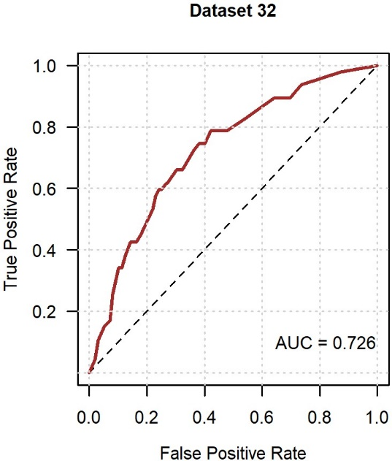

Supplementary Figure S1. ROC curve for internal validation of the risk model for incident neuropathic pain (imputed dataset 32)

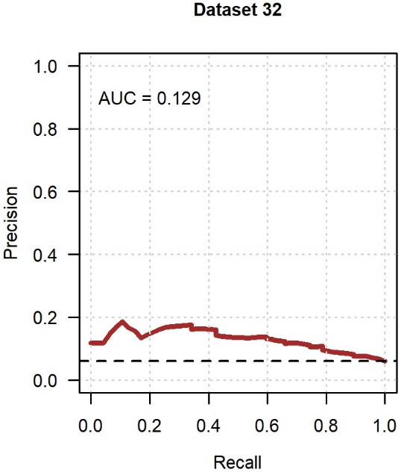

Supplementary Figure S2. Precision-recall curve for internal validation of the risk model for incident neuropathic pain (imputed dataset 32)

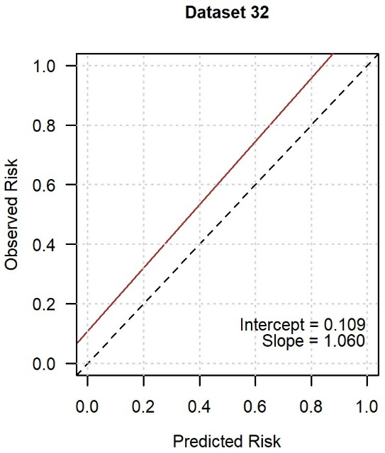

Supplementary Figure S3. Calibration curve for internal validation of the risk model for incident neuropathic pain (imputed dataset 32)

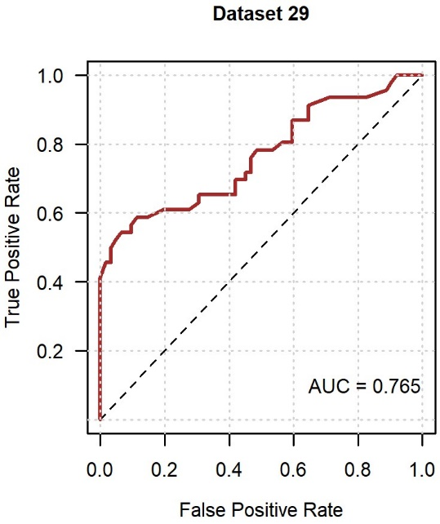

Supplementary Figure S4. ROC curve for internal validation of the risk model for resolved neuropathic pain (imputed dataset 29)

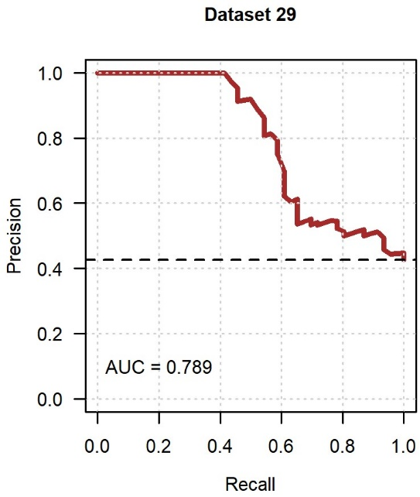

Supplementary Figure S5. Precision-recall curve for internal validation of the risk model for resolved neuropathic pain (imputed dataset 29)

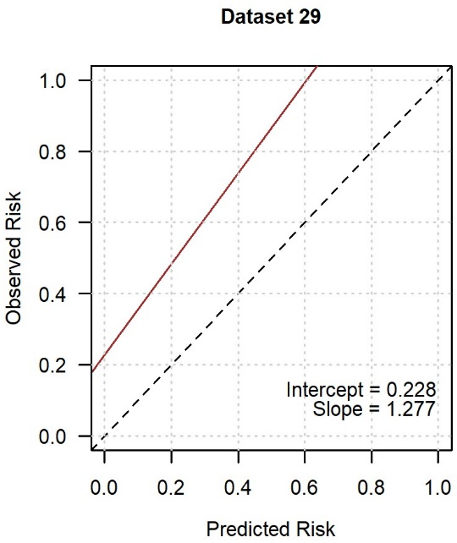

Supplementary Figure S6. Calibration curve for internal validation of the risk model for resolved neuropathic pain (imputed dataset 29)

