Supplementary Materials for

Who and why: a study of British distrust in the government and media during the COVID-19 pandemic

Maria Bălăeț*, Danielle L. Kurtin, Dragos C. Gruia, Annalaura Lerede, Darije Custovic, William Trender, Amy E. Jolly, Peter J. Hellyer, Adam Hampshire

*Corresponding author. Email: m.balaet17@imperial.ac.uk

This file includes:

Supplementary Text – Full questionnaire items, Further topic modelling explanations
Figs. S1 to S8
Tables S1 to S3

Other Supplementary Materials for this manuscript include the following separate files:
Table S4 to S6
Data S1 to S4
Regression Models Outputs R1
Supplementary Text
Full questionnaire items

Part 1 – Demographics

- How old are you?
From 0 to 100
- What sex have you been assigned?
  - Male
  - Female
  - Other
- To ensure we have a representative sample of the population, please indicate your ethnicity:
  - White or North American
  - East Asian
  - Indian/S/SE Asian
  - Mixed ethnicity
  - Other
  - Unknown
- What is your residence?
  - United Kingdom
  - Abroad
- What is your level of education?
  - Primary/elementary school or less
  - Secondary school/High school diploma
  - University Degree
  - PhD
- What is your occupational status?
  - Worker
  - Student
  - Homemaker
  - Retired
  - Unemployed/looking for work
  - Disabled/unapplicable/sheltered employment
  - Unknown

Part 2 – Mental health and wellbeing
These items were scored on a continuous scale from 0 to 6 and 0 to 7 respectively. The scores were grouped in three categories for analysis purposes: high wellbeing (below 20), medium wellbeing (between 20 and 40) and low wellbeing (above 40).

The GAD-7 Questionnaire
- Are you feeling nervous, anxious or on edge?
  - Never,
  - Almost never
  - Once or twice a week
  - Several times a week
  - Daily
  - Hourly
  - More Often
- Are you not being able to stop or control worrying?
  - Never
  - Almost never
  - Once or twice a week
  - Several times a week
  - Daily
  - Hourly
  - More Often
- Are you worrying too much about different things?
  - Never
  - Almost never
  - Once or twice a week
  - Several times a week
  - Daily
  - Hourly
  - More Often
- Are you having trouble relaxing?
  - Never
  - Almost never
  - Once or twice a week
  - Several times a week
  - Daily
  - Hourly
  - More Often
- Are you being so restless that it is hard to sit still?
  - Never
  - Almost never
  - Once or twice a week
  - Several times a week
  - Daily
  - Hourly
  - More Often
- Are you becoming easily annoyed or irritable?
  - Never
  - Almost never
  - Once or twice a week
  - Several times a week
  - Daily
  - Hourly
  - More Often
- Are you feeling afraid as if something awful might happen?
  - Never
  - Almost never
  - Once or twice a week
  - Several times a week
  - Daily
  - Hourly
  - More Often

The PHQ Questionnaire
- How often do you have little interest or pleasure in doing things?
  - Never
  - Almost never
  - Once or twice a week
  - Several times a week
  - Daily
  - Hourly
  - More Often
- How often are you feeling down or depressed?
  - Never
  - Almost never
  - Once or twice a week
  - Several times a week
  - Daily
  - Hourly
  - More Often
- How often are you feeling tired or having little energy?
  - Never
  - Almost never
  - Once or twice a week
  - Several times a week
  - Daily
  - Hourly
  - More Often
- How often do you have trouble concentrating on things, such as reading the newspaper or watching television?
  - Never
  - Almost never
  - Once or twice a week
  - Several times a week
  - Daily
  - Hourly
  - More Often
- How often are you not being able to get to sleep or stay asleep?
  - Never
  - Almost never
  - Once or twice a week
  - Several times a week
  - Daily
  - Hourly
  - More Often
- How many hours have you typically slept each night?
Choice from 0 to 24

Part 4 – Additional Questions

- On average, how many hours a day do you spend online?
Choice from 0 to 24
- Have you been diagnosed with a neurological or psychiatric condition?
  - No
  - I have a neurological condition
  - I have a psychiatric condition
  - I have both a neurological and a psychiatric condition
- How often did you use to take recreational drugs prior to the pandemic?
  - Never
  - Less than yearly
  - Yearly
  - Monthly
  - Weekly
  - Daily
  - Skip this question (unknown use)

Part 5 – Questions about belief and compliance during the COVID-19 pandemic

Compliance questions
Compliance questions were scored on a continuous scale from 0 to 2. The total scores represented the compliance score. The vaccine questions was initially asked when vaccines were just starting to be rolled out.

- Do you wear a mask in enclosed public spaces?
  - Yes = 0
  - Yes, but only because I have to = 0
  - No, I am exempt = 0 (because this is still complying)
  - No, I don’t think it makes a difference = 1
- Do you avoid leaving the house due to Covid?
  - Yes, I am scared for my health = 0
  - Yes, I am shielding = 0
  - Yes, I don’t trust others to be sensible = 0
  - Yes, for other reasons = 0
  - No, not anymore = 1
  - No = 2
- Have you followed the government guidelines about social distancing?
  - Yes = 0
  - Yes, most of the time = 1
  - I used to but I have given up = 1
  - No = 2
- Do you use the NHS Covid-19 app?
  - Yes = 0
  - No, it doesn’t work on my phone = 0
  - No, I don’t want to be tracked = 1
  - No, I don’t trust what the government will do with that data = 1
- When a vaccine is developed, would you get it?
  - Yes = 0
  - No = 2

Questions about beliefs
For some of the answers participants were also asked to provide their reasoning in free text form.
- Do you feel that there are ulterior motives behind the government’s response to Covid?
  - Yes – Free text
  - No
- Do you think that the media is hiding things from the public?
  - Yes– Free text
  - No
- Do you think that Covid is a naturally occurring phenomenon?
  - Yes
  - No – Free text
- Do you feel that current lockdown restrictions are justified?
  - Yes
  - Yes, but more needs to be done – Free text
  - No – Free text
- When a vaccine is developed, would you get it?
  - Yes
  - No - Free text

Question about information sources
- What are your primary sources of information about the pandemic?
  - Word of mouth
  - TV News
  - Radio
  - Newspapers
  - Social media
  - Podcasts
  - Internet news sites
  - Governmental communications

Further topic modelling explanations - Coherence

We estimated the average coherence per number of topics, ranging from 1-30 for each question (Figure S3). Coherence measures assess whether topics are more or less internally consistent; therefore, the number of topics with the highest coherence (range from 4-7) was chosen for each question as the optimal number of topics.

Then, LDA was applied using the optimal number of topics illustrated as the peaks in Figure S3 for each question.
The probabilistic graphical model of LDA is represented in Figure S4 (adopted from Syed and Spruit 2017). The topic mixtures per opinion were obtained and the top 20 opinions and words per topic were ranked based on this. Finally, the top 20 opinions associated with each topic were used to interpret and label each topic.

Fig. S1.

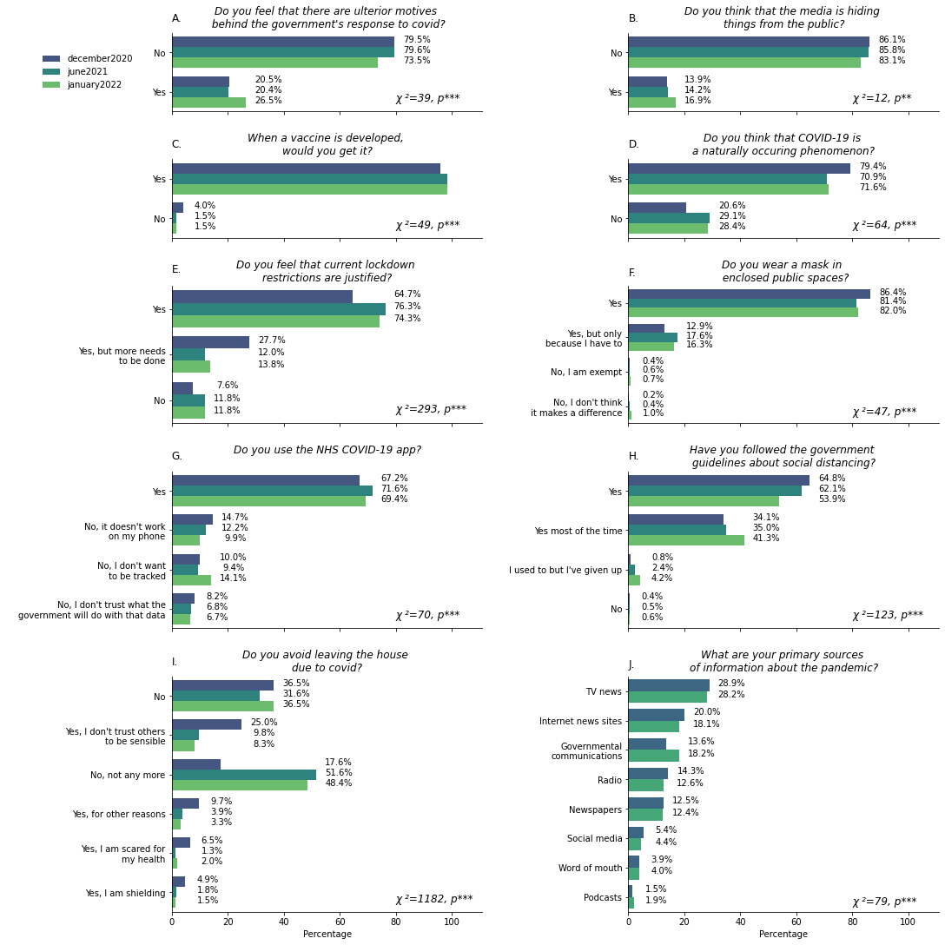
Longitudinal distribution of beliefs, compliance and media sources. The data presented only refers to the N=2797 respondents who completed all three timepoints. Panels A-E illustrate the proportions of various responses to belief-class questions. Panels F-I illustrate responses received to questions regarding compliance to measures that attempt to reduce COVID-19 transmission. Figure 1J illustrates the distribution of primary sources about the pandemic that people use. All x-axes show percentages. Each panel contains χ² and p values of tests for dissimilarity between the December 2020, June 2021 and January 2022 data. Answers are displayed in cascade order based on the most prevalent answers given in December 2020. Information regarding sources of information about the pandemic was not collected in January 2022. Significance is denoted as *, **, and *** for p<0.05, p<0.01, and p<0.001, respectively.
Fig. S2.
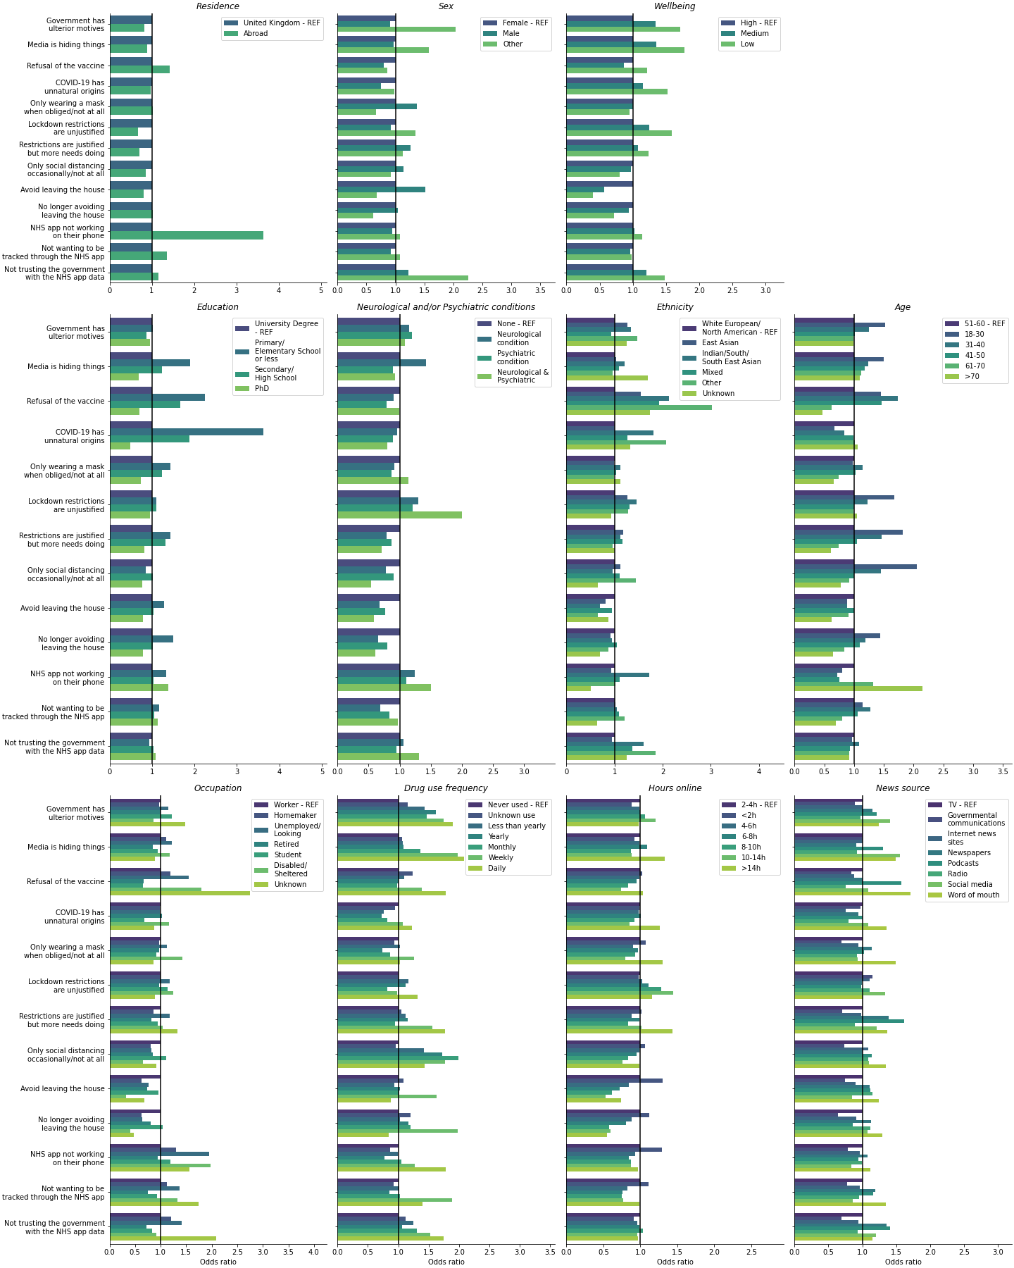
Odds of being distrustful and noncompliant. Odds ratios for divergent beliefs are illustrated for December 2020 on the x-axis. On the y-axis answers related to the government response to COVID-19, the media hiding things, vaccination, the origins of COVID-19, wearing a mask and following the social distancing guidelines are resulting from binomial logistic regression models. In the figure legend, categories which act as reference for the odds ratios are labelled “-REF”.

Fig. S3.
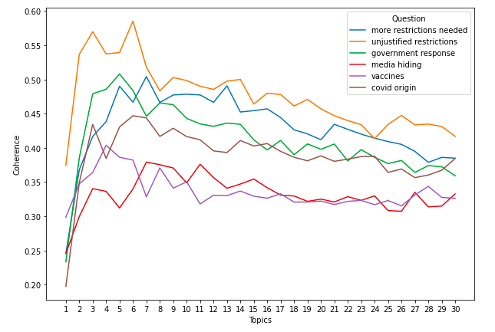
Topic modelling evaluation. In this figure we show the average coherence value for these questions per number of topics. Optimal topic numbers have been chosen based on the corresponding highest coherence value.

Fig. S4.
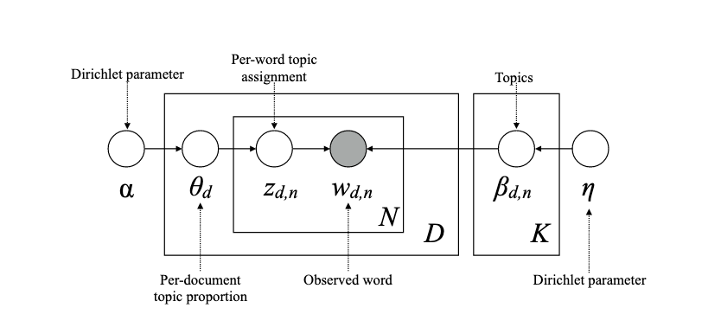

LDA represented as a graphical model. The nodes denote random variables. The edges represent the dependencies between random variables. The white nodes represent the hidden variables. The grey node represents the observed random variable. The boxes (plates) indicate replication. The figure has been adopted from Syed and Spruit 2017.

Fig. S5.
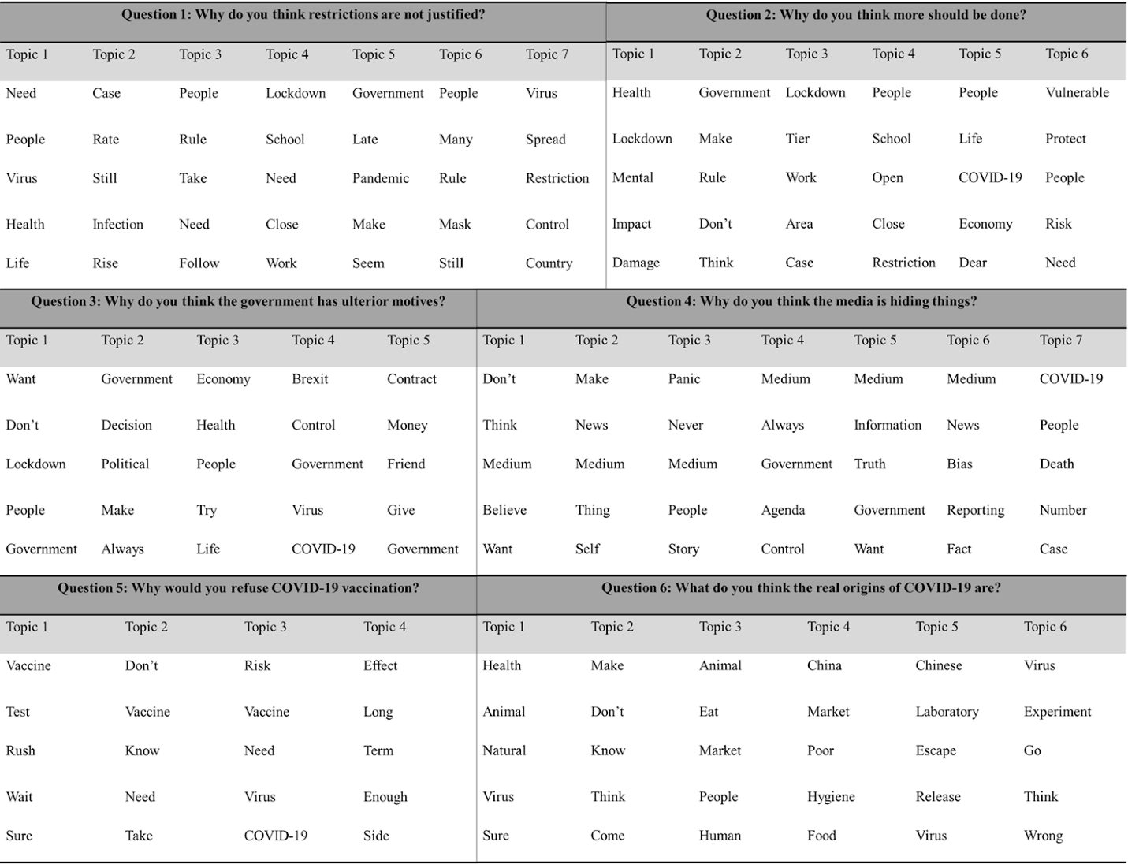
Top 5 words per topic. Top 5 words are presented for each of the free text questions assessed.

Fig S6.
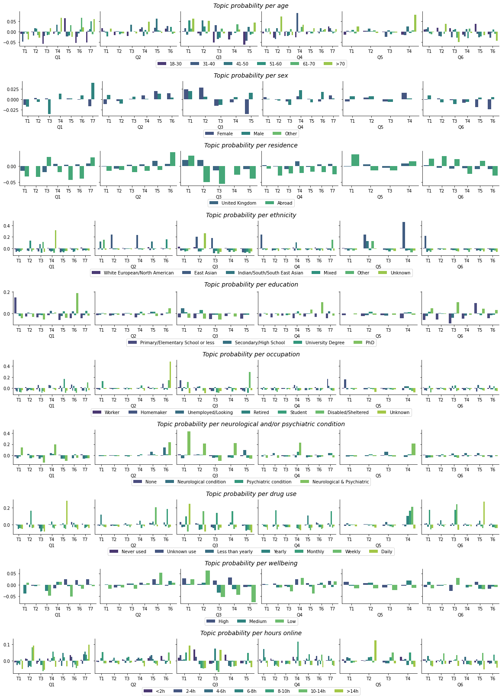
Changes in the distribution of beliefs per sociodemographic category from December 2020 to June 2021. The probability of a topic (y axis) in different levels of sociodemographic factors is presented as a difference June 2021-December 2020. Topics are labelled T= Topic. Topic labels in figure 2. Detailed topic label descriptions are in the Table S1.

Fig S7.
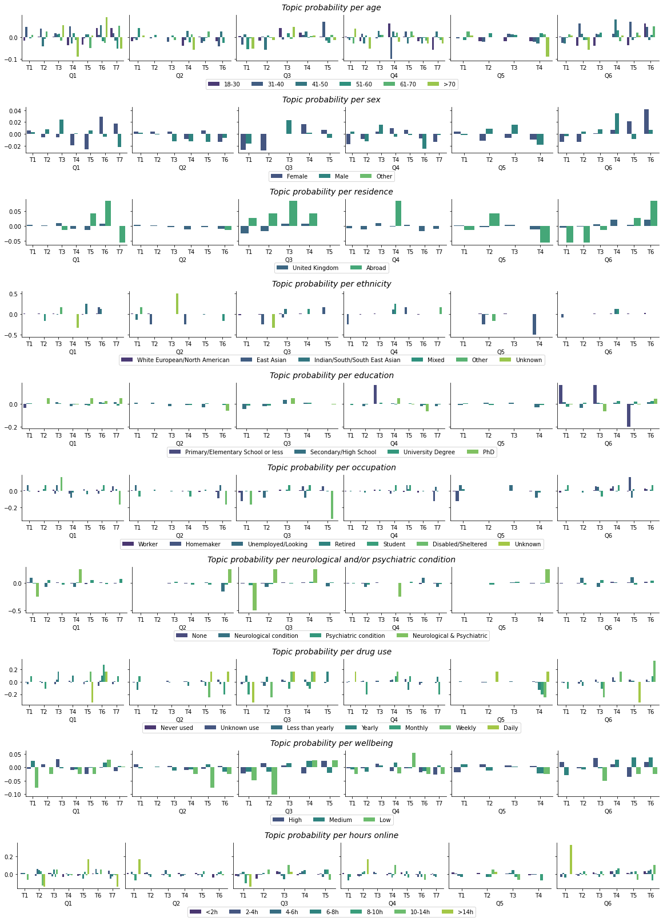
Changes in the distribution of beliefs per sociodemographic category from June 2021 to January 2022. The probability of a topic (y axis) in different levels of sociodemographic factors is presented as a difference January 2022-June 2021. Topics are labelled T= Topic. Topic labels in figure 2. Detailed topic label descriptions are in the Table S1.
Fig S8.
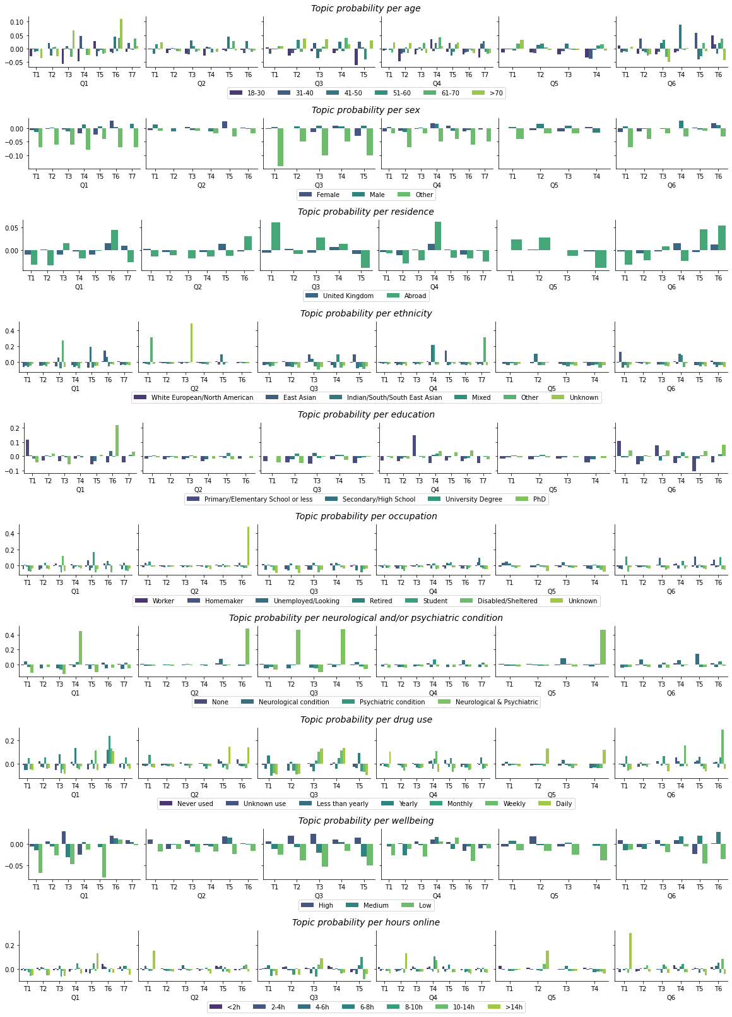
Changes in the distribution of beliefs per sociodemographic category from December 2020 to January 2022. The probability of a topic (y axis) in different levels of sociodemographic factors is presented as a difference January 2022-December 2020. Topics are labelled T= Topic. Topic labels in figure 2. Detailed topic label descriptions are in the Table S1.
Table S1.
Factor | Value | % Dec 2020 | N Dec 2020 | % June 2021 | N June 2021 | N Jan 2022 | % Jan 2022 | χ² | p-value
Age | 51 to 60 | 24.0 | 4965 | 24.4 | 3101 | 25.3 | 3541 | 86.03 | ***
 | 61 to 70 | 21.3 | 4422 | 22.3 | 2825 | 21.8 | 3056
 | 41 to 50 | 17.2 | 3555 | 17.5 | 2224 | 18.7 | 2627
 | 18 to 30 | 14.7 | 3053 | 13.7 | 1739 | 12.5 | 1754
 | 31 to 40 | 14.7 | 3048 | 14.5 | 1845 | 15.3 | 2144
 | Above 70 | 8.1 | 1677 | 7.6 | 960 | 6.4 | 899
Sex | Female | 50.9 | 10645 | 52.2 | 6682 | 53.1 | 7484 | 18.62 | ***
 | Male | 48.6 | 10172 | 47.3 | 6051 | 46.5 | 6548
 | Other | 0.5 | 105 | 0.5 | 63 | 0.4 | 58
Residence | United Kingdom | 93.4 | 19551 | 96.2 | 12305 | 95.8 | 13493 | 153.67 | ***
 | Abroad | 6.6 | 1371 | 3.8 | 491 | 4.2 | 597
Ethnicity | White European or North American | 90.7 | 18978 | 92.3 | 11807 | 91.7 | 12914 | 37.22 | ***
 | Indian, South Asian or South-East Asian | 2.1 | 443 | 1.7 | 216 | 1.8 | 253
 | Mixed ethnicity | 2.1 | 443 | 1.9 | 240 | 1.9 | 266
 | East Asian | 1.9 | 407 | 1.7 | 213 | 2.1 | 296
 | American Hispanic | 1.7 | 358 | 1.4 | 178 | 1.4 | 204
 | Other | 0.8 | 160 | 0.5 | 70 | 0.6 | 88
 | Unknown | 0.6 | 133 | 0.6 | 72 | 0.5 | 69
Education | University degree | 61.4 | 12836 | 61.5 | 7869 | 62.4 | 8791 | 8.40 | 0.21
 | Secondary school/High school diploma | 32.1 | 6721 | 32.3 | 4132 | 31.1 | 4376
 | PhD | 5.0 | 1040 | 4.8 | 620 | 5.1 | 718
 | Primary/Elementary school or less | 1.6 | 325 | 1.4 | 175 | 1.5 | 205
Occupation | Worker | 60.4 | 12629 | 60.5 | 7737 | 62.8 | 8854 | 111.90 | ***
 | Retired | 26.1 | 5463 | 27.6 | 3533 | 25.8 | 3642
 | Student | 6.3 | 1324 | 5.4 | 693 | 4.5 | 637
 | Unemployed/Looking for work | 3.3 | 682 | 2.7 | 343 | 2.7 | 375
 | Homemaker | 2.4 | 502 | 2.6 | 331 | 2.9 | 409
 | Disabled/Not applicable/Sheltered employment | 1.1 | 225 | 1.0 | 131 | 1.0 | 140
 | Unknown | 0.5 | 97 | 0.2 | 28 | 0.2 | 33
Prescence of a neuropsychiatric or neurological condition | None | 87.7 | 18247 | 86.8 | 11062 | 86.4 | 12149 | 44.98 | ***
 | I have a psychiatric condition | 8.8 | 1823 | 9.0 | 1143 | 8.5 | 1199
 | I have a neurological condition | 2.9 | 614 | 3.5 | 443 | 4.1 | 578
 | I have both a psychiatric and a neurological condition | 0.6 | 133 | 0.7 | 93 | 0.9 | 129
Drug use | Never used | 52.9 | 11061 | 24.1 | 3088 | 24.1 | 3088 | 7058.92 | ***
 | Unknown use | 29.0 | 6062 | 49.3 | 6313 | 49.3 | 6313
 | Less than yearly | 10.0 | 2101 | 19.6 | 2504 | 19.6 | 2504
 | Yearly | 4.0 | 843 | 3.1 | 402 | 3.1 | 402
 | Monthly | 1.8 | 386 | 1.9 | 238 | 1.9 | 238
 | Weekly | 1.1 | 240 | 1.0 | 131 | 1.0 | 131
 | Daily | 1.1 | 229 | 0.9 | 120 | 0.9 | 120
Level of wellbeing | High wellbeing | 58.8 | 12193 | 35.4 | 4527 | 34.7 | 4889 | 2681.64 | ***
 | Medium wellbeing | 34.2 | 7089 | 52.9 | 6773 | 54.5 | 7671
 | Low wellbeing | 7.0 | 1448 | 11.7 | 1493 | 10.8 | 1528
Time per day online | Between 2h and 4h | 32.4 | 6689 | 31.0 | 3953 | 32.0 | 4508 | 117.03 | ***
 | Less than 2h | 21.5 | 4448 | 24.2 | 3088 | 22.5 | 3163
 | Between 4h and 6h | 19.6 | 4048 | 17.1 | 2179 | 18.0 | 2538
 | Between 6h and 8h | 11.9 | 2465 | 11.5 | 1468 | 11.0 | 1544
 | Between 8h and 10h | 7.9 | 1626 | 9.6 | 1222 | 9.5 | 1331
 | Between 10h and 14h | 4.8 | 987 | 5.1 | 654 | 5.4 | 757
 | More than 14h | 1.9 | 400 | 1.5 | 191 | 1.7 | 236
Participant Demographics. Demographics of participants surveyed at the different timepoints are presented alongside chi-squared statistics (χ²). Significance stars for χ² analysis with * indicating p<0.05, ** indicating p<0.01, and *** indicating p<0.001.

Table S2.
Question | Topic | Label | % Dec | N Dec | % June | N June | % Jan | N Jan | Χ² | p-value
Q1.Why do you think more restrictions are needed? | Topic 1 | More needs to be done to protect the NHS, frontline workers, and the most vulnerable | 16.1 | 973 | 17.2 | 293 | 10.7 | 231 | 473.4 | ***
 | Topic 2 | Infection, transmission, hospitalisation and death rates are rising | 10.1 | 611 | 11.4 | 194 | 27.1 | 583
 | Topic 3 | Rules need to be stricter, clearer and better enforced | 18 | 1086 | 15 | 256 | 12.5 | 269
 | Topic 4 | Lockdown should have been more complete and prompter | 14.1 | 853 | 19.5 | 333 | 14.2 | 307
 | Topic 5 | The government's response to COVID-19 should be more proactive and stricter | 17.6 | 1064 | 13.6 | 232 | 12 | 259
 | Topic 6 | Too many people don't follow COVID-19 rules and guidelines | 13.8 | 834 | 10.4 | 178 | 16.2 | 350
 | Topic 7 | Stronger, clearer restrictions are required to prevent the spread of the virus | 10.2 | 619 | 12.9 | 221 | 7.2 | 156
Q2. Why do you think restrictions are unjustified? | Topic 1 | The physical, mental and economical toll due to COVID-19 policies are not justified by their impact on the pandemic | 19.2 | 380 | 26.7 | 414 | 10.7 | 231 | 137.3 | ***
 | Topic 2 | The government is inconsistent and indecisive in coming up with and applying COVID-19 rules | 13.9 | 274 | 18.8 | 291 | 27.1 | 583
 | Topic 3 | Lockdowns and other measures are ineffective, either because more should have been done sooner, or because they basically don't work | 14.6 | 289 | 9.8 | 152 | 12.5 | 269
 | Topic 4 | COVID-19 policies are often illogical, contradictory and unfair across different contexts (e.g. pubs, schools, supermarkets, small businesses | 18.5 | 365 | 17.8 | 277 | 14.2 | 307
 | Topic 5 | The toll on young people's health, wealth and opportunity from lockdown is not justified by its effect on diease burden | 18.9 | 373 | 10.8 | 167 | 12 | 259
 | Topic 6 | Restrictions should be focused on the vulnerable, allowing the majority to get on with life for their and the economy's benefit. | 15 | 297 | 16.2 | 251 | 16.2 | 350
Q3. Why do you think the government has ulterior motives? | Topic 1 | The government seems to prioritise COVID-19 policies that gain favourable opinion of businesses and the public resulting in slow and inconsistent decision-making | 18.8 | 872 | 25.7 | 729 | 18.9 | 778 | 116.7 | ***
 | Topic 2 | The government has not been transparent/has been dishonest with the public, and has ignored the advice of experts | 19.7 | 914 | 19.8 | 561 | 24.5 | 1007
 | Topic 3 | The economy has been prioritised over public health | 22.5 | 1044 | 20.1 | 571 | 19.8 | 815
 | Topic 4 | The government is using COVID-19 as a shield to conceal its true plans or failures, especially with regards to Brexit. | 13.9 | 644 | 11.2 | 317 | 16.2 | 666
 | Topic 5 | Government ministers have used the pandemic for personal gain and to unfairly reward friends and supporters, especially through award of contracts. | 25.3 | 1174 | 23.2 | 659 | 20.7 | 851
Q4. Why do you think the media is hiding things? | Topic 1 | The media tends to share partial and decontextualised information based on ambivalent reasons | 10.3 | 352 | 9.4 | 208 | 9.8 | 255 | 29.4 | ***
 | Topic 2 | The media seems to focus on the negative, sensational stories, often with profit as their primary interest | 15.6 | 533 | 15.2 | 336 | 16.1 | 419
 | Topic 3 | The media does not encourage critical discourse backed by scientific evidence about the pandemic and the government's handling of it. | 10.1 | 344 | 12.8 | 282 | 14.6 | 381
 | Topic 4 | The media does not present impartial news because it is influenced by the politics, the global economy and their investors. | 20.5 | 702 | 20.6 | 455 | 19.9 | 517
 | Topic 5 | The media is unreliable for various reasons | 14.4 | 493 | 13.8 | 305 | 11.4 | 297
 | Topic 6 | The media often has their own biases and agendas, and do not present enough global or alternative views. | 15.4 | 526 | 14.8 | 327 | 15 | 390
 | Topic 7 | COVID-19-related statistics are pereived as misleading or lacking | 13.7 | 470 | 13.4 | 297 | 13.1 | 342
Q5. Why would you refuse the COVID-19 vaccination? | Topic 1 | The testing and rollout of the vaccine was too rushed for some people, and others are medically exempt | 21.6 | 283 | 15.9 | 33 | 11.2 | 30 | 54 | ***
 | Topic 2 | People are unsure about taking either vaccines in general or the COVID-19 vaccine, and would prefer not to | 19 | 249 | 18.8 | 39 | 25.7 | 69
 | Topic 3 | The benefits of the vaccine are not worth its perceived risk or efficacy | 22.6 | 296 | 19.8 | 41 | 9.7 | 26
 | Topic 4 | Vaccine testing was too quick, and could not evaluate long-term side effects. | 36.7 | 481 | 45.4 | 94 | 53.5 | 144
Q6. Why would you refuse the COVID-19 vaccination? | Topic 1 | Human intefrerence with animal biosphere has encouraged zoonosis | 16.3 | 648 | 14.7 | 510 | 14.2 | 537 | 430 | ***
 | Topic 2 | The rapidity and severity of the pandemic coupled with opaque investigations, makes people unsure of the virus's origin | 11.5 | 457 | 10.4 | 362 | 9.5 | 357
 | Topic 3 | COVID-19 is a result of humans mistreating, eating and interfering with animals in their habitats | 18.5 | 735 | 31.9 | 1107 | 35.5 | 1341
 | Topic 4 | A lack of hygiene regulations, most importantly in food markets, has created conditions for Zoonosis | 14.3 | 568 | 10.7 | 370 | 10.6 | 402
 | Topic 5 | The virus was man-made in China, possibly as a biological weapon, and it was either accidentally or deliberately leaked | 20.7 | 821 | 21.3 | 737 | 21.6 | 816
 | Topic 6 | COVID-19 was created by humans, most likely in a lab, and was either deliberately or accidentally released. | 18.6 | 739 | 11 | 381 | 8.6 | 323
Topic distributuions at the different timepoints assessed. Distributions of opinions of participants surveyed at the different timepoints are presented alongside chi-squared statistics (χ²). This table also contains the tabulated data for Figure 4. Significance stars for χ² analysis with * indicating p<0.05, ** indicating p<0.01, and *** indicating p<0.001.

Table S3.
Factor | more restrictions needed | lockdown restrictions unjustified | government response to COVID-19 | media hiding things | vaccines | origins of COVID-19
age | 124.5, *** | 48, ** | 22, ns | 55.7, ** | 42.6, *** | 55.1, ***
sex | 46.6, *** | 34.4, *** | 27.3, *** | 22.7, * | 8.7, ns | 17.9, ns
residence | 13, * | 4, ns | 15.8, ** | 17, ** | 10.9, * | 2.3, ns
ethnicity | 32.4, ns | 26.9, ns | 19.9, ns | 21.5, ns | 29.7, * | 36.7, ns
education | 84.8, *** | 24.2, ns | 18.8, ns | 33.2, * | 3.3, ns | 46, ***
occupation | 98.6, *** | 54, ** | 30.7, ns | 51.1, * | 27.1, ns | 79.2, ***
neuropsychiatric status | 14.3, ns | 8.2, ns | 12.6, ns | 16.1, ns | 8.3, ns | 13.3, ns
drug use | 50.1, ns | 39.9, ns | 61.1, *** | 40.2, ns | 36.6, ** | 40.5, ns
time online | 48.9, ns | 16.3, ns | 49.3, ** | 31.4, ns | 13.8, ns | 40.8, ns
wellbeing | 37.2, *** | 6.4, ns | 16.7, * | 11.2, ns | 5.7, ns | 9.5, ns
Distribution of best-fitting topics varies between sociodemographic variables in December 2020. Significance stars for χ² analysis with * indicating p<0.05, ** indicating p<0.01, and *** indicating p<0.001 and ns indicating ‘not significant’.

Table S4. (separate file)
Probabilities of answering questions about beliefs, compliance and media sources based on sociodemographic factors at the different timepoints.

Table S5. (separate file)
Opinions used for the interpretation of topic labels presented alongside topic mixtures.

Table S6. (separate file)
Chi-squared statistics per Topic vary with sociodemographic factors.

Data S1. (separate file)
Tabulated data for Figure 1

Data S2. (separate file)
Tabulated data for Figure 2

Data S3 (separate file)
Tabulated data for Figure 3

Data S4 (separate file)
Tabulated data for Supplementary Fig S1

