Additional file 1.
Supplement Fig. 1
Protein pattern of S. agalactiae protein lysate and S. agalactiae protein lysate - loaded HNTs. a whole-cell protein profile of S. agalactiae serotypes Ia and III, b profile of the S. agalactiae protein lysate-loaded HNTs. Pellet represented the proteins that bound to the HNTs, supernatant exhibited the remnant proteins in solution. H, HA, HC, and HAC stranded for HNT, HNT-APTES, HNT-Chitosan, and HNT-APTES-Chitosan, respectively. (M = protein marker).

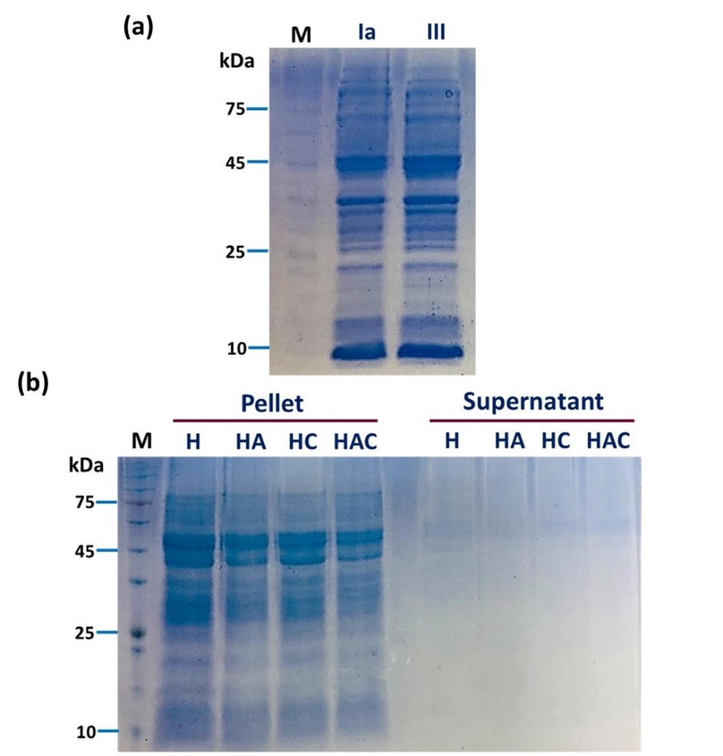

Supplement Fig. 2
The 12% SDS-PAGE analysis showing the acid-base tolerance profile of the S. agalactiae protein lysate-loaded HNTs after exposure to artificial acid-base solutions. a, b and c represented the releasing patterns at pH 2, pH 6, and pH8, respectively. The detectable band in the solution was the releasing S. agalactiae protein lysate, while in the pellet was the remaining proteins on HNTs particles.

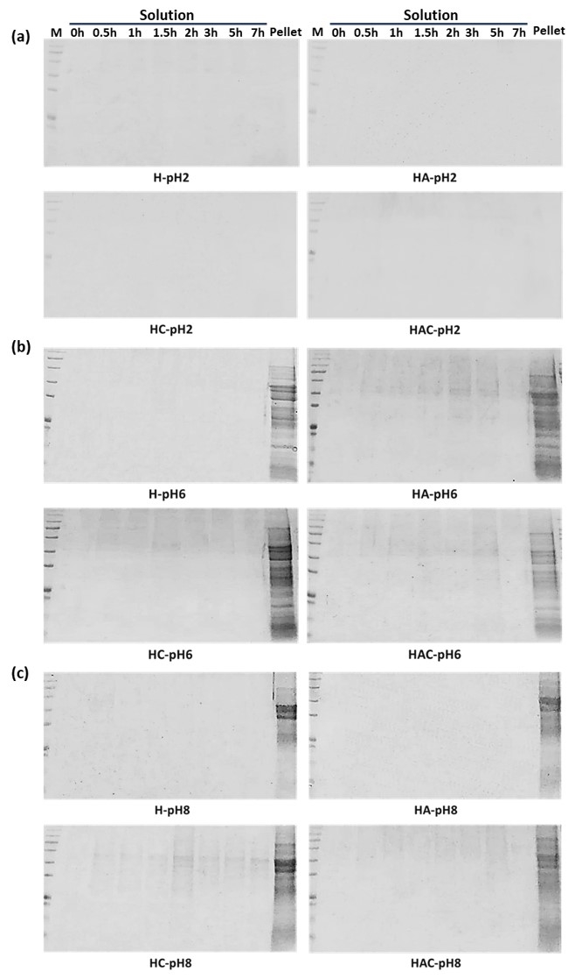

Supplement Fig. 3
12% SDS-PAGE analysis of the bile salt tolerance profile of the S. agalactiae protein lysate-loaded HNTs after 7h. The observed protein bands in the solution were the releasing Strep proteins, whereas in the pellet was the remaining proteins on HNTs.

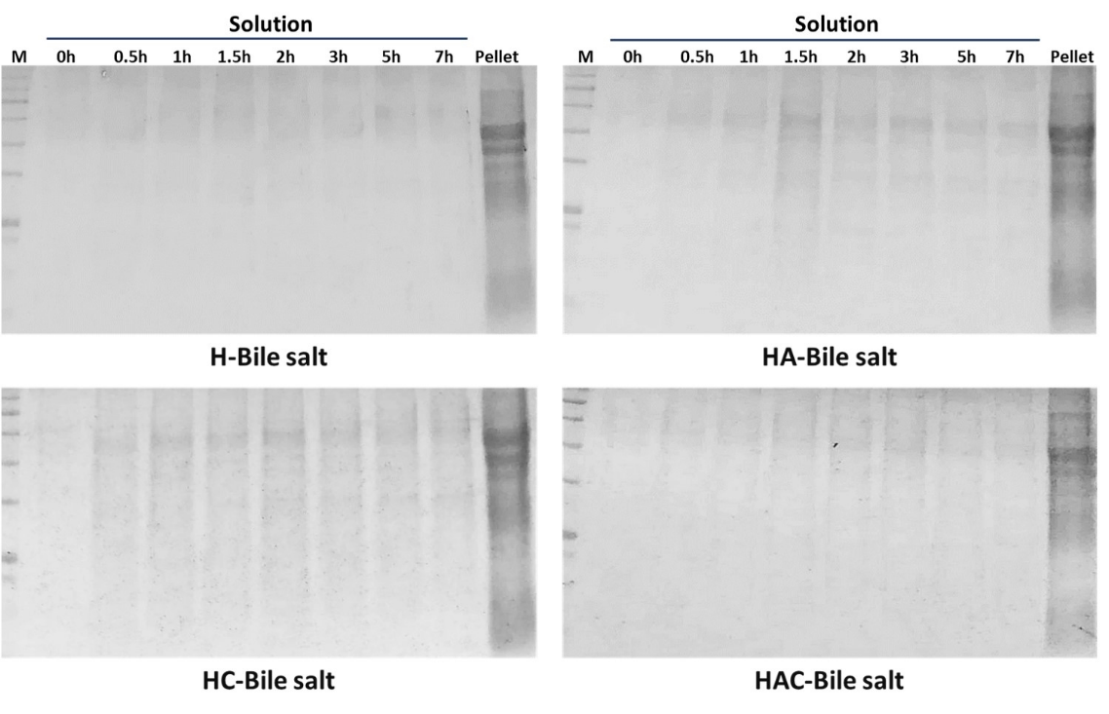

Supplement Fig. 4
The agarose gel electrophoresis demonstrating the multiplex PCR to confirm S. agalactiae serotype III infection and the noticeable symptoms after infection. a The specific bands of S. agalactiae serotype III were indicated at approximately 688 bp and 352 bp. b The exophthalmia and abscess symptoms were indicated at yellow and blue arrows, respectively. (N = negative, Ia = positive for S. agalactiae serotype Ia, III = positive for S. agalactiae serotype III, 1-6 = number of fish samples)

