Supplemental materials

Binding of LncRNA-DACH1 to dystrophin impairs the membrane trafficking of Nav1.5 protein and increases ventricular arrhythmia susceptibility

Supplementary Fig. 1
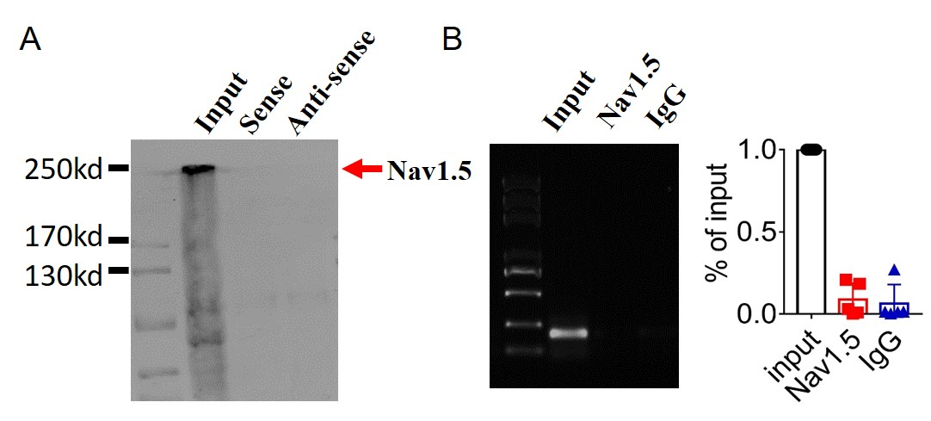
Supplementary Fig. 1 Examination of the potential interaction between lncDACH1 and Nav1.5. a, Pulldown of Nav1.5 with sense and antisense sequences of lncDACH1. b, RNA immunoprecipitation of lncDACH1 with anti-Nav1.5 antibody. N=4.

Supplementary Fig. 2

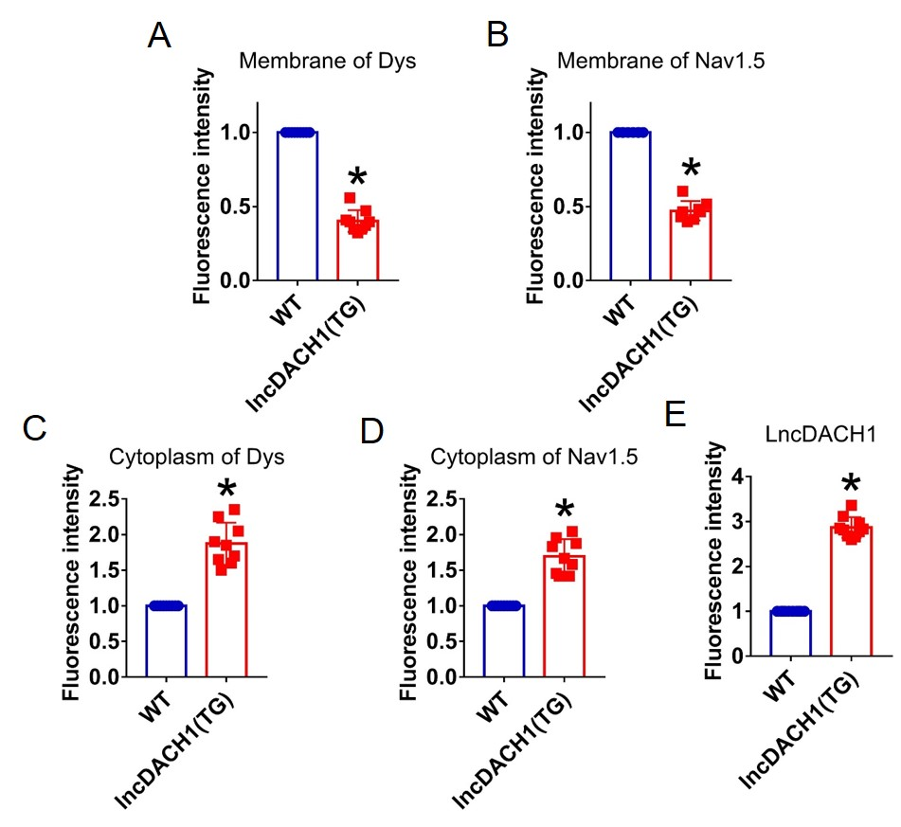
Supplementary Fig. 2 Fluorescence intensity of lncDACH1, dystrophin and Nav1.5 in isolated cardiomyocytes of lncDACH1-TG mice. a,b, Membrane levels of dystrophin (dys) and Nav1.5. N=9 for dys. N=8 for Nav1.5. *P<0.05 versus WT group. c,d, Cytoplasm levels of dystrophin and Nav1.5. N=9. *P<0.05 versus WT group. e, Fluorescence in situ hybridization (FISH) images of LncDACH1. N=10. *P<0.05 versus WT group. P-values were determined by unpaired t test.

Supplementary Fig. 3

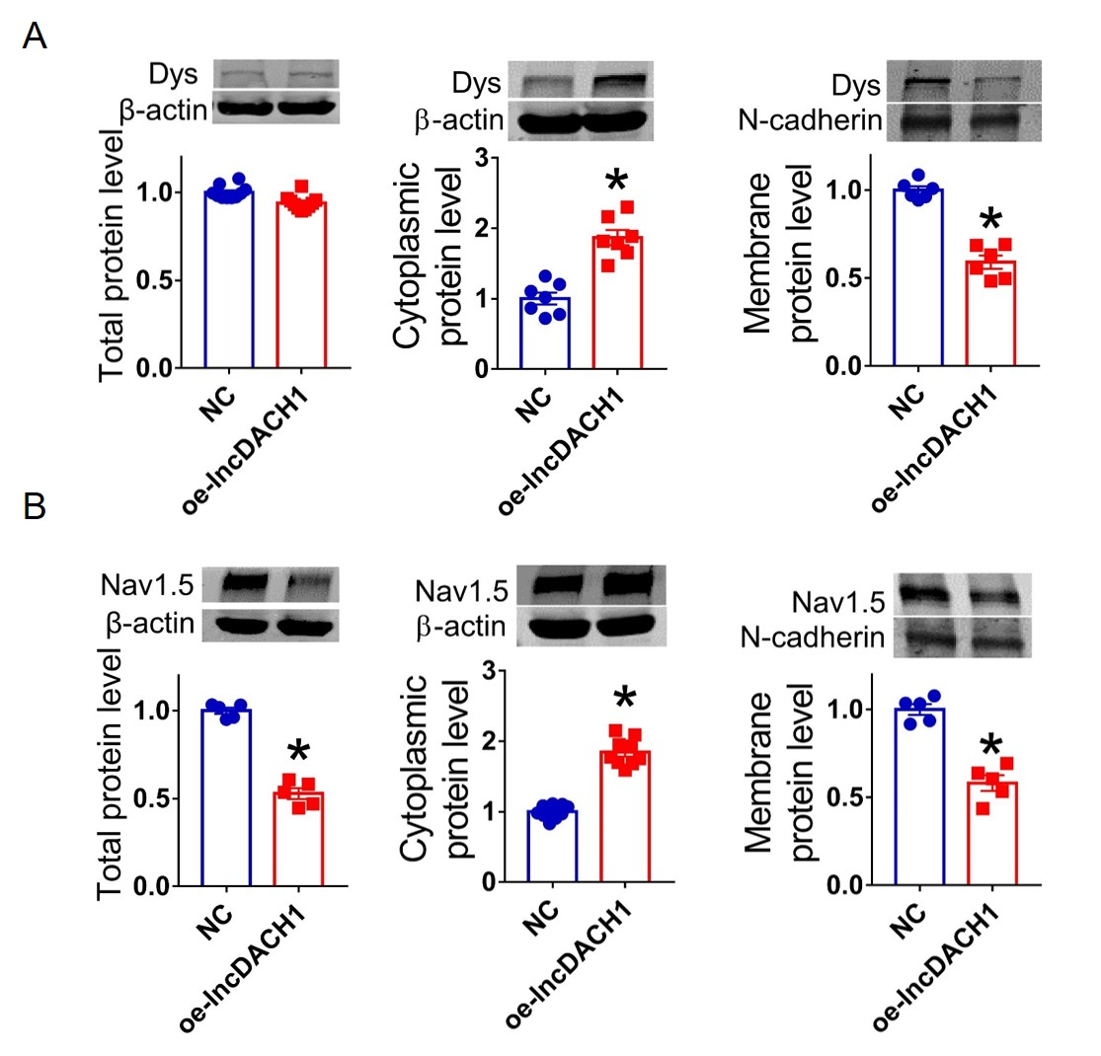
Supplementary Fig. 3. Overexpression of lncDACH1(oe-lncDACH1) in cultured neonatal cardiomyocytes decreased membrane dystrophin and Nav1.5 expression. a, The total, membrane and cytoplasm levels of dystrophin by Western blot. N-cadherin is the loading control for membrane extracts. N=10 for total protein; N= 6 for membrane protein; N= 7 for cytoplasm protein. *P<0.05 versus NC group. P-values were determined by unpaired t test. b, The total, membrane and cytoplasm levels of Nav1.5 by Western blot. N-cadherin is the loading control for membrane extracts. N=5 for total protein; N= 5 for membrane protein; N= 9 for cytoplasm protein. *P<0.05 versus WT group. P-values were determined by unpaired t test.
Supplementary Fig. 4

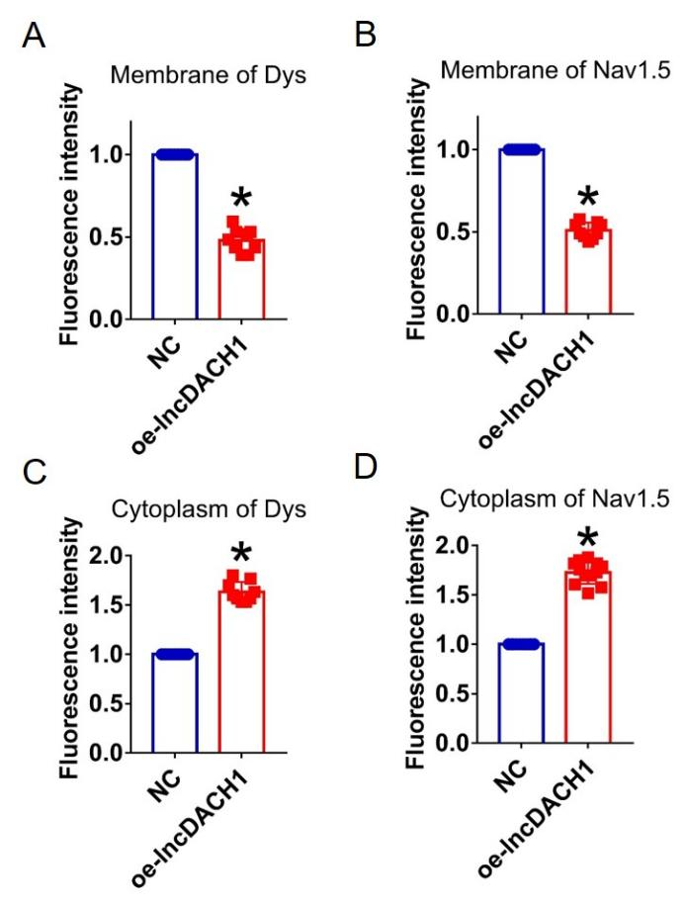
Supplementary Fig. 4 Fluorescence intensity of dystrophin and Nav1.5 in cultured neonatal cardiomyocyte overexpressing lncDACH1. a,b, Membrane levels of dystrophin and Nav1.5. N=9. *P<0.05 versus NC group. c,d, Cytoplasm levels of dystrophin and Nav1.5. N=9 for dys. N=12 for Nav1.5. *P<0.05 versus NC group. P-values were determined by unpaired t test.

Supplementary Fig. 5

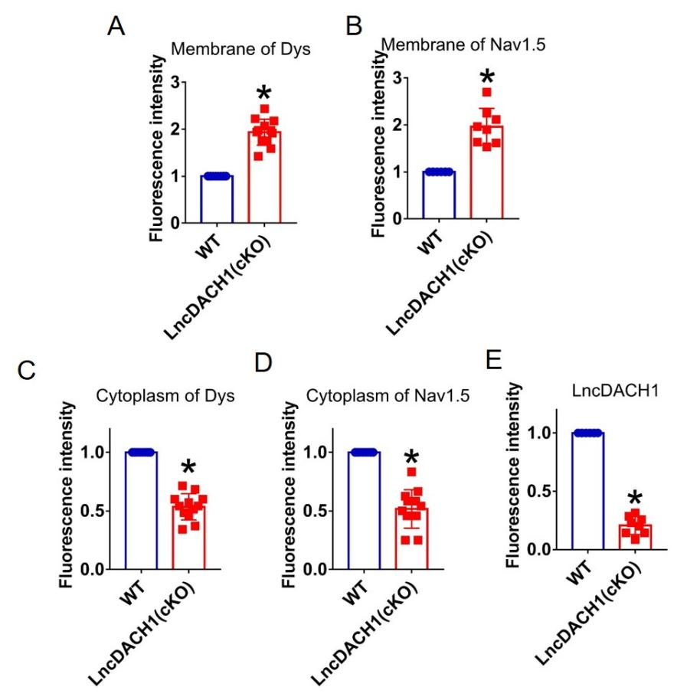
Supplementary Fig. 5 Fluorescence intensity of lncDACH1, dystrophin and Nav1.5 in isolated cardiomyocytes of lncDACH1-cKO mice. a,b, Membrane levels of dystrophin (dys) and Nav1.5. N=12 for dys. N=8 for Nav1.5. *P<0.05 versus WT group. c,d, Distribution of cytoplasm levels of dystrophin and Nav1.5. N=12. *P<0.05 versus WT group. e, Fluorescence in situ hybridization (FISH) images of LncDACH1 expression. N=8. *P<0.05 versus WT group. P-values were determined by unpaired t test.

Supplementary Fig. 6

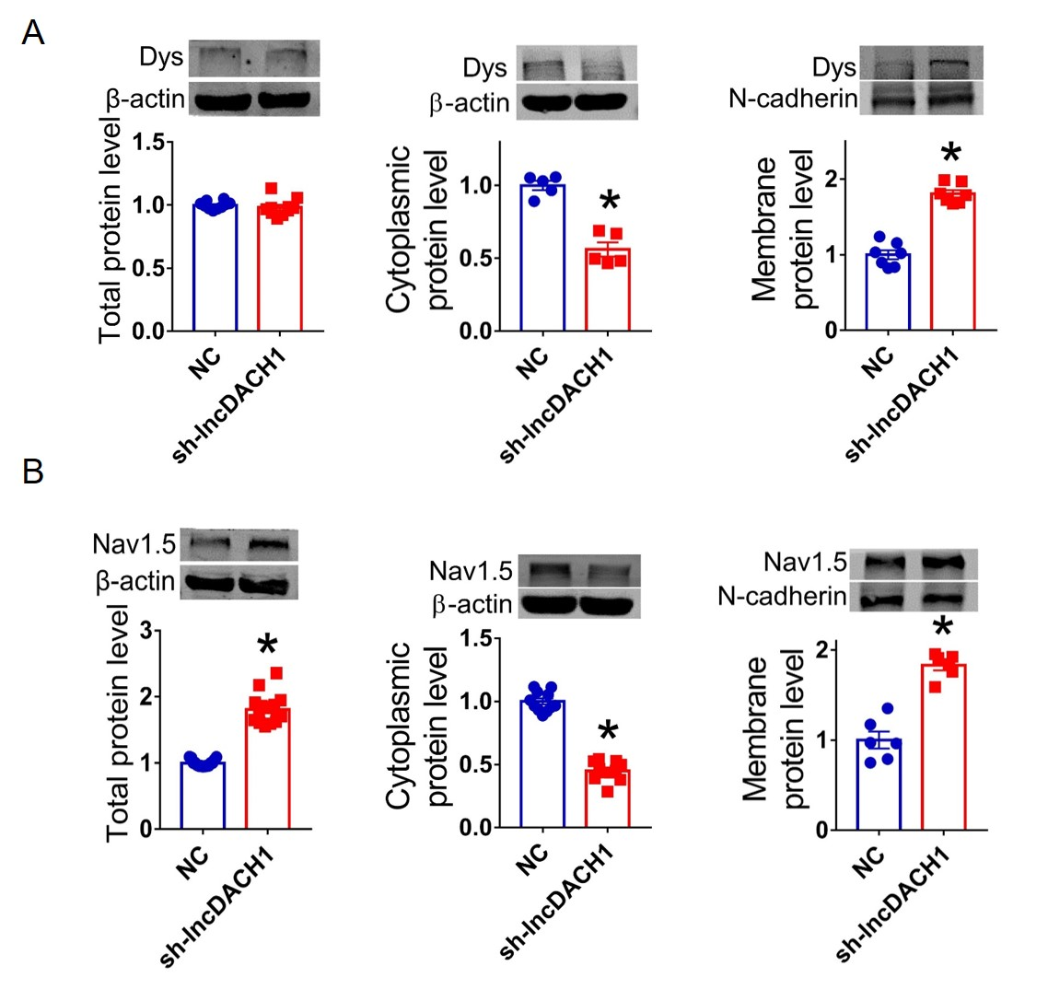
Supplementary Fig. 6 Effects of lncDACH1 knockdown with shRNA on the protein expression of dystrophin and Nav1.5 expression in cultured neonatal cardiomyocytes. a, The total, membrane and cytoplasm levels of dystrophin by Western blot. N-cadherin is the loading control for membrane extracts. N=10 for total protein; N= 7 for membrane protein; N= 5 for cytoplasm protein. *P<0.05 versus NC group. P-values were determined by unpaired t test. b, The total, membrane and cytoplasm levels of Nav1.5 by Western blot. N-cadherin is the loading control for membrane extracts. N=15 for total protein; N= 6 for membrane protein; N= 11 for cytoplasm protein. *P<0.05 versus WT group. P-values were determined by unpaired t test. Dys, dystrophin; NC, negative control; sh-lncDACH1, shRNA for lncDACH1

Supplementary Fig. 7

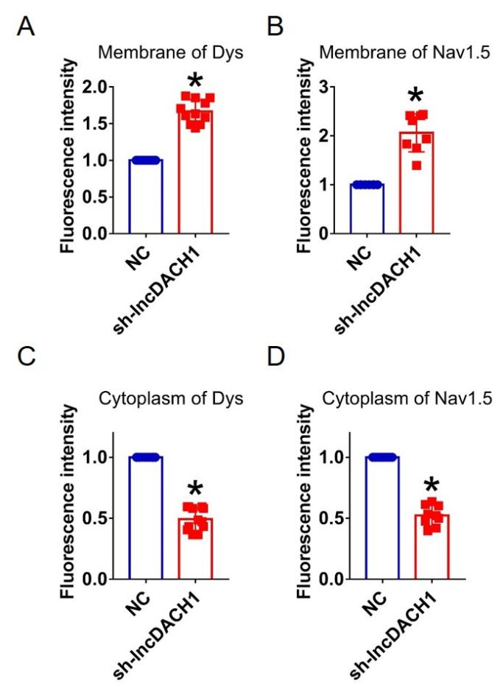
Supplementary Fig. 7 Fluorescence intensity of dystrophin and Nav1.5 in cultured neonatal cardiomyocytes after knocking down of lncDACH1. a,b, Distribution of membrane levels of dystrophin and Nav1.5. N=11 for dys. N=8 for Nav1.5.*P<0.05 versus NC group. c,d, Distribution of cytoplasm levels of dystrophin and Nav1.5. N=12 for dys. N=9 for Nav1.5.*P<0.05 versus NC group. P-values were determined by unpaired t test.

Supplementary Fig. 8

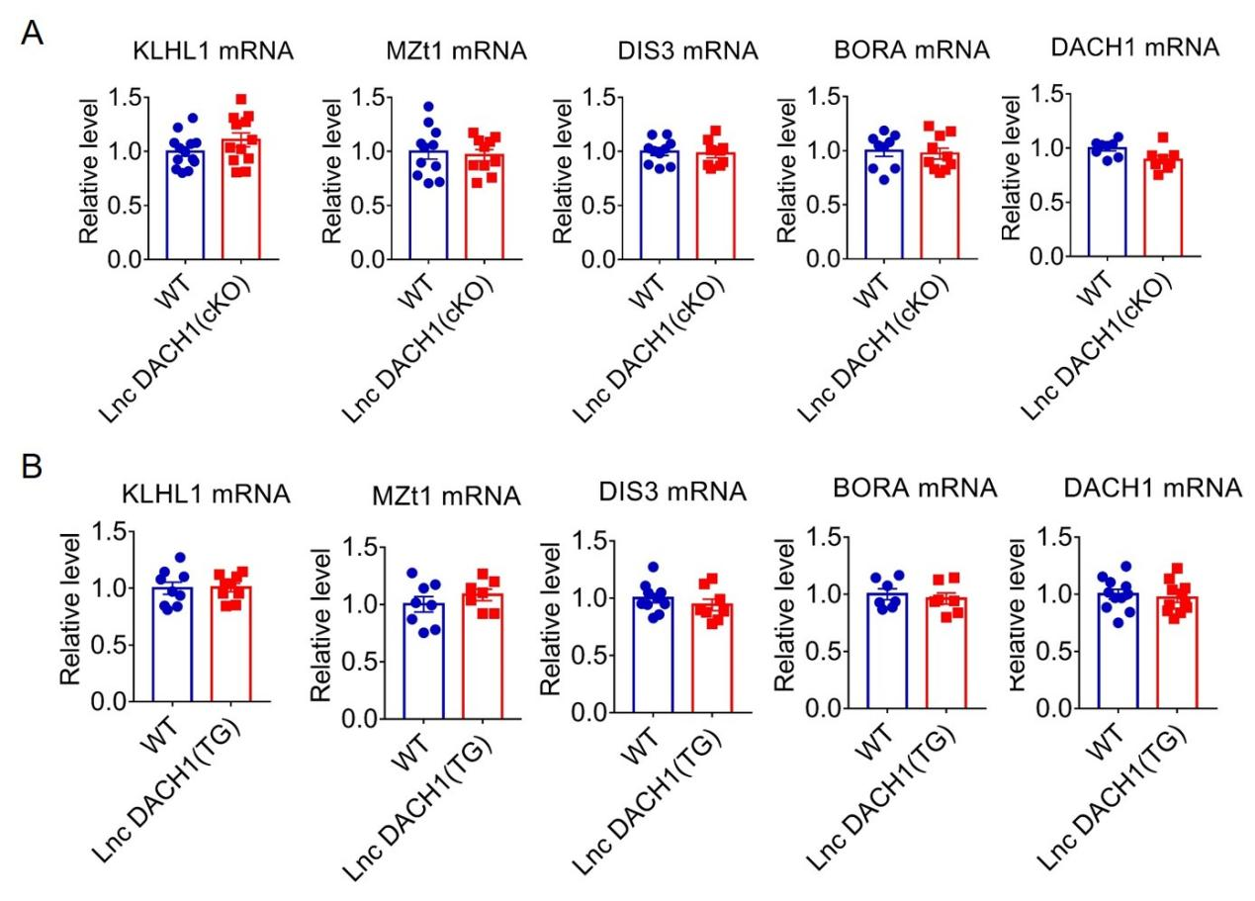
Supplementary Fig. 8 The mRNA expression of KLHL1, BORA, MZt1, DIS3 and Dach1 in the cardiac tissue of lncDACH1 knockout a, and transgenic overexpression (b) mice. N=7-12. *P<0.05 versus WT. Data are expressed as mean±SEM. Wt, wild type litter mates; lncDACH1(Tg), lncDACH1 cardiac transgenic overexpression; lncDACH1(CKO), lncDACH1 cardiomyocyte conditional knockout.

Supplementary Fig. 9

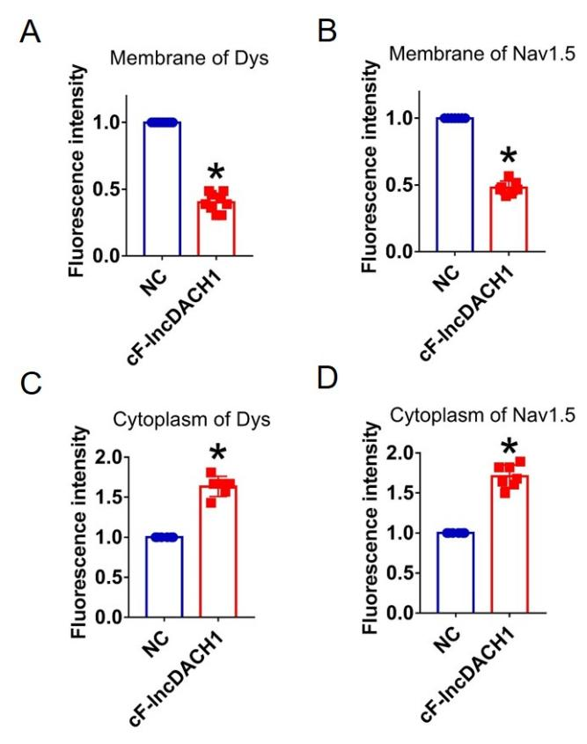
Supplementary Fig. 9 Fluorescence intensity of dystrophin and Nav1.5 in isolated cardiomyocytes overexpressing cF-lncDACH1. a,b, Membrane levels of dystrophin (dys) and Nav1.5. N=9 for dys. N=7 for Nav1.5. *P<0.05 versus NC group. c,d, Cytoplasm levels of dystrophin and Nav1.5. N=6 for dys. N=7 for Nav1.5. *P<0.05 versus NC group. P-values were determined by unpaired t test.

Supplementary Fig. 10
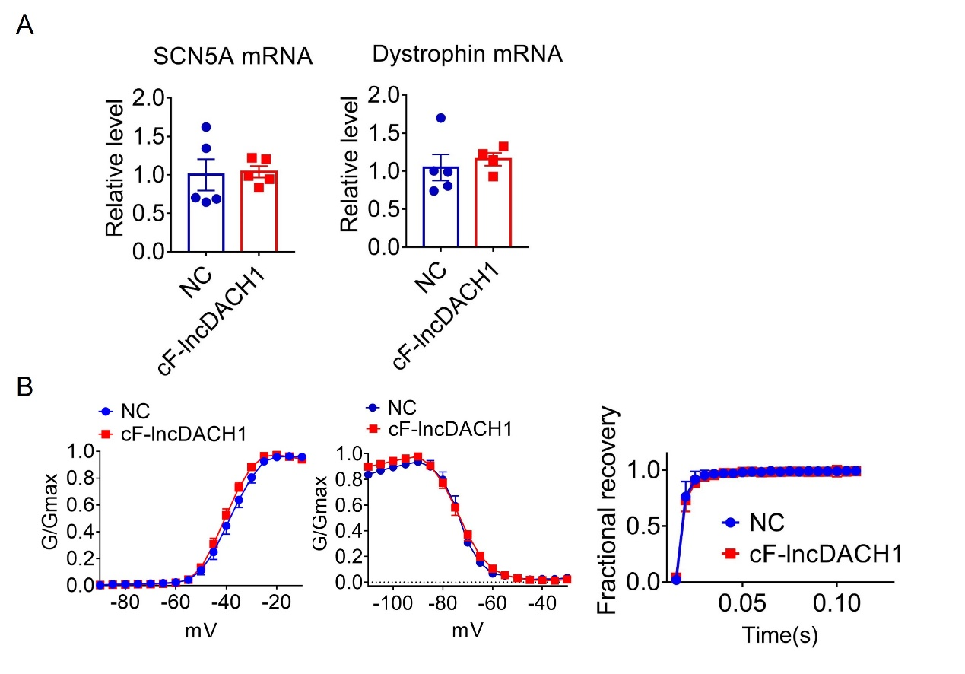
Supplementary Fig. 10 The conserved fragment of lncDACH1(cF-lncDACH1) inhibited sodium channel function in mice. a, The mRNA levels of SCN5A and dystrophin. N=4-5. b, Kinetics of I_{Na.} N=6-17 cells; N=3 mice of NC; N=4 mice of cF-lncDACH1.

Supplementary Fig. 11
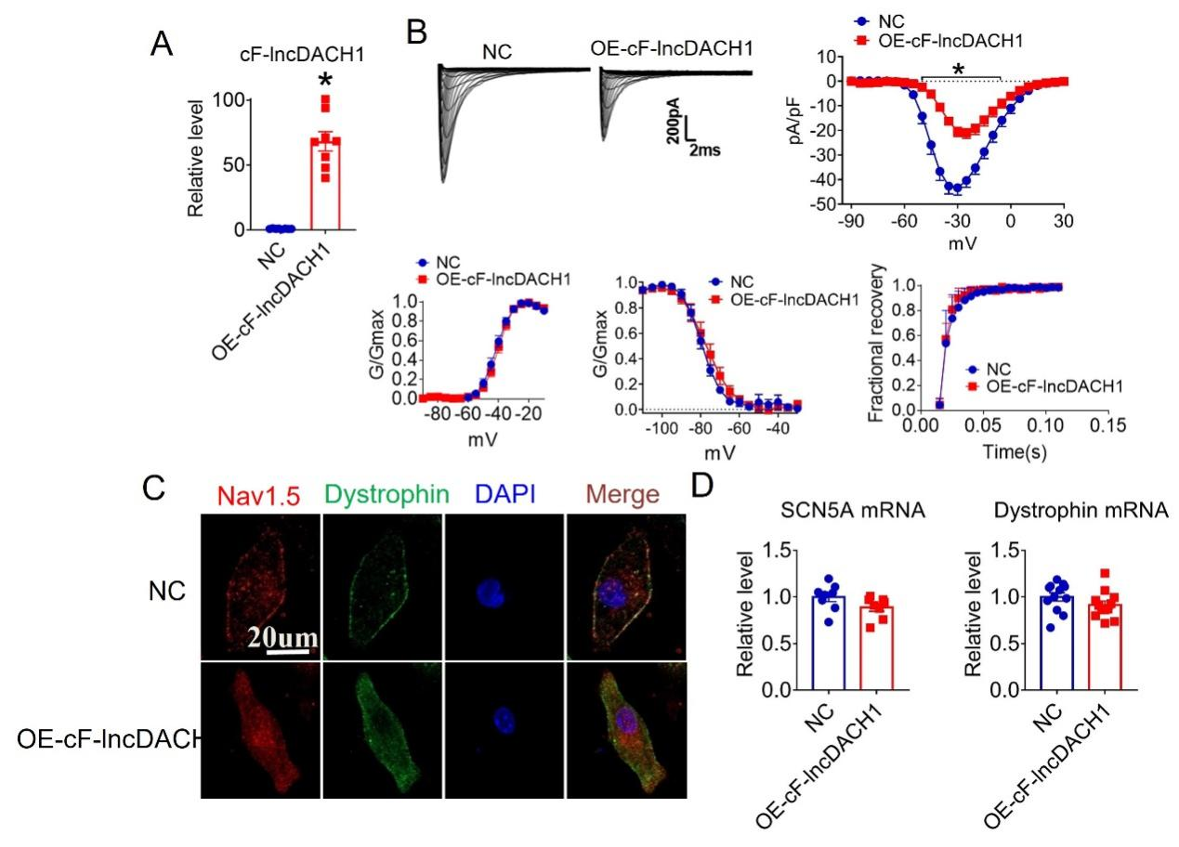
Supplementary Fig. 11 Effects of cF-lncDACH1 overexpression on sodium channel expression and function in cultured neonatal cardiomyocytes. a, Verification of the expression of cF-lncDACH1 after transfection of adenovirus carrying cF-lncDACH1. N=8 from 3 independent cultures. *P<0.05 versus NC (negative control, empty plasmid). P-values were determined by unpaired t test. b, Peak I_{Na} currents, I-V curves and kinetics of I_{Na.} N=8-15 cells from 3 independent cultures. *P<0.05 versus NC, P-values were determined by unpaired t test. c, Distribution of Nav1.5 and dystrophin by immunofluorescent staining. d, The mRNA levels of dystrophin and SCN5A. N=8-12 from 3 independent cultures.

Supplementary Fig. 12

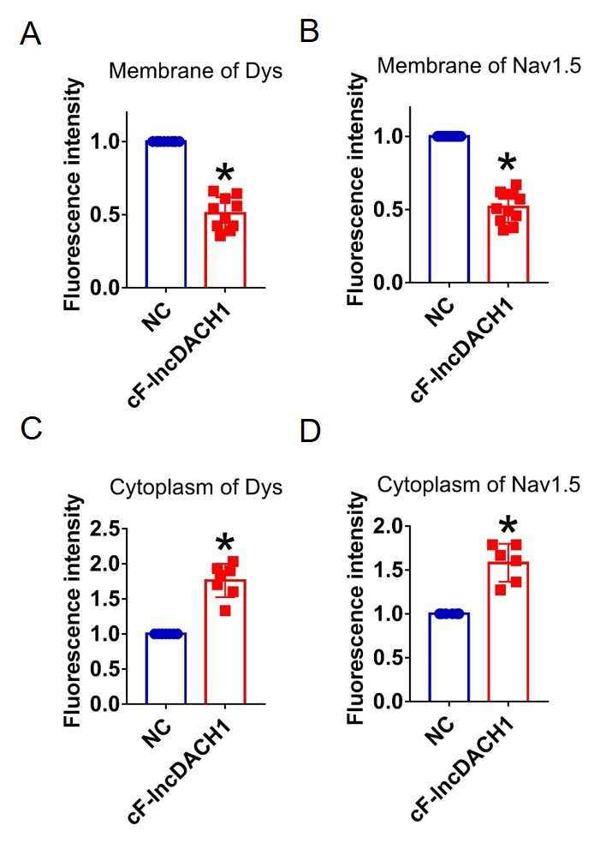
Supplementary Fig. 12 Fluorescence intensity of dystrophin and Nav1.5 in cultured neonatal cardiomyocytes overexpressing cF-lncDACH1. a,b, Membrane levels of dystrophin and Nav1.5. N=10 for dys. N=11 for Nav1.5. *P<0.05 versus NC group. c,d, Cytoplasm levels of dystrophin and Nav1.5. N=7 for dys. N=6 for Nav1.5.*P<0.05 versus NC group. P-values were determined by unpaired t test.

Supplementary Fig. 13
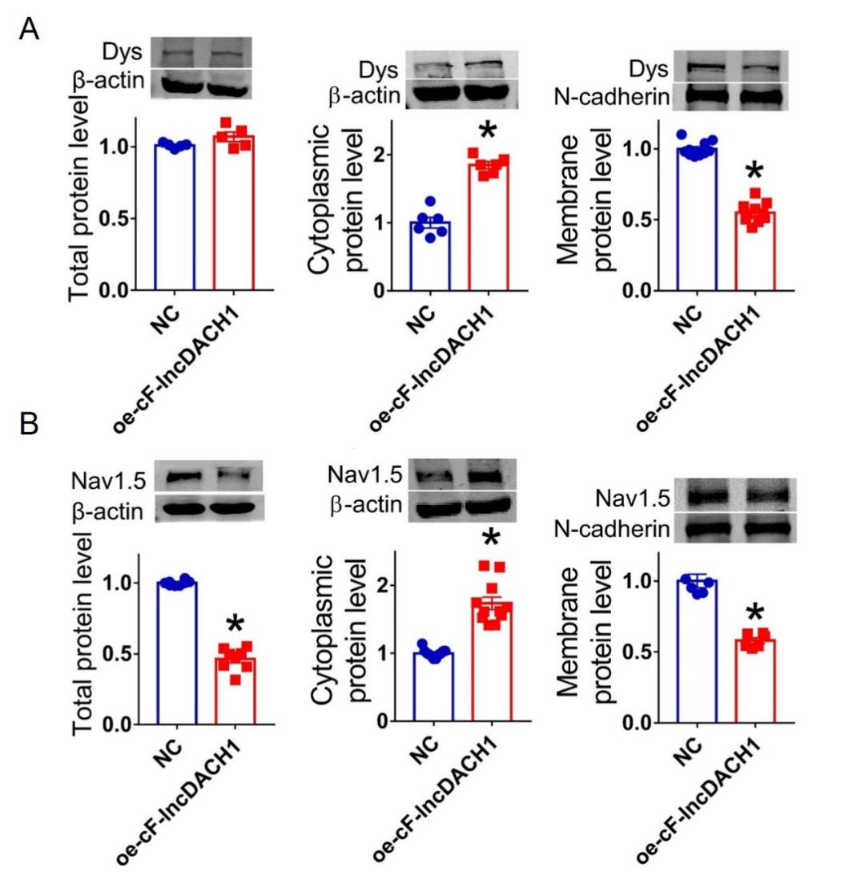

Supplementary Fig. 13 Overexpression of cF-lncDACH1(oe-cF-lncDACH1) in cultured neonatal cardiomyocytes decreased membrane dystrophin and Nav1.5 expression. a, The total, membrane and cytoplasm levels of dystrophin by Western blot. N-cadherin is the loading control for membrane extracts. N=5 for total protein; N= 8 for membrane protein; N= 6 for cytoplasm protein. *P<0.05 versus NC group. P-values were determined by unpaired t test. b, The total, membrane and cytoplasm levels of Nav1.5 by Western blot. N-cadherin is the loading control for membrane extracts. N=8 for total protein; N= 6 for membrane protein; N= 11 for cytoplasm protein. *P<0.05 versus WT group. P-values were determined by unpaired t test.

Supplementary Fig. 14

a, UCSC snapshot of lncDACH1
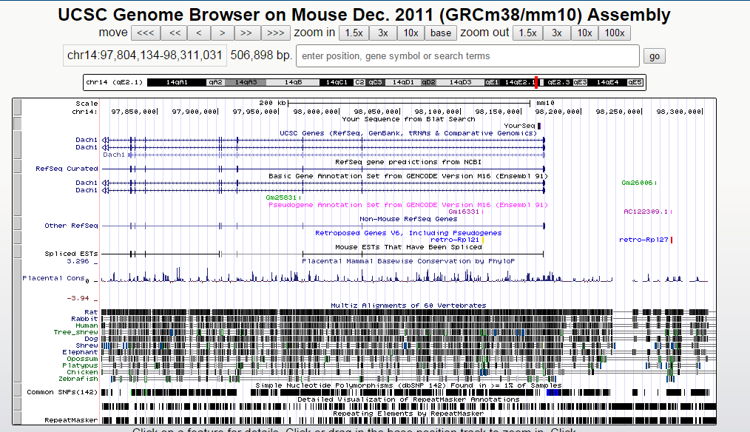

b, Conservation of lncdach1 between mice and other species

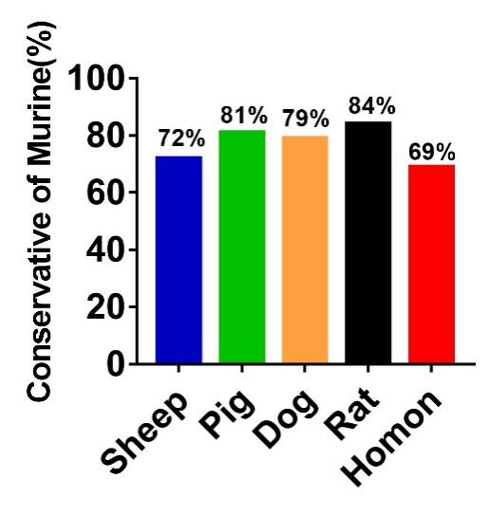
c, Alignment of murine lncDACH1 and human orthologue
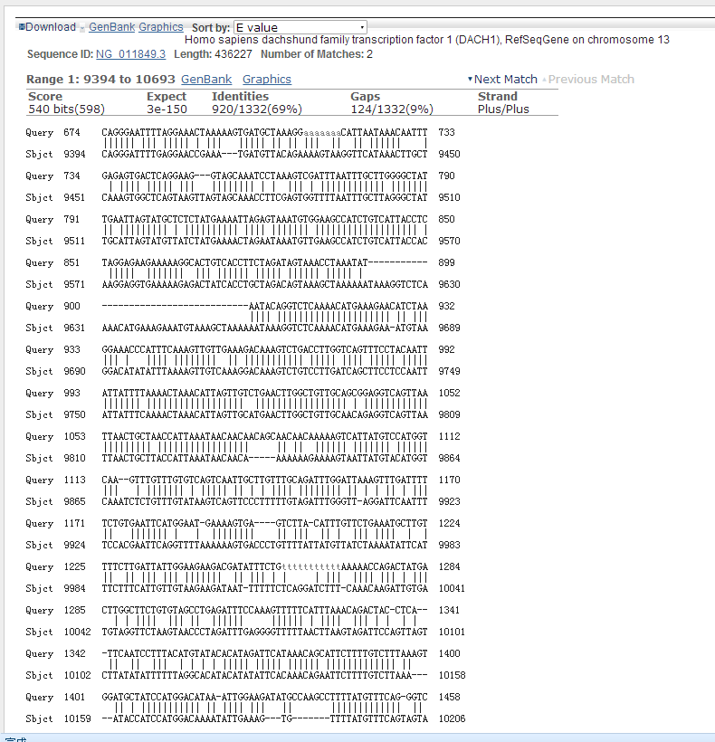
Human
Murine

d, Alignment of murine lncDACH1 and sheep orthologue
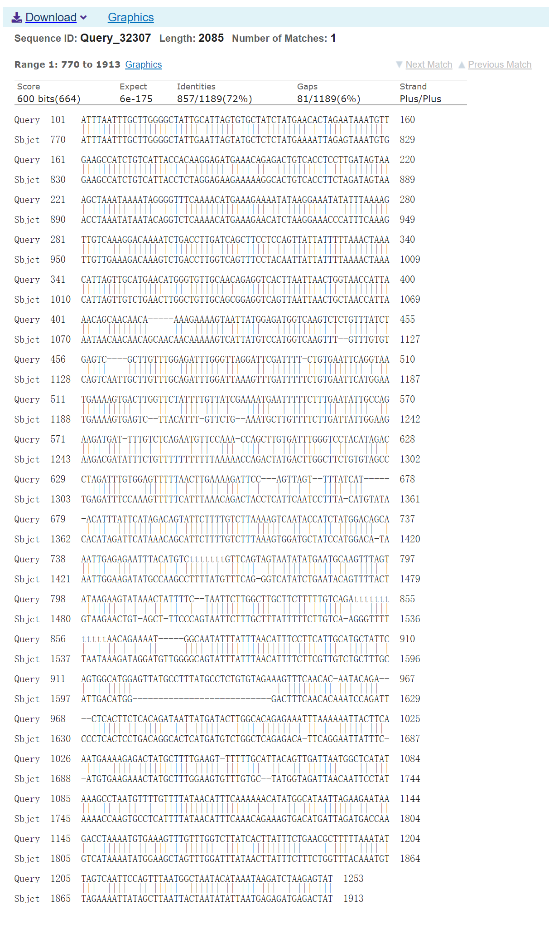
Sheep
Murine
e, Alignment of murine lncDACH1 and Pig orthologue
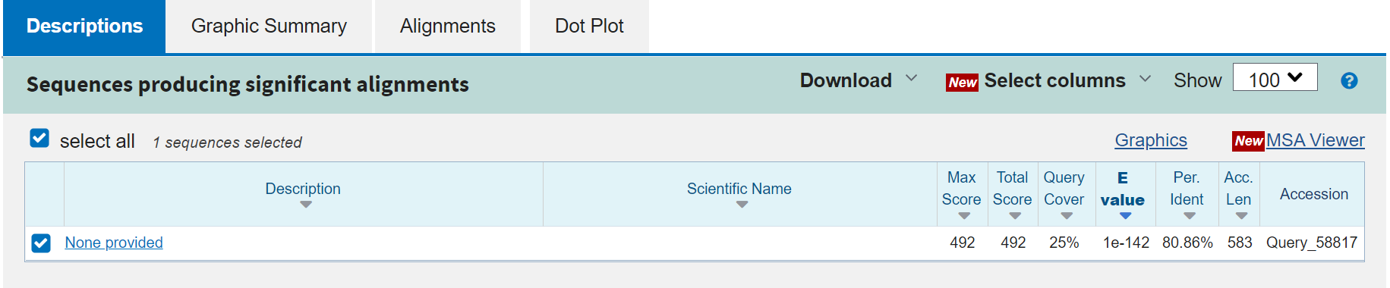
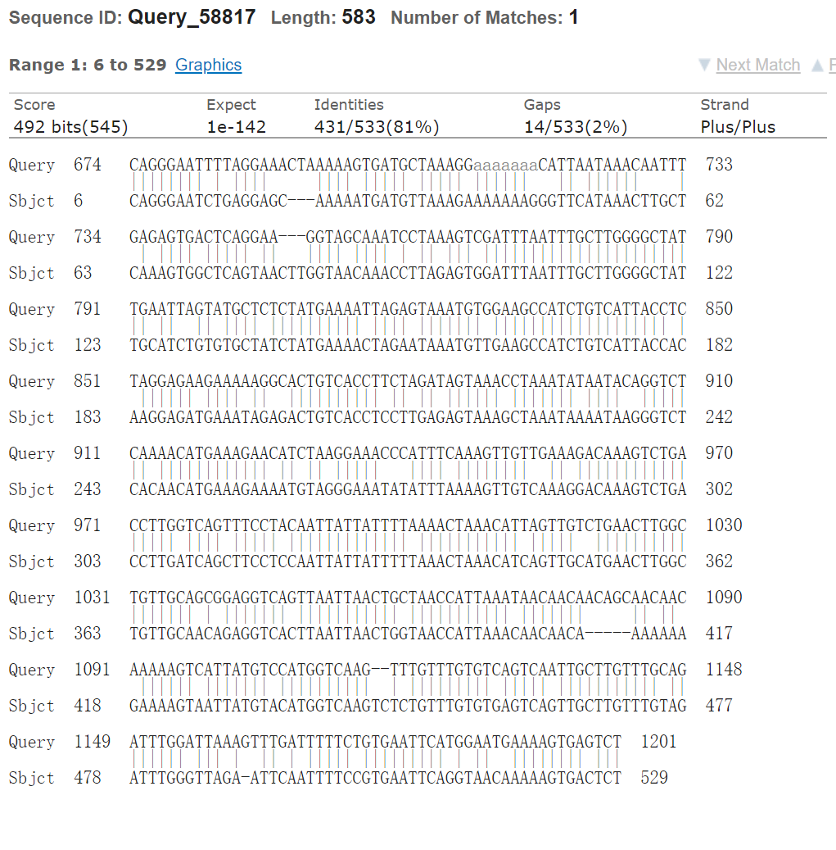
Pig
Murine

f, Alignment of murine lncDACH1 and dog orthologue

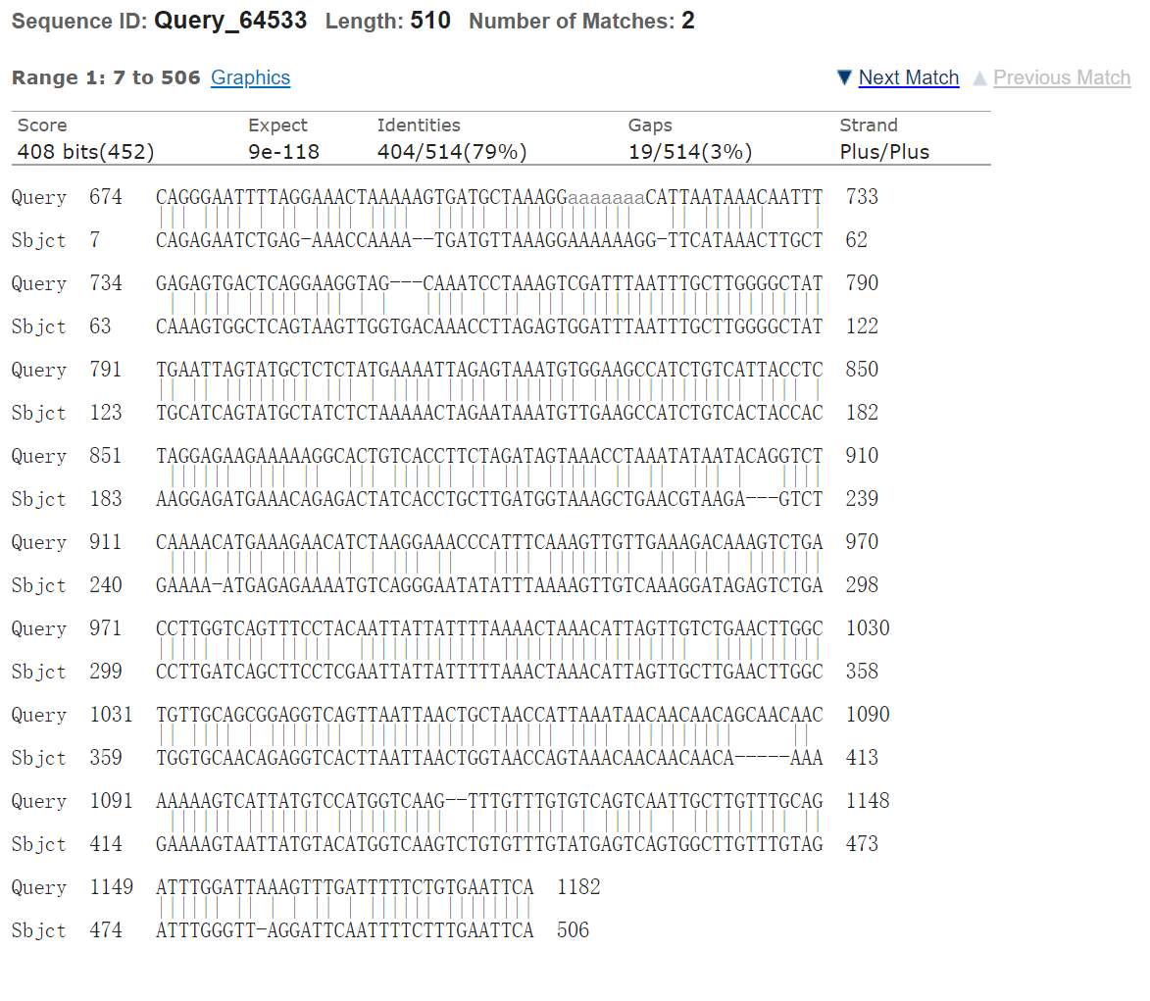
Dog
Murine

g, Alignment of murine lncDACH1 and Rat orthologue
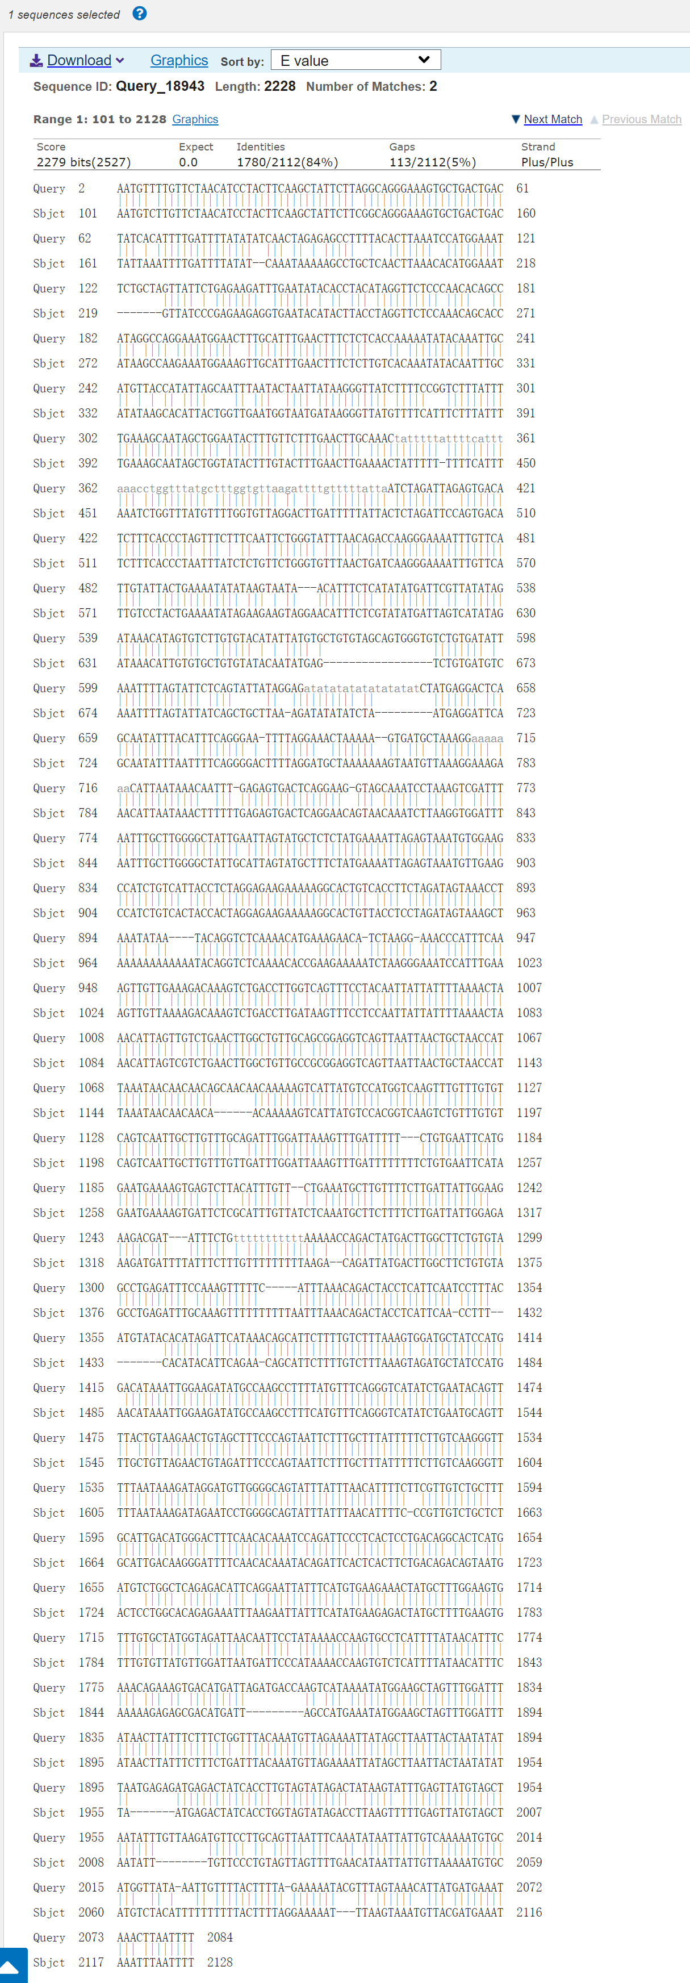
Rat
Murine

Supplementary Fig. 15
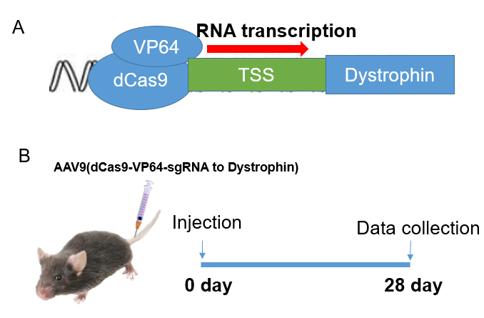
Supplementary Fig. 15 Schematic model for the construction of AAV9 virus carrying the dCas9-SAM system (a) to activate the transcription of dystrophin and tail-vein injection to mice (b). VP64, VP64 transactivator; dCas9, deactivated CRISPR associated protein 9 nuclease. TSS, transcriptional start point.

Supplementary Fig. 16
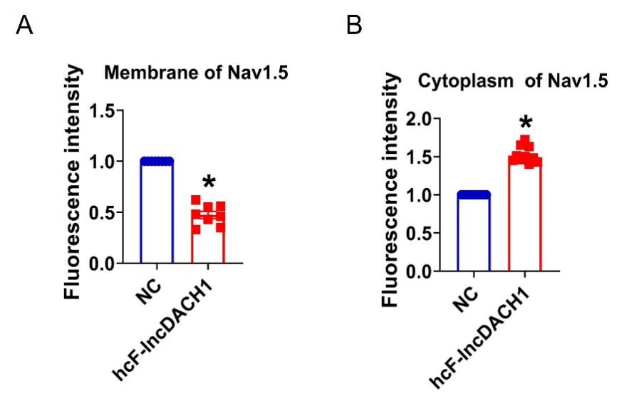
Supplementary Fig.16 Fluorescence intensity of Nav1.5 in human iPS differentiated cardiomyocytes overexpressing cF-lncDACH1. a, Membrane levels of Nav1.5. N=8 for Nav1.5. *P<0.05 versus NC group. b, Cytoplasm levels of Nav1.5. N=10 for Nav1.5.*P<0.05 versus NC group. P-values were determined by unpaired t test.

Supplementary Fig. 17

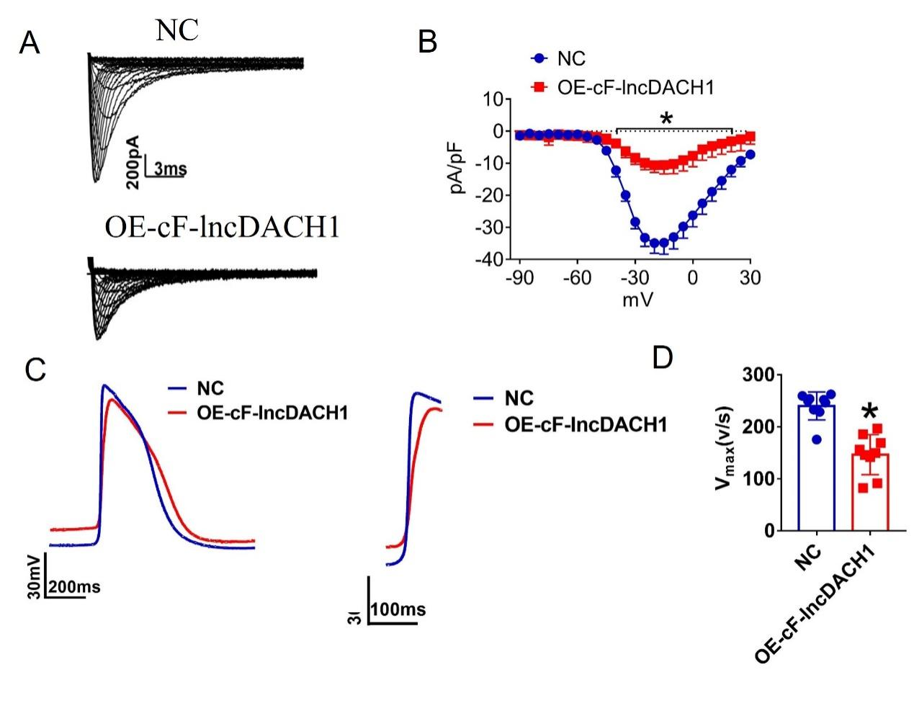
Supplementary Fig. 17 Effects of cF-lncDACH1 overexpression on sodium current and Vmax of APD in hiPS-CMs. a,b, Peak I_{Na} currents and I-V curve of I_{Na.} N=11-12 from 3 independent cultures. *P<0.05 versus NC. c,d, Rising phase diagram of action potential and V_{max} of ascending branch of action potential phase 0, N=9. *P<0.05 versus NC.

Supplementary Fig. 18

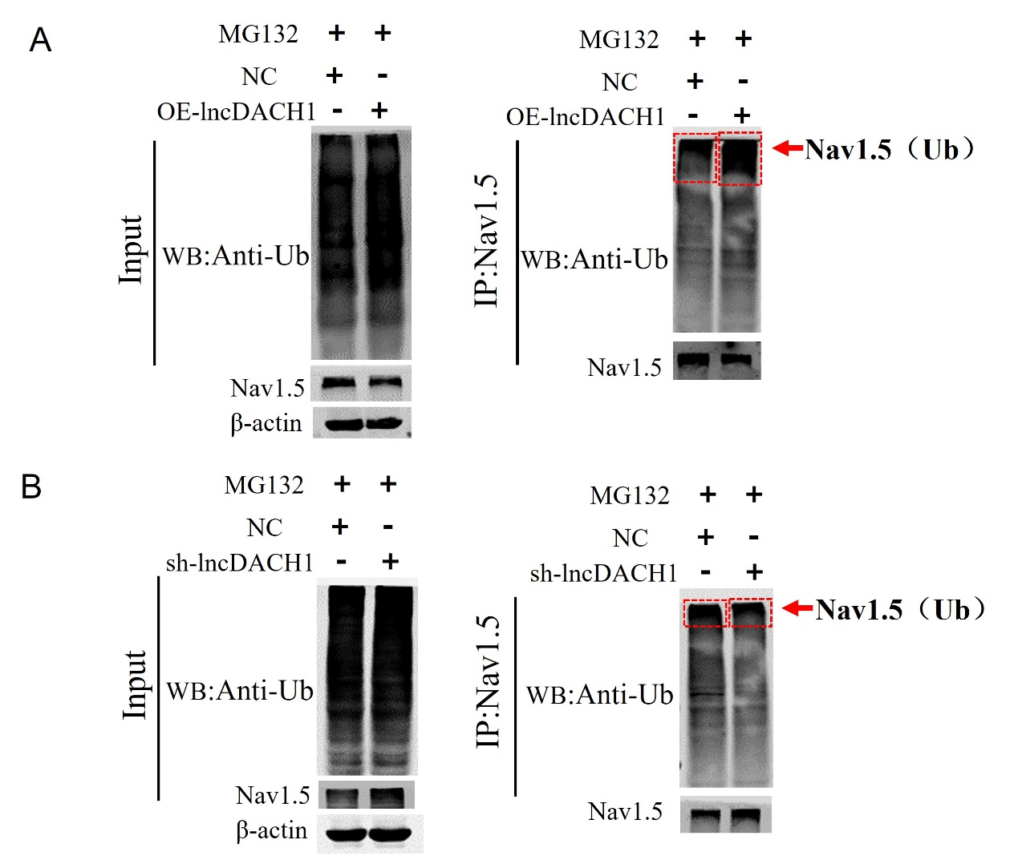

Supplementary Fig. 18 Ubiquitination of Nav1.5 in the Primary cardiomyocytes of lncDACH1 transgenic overexpression and knockout. a, the ubiquitination of Nav1.5 of overexpression of lncDACH1. b, the ubiquitination of Nav1.5 of Knockdown of lncDACH1.

