Supplemental materials

Binding of LncRNA-DACH1 to dystrophin impairs the membrane trafficking of Nav1.5 protein and increases ventricular arrhythmia susceptibility
Supplemental Figure 1
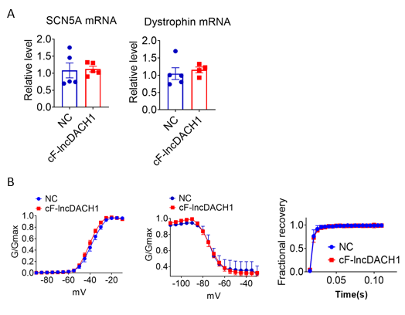
Supplemental Figure1. The conserved fragment of lncDACH1(cF-lncDACH1) inhibited sodium channel function in mice. (A) The mRNA levels of SCN5A and dystrophin. N=4-5. (B) Kinetics of I_{Na.} N=6-17 cells from 3 or more mice.

Supplemental Figure 2
Supplemental Figure2. Effects of cF-lncDACH1 overexpression on sodium channel expression and function in cultured neonatal cardiomyocytes. (A) Verification of the expression of cF-lncDACH1 after transfection of adenovirus carrying cF-lncDACH1. N=8 from 3 independent cultures. *P<0.05 versus NC (negative control, empty plasmid). P-values were determined by unpaired t test. (B) Peak I_{Na} currents, I-V curves and kinetics of I_{Na.} N=8-15 cells from 3 independent cultures. (C) Distribution of Nav1.5 and dystrophin by immunofluorescent staining. (D) The mRNA levels of dystrophin and SCN5A. N=8-12 from 3 independent cultures.

Supplemental Figure 3
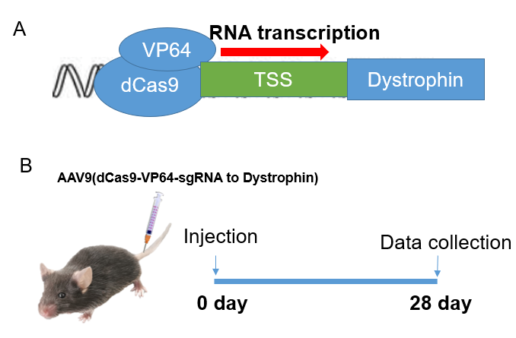
Supplemental Figure 3. Schematic model for the construction of AAV9 virus carrying the dCas9-SAM system (A) to activate the transcription of dystrophin and tail-vein injection to mice (B). VP64, VP64 transactivator; dCas9, deactivated CRISPR associated protein 9 nuclease. TSS, transcriptional start point.

