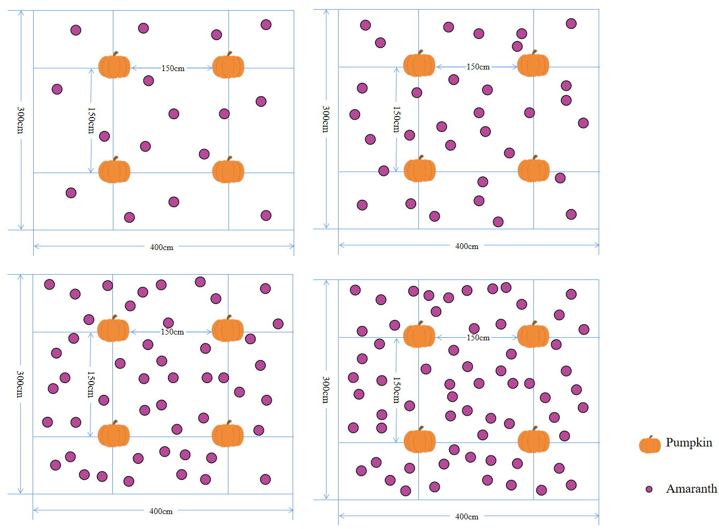

S1. Diagram of field experiment
Fig. 1 Diagram of field experiment.

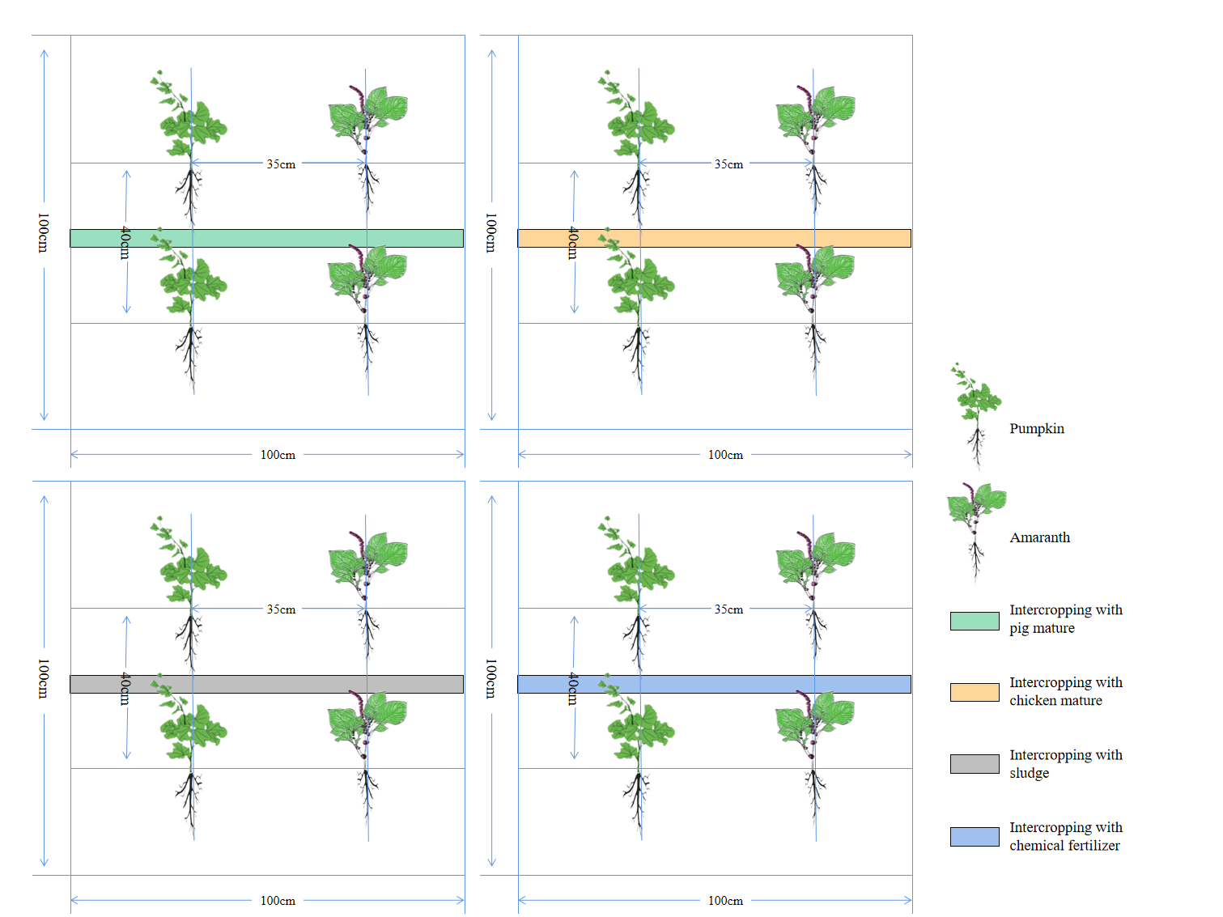

S2. Diagram of cement pool experiment

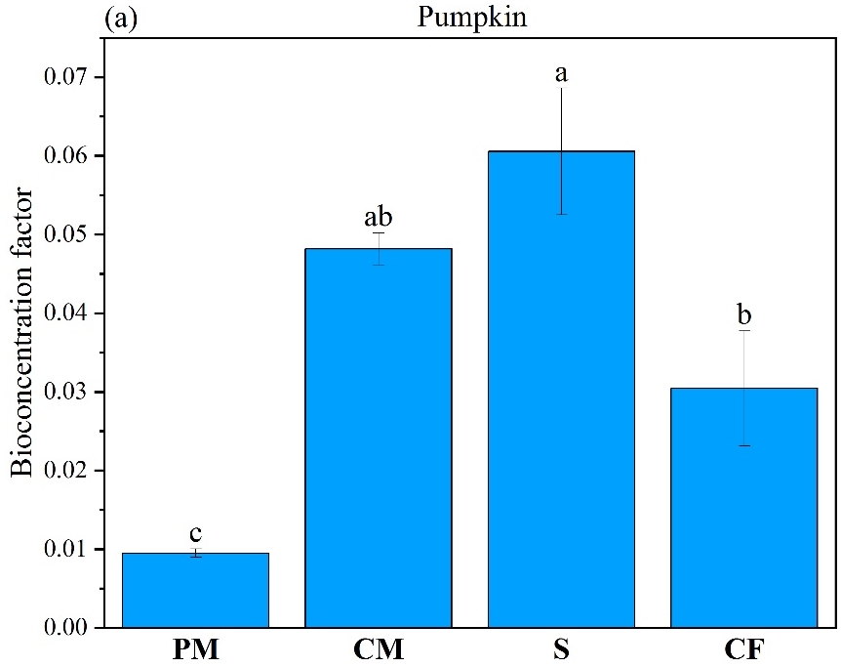
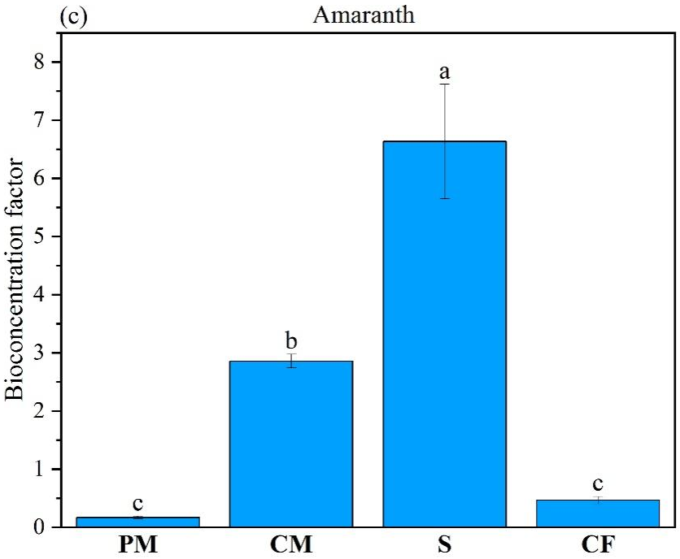

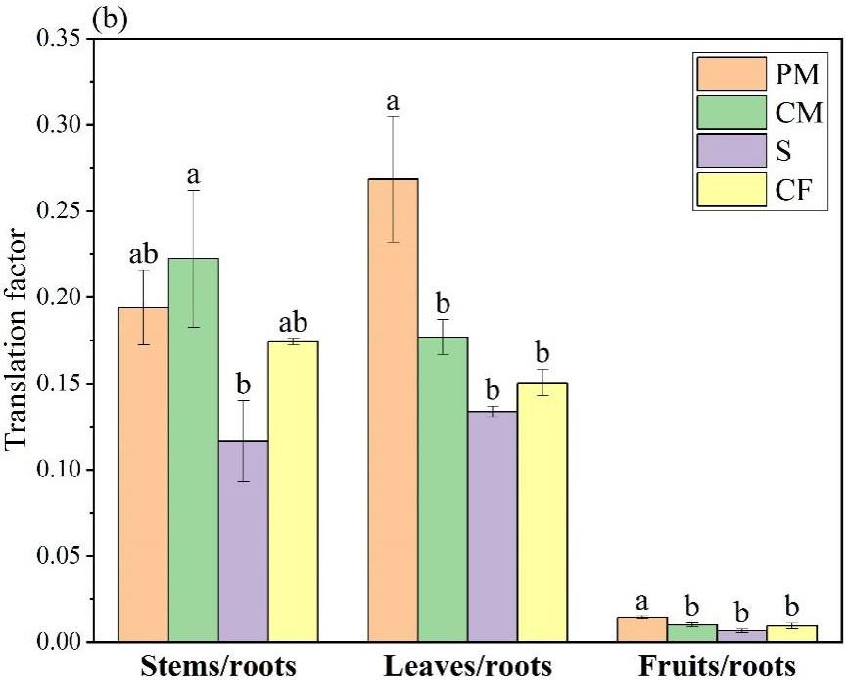
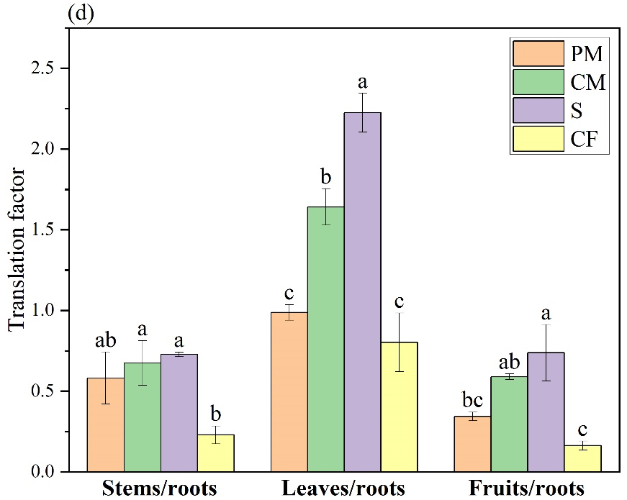

S3. Bioconcentration factor and translation factor of pumpkin (a,b) and amaranth (c,d) under different fertilizer treatments. Abbreviations: PM - pig manure treatment; CM - chicken manure treatment; S - sludge treatment; CF - chemical fertilizer treatment. Different lowercase letters indicate significant (P < 0.05) difference between the treatments according to Duncan's test.

Declarations

Ethics approval
Not applicable

Consent to participate
Not applicable

Consent for publication
Not applicable

