Figure S1: Distribution of Microbial Isolates
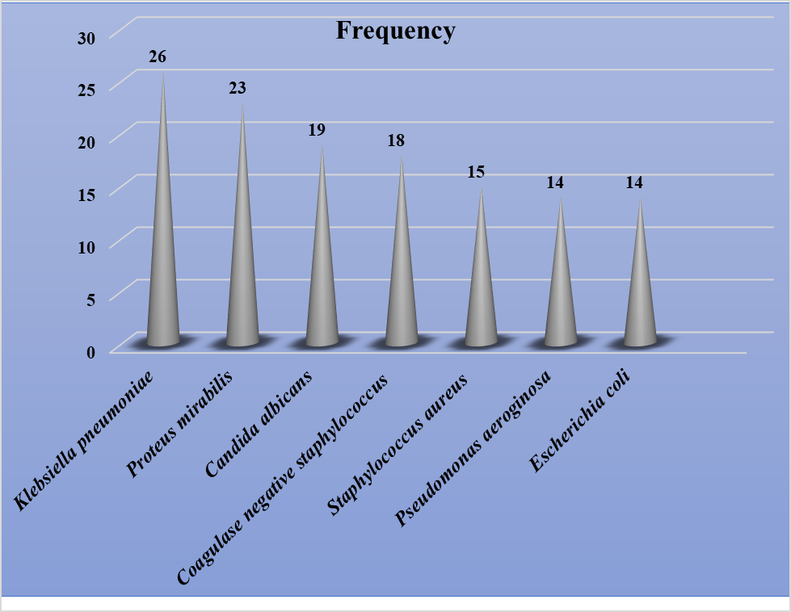

Table S1: Susceptibility pattern of bacteria isolated from CSOM
Antibiotics | % of bacteria susceptible
Antibiotics | K.pneumoniae | P.aeruginosa | E.coli | S.aureus | P.mirabilis
AMP | 0 | 0 | 0 | 0 | 4.4
CN | 80.8 | 100 | 50 | 46.7 | 65.2
AMC | 0 | 0 | 14.3 | 13.3 | 4.4
CHL | 42.3 | 21.4 | 71.4 | 53.3 | 39.1
CIP | 61.5 | 100 | 78.6 | 73.3 | 78.3
STX | 26.9 | 50 | 28.6 | 26.7 | 26.1
CRO | 73.1 | 57.1 | 71.4 | 40 | 73.9
AMK | 69.2 | 78.6 | 64.3 | 26.7 | 60.9
CEP | 46.2 | 0 | 35.7 | 60 | 60.9
AMP= Ampicillin, CN=Gentamicin, AMC=Amoxicillin-clavulanic acid, CHL =Chloramphenicol, TET=Tetracycline, CIP=Ciprofloxacin, STX=Trimethoprim-sulfonamide, CRO=Ceftriaxone, AMK=Amikacin, CEP= Cephalexin

