Extended data

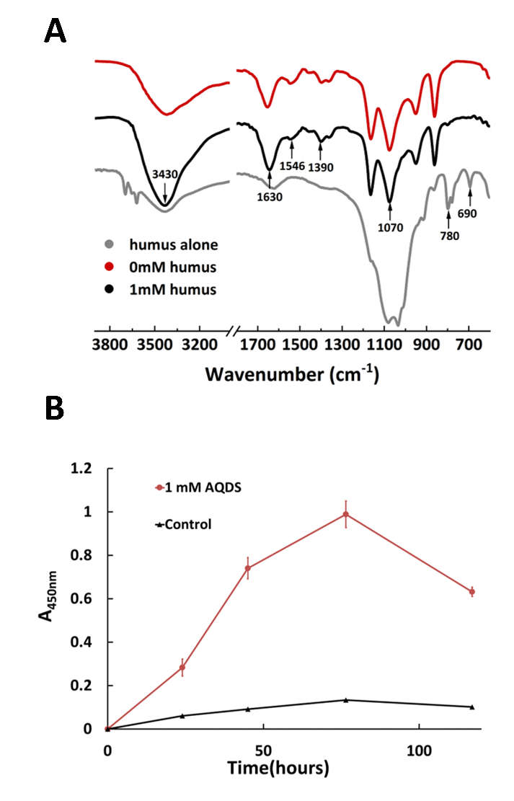
Extended fig. 1. Quinone groups in humus are the primary functional moiety interacting with M. acetivorans. (A) FTIR spectra of M. acetivorans cells cultured with 1 mM humus and not. (B) Time-dependent AQDS reduction of methanol-grown M. acetivorans cultured with 1 mM AQDS and not.

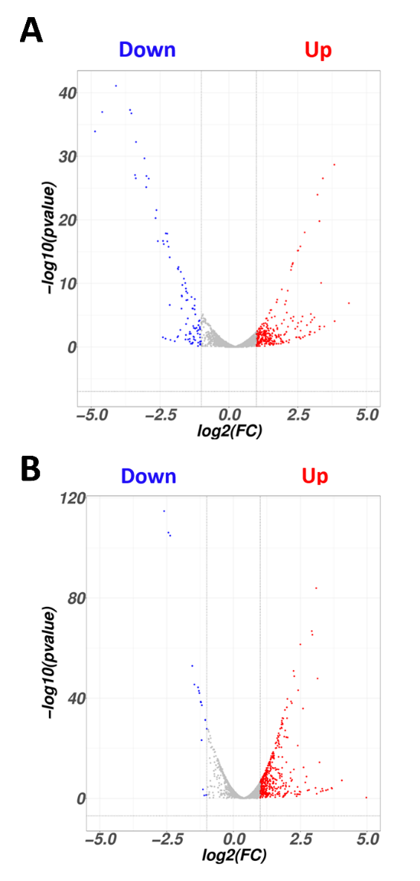
Extended fig. 2. Volcano maps of differential transcript genes for the humus-treated M. acetivorans vs no treatment. (A) Methanol-grown cultures. (B) Acetate-grown cultures. Blue represent the downregulated differential genes, red represent the upregulated differential genes, and gray represent the genes without significant difference.

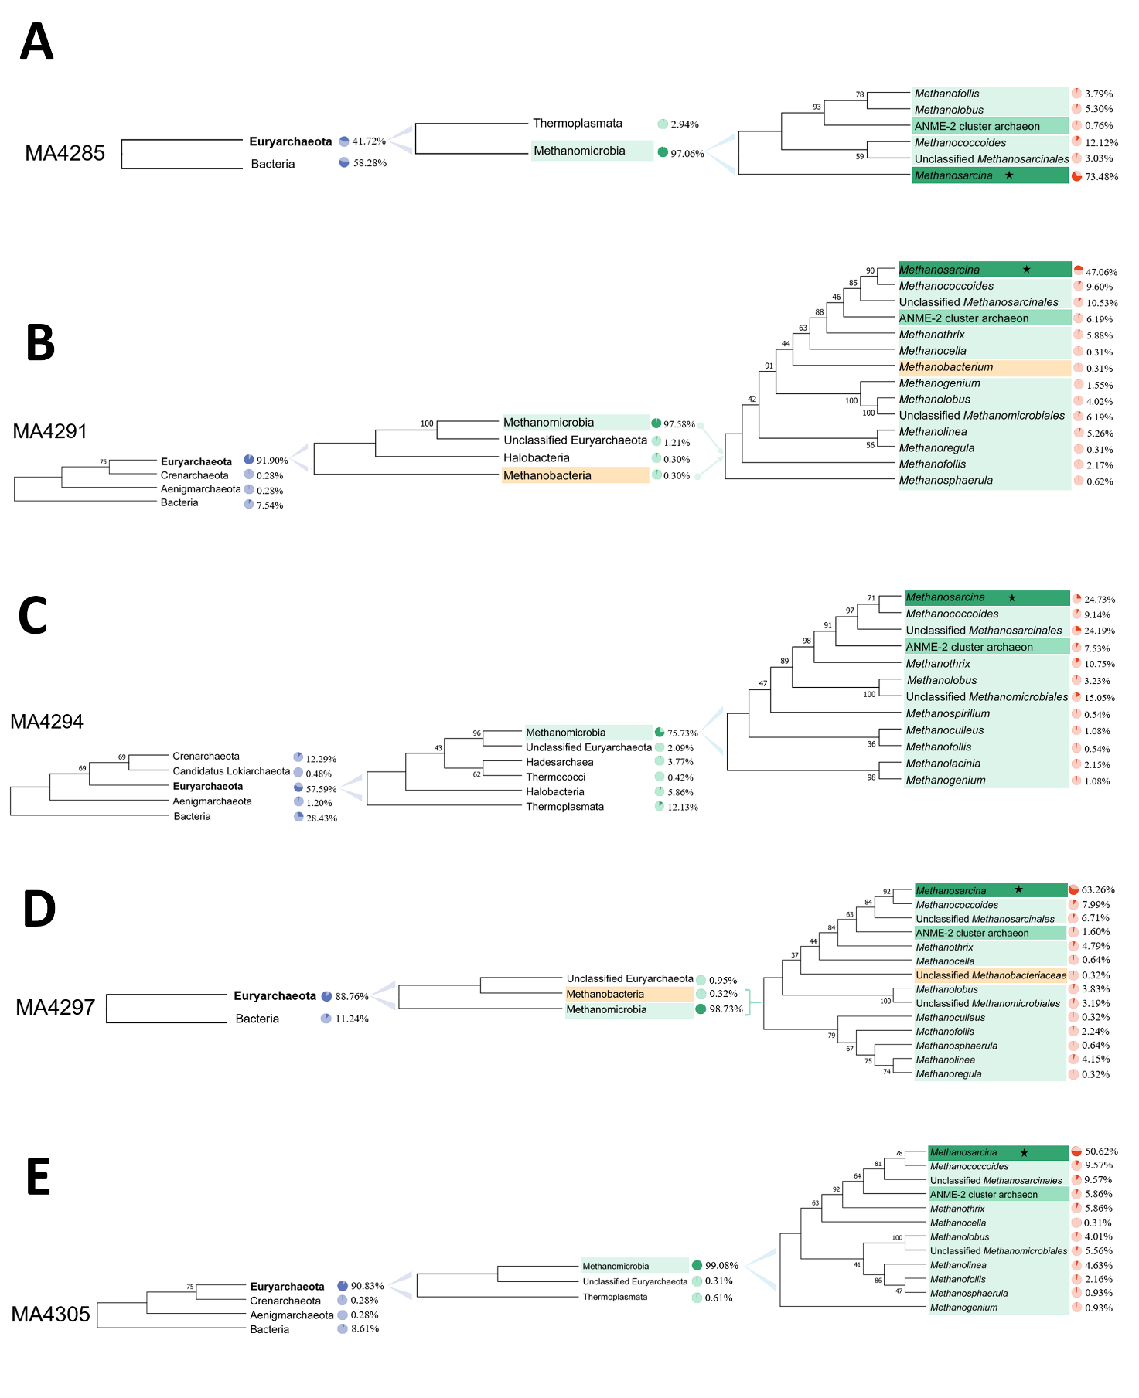

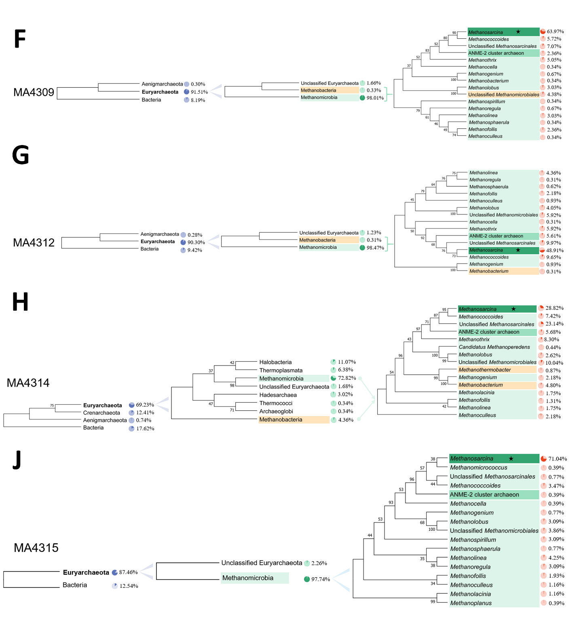

Extended fig. 3. Prevalence of CSQs homologues. (A) Predicted MA4285 homologues. (B) Predicted MA4291 homologues. (C) Predicted MA4294 homologues. (D) Predicted MA4297 homologues. (E) Predicted MA4305 homologues. (F) Predicted MA4309 homologues. (G) Predicted MA4312 homologues. (H) Predicted MA4314 homologues. (J) Predicted MA4315 homologues. Percentage numbers indicate the percentage of targeted protein among the retrieved proteins. Number on nodes indicated bootstrap values.

Extended table. 1. Transcript analysis for the genes directly involved in methanogenesis and membrane-bound electron transport chain of methanol- and acetate-grown cultures treated with humus and not.

Locus tag | Gene name | Annotation | Log₂FC |  | P-value
Locus tag | Gene name | Annotation | methanol-grown | acetate-grown | methanol-grown | acetate-grown
MA4379 | mtaA | MtaA/CmuA family methyltransferase(MT2) | 0.352747 | 0.047359 | >0.05 | <0.005
MA4546 | mcrA | mcrA; coenzyme-B sulfoethylthiotransferase subunit alpha | -0.12718 | -0.57353 | >0.05 | <0.001
MA4547 | mcrG | mcrG; coenzyme-B sulfoethylthiotransferase subunit gamma | -0.09108 | -0.30245 | >0.05 | <0.001
MA4548 | mcrC | mcrC; methyl-coenzyme M reductase I operon protein C | -0.03719 | 0.350387 | >0.05 | >0.05
MA4549 | mcrD | mcrD; methyl-coenzyme M reductase operon protein D | -0.19528 | 0.355881 | >0.05 | >0.05
MA4550 | mcrB | mcrB; coenzyme-B sulfoethylthiotransferase subunit beta | -0.10117 | -0.22769 | >0.05 | <0.001
MA1494 | FpoP | 4Fe-4S binding protein | 0.092395 | -0.46779 | >0.05 | <0.001
MA1495 | FpoA | NADH-quinone oxidoreductase subunit A | 0.667806 | 0.609228 | >0.05 | >0.05
MA1496 | FpoB | NADH-quinone oxidoreductase subunit B | 0.552021 | 0.236425 | >0.05 | >0.05
MA1497 | FpoC | NADH-quinone oxidoreductase subunit C | 0.649128 | 0.360097 | >0.05 | >0.05
MA1498 | FpoD | NADH-quinone oxidoreductase subunit D | 0.391807 | -0.01627 | >0.05 | <0.001
MA1499 | FpoH | nuoH; NADH-quinone oxidoreductase subunit NuoH | 0.598684 | 0.079731 | >0.05 | <0.01
MA1500 | FpoI | NADH-quinone oxidoreductase subunit I | 0.585729 | 0.188612 | >0.05 | >0.05
MA1501 | FpoJ | NADH-quinone oxidoreductase subunit J | 0.50611 | 0.137167 | >0.05 | >0.05
MA1502 | FpoJ | NADH-quinone oxidoreductase subunit J | 0.505076 | 0.169312 | >0.05 | >0.05
MA1503 | FpoK | nuoK; NADH-quinone oxidoreductase subunit NuoK | 0.485526 | 0.063344 | >0.05 | <0.05
MA1504 | FpoL | nuoL; NADH-quinone oxidoreductase subunit L | 0.577165 | 0.246853 | >0.05 | >0.05
MA1505 | FpoM | NuoM family protein | 0.66242 | 0.075033 | >0.05 | <0.01
MA1506 | FpoN | NADH-quinone oxidoreductase subunit N | 0.664025 | 0.022138 | >0.05 | <0.005
MA1507 | FpoO | F420H2 dehydrogenase subunit FpoO | 0.729702 | 0.00728 | >0.05 | <0.005
MA0687 | HdrE | disulfide reductase | 0.568201 | 0.21919 | >0.05 | >0.05
MA0688 | HdrD1 | (Fe-S)-binding protein | 0.382076 | 0.109534 | >0.05 | <0.05
MA3606 | Ack | acetate kinase | 0.328982 | -0.13657 | >0.05 | <0.001
MA3607 | Pta | pta; phosphate acetyltransferase | 0.443263 | 0.083587 | >0.05 | <0.01
MA3860 | cdhA | cdhA; CO dehydrogenase/acetyl-CoA synthase complex subunit epsilon | -0.55989 | -0.13818 | <0.005 | <0.001
MA3861 | cdhB | cdhB; CO dehydrogenase/acetyl-CoA synthase complex subunit epsilon | -0.64969 | 0.243921 | <0.005 | >0.05
MA3862 | cdhC | cdhC; CO dehydrogenase/CO-methylating acetyl-CoA synthase complex subunit beta | -0.54855 | -0.11266 | <0.005 | <0.001
MA3864 | cdhD | cdhD; CO dehydrogenase/acetyl-CoA synthase subunit delta | -0.28671 | -0.51754 | >0.05 | <0.001
MA3865 | cdhE | cdhE; acetyl-CoA decarbonylase/synthase complex subunit gamma | -0.17995 | -0.5775 | >0.05 | <0.001
MA0269 | mtrH | mtrH; tetrahydromethanopterin S-methyltransferase subunit H | 0.448569 | -0.17517 | >0.05 | <0.001
MA0270 | mtrG | mtrG; tetrahydromethanopterin S-methyltransferase subunit G | 0.798083 | 0.392166 | <0.05 | >0.05
MA0271 | mtrF | mtrF; tetrahydromethanopterin S-methyltransferase subunit F | 0.300214 | 0.080268 | >0.05 | <0.01
MA0272 | mtrA | mtrA; tetrahydromethanopterin S-methyltransferase subunit A | 0.344405 | -0.01854 | >0.05 | <0.001
MA0273 | mtrB | mtrB tetrahydromethanopterin S-methyltransferase subunit B | 0.35469 | -0.20777 | >0.05 | <0.001
MA0274 | mtrC | mtrC; tetrahydromethanopterin S-methyltransferase subunit C | 0.592463 | 0.064517 | >0.05 | <0.01
MA0275 | mtrD | mtrD; tetrahydromethanopterin S-methyltransferase subunit D | 0.459122 | -0.07262 | >0.05 | <0.001
MA0276 | mtrE | mtrE; tetrahydromethanopterin S-methyltransferase subunit E | 0.316244 | -0.30073 | >0.05 | <0.001
MA0658 | rnfx/MmcA | methanogenesis multiheme c-type cytochrome | 0.637404 | -0.20164 | >0.05 | <0.001
MA0659 | rnfC | SLBB domain-containing protein | 0.564214 | -0.04266 | >0.05 | <0.001
MA0660 | rnfD | RnfABCDGE type electron transport complex subunit D | 0.561148 | 0.10966 | >0.05 | <0.05
MA0661 | rnfG | RnfABCDGE type electron transport complex subunit G | 0.50563 | 0.009141 | >0.05 | <0.005
MA0662 | rnfE | RnfABCDGE type electron transport complex subunit E | 0.600858 | 0.143857 | >0.05 | <0.05
MA0663 | rnfA | electron transport complex protein RnfA | 0.650865 | -0.50594 | >0.05 | <0.001
MA0664 | rnfB | Fe-S cluster domain-containing protein | 0.65697 | -0.46988 | >0.05 | <0.001
MA0665 | rnfY | DUF4870 domain-containing protein | 0.302482 | -0.23614 | >0.05 | <0.001
MA3739 | Cyt c | Cytochrome c family protein | 0.234744 | 0.705709 | >0.05 | <0.001
MA0167 | Cyt c | c-type cytochrome | -1.86787 | 0.225582 | >0.05 | >0.05
MA2925 | Cyt c | Cytochrome c peroxidase | 0.656094 | 1.1299 | >0.05 | <0.001
MA2908 | Cyt c | Cytochrome c peroxidase | 0.541425 | 0.53149 | >0.05 | >0.05
MA0832 | fwdC | formylmethanofuran dehydrogenase subunit C | -0.17817 | 0.119721 | >0.05 | <0.05
MA0833 | fwdA | formylmethanofuran dehydrogenase subunit A | -0.29393 | 0.147032 | >0.05 | >0.05
MA0834 | fwdB | formylmethanofuran dehydrogenase subunit B | -0.40336 | 0.360928 | <0.05 | >0.05
MA0304 | fmdE | formylmethanofuran dehydrogenase subunit E | 0.218342 | 0.429781 | >0.05 | >0.05
MA0305 | fmdF | 4Fe-4S binding protein | 0.067963 | 0.242397 | >0.05 | >0.05
MA0306 | fmdA | formylmethanofuran dehydrogenase subunit A | 0.100187 | 0.523019 | >0.05 | >0.05
MA0307 | fmdC | formylmethanofuran dehydrogenase subunit C | 0.207935 | 0.738482 | >0.05 | <0.005
MA0308 | fmdD | formylmethanofuran dehydrogenase subunit D | 0.178346 | 0.821619 | >0.05 | <0.001
MA0309 | fmdB | formylmethanofuran dehydrogenase subunit B | -0.00797 | -0.01692 | >0.05 | <0.001
MA0975 | frhA | frhA; coenzyme F420 hydrogenase subunit alpha | 0.036712 | 0.109236 | >0.05 | <0.05
MA0976 | frhD | frhD; coenzyme F420-reducing hydrogenase, FrhD protein | 0.234623 | 0.491416 | >0.05 | >0.05
MA0977 | frhG | frhG; coenzyme F420 hydrogenase subunit gamma | 0.103571 | -0.34244 | >0.05 | <0.001
MA0978 | frhB | frhB; coenzyme F420 hydrogenase subunit beta | 0.445861 | -0.01948 | >0.05 | <0.005
MA3733 | mer | mer; 5,10-methylenetetrahydromethanopterin reductase | 0.62581 | 0.286678 | >0.05 | >0.05
MA4430 | mtd | F420-dependent methylenetetrahydromethanopterin dehydrogenase | 0.427342 | -0.02015 | >0.05 | <0.001
MA1710 | mch | mch; methenyltetrahydromethanopterin cyclohydrolase | -0.03269 | 0.0371 | >0.05 | <0.005

Extended table. 2. Summary of domain architectures for the upregulated gene cluster encoding CSQs.
Gene ID | Number of amino acids | Signal peptide | PQQ domain | LRR domain | PKD domain | PbH1 domain | Others
MA4284 | 1391 | √ | 11 | 0 | 5 | 0
MA4285 | 1743 | √ | 5 | 3 | 5 | 0
MA4289 | 1734 | √ | 0 | 4 | 3 | 0
MA4290 | 433 | ╳ | 3 | 0 | 0 | 0
MA4291 | 1898 | √ | 12 | 0 | 3 | 4
MA4292 | 2007 | √ | 0 | 6 | 6 | 0
MA4293 | 375 | √ | 0 | 0 | 0 | 0
MA4294 | 497 | √ | 3 | 0 | 0 | 0
MA4295 | 2188 | √ | 0 | 0 | 0 | 0 | CobN
MA4297 | 1817 | √ | 11 | 0 | 6 | 0
MA4298 | 300 | √ | 0 | 0 | 0 | 0
MA4302 | 427 | √ | 0 | 0 | 0 | 0
MA4304 | 250 | √ | 0 | 0 | 0 | 0 | DUF4430
MA4305 | 1932 | √ | 11 | 0 | 4 | 6
MA4309 | 1262 | ╳ | 7 | 0 | 4 | 5
MA4310 | 608 | √ | 0 | 0 | 0 | 0
MA4312 | 2029 | √ | 13 | 0 | 5 | 7
MA4314 | 558 | √ | 4 | 0 | 0 | 0
MA4315 | 1632 | √ | 4 | 0 | 8 | 4

