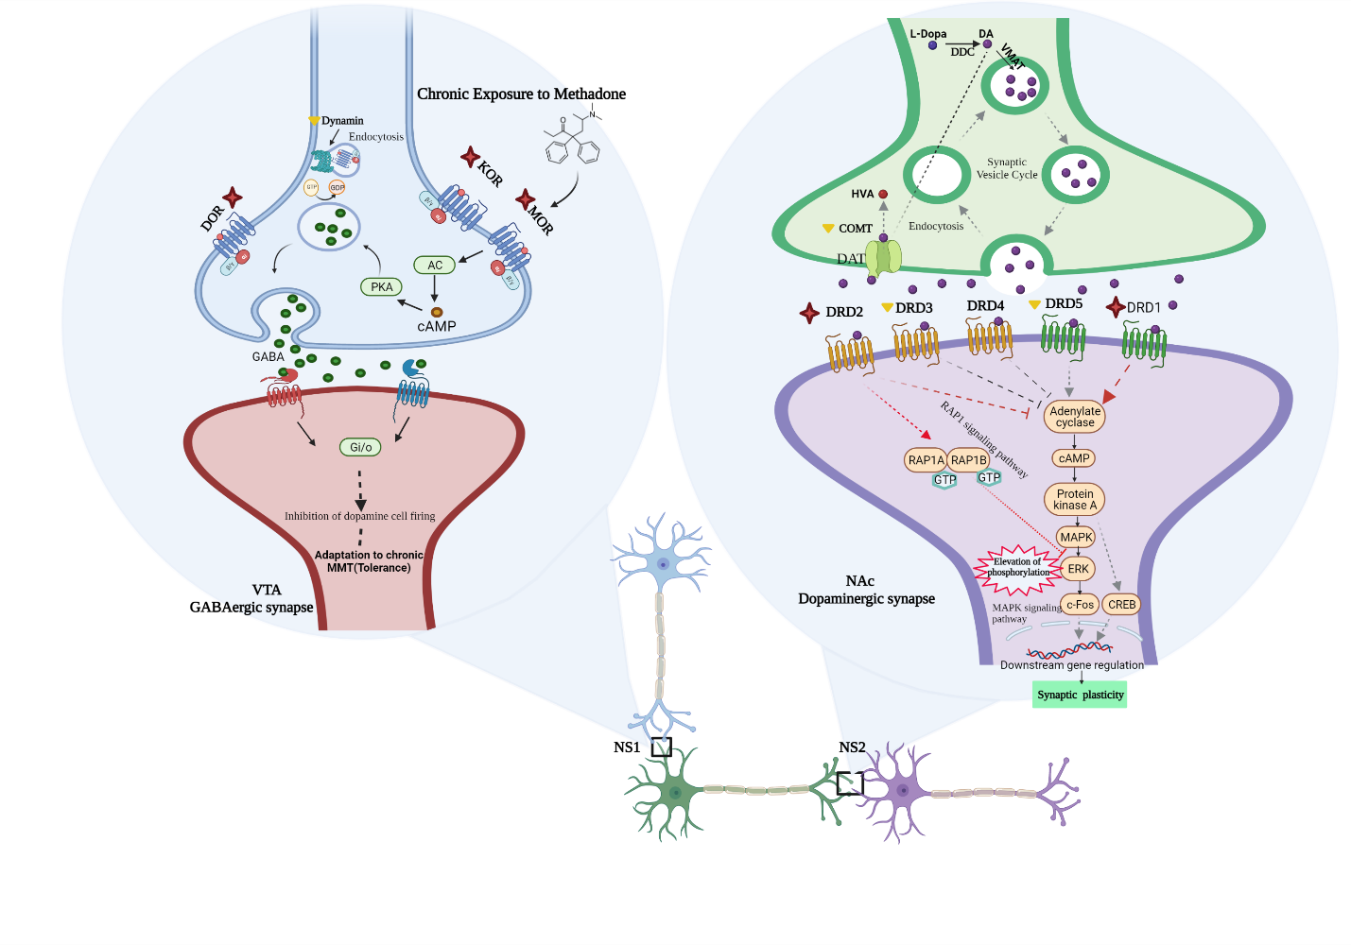
The schematic diagram illustrates the molecular pathway involved in chronic methadone-maintenance treatment (MMT), extracted from the linkage among experimental and the theoretical network analysis mentioned in this study. Overexpression of MOR, DOR, and KOR in chronic MMT, result in GABA secretion in VTA-neurosynapse (NS1) via activating Adenylate cyclase/cAMP- PKA which in the end suppress dopamine cell firing. In presynaptic neurons in NS1, Dynamin reduction reduces receptor desensitization which gives long-lasting excitation (Tolerance). In presynaptic neurons in NA, COMT reduction, compensate DA depict thru DA turnover withinside the cell cycle. Under starvation of DA in NA-neurosynapse (NS2) chronic MMT (Tolerance) result DRD1 overexpression, DRD2 upregulation became discovered as therapeutic effect as well. DRD1 turns on the MAPK-ERK signaling pathway which promotes transcription of genes regulating synaptic plasticity, on the alternative hand, DRD2 mediates ERK phosphorylation-dependent inhibition thru the RAP1 signaling pathway. Overcoming the competition among those responses with a bias in desire of DRD2 could enhance the curation approach in addiction. KOR: Kappa opioid receptor; MOR: Mu opioid receptor; DOR: Delta opioid receptor; AC: adenylate cyclase; cAMP: cyclic AMP; PKA: cAMP-dependent protein kinase; GABA: gamma-Aminobutyric acid; VTA: Ventral tegmental area; NS1: VTA-neurosynapse; NS2: NA-neurosynapse; NA: Nucleus accumbens; DDC: Dopamine decarboxylase;DA: Dopamine; COMT: catechol-O-methyltransferase; VMAT: vesicular monoamine transporter; HVA: Homovanillic acid; DAT: Dopamine transporter; DRD: DA receptor D; MAPK: mitogen-activated protein kinase; ERK: extracellular signal-regulated kinase; CREB: CREB-binding protein; RAP1: Ras-related protein.

