Supplementary document

Supplementary Figure S1. The effects of chronic administration of GLYN122 (33 mg/kg) on grip strength of female R6/2 mice from 4-12 weeks of age. Data are presented as mean ± SEM (WT Vehicle, n = 5; R6/2 Vehicle, n = 5; R6/2 GLYN122 33 mg/kg, n = 5). p > 0.05 for all timepoints.

Supplementary Figure S2. The effects of chronic administration of GLYN122 (33 mg/kg) on body weight of female R6/2 mice aged 3 to 12 weeks. Data are presented as mean ± SEM (WT Vehicle, n = 5; R6/2 Vehicle, n = 5; R6/2 GLYN122 33mg/kg, n = 5). # p < 0.05, R6/2 GLYN122 33mg/kg vs. R6/2 Vehicle.

Supplementary Figure S3. In the cortex of GLYN122 treated TG 44% of nuclei were IB free and just 15% of nuclei in vehicle treated TG mice. In the striatum 47% in GLYN122 treated TG and 29% in vehicle treated TG of nuclei were IB free. Both results were statistically not significant.

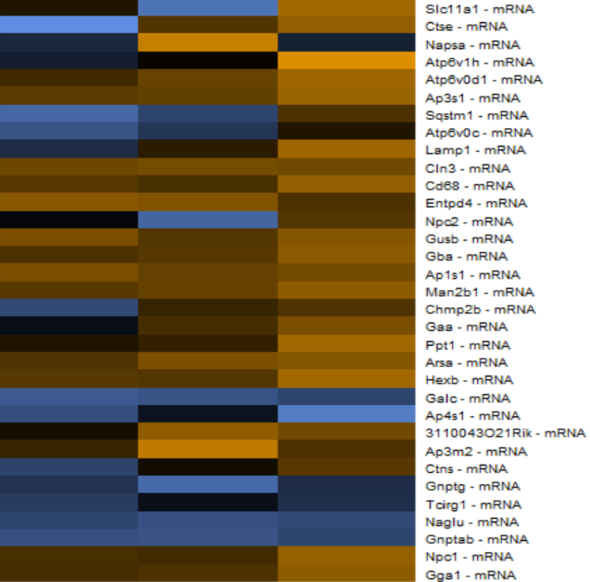
10 µM
NT
20 µM

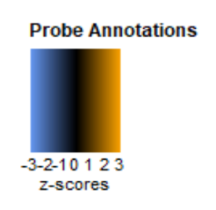

Supplementary Figure S4 STHdh Q111/111 autophagy genes are upregulated in treated neurons. There is a dose response. NT no treatment, 10 µM of GLYN122 or 20 µM of GLYN122.

Supplementary Table S1: Antibodies Used in Immunohistochemistry Studies
Antibodies
Mouse anti-human-mHtt mab (clone mEM48) Merck MAB5374
Alexa Fluor 488 Goat anti-Mouse IgG (H+L) ThermoFisher Invitrogen A-11001
Alexa Fluor 647 Goat anti-Rabbit IgG (H+L) ThermoFisher Invitrogen A-21244
Alexa Fluor 647 Goat anti-Guinea Pig IgG (H+L) ThermoFisher Invitrogen A-21450

Cell Culture

Cell lines used - ST HDH Q111/111 (CH00095, Coriell Institute) striatal derived cell line from a knock in transgenic mouse containing homozygous HTT loci with a humanized Exon 1 with 111 polyglutamine repeats.

Cell culture - ST HDH Q111/111 (CH00095, Coriell Institute) striatal derived cell line was grown at 33°C in DMEM (Sigma-Aldrich), supplemented with 10% fetal bovine serum (FBS), 1% Penicillin-Streptomycin (ThermoFisher Scientific), and 0.4 mg/ml G418 (Geneticin; Invitrogen). ST HDH Q111/111 are mouse striatal cells with polyQ length of 111.

Treatment - Medium was removed and new DMEM (DMEM, high glucose, HEPES, no phenol red) medium, supplemented with 1% fetal bovine serum (FBS), 1% Penicillin-Streptomycin, containing 0 µM, 10 µM or 20 µM compound was added. The cells were incubated at 33 °C for 48 h.

Supplementary Table S2. STHdh 111/111 primary mouse neurons treated with GLYN122 at the indicated concentration for 72 h.
SLOT | Cell Line | GLYN122 (µM) | Treatment time
1 | STHdh 111/111 | 0 | 48 h
2 | STHdh 111/111 | 10 | 48 h
3 | STHdh 111/111 | 20 | 48 h

