Myocardial Remodeling in Ischemic Heart Disease – Imaging from Cell to Organ Level by Synchrotron Propagation Based X-Ray Phase-Contrast Imaging
Ivo Planinc, MD^{1*}, Patricia Garcia-Canadilla, PhD^{2,3*}, Hector Dejea^{4,5*}, Assoc. prof. Ivana Ilic, MD, PhD⁶, Eduard Guasch, MD, PhD^{2,7,8}, Monica Zamora, MD, PhD^{2,3}, Assoc. prof. Fatima Crispi, MD, PhD^{2,3,9}, prof. Marco Stampanoni, PhD^{4,5}, prof. Davor Milicic, MD, PhD¹, prof. Bart Bijnens, MD, PhD^{2,10}, Anne Bonnin, PhD⁴, prof. Maja Cikes, MD, PhD¹

Expanded methods:
Animal models
A transmural myocardial infarction was induced by left coronary artery ligation through a left thoracotomy in 8 to 11 week-old Wistar male rats (Charles River Laboratories, France, EU) with weight range of 150-200g. Rats continuously ECG-monitored were induced to anaesthesia with inhaled isoflurane 5%, and maintained with inhaled isoflurane 2% with concomitant analgesia by subcutaneous buprenorphine (0.05 mg/body kg), and were intubated and mechanically ventilated (SAR-1000, CWE Inc). Mechanical ventilation parameters were set according to the manufacturer instructions, including a 2 cmH₂O external PEEP. The surgical procedure of thoracotomy consisted of incision through the left 4th intercostal space, careful dissection through the tissue and the left coronary artery was exposed at its proximal aspect, in the interventricular septum close to the left atrial appendage. The artery was ligated with a 6-0 silk; anterior wall myocardial paleness and akinesia were observed immediately during the procedure in all animals, later followed by overt ST-segment elevation in a DI-like lead. Subsequently, the chest was closed with a 2-0 silk, and the skin with a 3-0 resorbable suture. Recruiting maneuvers were performed before extubation.
Control healthy rat was also a male Wistar rat from the same laboratory, and in the same weight range.
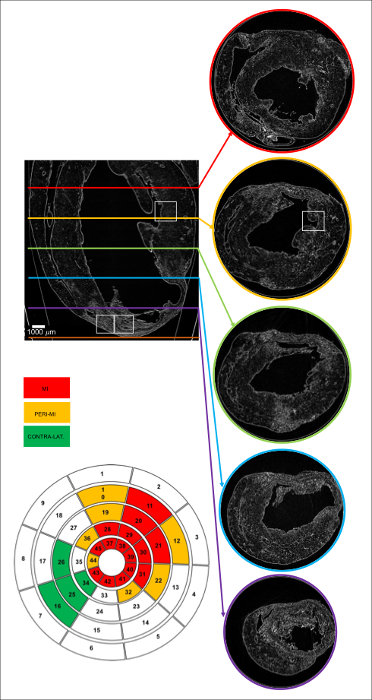

Online Figure 1: An example of the 45-segment LV model of a heart with MI. One infarcted heart from a rat with induced myocardial infarction was used. A long axis view of the original PB X-PCI LR dataset as well as the five short axis images, used for assessment of specific LV segments, are shown. The white rectangles on the images indicate areas that were also imaged in high resolution and in which cellular features were analyzed.

 | Control |  |  | Post-MI
 | ß₀ | ß₁ | R² | ß₀ | ß₁ | R²
MI segments | - | - | - | 91.1±26.8 | -95.9±66.1 | 0.79±0.14
Peri-MI segments | - | - | - | 99.6±20.7 | -67.3±25.8 | 0.92±0.06
Contralateral segments | - | - | - | 84.4±12.5 | -51.4±13.1 | 0.92±0.13
Remaining segments | - | - | - | 88.1±28.3 | -49.2±20.6 | 0.91±0.09
Overall | 77.7±18.1* | -45.7±10.8* | 0.92±0.06* | 90.8±25.1 | -69.3±47.1 | 0.87±0.12

Online Table 1: Parameters (β₁, β₀ and R²) of the linear fitting (y = β₁*x + β₀) of the transmural profile of the HA in all the 45 segments.
*denotes p<0.01 for comparison between healthy rat heart and post-MI hearts. p value as obtained using Student's T test.

Legends for video files

Video 1: Coronary anatomy of a control normal rat heart. One control heart from a healthy rat was used.

Video 2: Coronary anatomy of a post-myocardial infarction rat heart, including post-ligation vascular spaces. One infarcted heart from a rat with induced myocardial infarction was used.

Video 3: Superposition of 3-dimensional representation of post-ligation vascular spaces of a post-myocardial infarction rat heart on PB X-PCI images of the left ventricle in short axis view. One infarcted heart from a rat with induced myocardial infarction was used.

