Supplementary Online Content

e-Table 1:PRISMA checklist

Sample Search Strategy: Appendix 1 to Appendix 5.

Appendix 6. Summary of Findings Table: e-Table 2 to e-Table 7.

e-Figure 1: Summarizes the ROB for each individual trial.

e-Figure 2: Funnel plots of mortality.

e-Figure 3: Effect of dexmedetomidine on mortality. DF degrees of freedom.

e-Figure 4: Effect of dexmedetomidine on mortality. DF degrees of freedom.

e-Figure 5: Forest plot of duration of mechanical ventilation.

e-Figure 6: Forest plot of ventilator-free days.

e-Figure 7: Forest plot of Incidence of adverse events. DF degrees of freedom.

e-Figure 8: Forest plot of Incidence of adverse events. DF degrees of freedom.

e-Figure 9: Forest plot of Incidence of adverse events. DF degrees of freedom.

e-Figure 10: Forest plot of Incidence of delirium. DF degrees of freedom.

e-Figure 11: Forest plot of Incidence of adverse events. DF degrees of freedom.

e-Figure 12: Effect of dexmedetomidine on mortality. Studies are grouped by APACHE II score. df = degrees of freedom..

e-Figure 13: Effect of dexmedetomidine on mortality. Studies are grouped by ROB. df = degrees of freedom.

e-Figure 14: Sensitivity analysis of mortality.

Section/topic | # | Checklist item | Reported on page #
TITLE
Title | 1 | Use of dexmedetomidine in patients with sepsis: a systematic review and meta-analysis of randomized- controlled trials. | 1
ABSTRACT
Structured summary | 2 | Provide a structured summary including, as applicable: background; objectives; data sources; study eligibility criteria, participants, and interventions; study appraisal and synthesis methods; results; limitations; conclusions and implications of key findings; systematic review registration number. | 3
INTRODUCTION
Rationale | 3 | Describe the rationale for the review in the context of what is already known. | 6
Objectives | 4 | Provide an explicit statement of questions being addressed with reference to participants, interventions, comparisons, outcomes, and study design (PICOS). | 6-7
METHODS
Protocol and registration | 5 | Indicate if a review protocol exists, if and where it can be accessed (e.g., Web address), and, if available, provide registration information including registration number. | 7
Eligibility criteria | 6 | Specify study characteristics (e.g., PICOS, length of follow-up) and report characteristics (e.g., years considered, language, publication status) used as criteria for eligibility, giving rationale. | 8
Information sources | 7 | Describe all information sources (e.g., databases with dates of coverage, contact with study authors to identify additional studies) in the search and date last searched. | 8
Search | 8 | Present full electronic search strategy for at least one database, including any limits used, such that it could be repeated. | 8
Study selection | 9 | State the process for selecting studies (i.e., screening, eligibility, included in systematic review, and, if applicable, included in the meta-analysis). | 8-9
Data collection process | 10 | Describe method of data extraction from reports (e.g., piloted forms, independently, in duplicate) and any processes for obtaining and confirming data from investigators. | 9
Data items | 11 | List and define all variables for which data were sought (e.g., PICOS, funding sources) and any assumptions and simplifications made. | 9
Risk of bias in individual studies | 12 | Describe methods used for assessing risk of bias of individual studies (including specification of whether this was done at the study or outcome level), and how this information is to be used in any data synthesis. | 10
Summary measures | 13 | State the principal summary measures (e.g., risk ratio, difference in means). | 10-11
Synthesis of results | 14 | Describe the methods of handling data and combining results of studies, if done, including measures of consistency (e.g., I²) for each meta-analysis. | 11-12

Page 1 of 2
Section/topic | # | Checklist item | Reported on page #
Risk of bias across studies | 15 | Specify any assessment of risk of bias that may affect the cumulative evidence (e.g., publication bias, selective reporting within studies). | 10
Additional analyses | 16 | Describe methods of additional analyses (e.g., sensitivity or subgroup analyses, meta-regression), if done, indicating which were pre-specified. | 11-12
RESULTS
Study selection | 17 | Give numbers of studies screened, assessed for eligibility, and included in the review, with reasons for exclusions at each stage, ideally with a flow diagram. | 12
Study characteristics | 18 | For each study, present characteristics for which data were extracted (e.g., study size, PICOS, follow-up period) and provide the citations. | 12
Risk of bias within studies | 19 | Present data on risk of bias of each study and, if available, any outcome level assessment (see e-figure 1 ). | 12-13
Results of individual studies | 20 | For all outcomes considered (benefits or harms), present, for each study: (a) simple summary data for each intervention group (b) effect estimates and confidence intervals, ideally with a forest plot. | 12-16
Synthesis of results | 21 | Present results of each meta-analysis done, including confidence intervals and measures of consistency. | 11-12
Risk of bias across studies | 22 | Present results of any assessment of risk of bias across studies. | 12-13
Additional analysis | 23 | Give results of additional analyses, if done (e.g., sensitivity or subgroup analyses, meta-regression). | 16
DISCUSSION
Summary of evidence | 24 | Summarize the main findings including the strength of evidence for each main outcome; consider their relevance to key groups (e.g., healthcare providers, users, and policy makers). | 17-18
Limitations | 25 | Discuss limitations at study and outcome level (e.g., risk of bias), and at review-level (e.g., incomplete retrieval of identified research, reporting bias). | 19
Conclusions | 26 | Provide a general interpretation of the results in the context of other evidence, and implications for future research. | 19-20
FUNDING
Funding | 27 | Describe sources of funding for the systematic review and other support (e.g., supply of data); role of funders for the systematic review. | 5

From: Moher D, Liberati A, Tetzlaff J, Altman DG, The PRISMA Group (2009). Preferred Reporting Items for Systematic Reviews and Meta-Analyses: The PRISMA Statement. PLoS Med 6(6): e1000097. doi:10.1371/journal.pmed1000097
For more information, visit: www.prisma-statement.org.
Page 2 of 2

Appendix 1. EMBASE, PUBMED, Web of Science Search Strategy

EMBASE:
No. Query Results Results Date
#8. #5 AND #6 AND #7 54 12 Jan 2022
#7. 'randomized controlled trial':ab,ti OR 1,017,160 12 Jan 2022
'randomized':ab,ti OR 'placebo':ab,ti
#6. #3 OR #4 14,445 12 Jan 2022
#5. #1 OR #2 322,756 12 Jan 2022
#4. 'mpv-1440':ab,ti OR 'mpv 1440':ab,ti OR 190 12 Jan 2022
'mpv1440':ab,ti OR 'precedex':ab,ti OR
'dexmedetomidine hydrochloride':ab,ti OR
'hydrochloride, dexmedetomidine':ab,ti
#3. 'dexmedetomidine'/exp 14,440 12 Jan 2022
#2. 'bloodstream infection':ab,ti OR 'bloodstream 48,711 12 Jan 2022
infections':ab,ti OR 'infection,
bloodstream':ab,ti OR 'pyemia':ab,ti OR
'pyemias':ab,ti OR 'pyohemia':ab,ti OR
'pyohemias':ab,ti OR 'pyaemia':ab,ti OR
'pyaemias':ab,ti OR 'septicemia':ab,ti OR
'septicemias':ab,ti OR 'poisoning, blood':ab,ti
OR 'blood poisoning':ab,ti OR 'blood
poisonings':ab,ti OR 'poisonings, blood':ab,ti OR
'severe sepsis':ab,ti OR 'sepsis, severe':ab,ti
#1. 'sepsis'/exp 305,703 12 Jan 2022

PUBMED:
8 ((("Sepsis"[Mesh]) OR (((((((((((((((((Bloodstream Infection[Title/Abstract]) OR (Bloodstream Infections[Title/Abstract])) OR (Infection, Bloodstream[Title/Abstract])) OR (Pyemia[Title/Abstract])) OR (Pyemias[Title/Abstract])) OR (Pyohemia[Title/Abstract])) OR (Pyohemias[Title/Abstract])) OR (Pyaemia[Title/Abstract])) OR (Pyaemias[Title/Abstract])) OR (Septicemia[Title/Abstract])) OR (Septicemias[Title/Abstract])) OR (Poisoning, Blood[Title/Abstract])) OR (Blood Poisoning[Title/Abstract])) OR (Blood Poisonings[Title/Abstract])) OR (Poisonings, Blood[Title/Abstract])) OR (Severe Sepsis[Title/Abstract])) OR (Sepsis, Severe[Title/Abstract]))) AND (("Dexmedetomidine"[Mesh]) OR ((((((MPV-1440[Title/Abstract]) OR (MPV 1440[Title/Abstract])) OR (MPV1440[Title/Abstract])) OR (Precedex[Title/Abstract])) OR (Dexmedetomidine Hydrochloride[Title/Abstract])) OR (Hydrochloride, Dexmedetomidine[Title/Abstract])))) AND (randomized controlled trial[Publication Type] OR randomized[Title/Abstract] OR placebo[Title/Abstract]) ("Sepsis"[MeSH Terms] OR ("bloodstream infection"[Title/Abstract] OR "bloodstream infections"[Title/Abstract] OR "infection bloodstream"[Title/Abstract] OR "Pyemia"[Title/Abstract] OR "Pyemias"[Title/Abstract] OR "Pyohemia"[Title/Abstract] OR "Pyohemias"[Title/Abstract] OR "Pyaemia"[Title/Abstract] OR "Septicemia"[Title/Abstract] OR "Septicemias"[Title/Abstract] OR "poisoning blood"[Title/Abstract] OR "blood poisoning"[Title/Abstract] OR "blood poisonings"[Title/Abstract] OR (("poisoned"[All Fields] OR "Poisoning"[MeSH Terms] OR "Poisoning"[All Fields] OR "Poisonings"[All Fields] OR "Poisoning"[MeSH Subheading] OR "poisonous"[All Fields] OR "poisons"[Pharmacological Action] OR "poisons"[MeSH Terms] OR "poisons"[All Fields] OR "poison"[All Fields]) AND "Blood"[Title/Abstract]) OR "severe sepsis"[Title/Abstract] OR "sepsis severe"[Title/Abstract])) AND ("Dexmedetomidine"[MeSH Terms] OR ("MPV-1440"[Title/Abstract] OR "MPV-1440"[Title/Abstract] OR "MPV1440"[Title/Abstract] OR "Precedex"[Title/Abstract] OR "dexmedetomidine hydrochloride"[Title/Abstract] OR "hydrochloride dexmedetomidine"[Title/Abstract])) AND ("randomized controlled trial"[Publication Type] OR "randomized"[Title/Abstract] OR "placebo"[Title/Abstract]) 21 10:39:22
7 randomized controlled trial[Publication Type] OR randomized[Title/Abstract] OR placebo[Title/Abstract] "randomized controlled trial"[Publication Type] OR "randomized"[Title/Abstract] OR "placebo"[Title/Abstract] 929,767 10:36:06
6 ("Dexmedetomidine"[Mesh]) OR ((((((MPV-1440[Title/Abstract]) OR (MPV 1440[Title/Abstract])) OR (MPV1440[Title/Abstract])) OR (Precedex[Title/Abstract])) OR (Dexmedetomidine Hydrochloride[Title/Abstract])) OR (Hydrochloride, Dexmedetomidine[Title/Abstract])) "Dexmedetomidine"[MeSH Terms] OR "MPV-1440"[Title/Abstract] OR "MPV-1440"[Title/Abstract] OR "MPV1440"[Title/Abstract] OR "Precedex"[Title/Abstract] OR "dexmedetomidine hydrochloride"[Title/Abstract] OR "hydrochloride dexmedetomidine"[Title/Abstract] 4,575 10:35:45
5 (((((MPV-1440[Title/Abstract]) OR (MPV 1440[Title/Abstract])) OR (MPV1440[Title/Abstract])) OR (Precedex[Title/Abstract])) OR (Dexmedetomidine Hydrochloride[Title/Abstract])) OR (Hydrochloride, Dexmedetomidine[Title/Abstract]) "MPV-1440"[Title/Abstract] OR "MPV-1440"[Title/Abstract] OR "MPV1440"[Title/Abstract] OR "Precedex"[Title/Abstract] OR "dexmedetomidine hydrochloride"[Title/Abstract] OR "hydrochloride dexmedetomidine"[Title/Abstract] 120 10:35:38
4 "Dexmedetomidine"[Mesh] Most Recent "Dexmedetomidine"[MeSH Terms] 4,534 10:34:33
3 ("Sepsis"[Mesh]) OR (((((((((((((((((Bloodstream Infection[Title/Abstract]) OR (Bloodstream Infections[Title/Abstract])) OR (Infection, Bloodstream[Title/Abstract])) OR (Pyemia[Title/Abstract])) OR (Pyemias[Title/Abstract])) OR (Pyohemia[Title/Abstract])) OR (Pyohemias[Title/Abstract])) OR (Pyaemia[Title/Abstract])) OR (Pyaemias[Title/Abstract])) OR (Septicemia[Title/Abstract])) OR (Septicemias[Title/Abstract])) OR (Poisoning, Blood[Title/Abstract])) OR (Blood Poisoning[Title/Abstract])) OR (Blood Poisonings[Title/Abstract])) OR (Poisonings, Blood[Title/Abstract])) OR (Severe Sepsis[Title/Abstract])) OR (Sepsis, Severe[Title/Abstract])) "Sepsis"[MeSH Terms] OR ("bloodstream infection"[Title/Abstract] OR "bloodstream infections"[Title/Abstract] OR "infection bloodstream"[Title/Abstract] OR "Pyemia"[Title/Abstract] OR "Pyemias"[Title/Abstract] OR "Pyohemia"[Title/Abstract] OR "Pyohemias"[Title/Abstract] OR "Pyaemia"[Title/Abstract] OR "Septicemia"[Title/Abstract] OR "Septicemias"[Title/Abstract] OR "poisoning blood"[Title/Abstract] OR "blood poisoning"[Title/Abstract] OR "blood poisonings"[Title/Abstract] OR (("poisoned"[All Fields] OR "Poisoning"[MeSH Terms] OR "Poisoning"[All Fields] OR "Poisonings"[All Fields] OR "Poisoning"[MeSH Subheading] OR "poisonous"[All Fields] OR "poisons"[Pharmacological Action] OR "poisons"[MeSH Terms] OR "poisons"[All Fields] OR "poison"[All Fields]) AND "Blood"[Title/Abstract]) OR "severe sepsis"[Title/Abstract] OR "sepsis severe"[Title/Abstract]) 176,549 10:33:11
2 ((((((((((((((((Bloodstream Infection[Title/Abstract]) OR (Bloodstream Infections[Title/Abstract])) OR (Infection, Bloodstream[Title/Abstract])) OR (Pyemia[Title/Abstract])) OR (Pyemias[Title/Abstract])) OR (Pyohemia[Title/Abstract])) OR (Pyohemias[Title/Abstract])) OR (Pyaemia[Title/Abstract])) OR (Pyaemias[Title/Abstract])) OR (Septicemia[Title/Abstract])) OR (Septicemias[Title/Abstract])) OR (Poisoning, Blood[Title/Abstract])) OR (Blood Poisoning[Title/Abstract])) OR (Blood Poisonings[Title/Abstract])) OR (Poisonings, Blood[Title/Abstract])) OR (Severe Sepsis[Title/Abstract])) OR (Sepsis, Severe[Title/Abstract]) "bloodstream infection"[Title/Abstract] OR "bloodstream infections"[Title/Abstract] OR "infection bloodstream"[Title/Abstract] OR "Pyemia"[Title/Abstract] OR "Pyemias"[Title/Abstract] OR "Pyohemia"[Title/Abstract] OR "Pyohemias"[Title/Abstract] OR "Pyaemia"[Title/Abstract] OR "Septicemia"[Title/Abstract] OR "Septicemias"[Title/Abstract] OR "poisoning blood"[Title/Abstract] OR "blood poisoning"[Title/Abstract] OR "blood poisonings"[Title/Abstract] OR (("poisoned"[All Fields] OR "Poisoning"[MeSH Terms] OR "Poisoning"[All Fields] OR "Poisonings"[All Fields] OR "Poisoning"[MeSH Subheading] OR "poisonous"[All Fields] OR "poisons"[Pharmacological Action] OR "poisons"[MeSH Terms] OR "poisons"[All Fields] OR "poison"[All Fields]) AND "Blood"[Title/Abstract]) OR "severe sepsis"[Title/Abstract] OR "sepsis severe"[Title/Abstract] 64,320 10:32:50
1 "Sepsis"[Mesh] Most Recent "Sepsis"[MeSH Terms] 132,943 10:29:39

Web of Science:
4
#3 AND #2 AND #1 56
3
TS=（randomized controlled trial OR randomized OR placebo OR RCT ） 1,142,012
2
TS=（Dexmedetomidine OR MPV-1440 OR MPV 1440 OR MPV1440 OR Precedex OR Dexmedetomidine Hydrochloride OR Hydrochloride, Dexmedetomidine） 8,992
1
TS=（sepsis OR Bloodstream Infection OR Bloodstream Infections OR Infection, Bloodstream OR Pyemia OR Pyemias OR Pyohemia OR Pyohemias OR Pyaemia OR Pyaemias OR Septicemia OR Septicemias OR Poisoning, Blood OR Blood Poisoning OR Blood Poisonings OR Poisonings, Blood OR Severe Sepsis OR Sepsis, Severe） 311,390

Appendix 2. COCHRANE CENTRAL Search Strategy

COCHRANE Controlled Clinical Trials Registry:
#1 sepsis 13138
#2 (Bloodstream Infection):ab,ti,kw OR (Bloodstream Infections):ab,ti,kw OR (Infection, Bloodstream):ab,ti,kw OR (Pyemia):ab,ti,kw OR (Pyemias):ab,ti,kw OR (Pyohemia):ab,ti,kw OR (Pyohemias):ab,ti,kw OR (Pyaemia):ab,ti,kw OR (Pyaemias):ab,ti,kw OR (Septicemia):ab,ti,kw OR (Septicemias):ab,ti,kw OR (Poisoning, Blood):ab,ti,kw OR (Blood Poisoning):ab,ti,kw OR (Blood Poisonings):ab,ti,kw OR (Poisonings, Blood):ab,ti,kw OR (Severe Sepsis):ab,ti,kw OR (Sepsis, Severe):ab,ti,kw 5851
#3 #1 OR #2 15547
#4 Dexmedetomidine 6138
#5 (MPV-1440):ab,ti,kw OR (MPV 1440):ab,ti,kw OR (MPV1440):ab,ti,kw OR (Precedex):ab,ti,kw OR (Dexmedetomidine Hydrochloride):ab,ti,kw OR (Hydrochloride, Dexmedetomidine):ab,ti,kw 181
#6 #4 OR #5 6143
#7 (randomized controlled trial):ab,ti,kw OR (randomized):ab,ti,kw OR (placebo):ab,ti,kw OR (RCT):ab,ti,kw 1107982
#8 #3 AND #6 AND #7 47

Appendix 3. PROSPERO Search Strategy

PROSPERO:
dexmedetomidine AND sepsis
15 studies found

Appendix 4. GOOGLE Scholar Search Strategy

Google Scholar:
dexmedetomidine AND sepsis AND (RCT or randomized controlled trial or randomized or placebo)
First five pages of results (50 citations) included)

Appendix 5. CLINICALTRIALS.gov Search Strategy

Clinical Trials.gov
Advanced search, no date limit applied
Condition or disease: (sepsis)

AND

Other terms: (dexmedetomidine)

20 studies

Appendix 6 : Summary of Findings Table
e-Table 1：
Question: incidence of total adverse events compared to other sedatives for Patients with sepsis
Certainty assessment |  |  |  |  |  |  | № of patients |  | Effect |  | Certainty | Importance
№ of studies | Study design | Risk of bias | Inconsistency | Indirectness | Imprecision | Other considerations | 不良反应 | placebo | Relative  (95% CI) | Absolute  (95% CI) | Certainty | Importance
Incidence of Total Adverse Events
8 | randomised trials | not serious | not serious | not serious | seriousª | none | 112/418 (26.8%) | 122/413 (29.5%) | RR 1.06  (0.50 to 2.25) | 18 more per 1,000  (from 148 fewer to 369 more) | ⨁⨁⨁◯  Moderate | CRITICAL
Arrhythmia
6 | randomised trials | not serious | not serious | not serious | not serious | none | 56/258 (21.7%) | 39/254 (15.4%) | OR 2.36  (1.15 to 4.85) | 146 more per 1,000  (from 19 more to 314 more) | ⨁⨁⨁⨁  High | CRITICAL
Hypotension
4 | randomised trials | serious^{b} | not serious | not serious | seriousª | none | 13/159 (8.2%) | 14/153 (9.2%) | OR 0.82  (0.22 to 3.09) | 15 fewer per 1,000  (from 70 fewer to 146 more) | ⨁⨁◯◯  Low | IMPORTANT
CI: confidence interval; OR: odds ratio; RR: risk ratio

Explanations
a. Wide confidence intervals do not exclude important benefit or harm which lowers our certainty in effect.
b. Out of the four included studies, one had high risk of bias and two had some concerns.

e-Table 2:
Question: inflammatory cytokine compared to other sedatives for Patients with sepsis
Certainty assessment |  |  |  |  |  |  | № of patients |  | Effect |  | Certainty | Importance
№ of studies | Study design | Risk of bias | Inconsistency | Indirectness | Imprecision | Other considerations | 炎症指标 | placebo | Relative  (95% CI) | Absolute  (95% CI) | Certainty | Importance
Baseline levels of IL-6
8 | randomised trials | seriousª | serious^{b} | not serious | very serious^{c} | all plausible residual confounding would reduce the demonstrated effect | 316 | 315 | - | SMD 0.23 lower  (0.43 lower to 0.02 lower) | ⨁◯◯◯  Very low | IMPORTANT
Baseline levels of TNF-α
7 | randomised trials | seriousª | not serious | not serious | not serious | all plausible residual confounding would reduce the demonstrated effect | 298 | 298 | - | SMD 0.15 lower  (0.31 lower to 0.01 higher) | ⨁⨁⨁⨁  High | IMPORTANT
Levels of IL-6 at 24 h
8 | randomised trials | seriousª | not serious | not serious | serious^{d} | none | 316 | 315 | - | SMD 1.46 lower  (2.1 lower to 0.83 lower) | ⨁⨁◯◯  Low | IMPORTANT
Levels of TNF-α at 24 h
7 | randomised trials | seriousª | not serious | not serious | not serious^{d} | none | 298 | 298 | - | SMD 1.2 lower  (1.78 lower to 0.62 lower) | ⨁⨁⨁◯  Moderate | IMPORTANT
CI: confidence interval; SMD: standardised mean difference

Explanations
a. 3 studies have high ROB
b. High I2 (36%) and non-overlapping confidence intervals suggest important inconsistency which lowers our certainty in effect
c. There is significant heterogeneity among studies.
d. Wide confidence intervals that do not exclude serious benefit or harm

e-Table 3:
Question: ICU stays compared to other sedatives for Patients with sepsis
Certainty assessment |  |  |  |  |  |  | № of patients |  | Effect |  | Certainty | Importance
№ of studies | Study design | Risk of bias | Inconsistency | Indirectness | Imprecision | Other considerations | ICU住院天数 | placebo | Relative  (95% CI) | Absolute  (95% CI) | Certainty | Importance
ICU Stays
15 | randomised trials | not serious | not serious | not serious | not serious | none | 560 | 560 | - | MD 0.26 lower  (0.7 lower to 0.18 higher) | ⨁⨁⨁⨁  High | CRITICAL
CI: confidence interval; MD: mean difference
e-Table 4:
Question: use of mechanical ventilation compared to other sedatives for Patients with sepsis
Certainty assessment |  |  |  |  |  |  | № of patients |  | Effect |  | Certainty | Importance
№ of studies | Study design | Risk of bias | Inconsistency | Indirectness | Imprecision | Other considerations | 呼吸机使用时间 | placebo | Relative  (95% CI) | Absolute  (95% CI) | Certainty | Importance
Duration of Mechanical Ventilation
8 | randomised trials | not serious | not serious | not serious | not serious | all plausible residual confounding would reduce the demonstrated effect | 362 | 361 | - | MD 0.4 lower  (1.12 lower to 0.31 higher) | ⨁⨁⨁⨁  High | CRITICAL
Ventilator-free days
3 | randomised trials | not serious | very seriousª | not serious | serious^{b} | none | 345 | 341 | - | MD 1.68 higher  (1.5 lower to 4.85 higher) | ⨁◯◯◯  Very low | IMPORTANT
CI: confidence interval; MD: mean difference

Explanations
a. High I2 (63%) and non-overlapping confidence intervals suggest important inconsistency which lowers our certainty in effect
b. Low number of events below optimal information size contributing to imprecision which lowers our certainty in effect

e-Table 5:
Question: delirium compared to other sedatives for Patients with sepsis
Certainty assessment |  |  |  |  |  |  | № of patients |  | Effect |  | Certainty | Importance
№ of studies | Study design | Risk of bias | Inconsistency | Indirectness | Imprecision | Other considerations | 谵妄 | placebo | Relative  (95% CI) | Absolute  (95% CI) | Certainty | Importance
Incidence of delirium
3 | randomised trials | seriousª | not serious | not serious | serious^{b} | none | 50/162 (30.9%) | 57/165 (34.5%) | RR 0.89  (0.66 to 1.19) | 38 fewer per 1,000  (from 117 fewer to 66 more) | ⨁⨁◯◯  Low | IMPORTANT
CI: confidence interval; RR: risk ratio

Explanations
a. one study has high ROB
b. Low number of events below optimal information size contributing to imprecision which lowers our certainty in effect

e-Table 6:
Question: levels of creatinine compared to other sedatives for Patients with sepsis
Certainty assessment |  |  |  |  |  |  | № of patients |  | Effect |  | Certainty | Importance
№ of studies | Study design | Risk of bias | Inconsistency | Indirectness | Imprecision | Other considerations | 肌酐 | placebo | Relative  (95% CI) | Absolute  (95% CI) | Certainty | Importance
Baseline levels of creatinine
3 | randomised trials | seriousª | not serious | not serious | serious^{b} | none | 110 | 109 | - | SMD 0.06 higher  (0.2 lower to 0.33 higher) | ⨁⨁◯◯  Low | IMPORTANT
Levels of creatinine at 24 h
3 | randomised trials | seriousª | serious^{c} | not serious | serious^{b} | none | 110 | 109 | - | SMD 0.31 lower  (0.9 lower to 0.27 higher) | ⨁◯◯◯  Very low | IMPORTANT
CI: confidence interval; SMD: standardised mean difference

Explanations
a. Two studies had some concerns
b. Low number of events below optimal information size contributing to imprecision which lowers our certainty in effect
c. High I2 (76%) and non-overlapping confidence intervals suggest important inconsistency which lowers our certainty in effect

e-Table 7:
Question: ALT compared to other sedatives for Patients with sepsis
Certainty assessment |  |  |  |  |  |  | № of patients |  | Effect |  | Certainty | Importance
№ of studies | Study design | Risk of bias | Inconsistency | Indirectness | Imprecision | Other considerations | ALT | placebo | Relative  (95% CI) | Absolute  (95% CI) | Certainty | Importance
Baseline levels of ALT
3 | randomised trials | seriousª | not serious | not serious | serious^{b} | none | 110 | 109 | - | SMD 0.14 lower  (0.46 lower to 0.17 higher) | ⨁⨁◯◯  Low | IMPORTANT
Levels of ALT at 24 h
3 | randomised trials | seriousª | not serious | not serious | serious^{b} | none | 110 | 109 | - | SMD 0.24 lower  (0.58 lower to 0.1 higher) | ⨁⨁◯◯  Low | IMPORTANT
CI: confidence interval; SMD: standardised mean difference; ALT:alanine transaminase

Explanations
a. Two studies had some concerns
b. Low number of events below optimal information size contributing to imprecision which lowers our certainty in effect

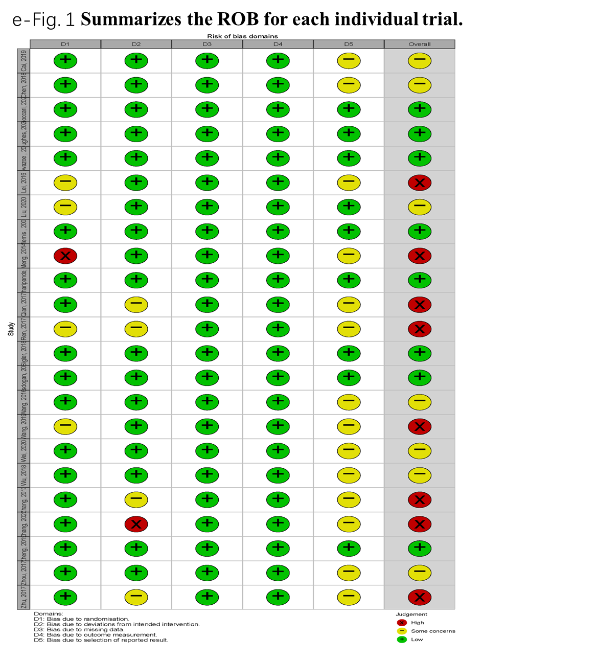
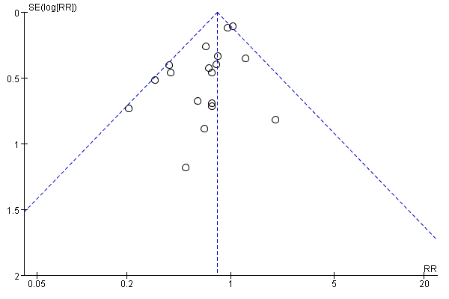
e-Fig. 2 Funnel plots of mortality

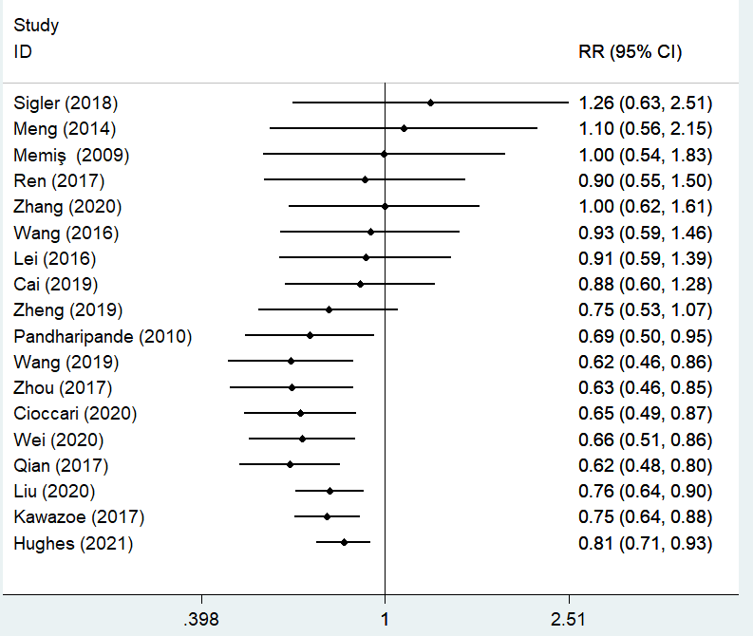

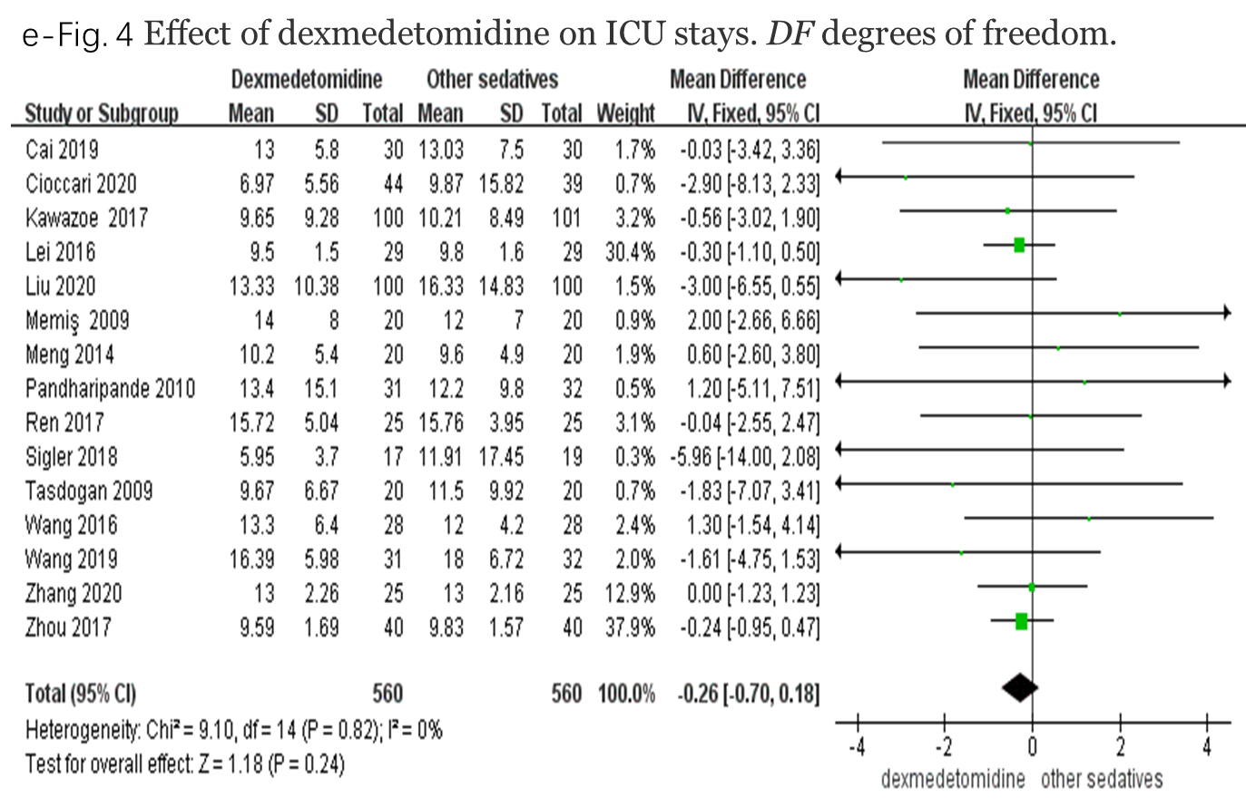

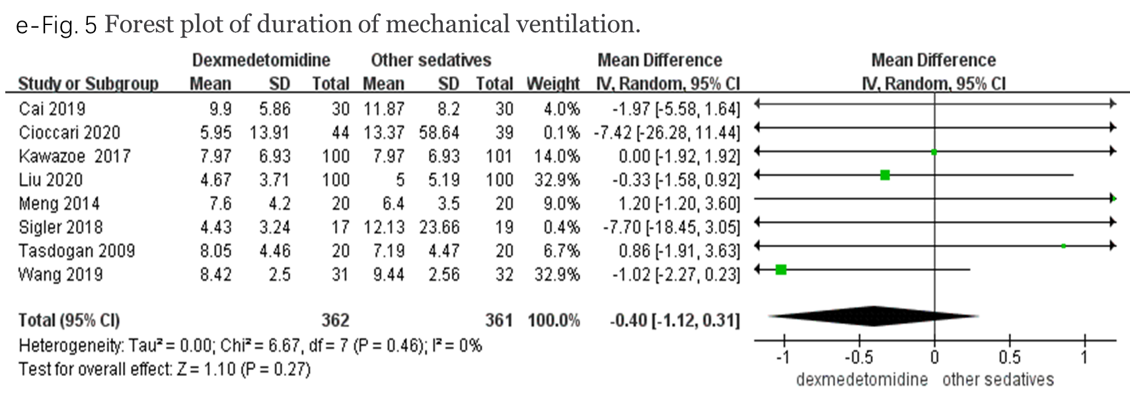

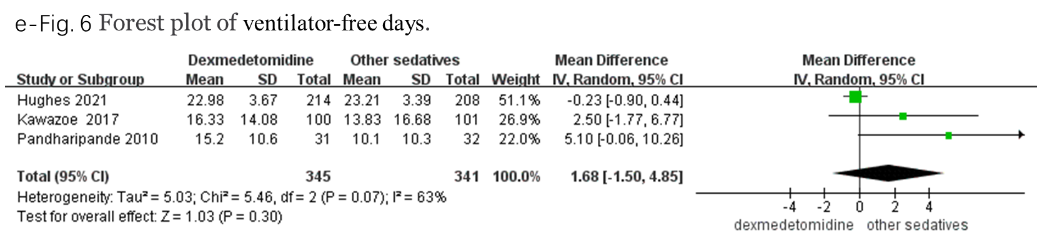

Explanation: a: Level before sedatives; b: Level after 24 hours with sedatives

Explanation: a: Level before sedatives; b: Level after 24 hours with sedatives

Explanation: a: Levels of Cr before sedatives; b: Levels of Cr after 24 hours with sedatives;
c: Levels of ALT before sedatives; b: Levels of ALT after 24 hours with sedatives.

