Supplementary material for:

When and how do national CO₂ emissions peak? The role of crises and structural change

Germán Bersalli^{1,*}, Tim Tröndle², Johan Lilliestam^{1,3}
¹ Energy Transitions & Public Policy group, Institute for Advanced Sustainability Studies (IASS), Potsdam, Germany.
² Climate Policy Lab, Institute for Environmental Decisions, ETH Zürich, Switzerland.
³ Faculty of Economics and Social Sciences, University of Potsdam, Germany

* Corresponding author: german.bersalli@iass-potsdam.de

Supplementary Note 1: Decoupling between GDP and CO₂ emissions

A decoupling analysis is a commonly used approach to understand whether a variable grows while another variable is increasing or decreasing. In environmental science, this is often done with GDP and emissions of some pollutant or consumption of a material; here, we investigate the coupling state of GDP and CO₂ emissions. Decoupling factors indicate the change in one unit of the environmental pressure, in our case CO₂ emissions, to the change of one unit of the economic driving force, here GDP, estimated at time t and compared with the base period 0. It can be formalised as follows [1-3]:
$DF=1-\frac{\frac{CO2(t)}{GDP(t)}}{\frac{CO2(0)}{GDP(0)}}$ (1)

A decoupling factor of zero (DF = 0) means the absence of any decoupling. A value of one (DF= 1) implies perfect decoupling such that carbon emissions are reduced to zero at time t. Negative values (DF < 0), by contrast, imply coupling. Using Eq. (1) we derived decoupling factors for all peak-and-decline countries, considering the period from the year of the CO₂ emissions peak to 2019.
Decoupling State | Condition | Growth paradigm
(1) Absolute decoupling | (-)ΔCO2 & (+)ΔGDP | Green growth
(2) Relative decoupling | (+)ΔCO2 < (+)ΔGDP | Low-carbon growth
(3) Expansive coupling | (+)ΔCO2 > (+)ΔGDP | Carbon-intensive growth
(4) Negative decoupling | (+)ΔCO2 & (-)ΔGDP | Dirty decline
(5) Negative coupling | (-)ΔCO2 & (-)ΔGDP | De-growth
Table S1: Identification of decoupling states
We distinguish between five decoupling states following the approach proposed by Naqvi and Zwickl [2] and use them to analyze changes in carbon emissions and economic growth dynamics in the countries studied. First, "absolute decoupling" requires that CO₂ emissions decrease while GDP grows, so ΔCO₂ ≤ 0 and ΔGDP > 0. This corresponds with the "green growth" discourse, seeking to continue growth while reducing (and eventually eliminating) emissions. Second, "relative decoupling", occurs when both variables increase but the economy grows faster than the environmental bad [1], such that ΔGDP > ΔCO₂. This state corresponds to "low-carbon growth" and is, barring massive CO₂ removal schemes, incompatible with the net-zero emissions implication Paris Agreement. Third, "expansive coupling", occurs when both variables are positive but in this case, CO₂ emissions increase faster than economic output. We include two last states referencing the situation where economic activity decreases. Fourth, "negative decoupling" refers to the possible but unlikely situation in which economic growth is negative, but emissions increase. Fifth, “negative coupling” occurs when both CO₂ emissions and economic output decrease, referring to a “de-growth” situation. Only the first and fifth states mean that the economy is decarbonizing. Negative coupling, however, may imply more severe social and political troubles and is still not considered a target by any government, although it is gaining attention in climate policy research [4].

Country | Peak | ΔCO₂ | ΔGDP | DF | State
Belgium | 1973 | -14% | 136% | 0.63 | Absolute decoupling
United Kingdom | 1973 | -44% | 160% | 0.78 | Absolute decoupling
Luxemburg | 1974 | -14% | 384% | 0.82 | Absolute decoupling
Sweden | 1980 | -47% | 130% | 0.77 | Absolute decoupling
Germany | 1980 | -35% | 92% | 0.63 | Absolute decoupling
France | 1980 | -32% | 99% | 0.65 | Absolute decoupling
Czechia | 1981 | -48% | 157% | 0.80 | Absolute decoupling
Hungary | 1982 | -42% | 123% | 0.74 | Absolute decoupling
Slovakia | 1988 | -44% | 122% | 0.75 | Absolute decoupling
Latvia | 1989 | -58% | 12% | 0.62 | Absolute decoupling
Poland | 1989 | -30% | 203% | 0.77 | Absolute decoupling
Estonia | 1989 | -34% | 23% | 0.47 | Absolute decoupling
Russia | 1990 | -28% | 94% | 0.63 | Absolute decoupling
Lithuania | 1991 | -65% | 50% | 0.80 | Absolute decoupling
Denmark | 1998 | -51% | 36% | 0.64 | Absolute decoupling
Switzerland | 2001 | -17% | 40% | 0.41 | Absolute decoupling
Portugal | 2005 | -15% | 8% | 0.21 | Absolute decoupling
Finland | 2006 | -37% | 10% | 0.42 | Absolute decoupling
Austria | 2006 | -12% | 18% | 0.26 | Absolute decoupling
Norway | 2007 | -10% | 14% | 0.21 | Absolute decoupling
United States | 2007 | -15% | 22% | 0.30 | Absolute decoupling
Italy | 2007 | -28% | -4% | 0.25 | Negative coupling
Netherlands | 2008 | -15% | 11% | 0.23 | Absolute decoupling
Japan | 2008 | -14% | 7% | 0.19 | Absolute decoupling
Ireland | 2008 | -22% | 71% | 0.54 | Absolute decoupling
Spain | 2008 | -24% | 7% | 0.28 | Absolute decoupling
Slovenia | 2008 | -17% | 5% | 0.21 | Absolute decoupling
Greece | 2008 | -29% | -23% | 0.07 | Negative coupling

Table S2: Decoupling factors (DF) and decoupling states in peak-and-decline countries; ΔGDP and ΔCO₂ denote the increase of GDP and CO₂ emissions (in %) between the year of emissions peaks and 2019; Sources: [5-7].

The results (Table 2) show that all but two peak-and-decline countries experienced absolute decoupling in the period peak year-2019, meaning that CO₂ emissions reached a maximum and then decreased while GDP grew. Because the first countries peaked already in the early 1970s, absolute decoupling is possible even for long periods. However, the trajectories after the peak can vary substantially. For instance, the UK and Belgium both peaked in 1973, but whereas Belgium reduced emissions by only 14% and increased GDP by 136% in 1974-2019, the UK reduced emissions by 44% despite much stronger GDP growth (160%). Notably, Ireland peaked emissions in 2008 but then reduced emissions faster than other countries, even with a booming economic activity, suggesting that substantial transformation has happened in the Irish economy and its energy system in the last decade.
The two exceptions in this group are Italy and particularly Greece. Both countries peaked emissions at the beginning of the Global Financial Crisis, then experienced deep recessions accompanied by a substantial reduction in emissions. The GDP started to grow again but had not yet reached pre-crisis levels in 2019.

Supplementary Note 2: Fuel switch in peak-and-decline countries

A group of Western European countries were the first to peak CO₂ emissions during the first and second oil crises. These early peaks were associated with a decrease in oil consumption (Table S3) mainly due to two factors: first, the implementation of conservation and energy efficiency measures as a response to the crises; and second, the acceleration of nuclear power development (Table S4), to replace oil power generation. Additionally, some countries like Sweden accelerated the deployment of biofuels. RD&D in renewables for electricity generation like solar and wind increased, but the deployment of these technologies was low, not mentionably affecting the energy mix in the 1970s.
In countries that peaked during the collapse of the Soviet Union, the fuel switch effect was less significant. These countries experienced a substantial drop in primary energy consumption from all sources, particularly oil (Table S5). When Russia and the Baltic countries recovered from the deep recession, oil consumption remained substantially lower than before the crisis, translating into energy intensity improvements.
The fuel switch in the countries that peaked during the Global Financial Crisis was different. Most of these countries saw a decrease in coal consumption during and after the crisis (Table S6). In the case of Spain, one of the countries hardest hit by the crisis, coal consumption fell by half between 2007 and 2009. Simultaneously, the deployment of renewable energy did not stop and even accelerated in some cases, such as in the US (Table S7). Even in countries that suffered strong recessions, such as Italy and Greece, the deployment of renewable energies continued. The decrease in coal consumption and the increase in renewables improved the carbon intensity in this group of countries. In parallel, oil consumption continued to decrease while gas consumption has increased, contributing to improvements in carbon intensity.

Table S3: Oil consumption* in countries that peaked during the First Oil Crisis (EJ). Numbers in red highlight the year of consumption peak.

 | 1965 | 1966 | 1967 | 1968 | 1969 | 1970 | 1971 | 1972 | 1973 | 1974 | 1975 | 1976 | 1977 | 1978 | 1979 | 1980 | 1981 | 1982 | 1983 | 1984
Belgium | 0.68 | 0.69 | 0.76 | 0.89 | 1.02 | 1.12 | 1.14 | 1.24 | 1.30 | 1.14 | 1.09 | 1.13 | 1.11 | 1.19 | 1.18 | 1.09 | 1.00 | 0.95 | 0.86 | 0.83
France | 2.29 | 2.46 | 2.83 | 3.06 | 3.54 | 4.02 | 4.38 | 4.86 | 5.42 | 5.15 | 4.71 | 5.09 | 4.89 | 5.10 | 5.07 | 4.71 | 4.25 | 3.94 | 3.85 | 3.71
Germany | 3.67 | 4.11 | 4.27 | 4.79 | 5.39 | 5.92 | 6.17 | 6.51 | 6.94 | 6.29 | 6.11 | 6.61 | 6.52 | 6.81 | 7.02 | 6.35 | 5.76 | 5.45 | 5.34 | 5.32
Luxembourg | 0.04 | 0.04 | 0.04 | 0.05 | 0.05 | 0.06 | 0.06 | 0.06 | 0.07 | 0.06 | 0.06 | 0.06 | 0.06 | 0.06 | 0.06 | 0.05 | 0.04 | 0.04 | 0.04 | 0.04
Sweden | 0.83 | 0.93 | 0.93 | 1.05 | 1.13 | 1.23 | 1.15 | 1.19 | 1.21 | 1.09 | 1.09 | 1.20 | 1.16 | 1.40 | 1.51 | 1.33 | 1.20 | 1.11 | 0.97 | 0.92
United Kingdom | 3.19 | 3.42 | 3.67 | 3.89 | 4.18 | 4.42 | 4.45 | 4.72 | 4.84 | 4.50 | 3.93 | 3.91 | 3.94 | 4.04 | 4.08 | 3.49 | 3.23 | 3.27 | 3.14 | 3.86

* Inland demand plus international aviation and marine bunkers and refinery fuel and loss. Consumption of biogasoline and biodiesel are excluded while derivatives of coal and natural gas are included.

Source: [5].

Table S4: Nuclear energy consumption* in countries that peaked during the First Oil Crisis (EJ, input-equivalent).
 | 1965 | 1966 | 1967 | 1968 | 1969 | 1970 | 1971 | 1972 | 1973 | 1974 | 1975 | 1976 | 1977 |  | 1978 | 1979 | 1980 | 1981 | 1982 | 1983 | 1984
Belgium | - | ^ | ^ | ^ | ^ | ^ | - | ^ | ^ | ^ | 0.07 | 0.10 | 0.12 |  | 0.13 | 0.11 | 0.13 | 0.13 | 0.16 | 0.24 | 0.28
France | 0.01 | 0.01 | 0.02 | 0.03 | 0.04 | 0.06 | 0.09 | 0.15 | 0.15 | 0.15 | 0.18 | 0.16 | 0.18 |  | 0.30 | 0.40 | 0.61 | 1.05 | 1.09 | 1.44 | 1.91
Germany | ^ | ^ | 0.01 | 0.02 | 0.05 | 0.06 | 0.06 | 0.10 | 0.12 | 0.14 | 0.24 | 0.30 | 0.41 |  | 0.44 | 0.52 | 0.56 | 0.66 | 0.74 | 0.78 | 1.04
Luxembourg | - | - | - | - | - | - | - | - | - | - | - | - | - |  | - | - | - | - | - | - | -
Sweden | ^ | ^ | ^ | ^ | ^ | ^ | ^ | 0.01 | 0.02 | 0.02 | 0.12 | 0.16 | 0.20 |  | 0.24 | 0.21 | 0.26 | 0.38 | 0.39 | 0.41 | 0.51
United Kingdom | 0.15 | 0.20 | 0.23 | 0.26 | 0.29 | 0.26 | 0.28 | 0.29 | 0.28 | 0.34 | 0.30 | 0.36 | 0.40 |  | 0.37 | 0.38 | 0.37 | 0.38 | 0.44 | 0.50 | 0.54
* Based on gross generation and not accounting for cross-border electricity supply.
“Input-equivalent” energy is the amount of fuel that would be required by thermal power stations to generate the reported electricity output
^ Less than 0.005
Source: [5]
.

Table S5: Oil consumption* in countries that peaked during the Soviet Union crisis (EJ). Numbers in red highlight the year of consumption peak.
 | 1985 | 1986 | 1987 | 1988 | 1989 | 1990 | 1991 | 1992 | 1993 | 1994 | 1995 | 1996 | 1997 | 1998 | 1999 | 2000 | 2001 | 2002 | 2003 | 2004
Slovakia | 0.26 | 0.26 | 0.25 | 0.24 | 0.24 | 0.21 | 0.18 | 0.17 | 0.14 | 0.14 | 0.14 | 0.15 | 0.15 | 0.16 | 0.15 | 0.15 | 0.14 | 0.15 | 0.14 | 0.14
Latvia | 0.24 | 0.21 | 0.17 | 0.15 | 0.15 | 0.14 | 0.14 | 0.10 | 0.09 | 0.09 | 0.08 | 0.08 | 0.07 | 0.07 | 0.07 | 0.05 | 0.06 | 0.06 | 0.06 | 0.07
Poland | 0.70 | 0.72 | 0.73 | 0.75 | 0.75 | 0.68 | 0.65 | 0.59 | 0.61 | 0.64 | 0.65 | 0.76 | 0.79 | 0.90 | 0.94 | 0.87 | 0.85 | 0.86 | 0.88 | 0.94
Estonia | 0.15 | 0.14 | 0.15 | 0.15 | 0.15 | 0.15 | 0.13 | 0.07 | 0.07 | 0.07 | 0.05 | 0.06 | 0.06 | 0.06 | 0.05 | 0.05 | 0.06 | 0.06 | 0.06 | 0.06
Russia | 10.57 | 10.70 | 10.78 | 10.70 | 10.90 | 10.74 | 10.47 | 10.00 | 8.34 | 7.37 | 6.43 | 5.54 | 5.50 | 5.27 | 5.38 | 5.28 | 5.43 | 5.24 | 5.43 | 5.36
Lithuania | 0.37 | 0.31 | 0.34 | 0.33 | 0.33 | 0.32 | 0.35 | 0.18 | 0.16 | 0.15 | 0.13 | 0.14 | 0.14 | 0.16 | 0.13 | 0.10 | 0.12 | 0.11 | 0.10 | 0.11

* Inland demand plus international aviation and marine bunkers and refinery fuel and loss. Consumption of biogasoline and biodiesel are excluded while derivatives of coal and natural gas are included.

Table S6: Coal consumption* in countries that peaked during the Global Financial Crisis (EJ). Numbers in red highlight the year of consumption peak
 | 1998 | 1999 | 2000 | 2001 | 2002 | 2003 | 2004 | 2005 | 2006 | 2007 | 2008 | 2009 | 2010 | 2011 | 2012 | 2013 | 2014 | 2015 | 2016 | 2017 | 2018 | 2019
US | 21.71 | 21.67 | 22.63 | 21.96 | 21.95 | 22.37 | 22.52 | 22.85 | 22.50 | 22.80 | 22.44 | 19.74 | 20.88 | 19.70 | 17.42 | 18.08 | 18.04 | 15.58 | 14.26 | 13.87 | 13.28 | 11.34
Japan | 3.54 | 3.73 | 4.00 | 4.09 | 4.35 | 4.47 | 4.59 | 4.81 | 4.72 | 4.96 | 5.09 | 4.27 | 4.87 | 4.62 | 4.88 | 5.07 | 4.99 | 5.03 | 5.02 | 5.10 | 4.99 | 4.91
Austria | 0.14 | 0.14 | 0.15 | 0.16 | 0.16 | 0.17 | 0.17 | 0.17 | 0.17 | 0.16 | 0.16 | 0.12 | 0.14 | 0.15 | 0.13 | 0.14 | 0.13 | 0.14 | 0.13 | 0.13 | 0.12 | 0.12
Finland | 0.23 | 0.22 | 0.21 | 0.25 | 0.28 | 0.34 | 0.31 | 0.20 | 0.31 | 0.29 | 0.22 | 0.22 | 0.28 | 0.23 | 0.19 | 0.21 | 0.19 | 0.16 | 0.18 | 0.17 | 0.18 | 0.15
Greece | 0.37 | 0.36 | 0.38 | 0.39 | 0.38 | 0.38 | 0.39 | 0.38 | 0.35 | 0.37 | 0.35 | 0.35 | 0.33 | 0.33 | 0.34 | 0.29 | 0.28 | 0.24 | 0.18 | 0.20 | 0.19 | 0.22
Ireland | 0.12 | 0.10 | 0.11 | 0.11 | 0.11 | 0.11 | 0.10 | 0.11 | 0.10 | 0.10 | 0.10 | 0.08 | 0.08 | 0.08 | 0.09 | 0.09 | 0.08 | 0.09 | 0.09 | 0.08 | 0.06 | 0.04
Italy | 0.49 | 0.49 | 0.52 | 0.56 | 0.57 | 0.62 | 0.69 | 0.69 | 0.70 | 0.68 | 0.66 | 0.52 | 0.57 | 0.64 | 0.66 | 0.57 | 0.55 | 0.52 | 0.46 | 0.40 | 0.37 | 0.28
Netherlands | 0.36 | 0.31 | 0.33 | 0.35 | 0.35 | 0.36 | 0.36 | 0.34 | 0.32 | 0.35 | 0.33 | 0.31 | 0.32 | 0.31 | 0.34 | 0.34 | 0.38 | 0.46 | 0.43 | 0.39 | 0.35 | 0.27
Norway | 0.04 | 0.04 | 0.04 | 0.04 | 0.03 | 0.03 | 0.04 | 0.03 | 0.03 | 0.03 | 0.03 | 0.02 | 0.03 | 0.04 | 0.03 | 0.03 | 0.04 | 0.03 | 0.03 | 0.03 | 0.03 | 0.03
Portugal | 0.15 | 0.16 | 0.16 | 0.13 | 0.15 | 0.14 | 0.14 | 0.14 | 0.14 | 0.12 | 0.11 | 0.12 | 0.07 | 0.09 | 0.12 | 0.11 | 0.11 | 0.14 | 0.12 | 0.14 | 0.11 | 0.05
Slovenia | 0.06 | 0.05 | 0.06 | 0.06 | 0.07 | 0.06 | 0.06 | 0.06 | 0.06 | 0.07 | 0.06 | 0.06 | 0.06 | 0.06 | 0.06 | 0.06 | 0.04 | 0.04 | 0.05 | 0.05 | 0.05 | 0.04
Spain | 0.73 | 0.82 | 0.88 | 0.80 | 0.90 | 0.84 | 0.88 | 0.86 | 0.75 | 0.84 | 0.57 | 0.39 | 0.29 | 0.54 | 0.65 | 0.48 | 0.49 | 0.57 | 0.44 | 0.56 | 0.46 | 0.16
* Commercial solid fuels only, i.e. bituminous coal and anthracite (hard coal), and lignite and brown (sub bituminous) coal, and other commercial solid fuels.
Excludes coal converted to liquid or gaseous fuels, but includes coal consumed in transformation processes.
Source: [5]

Table S7: Renewable energy consumption* in countries that peaked during the Global Financial Crisis (EJ, input-equivalent).
 | 1998 | 1999 | 2000 | 2001 | 2002 | 2003 | 2004 | 2005 | 2006 | 2007 |  | 2008 | 2009 | 2010 | 2011 | 2012 | 2013 | 2014 | 2015 | 2016 | 2017 | 2018 | 2019
US | 0.80 | 0.83 | 0.86 | 0.88 | 0.99 | 1.05 | 1.14 | 1.22 | 1.44 | 1.65 |  | 2.06 | 2.34 | 2.70 | 3.03 | 3.27 | 3.70 | 3.98 | 4.19 | 4.74 | 5.17 | 5.44 | 5.71
Japan | 0.16 | 0.17 | 0.17 | 0.17 | 0.18 | 0.19 | 0.20 | 0.24 | 0.25 | 0.26 |  | 0.26 | 0.25 | 0.29 | 0.30 | 0.33 | 0.39 | 0.49 | 0.64 | 0.67 | 0.80 | 0.90 | 1.01
Austria | 0.02 | 0.02 | 0.02 | 0.02 | 0.02 | 0.02 | 0.03 | 0.04 | 0.06 | 0.07 |  | 0.08 | 0.08 | 0.08 | 0.08 | 0.09 | 0.10 | 0.11 | 0.12 | 0.12 | 0.13 | 0.13 | 0.15
Finland | 0.09 | 0.08 | 0.09 | 0.08 | 0.09 | 0.09 | 0.10 | 0.09 | 0.11 | 0.10 |  | 0.10 | 0.09 | 0.11 | 0.12 | 0.12 | 0.13 | 0.14 | 0.14 | 0.14 | 0.17 | 0.18 | 0.19
Greece | ^ | ^ | ^ | 0.01 | 0.01 | 0.01 | 0.01 | 0.01 | 0.02 | 0.02 |  | 0.03 | 0.03 | 0.03 | 0.04 | 0.06 | 0.08 | 0.08 | 0.09 | 0.09 | 0.10 | 0.10 | 0.12
Ireland | ^ | ^ | ^ | ^ | ^ | 0.01 | 0.01 | 0.01 | 0.02 | 0.02 |  | 0.03 | 0.03 | 0.03 | 0.05 | 0.04 | 0.05 | 0.06 | 0.07 | 0.07 | 0.08 | 0.09 | 0.10
Italy | 0.05 | 0.06 | 0.07 | 0.07 | 0.09 | 0.10 | 0.12 | 0.13 | 0.14 | 0.15 |  | 0.19 | 0.24 | 0.30 | 0.40 | 0.53 | 0.60 | 0.61 | 0.63 | 0.65 | 0.67 | 0.64 | 0.65
Netherlands | 0.02 | 0.02 | 0.03 | 0.03 | 0.04 | 0.04 | 0.05 | 0.07 | 0.08 | 0.09 |  | 0.10 | 0.12 | 0.11 | 0.13 | 0.13 | 0.13 | 0.12 | 0.14 | 0.15 | 0.18 | 0.19 | 0.23
Norway | ^ | ^ | ^ | ^ | ^ | 0.01 | 0.01 | 0.01 | 0.01 | 0.01 |  | 0.02 | 0.02 | 0.02 | 0.02 | 0.02 | 0.03 | 0.03 | 0.03 | 0.04 | 0.05 | 0.05 | 0.07
Portugal | 0.01 | 0.01 | 0.02 | 0.02 | 0.02 | 0.02 | 0.02 | 0.03 | 0.05 | 0.06 |  | 0.08 | 0.10 | 0.13 | 0.13 | 0.14 | 0.16 | 0.16 | 0.16 | 0.16 | 0.16 | 0.16 | 0.18
Slovenia | - | ^ | ^ | ^ | ^ | ^ | ^ | ^ | ^ | ^ |  | ^ | ^ | ^ | ^ | 0.01 | 0.01 | 0.01 | 0.01 | 0.01 | 0.01 | 0.01 | 0.01
Spain | 0.03 | 0.04 | 0.07 | 0.09 | 0.12 | 0.16 | 0.19 | 0.24 | 0.26 | 0.30 |  | 0.38 | 0.46 | 0.57 | 0.59 | 0.70 | 0.72 | 0.69 | 0.67 | 0.66 | 0.68 | 0.69 | 0.73
*Includes renewable power (apart from hydro, which is reported separately) and biofuels
“Input-equivalent” energy is the amount of fuel that would be required by thermal power stations
^ Less than 0.005.
Source: [5]

Supplementary Note 3: CO₂ emissions Kaya-factors decomposition - all countries, whole period.
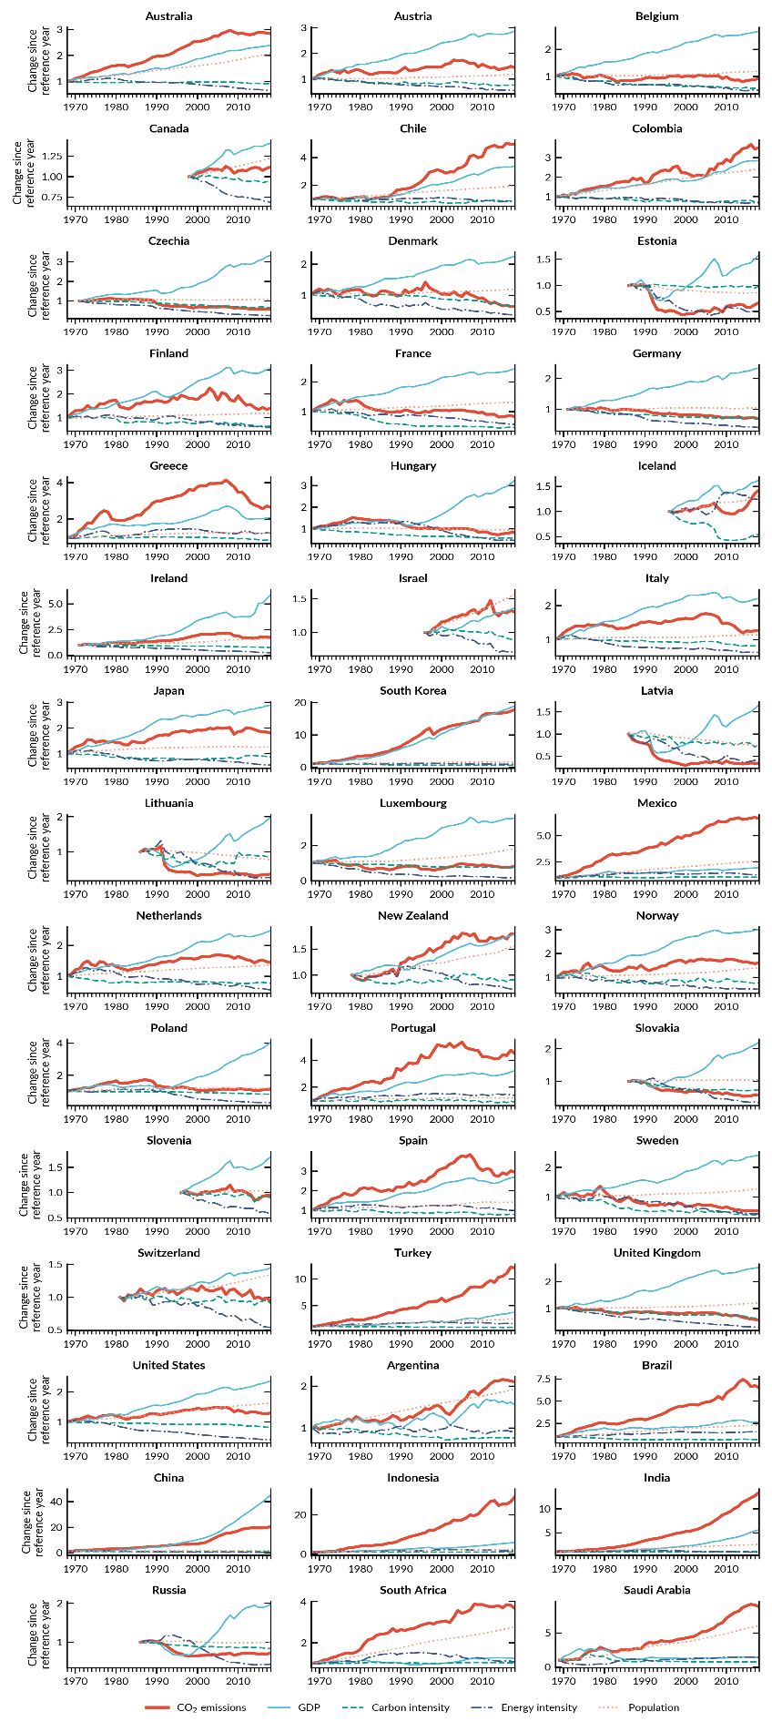
Figure S1: Kaya-factors decomposition - all countries, whole period. Sources: [5-7]

Supplementary Note 4: The impacts of the GFC crisis on non-peak countries.

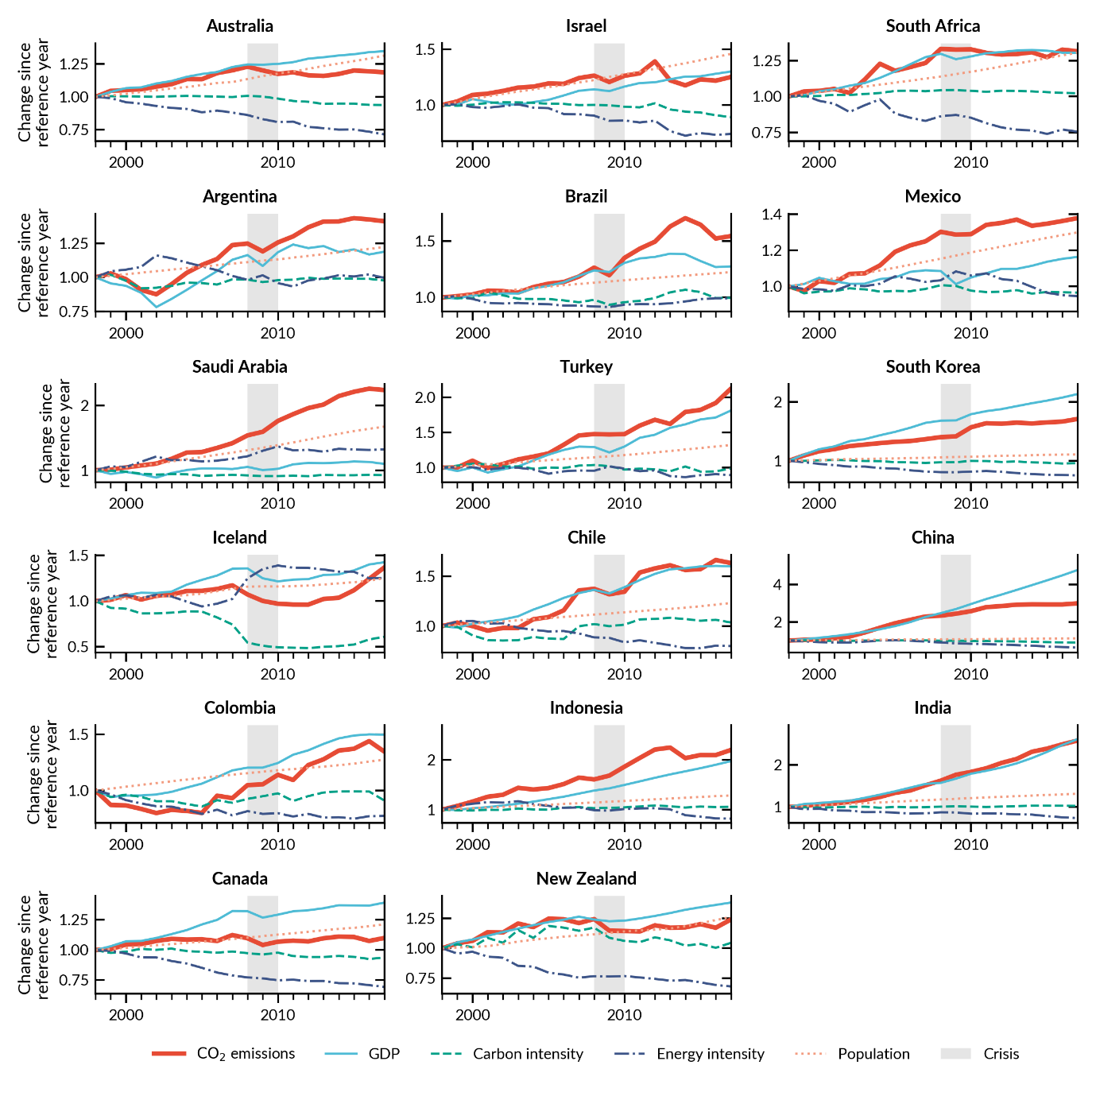
Figure S2: Emission driver decomposition in peak-and-decline countries. (1998-2019). Sources: [5, 6]

Supplementary Note 5: Kaya decomposition factors, all countries.

Table S8: Decomposition factors First Oil Crisis. Decomposition factors (yearly average GDP effect and Structural Change Effect) and yearly average CO₂ emission development for countries that peaked (left) and non-peak countries (right) for pre and post the First Oil Crisis (1974-75). Green indicates that the factor decreased in the post-crisis period compared to pre-crisis, orange colour indicates the opposite. Sources: [5-7]

 | Pre-crisis |  |  | Post-crisis |  |  |  |  | Pre-crisis |  |  | Post-crisis
 | GDP | SC | CO2 | GDP | SC | CO2 |  |  | GDP | SC | CO2 | GDP | SC | CO2
BEL | 4.9% | -2.7% | 2.2% | 1.9% | -1.7% | 0.2% |  | ARG | 3.7% | -1.8% | 1.9% | 2.0% | 1.1% | 3.1%
GBR | 3.7% | -2.8% | 0.8% | 2.3% | -2.2% | 0.1% |  | AUS | 2.5% | 0.9% | 3.4% | 2.5% | 0.9% | 3.4%
LUX | 4.6% | -2.9% | 1.8% | 0.7% | -5.1% | -4.4% |  | BRA | 5.9% | 0.0% | 5.8% | 5.9% | 0.0% | 5.8%
Median | 4.6% | -2.8% | 1.8% | 1.9% | -2.2% | 0.1% |  | CHL | 3.1% | -2.3% | 0.9% | 3.1% | -2.3% | 0.9%
 |  |  |  |  |  |  |  | CHN | 6.6% | 1.0% | 7.6% | 6.6% | 1.0% | 7.6%
 |  |  |  |  |  |  |  | COL | 5.0% | -1.3% | 3.7% | 5.0% | -1.3% | 3.7%
 |  |  |  |  |  |  |  | IDN | 6.9% | 10.8% | 17.8% | 6.9% | 10.8% | 17.8%
 |  |  |  |  |  |  |  | IND | 3.6% | 0.8% | 4.4% | 3.6% | 0.8% | 4.4%
 |  |  |  |  |  |  |  | KOR | 10.6% | 0.9% | 11.5% | 10.6% | 0.9% | 11.5%
 |  |  |  |  |  |  |  | MEX | 6.4% | 2.6% | 9.0% | 6.4% | 2.6% | 9.0%
 |  |  |  |  |  |  |  | TUR | 4.3% | 0.5% | 4.9% | 4.3% | 0.5% | 4.9%
 |  |  |  |  |  |  |  | ZAF | 2.1% | 1.1% | 3.3% | 2.1% | 1.1% | 3.3%
 |  |  |  |  |  |  |  | Median | 5.9% | 0.2% | 5.1% | 4.7% | 0.9% | 4.6%

Table S9: Decomposition factors Second Oil Crisis. Decomposition factors (yearly average GDP effect and Structural Change Effect) and yearly average CO₂ emission development for countries that peaked (left) and non-peak countries (right) for pre and post the Second Oil Crisis (1980-81). Green indicates that the factor decreased in the post-crisis period compared to pre-crisis, orange colour indicates the opposite. Sources: [5-7]

 | Pre-crisis |  |  | Post-crisis |  |  |  |  | Pre-crisis |  |  | Post-crisis
 | GDP | SC | CO2 | GDP | SC | CO2 |  |  | GDP | SC | CO2 | GDP | SC | CO2
CZE | 2.6% | -2.4% | 0.3% | 1.6% | -4.0% | -2.4% |  | ARG | 4.0% | -0.7% | 3.3% | 0.1% | -0.2% | -0.1%
DEU | 3.5% | -3.1% | 0.4% | 2.5% | -3.7% | -1.2% |  | AUS | 2.8% | 1.1% | 4.0% | 3.0% | -1.1% | 1.9%
FRA | 3.7% | -3.5% | 0.2% | 2.3% | -4.2% | -1.8% |  | BRA | 4.9% | 0.7% | 5.6% | 1.7% | -0.2% | 1.5%
HUN | 4.3% | 1.6% | 5.9% | 1.0% | -2.3% | -1.3% |  | CHL | 8.8% | -4.1% | 4.8% | 3.4% | 0.3% | 3.7%
SWE | 1.3% | 5.8% | 7.1% | 2.2% | -6.0% | -3.8% |  | CHN | 8.8% | -1.5% | 7.4% | 9.3% | -4.1% | 5.2%
Median | 3.5% | -2.4% | 0.4% | 2.2% | -4.0% | -1.8% |  | COL | 6.0% | -2.7% | 3.3% | 3.3% | -1.8% | 1.5%
 |  |  |  |  |  |  |  | IDN | 7.6% | 5.6% | 13.2% | 5.6% | 0.7% | 6.3%
 |  |  |  |  |  |  |  | IND | 2.4% | 1.4% | 3.9% | 5.1% | 1.7% | 6.8%
 |  |  |  |  |  |  |  | KOR | 10.6% | 1.5% | 12.2% | 10.1% | -2.7% | 7.4%
 |  |  |  |  |  |  |  | MEX | 7.3% | 0.6% | 7.9% | 2.1% | 0.7% | 2.8%
 |  |  |  |  |  |  |  | SAU | 4.3% | 4.7% | 9.1% | -0.5% | 3.4% | 2.9%
 |  |  |  |  |  |  |  | TUR | 1.4% | 0.9% | 2.3% | 4.8% | 1.0% | 5.8%
 |  |  |  |  |  |  |  | ZAF | 2.2% | -0.4% | 1.8% | 1.3% | 2.8% | 4.0%
 |  |  |  |  |  |  |  | Median | 4.9% | 0.7% | 4.8% | 3.3% | 0.33% | 3.7%

Table S10: Decomposition factors Soviet Union crisis. Decomposition factors (yearly average GDP effect and Structural Change Effect) and yearly average CO₂ emission development for countries that peaked (left) and non-peak countries (right) for pre and post the Soviet Union collapse (1990-91). Green indicates that the factor decreased in the post-crisis period compared to pre-crisis, orange colour indicates the opposite. Sources: [5-7]

 | Pre-crisis |  |  | Post-crisis |  |  |  |  | Pre-crisis |  |  | Post-crisis
 | GDP | SC | CO2 | GDP | SC | CO2 |  |  | GDP | SC | CO2 | GDP | SC | CO2
EST | 3.8% | -3.2% | 0.6% | 0.2% | -4.7% | -4.5% |  | ARG | -0.6% | 1.0% | 0.4% | 3.3% | -1.9% | -1.4%
LTU | 4.6% | -6.2% | -1.6% | -0.4% | -6.6% | -7.0% |  | AUS | 3.4% | -1.2% | 2.1% | 3.2% | -0.8% | 2.4%
LVA | 2.5% | -8.4% | -5.9% | -1.0% | -5.5% | -6.5% |  | BRA | 2.2% | -0.4% | 1.8% | 2.5% | 1.8% | 4.3%
POL | 1.3% | -0.1% | 1.2% | 3.2% | -6.5% | -3.3% |  | CHL | 2.9% | 1.0% | 3.8% | 6.0% | -1.1% | 4.9%
RUS | 1.2% | 0.2% | 1.3% | 2.9% | -4.6% | -1.7% |  | CHN | 9.9% | -4.3% | 5.6% | 10.2% | -5.8% | 4.4%
SVK | 2.4% | -4.5% | -2.1% | 1.7% | -4.5% | -2.8% |  | COL | 3.3% | -0.5% | 2.8% | 2.6% | -0.4% | 2.2%
Median | 2.4% | -3.9% | -0.5% | 0.9% | -5.1% | -3.9% |  | IDN | 5.3% | -0.3% | 5.0% | 3.9% | 2.9% | 6.8%
 |  |  |  |  |  |  |  | IND | 5.6% | 1.3% | 6.9% | 5.5% | -1.2% | 4.3%
 |  |  |  |  |  |  |  | KOR | 10.0% | -3.3% | 6.7% | 6.9% | -1.0% | 6.0%
 |  |  |  |  |  |  |  | MEX | 1.5% | 0.9% | 2.4% | 3.1% | -0.4% | 2.7%
 |  |  |  |  |  |  |  | NZL | 2.1% | -1.2% | 0.9% | 3.1% | -0.4% | 2.7%
 |  |  |  |  |  |  |  | SAU | -3.6% | 4.0% | 0.4% | 2.2% | 0.4% | 2.6%
 |  |  |  |  |  |  |  | TUR | 4.8% | 1.4% | 6.2% | 2.8% | 0.1% | 2.9%
 |  |  |  |  |  |  |  | ZAF | 1.7% | 3.0% | 4.7% | 1.9% | -0.5% | 1.4%
 |  |  |  |  |  |  |  | Median | 3.1% | 0.3% | 3.3% | 3.2% | -0.5% | 2.8%

Table S11: Decomposition factors Global Financial Crisis. Decomposition factors (yearly average GDP effect and Structural Change Effect) and yearly average CO₂ emission development for countries that peaked (left) and non-peak countries (right) for pre and post the GFC 2008-09). Green indicates that the factor decreased in the post-crisis period compared to pre-crisis, orange colour indicates the opposite. Sources: [5-7]

 | Pre-crisis |  |  | Post-crisis |  |  |  |  | Pre-crisis |  |  | Post-crisis
 | GDP | SC | CO2 | GDP | SC | CO2 |  |  | GDP | SC | CO2 | GDP | SC | CO2
AUT | 2.5% | -1.6% | 0.9% | 1.1% | -1.9% | -0.8% |  | ARG | 2.4% | 0.0% | 2.4% | 0.6% | -0.2% | 0.4%
ESP | 3.8% | -0.1% | 3.7% | 0.6% | -3.0% | -2.4% |  | AUS | 3.5% | -1.4% | 2.1% | 2.5% | -2.8% | -0.2%
FIN | 3.6% | -2.4% | 1.2% | 0.3% | -3.0% | -2.7% |  | BRA | 3.3% | -1.3% | 1.9% | 1.3% | 0.2% | 1.5%
GRC | 3.9% | -2.4% | 1.6% | -2.4% | -0.7% | -3.1% |  | CAN | 4.2% | -2.7% | 1.4% | 1.7% | -1.5% | 0.2%
IRL | 6.3% | -3.9% | 2.4% | 5.0% | -6.9% | -1.9% |  | CHL | 4.4% | -0.9% | 3.5% | 2.8% | -1.0% | 1.8%
ITA | 1.5% | -0.7% | 0.8% | -0.3% | -2.4% | -2.6% |  | CHN | 10.2% | -0.5% | 9.7% | 7.8% | -4.8% | 3.0%
JPN | 1.2% | -0.3% | 1.0% | 0.6% | -1.9% | -1.3% |  | COL | 3.3% | -4.0% | -0.6% | 3.5% | -0.3% | 3.2%
NLD | 2.6% | -2.0% | 0.6% | 1.0% | -2.4% | -1.4% |  | IDN | 4.6% | 1.1% | 5.6% | 5.3% | -0.8% | 4.5%
NOR | 2.4% | -2.3% | 0.1% | 1.2% | -2.0% | -0.8% |  | IND | 6.7% | -1.9% | 4.9% | 6.8% | -1.8% | 5.0%
PRT | 1.8% | -1.4% | 0.3% | 0.5% | -1.6% | -1.1% |  | ISL | 4.9% | -3.0% | 1.9% | 1.8% | -0.3% | 1.5%
SVN | 4.4% | -3.5% | 0.9% | 1.0% | -3.1% | -2.1% |  | ISR | 3.4% | -1.0% | 2.5% | 3.5% | -3.3% | 0.2%
USA | 2.9% | -2.2% | 0.8% | 1.9% | -2.9% | -1.1% |  | KOR | 6.3% | -2.6% | 3.7% | 3.1% | -1.3% | 1.8%
Median | 2.8% | -2.1% | 0.9% | 0.8% | -2.4% | -1.6% |  | MEX | 2.4% | 0.1% | 2.5% | 1.9% | -1.9% | 0.0%
 |  |  |  |  |  |  |  | NZL | 3.8% | -1.6% | 2.2% | 2.6% | -2.1% | 0.4%
 |  |  |  |  |  |  |  | SAU | 2.9% | 1.0% | 3.9% | 2.9% | 0.2% | 3.1%
 |  |  |  |  |  |  |  | TUR | 4.4% | -0.1% | 4.3% | 4.8% | -1.7% | 3.2%
 |  |  |  |  |  |  |  | ZAF | 4.1% | -1.7% | 2.4% | 1.4% | -1.6% | -0.2%
 |  |  |  |  |  |  |  | Median | 4.1% | -1.3% | 2.5% | 2.8% | -1.5% | 1.5%

Supplementary Note 6: CO₂ emission peaks in Denmark and Switzerland

Denmark (1998) and Switzerland (2001) are the only two peak-and-decline countries in our group where emissions peaked outside major economic crises. Switzerland had a minor national recession in 2002-03, and during the recovery years, the energy intensity decreased firmly, preventing emissions from increasing. There was no national economic crisis in Denmark around the emission peak year, and structural change alone explained the peak in emissions, due substantial improvement in both energy and carbon intensities.

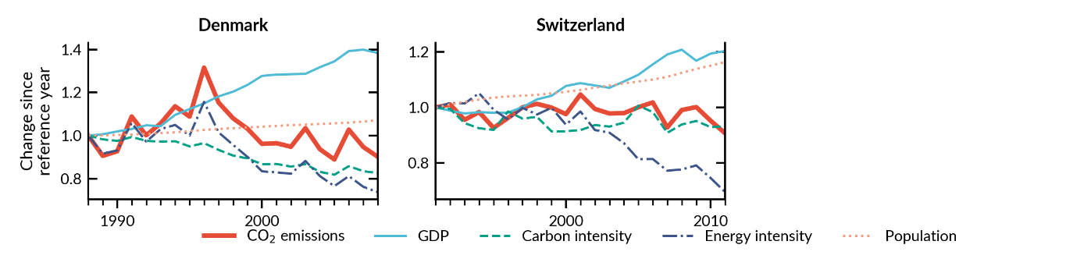
Figure S3: Emission driver decomposition in Denmark (1988-2007) and Switzerland (1991-2010). Sources: [5, 6]

Supplementary references

1. OECD, Indicators to Measure Decoupling of Environmental Pressure from Economic Growth. 2002.
2. Naqvi, A. and K. Zwickl, Fifty shades of green: Revisiting decoupling by economic sectors and air pollutants. Ecological Economics, 2017. 133: p. 111-126.
3. Tapio, P., Towards a theory of decoupling: degrees of decoupling in the EU and the case of road traffic in Finland between 1970 and 2001. Transport policy, 2005. 12(2): p. 137-151.
4. Kallis, G., et al., Research on degrowth. Annual Review of Environment and Resources, 2018. 43: p. 291-316.
5. BP, Statistical Review of World Energy 2021 | 70th edition. 2021.
6. World Bank, World Development Indicators, W. Bank, Editor. 2022.
7. Maddison Project Database, Maddison style estimates of the evolution of the world economy. A new 2020 update. 2020.

