Supplementary Materials for

Water resistant soil stabilization via a mussel mimicry ultra-low swelling hydrogel
Zhi Zhao*, Yupeng Shan, Haibin Wang, Hao Lu, Xuemei Liu, Bowen Wang, Xiaoyan Song*

*Corresponding author. Email: zhaozhi@bjut.edu.cn; xysong@bjut.edu.cn

This file includes:

Supplementary Text
Figures S1 to S4
Table S1

Supplementary Text
1. Hydrogel precursor recipes
A series of recipes had been tested to find out the optimal formulation (Table S1). The listed amount of chemicals are intended for preparing 13 mL precursors.

2. Additional sample characterizations
Hydrogel stabilized sands were checked under SEM to figure out the distribution and morphology of hydrogel moieties (Fig. S1). By conducting EDX mapping, it is possible to distinguish closely connected sand particles and hydrogel. For example, the sand was mainly silica, which was rich in O and Si element. In comparison, the hydrogel was dominated by C. As a result, the boundary between sand and hydrogel could be readily told.
The FR-IR spectrum of pure pMAAc and pAAm gel was recorded (Fig. S2). If no intermolecular interaction existed, the spectra of p(MAAc-co-AAm) samples should be a linear combination of pMAAc and pAAm spectra. The simulated spectra of a hydrogel sample was obtained through the following equation:
$$I_{s}=α∙I_{pMAAc}+(1-α)∙I_{pAAM}$$
here I_{s}, I_{pMAAc} and I_{pAAm} were the simulated spectrum of p(MAAc-co-AAm) samples, the actual spectrum of pMAAc and pAAm, respectively. The parameter α is the normalized content of MAAc. For example, α=0.6 represented 60% MAAc in the recipe.
Increasing crosslinker concentrations brought great benefit when the crosslinker content was relatively low (Fig. S2a). For example, the S_{w} of hydrogel A7 could be reduced from 123% to 104% with the addition of 15.4 mg/mL Bis (recipe E7). On the other hand, keeping adding crosslinkers beyond this point didn’t provide much profit. From E7 to G7, the crosslinker content was more than doubled. However, the S_{w} only dropped by 4%. Excessive crosslinkers might weaken the toughness of hydrogel fixed sands. This was because that a high crosslinker concentration led to hard but brittle gels, which made sand columns easy to break. It can be found from Fig. S2b that the peak strength and the corresponding strain level of sand columns stabilized by recipe II and III were much lower compared with using recipe I, indicating a suitable crosslinker content was critical.
AFM measurements were carried out to test the position-dependence of the hardness of the presented hydrogel. The surface and the interior of the hydrogel was first imaged under the contact mode in air (Fig. S4a-S4b). Next, the AFM was switched to the ramp mode to measure the local stiffness at the center of the image (indicated by the red cross). One force curve was recorded for each testing region (Fig. S4c-S4d) while 9 parallel measurements were conducted for the same type of surface to improve accuracy. Next, the spring constant of the AFM probe was decided using thermal tuning and the Y-axis of the force curve was re-plotted accordingly. Finally, the force curves were processed through the NanoScope Analysis 1.8 software, which directly reported the Young’s modulus.

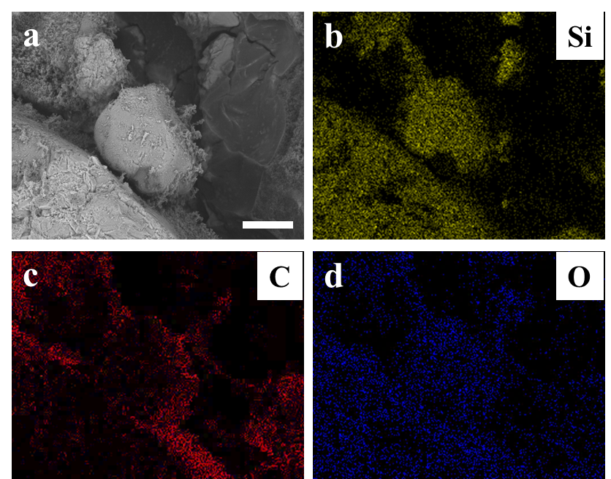

Fig. S1 SEM characterization of hydrogel stabilized sand samples. a SEM image of a representative sample. Scale bar: 100 μm. b-d EDX elemental mapping of the area in a.
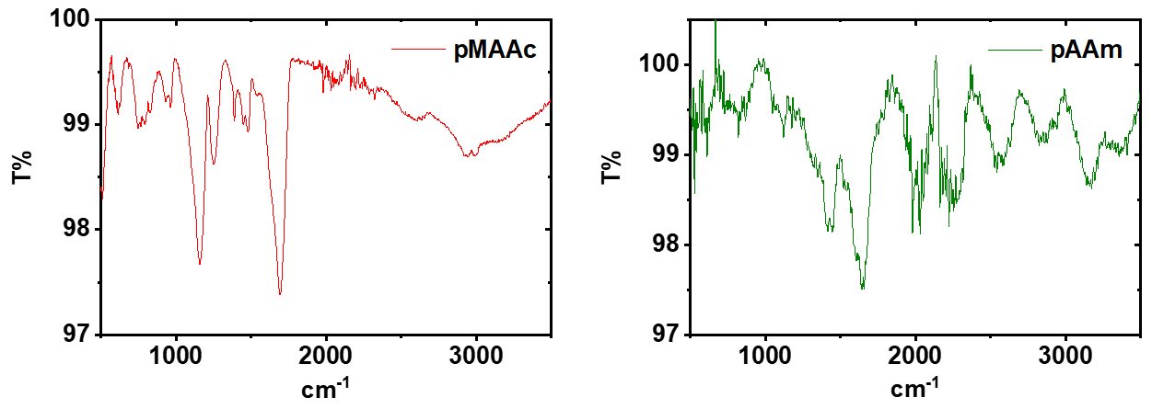
Fig. S2 Experimental spectrum of pure pMAAc and pAAm.
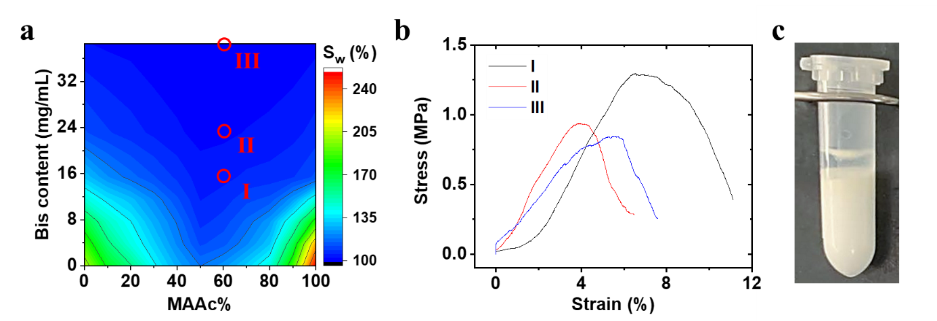

Fig. S3 The influence of crosslinkers. a The change of swelling ratio as a function of crosslinker concentration and MAAc content. b UCS curves of sand columns stabilized by hydrogels with composition I (E7), II (F7) and III (G7), as circled in a. c The curing of Bis-free hydrogel.

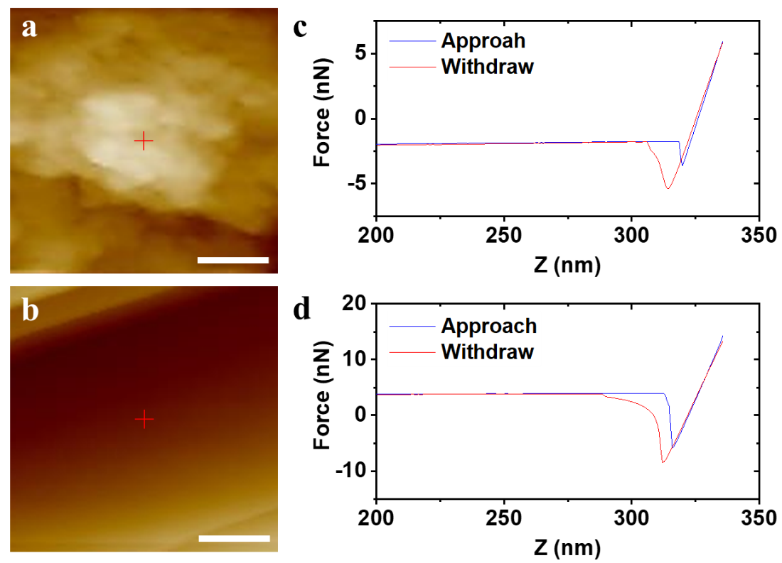

Fig. S4 AFM measurements of the mussel mimicry hydrogel. a The representative morphology of the shell region of hydrogel. Scale bar: 1 μm. b The representative morphology of the core region of hydrogel. Scale bar: 1 μm. c The force curve of the sample in a. d The force curve of the sample in b.

Table S1. A list of all the recipes of precursor.
 | 48.9 wt% MAAc (mL) | 44.4 wt% AAm (mL) | 44.8 wt% AAc (mL) | Bis (mg) | TEMED (μL) | Water (mL) | 10% APS (mL)
A1 | 0 | 6.4 | 0 | 0 | 5 | 5.595 | 1
A2 | 0.66 | 5.76 | 0 | 0 | 100 | 5.48 | 1
A3 | 1.32 | 5.12 | 0 | 0 | 100 | 5.46 | 1
A4 | 1.98 | 4.48 | 0 | 0 | 100 | 5.44 | 1
A5 | 2.64 | 3.84 | 0 | 0 | 100 | 5.42 | 1
A6 | 3.3 | 3.2 | 0 | 0 | 100 | 5.4 | 1
A7 | 3.96 | 2.56 | 0 | 0 | 100 | 5.38 | 1
A8 | 4.62 | 1.92 | 0 | 0 | 100 | 5.36 | 1
A9 | 5.28 | 1.28 | 0 | 0 | 100 | 5.34 | 1
A10 | 5.94 | 0.64 | 0 | 0 | 100 | 5.32 | 1
A11 | 6.6 | 0 | 0 | 0 | 100 | 5.3 | 1
B1 | 0 | 6.4 | 0 | 3.8 | 5 | 5.595 | 1
B2 | 0.66 | 5.76 | 0 | 3.8 | 100 | 5.48 | 1
B3 | 1.32 | 5.12 | 0 | 3.8 | 100 | 5.46 | 1
B4 | 1.98 | 4.48 | 0 | 3.8 | 100 | 5.44 | 1
B5 | 2.64 | 3.84 | 0 | 3.8 | 100 | 5.42 | 1
B6 | 3.3 | 3.2 | 0 | 3.8 | 100 | 5.4 | 1
B7 | 3.96 | 2.56 | 0 | 3.8 | 100 | 5.38 | 1
B8 | 4.62 | 1.92 | 0 | 3.8 | 100 | 5.36 | 1
B9 | 5.28 | 1.28 | 0 | 3.8 | 100 | 5.34 | 1
B10 | 5.94 | 0.64 | 0 | 3.8 | 100 | 5.32 | 1
B11 | 6.6 | 0 | 0 | 3.8 | 100 | 5.3 | 1
C1 | 0 | 6.4 | 0 | 7.7 | 5 | 5.595 | 1
C2 | 0.66 | 5.76 | 0 | 7.7 | 100 | 5.48 | 1
C3 | 1.32 | 5.12 | 0 | 7.7 | 100 | 5.46 | 1
C4 | 1.98 | 4.48 | 0 | 7.7 | 100 | 5.44 | 1
C5 | 2.64 | 3.84 | 0 | 7.7 | 100 | 5.42 | 1
C6 | 3.3 | 3.2 | 0 | 7.7 | 100 | 5.4 | 1
C7 | 3.96 | 2.56 | 0 | 7.7 | 100 | 5.38 | 1
C8 | 4.62 | 1.92 | 0 | 7.7 | 100 | 5.36 | 1
C9 | 5.28 | 1.28 | 0 | 7.7 | 100 | 5.34 | 1
C10 | 5.94 | 0.64 | 0 | 7.7 | 100 | 5.32 | 1
C11 | 6.6 | 0 | 0 | 7.7 | 100 | 5.3 | 1
D1 | 0 | 6.4 | 0 | 11.5 | 5 | 5.595 | 1
D2 | 0.66 | 5.76 | 0 | 11.5 | 100 | 5.48 | 1
D3 | 1.32 | 5.12 | 0 | 11.5 | 100 | 5.46 | 1
D4 | 1.98 | 4.48 | 0 | 11.5 | 100 | 5.44 | 1
D5 | 2.64 | 3.84 | 0 | 11.5 | 100 | 5.42 | 1
D6 | 3.3 | 3.2 | 0 | 11.5 | 100 | 5.4 | 1
D7 | 3.96 | 2.56 | 0 | 11.5 | 100 | 5.38 | 1
D8 | 4.62 | 1.92 | 0 | 11.5 | 100 | 5.36 | 1
D9 | 5.28 | 1.28 | 0 | 11.5 | 100 | 5.34 | 1
D10 | 5.94 | 0.64 | 0 | 11.5 | 100 | 5.32 | 1
D11 | 6.6 | 0 | 0 | 11.5 | 100 | 5.3 | 1
E1 | 0 | 6.4 | 0 | 15.4 | 5 | 5.595 | 1
E2 | 0.66 | 5.76 | 0 | 15.4 | 100 | 5.48 | 1
E3 | 1.32 | 5.12 | 0 | 15.4 | 100 | 5.46 | 1
E4 | 1.98 | 4.48 | 0 | 15.4 | 100 | 5.44 | 1
E5 | 2.64 | 3.84 | 0 | 15.4 | 100 | 5.42 | 1
E6 | 3.3 | 3.2 | 0 | 15.4 | 100 | 5.4 | 1
E7 | 3.96 | 2.56 | 0 | 15.4 | 100 | 5.38 | 1
E8 | 4.62 | 1.92 | 0 | 15.4 | 100 | 5.36 | 1
E9 | 5.28 | 1.28 | 0 | 15.4 | 100 | 5.34 | 1
E10 | 5.94 | 0.64 | 0 | 15.4 | 100 | 5.32 | 1
E11 | 6.6 | 0 | 0 | 15.4 | 100 | 5.3 | 1
F1 | 0 | 6.4 | 0 | 23.1 | 5 | 5.595 | 1
F2 | 0.66 | 5.76 | 0 | 23.1 | 100 | 5.48 | 1
F3 | 1.32 | 5.12 | 0 | 23.1 | 100 | 5.46 | 1
F4 | 1.98 | 4.48 | 0 | 23.1 | 100 | 5.44 | 1
F5 | 2.64 | 3.84 | 0 | 23.1 | 100 | 5.42 | 1
F6 | 3.3 | 3.2 | 0 | 23.1 | 100 | 5.4 | 1
F7 | 3.96 | 2.56 | 0 | 23.1 | 100 | 5.38 | 1
F8 | 4.62 | 1.92 | 0 | 23.1 | 100 | 5.36 | 1
F9 | 5.28 | 1.28 | 0 | 23.1 | 100 | 5.34 | 1
F10 | 5.94 | 0.64 | 0 | 23.1 | 100 | 5.32 | 1
F11 | 6.6 | 0 | 0 | 23.1 | 100 | 5.3 | 1
G1 | 0 | 6.4 | 0 | 38.5 | 5 | 5.595 | 1
G2 | 0.66 | 5.76 | 0 | 38.5 | 100 | 5.48 | 1
G3 | 1.32 | 5.12 | 0 | 38.5 | 100 | 5.46 | 1
G4 | 1.98 | 4.48 | 0 | 38.5 | 100 | 5.44 | 1
G5 | 2.64 | 3.84 | 0 | 38.5 | 100 | 5.42 | 1
G6 | 3.3 | 3.2 | 0 | 38.5 | 100 | 5.4 | 1
G7 | 3.96 | 2.56 | 0 | 38.5 | 100 | 5.38 | 1
G8 | 4.62 | 1.92 | 0 | 38.5 | 100 | 5.36 | 1
G9 | 5.28 | 1.28 | 0 | 38.5 | 100 | 5.34 | 1
G10 | 5.94 | 0.64 | 0 | 38.5 | 100 | 5.32 | 1
G11 | 6.6 | 0 | 0 | 38.5 | 100 | 5.3 | 1
H1 | 6 | 4 | 0 | 30.8 | 200 | 0.8 | 2
H2 | 5 | 5 | 0 | 30.8 | 200 | 0.8 | 2
H3 | 4 | 6 | 0 | 30.8 | 200 | 0.8 | 2
H4 | 0 | 10 | 0 | 30.8 | 5 | 0.995 | 2
O2 | 0 | 5.76 | 0.65 | 15.4 | 100 | 5.49 | 1
O3 | 0 | 5.12 | 1.3 | 15.4 | 100 | 5.48 | 1
O4 | 0 | 4.48 | 1.95 | 15.4 | 100 | 5.47 | 1
O5 | 0 | 3.84 | 2.6 | 15.4 | 100 | 5.46 | 1
O6 | 0 | 3.2 | 3.25 | 15.4 | 100 | 5.45 | 1
O7 | 0 | 2.56 | 3.9 | 15.4 | 100 | 5.44 | 1
O8 | 0 | 1.92 | 4.55 | 15.4 | 100 | 5.43 | 1
O9 | 0 | 1.28 | 5.2 | 15.4 | 100 | 5.42 | 1
O10 | 0 | 0.64 | 5.85 | 15.4 | 100 | 5.41 | 1
O11 | 0 | 0 | 6.5 | 15.4 | 100 | 5.4 | 1

