Figure_SI
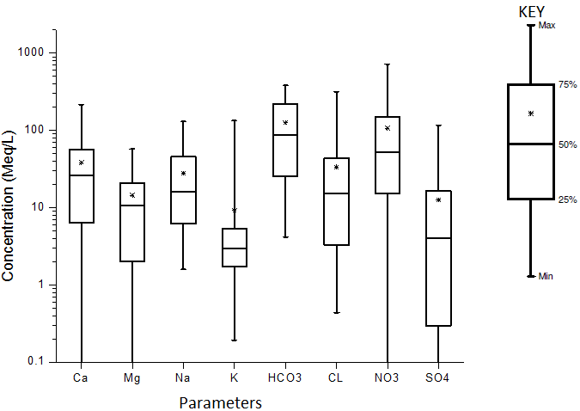
Figure S1. Box and whisker plot showing the concentration of the cations and anions in groundwater.

Figure S2. The Wilcox diagram for groundwater samples in the area (After Wilcox, 1955).

