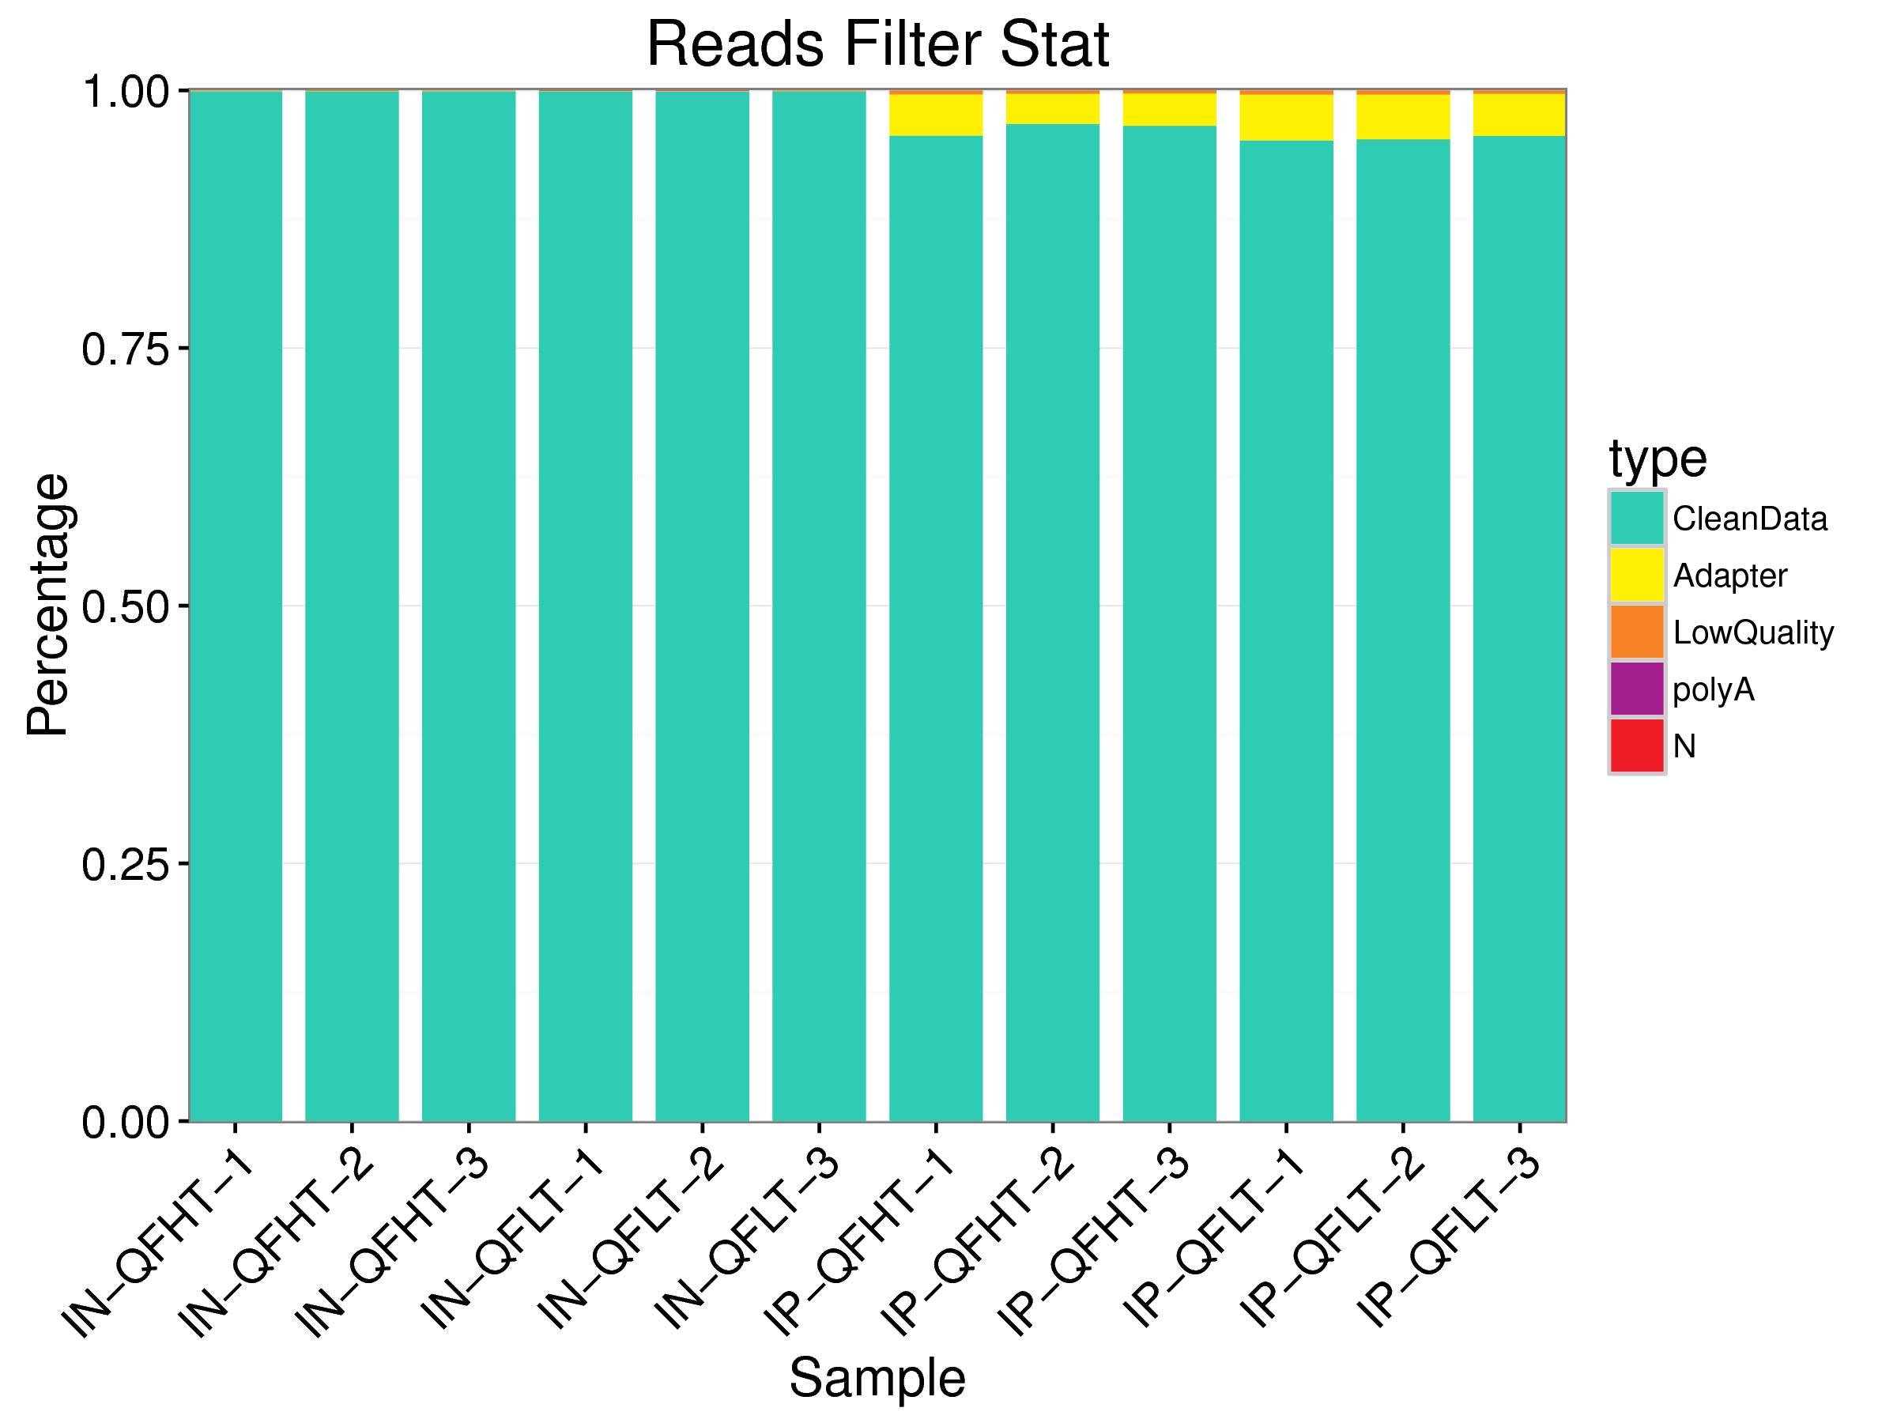
Figure S1. Data preprocessing distribution map (percentage)
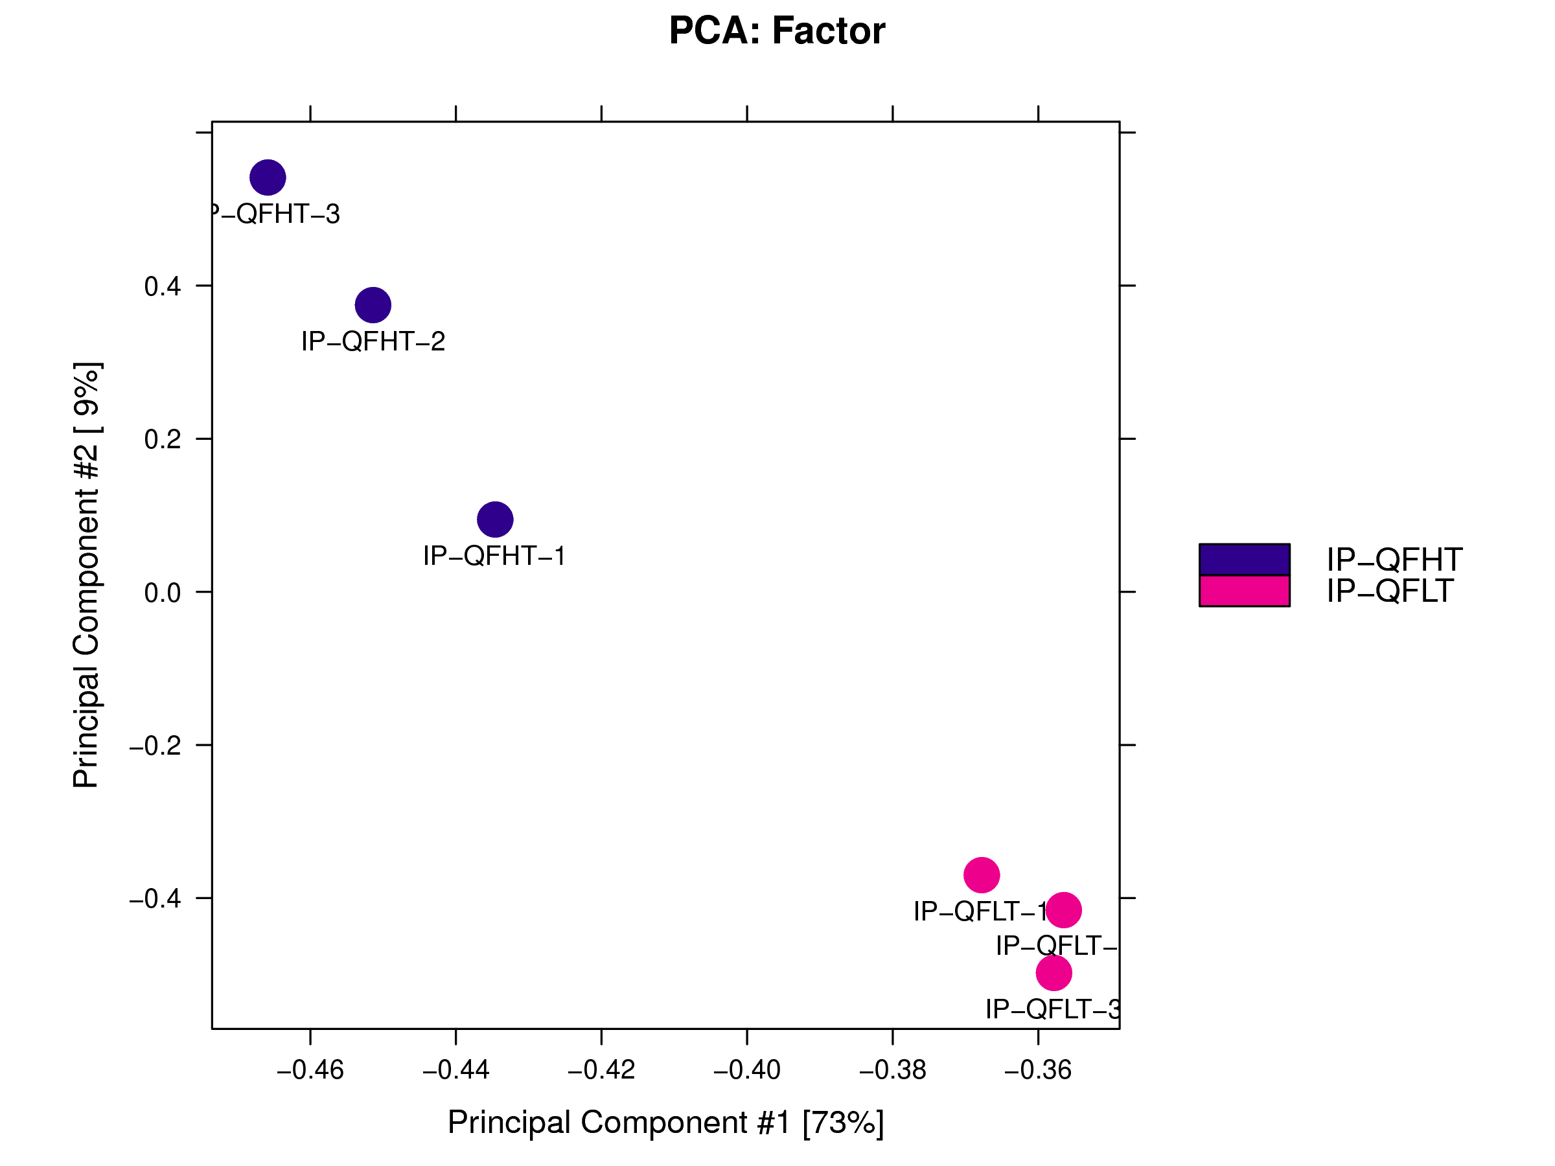
Figure S2. PCA analysis chart
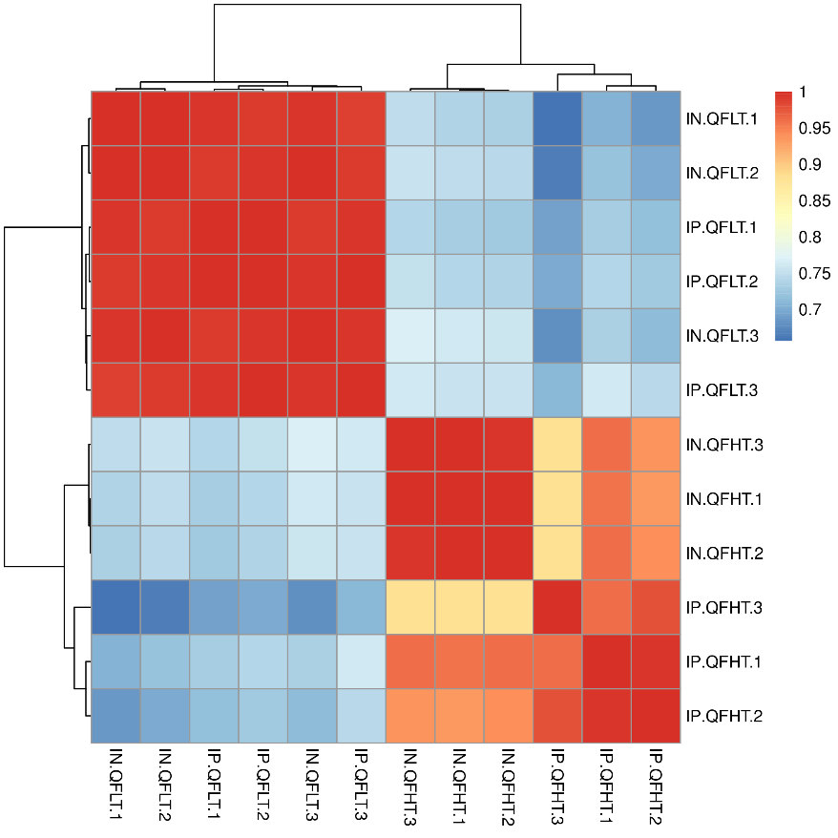
Figure S3. Correlation heatmap

