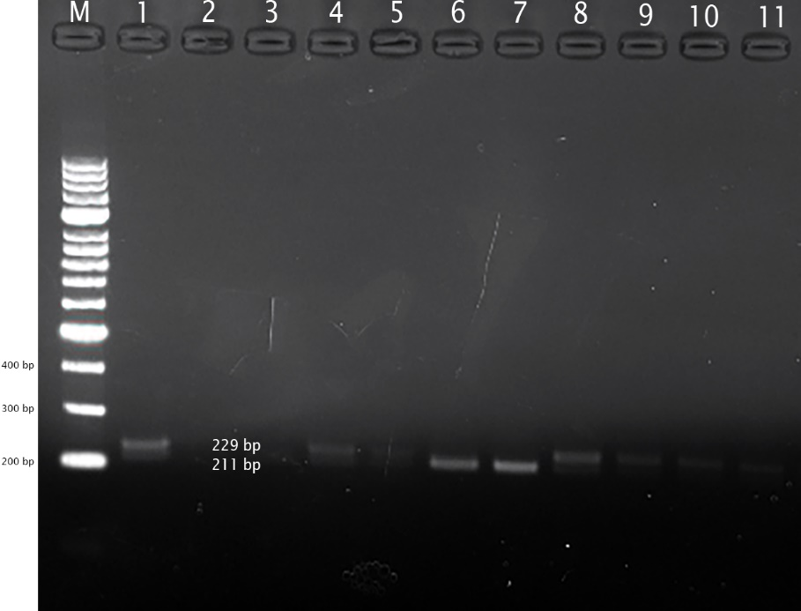
Figure 1. VEGFA VNTR variant in agarose gel (%1,5) electrophoresis
Notes: Lane M=Marker; Lanes 1,4,5,8,9= ID heterozygous allele (211 and 229 bp); Lanes 10,11= II homozygous allele (229 bp); Lane 6,7= DD homozygous allele (211 bp); Lane 2,3= no template control.

