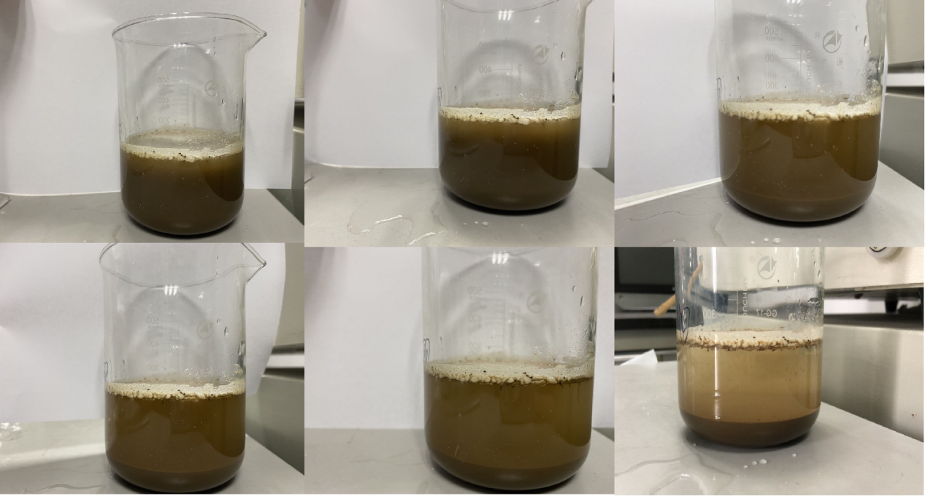
Figure. S1. Comparison of different settling times for density extraction of microplastics from soil（From left to right from top to bottom once for 30min, 1h, 2h,4h, 6h,8h)

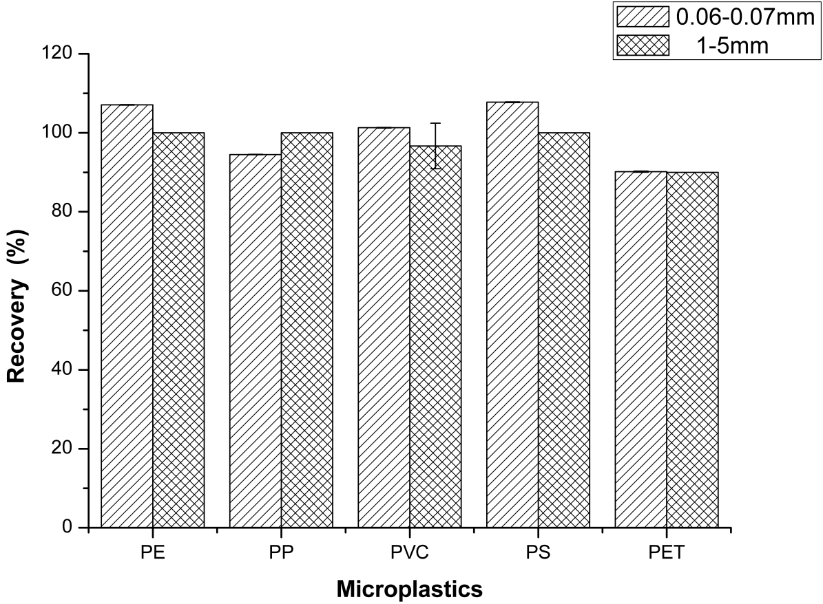
Fig. S2. Extraction recovery of MPs of two particle sizes by MgCl₂

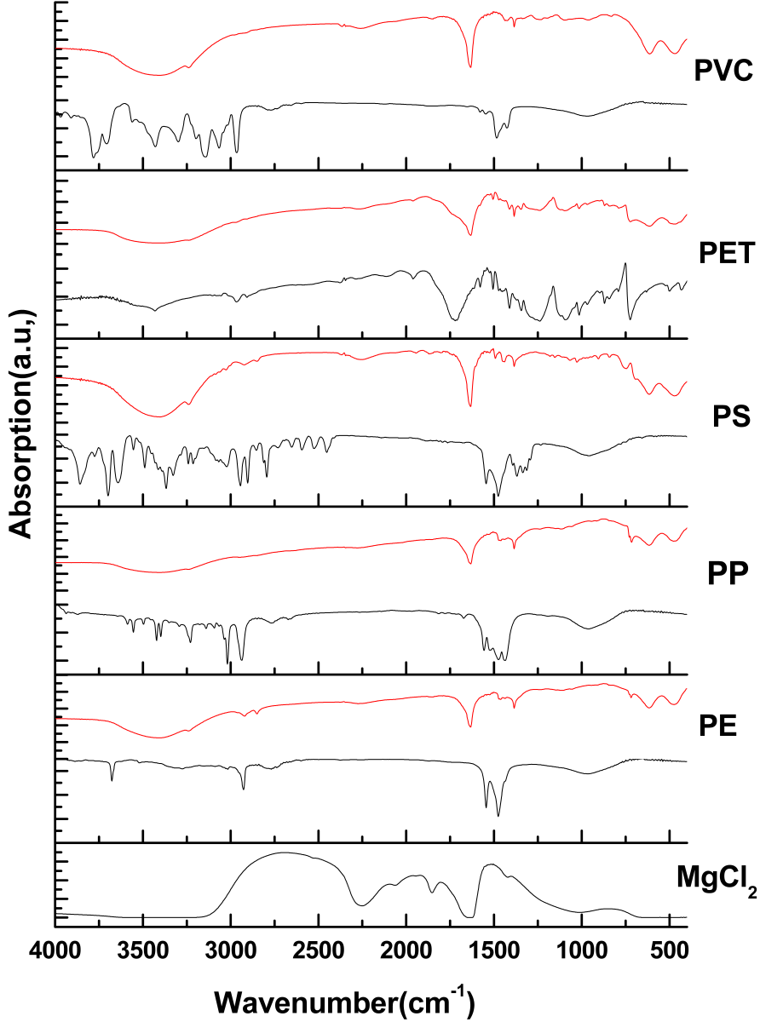
Figure. S3. Fourier transform infrared spectroscopy (FTIR) spectra of common polymers before (black lines) and after (red lines) extraction.

Figure. S4. Raman diagram of treated microplastic standard
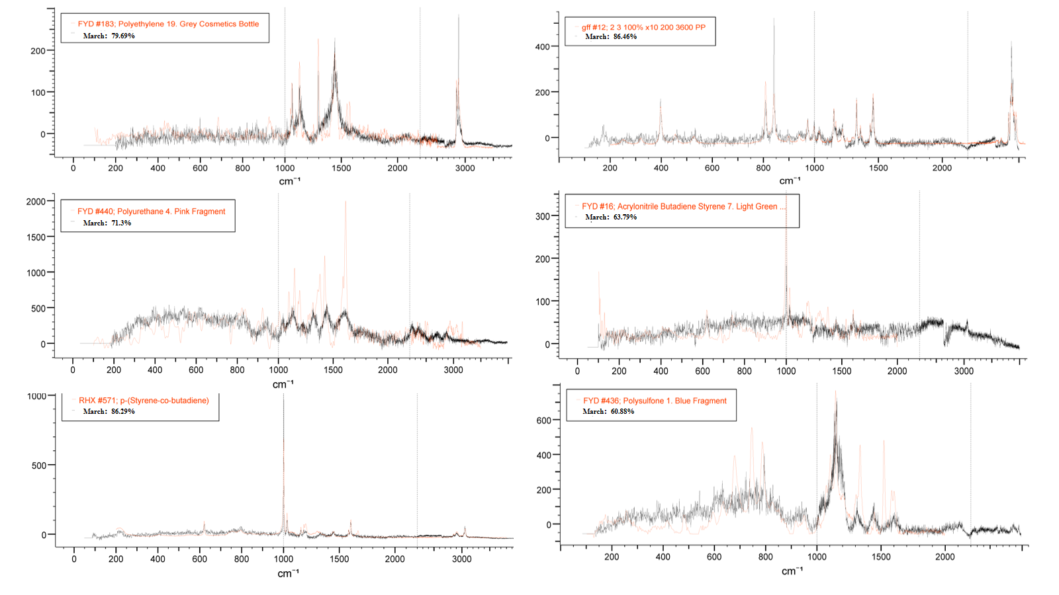
Figure. S5. Raman diagram of actual farmland soil samples

