Graphical Abstract

for
RAFT Polymerization of MMA in the Channels of
Different Mesoporous Materials

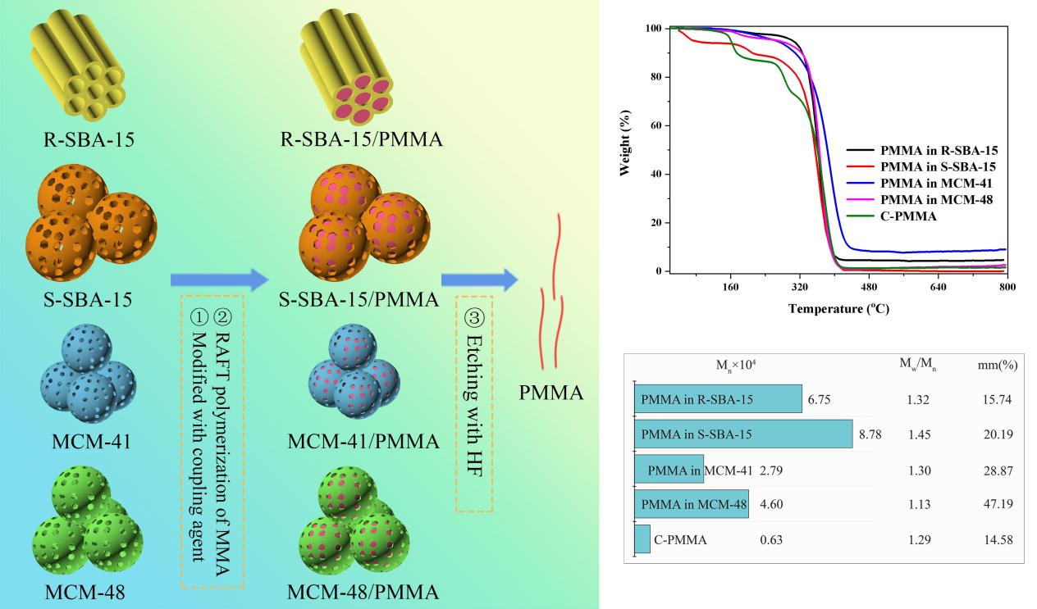

- Thermal stability and molecular weight of MMA from RAFT polymerization within the mesoporous materials pore was higher than corresponding polymers from external one due to a confinement effect.

