Research Article
Antimicrobial Susceptibility and Public Health Importance of Salmonella Isolated from Raw Chicken Egg in MizanTeferi Town, South West Ethiopia

Shimelis Mengistu Hailu^{2*}, Melkamu Melese¹, Berhanu Sibhat², Pawlos Wasihun², Selamawit Fentahun³
¹Masha livestock and fishery office, Ethiopia
²Haramaya University, College of Veterinary Medicine, P.o.box: 138, Dire Dawa, Ethiopia. ³Wollo University, P.o.box: 1145

Correspondence should be address to Shimelis Mengistu; shimemenge2@gmail.com

Questionnaire
1. Sample collection date _____________________ Site of collection ___________________
2. What is the kind of chickens? _________________________________________________
3. What is the source of the egg used for consumption?
Homemade Purchased from market
4. Do you wash the egg before preparation for consumption? Yes No
5. Do you consume raw egg? Yes No
6. If yes, what is the reason? Justify ______________________________________________
__________________________________________________________________________
7. Does your family consume raw egg? Yes No
If yes to Q7, for what reason do they consume raw egg?
A) For medicinal B) for nutritious purpose C) Other (specify)
If yes to Q7, age group up to 5 yrs 6-10 yrs 11-15yrs above 15 yrs
8. What do you do with cracked egg? Consumed Sold Rejected
9. Do you keep eggs before consumption? Yes No
10. If yes, for how many days do you keep?
1 - 7 days 7 – 15days 15-30 days above 30 days
11. What is your keeping mechanism?
At room/ambient temperature in egg cartons
At room/ambient temperature in box
Together with crops and coffee
12. Would you change after usage or reused it again if you used carton?
Changed Reused
13. Which cooking method do you used for consumption of eggs?
a) Boiling with shell b) Scrambling c) Baking
14. Have you ever had any sickness following raw egg consumption?
Yes No
If yes, what were the symptoms?
- Nausea and vomiting c. Abdominal discomfort
- Diarrhea d. other( specify)
15. Do you know that disease could be transmitted by consuming raw egg?
Yes No
If yes, what type of disease are transmitted by raw eggs?
---------------------------------
----------------------------------
-----------------------------------
This is the end of our interview. Thank you very much for your participation in the interview.

Pictures
- Salmonella isolates
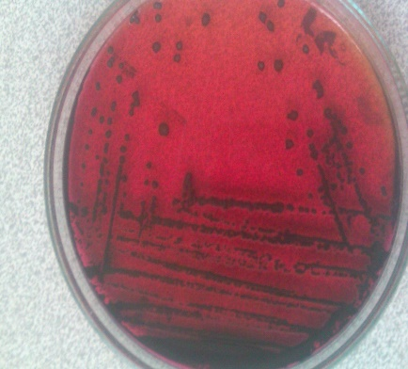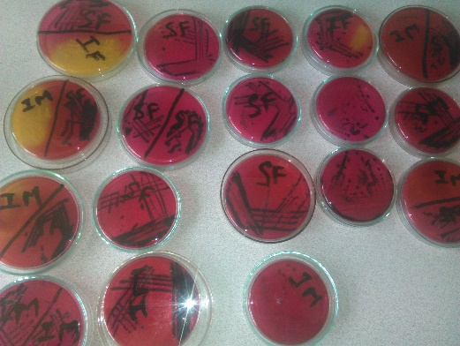
- Egg samples of study area
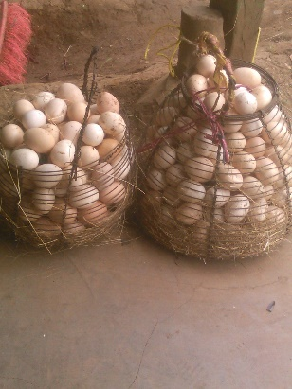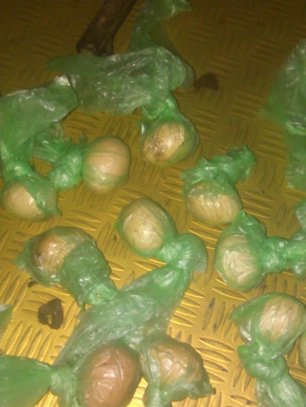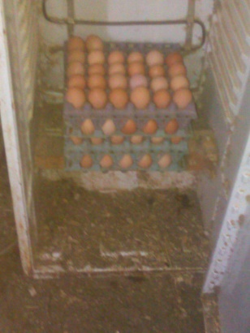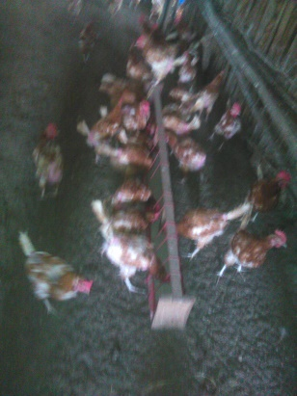
- Laboratory work
