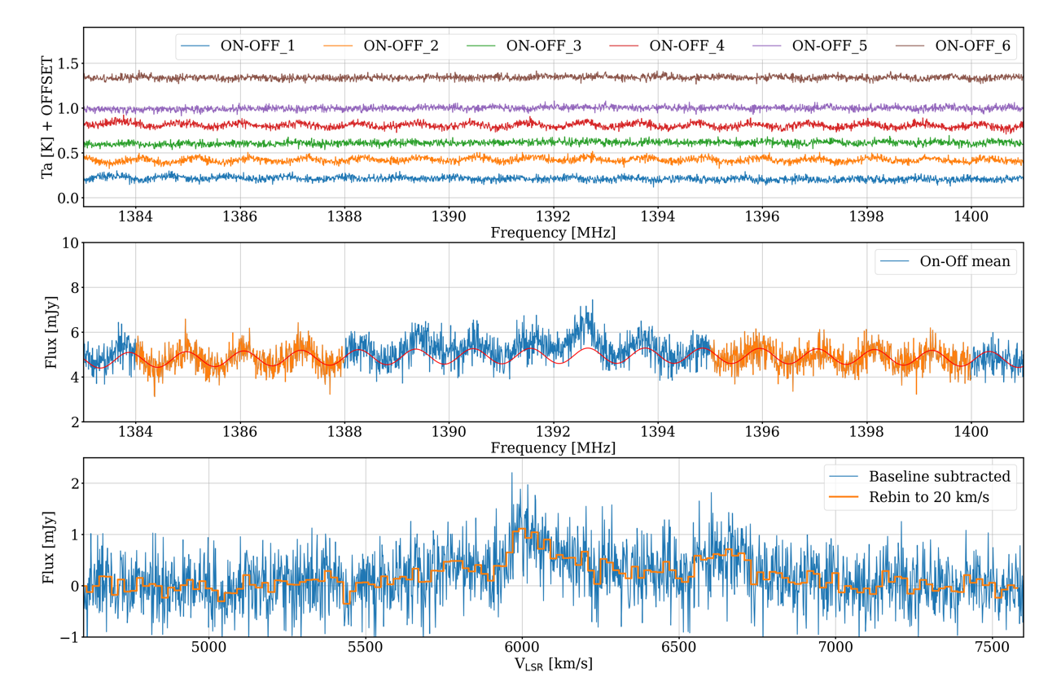
Extended Data Figure 1 | Examples of intermediate products of spectral data reduction. Upper Panel: Individual ON-OFF spectra obtained by beam M01 in Pointing 1 observation (i.e the data obtained at the pixel P1 in Figure 1). An offset of 0.2 K is added to every spectrum relative to the previous one in order to make them separated from each other. Middle Panel: The mean of the ON-OFF spectra in the upper panel. The units of the flux density are converted from K to mJy using the gain factor taken from Extended Data Table 2. The red line shows the baseline model derived by fitting the parts of the spectrum free of signals (marked by orange color) using a sinusoidal (representing standing waves) plus a polynomial (for baseline gradient). Bottom Panel: The spectrum after the baseline removal. The frequency is converted to radial velocity in the optical convention relative to the local standard rest reference frame (LSR). The orange line presents the rebinned spectrum with the velocity bin width of 20 km s⁻¹.
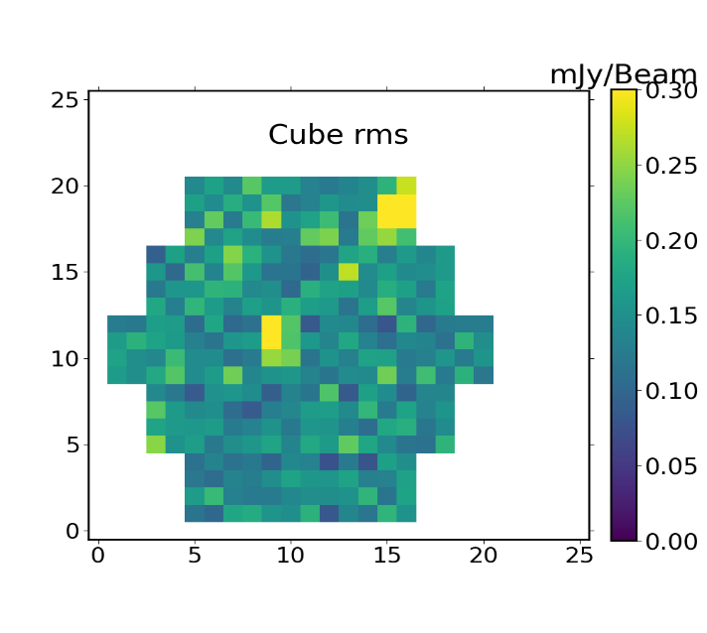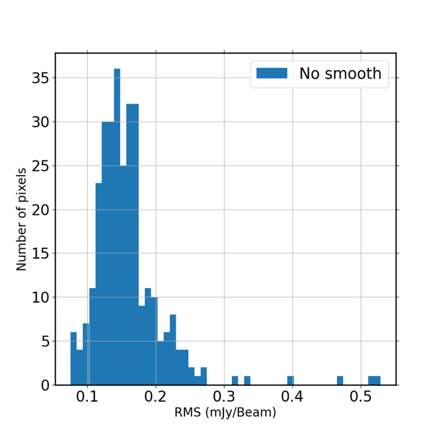
Extended Data Figure 2 | Spectral RMS noise of individual sky pixels. Left: The false color image of the rms noise at different sky pixels. Right: Histogram of the distribution of the rms noise.

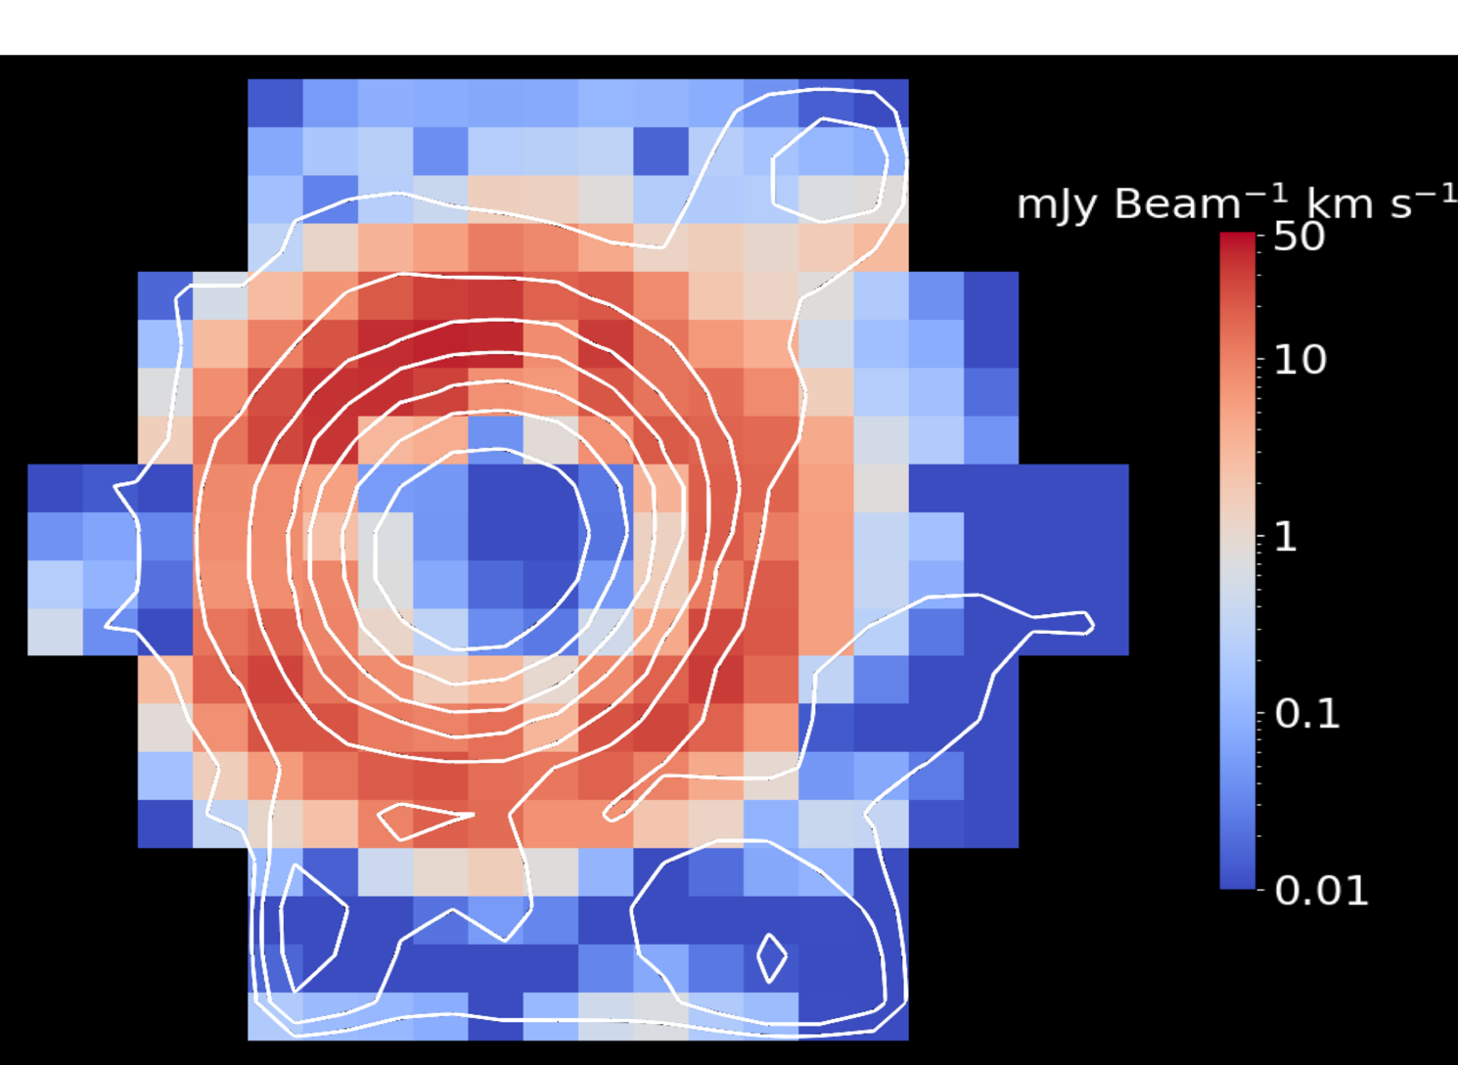
Extended Data Figure 3 | Sidelobe contribution to the integrated HI emission in the velocity range of 6550 – 6750 km s⁻¹. False color image of the sidelobe contribution overlaid by the contour map of integrated HI emission in the velocity range of 6550 – 6750 km s⁻¹ (before the sidelobe correction and after the convolution by a Gaussian kernel of FWHM=2’.8). The contours start from 20 mJy km s⁻¹ beam⁻¹ (corresponding to N_{HI} =7.4 × 10¹⁷ cm⁻² for the original beam of FWHM = 2’.9) with an increment of a factor of 2.

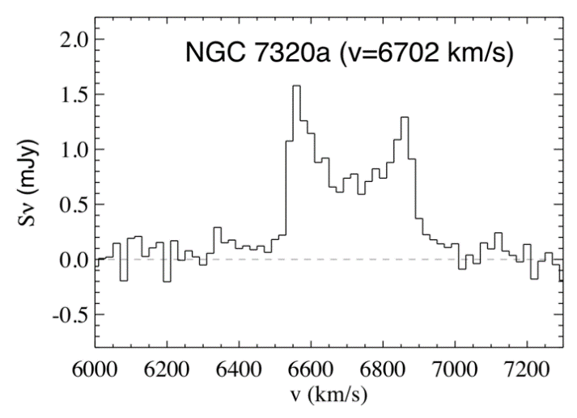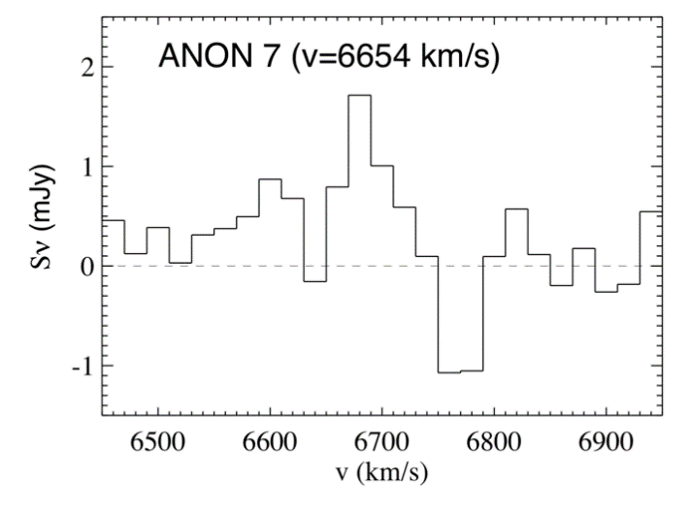

Extended Data Figure 4 | HI spectra of NGC 7320a and Anon 7. HI spectra of two newly detected HI sources (NGC 7320a and Anon 7) in the SQ neighborhood.

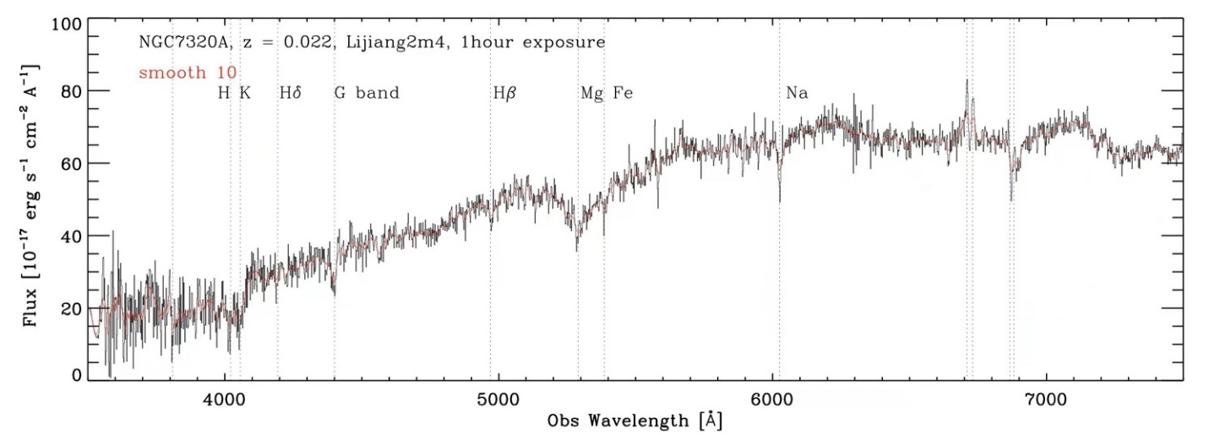
Extended Data Figure 5 | Optical spectrum of NGC 7320a. Optical spectrum of NGC 7320a obtained at Lijiang 2.4 meter telescope.

Extended Data Table 1 | FAST Observations

Obs. | date | t_{total} ª (secs) | R.A. ^{b} (2000J) | Decl. ^{b} (2000J) | cent freq. (MHz) | ON-OFF cycles | t_{on} ^{c} (secs)
Pointing 1 ^{d} | 2021-09-09 | 5580 | 22:35:43.37 | +33:59:20.6 | 1391.64 | 6 | 1800
Pointing 2 ^{d} | 2021-09-14 | 5580 | 22:35:50.39 | +33:59:20.6 | 1391.64 | 6 | 1800
Pointing 3 ^{d} | 2021-09-11 | 5580 | 22:35:57.31 | +33:59:20.6 | 1391.64 | 6 | 1800
Pointing 4 ^{d} | 2021-09-13 | 5580 | 22:36:04.23 | +33:59:20.6 | 1391.64 | 6 | 1800
Pointing 5 | 2021-09-15 | 4860 | 22:35:43.37 | +33:58:06.1 | 1391.64 | 6 | 1800
Pointing 6 | 2021-09-18 | 4860 | 22:35:50.39 | +33:58:06.1 | 1391.64 | 6 | 1800
Pointing 7 | 2021-09-20 | 4860 | 22:35:57.31 | +33:58:06.1 | 1391.64 | 6 | 1800
Pointing 8 | 2021-09-24 | 4860 | 22:36:04.23 | +33:58:06.1 | 1391.64 | 6 | 1800
Pointing 9 | 2021-09-26 | 4860 | 22:35:43.37 | +33:56:51.5 | 1391.64 | 6 | 1800
Pointing 10 | 2021-09-27 | 4860 | 22:35:50.39 | +33:56:51.5 | 1391.64 | 6 | 1800
Pointing 11 | 2021-09-29 | 4860 | 22:35:57.31 | +33:56:51.5 | 1391.64 | 6 | 1800
Pointing 12 | 2021-09-28 | 4860 | 22:36:04.23 | +33:56:51.5 | 1391.64 | 6 | 1800
Pointing 13 | 2021-09-30 | 4860 | 22:35:43.37 | +33:55:36.9 | 1391.64 | 6 | 1800
Pointing 14 | 2021-10-03 | 4860 | 22:35:50.39 | +33:55:36.9 | 1391.64 | 6 | 1800
Pointing 15 | 2021-10-01 | 4860 | 22:35:57.31 | +33:55:36.9 | 1391.64 | 6 | 1800
Pointing 16 | 2021-10-05 | 4860 | 22:36:04.23 | +33:55:36.9 | 1391.64 | 6 | 1800
a: Total observation time including all overheads.
b: Coordinates of the pointing position of the central beam M01.
c: Total on-target time.
d: These earlier observations have higher overheads than the later observations.

Extended Data Table 2 | Properties of beams in the 19-beam receiver

Beam  ID | half-power size ª  [arcmin] | gain factor ^{b}  (Jy/K) | rms ^{c}  (mJy beam⁻¹) | δ rms ^{d}  (mJy beam⁻¹)
M01 | 2.8335 | 16.0128 | 0.18 | 0.07
M02 | 2.8635 | 15.0520 | 0.14 | 0.03
M03 | 2.8535 | 15.5324 | 0.13 | 0.02
M04 | 2.8780 | 15.2122 | 0.16 | 0.04
M05 | 2.8480 | 15.6638 | 0.15 | 0.04
M06 | 2.9680 | 15.0520 | 0.16 | 0.04
M07 | 2.8690 | 14.9207 | 0.16 | 0.04
M08 | 2.9090 | 14.3089 | 0.17 | 0.03
M09 | 2.8935 | 14.3089 | 0.16 | 0.04
M10 | 2.9590 | 15.2409 | 0.14 | 0.03
M11 | 2.9290 | 14.6004 | 0.14 | 0.03
M12 | 2.9590 | 14.2802 | 0.15 | 0.03
M13 | 2.9190 | 15.2409 | 0.14 | 0.03
M14 | 2.9635 | 14.6004 | 0.14 | 0.03
M15 | 2.8990 | 13.9599 | 0.16 | 0.02
M16 | 2.9790 | 13.3194 | 0.26 | 0.14
M17 | 2.9290 | 13.8285 | 0.17 | 0.05
M18 | 2.9545 | 13.7710 | 0.17 | 0.04
M19 | 2.9190 | 14.2802 | 0.15 | 0.03
a: Half-power beam size at 1391 MHz.
b: Gain factor at 1391 MHz.
c: Mean rms of the 16 spectra (bin-width of 20 km s⁻¹) obtained with a given beam.
d: Standard deviation of the rms.

Extended Data Table 3 | Two new HI sources in the SQ neighborhood

Source ID | R.A. (2000J) | Decl. (2000J) | v_{HI}  (km s⁻¹) | Δv₂₀  (km s⁻¹) | M_{HI}  (10⁸ M⨀)
NGC 7320a | 22:36:32.2 | +33:47:46 | 6702 ± 24 | 360 | 6.3 ± 0.2
Anon 7 | 22:35:19.3 | +34:08:00 | 6654 ± 16 | 160 | 2.2 ± 0.5

