Supplementary information
~
Can polygenic-informed EEG biomarkers predict differential antidepressant treatment response? An EEG stratification marker for rTMS and sertraline

Hannah Meijs^{1,2,3,4}, Bochao Lin^{1,6}, Guido van Wingen³, Evian Gordon⁷, Damiaan Denys³, Bieke De Wilde⁸, Jan Van Hecke⁸, Peter Niemegeers⁸, Kristel van Eijk^{1,6}, Jurjen J. Luykx^{1,2,6#} & Martijn Arns^{3,4,5#}
Affiliations:
¹ Department of Psychiatry, University Medical Center Utrecht Brain Center, Utrecht University, Utrecht, The Netherlands
² GGNet Mental Health, Warnsveld, The Netherlands
³ Department of Psychiatry, Amsterdam UMC, University of Amsterdam, Location AMC, Amsterdam Neuroscience, The Netherlands
⁴ Research Institute Brainclinics, Brainclinics Foundation, Nijmegen, The Netherlands
⁵ Department of Cognitive Neuroscience, Faculty of Psychology and Neuroscience, Maastricht University, Maastricht, The Netherlands
⁶ Department of Translational Neuroscience, University Medical Center Utrecht Brain Center, Utrecht University, Utrecht, The Netherlands
⁷ Brain Resource Center, New York, USA
⁸ Department of Psychiatry, Ziekenhuis Netwerk Antwerpen (ZNA), Antwerp, Belgium

Running head: Genetics informed EEG biomarker

# Shared supervision
* Correspondence to:
Martijn Arns, PhD
Brainclinics Foundation
Bijleveldsingel 32
6524 AD Nijmegen
The Netherlands
Tel: +31 24 7503505
E-mail: martijn@brainclinics.com

SI Guide

Summary: This file contains all supplementary information to provide more detailed information of the results presented in the manuscript text which is needed to properly understand the study and to support our main conclusions. The supplementary information is arranged in order of occurrence in the manuscript text. In total 5 supplementary tables and 2 supplementary figures are included.

Index:
- QC steps page 2
- PRS model fit page 3
- SNP analysis page 4
- Network visualization page 5
- Sensitivity analyses page 6
- Correlation analysis
- Discriminant analysis
- TMS protocol interaction analysis
- Simulation page 7
QC steps
Of the 1,123 participants, PRS-MDD association analysis was performed using the data of 722 participants remaining after EEG pre-processing. See Supplementary Table 1 for all quality control (QC) steps and participants remaining after each step.

Supplementary Table 1 QC steps of genotype data
Quality control stepsª | Subjects |  | SNPs
Quality control stepsª | Batch 1 | Batch 2 | Batch 1 | Batch 2
Data available for QC genotyping | 537 | 350 | 686,082 | 692,319
Pre-imputation steps (separate batches)
Individuals >0.05 missing genotypes | -4 | -0
Creating SNP superset | 533 | 350 | 686,082 | 692,319
Genotype rate <0.01, MAF <0.1, HWE <1×10⁻⁴, LD pruning (50 5 0.2) |  |  | -545,698 | -530,759
Perform subject-level QC with SNP superset | 533 | 350 | 140,384 | 161,560
Sex check, heterozygosity (≥3 SD), relatedness, pi-hat >0.1, genetic outliers (≥3 SD) | -20 | -62
Normal SNP QC | 513 | 288 | 686,082 | 692,319
Genotype rate <0.01, MAF <0.01, HWE <1×10⁻⁵ |  |  | -227,781 | -197,418
Compare with HapMap | 513 | 288 | 458,301 | 494,901
Removal of genetic outliers (≥3 SD) from HapMap-CEU | -1 | -18
Retained after pre-imputation QC | 512 | 270 | 458,301 | 494,901
Post-imputation steps (merged batches)
Imputed total |  |  | 16,271,699
QC (MAF <0.05, LD R² ≥0.8) |  |  | -11,059,999
FINAL post-imputation TOTAL | 762^{b} |  | 5,211,700
Abbreviations: QC=quality control; SD=standard deviation; SNP=single nucleotide polymorphism; MAF=minor allele frequency; HWE=Hardy-Weinberg equilibrium; LD=linkage disequilibrium; PC=principal component; HapMap=haplotype map; GSA = global screening array.
ª ‘-’ is referring to excluded in this QC step.
^{b} 762 individuals retained after post-imputation QC, of those 40 were excluded after EEG preprocessing.

PRS model fit
After EEG preprocessing, PRSs of MDD were available for 722 participants (N=386 male; N=336 female). One significant association was found (adding age and the first five genetic-ancestry PCs as covariates to the model) with independent component 13 in women only; the PRS model fit is represented in Supplementary Figure 1. A significant p-value (α=0.001) is reached for the most stringent P_{T} – which yielded an R² of 3.3% (P_{T}=5×10⁻⁸; 47 SNPs; p<0.001) – and the explained variance rapidly decreases as the P_{T} becomes more lenient, suggesting the functional brain network found here has genetic underpinnings based on few variants.

Supplementary Figure 1 PRS model fit
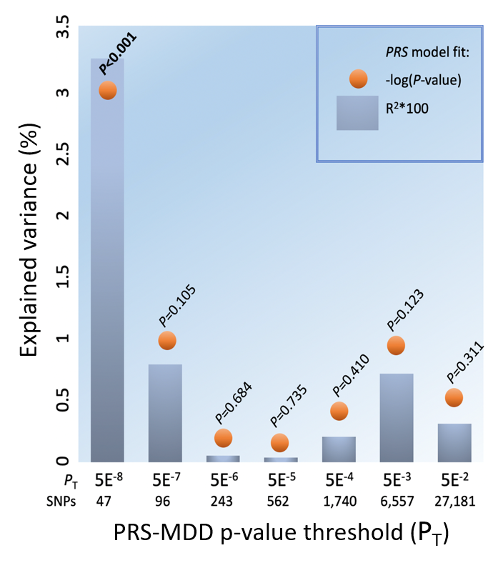
The explained variance (R² as %) of the individual loading on independent component 13 by PRS-MDD (polygenic risk score of major depressive disorder; grey bar) and the corresponding p-value (presented as -log; orange dot) per p-value threshold (P_{T}), in women only.

SNP analysis
Component loadings were compared across three groups, i.e. homozygote for reference allele (group 0), heterozygote for the variant (group 1), and homozygote for the variant (group 2), for the 47 SNPs that were included in the PRS-MDD P_{T}=5×10⁻⁸. Statistical differences were calculated using ANCOVA (covariates: age and five PCs) and post-hoc tests, man and women separately. Significant differences at p<0.05 were found for five SNPs (results are outlined in Supplementary Table 2).

For one variant on SGIP1 (rs6656912) loadings per group were in opposite direction in men compared to women, and post-hoc analysis revealed that homozygotes groups (group 0 versus 2) were significantly different in both men (Cohen’s d, d=-0.435; p=0.007) and women (d=0.310; p=0.041).

Supplementary Table 2 SNP statistical analysis
 | Men |  |  |  |  |  |  | Women
 | ANCOVA p-value | 0 | 1 | 2 | Post-hoc  p-value |  | d | ANCOVA p-value | 0 | 1 | 2 | Post-hoc  p-value |  | d
1:67083671:T:C_T  (rs6656912) | 0.006 | m=328 | m=634 | m=829 | 0 vs 1 | 0.008 | -0.276 | 0.12 | m=591 | m=475 | m=209 | 0 vs 1 | 0.50 | 0.100
1:67083671:T:C_T  (rs6656912) | 0.006 | N=138 | N=203 | N=45 | 0 vs 2 | 0.007 | -0.435 | 0.12 | N=114 | N=164 | N=58 | 0 vs 2 | 0.041 | 0.310
6:66534041:G:T_T  (rs68170059) | 0.71 | m=510 | m=482 | m=592 | 0 vs 1 | 0.43 | 0.096 | 0.004 | m=297 | m=715 | m=308 | 0 vs 1 | 0.001 | -0.354
6:66534041:G:T_T  (rs68170059) | 0.71 | N=206 | N=154 | N=26 | 0 vs 2 | 0.93 | -0.001 | 0.004 | N=177 | N=137 | N=22 | 0 vs 2 | 0.89 | -0.010
9:11155055:G:T_T  (rs72694269) | 0.88 | m=555 | m=500 | m=834 | 0 vs 1 | 0.75 | 0.050 | 0.017 | m=408 | m=674 | m=3215 | 0 vs 1 | 0.08 | -0.226
9:11155055:G:T_T  (rs72694269) | 0.88 | N=307 | N=75 | N=4 | 0 vs 2 | 0.72 | -0.220 | 0.017 | N=269 | N=66 | N=1 | 0 vs 2 | 0.022 | -
9:11423966:T:C_C  (rs56072039) | 0.045 | m=443 | m=742 | m=412 | 0 vs 1 | 0.017 | -0.270 | 0.21 | m=410 | m=535 | m=891 | 0 vs 1 | 0.27 | -0.109
9:11423966:T:C_C  (rs56072039) | 0.045 | N=229 | N=137 | N=20 | 0 vs 2 | 0.78 | 0.027 | 0.21 | N=214 | N=110 | N=12 | 0 vs 2 | 0.13 | -0.388
11:113365084:C:T_C  (rs4936275) | 0.021 | m=711 | m=481 | m=312 | 0 vs 1 | 0.040 | 0.210 | 0.80 | m=474 | m=437 | m=555 | 0 vs 1 | 0.65 | 0.031
11:113365084:C:T_C  (rs4936275) | 0.021 | N=152 | N=179 | N=55 | 0 vs 2 | 0.012 | 0.342 | 0.80 | N=154 | N=141 | N=41 | 0 vs 2 | 0.75 | -0.074
Abbreviations: 0=no minor alleles, 2 reference alleles; 1=1 minor allele, 1 reference allele (heterozygote variant); 2=2 minor alleles (homozygote variant); d=Cohen’s d; N=number of participants per group; m=component loadings group mean.

Network visualization
The networks of the component that was associated with PRS-MDD in women is shown in Supplementary Figure 2 and represents correlated brain activity (thresholded at 3 z-values) seen at:
- the prefrontal cortex (Brodmann area [BA] 6 and 8 to 10), left-sided alpha power activity (more laterally) is accompanied by right-sided delta and theta activation (more anteriorly);
- the occipital cortex (BA 17 to 19), there is a notable right-left asymmetry (i.e. negative correlation), inversely for alpha and theta power, whereas delta activity is diffusely activated/deactivated;
- a large area surrounding the left lateral sulcus including parts of the parietal (somatosensory cortex, BA 1 to 3; supramarginal gyrus, BA 40), temporal (Wernicke’s area, BA 22), and frontal (motor cortex, BA 4 and 6; Broca’s area, BA 44) lobe, only delta power activity.

In summary, the areas that are predominantly involved in this functional network are the prefrontal, somatosensory-motor, visual and auditory cortex, here referred to as the prefrontal and sensorimotor (PF-SM) network.

Supplementary Figure 2 Functional networks of the component associated with PRS-MDD in women
Delta | 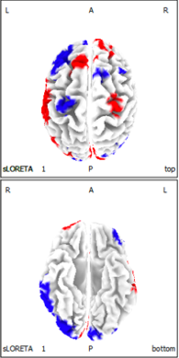 | 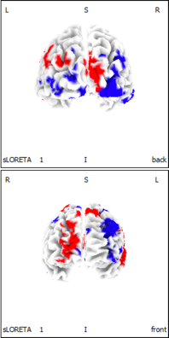 | 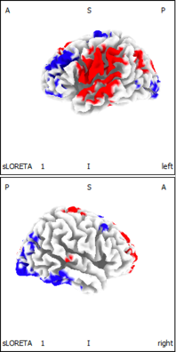 | 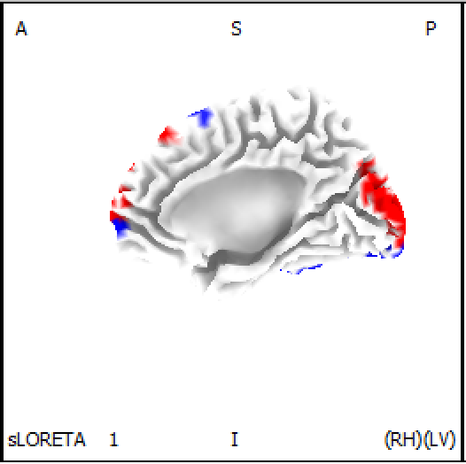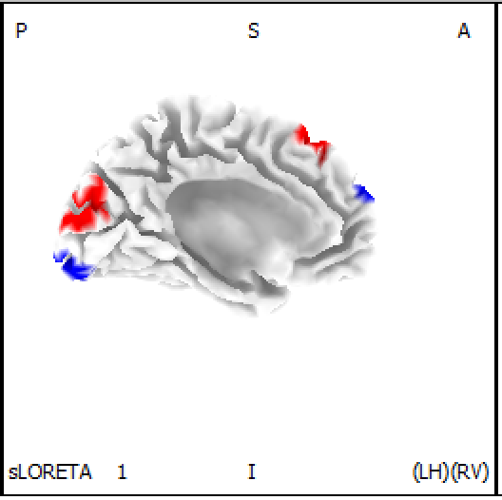
Theta | 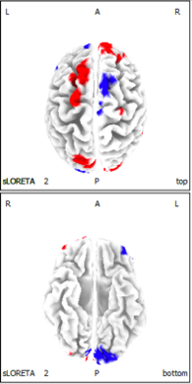 | 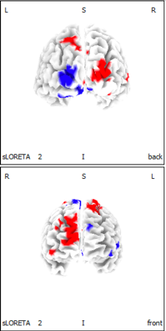 | 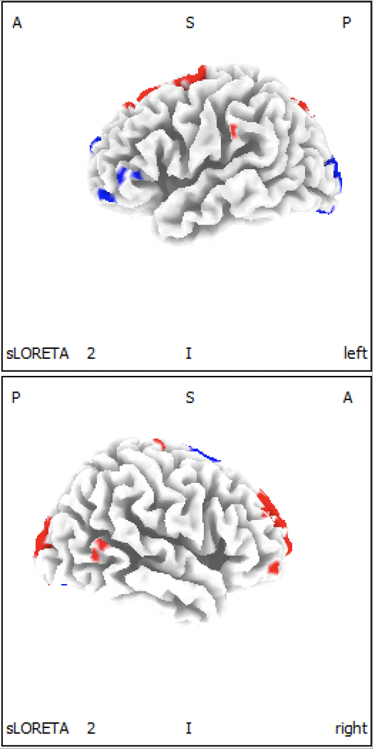 | 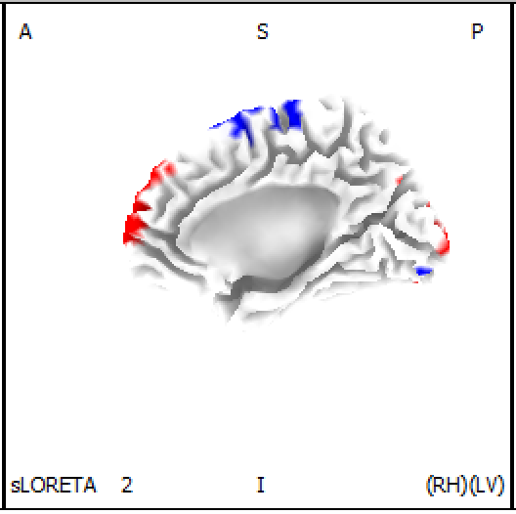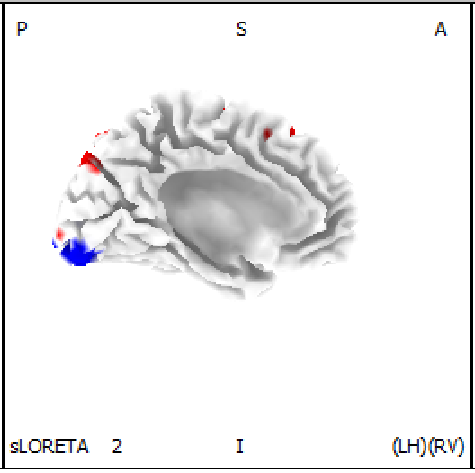
Alpha | 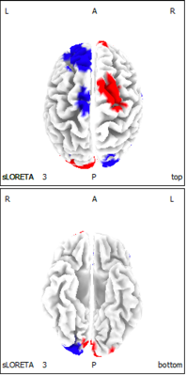 | 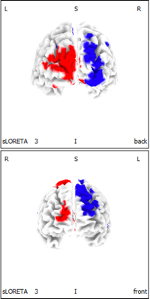 | 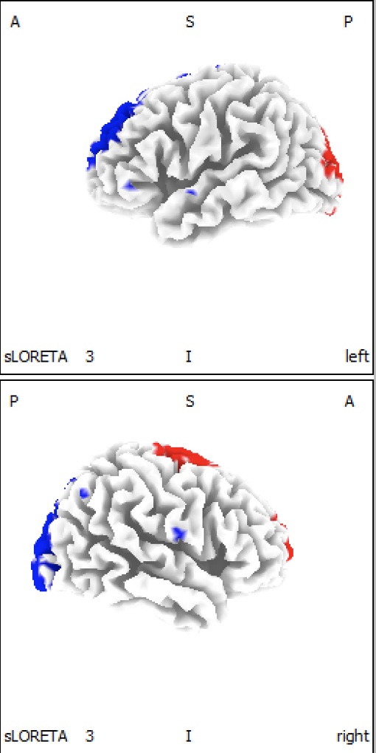 | 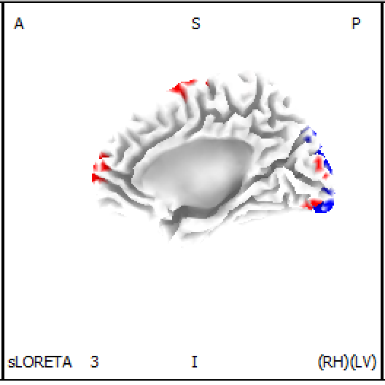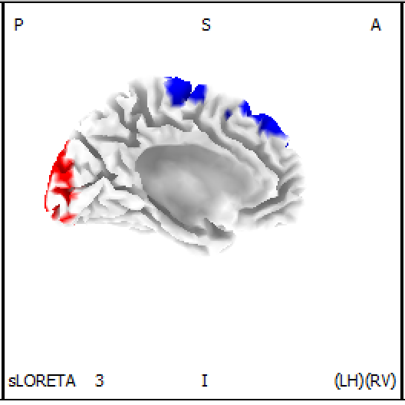
Colored map of the EEG network obtained in this study using LORETA-ICA (independent component 13) where the colors represent jointly power activation or deactivation (i.e. correlation, z-value ≥3) of brain regions with increasing loading value.

Correlation analysis (sensitivity)
Pearson correlation analyses within the rTMS and sertraline treatment group showed no significant correlations at p<0.01 with the obtained LORETA-ICA component and several baseline characteristics (Supplementary Table 3), including frontal alpha asymmetry (FAA) scores, obtained in a previous iSPOT-D study by Arns et al, 2016. Correlation analyses – within the sertraline iSPOT-D group – between the component and QIDS change yielded no difference in effect size (of absolute nor relative change) when FAA with 1) eyes open or 2) eyes closed were added as covariate (Supplementary Table 4). This indicates the effect on treatment outcome is not (solely) attributable to frontal asymmetry part of the component.

Supplementary Table 3 Correlation between the LORETA-ICA component and baseline characteristics
Baseline characteristic | Effect size of Pearson correlation with independent component
Baseline characteristic | Women TMS | Men TMS | Women/men sertraline
Age | r=0.035 (p>0.05) | r=-0.069 (p>0.05) | r=-0.038 (p>0.05)
BDI-II/QIDS | r=0.056 (p>0.05) | r=-0.086 (p>0.05) | r=0.060 (p>0.05)
DASS-depression | r=0.088 (p>0.05) | r=-0.058 (p>0.05) | N/A
DASS-anxiety | r=0.210 (p=0.047) | r=0.121 (p>0.05) | r=0.046 (p=0.047)
DASS-stress | r=0.054 (p>0.05) | r=0.069 (p>0.05) | N/A
Years of education | r=-0.043 (p>0.05) | r=-0.163 (p>0.05) | r=0.085 (p>0.05)
FAA (eyes closed) | N/A | N/A | r=0.022 (p>0.05)
FAA (eyes open) | N/A | N/A | r=0.088 (p>0.05)
Abbreviations: BDI-II=Beck Depression Inventory, second edition; QIDS=Quick Inventory of Depressive Symptomatology; DASS=Depression Anxiety Stress Scales; FAA=Frontal Alpha Asymmetry; TMS=transcranial magnetic stimulation; N/A=data for analysis not available.

Supplementary Table 4 Correlation analysis adding FAA as covariate
QIDS change | Effect size of Pearson correlation with independent component within sertraline group
QIDS change | Without covariates | FAA eyes closed as covariate | FAA eyes open as covariate
Absolute change | r=0.180 (p=0.015) | r=0.180 (p=0.015) | r=0.183 (p=0.017)
Relative change | r=0.182 (p=0.014) | r=0.183 (p=0.014) | r=0.186 (p=0.015)
Abbreviations: QIDS=Quick Inventory of Depressive Symptomatology; FAA=Frontal Alpha Asymmetry.

Discriminant analysis (sensitivity)
Including the component loading as the only predictor in the model yielded the following results:
- model predicting rTMS response: Wilk’s Lambda=0.919, Chi-Square=7.639, p=0.006 (men);
- model predicting rTMS remission: Wilk’s Lambda=0.955, Chi-Square=4.193, p=0.041 (women) and Wilk’s Lambda=0.953, Chi-Square=4.361, p=0.037 (men);
- model predicting sertraline response: Wilk’s Lambda=0.977, Chi-Square=4.250, p=0.039 (women and men).

TMS protocol interaction analysis (sensitivity)
ANCOVA with response, sex and rTMS protocol as fixed factors, and age and as covariate yielded a significant response x sex interaction (p=0.004; F(1,177)=8.753). Repeating the analysis for men and women separately without sex as fixed factor resulted in a main effect of response (p=0.001; F(1,88)=12.967) and response x protocol interaction (p=0.027; F(1,88)=5.071) in men only. Running this analysis in men for both protocols separately and without rTMS protocol as fixed factor yielded a main effect for protocol 1 only (p=0.004; F(1,34)=9.752; d=0.963).

ANCOVA with remission and sex as fixed factors, and age and baseline BDI-II score as covariates yielded a significant remission x sex interaction (p=0.001; F(1,176)=10.430), but no significant interactions with rTMS protocol.

Simulation
The results of the simulation using a component (PF-SM network) loading of 0 as cut-off are shown below (Supplementary Table 5). The blue cells represent the percentages responders and remitters in the full sample (i.e. no stratification); the green cells the improved outcome if only the patients with PF-SM loading >0 or <0 would have been assigned to treatment (i.e. stratification): rTMS 10 Hz left dorsolateral prefrontal cortex (DLPFC) or 1 Hz right DLPFC, or sertraline. The darker green and blue cells represent a subgroup of only patients treated with 10 Hz rTMS.

Results of this simulation were as follows: if only men with loading >0 PF-SM would have been assigned to rTMS the remission rate would have improved from 55% to 69% (26% relative improvement). If only men with loading <0 PF-SM would have been assigned to rTMS the improvement would have been from 56% to 62% for remission and from 61% to 68% in men for response (11% relative improvement). The improvement was largest for 10 Hz rTMS: from 58% to 75% in women and from 59% to 70% in men for remission and from 68% to 80% in men for response (relative improvement of 29% and 18% in women and men, respectively). If men/women with loading >0 PF-SM would have been assigned to sertraline, the response and remission rates would have improved from 53% to 69% and from 35% to 46% in men and women (relative improvements of 30% and 34%), respectively. Lastly, if only women with loading <0 would have been assigned to escitalopram or venlafaxine, this would have led to only small improvements rates (4% for response and 5% for remission). This however, is clinically relevant, since this patient group would have responded less to both rTMS and sertraline and therefore not first-choice treatments.

Supplementary Table 5 Percentages responders and remitters for stratification versus no stratification
 | Component loading | TMS ♀ |  | TMS ♂ |  | SER  ♀+♂ | ESC/VEN  ♀
 | Component loading | 1 or 10 Hz | only 10 Hz | 1 or 10 Hz | only 10 Hz | SER  ♀+♂ | ESC/VEN  ♀
Response | >0 | 76 | 75 | 53 | 53 | 69 | 45
Response | <0 | 67 | 65 | 68 | 80 | 46 | 50
Response | Full sample | 71 | 69 | 61 | 68 | 53 | 48
Remission | >0 | 69 | 75 | 47 | 47 | 46 | 33
Remission | <0 | 43 | 45 | 62 | 70 | 30 | 38
Remission | Full sample | 55 | 58 | 56 | 59 | 35 | 36
Abbreviation: TMS=transcranial magnetic stimulation. SER=sertraline; ESC=escitalopram; VEN=venlafaxine.

