Appendix A
Supplementary Figure 1. The selection process.
Supplementary Figure 2. KEGG pathway enrichment analysis and pathway map for LN.

Supplementary Figure 3. The distribution of 22 immune cells in 155 tissues. Pink indicates higher immune infiltration expression, and red indicates lower expression.
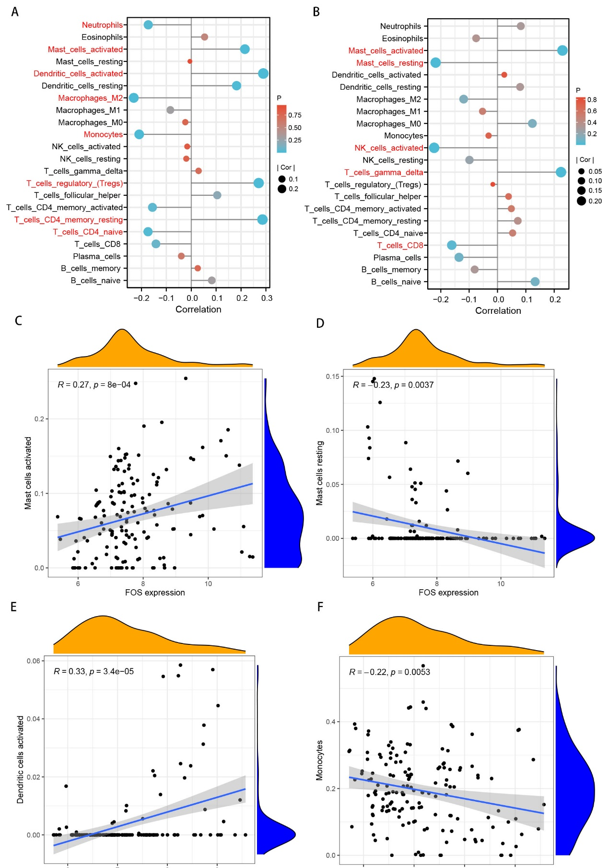
Supplementary Figure 4. Correlation between biomarkers and immune cells in LN. a. Correlation between FOS and 22 immune cells; b. Correlation between IGF1 and 22 immune cells; c. Correlation between FOS and activated mast cells; d. Correlation between FOS and resting mast cells; e. Correlation between IGF1 and activated dendritic cells; f. Correlation between IGF1 and monocytes.

Appendix B
Supplementary Table1.Top 10 hub genes from five centrality methods
No. | Bottleneck | Stress | MNC | Radiality | Betweenness
1 | ALB | ALB | ALB | ALB | ALB
2 | FOS | EGF | EGF | EGF | EGF
3 | IGF1 | FOS | FOS | FOS | FOS
4 | KNG1 | IGF1 | IGF1 | IGF1 | IGF1
5 | AGT | KNG1 | KNG1 | KNG1 | KNG1
6 | SDC1 | EGR1 | MYC | MYC | G6PC
7 | FAH | G6PC | EGR1 | AGT | CTLA4
8 | GAD2 | CTLA4 | AGT | PLG | SDC1
9 | UMOD | SDC1 | FABP1 | REN | GAD2
10 | C1QB | GAD2 | PLG | G6PC | UMOD

