Supplementary figure 1. A model system integrating the role of Notch/Wnt signaling in trophoblast stemness and extravillous trophoblast differentiation³⁶. vCTB: villous cytotrophoblast including intravillous cytotrophobrlasts (CYT1, CYT2, and CYT3); CCT: cell column trophoblast; EVT: extravillous trophoblast; N1^{ICD}: Notch1 intracellular domain; TEAD4: Transcriptional enhancer factor TEF-3 gene; p63: Tumor protein p63; TCF1: transcription factor T cell factor 1; TCF4: transcription factor T cell factor 4; IRF6: interferon regulatory factor 6; Notch 2: Notch Receptor 2.

Supplementary figure 2. Examples of apparent variants sites represented as deviations from the reference genome sequence. Cell 1 and Cell 2: part of mapped read sequences in single cells Cell 1 and Cell 2, respectively; T/T: A homozygous site in Cell 1; C/T: A heterozygous site in Cell 2. In this step, we simply select any sites deviated from homologous sites of the reference genome (in this case, the homologous site is ‘C’).

Supplementary figure 3. Percentage of coverage of transcriptome data mapped on the reference genome (GRCh38). Axis of abscissas: the percentage of coverage in the reference genome; single-cell transcriptome data sampled from two pregnant women. Red bars indicate cells that were classified in a putatively discrepant manner (Figure 4 and Figure 5).

Supplementary figure 4. A pipeline for the single-cell somatic mutational pattern analysis. FASTQ⁵⁸, BAM⁴, and VCF⁵⁹ files are generated for each single cell.

Supplementary Table 1. Estimated variant types using SnpEff software⁵¹ (SRP090944 data; Batch1, 54 cells)

Type |  |  |  | Region
Type (alphabetical order) | Count | Percent |  | Type (alphabetical order) | Count | Percent
3_prime_UTR_variant | 1,214 | 16.18% |  | DOWNSTREAM | 557 | 7.43%
5_prime_UTR_premature_start_codon_gain_variant | 6 | 0.08% |  | EXON | 991 | 13.22%
5_prime_UTR_variant | 62 | 0.83% |  | INTERGENIC | 281 | 3.75%
downstream_gene_variant | 557 | 7.43% |  | INTRON | 3,901 | 52.04%
intergenic_region | 281 | 3.75% |  | SPLICE_SITE_ACCEPTOR | 2 | 0.03%
intron_variant | 3,905 | 52.05% |  | SPLICE_SITE_REGION | 16 | 0.21%
missense_variant | 550 | 7.33% |  | UPSTREAM | 466 | 6.22%
non_coding_transcript_exon_variant | 193 | 2.57% |  | UTR_3_PRIME | 1,214 | 16.20%
splice_acceptor_variant | 2 | 0.03% |  | UTR_5_PRIME | 68 | 0.91%
splice_region_variant | 16 | 0.21%
start_lost | 6 | 0.08%
stop_gained | 45 | 0.60%
synonymous_variant | 199 | 2.65%
upstream_gene_variant | 466 | 6.21%
Note. Variant counts are not exclusive for each category.

Supplementary Table 2. Estimated variant types using SnpEff software⁵¹ (SRP090944 data; Batch2, 33 cells)

Type |  |  |  |  | Region
Type (alphabetical order) |  | Count | Percent |  | Type (alphabetical order) | Count | Percent
3_prime_UTR_variant |  | 886 | 15.89% |  | DOWNSTREAM | 515 | 9.26%
5_prime_UTR_premature_start_codon_gain_variant |  | 2 | 0.04% |  | EXON | 455 | 8.19%
5_prime_UTR_variant |  | 77 | 1.38% |  | INTERGENIC | 253 | 4.55%
downstream_gene_variant |  | 515 | 9.24% |  | INTRON | 2,968 | 53.39%
intergenic_region |  | 253 | 4.54% |  | SPLICE_SITE_DONOR | 12 | 0.22%
intron_variant |  | 2,980 | 53.45% |  | SPLICE_SITE_REGION | 32 | 0.58%
missense_variant |  | 216 | 3.87% |  | UPSTREAM | 359 | 6.46%
non_coding_transcript_exon_variant |  | 84 | 1.51% |  | UTR_3_PRIME | 886 | 15.94%
splice_donor_variant |  | 12 | 0.22% |  | UTR_5_PRIME | 79 | 1.42%
splice_region_variant |  | 32 | 0.57%
stop_gained |  | 24 | 0.43%
synonymous_variant |  | 135 | 2.42%
upstream_gene_variant |  | 359 | 6.44%
Note. Variant counts are not exclusive for each category.

Supplementary Table 3. Relationships between single cell ID (Batch 1), Batch cell ID, and GSM ID
Single cell ID | Batch cell ID | GSM
SRR4371525 | B1_Cell_1 | GSM2339239
SRR4371527 | B1_Cell_2 | GSM2339240
SRR4371529 | B1_Cell_3 | GSM2339241
SRR4371530 | B1_Cell_4 | GSM2339242
SRR4371531 | B1_Cell_5 | GSM2339243
SRR4371532 | B1_Cell_6 | GSM2339244
SRR4371533 | B1_Cell_7 | GSM2339245
SRR4371534 | B1_Cell_8 | GSM2339246
SRR4371535 | B1_Cell_9 | GSM2339247
SRR4371536 | B1_Cell_10 | GSM2339248
SRR4371537 | B1_Cell_11 | GSM2339249
SRR4371538 | B1_Cell_12 | GSM2339250
SRR4371539 | B1_Cell_13 | GSM2339251
SRR4371540 | B1_Cell_14 | GSM2339252
SRR4371541 | B1_Cell_15 | GSM2339253
SRR4371542 | B1_Cell_16 | GSM2339254
SRR4371543 | B1_Cell_17 | GSM2339255
SRR4371544 | B1_Cell_18 | GSM2339256
SRR4371545 | B1_Cell_19 | GSM2339257
SRR4371546 | B1_Cell_20 | GSM2339258
SRR4371547 | B1_Cell_21 | GSM2339259
SRR4371548 | B1_Cell_22 | GSM2339260
SRR4371549 | B1_Cell_23 | GSM2339261
SRR4371550 | B1_Cell_24 | GSM2339262
SRR4371551 | B1_Cell_25 | GSM2339263
SRR4371552 | B1_Cell_26 | GSM2339264
SRR4371553 | B1_Cell_27 | GSM2339265
SRR4371554 | B1_Cell_28 | GSM2339266
SRR4371555 | B1_Cell_29 | GSM2339267
SRR4371556 | B1_Cell_30 | GSM2339268
SRR4371557 | B1_Cell_31 | GSM2339269
SRR4371558 | B1_Cell_32 | GSM2339270
SRR4371559 | B1_Cell_33 | GSM2339272
SRR4371560 | B1_Cell_34 | GSM2339275
SRR4371561 | B1_Cell_35 | GSM2339277
SRR4371562 | B1_Cell_36 | GSM2339280
SRR4371563 | B1_Cell_37 | GSM2339281
SRR4371564 | B1_Cell_38 | GSM2339282
SRR4371565 | B1_Cell_39 | GSM2339283
SRR4371566 | B1_Cell_40 | GSM2339284
SRR4371567 | B1_Cell_41 | GSM2339285
SRR4371568 | B1_Cell_42 | GSM2339286
SRR4371569 | B1_Cell_43 | GSM2339287
SRR4371570 | B1_Cell_44 | GSM2339288
SRR4371571 | B1_Cell_45 | GSM2339289
SRR4371572 | B1_Cell_46 | GSM2339290
SRR4371573 | B1_Cell_47 | GSM2339291
SRR4371574 | B1_Cell_48 | GSM2339292
SRR4371575 | B1_Cell_49 | GSM2339293
SRR4371576 | B1_Cell_50 | GSM2339294
SRR4371577 | B1_Cell_51 | GSM2339295
SRR4371578 | B1_Cell_52 | GSM2339296
SRR4371579 | B1_Cell_53 | GSM2339297
SRR4371580 | B1_Cell_54 | GSM2339298
Note. Batch cell IDs are used to identify the corresponding cluster numbers.

Supplementary Table 4. Relationships between single cell ID (Batch 2), Batch cell ID, and GSM ID
Single cell ID | Batch cell ID | GSM
SRR4371581 | B2_Cell_1 | GSM2339299
SRR4371582 | B2_Cell_2 | GSM2339300
SRR4371583 | B2_Cell_3 | GSM2339301
SRR4371584 | B2_Cell_4 | GSM2339302
SRR4371585 | B2_Cell_5 | GSM2339303
SRR4371586 | B2_Cell_6 | GSM2339304
SRR4371587 | B2_Cell_7 | GSM2339305
SRR4371588 | B2_Cell_8 | GSM2339306
SRR4371589 | B2_Cell_9 | GSM2339307
SRR4371590 | B2_Cell_10 | GSM2339308
SRR4371591 | B2_Cell_11 | GSM2339309
SRR4371592 | B2_Cell_12 | GSM2339310
SRR4371593 | B2_Cell_13 | GSM2339311
SRR4371594 | B2_Cell_14 | GSM2339312
SRR4371595 | B2_Cell_15 | GSM2339313
SRR4371596 | B2_Cell_16 | GSM2339314
SRR4371597 | B2_Cell_17 | GSM2339315
SRR4371598 | B2_Cell_18 | GSM2339316
SRR4371599 | B2_Cell_19 | GSM2339317
SRR4371600 | B2_Cell_20 | GSM2339318
SRR4371601 | B2_Cell_21 | GSM2339319
SRR4371602 | B2_Cell_22 | GSM2339320
SRR4371603 | B2_Cell_23 | GSM2339321
SRR4371604 | B2_Cell_24 | GSM2339322
SRR4371605 | B2_Cell_25 | GSM2339323
SRR4371606 | B2_Cell_26 | GSM2339324
SRR4371607 | B2_Cell_27 | GSM2339325
SRR4371608 | B2_Cell_28 | GSM2339326
SRR4371609 | B2_Cell_29 | GSM2339327
SRR4371610 | B2_Cell_30 | GSM2339328
SRR4371611 | B2_Cell_31 | GSM2339329
SRR4371612 | B2_Cell_32 | GSM2339330
SRR4371613 | B2_Cell_33 | GSM2339331
Note. Batch cell IDs are used to identify the corresponding cluster numbers.

Supplementary figure 1
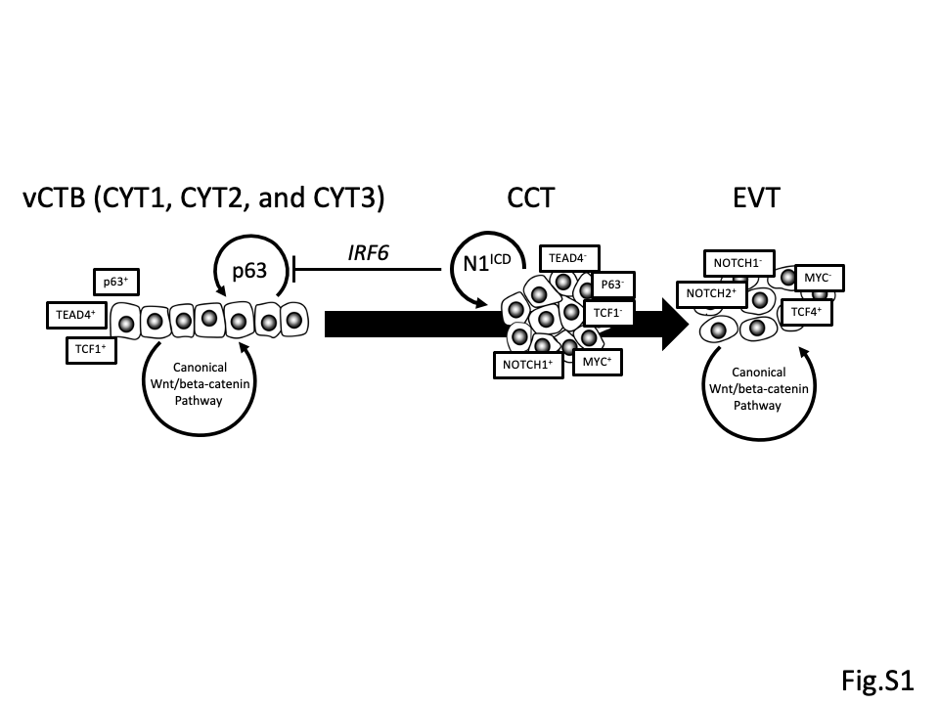

Supplementary figure 2
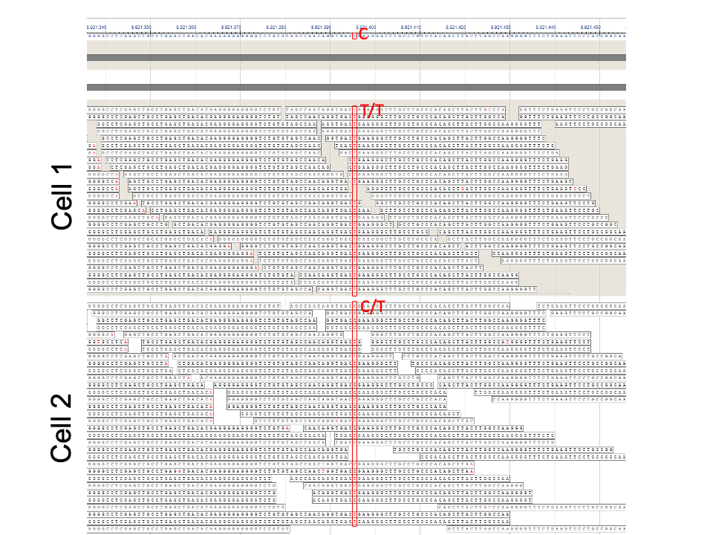

Supplementary figure 3
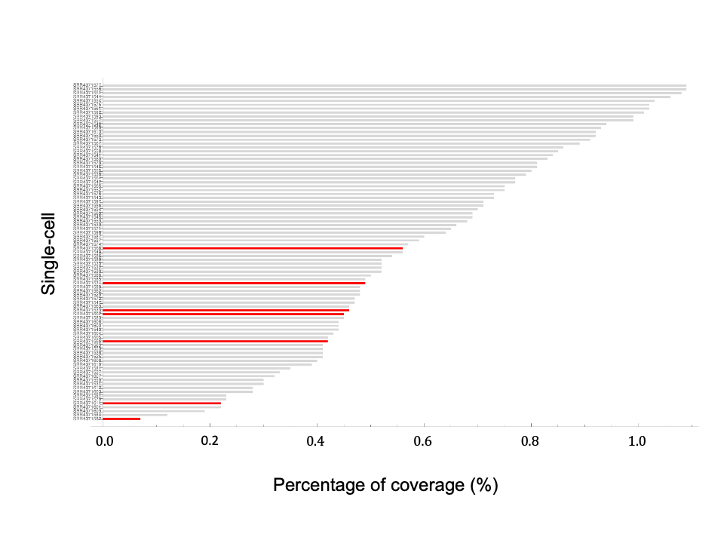
Supplementary figure 4
