Appendix S1 – ROE DEER SAMPLE POPULATIONS
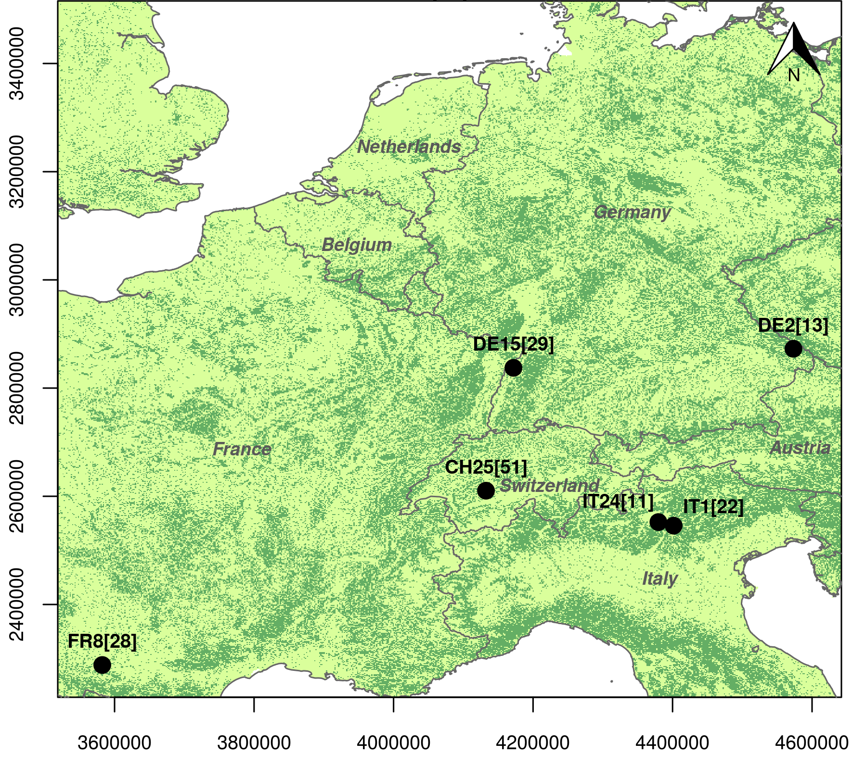
Figure S1.1 Distribution of roe deer populations considered in this study. The map includes the code and number of individuals per population, plotted on the reclassified Tree Cover Density raster layer (TCD, EEA 2012; dark and light green are respectively closed and open habitat). IT1 and IT24 are located in Eastern Italian Alps; CH25 in Bernese Oberland; DE15 in the Rhine Valley in Baden-Württemberg; DE2 in the Bavarian Forest National Park; FR8 in Aurignac countryside, near Toulouse. For the landscape characteristics of the study areas, see Table S1.1.

Table S1.1 Description of the six populations, number of animals (females/males), sequences, proportion of open and closed edge per hectare and proportion of closed habitat.
Population |  | Description | Animals (f/m) | Sequences | Open-Closed edge | Forest proportion
Southern France | FR8 | Fragmented agricultural open landscape | 28 (14/14) | 492 | 0.10 – 0.06 | 0.28
Switzerland | CH25 | Fragmented pastoral mountainous landscape | 51 (34/17) | 1498 | 0.12 – 0.10 | 0.32
Southern Germany | DE15 | Fragmented agricultural open landscape | 29 (20/9) | 841 | 0.08 – 0.06 | 0.30
Southeast Germany | DE2 | Forest landscape | 13 (6/7) | 264 | 0.10 – 0.12 | 0.70
Northern Italy 1  (Mount Bondone) | IT1 | Forest landscape with large high elevation pastures | 22 (13/9) | 495 | 0.09 – 0.12 | 0.77
Northern Italy 2  (Rendena Valley) | IT24 | Forest landscape | 11 (8/3) | 310 | 0.07 – 0.10 | 0.81

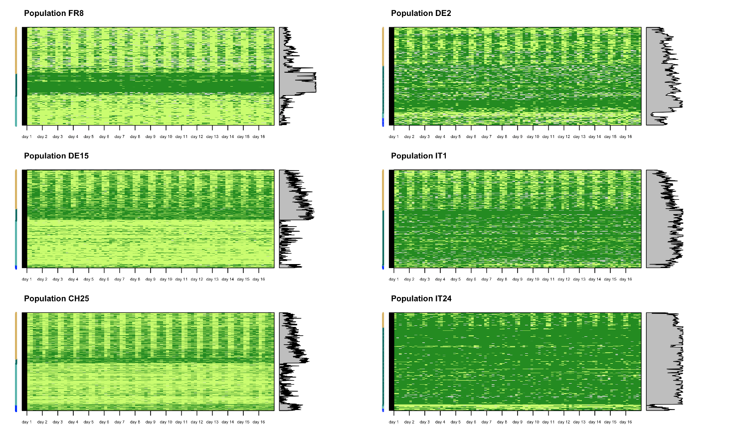
Figure S1.2 The IM-SAM classification of the roe deer habitat use sequences (dark green, closed habitat; light green, open habitat) in the four sequential habitat use patterns: daily alternation (light brown on the side colored-bar), homogeneous closed (dark green), homogeneous open (turquoise) and random (blue), for the six studied populations. Aligned on the right: proportion of closed habitat for each sequence.

Table S1.2 Contingency table for age and sex, where age is dynamic for animals with multiple monitoring years.
age | sex |  | frequency
adult |  | female | 83
 |  | male | 49
fawn |  | female | 22
 |  | male | 22

Appendix S2 – MODEL SELECTION PROCEDURE
Table S2.1. Generalized additive mixed model selection procedure (selected models in bold and black) for variation in day-night habitat alternation (0/1, binomial) as a function of the spline of the biweek, population (P2.1) and individual-based traits (sex * age: P2.2-P2.3) fitted as fixed factors, ordered factors (indicated with “o”) or as factors of the spline. The summary includes the Akaike’s selection criterion, the delta and the adjusted R-squared for each model. Models are ordered according to AIC-score. Based on the previous analysis, and to account for pseudo-replication, all models include individual identity as a random effect on the intercept.
s(biweek * population) | s(biweek) | population | AIC | Delta | R-squared
x | x | x | 3777.702 | 0.000 | 0.371
x |  | x | 3777.711 | 0.009 | 0.371
x | x |  | 3923.698 | 145.996 | 0.331
 | x |  | 3923.705 | 146.003 | 0.331
 |  | x | 3998.860 | 221.158 | 0.313
 |  |  | 3998.863 | 221.161 | 0.313

s(biweek * sex:age) | s(biweek) | sex * age | population | AIC | Delta | R-squared
o | x | o | x | 3837.873 | 0 | 0.352
o | x | o |  | 3837.880 | 0.007 | 0.352
x |  | x | x | 3850.414 | 12.541 | 0.352
x |  | x |  | 3850.418 | 12.545 | 0.352
x | x |  |  | 3850.418 | 12.545 | 0.351
 | x |  |  | 3923.705 | 85.832 | 0.331
 |  | x |  | 3995.075 | 157.202 | 0.314
 |  |  |  | 3998.863 | 160.990 | 0.313

Appendix S3. ANODEV PROCEDURE (proportion of the biweekly variation in habitat alternation accounted for by NDVI) AND NDVI MODEL SELECTION
Table S3.1. Results of the ANODEV procedure to model the proportion of the temporal variation in habitat alternation (P_{WMT}) that is accounted for by the biweekly value of NDVI.
model | loglik | P_{WMT}
alternation ~ population | -1849.215 | 0.440
alternation ~ s(ndvi, bs=“cr”,by = population) + population | -1763.044
alternation ~ factor(biweek) * population | -1653.281

Table S3.2. Generalized additive mixed model selection procedure for NDVI as a function of the spline of the biweek and population fitted as a single factors, or the spline of the interaction between biweek and population. The summary includes the Akaike’s selection criterion, the delta and the adjusted R-squared for each model. Models are ordered according to AIC-score. Based on the previous analysis, and to account for pseudo-replication, all models include individual identity as a random effect on the intercept.
s(biweek * population) | s(biweek) | population | AIC | Delta | R-squared
x |  |  | -14768.966 | 0.000 | 0.971
 | x | x | -7014.520 | 7754.446 | 0.779
 | x |  | -6906.507 | 7862.459 | 0.781
 |  | x | -1759.225 | 13009.740 | 0.149
 |  |  | -1644.724 | 13124.242 | 0.150

