Supplementary Material

Cerebrospinal fluid p-tau231 as an early indicator of emerging pathology in Alzheimer’s disease
Nicholas J. Ashton^{1, 2, 3, 4*,} Andréa L. Benedet^{1,5*,} Tharick A. Pascoal⁵, Thomas K. Karikari¹, Juan Lantero Rodriguez¹, Sulantha Mathotaarachchi⁵, Joseph Therriault⁵, Melissa Savard⁵, Mira Chamoun⁵, Erik Stoops⁶, Cindy Francois⁶, Eugeen Vanmechelen⁶, Serge Gauthier^{7, 8}, Eduardo R. Zimmer^{9,10}, Henrik Zetterberg^{1, 11, 12, 113}, Kaj Blennow^{1, 11†,} Pedro Rosa-Neto^{8, 14†}

¹Department of Psychiatry and Neurochemistry, Institute of Neuroscience & Physiology, the Sahlgrenska Academy at the University of Gothenburg, Mölndal, Sweden; ²Wallenberg Centre for Molecular and Translational Medicine, University of Gothenburg, Gothenburg, Sweden; ³King’s College London, Institute of Psychiatry, Psychology and Neuroscience, Maurice Wohl Institute Clinical Neuroscience Institute, London, UK; ⁴NIHR Biomedical Research Centre for Mental Health and Biomedical Research Unit for Dementia at South London and Maudsley NHS Foundation, London, UK; ⁵Translational Neuroimaging Laboratory, McGill Centre for Studies in Aging, McGill University, Montreal, QC, Canada; ⁶ADx NeuroSciences, Technologiepark 94, 9052 Ghent, Belgium; ⁷McGill University Research Centre for Studies in Aging, Douglas Research Institute, Le Centre intégré universitaire de santé et de services sociaux (CIUSSS) de l'Ouest-de-l'Île-de-Montréal; ⁸Department of Neurology and Neurosurgery, Psychiatry and Pharmacology and Therapeutics, McGill University, Montreal, Canada; ⁹Department of Pharmacology, Universidade Federal do Rio Grande do Sul (UFRGS), Porto Alegre, Brazil; ¹⁰Graduate Program in Biological Sciences: Biochemistry; and Pharmacology and Therapeutcis, UFRGS, Porto Alegre, RS, Brazil; ¹¹Clinical Neurochemistry Laboratory, Sahlgrenska University Hospital, Mölndal, Sweden; ¹²Department of Neurodegenerative Disease, UCL Institute of Neurology, Queen Square, London, UK; ¹³UK Dementia Research Institute at UCL, London, UK; ¹⁴Montreal Neurological Institute, Montreal, QC, Canada;

Corresponding author:
Pedro Rosa-Neto, MD, PhD
Director of the McGill University Research Centre for Studies in Aging
Department of Neurology and Neurosurgery, Faculty of Medicine
McGill University, Montreal, QC, Canada
Tel: +1 (514)761-6131
Email: pedro.rosa@mcgill.ca

* First authors contributed equally
† Senior authors contributed equally

Supplementary figures
Fig. S1. Biomarker correlations
Fig. S2. Amyloid status predictivity.

Supplementary tables
Table S1. Demographics of the Translational Biomarkers in Aging and Dementia (TRIAD) cohort
Table S2. ROC analysis of CSF p-tau for distinguishing diagnostic groups without PET status
Table S5. Correlations between CSF biomarkers and [¹⁸F]MK6240

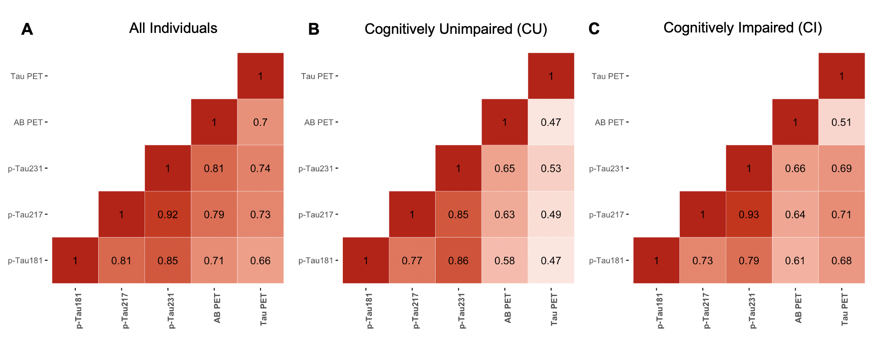

Supplementary Figure 1. Biomarker correlations. Heatmaps show the Spearman correlation values of the correlations between CSF and PET biomarkers in all subjects (A), within cognitively unimpaired group (B) and within cognitively impaired group (C).

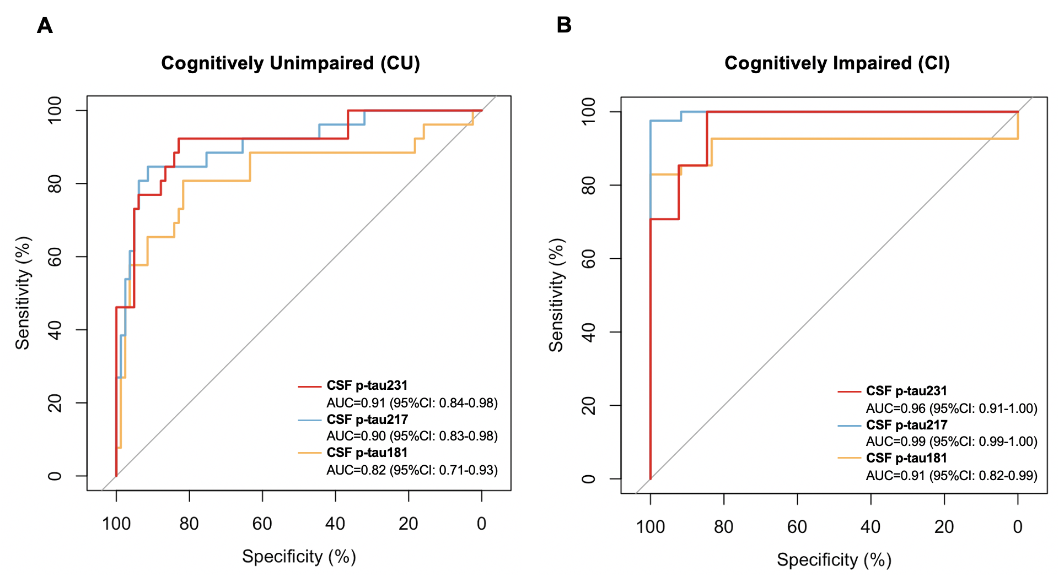

Supplementary Figure 2. Amyloid status predictivity. The accuracy of CSF biomarkers in distinguishing Aβ PET status (positive vs negative) is evidenced by ROC curves and the AUCs as shown in (A) for cognitively unimpaired subjects and (B) for cognitively impaired subjects.

Supplementary Table 1. Demographics

 | Young (n = 27) | CU Aβ- (n = 56) | CU Aβ+ (n = 26) | MCI Aβ+ (n = 20) | AD (n = 21) | Non-AD (n = 21)
Females | 16 (59) | 35 (62) | 17 (65) | 9 (45) | 9 (42) | 11 (52)
Age (yr) | 23.34 (1.90)*** | 70.97 (7.30) | 72.20 (7.54) | 72.17 (5.99) | 63.77 (7.36)*** | 67.24 (9.91)***
Education (yr) | 16.72 (1.53) | 15.00 (3.57) | 14.42 (2.70) | 15.68 (2.90) | 15.19 (3.10) | 14.04 (3.77)
APOE-ε4 carriers | 6 (22) | 17 (30) | 8 (30) | 13 (65)* | 14 (70)** | 4 (19)
MMSE | 29.77 (0.50)* | 29.19 (0.99) | 29.23 (0.86) | 28.00 (1.83) | 19.85 (6.08)*** | 26.76 (4.29)***
Aβ PET SUVR | 1.16 (0.08) | 1.26 (0.10) | 1.96 (0.42)*** | 2.39 (0.41)*** | 2.37 (0.44)*** | 1.25 (0.13)
Tau PET SUVR | 0.82 (0.08)* | 0.90 (0.10) | 1.00 (0.15) | 1.54 (0.45)*** | 2.18 (0.59)*** | 0.85 (0.13)
p-tau231 (pg/mL) | 6.57 (1.48) | 9.75 (3.43) | 22.14 (17.67)*** | 31.64 (14.09)*** | 36.88 (24.22)*** | 9.64 (4.19)
p-tau217 (pg/mL) | 3.10 (1.72) | 5.09 (3.11) | 15.64 (17.63)*** | 24.29 (10.21)*** | 29.17 (21.40)*** | 5.04 (2.30)
p-tau181 (pg/mL) | 108.26 (46.86) | 242.50 (123.54) | 404.70 (213.81)** | 675.07 (462.83)*** | 931.32 (529.73)*** | 219.96 (91.13)
Data are mean (SD) or n (%); MMSE Mini-Mental State Examination.
*P values were calculated comparing groups against CU Aβ- subjects using linear regression models for continuous variables and Chi-square tests for categorical variables.
*P<0.05; **P<0.01; ***P<0.001.

Supplementary Table 2. ROC analysis of CSF p-tau for distinguishing diagnostic groups without PET status

 | CU vs CI | CU vs AD | CU vs MCI | non-AD vs MCI | non-AD vs AD
P-tau231 | 0.83ª  (0.77-0.90) | 0.93ª  (0.89-0.97) | 0.93  (0.89-0.98) | 0.98  (0.95-1.00) | 0.97  (0.94-1.00)
P-tau217 | 0.85ª  (0.79-0.91) | 0.95  (0.91-0.98) | 0.94  (0.91-0.98) | 0.99  (0.98-1) | 1.00  (1.00-1.00)
P-tau181 | 0.82  (0.74-0.90) | 0.97  (0.95-0.99) | 0.81  (0.66-0.96) | 0.83  (0.67-0.99) | 0.99  (0.99-1.00)
AD, Alzheimer’s disease; CI, cognitively impaired; CU, cognitively unimpaired; MCI, mild cognitive impairment; ROC, Receiver Operating Characteristic
ª Significantly different from p-tau181 (P_{adjusted}<0.05).

