Supplementary material of the manuscript

Accelerated Carbonates Dissolution Caused by Anthropogenic Acidification - Contrast of Watershed Soils to Lake Sediments in Taihu Region, China
Yu Tao¹∗, Jia Binyang², Wang Rui¹, Deng Yixiang³, Cheng Zhonghua¹, Zhuo Xiaoke¹, He Chengda¹
- College of Environmental Sciences and Engineering, Yangzhou University, Yangzhou 225217, China
- Chengdu Operation Center for Environmental Emergencies, Chengdu 610041, China
- Chinese Research Academy of Environmental Sciences, Beijing 100012, China

This file includes 2 figures and 1 table.

Figure S1 Sampled carbonate areas in this study
Figure S2 pH contrast of carbonate soils from different land uses
Table S1 Soil pH from Paddy lands in Taihu watershed in 1980s and data source

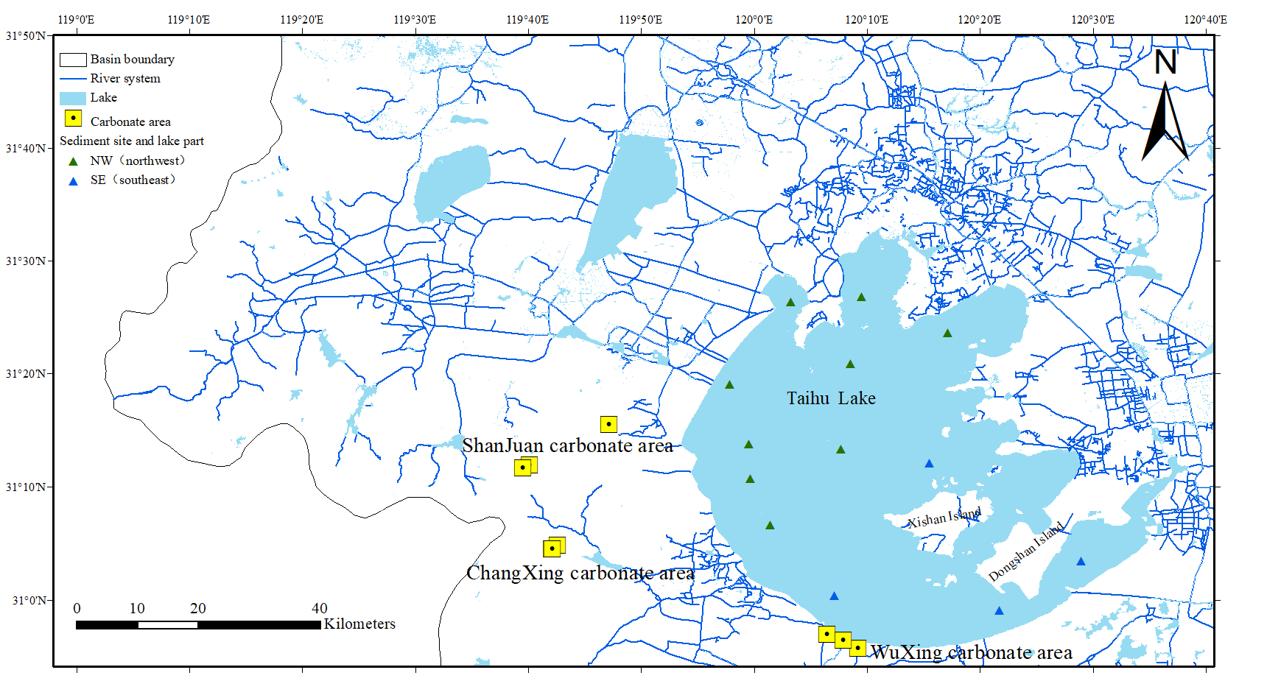

Figure S1 Sampled carbonate areas in this study (soils of land uses are shown in Figure 1 in the text. Xishan Island and nearby small islands in the lake are also carbonate areas)

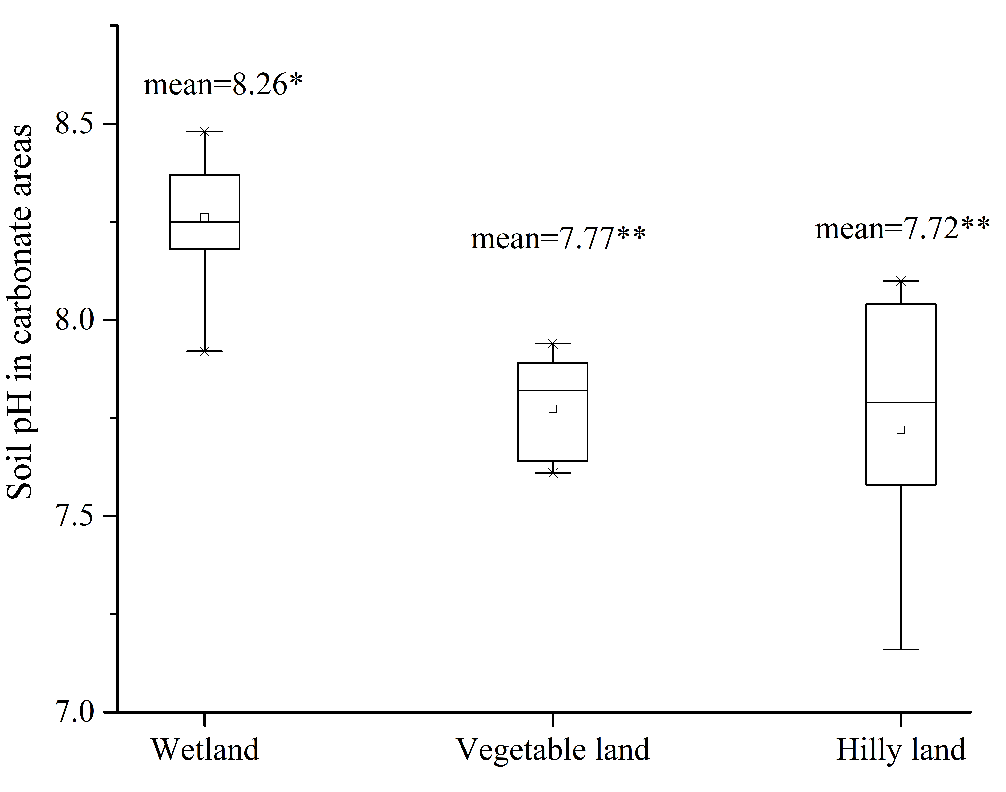
Figure S2 pH comparison of carbonate soils from different land uses (mean values with different asterisks indicate significant difference at p<0.01)

Table S1 Available soil pH from paddy lands in Taihu watershed in 1980s and data source (soil site were selected to fit our study area in this work)
年份 | pH | Source
1980 | 6.3 | Gao J.H., Hang D.M., Wu J.M., Pan Z.P. 1982. Study on nitrogen supply characteristics of yellow soil and white soil in Pingtian area, Taihu Region. Jiangsu Agricultural Sciences,7:33-38
1980 | 6.8 | Gao J.H., Hang D.M., Wu J.M., Pan Z.P. 1982. Study on nitrogen supply characteristics of yellow soil and white soil in Pingtian area, Taihu Region. Jiangsu Agricultural Sciences,7:33-38
1980 | 6.7 | Xiao W.W., Fan X. H., Yang L.Z., Shen M.X. 2008. Effects of long-term fertilization on soil organic nitrogen forms and organic carbon in paddy soil in the Tai Lake Region in China. Soils, 40(1):93-99
1982 | 6.59 | Cheng J.M., Pan G.X., Zheng J.W. 2001. Factors affecting pH and availability of heavy metals in paddy soils in Taihu Lake Area. Agro-environmental Protection, 20(3):141-144
1987 | 5.6 | Zhan Y. 2003. Effects of the long-term fertilization practices on the carbon, nitrogen and phosphorus pools and their mobility [D]. Nanjing Agricultural University.
1987 | 6 | Zhan Y. 2003. Effects of the long-term fertilization practices on the carbon, nitrogen and phosphorus pools and their mobility [D]. Nanjing Agricultural University.
1987 | 7.8 | Zhang J.Q., Wang Y.G., Bang J.H., Zhang M.Z. 1987. The relation between the organic matter and pH in soil and the heavy metal of soil in Tai Lake Valley. Acta Agriculturae Shanghai, 3(3):31-38
1987 | 6.8 | Zhang J.Q., Wang Y.G., Bang J.H., Zhang M.Z. 1987. The relation between the organic matter and pH in soil and the heavy metal of soil in Tai Lake Valley. Acta Agriculturae Shanghai, 3(3):31-38
1987 | 7.3 | Zhang J.Q., Wang Y.G., Bang J.H., Zhang M.Z. 1987. The relation between the organic matter and pH in soil and the heavy metal of soil in Tai Lake Valley. Acta Agriculturae Shanghai, 3(3):31-38
1987 | 7.9 | Zhang J.Q., Wang Y.G., Bang J.H., Zhang M.Z. 1987. The relation between the organic matter and pH in soil and the heavy metal of soil in Tai Lake Valley. Acta Agriculturae Shanghai, 3(3):31-38
1987 | 7.3 | Zhang J.Q., Wang Y.G., Bang J.H., Zhang M.Z. 1987. The relation between the organic matter and pH in soil and the heavy metal of soil in Tai Lake Valley. Acta Agriculturae Shanghai, 3(3):31-38
1987 | 6.9 | Zhang J.Q., Wang Y.G., Bang J.H., Zhang M.Z. 1987. The relation between the organic matter and pH in soil and the heavy metal of soil in Tai Lake Valley. Acta Agriculturae Shanghai, 3(3):31-38

∗ Corresponding author: yutao0325@sina.com

