SUPPLEMENTAL MATERIALS
Supplemental Table S1. Descriptive details about data sources of sleep duration and atherosclerosis(AS)
Supplemental Table S2. Summary statistics for the genetic variants associated with sleep duration and AS
Supplemental Table S3. Variances explained by the selected instruments and power calculations for the Mendelian randomization (MR) analysis among European populations
Supplemental Table S4. The result of sensitivity analyses by F statistic and Weighted median，MR-Egger Test for sleep duration
Supplemental Figure S1. Forest plots of SNPs associated with sleep duration and atherosclerosis(AS)
Supplemental Figure S2. Scatter plots of SNPs associated with sleep duration and atherosclerosis(AS)
Supplemental Figure S3. Funnel plots of SNPs associated with sleep duration and atherosclerosis(AS)
Supplemental Figure S4. Leave-one-out plots of SNPs associated with sleep duration and atherosclerosis(AS)
Exposure or outcome | First author (year) | Participants (Sample size) | Web source
Sleep duration | Ben Elsworth (2018) | 460,099individuals of European ancestries | MRC-IEU. 2018
AS | Neale lab (2018) | 14,334 AS cases and 346,860 controls of European ancestries | UK Biobank(Binary).2018
Supplemental Table S1. Descriptive details about data sources of sleep duration and AS
Abbreviations: AS: atherosclerosis.

Supplemental Table S2. Summary statistics for the genetic variants associated with sleep duration and atherosclerosis (AS)
SNP | Chr | Pos | EA | OA | EAF | Sleep duration |  |  | Number of individuals involved | AS
 |  |  |  |  |  | Beta | SE | P-value | Number of individuals involved | Beta | SE | P-value
rs10510128 | 10 | 1.25E+08 | A | G | 0.207951 | 0.0114031 | 0.001974 | 7.70E-09 | 377,234 | -9.73E-05 | 0.00056 | 0.862116
rs11039216 | 11 | 47406592 | T | C | 0.532944 | -0.010277 | 0.001604 | 1.50E-10 | 377,234 | -2.24E-05 | 0.000453 | 0.960529
rs112100783 | 10 | 70541193 | A | G | 0.033439 | -0.025295 | 0.004549 | 2.70E-08 | 377,234 | -0.000888 | 0.001283 | 0.48878
rs113113059 | 6 | 43160375 | C | T | 0.219834 | -0.011128 | 0.001933 | 8.60E-09 | 377,234 | 0.0002589 | 0.000545 | 0.634897
rs11621908 | 14 | 78495761 | T | C | 0.082807 | -0.019985 | 0.002943 | 1.10E-11 | 377,234 | -0.000194 | 0.00083 | 0.815292
rs11643715 | 16 | 23909538 | G | C | 0.292625 | 0.0109493 | 0.00176 | 5.00E-10 | 377,234 | -0.000318 | 0.000498 | 0.522581
rs11650677 | 17 | 11231513 | A | G | 0.339185 | 0.0111701 | 0.00169 | 3.80E-11 | 377,234 | 0.0009424 | 0.000477 | 0.048243
rs11982852 | 7 | 1.33E+08 | T | C | 0.243858 | -0.011726 | 0.001862 | 3.10E-10 | 377,234 | 0.0003114 | 0.000525 | 0.552962
rs12518468 | 5 | 7249696 | C | T | 0.328685 | -0.010644 | 0.001703 | 4.10E-10 | 377,234 | -0.000607 | 0.000481 | 0.206411
rs12567114 | 1 | 98527951 | A | G | 0.276368 | 0.0123378 | 0.001794 | 6.10E-12 | 377,234 | -0.000106 | 0.000507 | 0.833685
rs13107325 | 4 | 1.03E+08 | T | C | 0.074905 | -0.02427 | 0.003039 | 1.40E-15 | 377,234 | -0.000727 | 0.000859 | 0.397155
rs1348047 | 18 | 53050058 | T | G | 0.267253 | -0.012642 | 0.00182 | 3.80E-12 | 377,234 | -0.000245 | 0.000514 | 0.63375
rs151014368 | 5 | 1.77E+08 | A | G | 0.20734 | 0.0113794 | 0.001988 | 1.00E-08 | 377,234 | 0.000539 | 0.000563 | 0.33803
rs1517572 | 11 | 28829882 | C | A | 0.581256 | 0.0116589 | 0.001622 | 6.50E-13 | 377,234 | -0.000189 | 0.000457 | 0.680071
rs1553132 | 11 | 88297740 | G | A | 0.258638 | 0.0105257 | 0.001825 | 8.10E-09 | 377,234 | 0.000131 | 0.000515 | 0.799016
rs1611719 | 6 | 29829636 | A | G | 0.209698 | -0.013211 | 0.002027 | 7.10E-11 | 377,234 | -0.001048 | 0.000571 | 0.066254
rs17391944 | 9 | 36901494 | G | T | 0.04986 | 0.0218515 | 0.003724 | 4.40E-09 | 377,234 | 0.0002787 | 0.001047 | 0.790005
rs174564 | 11 | 61588305 | G | A | 0.348602 | 0.0097453 | 0.001678 | 6.30E-09 | 377,234 | -0.00013 | 0.000473 | 0.783235
rs1939455 | 11 | 1.02E+08 | T | G | 0.120291 | -0.0158 | 0.002517 | 3.50E-10 | 377,234 | 9.06E-05 | 0.000711 | 0.898685
rs1972712 | 2 | 1.67E+08 | C | T | 0.249455 | 0.011796 | 0.001848 | 1.70E-10 | 377,234 | -0.00033 | 0.000524 | 0.528739
rs2072727 | 20 | 43538733 | C | T | 0.56459 | -0.009269 | 0.001614 | 9.30E-09 | 377,234 | 7.46E-06 | 0.000455 | 0.986921
rs2079070 | 7 | 1.14E+08 | G | C | 0.734582 | -0.013436 | 0.001811 | 1.20E-13 | 377,234 | 0.0008987 | 0.000511 | 0.078924
rs2192528 | 4 | 18327896 | G | A | 0.522493 | -0.009807 | 0.001601 | 9.10E-10 | 377,234 | 0.0002217 | 0.000453 | 0.62442
rs2279681 | 1 | 2.02E+08 | G | C | 0.341785 | 0.0092985 | 0.001685 | 3.40E-08 | 377,234 | -0.000974 | 0.000476 | 0.040815
rs2683630 | 2 | 58058069 | G | C | 0.629076 | 0.0149506 | 0.001656 | 1.70E-19 | 377,234 | 0.0002776 | 0.000469 | 0.553905
rs2734831 | 11 | 1.13E+08 | G | T | 0.606881 | -0.009797 | 0.001639 | 2.20E-09 | 377,234 | -0.000389 | 0.000463 | 0.400054
rs2748809 | 14 | 99735233 | C | T | 0.429258 | -0.009253 | 0.001645 | 1.90E-08 | 377,234 | 0.0003932 | 0.000464 | 0.39703
rs2839753 | 4 | 82287250 | C | T | 0.265347 | -0.010637 | 0.001812 | 4.40E-09 | 377,234 | 0.0012151 | 0.000511 | 0.017474
rs34354917 | 12 | 38764559 | A | C | 0.288625 | -0.010021 | 0.001768 | 1.40E-08 | 377,234 | -0.000346 | 0.000499 | 0.48768
rs34556183 | 6 | 28584775 | G | A | 0.279888 | -0.013353 | 0.001782 | 6.60E-14 | 377,234 | -0.000105 | 0.000502 | 0.834071
rs34786000 | 19 | 9942123 | T | G | 0.553361 | 0.0109576 | 0.001628 | 1.70E-11 | 377,234 | -0.000416 | 0.000459 | 0.365255
rs35126035 | 19 | 34986767 | C | A | 0.55833 | -0.009196 | 0.001644 | 2.20E-08 | 377,234 | 6.58E-05 | 0.000464 | 0.887268
rs35662245 | 2 | 1.48E+08 | A | T | 0.338713 | 0.0101569 | 0.001691 | 1.90E-09 | 377,234 | -0.000677 | 0.000478 | 0.156459
rs365663 | 5 | 1428883 | G | A | 0.45495 | -0.009283 | 0.00161 | 8.10E-09 | 377,234 | 0.00029 | 0.000454 | 0.523306
rs374153 | 2 | 40382712 | T | C | 0.842567 | -0.0131 | 0.002197 | 2.50E-09 | 377,234 | 0.0003345 | 0.000619 | 0.588898
rs4767550 | 12 | 1.18E+08 | G | A | 0.413171 | 0.0108732 | 0.001633 | 2.70E-11 | 377,234 | 4.93E-05 | 0.00046 | 0.914701
rs55658675 | 14 | 65554638 | T | C | 0.352906 | -0.009695 | 0.001675 | 7.10E-09 | 377,234 | 0.0001172 | 0.000472 | 0.803732
rs56367859 | 16 | 6540795 | G | A | 0.397585 | 0.0116218 | 0.001636 | 1.20E-12 | 377,234 | -0.000741 | 0.000462 | 0.108141
rs62444917 | 7 | 2107262 | C | A | 0.222315 | 0.0129633 | 0.001926 | 1.70E-11 | 377,234 | -0.001062 | 0.000546 | 0.051797
rs6561715 | 13 | 53888526 | A | T | 0.630636 | 0.0097823 | 0.001661 | 3.90E-09 | 377,234 | -0.000809 | 0.000469 | 0.08461
rs6681755 | 1 | 71703970 | A | G | 0.199783 | 0.0115272 | 0.002005 | 9.00E-09 | 377,234 | -0.000126 | 0.000566 | 0.824349
rs6783516 | 3 | 1.79E+08 | T | G | 0.583817 | -0.009838 | 0.001631 | 1.60E-09 | 377,234 | -0.000176 | 0.000461 | 0.702826
rs6889592 | 5 | 1.02E+08 | A | G | 0.332608 | 0.0117662 | 0.001697 | 4.10E-12 | 377,234 | -0.000791 | 0.000478 | 0.09836
rs7016314 | 8 | 14043662 | C | T | 0.655927 | 0.0100011 | 0.001688 | 3.10E-09 | 377,234 | -4.19E-05 | 0.000476 | 0.929936
rs72771082 | 16 | 20023601 | G | A | 0.217832 | 0.0109737 | 0.001936 | 1.40E-08 | 377,234 | -0.000643 | 0.000546 | 0.239017
rs72831782 | 2 | 1.04E+08 | A | T | 0.269409 | -0.010181 | 0.001844 | 3.40E-08 | 377,234 | 0.0002237 | 0.00052 | 0.667119
rs7517981 | 1 | 31555056 | C | T | 0.601498 | -0.009966 | 0.001634 | 1.10E-09 | 377,234 | 0.0008242 | 0.000462 | 0.074333
rs75539574 | 2 | 58871658 | C | A | 0.085774 | 0.0236649 | 0.002874 | 1.80E-16 | 377,234 | 0.0006046 | 0.000811 | 0.455947
rs76258078 | 3 | 55823890 | G | A | 0.049994 | -0.021687 | 0.003681 | 3.80E-09 | 377,234 | 0.0008165 | 0.001028 | 0.427148
rs7644809 | 3 | 1.08E+08 | C | T | 0.576033 | -0.010152 | 0.001625 | 4.10E-10 | 377,234 | -8.35E-05 | 0.000459 | 0.855622
rs7711696 | 5 | 1.35E+08 | T | G | 0.304987 | -0.009867 | 0.001735 | 1.30E-08 | 377,234 | 0.0005075 | 0.00049 | 0.300432
rs7740402 | 6 | 1.31E+08 | G | T | 0.3061 | -0.009515 | 0.001735 | 4.10E-08 | 377,234 | -0.00072 | 0.00049 | 0.141835
rs8038326 | 15 | 47989799 | G | A | 0.273169 | -0.013384 | 0.001793 | 8.40E-14 | 377,234 | 0.0002932 | 0.000507 | 0.562722
rs8072993 | 17 | 21335709 | G | T | 0.635677 | 0.0109222 | 0.001992 | 4.20E-08 | 377,234 | -0.00024 | 0.000527 | 0.648597
rs8074498 | 17 | 79954544 | A | T | 0.580951 | -0.009328 | 0.001634 | 1.10E-08 | 377,234 | -0.000747 | 0.000461 | 0.105332
rs915416 | 1 | 34731984 | G | C | 0.70906 | -0.012728 | 0.00176 | 4.80E-13 | 377,234 | -0.000178 | 0.000498 | 0.720026
rs9302680 | 16 | 56269892 | A | G | 0.439272 | 0.0120438 | 0.001611 | 7.60E-14 | 377,234 | 4.93E-05 | 0.000454 | 0.913528
rs9345234 | 6 | 93162639 | C | A | 0.57786 | 0.0091922 | 0.001624 | 1.50E-08 | 377,234 | 0.0001177 | 0.000458 | 0.797248
rs9382445 | 6 | 54937974 | C | T | 0.375168 | -0.009484 | 0.001649 | 8.90E-09 | 377,234 | -0.000185 | 0.000465 | 0.690671
rs9611007 | 22 | 39077058 | T | C | 0.141673 | -0.013594 | 0.002297 | 3.30E-09 | 377,234 | -0.001866 | 0.000647 | 0.003952
rs9810474 | 3 | 74961196 | T | C | 0.232184 | -0.011155 | 0.001894 | 3.90E-09 | 377,234 | -5.28E-05 | 0.000534 | 0.921242
rs9903898 | 17 | 45575354 | T | C | 0.488883 | -0.009448 | 0.001601 | 3.60E-09 | 377,234 | 0.0017359 | 0.000452 | 0.000124

Note: According to Bonferroni correction, only P values lower than 5*10⁻⁸ were considered statistically significant. *Included SNPs: rs8072993 (proxy: rs8067316).
Abbreviations: SNP: single-nucleotide polymorphisms; Chr: chromosome; Pos: position; EA: effect allele; OA: other allele, EAF: effect allele frequency; SE: standard error.

Supplemental Table S3. Variances explained by the selected instruments and power calculations for the Mendelian randomization (MR) analysis among European populations
Trait | Variance explained (R², %) | AS GWAS Sample size | Ratio of cases to control | Odds ratio estimated for α¹
Sleep duration | 0.002 | 460，099 | 1：1.041 | 0.992
Note: ¹ Odds ratio estimated for α, the smallest effect detected by the sample size to provide 80% statistical power at an alpha level of 5%.

Supplemental Table S4. Results for MR-Egger (intercept), F statistic ,IVW,Weighted melian of sleep duration for atherosclerosis (AS).
Trait | MR-Egger Test |  |  | F | IVW |  |  |  | Weighted melian
Trait | Intercept | SE | P-value | F | OR | CI | P-value |  | OR | CI |  | P-value | P-value
Sleep duration | -0.001 | 0.001 | 0.071 | 15.671 | 0.992 | 0.979-1.004 | 0.186 |  | 0995 |  | 0.979-1.012 | 0.517 | 0.598
Note:
Abbreviations: MR-Egger: Mendelian randomization-Egger,IVW:Inverse variance weighted,OR:odds ratio,

Supplemental Figure S1. Forest plots of SNPs associated with sleep duration and atherosclerosis (AS).
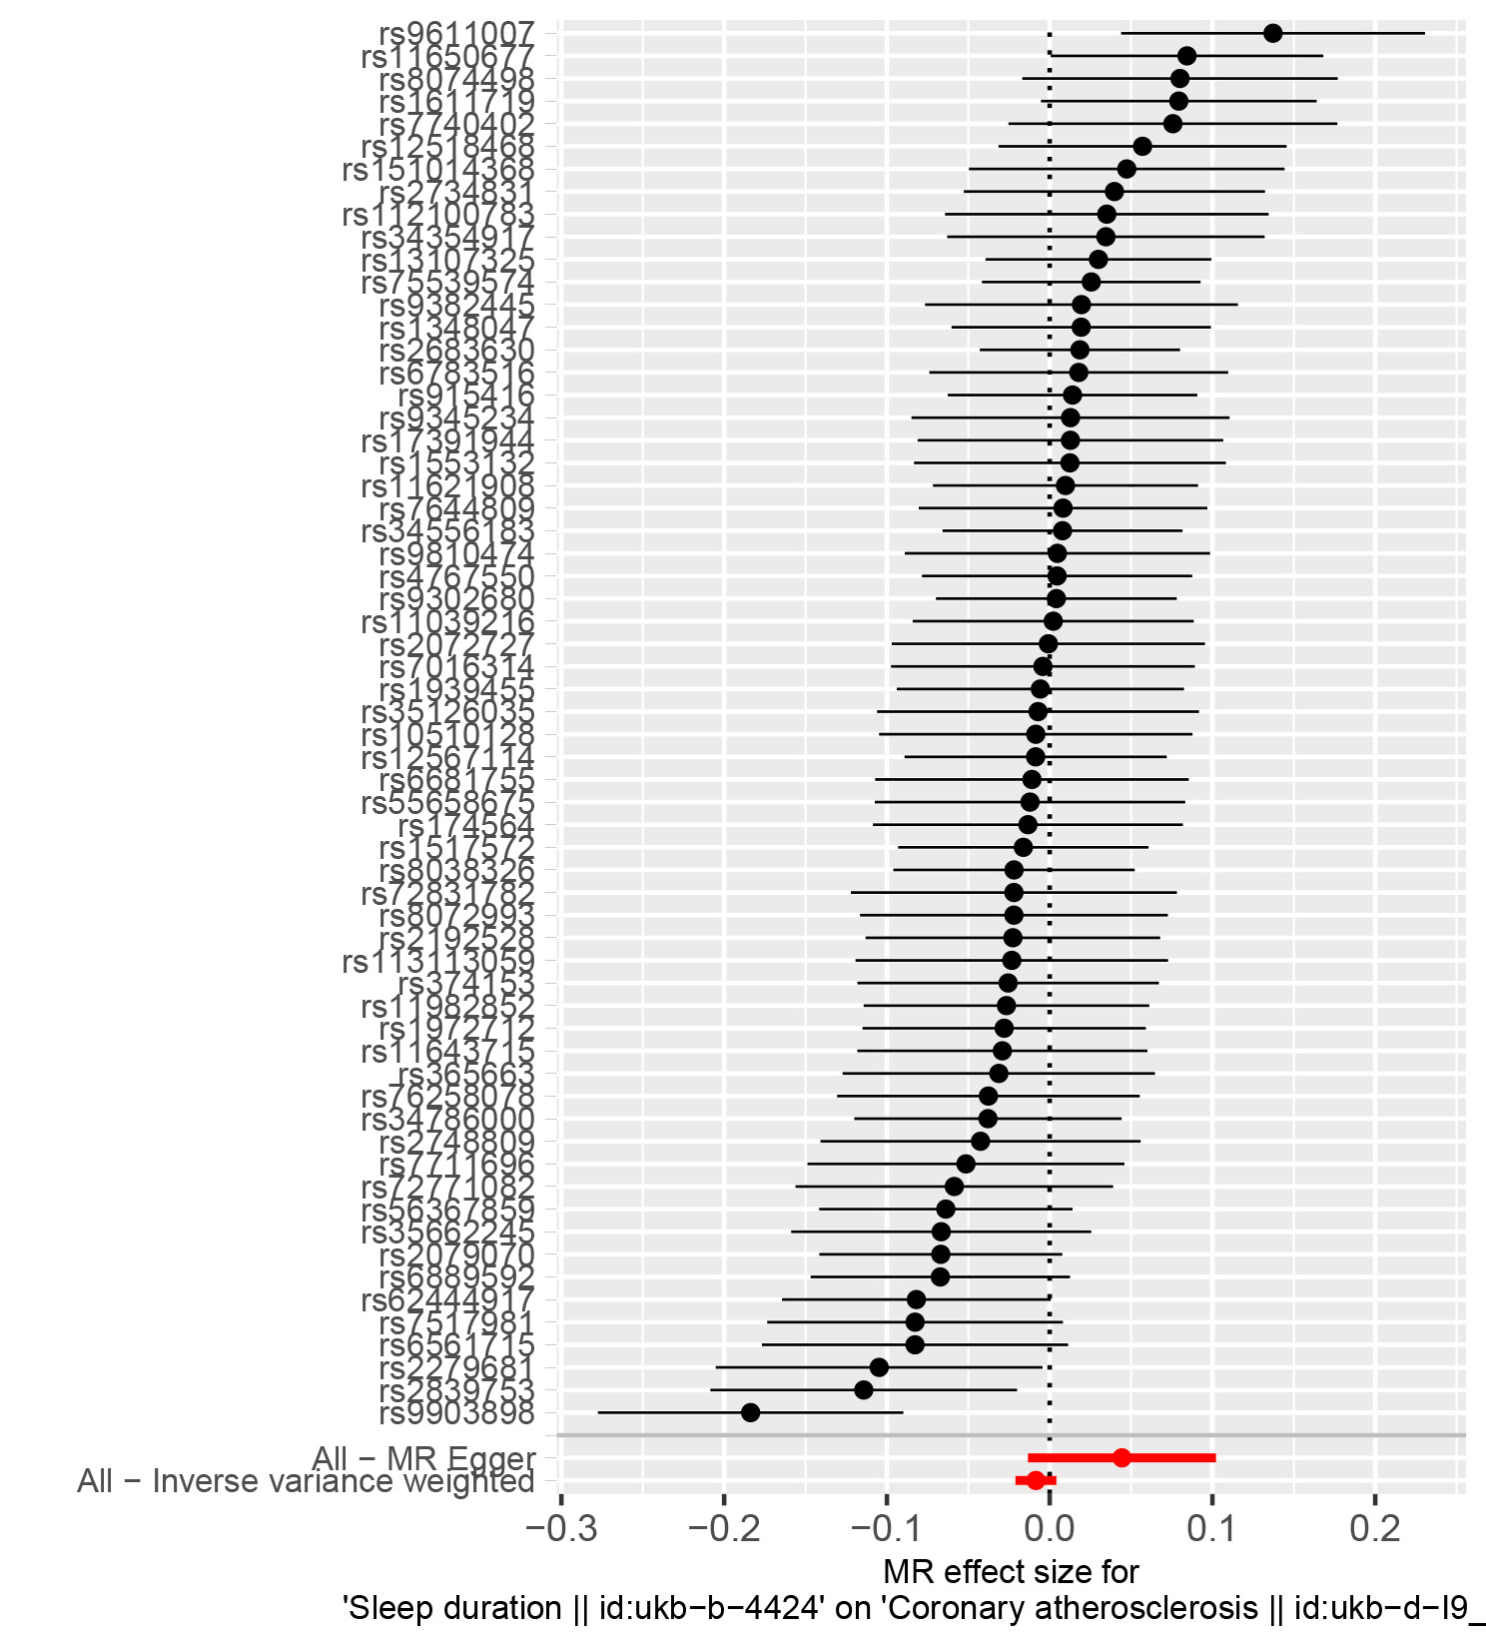

Note: Each row (black lines) represents the result after the removal of the corresponding SNP, and the overall effect is shown at the bottom (red line).
Supplemental Figure S2. Scatter plots of SNPs associated with sleep duration and atherosclerosis (AS).
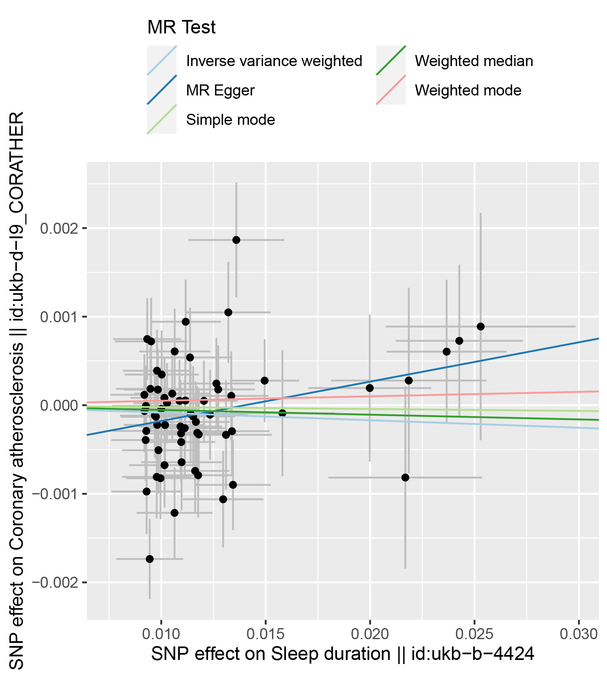
Note: According to the catter plots, the sleep duration was not associated with atherosclerosis(AS).
Supplemental Figure S3. Funnel plots of SNPs associated with sleep duration and atherosclerosis (AS).
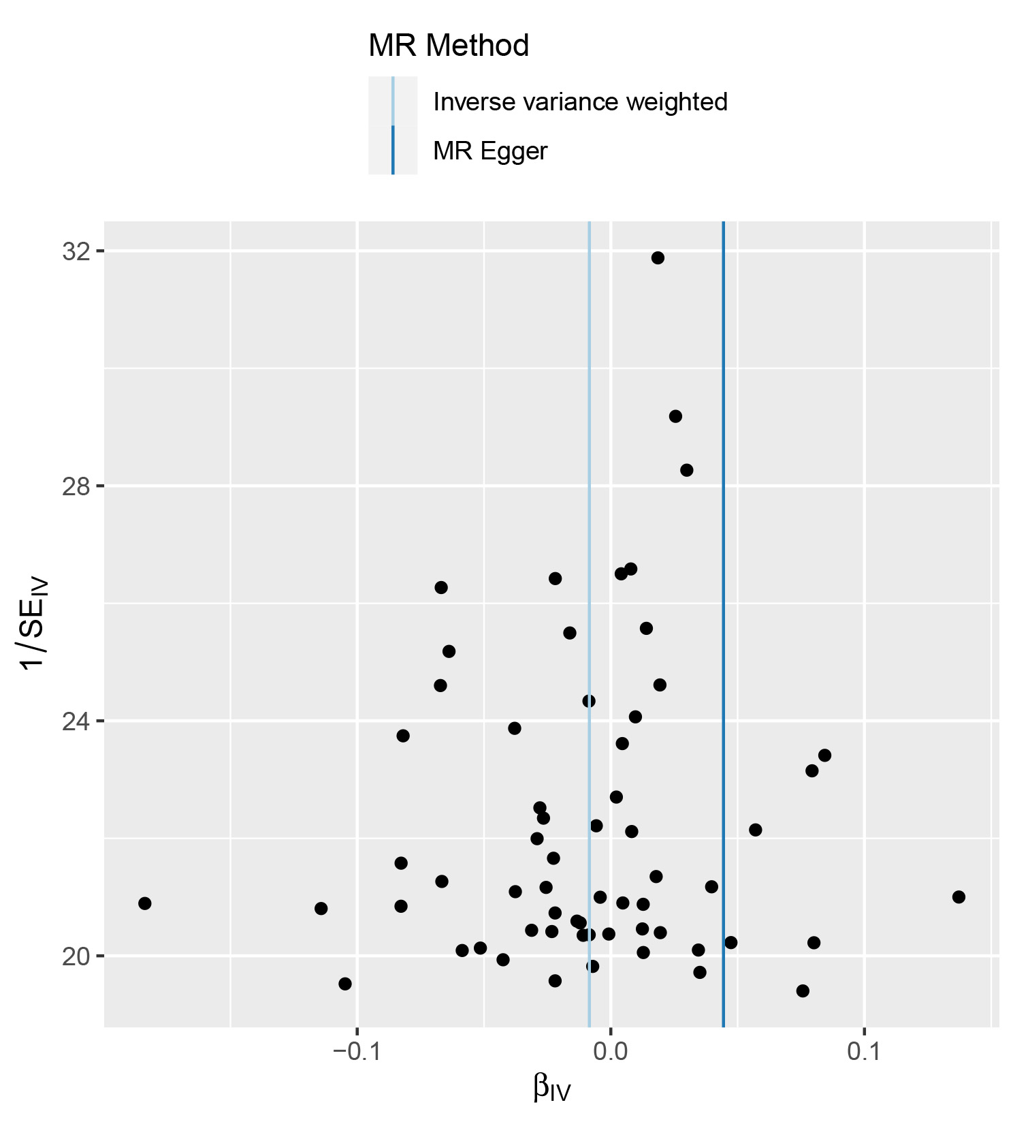
Note: The funnel plot showed that there was not basically symmetry.
Supplemental Figure S4. Leave-one-out plots of SNPs associated with sleep duration and atherosclerosis (AS).
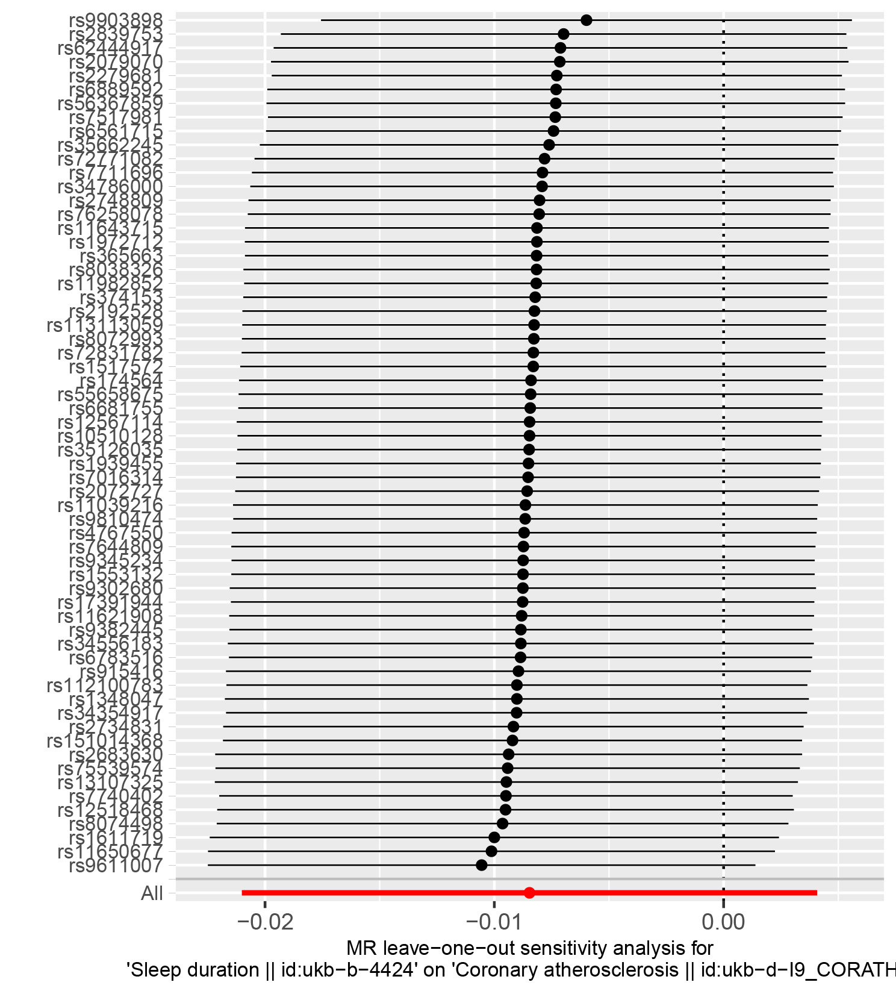
Note: Each row (black lines) represents the result after the removal of the corresponding SNP, and the overall effect is shown at the bottom (red line).

References
1..Palmer TM, Lawlor DA, Harbord RM, Sheehan NA, Tobias JH, Timpson NJ, Davey Smith G, Sterne JA. Using multiple genetic variants as instru-
mental variables for modifiable risk factors. Stat Methods Med Res.2012;21:223–242. doi: 10.1177/0962280210394459

