Supplementary Figures

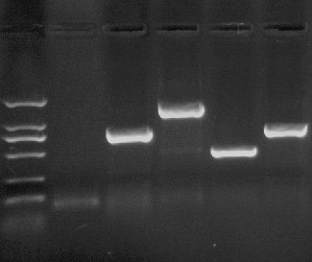
100
250
500
750
1000CVVV
2000CVVV
bp M 1 2 3 4 5

Supplementary Fig. S1 Screening and identification SL1344, △STnc1480 and △STnc1480/STnc1480 strain by PCR
M: DNA Marker DL-2000 (2000, 1000, 750, 500, 250, 100 bp);
1: Negative control; 2: SL1344 strain; 3: △STnc1480：：cat recombinant strain; 4: △: STnc1480 strain; 5: △STnc1480/STnc1480 complement strain.

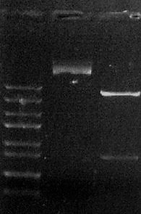
250
500
1000
1500
2000
3000
5000
800
bp M 1 2

Supplementary Fig. S2 Identification of pBR322-STnc1480 plasmid by double digestion
M: DNA marker DL-5000 (5000, 3000, 2000, 1500, 1000, 800, 500,250, 100 bp);
1: pBR322-STnc1480 plasmid; 2: pBR322-STnc1480 plasmid digested by restriction enzyme

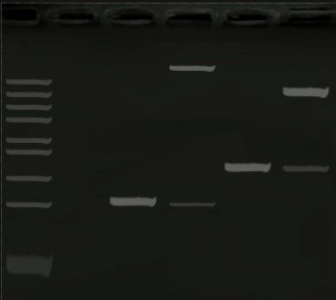
100
250
500
800
1000
1500
2000
3000
5000
bp M 1 2 3 4 5

Supplementary Fig. S3 Screening and identification of pMR-LacZ-lpfA and pUT18C-STnc1480 using PCR and restriction enzyme digestion
M: DNA markerDL-5000(5000, 3000, 2000, 1500, 1000, 800, 500,250, 100bp);
1: Negative control; 2: Verification of pMR-LacZ-lpfA by PCR;
3: pMR-LacZ-lpfA digested by restriction enzyme;
4: Identification of pUT18C-STnc1480 by PCR;
5: pUT18C-STnc1480 digested by restriction enzyme.

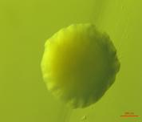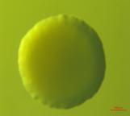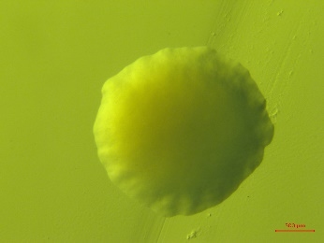
A
C
B

Supplementary Fig. S4 Bacterial single colony of SL1344, △STnc1480 and △STnc1480 /STnc1480 cultured in LB agar plate
A: SL1344 strain; B: △STnc1480 strain; C: △STnc1480 /STnc1480 strain

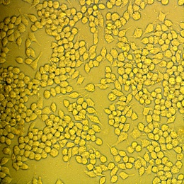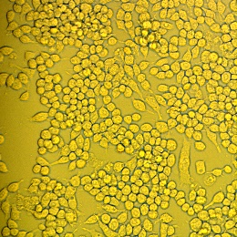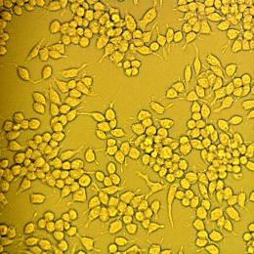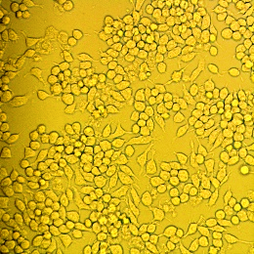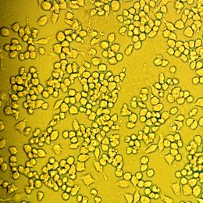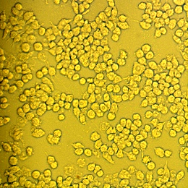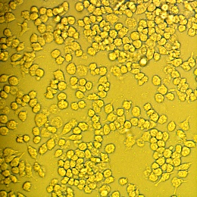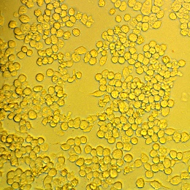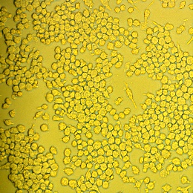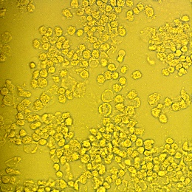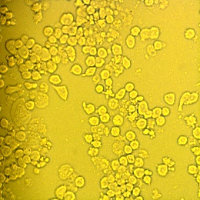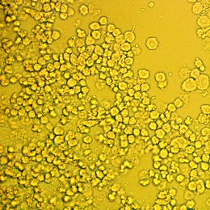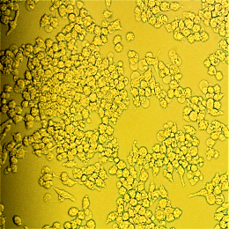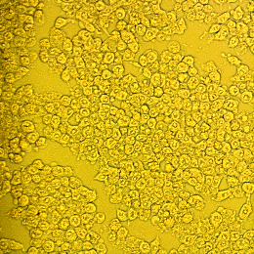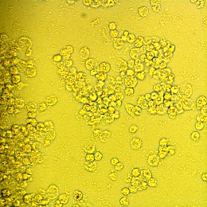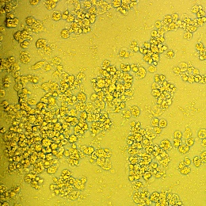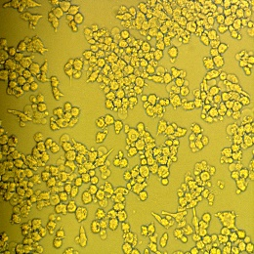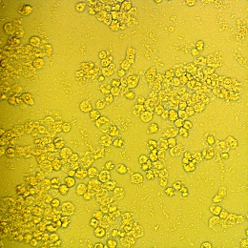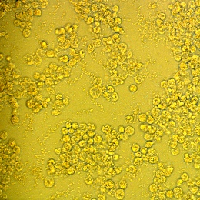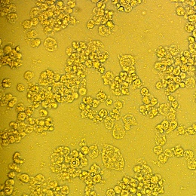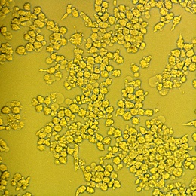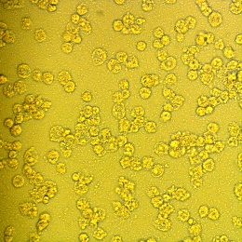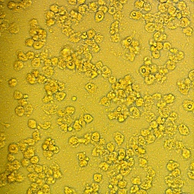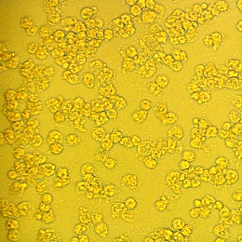
10h
DMEM SL1344 △STnc1480 △STnc1480 /STnc1480
2h
4h
6h
8h
12h

Supplementary Fig. S5 Cytopathic effects of RAW264.7 cells infected by SL1344, △STnc1480 and △STnc1480/STnc1480 strain, respectively (20×10).

