Supplementary Table 1. Number of population and deaths during the 10-year study period between 2008 and 2017.
Year | Overall |  | National Health Insurance |  | Medical Aid
Year | No. of population | No. of deaths | No. of population | No. of deaths | No. of population | No. of deaths
Overall (men and women)
2008 | 49,245,374 | 239,798 | 47,403,267 | 200,905 | 1,842,107 | 38,893
2009 | 49,519,213 | 240,935 | 47,689,560 | 204,211 | 1,829,653 | 36,724
2010 | 49,756,545 | 249,930 | 48,093,925 | 214,021 | 1,662,620 | 35,909
2011 | 49,980,840 | 252,191 | 48,324,794 | 215,822 | 1,656,046 | 36,369
2012 | 50,228,255 | 262,277 | 48,634,986 | 225,154 | 1,593,269 | 37,123
2013 | 50,455,808 | 259,431 | 48,961,585 | 225,323 | 1,494,223 | 34,108
2014 | 50,658,369 | 262,816 | 49,212,587 | 227,845 | 1,445,782 | 34,971
2015 | 50,855,927 | 269,976 | 49,437,004 | 235,119 | 1,418,923 | 34,857
2016 | 51,042,438 | 271,023 | 49,524,158 | 236,893 | 1,518,280 | 34,130
2017 | 51,195,634 | 276,028 | 49,703,483 | 241,223 | 1,492,151 | 34,805
Sum | 502,938,403 | 2,584,405 | 486,985,349 | 2,226,516 | 15,953,054 | 357,889
Men
2008 | 24,681,837 | 132,347 | 23,876,217 | 113,179 | 805,620 | 19,168
2009 | 24,814,033 | 133,287 | 24,011,827 | 115,339 | 802,206 | 17,948
2010 | 24,922,943 | 138,129 | 24,195,480 | 120,658 | 727,463 | 17,471
2011 | 25,023,245 | 139,216 | 24,299,816 | 121,852 | 723,429 | 17,364
2012 | 25,136,066 | 143,509 | 24,436,925 | 125,925 | 699,141 | 17,584
2013 | 25,237,439 | 141,885 | 24,582,055 | 125,684 | 655,384 | 16,201
2014 | 25,327,681 | 143,549 | 24,692,284 | 126,767 | 635,397 | 16,782
2015 | 25,415,837 | 146,065 | 24,786,628 | 129,277 | 629,209 | 16,788
2016 | 25,498,033 | 146,293 | 24,820,487 | 129,393 | 677,546 | 16,900
2017 | 25,563,384 | 148,139 | 24,893,770 | 131,104 | 669,614 | 17,035
Sum | 251,620,498 | 1,412,419 | 244,595,489 | 1,239,178 | 7,025,009 | 173,241
Women
2008 | 24,563,537 | 107,451 | 23,527,050 | 87,726 | 1,036,487 | 19,725
2009 | 24,705,180 | 107,648 | 23,677,733 | 88,872 | 1,027,447 | 18,776
2010 | 24,833,602 | 111,801 | 23,898,445 | 93,363 | 935,157 | 18,438
2011 | 24,957,595 | 112,975 | 24,024,978 | 93,970 | 932,617 | 19,005
2012 | 25,092,189 | 118,768 | 24,198,061 | 99,229 | 894,128 | 19,539
2013 | 25,218,369 | 117,546 | 24,379,530 | 99,639 | 838,839 | 17,907
2014 | 25,330,688 | 119,267 | 24,520,303 | 101,078 | 810,385 | 18,189
2015 | 25,440,090 | 123,911 | 24,650,376 | 105,842 | 789,714 | 18,069
2016 | 25,544,405 | 124,730 | 24,703,671 | 107,500 | 840,734 | 17,230
2017 | 25,632,250 | 127,889 | 24,809,713 | 110,119 | 822,537 | 17,770
Sum | 251,317,905 | 1,171,986 | 242,389,860 | 987,338 | 8,928,045 | 184,648

Supplementary Table 2. Age-specific contributions to the life expectancy difference between National Health Insurance beneficiaries and Medical Aid recipients between 2008 and 2017 by sex
 | Overall |  | Men |  | Women
Age | Years | % Contribution | Years | % Contribution | Years | % Contribution
0 | 0.13 | 0.9 | 0.17 | 1.0 | 0.10 | 0.9
1-4 | 0.19 | 1.3 | 0.22 | 1.3 | 0.16 | 1.6
5-9 | 0.11 | 0.8 | 0.13 | 0.7 | 0.10 | 0.9
10-14 | 0.10 | 0.7 | 0.12 | 0.7 | 0.07 | 0.7
15-19 | 0.14 | 0.9 | 0.17 | 1.0 | 0.09 | 0.9
20-24 | 0.23 | 1.6 | 0.26 | 1.5 | 0.20 | 1.9
25-29 | 0.83 | 5.7 | 0.91 | 5.2 | 0.69 | 6.8
30-34 | 1.29 | 8.9 | 1.59 | 9.1 | 1.02 | 10.0
35-39 | 1.37 | 9.5 | 1.96 | 11.2 | 0.92 | 9.0
40-44 | 1.52 | 10.5 | 2.31 | 13.2 | 0.81 | 8.0
45-49 | 1.85 | 12.8 | 2.41 | 13.8 | 0.96 | 9.3
50-54 | 2.03 | 14.0 | 2.28 | 13.0 | 1.12 | 10.9
55-59 | 1.77 | 12.2 | 1.86 | 10.6 | 1.12 | 10.9
60-64 | 1.32 | 9.1 | 1.41 | 8.0 | 0.97 | 9.4
65-69 | 0.77 | 5.3 | 0.85 | 4.9 | 0.70 | 6.8
70-74 | 0.47 | 3.3 | 0.52 | 2.9 | 0.55 | 5.4
75-79 | 0.29 | 2.0 | 0.28 | 1.6 | 0.43 | 4.2
80-84 | 0.15 | 1.0 | 0.12 | 0.7 | 0.27 | 2.6
85+ | -0.08 | -0.6 | -0.01 | -0.1 | -0.03 | -0.3
Total | 14.47 | 100.0 | 17.55 | 100.0 | 10.24 | 100.0

Supplementary Table 3. Cause-specific contributions to the life expectancy difference between Medical Aid recipients and National Health Insurance beneficiaries by sex in 2008-2017 combined
Causes of death | Overall |  | Men |  | Women
Causes of death | Years | % Contribution | Years | % Contribution | Years | % Contribution
Infectious diseases (A00-B99) | 0.64 | 4.4 | 0.84 | 4.8 | 0.39 | 3.8
Cancers (C00-C97) | 2.96 | 20.5 | 3.30 | 18.8 | 2.48 | 24.2
Endocrine diseases (E00-E89) | 0.98 | 6.8 | 1.12 | 6.4 | 0.74 | 7.2
Mental and nervous diseases (F01-G99) | 1.22 | 8.4 | 1.53 | 8.7 | 0.83 | 8.2
Cardiovascular diseases (I00-I99) | 2.09 | 14.4 | 2.38 | 13.6 | 1.68 | 16.4
Respiratory diseases (J00-J99) | 0.85 | 5.9 | 1.08 | 6.2 | 0.66 | 6.4
Digestive disease (K00-K95) | 1.76 | 12.2 | 2.43 | 13.8 | 0.79 | 7.8
Musculoskeletal disease (M00-M99) | 0.10 | 0.7 | 0.09 | 0.5 | 0.13 | 1.2
Urinary diseases (N00-N99) | 0.44 | 3.0 | 0.46 | 2.6 | 0.42 | 4.1
Conditions during pregnancy, childbirth and the puerperium (O00-O99) | 0.00 | 0.0 | 0.00 | 0.0 | 0.01 | 0.1
Perinatal conditions (P00-P96) | 0.00 | 0.0 | 0.00 | 0.0 | 0.01 | 0.1
Congenital malformation (Q00-Q99) | 0.16 | 1.1 | 0.18 | 1.0 | 0.14 | 1.3
External causes (V00-Y99) | 2.11 | 14.6 | 2.73 | 15.6 | 1.34 | 13.1
Ill-defined causes (R00-R99) | 0.98 | 6.8 | 1.23 | 7.0 | 0.48 | 4.7
Residual | 0.16 | 1.1 | 0.17 | 1.0 | 0.14 | 1.4
Total | 14.47 | 100.0 | 17.54 | 100.0 | 10.24 | 100.0

Supplementary Table 4. Cause-specific contributions to the life expectancy difference according to 60 causes of death
 | Overall |  | Men |  | Women
Causes | Years | % Contribution | Years | % Contribution | Years | % Contribution
Tuberculosis (A15-A19) | 0.236 | 1.63 | 0.335 | 1.91 | 0.106 | 1.03
Septicemia (A40-A41) | 0.137 | 0.95 | 0.157 | 0.89 | 0.116 | 1.13
Other infectious diseases | 0.267 | 1.85 | 0.346 | 1.97 | 0.173 | 1.69
Esophageal cancer (C15) | 0.060 | 0.41 | 0.087 | 0.50 | 0.017 | 0.16
Stomach cancer (C16) | 0.369 | 2.55 | 0.451 | 2.57 | 0.238 | 2.32
Colorectal cancer (C18) | 0.152 | 1.05 | 0.169 | 0.96 | 0.128 | 1.25
Rectal cancer (C19-C21) | 0.174 | 1.20 | 0.204 | 1.16 | 0.123 | 1.20
Liver cancer (C22) | 0.520 | 3.60 | 0.739 | 4.21 | 0.207 | 2.02
Biliary tract/gall bladder cancer (C23-24) | 0.060 | 0.41 | 0.061 | 0.35 | 0.058 | 0.57
Pancreatic cancer (C25) | 0.076 | 0.52 | 0.092 | 0.52 | 0.056 | 0.55
Lung and bronchus cancer (C33-C34) | 0.354 | 2.44 | 0.456 | 2.60 | 0.260 | 2.54
Breast cancer (C50) | 0.204 | 1.41 | 0.002 | 0.01 | 0.462 | 4.51
Uterine cervix cancer (C53) | 0.114 | 0.79 | 0.000 | 0.00 | 0.249 | 2.43
Other and unspecified uterine cancer (C54-C55) | 0.013 | 0.09 | 0.000 | 0.00 | 0.030 | 0.29
Ovarian cancer (C56) | 0.046 | 0.32 | 0.000 | 0.00 | 0.106 | 1.04
Prostatic cancer (C61) | 0.009 | 0.06 | 0.018 | 0.10 | 0.000 | 0.00
Kidney cancer (C64) | 0.033 | 0.23 | 0.042 | 0.24 | 0.022 | 0.21
Urinary bladder cancer (C67) | 0.027 | 0.19 | 0.041 | 0.23 | 0.010 | 0.10
Brain and CNS cancer (C70-C72) | 0.131 | 0.90 | 0.157 | 0.89 | 0.104 | 1.02
Thyroid cancer (C73) | 0.007 | 0.05 | 0.006 | 0.03 | 0.009 | 0.09
Non-Hodgkin's lymphoma (C82-C86) | 0.063 | 0.44 | 0.083 | 0.47 | 0.044 | 0.43
Multiple myeloma (C90) | 0.019 | 0.13 | 0.020 | 0.12 | 0.015 | 0.15
Leukemia (C91-C95) | 0.190 | 1.32 | 0.240 | 1.37 | 0.136 | 1.33
Other cancers | 0.340 | 2.35 | 0.436 | 2.48 | 0.206 | 2.01
Diabetes (E10-E14) | 0.875 | 6.05 | 1.000 | 5.70 | 0.653 | 6.38
Other endocrine diseases | 0.107 | 0.74 | 0.122 | 0.69 | 0.084 | 0.82
Dementia (F01-F09, G30) | 0.102 | 0.71 | 0.117 | 0.67 | 0.116 | 1.13
Meningitis (G00, G03) | 0.006 | 0.04 | 0.006 | 0.03 | 0.006 | 0.06
Alcohol/substance abuse (F10-F19) | 0.230 | 1.59 | 0.353 | 2.01 | 0.055 | 0.53
Parkinson's disease (G20) | 0.047 | 0.33 | 0.047 | 0.27 | 0.046 | 0.45
Other mental and nervous diseases | 0.833 | 5.76 | 1.010 | 5.76 | 0.612 | 5.97
Rheumatic heart disease (I00-I09) | 0.014 | 0.10 | 0.012 | 0.07 | 0.016 | 0.16
Hypertensive disease (I10-I13) | 0.104 | 0.72 | 0.119 | 0.68 | 0.111 | 1.08
Ischemic heart disease (I20-I25) | 0.420 | 2.90 | 0.481 | 2.74 | 0.335 | 3.27
Cerebrovascular accidents (I60-I69) | 1.012 | 6.99 | 1.153 | 6.57 | 0.776 | 7.58
Other cardiovascular diseases | 0.538 | 3.72 | 0.613 | 3.49 | 0.437 | 4.27
Influenza (J09-J11) | 0.009 | 0.06 | 0.010 | 0.06 | 0.008 | 0.07
Pneumonia (J12-J18) | 0.443 | 3.06 | 0.562 | 3.20 | 0.337 | 3.29
Chronic lower respiratory disease (J40-J47) | 0.227 | 1.57 | 0.294 | 1.67 | 0.175 | 1.71
Other respiratory disease | 0.175 | 1.21 | 0.215 | 1.22 | 0.136 | 1.33
Alcoholic liver disease (K70) | 0.997 | 6.89 | 1.454 | 8.28 | 0.333 | 3.25
Liver cirrhosis (K74) | 0.354 | 2.44 | 0.483 | 2.75 | 0.159 | 1.55
Other digestive disease | 0.411 | 2.84 | 0.492 | 2.81 | 0.302 | 2.95
Musculoskeletal disease (M00-M99) | 0.103 | 0.71 | 0.087 | 0.50 | 0.126 | 1.23
Chronic renal failure (N18) | 0.338 | 2.34 | 0.351 | 2.00 | 0.318 | 3.10
Other urinary disease | 0.102 | 0.70 | 0.111 | 0.63 | 0.099 | 0.97
Conditions during pregnancy, childbirth and the puerperium (O00-O99) | 0.004 | 0.03 | 0.000 | 0.00 | 0.007 | 0.07
Perinatal conditions (P00-P96) | 0.005 | 0.03 | 0.000 | 0.00 | 0.011 | 0.10
Congenital malformation (Q00-Q99) | 0.158 | 1.09 | 0.176 | 1.00 | 0.135 | 1.32
Transport accidents (V01-V99) | 0.264 | 1.83 | 0.388 | 2.21 | 0.121 | 1.18
Falls (W00-W19) | 0.144 | 0.99 | 0.203 | 1.16 | 0.063 | 0.62
Drowning (W65-W74) | 0.050 | 0.35 | 0.069 | 0.39 | 0.027 | 0.26
Exposure to fire (X00-X09) | 0.037 | 0.26 | 0.047 | 0.27 | 0.021 | 0.21
Accidental poisoning (X40-X49) | 0.023 | 0.16 | 0.034 | 0.20 | 0.012 | 0.11
Suicide (X60-X84) | 1.003 | 6.93 | 1.228 | 7.00 | 0.733 | 7.15
Homicide (X85-Y09) | 0.104 | 0.72 | 0.108 | 0.62 | 0.095 | 0.93
Other external causes | 0.486 | 3.36 | 0.654 | 3.73 | 0.273 | 2.67
Senility (R54) | 0.083 | 0.57 | 0.035 | 0.20 | 0.036 | 0.35
Other ill-defined causes | 0.901 | 6.23 | 1.197 | 6.82 | 0.448 | 4.37
Residual | 0.157 | 1.09 | 0.172 | 0.98 | 0.141 | 1.38
Total | 14.467 | 100.0 | 17.545 | 100.0 | 10.240 | 100.0

Supplementary Figure 1. The age-specific contribution of cancer to the life expectancy difference between National Health Insurance beneficiaries and Medical Aid recipients between 2008 and 2017 by sex.

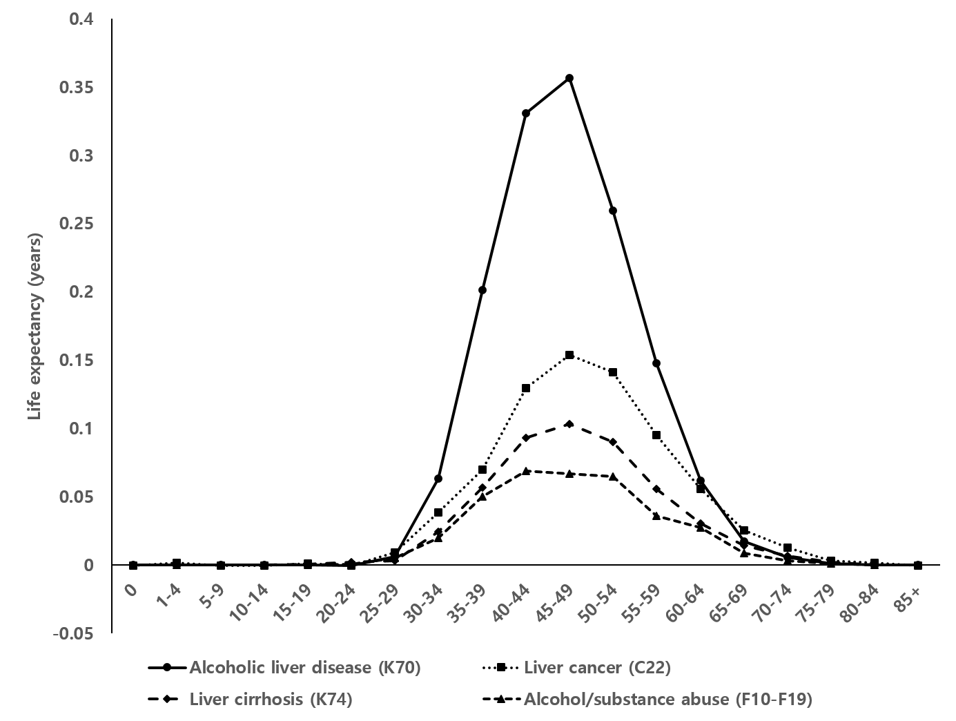
Supplementary Figure 2. The age-specific contribution of alcohol-related deaths to the life expectancy difference between National Health Insurance beneficiaries and Medical Aid recipients between 2008 and 2017 among men.

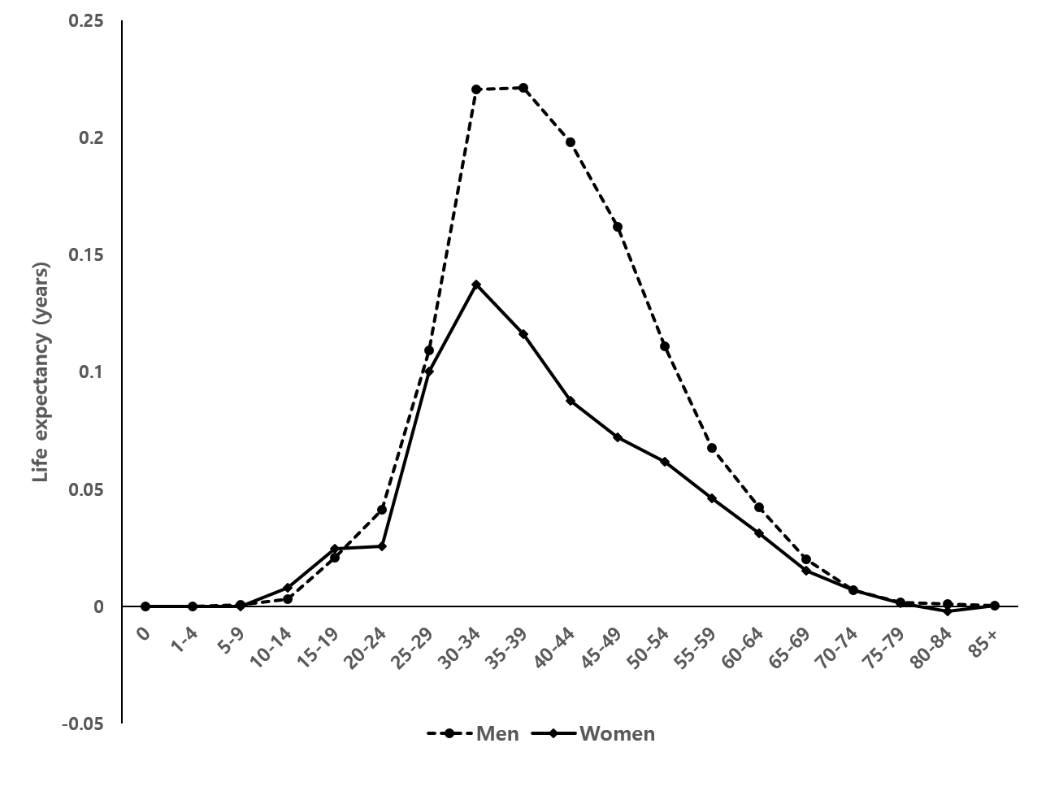
Supplementary Figure 3. The age-specific contribution of suicide to the life expectancy difference between National Health Insurance beneficiaries and Medical Aid recipients between 2008 and 2017 by sex.

