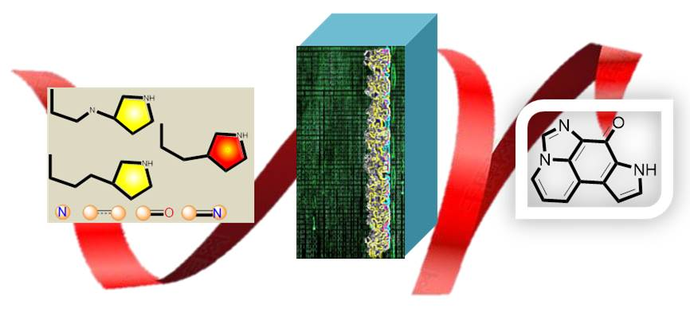
Unambiguously confirming natural products with high C/H ratio or proton-deficient and multi heteroatoms is challenging. A time-saving module-assembly calculation study of aaptourinamine rendered us the fold of a new scaffold of biosynthetically aaptamine related imidazo[4,5,1-ij]pyrrolo[3,2-f]quinolin-7(8H)-one.

